Components and Advantages
Pre-Engineered Buildings: Components and Advantages. In the fast-evolving landscape of construction, Pre-Engineered Buildings (PEBs) have emerged as a transformative solution. Unlike conventional buildings, PEBs are pre-manufactured at a factory and assembled at the construction site, ensuring faster, more efficient, and highly customizable building solutions. One of the key players in this domain, Steelbuild Infra Projects Ltd, is leading the change by offering cutting-edge, pre-engineered steel buildings tailored to client specifications with impeccable precision.

What are Pre-Engineered Buildings (PEBs)?
Pre-Engineered Buildings are steel structures built over a structural concept of primary and secondary framing along with roof and wall sheeting. These buildings are designed and fabricated in factories and then shipped to the construction site for assembly. The concept aims to streamline the construction process, reduce cost, and offer a high degree of flexibility.
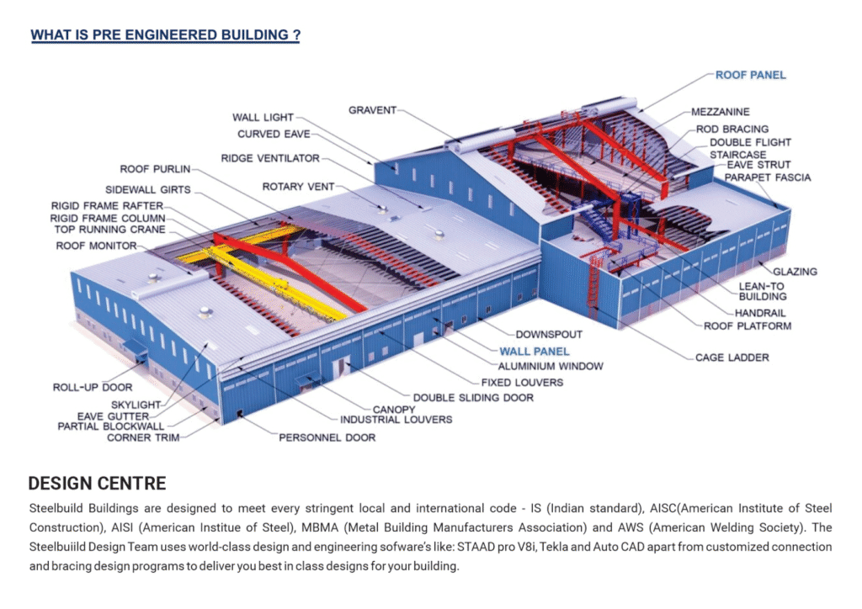
PEBs are extensively used for warehouses, industrial sheds, schools, hospitals, airports, multi-level car parking systems, and commercial complexes, among others.

Key Components of PEBs
To fully understand how PEBs outperform traditional buildings, let us delve into their core components:

1. Primary Frames
The primary framing system forms the backbone of the structure. These frames include columns, rafters, and other load-bearing elements made from high-strength steel. Precision-engineered for strength and durability, these elements ensure the building's structural integrity.

2. Secondary Structural Elements
These include purlins, girts, eave struts, and bracings that provide lateral stability and transfer loads to the primary framing system. They enhance both the aesthetic and functional aspects of the building.

3. Roof and Wall Panels
Roof and wall panels are generally made from pre-painted galvanized steel. These panels offer superior insulation, weather resistance, and contribute to the overall aesthetic appeal of the building.

4. Accessories
These include doors, windows, ventilators, skylights, louvers, and insulation materials. All these components are pre-designed and manufactured to ensure quick and smooth installation.

Design Considerations in PEBs
At Steelbuild Infra Projects Ltd, the design of every PEB is meticulously planned. Some of the vital considerations include:
- Slope of the roof
- Space between bearing points
- Deflection criteria
- Bay spacing
- Practical size limits of components
Our team conducts extensive site visits to ensure accurate measurements and optimal integration with environmental factors. Furthermore, we use only high-quality, environment-friendly materials to enhance durability and sustainability.

Advantages of Pre-Engineered Buildings

1. Superior Quality Control
Since PEBs are fabricated in a controlled factory setting, quality assurance is more rigorous and consistent. Each component undergoes stringent checks, ensuring defect-free delivery. This reduces the likelihood of structural issues post-construction.

2. Faster Construction
PEBs can be erected at a fraction of the time compared to traditional buildings. With factory-fabricated components ready for quick on-site assembly, project timelines are significantly reduced. This is especially valuable in commercial and industrial projects where time is critical.

3. Cost-Effective
PEBs reduce costs across multiple fronts:
- Reduced labor requirements
- Lesser construction time
- Minimal material waste
- Integrated design and production processes
The need for multiple vendors is eliminated, as Steelbuild Infra Projects Ltd handles the end-to-end process, from design to assembly.

4. Low Maintenance
High-quality paints, coatings, and corrosion-resistant materials ensure that PEBs require significantly less maintenance. Issues such as rusting, chipping, or wear and tear are almost negligible, especially when compared to traditional construction methods.

5. Design Flexibility
PEBs offer immense design flexibility. Whether you require a single-story warehouse or a multi-level hospital, the structure can be tailored to suit exact specifications, including future scalability.

6. Structural Strength and Durability
Steel, being a robust material, offers excellent strength-to-weight ratio. PEBs are capable of withstanding harsh climatic conditions, seismic loads, and heavy-duty operations, making them ideal for a wide range of applications.

7. Space Optimization
PEBs are designed to maximize internal space. The column-free interiors and long-span capabilities allow businesses to utilize more floor area, making these buildings ideal for warehouses, factories, and hangars.

8. Environmentally Friendly
Pre-Engineered Buildings are a sustainable option. The steel used is 100% recyclable, and the construction process involves less waste generation. Additionally, energy-efficient insulation materials can be incorporated to improve thermal performance.

Applications of Pre-Engineered Buildings
- Warehouses
- Factories
- Commercial Buildings
- Hospitals
- Educational Institutions
- Aircraft Hangars
- Sports Facilities
- Shopping Complexes

Why Choose Steelbuild Infra Projects Ltd?
With over 24 years of experience, Steelbuild Infra Projects Ltd has set a benchmark in the field of pre-engineered construction. Here’s why clients across India trust us:
- End-to-End Solutions: From design, fabrication to installation
- 100% In-House Manufacturing: Eliminates dependency on third-party vendors
- Customization: Every project is tailored to client-specific needs
- Unmatched Precision: 99.99% accuracy in fabrication and fit
- Sustainable Practices: Focus on green building initiatives
- Skilled Workforce: A team of experienced engineers and technicians

Conclusion
Pre-Engineered Buildings offer a revolutionary approach to modern construction. With unmatched benefits in terms of speed, cost, quality, and sustainability, they have become the preferred choice across sectors. Understanding the core components and advantages of PEBs helps stakeholders make informed decisions that ensure long-term structural efficiency and cost savings.
Steelbuild Infra Projects Ltd stands at the forefront of this transformation. Our commitment to quality, innovation, and customer satisfaction has made us one of the most trusted PEB manufacturers in India. From industrial giants to educational institutions, we deliver future-ready infrastructure built to last.
Ready to elevate your next project? Choose Steelbuild Infra Projects Ltd – where precision meets passion.
Visit us at: steelbuildinfra.com

