How Can You Soundproof Your PEB or Prefab with Rockwool Sandwich Panels?
Rockwool Sandwich Panels. As industries and businesses adopt modern construction solutions, soundproofing has become an essential consideration. Whether it’s a factory with heavy machinery or an airport terminal with continuous noise, managing sound levels is crucial. Pre-engineered buildings (PEBs) and prefabricated structures provide innovative solutions for various industries, and one major component that enhances their functionality is rockwool sandwich panels.
These panels are an effective way to reduce noise levels in a structure while offering additional benefits like insulation and durability. In this blog, we’ll explore the role of rockwool panels in soundproofing and how they can be integrated into prefab buildings.

The Role of Rockwool Panels in Soundproofing
The unique composition of rockwool panels makes them an excellent choice for soundproofing. The dense rockwool core effectively absorbs and blocks sound waves, preventing noise transmission. This feature makes them ideal for various applications across industries where noise reduction is a priority.
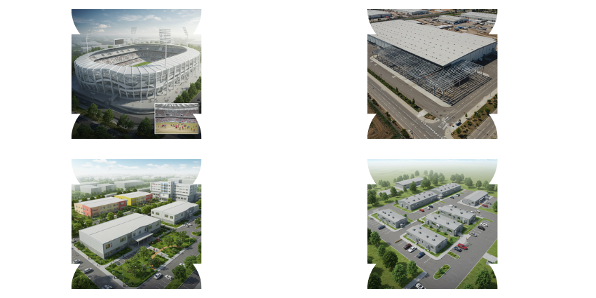

Industrial Applications
Factories and warehouses are known for their high noise levels, which can affect worker productivity and safety. Rockwool panels help in controlling this noise, ensuring a more comfortable working environment. In clean rooms and cold storage units, maintaining soundproofing along with thermal insulation is crucial. Rockwool panels provide a two-in-one solution for such needs.
Poultry farms and industrial enclosures also benefit from soundproofing. In poultry sheds, excessive noise can cause stress to animals, affecting their health and productivity. Rockwool panels provide a calm and controlled environment, reducing disturbances.

Infrastructure Projects
Transportation hubs like airports and metro stations experience high levels of noise pollution. Passengers and workers need a controlled sound environment to ensure comfort and efficiency. Rockwool panels act as barriers to external noise, making them a preferred choice for such large-scale infrastructure projects.
Shopping malls and railway sheds also require noise control to enhance customer experience and operational functionality. The ability of rockwool panels to minimize ambient noise ensures an improved environment for visitors and staff.

Institutional Buildings
Educational institutions and hospitals require noise-free environments for optimal learning and healing. In schools, excessive noise can be a distraction, reducing student concentration. Similarly, in hospitals, noise control is essential for patient recovery. Rockwool panels help in creating quieter spaces, making them a practical choice for these institutions.
Office buildings and research laboratories also benefit from rockwool panels. A controlled acoustic environment ensures higher productivity and accuracy in research, making these panels a crucial component in corporate and scientific settings.

Construction Sites
Construction sites often include temporary offices and staff accommodations. These structures require quick installation while maintaining soundproofing. Rockwool panels offer an easy-to-install, effective soundproofing solution for these temporary spaces, ensuring a comfortable working environment.
Canteens and security guard rooms at construction sites can also benefit from rockwool panels. A quieter, controlled environment improves staff efficiency and well-being.

Sports and Leisure Facilities
Large stadiums and sports complexes require extensive soundproofing to manage crowd noise. Rockwool panels are highly effective in insulating such areas, ensuring a well-maintained acoustic environment.
Auditoriums and gymnasiums rely on controlled sound levels for better acoustics. Whether it’s a public address system or music for training, rockwool panels help maintain a high-quality sound experience by reducing echo and outside noise interference.

Special Buildings
Control rooms and noise-proof enclosures need specialized soundproofing to protect sensitive equipment and operations. Rockwool panels provide high-performance insulation, ensuring clarity and efficiency in these critical spaces.
Multilevel car parking structures and GIS buildings also benefit from soundproofing. Managing noise in these spaces ensures comfort and operational efficiency for users.

Advantages of Rockwool Panels Over Traditional Materials


1. Quick Installation
One of the major advantages of Rockwool panels is their quick installation process. Unlike traditional brick-and-mortar buildings, which require extensive labor and time, Rockwool panels are prefabricated and ready to assemble. The installation is straightforward, which significantly reduces the overall construction time. Faster installation also leads to reduced labor costs, making it a smart and cost-effective option for industrial and commercial projects.

2. Superior Soundproofing Properties
Traditional materials like concrete and wood provide some degree of sound insulation, but they cannot match the soundproofing efficiency of Rockwool panels. The dense core of these panels absorbs sound waves, preventing them from traveling through the structure. This makes them ideal for buildings where noise control is crucial, such as factories, auditoriums, airports, and hospitals. The ability to minimize noise pollution enhances productivity, comfort, and overall efficiency.

3. Excellent Fire Resistance
Fire safety is a critical concern in any industrial or commercial building. Rockwool panels offer superior fire resistance compared to traditional materials. Since they are made from non-combustible mineral wool, they do not contribute to the spread of fire. In high-risk environments like warehouses, cold storage, and manufacturing plants, Rockwool panels provide an added layer of security by reducing fire hazards and improving safety measures.

4. Thermal Insulation and Energy Efficiency
Energy efficiency is a growing concern in modern construction. Rockwool panels offer high thermal insulation, keeping interiors cool in summer and warm in winter. Unlike traditional concrete structures, which absorb and retain heat, these panels regulate indoor temperatures efficiently. This reduces reliance on heating and cooling systems, leading to lower energy consumption and significant cost savings over time. This feature makes them particularly useful for cold storage facilities, food processing units, and temperature-sensitive environments.

5. Durability and Low Maintenance
Rockwool panels are highly durable and designed to withstand harsh environmental conditions. Traditional materials like concrete can crack over time due to temperature fluctuations and structural stress. However, Rockwool panels maintain their strength and stability over long periods. They are resistant to moisture, mold, and pests, ensuring that the structure remains in optimal condition for years. Additionally, their low maintenance requirements make them a cost-effective solution for businesses looking for long-term benefits.

6. Versatility in Applications
Unlike conventional building materials, Rockwool panels can be used across a wide range of industries. Whether for warehouses, metro stations, schools, offices, or control rooms, they provide the flexibility to suit different construction needs. They are available in various sizes, thicknesses, and finishes, allowing businesses to customize their buildings according to specific requirements. Their adaptability ensures that they can be used for both temporary and permanent structures with ease.

7. Environmentally Friendly and Sustainable
Sustainability is an essential factor in modern construction. Traditional materials, such as bricks and concrete, require extensive raw materials and contribute to environmental degradation. Rockwool panels, on the other hand, are made from recycled and sustainable materials. They generate minimal waste during manufacturing and can be reused or repurposed. Their energy-efficient properties further reduce carbon footprints, making them an eco-friendly choice for industries committed to sustainable development.

8. Cost-Effectiveness in the Long Run
While Rockwool panels may have a slightly higher upfront cost compared to traditional materials, they offer substantial savings in the long run. Their thermal insulation reduces energy bills, their durability minimizes maintenance costs, and their quick installation lowers labor expenses. Businesses that invest in Rockwool panels benefit from reduced operational costs and improved efficiency over time.

Why Rockwool Panels are the Best Choice for PEB and Prefab Buildings
Rockwool panels are an essential component for any PEB or prefab structure requiring soundproofing. Their effectiveness in noise reduction, combined with durability and insulation properties, makes them the best choice for various industries. Whether it's for industrial, commercial, or institutional applications, rockwool panels provide a sustainable and efficient solution.
For businesses looking to enhance their construction projects with soundproofing solutions, integrating rockwool panels is a smart investment. They not only provide a noise-free environment but also improve energy efficiency and long-term cost savings.
By choosing the right materials like rockwool panels, industries can create comfortable, functional, and high-performing spaces, ensuring productivity and user satisfaction.

