Pre-Engineered Building Systems: A Promising Future for Indian Construction
Pre-Engineered Building Systems. India’s construction landscape has started evolving. With initiatives like Make in India and Atmanirbhar Bharat, the need for fast infrastructure development and sustainable solutions is growing. By achieving these targets, India can compete with global players more effectively.
Our country’s construction and manufacturing environment has become more dynamic than ever. Pre-engineered building systems (PEB) can support this need. Not only have they evolved to be game changers, but they can also help with the necessity for a sustainable, multi-industry, and flexible infrastructure.

What are Pre-Engineered Building Systems?
PEB systems are building kits comprising steel components manufactured off-site and assembled on-site. This streamlined approach offers several advantages over traditional construction methods. These systems reduce material waste, optimize labor use, and ensure quick project completion.
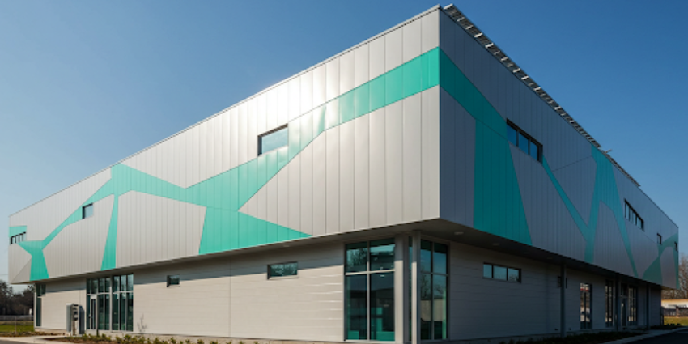
Compared to conventional structures, PEB solutions are much faster and more cost-effective. Components are fabricated with precision in factories before being transported to the construction site. This eliminates unpredictable delays due to weather conditions or labor shortages. These benefits make PEB an attractive choice for industries looking for scalable and sustainable infrastructure solutions.

The Versatility of Pre-Engineered Building Systems
Pre-engineered steel building systems are not limited to a single building type. They find applications across a wide range of sectors, catering to diverse needs. The following table provides an overview of different industries and their applications of PEB structures:
Sector | Pre-Engineered Building Applications
Industrial | Warehouses, industrial sheds, factory buildings, cold storage facilities, clean rooms, poultry sheds, industrial enclosures
Infrastructure | Airport terminals, aircraft hangars, metro stations, railway sheds, foot-over bridges, shopping complexes, petrol pump stations
Institutional | School buildings, hospitals, hostels, laboratories, exhibition halls, office buildings
Construction | Site offices, staff accommodations, canteens, toilet blocks, guard rooms
Sports & Leisure | Stadiums, sports complexes, auditoriums, gymnasiums
Unique Buildings | Control rooms, kiosks, noise-proof enclosures, multi-level car parks, GIS buildings
These structures are designed with flexibility in mind. Businesses can easily modify their facilities, expand their operations, or repurpose spaces without needing extensive modifications.

The Rise of Pre-Engineered Steel Building Systems
PEB systems, particularly those made from steel, have gained immense popularity due to their exceptional strength, durability, and resistance to fire, corrosion, and earthquakes. These systems have changed the way industrial and commercial structures are built in India.
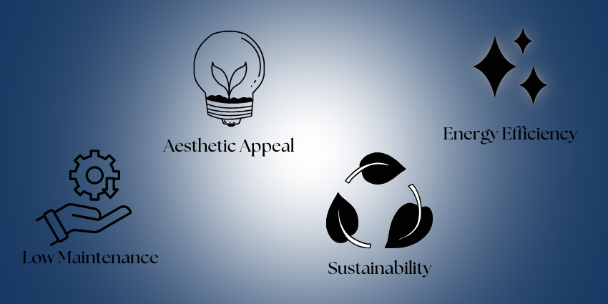
PEB structures require minimal maintenance, which reduces long-term operational costs. The materials used in their construction are recyclable, making them a more sustainable option than traditional concrete buildings. With advancements in technology, modern PEB structures are now aesthetically appealing, offering sleek designs and customizable features that enhance their functionality.
Moreover, steel’s insulation properties help lower energy consumption, making these buildings highly energy-efficient. When paired with innovative insulation materials, they reduce the need for excessive heating or cooling, further cutting down on energy costs.

The Future of Pre-Engineered Building Systems in India
Did you know that prefabricated buildings in India had a market size of $2.3 billion in 2023? The growth of this industry is unstoppable, with predictions estimating a CAGR of 13% between 2024 and 2029. These numbers solidify the future of pre-engineered building systems in India.
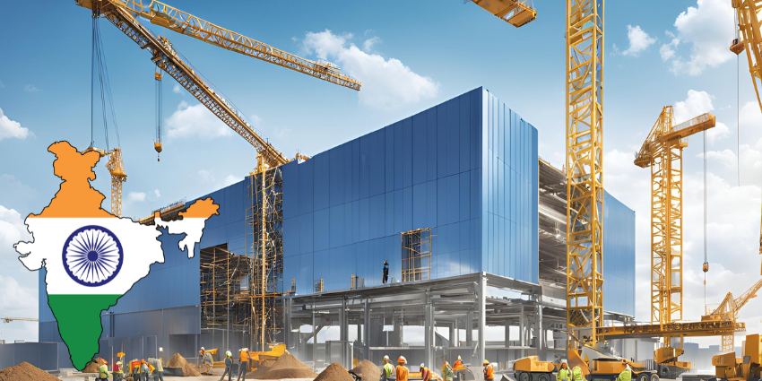
The demand for rapid construction, cost-effective solutions, and sustainable buildings is driving the adoption of PEB technology across various sectors. The government is also prioritizing infrastructural development and industrial growth, and PEB solutions are playing a key role in fulfilling this mission.
As India continues its push for modernization, the use of PEB structures will likely increase in large-scale industrial and commercial projects. Businesses are recognizing that these buildings offer a blend of efficiency, durability, and sustainability that is hard to match with conventional methods.

Your Partner for Pre-Engineered Building Solutions
Steelbuild Infra Projects has been delivering end-to-end solutions for more than 15 years. We have worked with 20+ industries, offering customized PEB solutions that cater to different business needs. Our expertise covers everything from design and manufacturing to on-site installation, ensuring that every project meets high-quality standards.
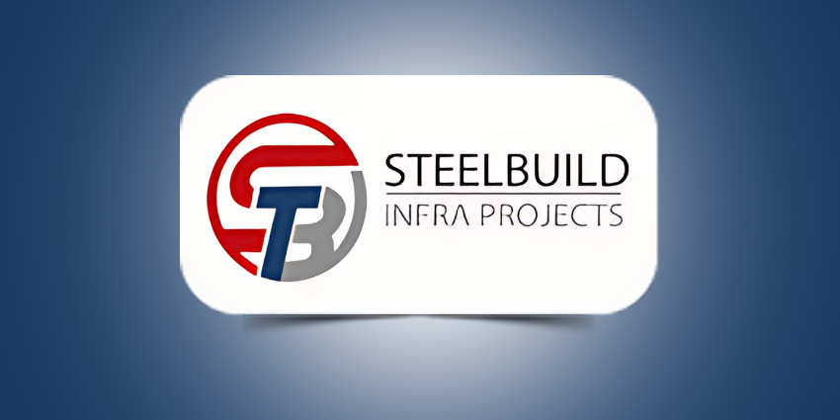
By choosing a trusted partner like Steelbuild Infra, businesses can benefit from cutting-edge PEB technology, ensuring they get a durable and efficient structure tailored to their requirements. Whether you need a warehouse, an office space, or a large-scale industrial facility, our team can provide the right solutions to meet your needs.

Conclusion
Pre-engineered building systems are changing the way construction happens in India. With their speed, cost-effectiveness, and environmental benefits, they offer a compelling alternative to traditional construction methods. As the demand for smart infrastructure solutions continues to rise, PEB technology will play an even greater role in shaping India’s commercial and industrial landscape.
With Steelbuild Infra leading the way, businesses have access to high-quality, sustainable, and customizable PEB solutions that align with India’s evolving construction needs. If you're planning a project, consider the advantages of PEB systems and how they can support your growth and expansion plans.

