How Can Pre-Engineered Buildings (PEBs) Shape India’s Commercial Construction?
Pre-Engineered Buildings. Commercial construction in India is undergoing a rapid transformation. The need for cost-effective, durable, and scalable infrastructure has led to the rise of Pre-Engineered Buildings (PEBs). Businesses are now prioritizing speed and efficiency, and PEBs provide a solution that aligns perfectly with these needs.
The construction industry has long relied on traditional methods, but these methods often come with high costs, delays, and resource inefficiencies. PEBs are changing the game by offering ready-to-assemble structures that cut construction time in half and minimize waste. This shift is especially important in India, where urbanization and industrial growth demand quick and reliable solutions.

The Growing Popularity of PEBs in India
India’s commercial sector is expanding, and businesses require modern infrastructure to keep up with market demands. PEBs offer an innovative alternative that suits warehouses, office buildings, cold storage units, and manufacturing plants. Their ability to be customized to fit specific requirements makes them an excellent choice for industries seeking functional and adaptable structures.
Traditional buildings take months or even years to complete, but PEBs reduce this timeline significantly. Since the components are manufactured off-site and assembled quickly, businesses can start operations much sooner. This advantage is crucial in today’s competitive market, where time directly impacts profitability.

Advantages of PEBs in Commercial Construction
One of the primary reasons for the increasing adoption of PEBs is their efficiency. These structures provide multiple benefits, making them a smart investment for businesses.

Faster Construction
The time required to construct a commercial building is a significant factor in determining the feasibility of a project. Traditional construction involves multiple stages, each dependent on different factors such as weather, labor availability, and material procurement. This often leads to delays and cost overruns.

PEBs, on the other hand, streamline the process. Since the structural components are manufactured in a factory, they are not affected by weather or labor shortages. Once the materials reach the site, assembly takes only a few weeks instead of several months. This fast-tracked construction method helps businesses launch operations faster, resulting in quicker returns on investment.

Cost-Effectiveness
Cost is always a major concern in construction projects. Traditional buildings involve high material costs, labor expenses, and ongoing maintenance. PEBs help reduce costs at every stage.

Manufacturing PEB components in a controlled environment ensures minimal material wastage. Additionally, the lightweight nature of these structures lowers foundation and transportation costs. Since construction time is reduced, businesses also save on labor expenses. Over time, PEBs require less maintenance, further contributing to long-term savings.

Durability and Strength
Commercial buildings must withstand harsh environmental conditions and heavy usage. PEBs are designed with high-quality steel and advanced engineering techniques to ensure superior durability. These structures can endure extreme weather conditions such as heavy rains, high winds, and seismic activity.

Unlike traditional buildings, PEBs resist corrosion, fire, and wear and tear. This makes them an excellent choice for businesses that need reliable infrastructure with a long lifespan. The structural integrity of PEBs ensures that companies can operate without frequent disruptions caused by maintenance issues.

Energy Efficiency
Sustainability has become a key focus in modern construction. PEBs contribute to energy efficiency in multiple ways. These buildings are designed with insulation materials that regulate internal temperatures, reducing the need for artificial cooling and heating.

Reflective roofing, insulated wall panels, and ventilation systems in PEBs help businesses cut down on energy consumption. Lower energy use translates to cost savings and a reduced carbon footprint. With increasing environmental regulations, opting for PEBs ensures compliance with green building standards.

Customization and Flexibility
Every business has unique requirements when it comes to infrastructure. PEBs offer unparalleled flexibility in design and functionality. Whether a company needs a warehouse, factory, retail space, or office building, PEBs can be customized accordingly.
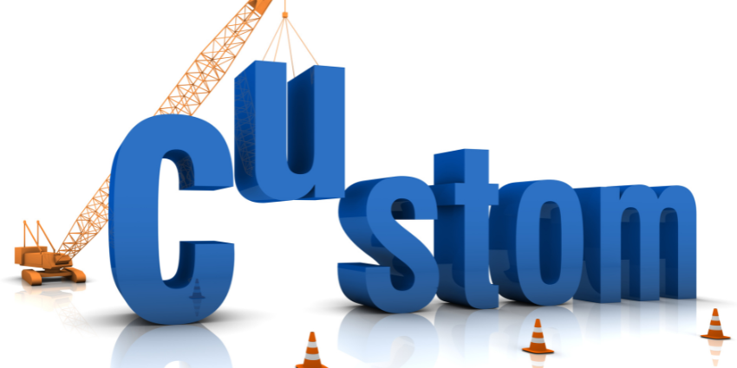
These structures allow for easy expansion. Businesses that anticipate future growth can modify or extend their existing PEBs without major disruptions. This adaptability makes PEBs a long-term solution for companies looking to scale operations efficiently.

Applications of PEBs in India’s Commercial Sector
PEBs are being widely used across different industries. Their versatility allows them to be applied in multiple commercial sectors, making them an attractive choice for businesses looking for reliable infrastructure solutions.
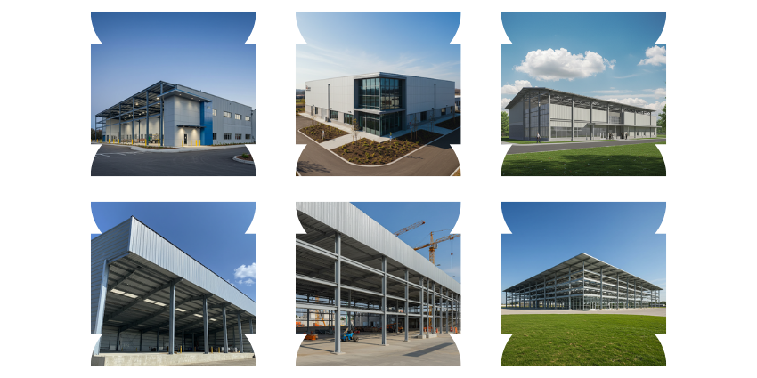

Warehousing and Logistics
With the boom in e-commerce and retail, warehouse spaces have become essential. PEBs provide cost-effective and spacious storage solutions that meet modern logistical needs. These warehouses are designed for easy access and efficient space utilization, ensuring smooth operations.

Manufacturing and Industrial Facilities
Factories require durable and customizable spaces that can support heavy machinery and large-scale production. PEBs offer structural strength and flexibility, making them ideal for industrial use. Their ability to withstand environmental stress ensures the safety of equipment and personnel.

Cold Storage Units
The food and pharmaceutical industries rely on cold storage solutions to maintain product quality. PEBs are well-suited for this purpose, as they can be equipped with advanced insulation and climate control systems. These units help businesses store perishable goods efficiently while reducing energy costs.

Commercial Office Spaces
PEBs are also gaining traction in commercial office construction. Businesses require modern, open-layout spaces that can be customized based on their work culture and operational needs. PEBs provide a sleek and efficient solution for corporate environments.

Retail and Shopping Centers
Shopping complexes and retail outlets benefit from the adaptability of PEBs. These buildings can be designed to match aesthetic requirements while ensuring structural efficiency. The ability to expand and modify PEBs makes them a preferred choice for businesses looking to upgrade retail spaces.

Future Outlook for PEBs in India
As urbanization and industrialization continue to grow in India, the demand for PEBs is expected to rise. Government initiatives such as “Make in India” and infrastructure development projects are further driving the adoption of these structures. The construction industry is shifting towards more sustainable and cost-efficient methods, making PEBs a future-proof choice.
Technological advancements will also play a role in shaping the future of PEBs. Innovations in design software, material science, and construction techniques will enhance the performance of these buildings. As businesses increasingly recognize the benefits of PEBs, their integration into commercial projects will become more widespread.

Conclusion
Pre-Engineered Buildings are revolutionizing commercial construction in India. Their speed, cost-effectiveness, durability, and flexibility make them a game-changer for businesses seeking efficient infrastructure solutions. As the demand for modern and scalable buildings grows, PEBs will continue to play a crucial role in shaping India’s commercial landscape.
For businesses looking to invest in commercial infrastructure, PEBs offer a smart and future-ready solution. The ability to save time and money while ensuring quality and sustainability makes PEBs an essential choice in the evolving construction industry.
Our Similar Posts:
Click Here 👉 Pre Engineered Buildings Introductions and Features
Click Here 👉 Pre Engineered Buildings Introductions and Features Steelbuild Roofing Sheets
Click Here 👉 Steelbuild Cladding Sheets: Transforming Modern Architecture with Strength and Style
Click Here 👉 Standing Seam Roofing Sheets: Revolutionizing Modern Architecture with Durability & Style
Click Here 👉 Steelbuild Deck Sheets: The Ultimate Solution for Durable and Efficient Flooring Systems
Click Here 👉 Enhancing Building Performance: A Comprehensive Guide to Sheeting Accessories by Steelbuild
Click Here 👉 Role of Insulation in Modern Infrastructure: A Comprehensive Guide
Click Here 👉 Enhancing Pre-Engineered Building Construction: A Comprehensive Guide to Accessories
Click Here 👉 Industrial Coating: Building the Dream Project with Care
Click Here 👉 Unleashing Excellence in Construction: Steelbuild’s Project Management Consultancy
Click Here 👉 Revolutionizing Construction with Steelbuild Infra’s Advanced Plant Facility
View Post in LinkedIn Click Here

