The Future of Construction: Why PEB Buildings are Becoming Popular

Introduction
Future of Construction - PEB. The construction industry is undergoing a major transformation. In India, the demand for faster, cost-effective, and sustainable building solutions has led to the rise of Pre-Engineered Buildings (PEBs). These structures are gaining popularity because they provide an efficient and flexible alternative to traditional construction methods. With rapid urbanization and industrialization, businesses are turning to PEB solutions to meet their infrastructure needs.
PEBs are designed using advanced software and manufactured in a controlled factory environment. The components are then transported to the construction site for assembly. This modern approach significantly reduces construction time, minimizes material wastage, and improves overall project efficiency. In this blog, we will explore why PEB buildings are the smart choice for commercial construction in India and how they are shaping the future of the industry.

Understanding PEB Structures
PEBs are metal structures that are designed, fabricated, and assembled using pre-engineered components. Unlike traditional buildings, which require extensive on-site work, PEBs use prefabricated components that are made in a factory setting. These components include primary and secondary framing, roof and wall panels, and other accessories, all of which are engineered for easy assembly.
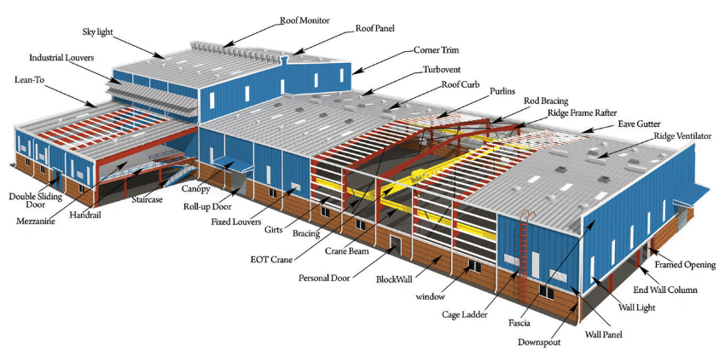
The adoption of PEB technology has revolutionized the construction sector. Businesses no longer need to rely on outdated building methods that are time-consuming and costly. Instead, they can opt for a streamlined approach that enhances efficiency and ensures higher quality standards.

Advantages of PEB Buildings

Cost-Effectiveness
One of the biggest advantages of PEB structures is cost savings. The manufacturing process optimizes material usage, reducing waste and unnecessary expenses. Additionally, PEB buildings require fewer labor hours for assembly, cutting down on construction costs. Since components are fabricated off-site, delays due to weather conditions and labor shortages are minimized.
For businesses, this means significant financial savings. They can allocate resources more effectively and focus on other critical aspects of their operations without worrying about unexpected cost overruns.

Faster Construction
Traditional construction methods often face delays due to unpredictable weather, material shortages, and labor inefficiencies. PEB buildings, on the other hand, can be constructed in a fraction of the time. The factory-made components are designed for quick assembly, allowing businesses to start operations much sooner.
This speed advantage is particularly beneficial for industries that require immediate infrastructure expansion. Whether it is a warehouse, a factory, or an office building, PEBs provide a faster route to completion without compromising quality.

Flexibility and Versatility
PEB structures offer unmatched flexibility in design and functionality. Businesses can customize their buildings based on specific requirements, whether they need open spaces for manufacturing, multiple floors for office use, or specialized areas for storage.
PEBs are widely used in various sectors, including:
Sector | Application | Description
Industrial | Warehouses | Efficient storage solutions
 | Factory buildings | Custom layouts for production
 | Cold storage | Temperature-controlled environments
Infrastructure | Airport terminals | Large-span designs for efficiency
 | Metro stations | Durable structures for transit hubs
Commercial | Shopping complexes | Modern and attractive retail spaces
Institutional | Schools and universities | Safe and durable learning environments
 | Hospitals | Functional spaces for healthcare
Special | Sports complexes | Venues for various sports activities
 | Auditoriums | Acoustically optimized structures
This adaptability makes PEBs an excellent choice for businesses looking for customizable and scalable infrastructure solutions.

Durability and Strength
PEBs are engineered to withstand extreme weather conditions, seismic activities, and heavy loads. The use of high-grade steel ensures that these buildings are long-lasting and require minimal maintenance.
Unlike traditional structures, which may deteriorate over time due to moisture, temperature fluctuations, and external forces, PEBs are designed for resilience. This makes them a reliable investment for businesses that require sturdy and stable infrastructure.

Sustainability and Energy Efficiency
Sustainability is a growing concern in the construction industry. Traditional buildings contribute significantly to environmental degradation due to excessive material usage, high energy consumption, and increased carbon emissions. PEB buildings address these concerns by using recyclable materials, reducing construction waste, and incorporating energy-efficient designs.
PEB buildings can be equipped with:
- Solar panels for renewable energy
- Insulated panels for better temperature control
- Natural lighting solutions to reduce electricity usage
These features not only contribute to environmental conservation but also help businesses save on energy costs in the long run.

Low Maintenance Costs
One of the overlooked benefits of PEBs is their low maintenance requirements. Traditional buildings often require frequent repairs and renovations, which can be costly and disruptive. PEB structures, however, are designed to be low-maintenance, thanks to their durable materials and superior engineering.
The use of corrosion-resistant coatings, high-quality roofing, and sturdy frames reduces the need for constant upkeep. This makes PEBs an economical choice for businesses that want to minimize long-term operational costs.

Scalability for Future Growth
As businesses grow, their infrastructure needs evolve. PEB buildings offer easy scalability, allowing for seamless expansion without major structural changes. Since the components are prefabricated, additional sections can be added without disrupting existing operations.
This scalability is particularly beneficial for industries that anticipate rapid growth, such as logistics, manufacturing, and retail. With PEBs, businesses can expand their operations without facing significant downtime or construction delays.

The Growing Popularity of PEBs in India
The Indian construction sector is witnessing a paradigm shift with the increasing adoption of PEB buildings. Several factors contribute to this trend:
- Urbanization: The rapid growth of cities and the need for modern infrastructure have fueled demand for PEB solutions.
- Government Initiatives: Programs like Make in India and Smart Cities Mission promote industrial and infrastructural development, where PEBs play a crucial role.
- Technological Advancements: Innovations in design and engineering have made PEBs more efficient and cost-effective.
- Increased Awareness: Businesses are becoming more aware of the advantages of PEB structures, leading to higher adoption rates across various industries.

Conclusion
PEB buildings are transforming the construction landscape by offering superior alternatives to conventional methods. Their cost-effectiveness, speed, flexibility, durability, sustainability, and scalability make them the ideal choice for modern businesses.
As India continues to embrace industrialization and infrastructural development, the demand for PEB structures will only grow. Companies looking for innovative, long-term solutions should consider PEB buildings as the foundation for their future projects. By partnering with a reputable PEB manufacturer, businesses can ensure they receive high-quality, efficient, and customized solutions that meet their unique needs.
The future of construction is here, and PEB buildings are leading the way.

