How to Choose the Right PEB Suppliers for Your Construction Project
Right PEB Suppliers. The world of construction is evolving at a rapid pace. India is witnessing a significant transformation in how buildings are designed and constructed. One of the most prominent trends in this change is the growing popularity of Pre-Engineered Buildings (PEBs). These structures have become the preferred choice for industrial, institutional, and commercial projects due to their efficiency, cost-effectiveness, and durability.
When planning a factory, sports complex, warehouse, or cold storage facility, selecting the right PEB supplier is a crucial decision. The right supplier ensures that your project remains within budget, withstands various weather conditions, and meets the set deadlines. Making an informed decision can save your business from unexpected construction delays and financial setbacks. This guide will help you navigate the key factors to consider when selecting a reliable PEB supplier.

Understanding the Importance of PEB Suppliers
PEB suppliers play a pivotal role in ensuring the success of any pre-engineered building project. These suppliers are responsible for manufacturing and delivering the essential components of your structure. The quality of their products and services directly impacts the efficiency, longevity, and overall performance of the building. A poor choice in supplier selection can result in increased costs, frequent maintenance issues, and compromised structural integrity.
Choosing the right supplier involves assessing various factors, including experience, customization capabilities, technological advancements, regulatory compliance, and customer service. By evaluating these aspects, you can ensure that your project benefits from the best practices in the industry.

Certification and Quality Standards
A reliable PEB supplier must adhere to stringent quality standards and industry certifications. These certifications act as proof of the supplier’s commitment to delivering high-quality products that meet safety and regulatory requirements. Reputable suppliers obtain ISO 9001:2015 certification for quality management systems, ensuring that their processes maintain consistency and efficiency.
- ISO 9001:2015 Certification – Ensures the company follows international quality management systems.
- Zero Lost Time Injury Certification – Indicates strong safety standards during construction.
- Membership in Industry Associations – Such as the MES Builders Association of India, which signifies credibility and reliability.
- Project Completion Awards – Recognition from major clients for timely and successful project execution.
- Exhibition and Trade Fair Participation – Presence in international expos like Nepal Buildcon and Destination Bihar Expo showcases a supplier’s commitment to innovation and excellence.
Beyond ISO certification, look for suppliers who have recognition from industry organizations. Certifications from bodies such as the Quality Research Organization and the MES Builders Association of India indicate that the supplier follows industry best practices. Ensuring that your supplier meets these quality standards guarantees that your building components will be durable, structurally sound, and compliant with safety regulations.
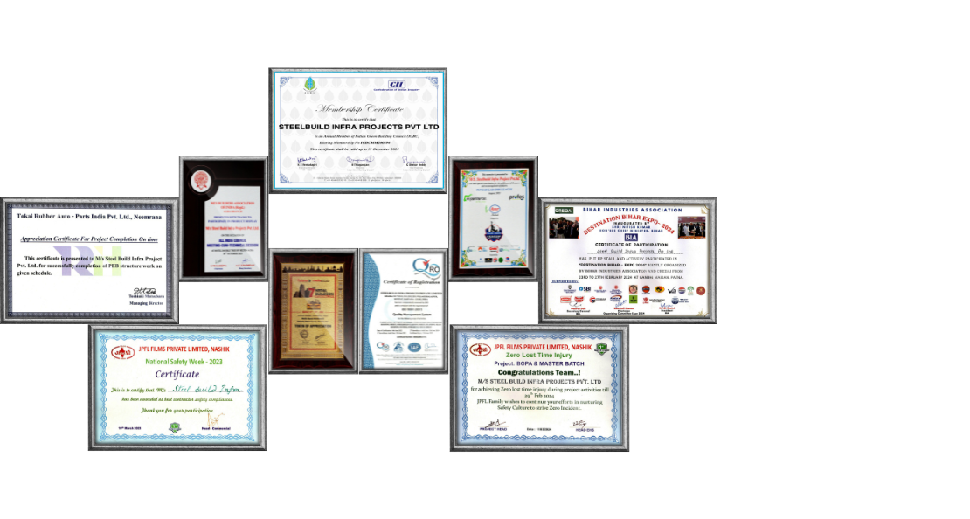

Experience and Proven Track Record
Experience is a key determinant of a supplier’s reliability. A PEB manufacturer with years of experience in the industry is more likely to deliver high-quality results. Evaluating a supplier's track record involves reviewing past projects to understand their expertise in handling different types of structures, including warehouses, industrial sheds, office buildings, and cold storage facilities.
A supplier with a well-established reputation will have completed projects across various sectors and geographic locations. Their ability to adapt to different environmental conditions and project requirements is a testament to their industry expertise. You can request case studies, customer testimonials, and references to validate their credibility.

Customization Capabilities
Every construction project is unique, with specific design and functional requirements. The ability to customize solutions is a crucial factor when selecting a PEB supplier. Some suppliers offer limited customization, while others provide extensive options to tailor the building design according to client needs.
A competent supplier should accommodate modifications in structure size, load-bearing capacity, insulation requirements, and aesthetic elements. The ability to design buildings that align with your operational needs, industry standards, and budget constraints is a key advantage. Ensuring that the supplier offers flexibility in design helps in achieving a structure that aligns with your business objectives.

Technological Advancements
Technology plays a crucial role in the design and manufacturing of PEB structures. Advanced design software and modern fabrication techniques ensure precision and efficiency in construction. Leading PEB suppliers utilize software such as ETABS, STAAD.Pro, Tekla Structures, Autodesk AutoCAD, and Vertex Systems to develop highly accurate building plans.
In addition to software capabilities, assess the supplier's manufacturing facility. A well-equipped facility with automated machinery and stringent quality control processes ensures that the building components are manufactured with precision. Some suppliers follow a 180-step quality check process to maintain consistency and reliability in their products.

End-to-End Solutions
A seamless construction process requires coordination between different phases, from design to installation. Choosing a supplier that provides end-to-end solutions simplifies project execution. Some PEB manufacturers specialize only in component manufacturing, while others offer a complete package, including design, engineering, fabrication, transportation, and on-site installation.
Opting for a supplier with a comprehensive service offering eliminates the need for multiple vendors, reducing the risk of communication gaps and project delays. It ensures that the entire construction process is managed efficiently, from initial planning to final assembly.

Compliance with Local Regulations
Adherence to building regulations and legal requirements is a fundamental aspect of construction. A trustworthy PEB supplier must have a thorough understanding of local laws, zoning regulations, and safety codes. Compliance with these regulations ensures that your structure is legally sound and does not face challenges during approval and inspection processes.
Non-compliance with regulations can lead to penalties, project halts, or even legal disputes. Ensure that the supplier is well-versed in national and regional building codes and follows industry best practices in safety and structural integrity.

Customer Support and After-Sales Service
The relationship with a PEB supplier does not end once the construction is complete. Ongoing support, maintenance, and troubleshooting are essential for ensuring the longevity of your structure. Reliable suppliers provide after-sales service, including periodic inspections, maintenance guidance, and support for future modifications or expansions.
Before finalizing a supplier, evaluate their customer service policies. Responsive and knowledgeable support teams make a significant difference in handling unexpected issues and ensuring a smooth post-construction experience.

Sustainability and Environmental Responsibility
Sustainability is becoming an essential factor in modern construction. PEB structures are already known for their Eco-friendly attributes, such as reduced material waste and energy-efficient designs. However, selecting a supplier that prioritizes sustainable practices adds further value to your project.
Look for suppliers who use recyclable materials, incorporate energy-efficient solutions, and follow environmentally friendly manufacturing processes. Some suppliers integrate solar panel compatibility and insulation solutions that contribute to green building initiatives. Choosing a supplier with a commitment to sustainability not only benefits the environment but also enhances the long-term cost savings of your project.

Cost Considerations and Budget Planning
Budget constraints often influence supplier selection. While it is important to optimize costs, selecting the cheapest option may lead to compromises in quality and performance. Instead of focusing solely on price, assess the overall value offered by the supplier.
Transparent pricing, clear cost breakdowns, and the ability to work within a budget without sacrificing quality are indicators of a reliable supplier. Ensure that there are no hidden costs and that the supplier provides a detailed quotation covering materials, labor, transportation, and installation.

Making the Final Decision
Choosing the right PEB supplier requires thorough research and careful evaluation. Start by identifying potential suppliers, gathering information about their credentials, and conducting site visits to assess their capabilities. Engage in discussions with their team to understand their approach, expertise, and commitment to quality.
Compare multiple suppliers based on their certifications, experience, technological capabilities, customization options, and customer feedback. Weigh the pros and cons of each supplier before making a final decision. Investing time in supplier selection ensures a successful project with durable and efficient results.

Conclusion
Selecting the right PEB supplier is a critical step in ensuring the success of your construction project. The right supplier will provide high-quality materials, innovative design solutions, regulatory compliance, and exceptional customer support. By evaluating factors such as experience, technological advancements, customization capabilities, and sustainability practices, you can make an informed decision.
With Steelbuild Infra, one of the leading PEB building manufacturers in India, you are assured of reliable solutions that combine durability, efficiency, and cost-effectiveness. With over 15 years of experience serving multiple industries across India, Steelbuild Infra remains committed to delivering top-notch PEB solutions tailored to meet diverse project requirements. Choosing the right partner guarantees the success and longevity of your industrial, commercial, or institutional structure.

