Purlin or Structural Steel? Which is Better for Your Shed in Pre-Engineered Buildings?
When designing a shed or warehouse, especially in Pre-Engineered Buildings (PEBs), the choice of materials plays a crucial role in determining the structure’s durability, functionality, and cost. Two commonly used materials for the structural framework of sheds are purlins and structural steel. Each has unique characteristics, applications, and advantages. To determine which option is better for your shed, it’s essential to analyze their features in detail and evaluate them based on your specific requirements.
This article delves into the comparison between purlins and structural steel, highlighting their suitability for PEB applications.
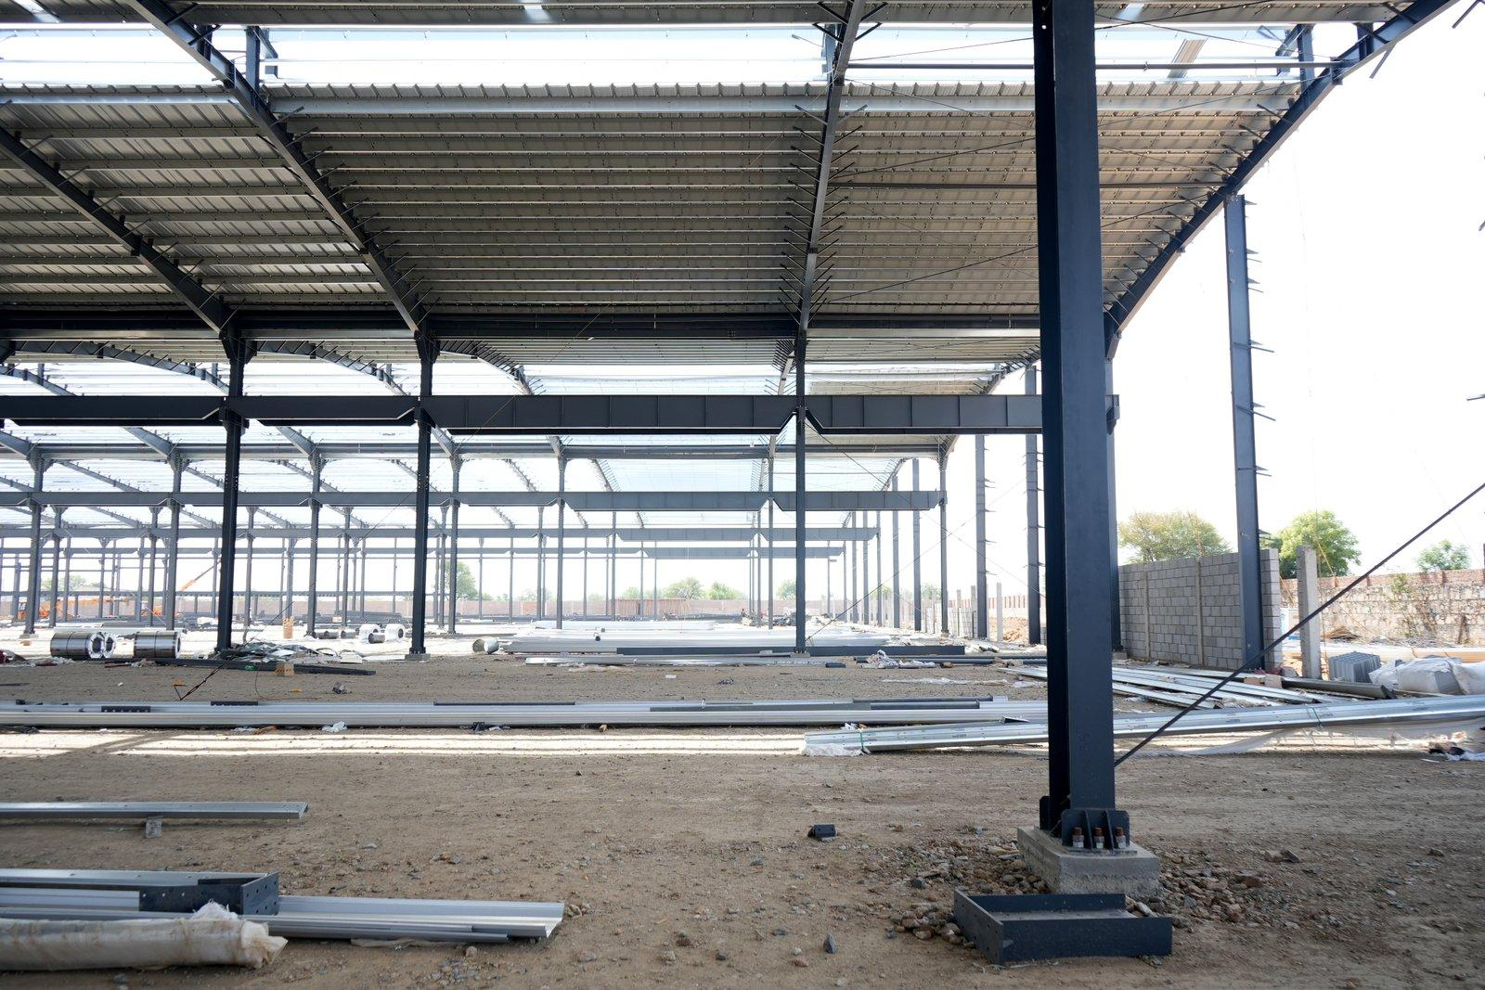

What Are Purlins?
Purlins are lightweight structural members made of rolled or cold-formed steel, used to provide support to the roof and walls of a building. In PEBs, they act as secondary framing, running horizontally between the primary framing members to support roof sheets or wall panels.
Purlins are typically classified into two types based on their shape:
- Z-Purlins: Z-shaped purlins offer excellent structural strength and are commonly used in roofs with significant spans.
- C-Purlins: C-shaped purlins are ideal for wall applications or shorter roof spans.

Advantages of Using Purlins
- Lightweight and Easy to Handle: Due to their light weight, purlins are easy to transport, install, and assemble.
- Cost-Effective: Purlins are generally less expensive than structural steel, making them an economical choice for smaller or budget-conscious projects.
- Versatility: They are highly versatile and can be customized to suit specific designs, whether for curved roofs or unconventional layouts.
- Corrosion Resistance: Galvanized purlins offer excellent protection against rust, ensuring longevity even in harsh environments.
- Compatible with Roofing Materials: Purlins provide a seamless connection for roofing sheets, ensuring better integration and stability.

Applications of Purlins in PEBs
- Small to Medium-Sized Sheds: Purlins are ideal for sheds, warehouses, and garages with moderate load requirements.
- Wall and Roof Panels: They act as a support system for roofing sheets and cladding materials.

What Is Structural Steel?
Structural steel refers to hot-rolled steel sections, such as I-beams, H-beams, angles, and channels, used for constructing primary and secondary frames in buildings. It is renowned for its incredible strength and load-bearing capacity, making it a go-to choice for large-scale projects requiring exceptional durability.

Advantages of Using Structural Steel
- High Strength-to-Weight Ratio: Structural steel provides exceptional strength, allowing it to support heavy loads without excessive bulk.
- Durability and Longevity: With proper treatment, structural steel can withstand extreme weather, corrosion, and wear over time.
- Flexibility in Design: Structural steel can accommodate complex architectural designs and large spans, offering greater flexibility for customization.
- Fire Resistance: When treated with fireproof coatings, structural steel can offer higher safety in case of fires.
- Load-Bearing Capacity: It is highly suitable for applications where heavy machinery, equipment, or materials need to be stored.

Applications of Structural Steel in PEBs
- Large Sheds and Warehouses: Structural steel is preferred for sheds that require significant spans and load-bearing capabilities.
- Industrial Facilities: It is often used in factories, workshops, and logistics hubs.
- Primary Framing: Structural steel forms the backbone of PEBs, providing the core framework for the entire structure.

Key Differences Between Purlins and Structural Steel

1. Strength and Load-Bearing Capacity
- Purlins: Best suited for lighter loads, such as supporting roofing sheets and cladding panels.
- Structural Steel: Can support heavy machinery, equipment, and loads, making it ideal for large-scale industrial applications.

2. Weight
- Purlins: Lightweight and easy to handle, reducing construction time and labor costs.
- Structural Steel: Heavier and more robust, requiring specialized equipment for installation.

3. Cost
- Purlins: More affordable and cost-efficient for small to medium-sized projects.
- Structural Steel: Higher upfront costs due to material and installation expenses but offers long-term durability.

4. Design Flexibility
- Purlins: Limited to standard shapes and sizes; customization is possible but within a narrower range.
- Structural Steel: Offers immense design flexibility, making it suitable for unique architectural styles and expansive spans.

5. Corrosion Resistance
- Purlins: Galvanized purlins resist rust and corrosion, especially in humid or coastal areas.
- Structural Steel: Requires additional coatings or galvanization for corrosion resistance, adding to the cost.

Factors to Consider When Choosing Between Purlins and Structural Steel

1. Project Size
- For smaller sheds or warehouses, purlins are a practical and cost-effective choice.
- For larger industrial facilities, structural steel provides the necessary strength and durability.

2. Load Requirements
- Evaluate the weight of equipment, roofing materials, and other structural loads.
- If the shed is intended for heavy-duty applications, structural steel is the better option.

3. Budget
- Purlins are an economical solution for projects with limited budgets.
- Structural steel, while more expensive, offers better long-term value for larger and more demanding projects.

4. Environmental Conditions
- In areas with high humidity, salt exposure, or frequent rainfall, galvanized purlins can offer good resistance to rust.
- Structural steel may require additional treatments to withstand such conditions effectively.

5. Aesthetic Requirements
- Purlins are straightforward and functional, best suited for projects without intricate architectural designs.
- Structural steel is ideal for projects requiring innovative designs or large spans.

Why Both Are Essential in PEBs
In most PEBs, both purlins and structural steel play vital roles. While structural steel forms the primary framework, purlins serve as secondary supports, ensuring a complete and stable structure. Combining the strengths of both materials allows for optimized construction tailored to the specific needs of the project.
For instance:
- Primary Framework: Structural steel forms the skeleton of the shed, providing the necessary strength and support.
- Roof and Wall Supports: Purlins act as the intermediary members, connecting the roof and wall panels to the main structure.

Advancements in Purlins and Structural Steel
Recent technological advancements have enhanced the performance of both purlins and structural steel. Pre-galvanized purlins, for example, offer superior resistance to corrosion and longer life spans. Similarly, innovations in structural steel manufacturing, such as high-strength alloys, have increased load capacities while reducing overall weight.

Conclusion: Which Is Better for Your Shed?
Deciding between purlins and structural steel depends on your specific requirements. For small to medium-sized sheds with moderate loads, purlins provide an economical and efficient solution. On the other hand, structural steel is the preferred choice for larger, heavy-duty projects requiring significant strength and durability.
Ultimately, a combination of both materials often proves to be the best approach in PEB construction. By leveraging the lightweight nature of purlins and the robustness of structural steel, you can achieve a shed that is both cost-effective and built to last.
Steelbuild Infra Projects Ltd specializes in designing and constructing customized PEBs that meet your unique needs. Whether you require purlins, structural steel, or a combination of both, our experts are here to guide you every step of the way. Reach out to us today to build your dream shed with the perfect materials!

