Deck Sheets: Know When to Replace Your Roof Deck
Roof decks are an essential part of any building’s structural integrity. Whether residential, commercial, or industrial, the roof deck forms the base upon which the roofing materials are applied. One component of a roofing system that often demands attention is the deck sheet. These sheets provide structural support and help distribute loads evenly across the roof. Ensuring they are in good condition is crucial to maintaining the overall health of your roof. But how do you know when it’s time to replace your roof deck sheets? This blog will dive deep into everything you need to know about deck sheets, their role in a roofing system, signs of damage, and when replacement becomes necessary.

Understanding Roof Deck Sheets
Roof deck sheets, often made of materials like galvanized steel, aluminum, or other durable metals, serve as the foundation layer for the roof. They are installed directly over the structural framework of a building and provide essential support for insulation, waterproofing, and final roofing materials like shingles, tiles, or membranes. Deck sheets play a critical role in maintaining structural stability and ensuring that your roof can withstand external pressures like wind, snow, and rain.

Key Features of Deck Sheets:
- Durability: Deck sheets are designed to last for decades when properly maintained.
- Load-Bearing Capacity: They help distribute the weight of roofing materials and additional loads, such as snow and equipment.
- Moisture Resistance: High-quality deck sheets are coated to prevent rust and corrosion.
- Ease of Installation: Pre-engineered and customizable, they can be easily installed during new construction or retrofits.
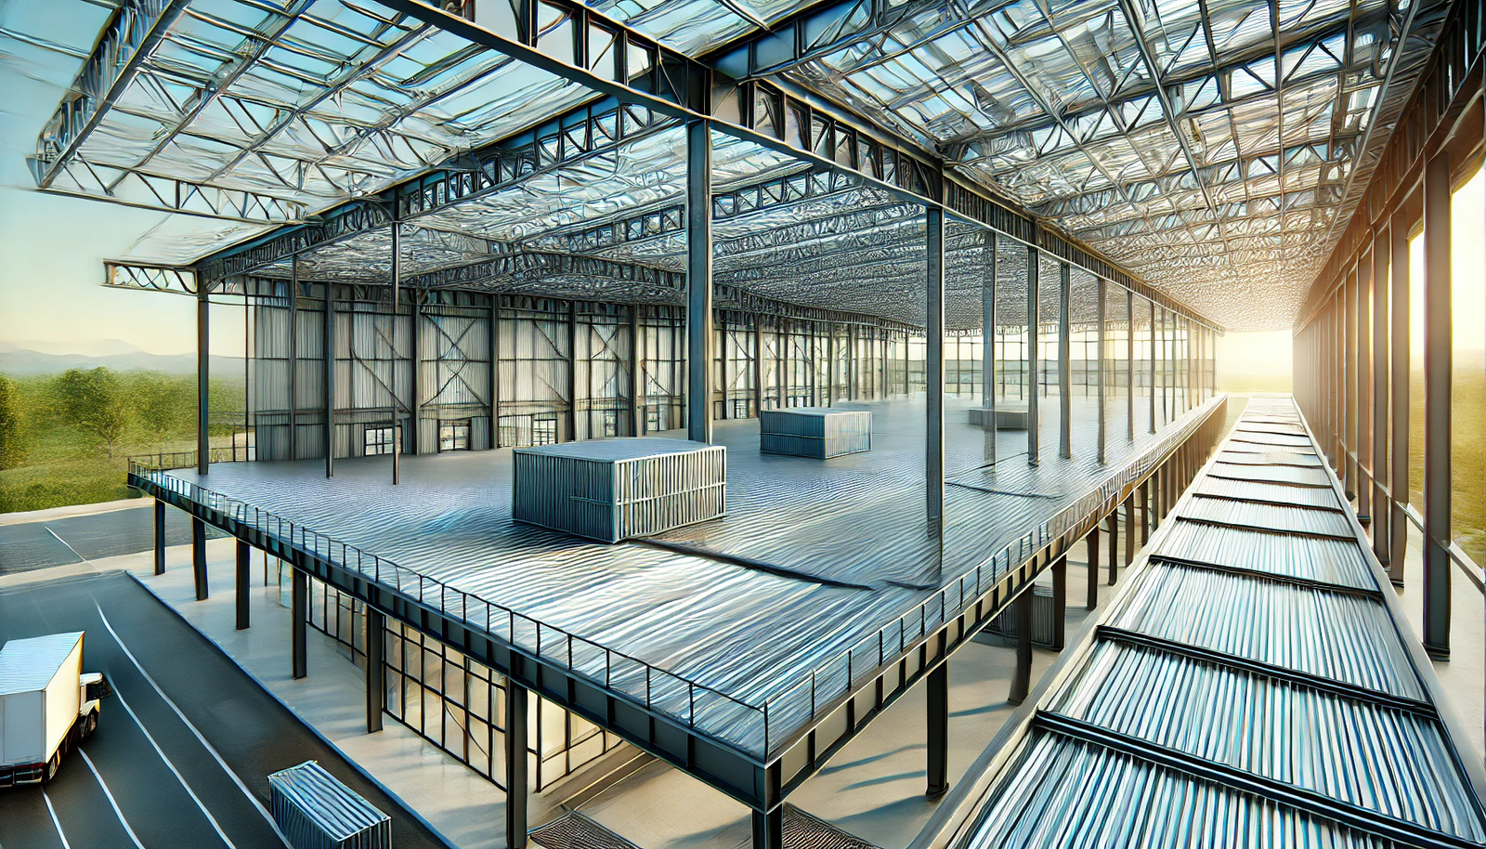

Signs Your Roof Deck Sheets Need Replacement
Just like any part of a building, roof deck sheets are not immune to wear and tear. Over time, they may show signs of deterioration due to environmental conditions, aging, or improper maintenance. Identifying these warning signs early can save you from costly repairs or structural issues.

1. Visible Rust or Corrosion
Deck sheets made of metal are prone to rust and corrosion when their protective coating wears off. Rust weakens the structural integrity of the sheets and can lead to leaks or collapse. If you notice visible rust patches, it’s a clear sign that the sheets need attention.

2. Water Damage or Leaks
Water infiltration is a major red flag. Leaks in the roofing system often stem from damaged or deteriorated deck sheets. Look for water stains on ceilings, sagging rooflines, or puddles forming in the attic. Persistent leaks can compromise the entire roofing system.

3. Warping or Buckling
If the deck sheets are warped or buckling, they’re likely no longer providing the even support needed for the roof. This can result from prolonged exposure to moisture or uneven weight distribution. Such issues should be addressed immediately.

4. Sagging Rooflines
A sagging roofline is one of the most apparent signs of structural issues. If the deck sheets are failing, the roof may no longer be able to hold its shape, leading to a dip or sag in the overall structure. This is often a precursor to severe damage or even collapse.

5. Increased Energy Costs
A compromised roof deck often leads to poor insulation, allowing heat or cold to escape easily. If you’ve noticed a sudden spike in your energy bills, it could be due to damage in the roof deck sheets, causing insulation inefficiencies.

6. Age of the Roof Deck
Even the best-quality deck sheets have a lifespan. If your roof is over 20-30 years old, it’s wise to inspect the deck sheets for signs of aging. Replacing them proactively can save you from emergency repairs later.

The Importance of Timely Replacement
Delaying the replacement of roof deck sheets can lead to a cascade of problems that affect the entire roofing system and even the structural safety of your building. Here are some reasons why timely replacement is crucial:

Prevent Structural Damage
Failing deck sheets can compromise the structural integrity of the roof and the building as a whole. By replacing damaged sheets promptly, you avoid issues like roof collapse or extensive repairs.

Enhance Longevity of Roofing Materials
A compromised deck can shorten the lifespan of other roofing components, such as shingles or membranes. Proper support ensures these materials perform as intended.

Improve Energy Efficiency
Replacing damaged deck sheets restores the roof’s insulation properties, reducing energy consumption and lowering utility bills.

Avoid Costly Repairs
Addressing deck sheet issues early is far more cost-effective than dealing with widespread damage caused by neglect.

Steps to Replace Roof Deck Sheets
Replacing roof deck sheets is a significant undertaking that requires careful planning and execution. While it’s always recommended to hire professional roofing contractors for such tasks, understanding the process can help you make informed decisions.

Step 1: Inspection and Assessment
Start with a thorough inspection of the roof. Identify areas where the deck sheets are damaged, rusted, or warped. Professional contractors often use specialized tools and techniques to evaluate the condition of the deck.

Step 2: Remove Existing Roofing Materials
To access the deck sheets, all existing roofing materials, including shingles, membranes, and insulation, must be removed. This step requires careful handling to avoid further damage.

Step 3: Replace Damaged Deck Sheets
The damaged deck sheets are removed and replaced with new ones. Ensure the new sheets are of high quality and compatible with the rest of the roofing system.

Step 4: Reinstall Roofing Materials
Once the deck sheets are replaced, the roofing materials are reinstalled, ensuring proper alignment and sealing to prevent leaks.

Step 5: Final Inspection
After the replacement, conduct a final inspection to ensure the roof deck and materials are installed correctly and meet safety standards.

Tips for Maintaining Roof Deck Sheets
Prevention is better than cure. Regular maintenance can extend the lifespan of your roof deck sheets and minimize the need for replacement. Here are some tips:
- Conduct Regular Inspections: Check your roof at least twice a year and after extreme weather events.
- Clean Gutters and Drains: Ensure proper water drainage to prevent moisture buildup on the roof.
- Address Repairs Promptly: Fix minor issues, such as small leaks or rust spots, before they escalate.
- Apply Protective Coatings: Periodic application of rust-resistant coatings can enhance the durability of metal deck sheets.
- Hire Professionals for Maintenance: Routine professional maintenance can identify and address potential problems before they become significant.

Choosing the Right Deck Sheets for Replacement
When it’s time to replace your roof deck sheets, selecting the right materials is crucial. Consider the following factors:

Material Options
- Galvanized Steel: Durable, rust-resistant, and ideal for most applications.
- Aluminum: Lightweight and corrosion-resistant but may not be as strong as steel.
- Fiber Cement: Offers excellent fire resistance but is heavier and more challenging to install.
- Composite Materials: Combines multiple materials for enhanced performance.

Thickness and Load Capacity
Choose deck sheets with appropriate thickness and load capacity to support your specific roofing system and environmental conditions.

Compatibility
Ensure the new deck sheets are compatible with your existing roofing materials and insulation.

Warranty
Opt for deck sheets that come with a warranty, guaranteeing quality and performance.

Conclusion
Roof deck sheets are a vital component of any roofing system, providing structural support and enhancing overall performance. Recognizing the signs of damage and knowing when to replace your deck sheets is essential to maintaining the safety and efficiency of your building. Timely replacement not only prevents costly repairs but also extends the lifespan of your roof and improves energy efficiency. By investing in high-quality materials and professional installation, you can ensure your roof remains in top condition for years to come. Steelbuild Infra Projects Ltd specializes in durable, high-performance roofing solutions, offering expert guidance and top-tier products for all your roofing needs. Don’t wait for damage to escalate—take action today and safeguard your property against the elements.

