Industrial Coating: Building the Dream Project with Care
Industrial Coating. Steelbuild Infra Projects (SBIP) was established with a clear vision: to transform the steel business and construction industry with innovative solutions. Founded by a team of seasoned professionals, SBIP specializes in creating and maintaining industrial, commercial, and residential infrastructure. The company has earned its reputation by offering:
- Long-lasting Annual Maintenance Contracts (AMC)
- Efficient Cleanliness Services
- Customized Solutions for PEB Sheds
- Architectural Services

SBIP Black & White: Revolution in the Coating Industry (Industrial Coating)
For the Pre-Engineered Building (PEB) industry, SBIP has introduced an advanced and revolutionary coating system. The SBIP Black & White range brings a cutting-edge liquid coating system to the Indian market.

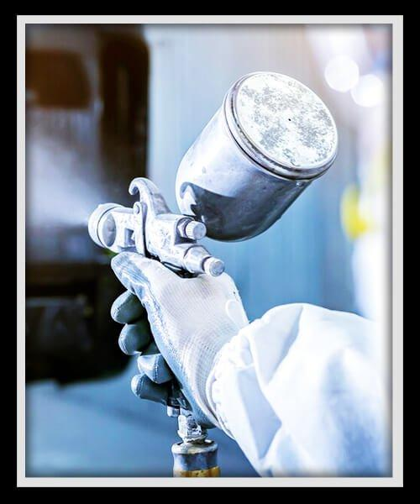

Our Vision
To deliver eco-friendly, high-quality, and cost-effective products that meet the growing demands of modern infrastructure.

SBIP Black: The Most Promising Waterproof Coating (Industrial Coating)

SBIP Black is a scientifically formulated waterproof coating that provides unparalleled protection against water leakage.

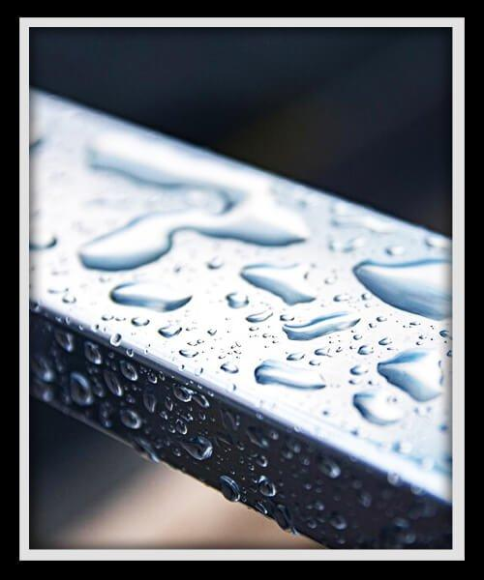

Key Features:
- A blend of synthetic resins, selected minerals, and fillers
- High-performance waterproof and protective coating
- Fast drying for superior elasticity and flexibility
- Impermeability that ensures a watertight surface

SBIP White: The Solid Coating Solution (Industrial Coating)
SBIP White is a synthetic resin-based waterproof coating that excels in protection and aesthetics.

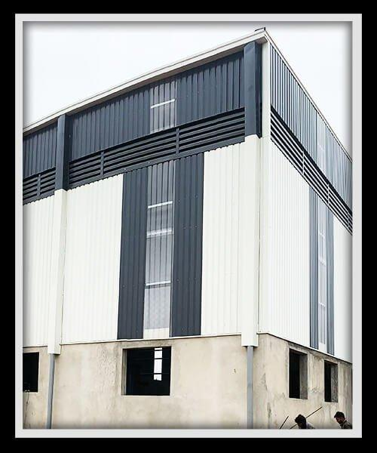

Key Features:
- Excellent flexibility and thixotropic properties
- Pollution-free and economical waterproof coating
- Superior solar insulation thanks to its white color
- Provides a clean, uniform finish that enhances the lifespan and appearance of steel structures

Why Choose SBIP Black & White Coatings?
Ease of Application:
- Cold-applied and seamless, requiring no heating or joint assembly
- Lightweight compared to conventional roofing systems, reducing roof load
- Lower labor costs due to simplicity and quick application

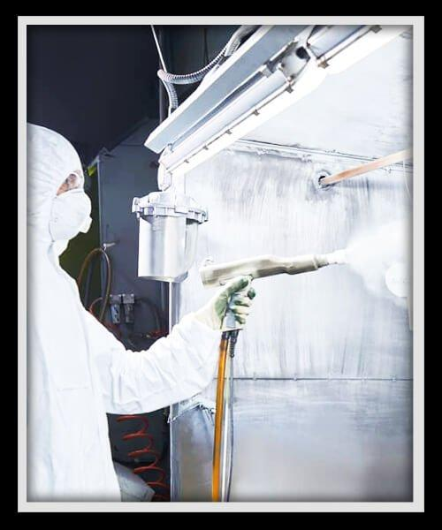

Protection:
- Impervious to water leakage and resistant to corrosion
- Acts as a vapor barrier, ensuring durability
- Maximizes the life of steel structures

Surface Preparation for SBIP Coatings
Proper surface preparation is essential for optimal results.
Steps:
- Ensure the surface is clean and free of dust, grease, and loose particles.
- The surface can be damp but not saturated.
- Apply one coat of SBIP-Black Primer, diluted with water at a ratio of 1:2, to prepare the surface.
- Stir SBIP-B well before use.
- Depending on the required protection, apply 1-2 coats of SBIP-Black coating.

Application Method in 5 Simple Steps
- Apply the first coat of SBIP-B Primer on a prepared surface and let it dry.
- Once the primer is completely dry, apply the first coat of SBIP-B.
- For added strength, embed Glass Fibre Reinforcement into the first coat while it’s still wet.
- Apply the second coat after the first coat has fully dried.
- Clean all tools and brushes with water immediately after use.
Dilution Guidelines:
- 1st coat: Dilute SBIP-B up to 15-25% for optimal coverage.
- 2nd coat: Dilute SBIP-B up to 10-15%.

Technical Specifications

Property | Details
Base Appearance | Single component, resin-based
Color | White
Consistency | Paste-like, thixotropic
Solid Content | 65%
Elongation at Break | Approx. 350% (ASTM D-2370)
Cured Film | Flexible, elastic, and tough
Touch Dry Time | Approx. 2 hours
Bend Strength | Excellent
Bond Strength | 60 psi
Flash Point | Non-inflammable
Water Tightness | Excellent
Solar Reflection | 90%
Coverage | 1.2 Kg/m² in 2-3 coats

The Advantages of SBIP Coatings
- Cost-Effectiveness:
  - Reduces overall construction costs by minimizing maintenance needs.
- Energy Efficiency:
  - Solar reflection properties help maintain cooler interior temperatures, reducing energy consumption.
- Eco-Friendly:
  - Pollution-free coatings contribute to sustainable construction practices.
- Long-Lasting Durability:
  - Protects against water, corrosion, and environmental damage, extending the lifespan of structures.
- Aesthetic Appeal:
  - Clean and uniform finishes enhance the appearance of buildings.

Applications of SBIP Black & White Coatings
SBIP coatings are suitable for a variety of applications, including:
- Industrial Roofs: Prevent water leakage and corrosion in factory environments.
- Commercial Buildings: Enhance the visual appeal and durability of retail and office spaces.
- Residential Projects: Protect and beautify homes with eco-friendly and efficient coatings.
- PEB Sheds: Improve performance and aesthetics of pre-engineered buildings.

Steelbuild Infra Projects: Innovating with Excellence
At Steelbuild Infra Projects, we believe in creating solutions that redefine the standards of construction and infrastructure. Our SBIP Black & White coatings embody our commitment to innovation, quality, and customer satisfaction.
Let us partner with you in building durable, efficient, and visually appealing structures that stand the test of time.

