Accessories in PEB Enhancing Pre-Engineered Building Construction
Accessories. Pre-engineered buildings (PEBs) are renowned for their efficiency, cost-effectiveness, and adaptability. However, the right accessories can elevate their functionality, safety, and aesthetics, making them stand out as modern architectural marvels. Steelbuild offers an impressive range of accessories designed to complement and enhance the appeal of commercial, residential, and industrial structures.
This article explores the vital role of accessories in pre-engineered buildings, focusing on Turbovents, Ridge Ventilators, and Polycarbonate Sheets, their features, benefits, and applications.

The Role of Accessories in Pre-Engineered Buildings
Accessories in PEBs are not just decorative elements; they are essential components that:
- Improve energy efficiency.
- Enhance ventilation and air circulation.
- Strengthen durability against environmental factors.
- Add stylistic and aesthetic appeal.
Incorporating the right accessories ensures that the building performs optimally while maintaining an attractive appearance.

1. Turbovents: Efficient Ventilation Solutions

Overview
Turbo air ventilators are designed to replace stale, hot, and polluted air with fresh air continuously. These ventilators operate on wind pressure and rotational force, functioning even when external airflow ceases, thanks to the flywheel mechanism.

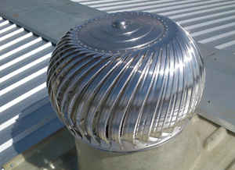

Features and Benefits
- Cost-Effective and Power-Free: Turbovents operate without electricity, reducing energy costs significantly.
- Environment-Friendly: Lightweight, noiseless, and non-polluting, they contribute to a sustainable environment.
- Corrosion-Resistant: Built to withstand harsh weather conditions and ensure long-lasting performance.
- Low Maintenance and Payback Period: Their durability and efficiency make them a cost-effective investment with quick returns.

Applications
- Industrial facilities requiring continuous ventilation.
- Warehouses and storage units.
- Residential spaces for improved indoor air quality.

2. Ridge Ventilators: Enhancing Roof Performance

Overview
Ridge ventilators are essential air exhaust systems installed at the peak of a roof. They provide consistent and uniform ventilation by allowing hot air to escape from the attic while resisting wind-driven rain, snow, insects, and debris.

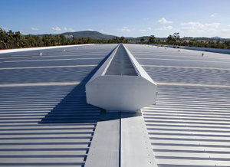

Features and Benefits
- Heat Build-Up Reduction: Helps in maintaining a cooler indoor temperature by expelling hot air.
- Prevents Gaseous Accumulation: Particularly useful in manufacturing setups where gaseous by-products are released.
- Fire Risk Mitigation: Reduces flammable fumes, enhancing safety.
- Improved Building Performance: Optimizes air circulation and energy efficiency in pre-engineered structures.

Applications
- Industrial buildings with high heat or gaseous emissions.
- Residential buildings in warmer climates.
- Warehouses and agricultural structures.

3. Polycarbonate Sheets: Versatile and Durable Roofing Solutions

Overview
Polycarbonate sheets are transparent or translucent materials that offer exceptional strength and versatility. Steelbuild’s range includes Polycarbonate Compact Sheets, Embossed Sheets, Margard Solid Sheets, and Lexgard Solid Sheets, crafted from high-grade raw materials.

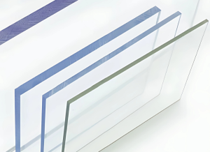

Features and Benefits
- Ease of Shaping and Cutting: Polycarbonate sheets can be molded and cut to fit various architectural designs effortlessly.
- Lightweight and Insulating: Their lightweight nature makes installation easier, while thermal insulation enhances energy efficiency.
- UV Protection: Polycarbonate sheets block harmful UV rays, ensuring durability and occupant safety.
- Wide Range of Colors: Available in various thermal colors to suit different aesthetic preferences.

Applications
- Skylights and roofing solutions in commercial and industrial buildings.
- Greenhouses for their transparency and thermal efficiency.
- Noise barriers in highways and railways.

The Importance of Choosing High-Quality Accessories
The performance of a pre-engineered building depends significantly on the quality of its accessories. Accessories like Turbovents, Ridge Ventilators, and Polycarbonate Sheets from Steelbuild ensure:
- Enhanced Functionality: Improved ventilation, insulation, and structural efficiency.
- Durability and Longevity: Built to withstand environmental challenges and minimize maintenance costs.
- Aesthetic Appeal: Adding modern and sleek elements to building designs.
- Energy Efficiency: Reduced energy consumption and better sustainability.

Installation and Maintenance Tips

Turbovents
- Ensure proper alignment with wind direction for optimal performance.
- Regularly clean to remove dust and debris for smooth rotation.

Ridge Ventilators
- Install at the highest point of the roof for maximum efficiency.
- Inspect periodically to ensure no blockages or damage to the vent slots.

Polycarbonate Sheets
- Use appropriate sealing techniques to prevent leaks.
- Clean with mild soap and water to maintain transparency and appearance.

Why Choose Steelbuild Accessories?
Steelbuild is dedicated to providing top-tier solutions that align with modern construction needs. Our accessories are designed with precision, combining functionality and aesthetics to create value for our customers.

Key Advantages
- Extensive range of options for diverse applications.
- High-quality materials for durability and performance.
- Customization to suit specific project requirements.
- Expert guidance and support from our team.

Conclusion: Transforming Pre-Engineered Buildings with Accessories
Accessories play a crucial role in the success of pre-engineered buildings, offering benefits that go beyond mere aesthetics. Whether it’s the efficient ventilation provided by Turbovents, the performance-enhancing capabilities of Ridge Ventilators, or the versatile applications of Polycarbonate Sheets, each accessory contributes to a building’s functionality and appeal.
Steelbuild’s commitment to quality and innovation ensures that you get the best accessories to meet your construction needs. With our products, you can achieve superior performance, enhanced aesthetics, and long-term savings.
Upgrade your pre-engineered building with Steelbuild Accessories—where functionality meets style. Contact us today to learn more!

