Steelbuild Sheeting Accessories: Enhancing Building Performance
Steelbuild Sheeting Accessories. In the realm of pre-engineered building construction, every component plays a critical role in ensuring the structure's durability, functionality, and aesthetic appeal. Among these, sheeting accessories are often overlooked yet hold immense importance. These components not only complement the primary structure but also safeguard it against weather, leaks, and other potential damage. At Steelbuild, we are committed to offering a wide range of high-quality sheeting accessories designed to seamlessly integrate with all cladding materials.
Here’s an in-depth look into the sheeting accessories provided by Steelbuild and their value in modern construction.

Downtake Pipes and Gutters: Ensuring Efficient Water Management
Downtake Pipes and Gutters form an integral part of the building's drainage system. They are engineered to efficiently manage rainwater, transporting it from the roof to designated storage or drainage systems, thus preventing water pooling and damage.

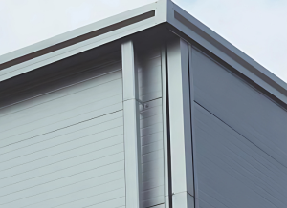

Key Features of Downtake Pipes and Gutters
- Corrosion Resistance: Manufactured from premium-quality materials, these components are designed to withstand corrosion, ensuring longevity even in challenging weather conditions.
- Lightweight yet Strong: The lightweight design allows easy installation without compromising strength.
- Water Tightness: Engineered for a leak-proof fit, ensuring effective water management.
- Customized Solutions: Available in various lengths and panel configurations to cater to different building pitches and regional rainfall patterns.
- Aesthetic Appeal: Professionally designed eave gutters enhance the building's appearance while offering practical benefits.

Benefits
- Efficiently directs rainwater away from the structure, protecting the foundation and walls.
- Reduces water wastage through optimized flow and minimized splashing.
- Available in multiple colors to match the building’s design and style.

Ridge Caps: Protecting and Ventilating Roofs
A ridge cap is a critical roofing component applied over the ridge of a roof. It overlaps the intersecting field roofing panels, offering essential protection and enhancing the roof's performance.

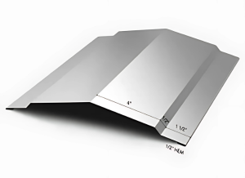

Advantages of Ridge Caps
- Weatherproofing: Prevents debris, dirt, and water from entering the roof, thus safeguarding the interior.
- Ventilation: When paired with a ridge vent, it allows proper airflow, maintaining an optimal temperature inside the structure.
- Durable Design: Made from robust materials to resist wear and tear, ensuring longevity with minimal maintenance.
- Rodent Barrier: Unlike traditional ventilation systems, ridge vents with caps act as effective barriers against rodents and pests.

Applications
- Ideal for both residential and commercial buildings with metal roofing systems.
- Enhances the overall structural stability of the roof by providing a secure fit over the ridge.

Gutters: Safeguarding the Building Perimeter
Gutters are indispensable for managing rainwater efficiently. By collecting water from the roof and channeling it away from the building, they prevent water-related damage to the walls, foundation, and landscape.

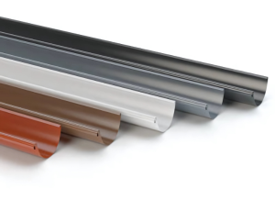

Key Features of Steelbuild Gutters
- Made from corrosion-resistant materials for durability.
- Designed for optimal water flow, reducing the risk of overflow during heavy rains.
- Aesthetic designs that complement the building’s exterior.

Benefits
- Minimizes erosion around the foundation by directing water away.
- Protects walls and cladding from water stains and damage.
- Offers a cleaner, more professional look to the building's exterior.

Why Sheeting Accessories Matter
While the primary structure provides the framework, accessories like downtake pipes, gutters, and ridge caps ensure the building’s longevity and efficiency. They contribute significantly to the overall performance by:
- Preventing structural damage caused by water infiltration.
- Enhancing the building’s aesthetic appeal.
- Reducing maintenance costs by offering durable and efficient solutions.

Steelbuild Sheeting Accessories: The Trusted Choice
Steelbuild’s range of sheeting accessories is designed to meet the diverse needs of modern construction. Our commitment to quality and innovation ensures that every product is:
- Durable: Manufactured using premium materials to withstand the test of time.
- Efficient: Engineered for optimal performance, offering maximum protection and functionality.
- Customizable: Available in various sizes, designs, and finishes to suit specific project requirements.
- Eco-Friendly: Produced with sustainable practices, minimizing environmental impact.

Applications Across Industries
Steelbuild sheeting accessories are versatile and suitable for a wide range of applications, including:
- Industrial Facilities: Protecting large-scale operations from weather-related disruptions.
- Commercial Buildings: Enhancing the durability and appearance of office spaces, shopping malls, and showrooms.
- Residential Projects: Offering homeowners reliable solutions for rainwater management and roof protection.
- Agricultural Structures: Providing robust and weatherproof solutions for barns, storage units, and other farm buildings.

Steelbuild Sheeting Accessories: Maintenance Tips
To maximize the lifespan and efficiency of your sheeting accessories, consider the following maintenance practices:
- Regular Cleaning: Remove debris, leaves, and dirt to prevent clogging and corrosion.
- Periodic Inspections: Check for any signs of damage or wear, especially after heavy rains or storms.
- Repainting or Coating: Apply protective coatings as needed to maintain the aesthetic and structural integrity.
- Proper Installation: Ensure all accessories are correctly installed to avoid leaks and inefficiencies.

Conclusion: Building Better with Steelbuild
Steelbuild’s sheeting accessories are more than just functional components—they are integral to creating sustainable, durable, and aesthetically pleasing structures. From efficient water management to enhanced roof protection, these accessories play a vital role in ensuring the longevity and performance of your building.
Whether you are constructing a residential, commercial, or industrial project, Steelbuild offers the perfect solutions tailored to your needs. Choose Steelbuild for reliable, high-quality sheeting accessories that redefine building performance.
For more information on our products and services, visit our website or contact us today. Build smarter, build better with Steelbuild!

