**BTECH CSE (2022-26)**

**BATCH: KOC49**

**Program Task:**

The task is to find if it is possible to cut the cake in the below the mentioned ways for a

Given a value of N.

Given a integer N and a cake which can be cut into pieces, each cut should be a

Straight line going from the center of the cake to its border. Also, the angle between any

Two cuts must be a positive integer. Two pieces are equal if their appropriate angles are

Equal.

The given cake can cut in the following three ways:

* Cut the cake into N equal pieces.
* Cut the cake into N pieces of any size.
* Cut the cake into N pieces such that no two of them are equal.

**GROUP MEMBERS:**

**Registration number Roll No Name**

12224169 62 ANKIT KUMAR RAI

12223895 61 GEDDA LAL KRISHNA

12223493 63 ABHISHEK YADAV

**PROGRAM:**

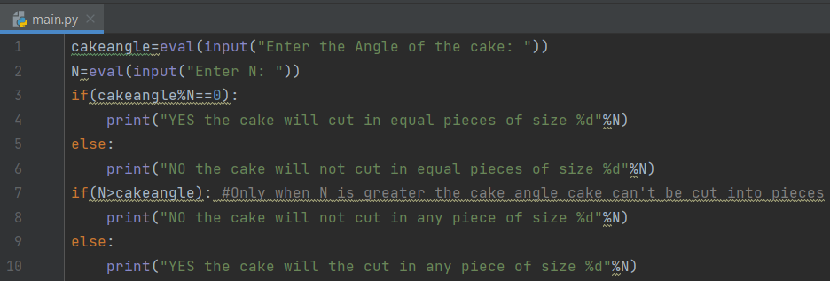

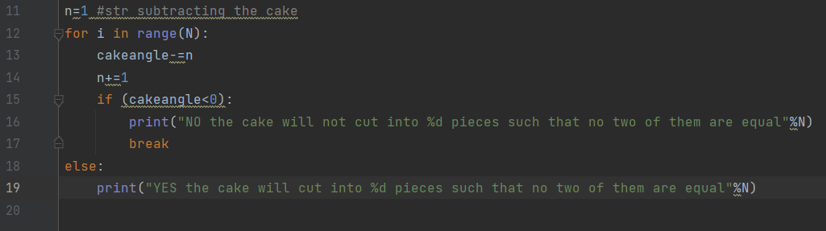

**OUTPUT 1:**

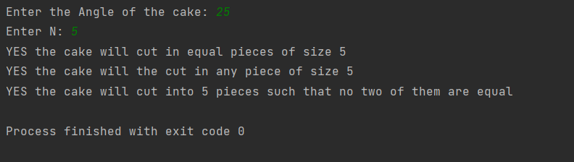

**OUTPUT 2:**

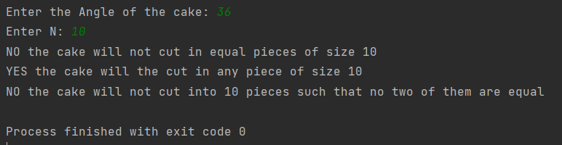

**NAME: ABHISHEK YADAV**

**ROLL. NO. 62**

**REG.NO. 12224169**