Vendor Performance Analysis
Data-Driven Insights on Vendor Profitability, Pricing and Inventory Efficiency

Project Report
Tools: Python · SQLite · Pandas · Matplotlib · Seaborn · SciPy · Jupyter Notebook
Prepared: 14 October 2026

Contents
1. Executive Summary
2. Introduction and Objectives
3. Project Structure and Tech Stack
4. Data Ingestion Pipeline (ingestion_db.py)
5. Exploratory Data Analysis – Database Tables
6. Vendor Summary Table (get_vendor_summary.py)
7. Data Exploration and Cleaning
8. Business Analysis and Results
9. Statistical Analysis
10. Dashboard
11. Key Findings and Recommendations
12. Limitations and Future Work
13. Conclusion

1. Executive Summary
This project analyses the purchase, sales, pricing and freight data of a beverage-alcohol distributor to find out which vendors and brands drive profitability, where capital is tied up in slow-moving stock, and how pricing and purchasing behaviour affect margins. Raw CSV files were loaded into a SQLite database, merged by SQL into a single vendor-level summary table, cleaned, and then analysed in Jupyter with visualisations and statistical tests.
Headline results:
- Procurement is concentrated: the top 10 vendors account for 65.69% of all purchase dollars; Diageo North America alone contributes 16.30%.
- Bulk buying pays off: large orders have an average unit price of $10.78 versus $39.07 for small orders (about 72% lower).
- Capital is tied up in stock: about $2.71M is locked in unsold inventory, led by Diageo ($722K), Jim Beam ($555K) and Pernod Ricard ($471K).
- Margins differ significantly: low-sales vendors earn a mean margin of 41.57% (95% CI 40.50–42.64) versus 31.18% (30.74–31.61) for top-sales vendors; Welch's t-test gives t = −17.67, p < 0.001.
- Hidden opportunities: 198 brands combine low sales with high margins and are candidates for promotion or price adjustment.

2. Introduction and Objectives
Effective inventory and sales management are critical for distributors in the retail and wholesale industry. Poor vendor selection, weak pricing decisions and excess stock reduce profit and lock up cash. This project builds a reproducible analysis pipeline to support decisions on vendor selection and product pricing.
Objectives
- Identify brands that need promotional or pricing adjustments (low sales, high margin).
- Determine which vendors and brands deliver the highest sales performance.
- Measure how much of total procurement depends on the top vendors.
- Test whether bulk purchasing reduces the unit purchase price.
- Identify vendors with low inventory turnover and quantify the capital locked in unsold inventory.
- Compare profit margins of top- and low-performing vendors using confidence intervals and a hypothesis test.

3. Project Structure and Tech Stack
File | Type | Purpose
ingestion_db.py | Python script | Reads every CSV in the data/ folder and loads it into SQLite database inventory.db, with logging.
get_vendor_summary.py | Python script | Runs the SQL aggregation, cleans data, adds calculated metrics and stores the table vendor_sales_summary.
Exploratory Data Analysis.ipynb | Notebook | Explores the source tables and designs the summary query.
vendor perfromance analysis.ipynb | Notebook | Cleans the summary table, plots distributions, answers business questions and runs statistical tests.

Pipeline: CSV files → ingestion_db.py → inventory.db (raw tables) → get_vendor_summary.py → vendor_sales_summary table → analysis notebook → insights.
Libraries: pandas, numpy, sqlite3, SQLAlchemy, matplotlib, seaborn, scipy.stats, logging, os, time.

4. Data Ingestion Pipeline (ingestion_db.py)
The script automates loading of raw data. It creates a SQLAlchemy engine for sqlite:///inventory.db, scans the data folder, reads each .csv file with pandas, and writes it into a table named after the file using to_sql (if_exists='replace', chunks of 10,000 rows so large files do not exhaust memory). A logs/ingestion_db.log file records each ingestion and the total time taken in minutes.
Resulting raw tables used in the analysis:
Table | Content
purchases | Actual purchase transactions: vendor, brand, PO/receiving/invoice/pay dates, purchase price, quantity, dollars.
purchase_prices | Product-wise actual (retail) price and purchase price per brand and vendor, plus volume.
vendor_invoice | Invoices aggregated from purchases with quantity, dollars and freight; unique per vendor and PO number.
sales | Sales transactions: quantity sold, sales dollars, sales price, date, excise tax, vendor and brand.

5. Exploratory Data Analysis – Database Tables
The first notebook inspects each table by row counts and sample rows. A single vendor (VendorNumber 4466, American Vintage Beverage) was traced across all four tables to understand how they relate. For that vendor, purchases of three brands were checked, for example brand 3140 (4,640 units, $51,921.60 at $11.19), brand 5215 (4,923 units, $46,325.43 at $9.41) and brand 5255 (6,215 units, $58,110.25 at $9.35).
Findings that shaped the design of the summary table:
- The data needed for profitability analysis is spread over several tables, so repeated joins would be slow on large data.
- Freight cost lives at vendor level in vendor_invoice (126 vendors with freight), so it is summed per vendor.
- Sales and purchases connect through VendorNumber/VendorNo and Brand.
Therefore a single pre-aggregated table was created combining purchase transactions, sales transactions, freight cost and actual product prices. Storing it avoids expensive repeated joins and allows dashboards to read directly from vendor_sales_summary. The resulting table has 10,692 rows (vendor-brand combinations) and 14 columns.

6. Vendor Summary Table (get_vendor_summary.py)

6.1 SQL aggregation
Three common table expressions are combined:
- FreightSummary – total freight per vendor from vendor_invoice.
- PurchaseSummary – purchase quantity and dollars per vendor/brand joined with purchase_prices (volume and actual price), keeping only PurchasePrice > 0.
- SalesSummary – sales dollars, sales price, quantity and excise tax per vendor/brand.
They are joined with LEFT JOINs on vendor and brand, ordered by total purchase dollars (descending).

6.2 Cleaning and feature engineering
- Missing values are filled with 0 (brands purchased but never sold).
- Volume converted to float; whitespace stripped from VendorName and Description.
New column | Formula | Meaning
GrossProfit | TotalSalesDollars − TotalDollarsQuantity | Profit before freight and tax
ProfitMargin | (GrossProfit / TotalSalesDollars) × 100 | Profit as % of revenue
StockTurnover | TotalSalesQuantity / TotalPurchaseQuantity | How fast stock is sold (>1 = sold from older stock)
SalesToPurchaseRatio | TotalSalesDollars / TotalDollarsQuantity | Revenue earned per purchase dollar

The cleaned table is saved to the database as vendor_sales_summary, and every stage is logged to logs/get_vendor_summary.log.

7. Data Exploration and Cleaning

7.1 Summary statistics
describe() on the 10,692 rows shows:
Metric | Mean | Median | Min | Max
PurchasePrice ($) | 24.39 | 10.46 | 0.36 | 5,681.81
ActualPrices ($) | 35.64 | 15.99 | 0.49 | 7,499.99
TotalPurchaseQuantity | 3,141 | 262 | 1 | 337,660
TotalSalesDollars ($) | 42,239 | 5,298 | 0 | 5,101,920
Freight_cost ($) | 61,434 | 50,294 | 0.09 | 257,032
GrossProfit ($) | 12,132 | 1,400 | −52,003 | 1,290,668
ProfitMargin (%) | −2,654.8 | 30.41 | −2,399,136 | 99.72
StockTurnover | 1.71 | 0.98 | 0 | 274.5

Insights from the notebook:
- Negative and zero values: Gross profit goes as low as −$52,003 (selling below cost); profit margin has an extreme negative minimum where revenue is zero; some brands have zero sales (slow or obsolete stock).
- Outliers: purchase/actual price maxima ($5,681.81 / $7,499.99) are far above the means ($24.39 / $35.64), indicating premium products; freight ranges from $0.09 to $257,032, suggesting bulk shipments or logistics inefficiency; stock turnover up to 274.5 means some items sell far faster than they are restocked.
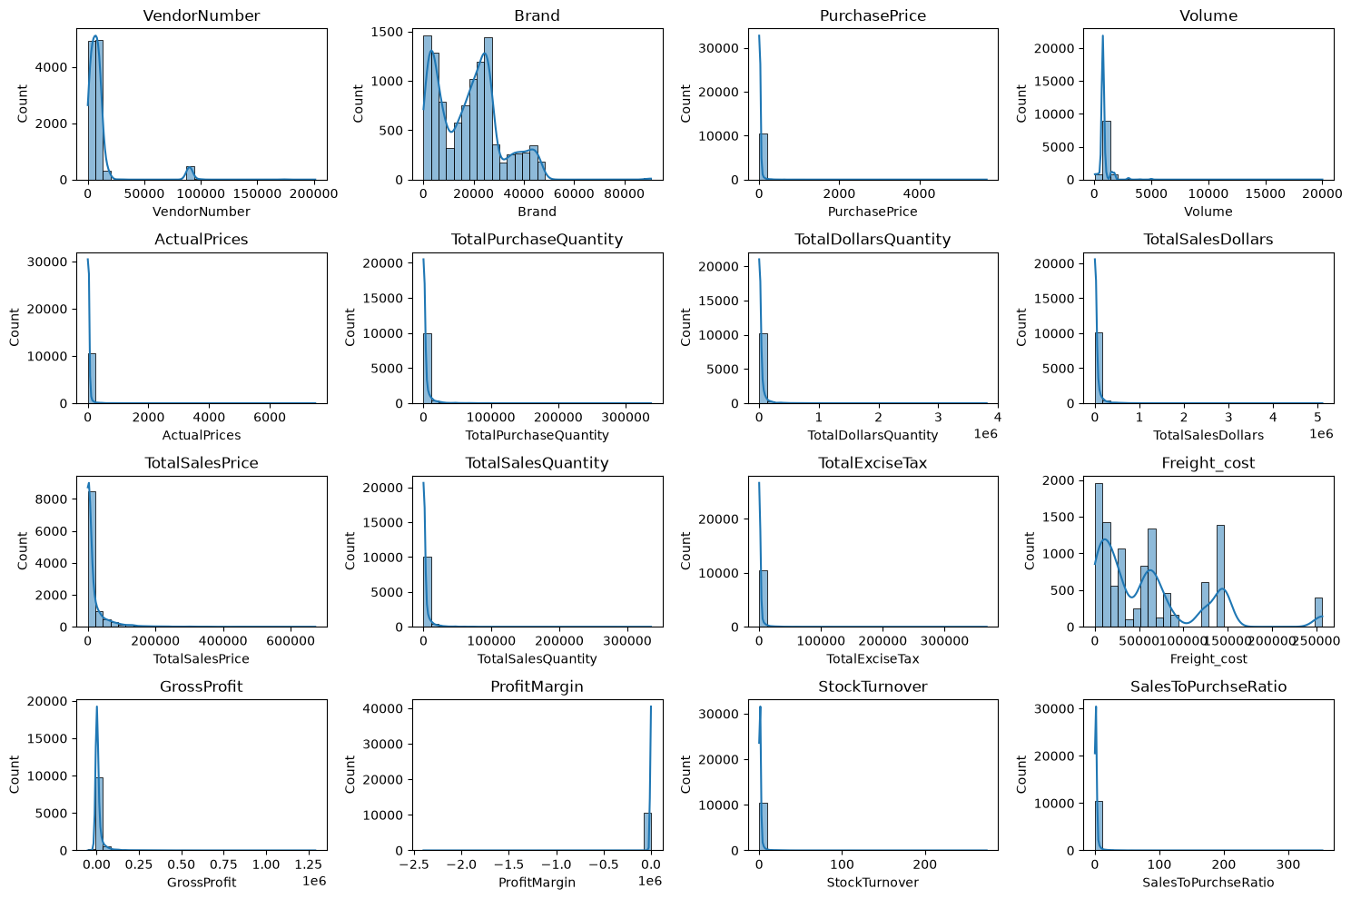
Figure 1: Distributions of numerical columns before filtering (raw summary table)
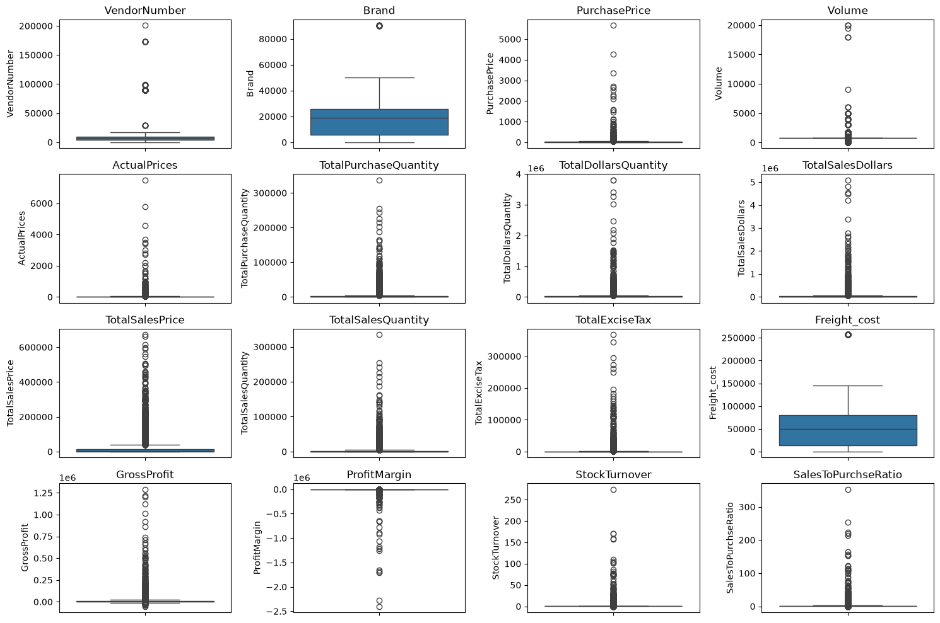
Figure 2: Box plots for outlier detection (before filtering)
Observation: the strongly right-skewed histograms and the many outliers in the box plots confirm that a few very large brands and vendors dominate the data and that loss-making and unsold rows distort the statistics.

7.2 Filtering inconsistent records
To obtain a reliable analytical dataset, rows were kept only where GrossProfit > 0, ProfitMargin > 0 and TotalSalesQuantity > 0. This reduced the data from 10,692 to 8,564 rows.
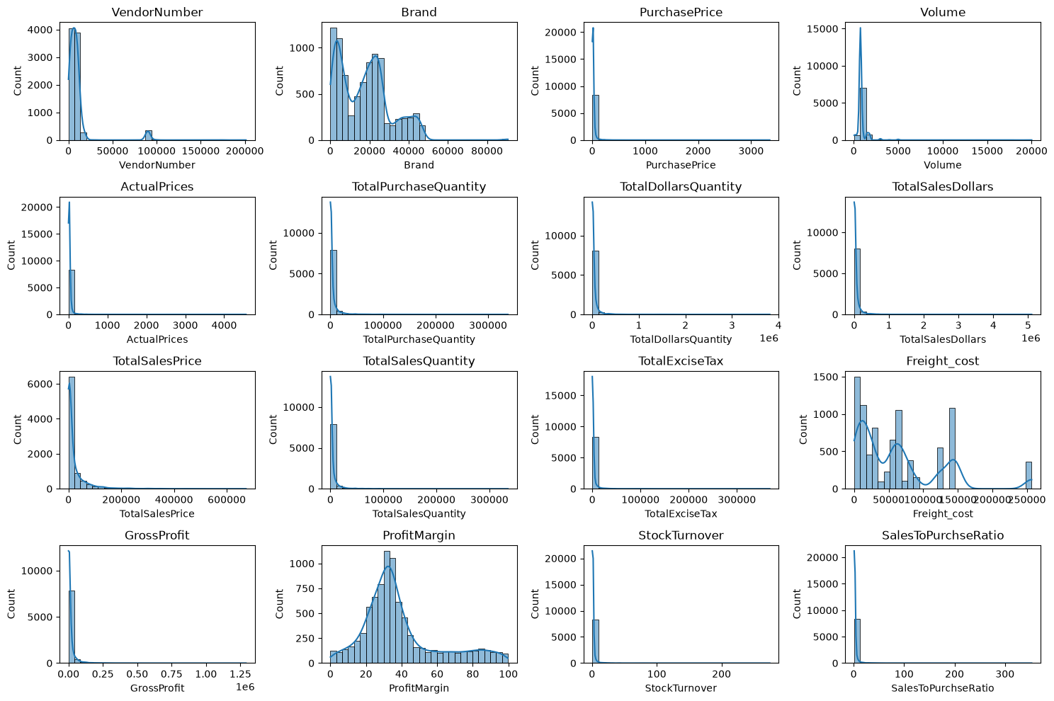
Figure 3: Distributions of numerical columns after filtering
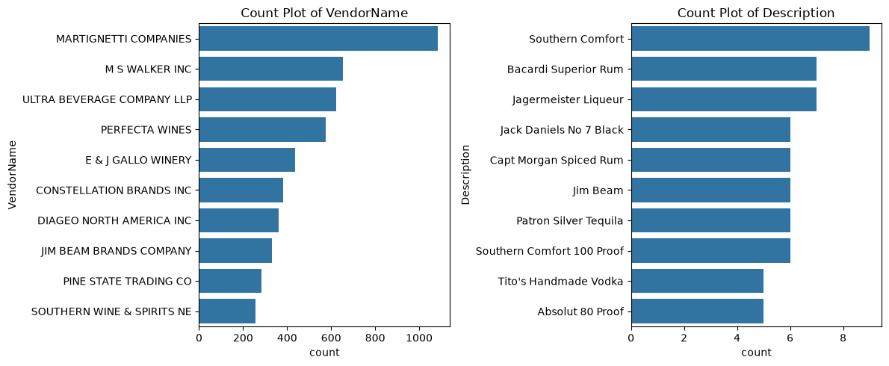
Figure 4: Top 10 vendors and descriptions by record count

7.3 Correlation analysis
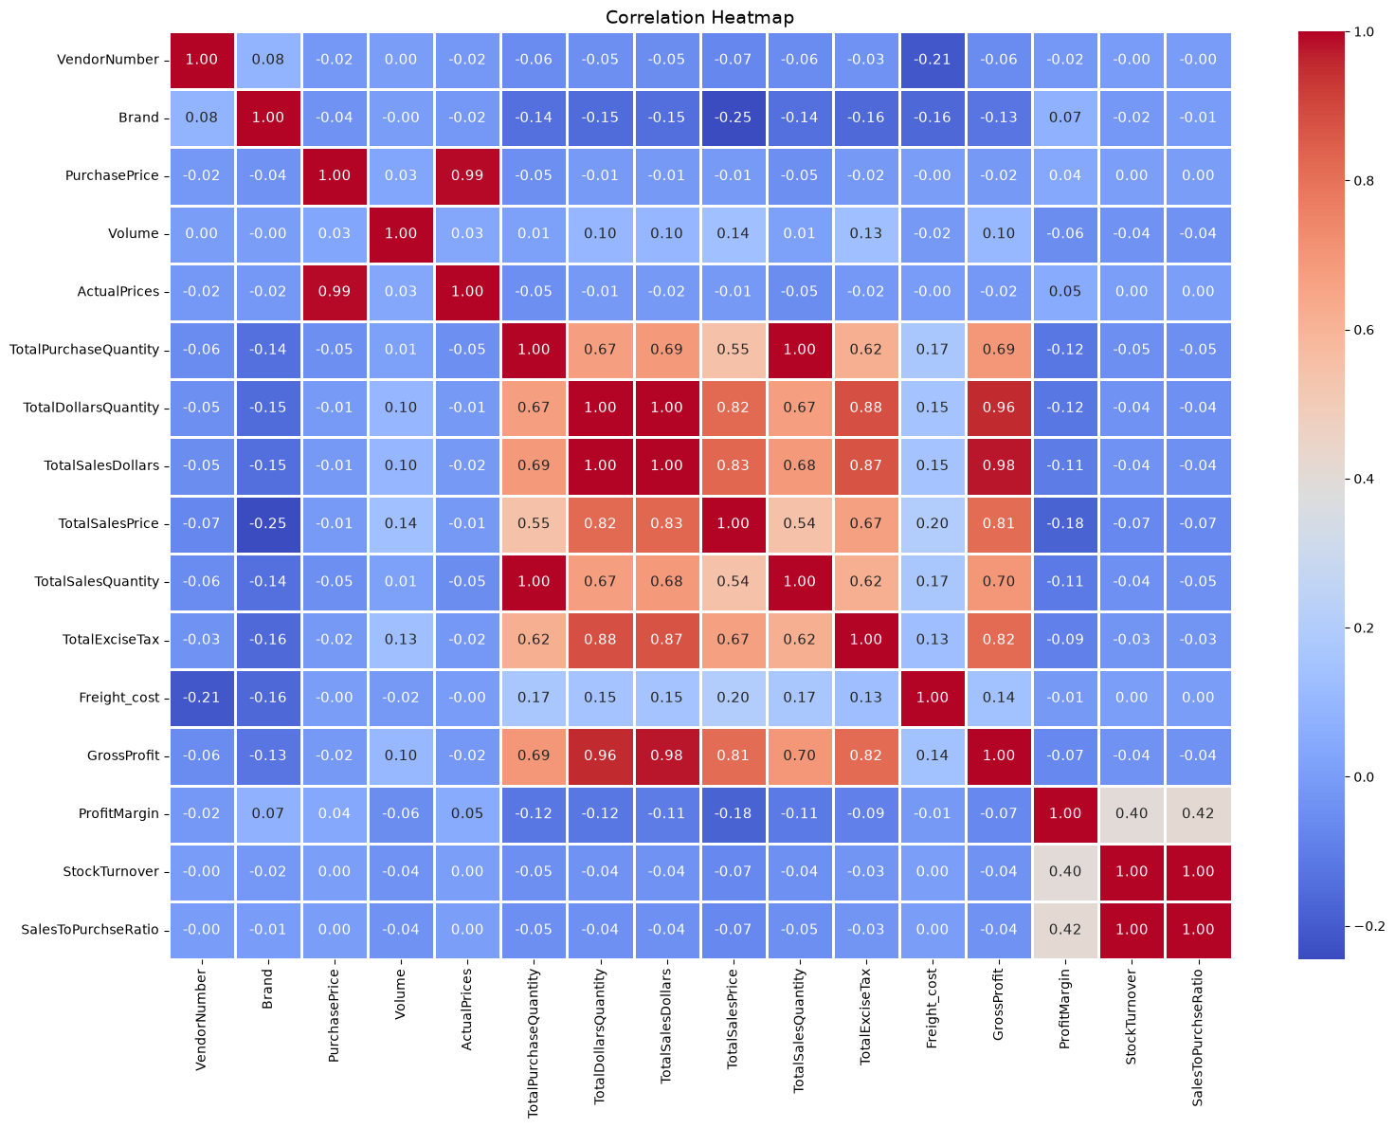
Figure 5: Correlation heatmap of numerical variables
- Purchase price has almost no correlation with sales dollars (−0.012) or gross profit (−0.016): price alone does not drive revenue or profit.
- Total purchase quantity and total sales quantity are almost perfectly correlated (0.999), confirming that stock purchased is being sold.
- Profit margin and total sales price are negatively correlated (−0.179): higher selling prices tend to come with lower margins, possibly due to competitive pricing pressure.
- Stock turnover is weakly negatively correlated with gross profit (−0.038) and profit margin (−0.055): faster turnover does not automatically mean higher profit.

8. Business Analysis and Results

8.1 Brands needing promotional or pricing adjustments
Brands were aggregated by Description (total sales and mean profit margin). Thresholds were set at the 15th percentile of sales ($560.30) and the 85th percentile of margin (64.97%). Brands below the sales threshold and above the margin threshold are 'target brands'; 198 brands qualified.
Brand | Total Sales ($) | Profit Margin (%)
Santa Rita Organic Svgn Bl | 9.99 | 66.47
Debauchery Pnt Nr | 11.58 | 65.98
Concannon Glen Ellen Wh Zin | 15.95 | 83.45
Crown Royal Apple | 27.86 | 89.81
Sauza Sprklg Wild Berry Marg | 27.96 | 82.15
Dad's Hat Rye Whiskey | 538.89 | 81.85
Sbragia Home Ranch Merlot | 549.75 | 66.44
Goulee Cos d'Estournel 10 | 558.87 | 69.43

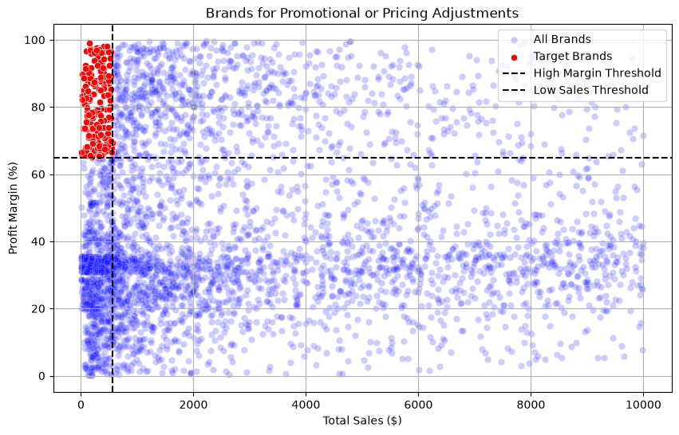
Figure 6: Brands for promotional or pricing adjustments (red = target brands)
Interpretation: these brands are profitable per unit but sell very little. Targeted promotion, better shelf placement or modest price reductions could grow volume without sacrificing much margin.

8.2 Highest sales performance
Top vendors by sales | Sales ($) | Top brands by sales | Sales ($)
Diageo North America | 67.99M | Jack Daniels No 7 Black | 7.96M
Martignetti Companies | 39.33M | Tito's Handmade Vodka | 7.40M
Pernod Ricard USA | 32.06M | Grey Goose Vodka | 7.21M
Jim Beam Brands | 31.42M | Capt Morgan Spiced Rum | 6.36M
Bacardi USA | 24.85M | Absolut 80 Proof | 6.24M
Constellation Brands | 24.22M | Jameson Irish Whiskey | 5.72M
E & J Gallo Winery | 18.40M | Ketel One Vodka | 5.07M
Brown-Forman Corp | 18.25M | Baileys Irish Cream | 4.15M
Ultra Beverage Company | 16.50M | Kahlua | 3.60M
M S Walker Inc | 14.71M | Tanqueray | 3.46M

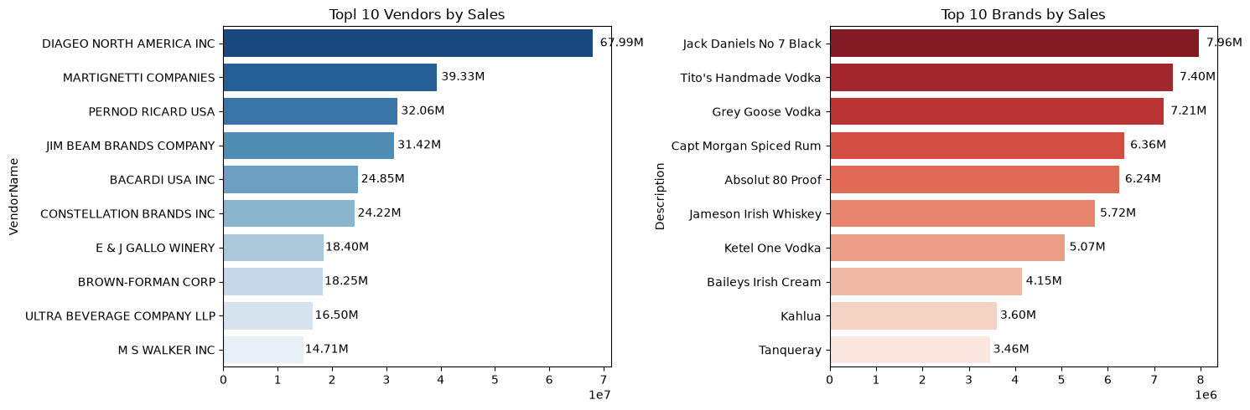
Figure 7: Top 10 vendors and top 10 brands by sales
Diageo leads by a wide margin (almost double the second vendor). The top brands are mainstream whiskey and vodka labels, which suggests sales are driven by a few well-known products.

8.3 Vendors contributing most to purchase dollars
Vendor | Purchases | Gross Profit | Sales | Purchase share
Diageo North America | 50.10M | 17.89M | 67.99M | 16.30%
Martignetti Companies | 25.50M | 13.83M | 39.33M | 8.30%
Pernod Ricard USA | 23.85M | 8.21M | 32.06M | 7.76%
Jim Beam Brands | 23.49M | 7.93M | 31.42M | 7.64%
Bacardi USA | 17.43M | 7.42M | — | —
Constellation Brands | 15.27M | 8.95M | — | —
Brown-Forman Corp | 13.24M | 5.01M | — | —
E & J Gallo Winery | 12.07M | 6.33M | — | —
Ultra Beverage Company | 11.17M | 5.34M | — | —
M S Walker Inc | 9.76M | 4.94M | — | —

(Top-10 vendors together account for 65.69% of purchase dollars; individual shares for ranks 5–10 are shown in Figure 8.)
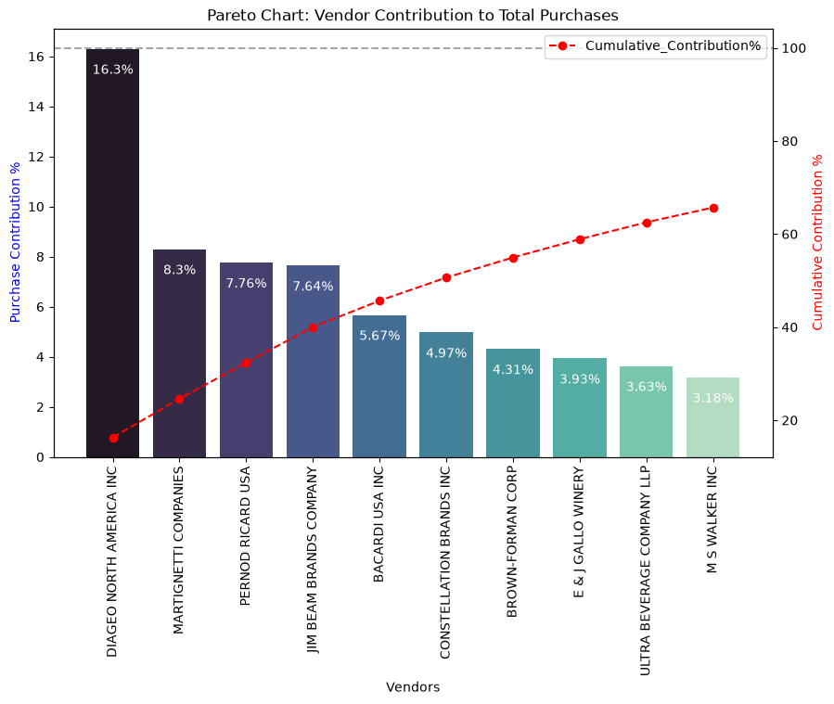
Figure 8: Pareto chart – vendor purchase contribution and cumulative percentage

8.4 Dependency on top vendors
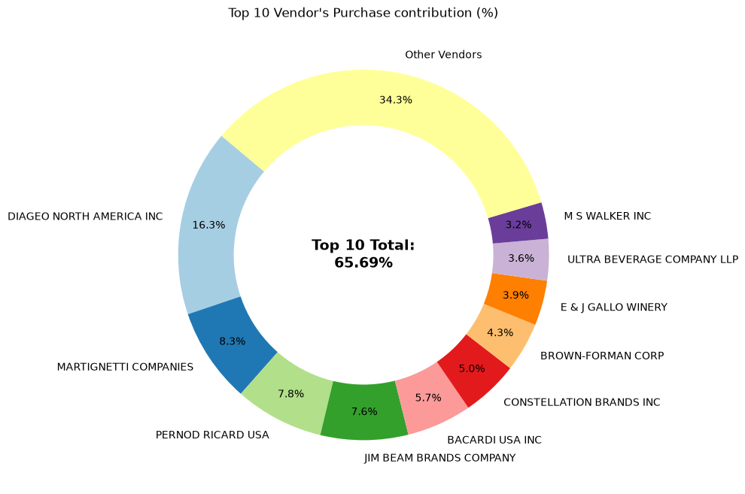
Figure 9: Donut chart – top 10 vendors vs. all other vendors
Roughly two-thirds of procurement depends on only 10 vendors out of 128. This offers negotiating power through volume, but also creates supply-chain risk: any disruption, price rise or contract change at a top vendor would have a large impact. Diversifying suppliers is advisable.

8.5 Does bulk purchasing reduce unit price?
Unit purchase price was computed as TotalDollarsQuantity / TotalPurchaseQuantity, and records were split into three equal-sized groups by purchase quantity (Small, Medium, Large).
Order size | Average unit purchase price ($)
Small | 39.07
Medium | 15.49
Large | 10.78

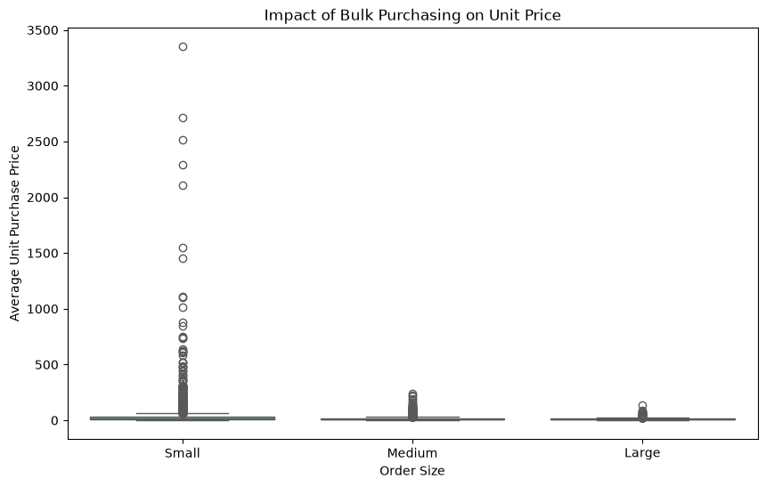
Figure 10: Impact of bulk purchasing on unit price
Large orders cost about 72% less per unit than small orders. Bulk-pricing incentives work, but the saving is only a real gain if the extra stock is sold quickly (see 8.6 and 8.7).

8.6 Vendors with low inventory turnover
Among records with stock turnover below 1, the slowest-moving vendors (mean turnover) are:
Vendor | Mean stock turnover
Alisa Carr Beverages | 0.615
Highland Wine Merchants LLC | 0.708
Park Street Imports LLC | 0.751
Circa Wines | 0.756
Dunn Wine Brokers | 0.766
Centeur Imports LLC | 0.774
Smoky Quartz Distillery LLC | 0.784
Tamworth Distilling | 0.797
The Imported Grape LLC | 0.808
Walpole Mtn View Winery | 0.821

These vendors sell less than ~60–80% of what is purchased, indicating excess stock and slow-moving products. Purchase quantities from them should be reduced or promotions used to clear stock.

8.7 Capital locked in unsold inventory
Unsold inventory value = (TotalPurchaseQuantity − TotalSalesQuantity) × PurchasePrice. Total unsold capital is about $2.71M.
Vendor | Unsold inventory value
Diageo North America | $722.21K
Jim Beam Brands Company | $554.67K
Pernod Ricard USA | $470.63K
William Grant & Sons | $401.96K
E & J Gallo Winery | $228.28K
Sazerac Co | $198.44K
Brown-Forman Corp | $177.73K
Constellation Brands | $133.62K
Moet Hennessy USA | $126.48K
Remy Cointreau USA | $118.60K

The largest vendors also lock up the most capital in absolute terms, even though their turnover is generally healthy – scale, not inefficiency, drives this. Better demand forecasting and smaller, more frequent orders would release working capital.

9. Statistical Analysis

9.1 95% confidence intervals for profit margin
Vendors/brands were grouped by total sales: top performers (≥ 75th percentile, n = 2,141) and low performers (≤ 25th percentile). Confidence intervals use the t-distribution: mean ± t(0.975, n−1) × SD/√n.
Group | Mean margin | 95% CI
Top performers | 31.18% | 30.74% – 31.61%
Low performers | 41.57% | 40.50% – 42.64%

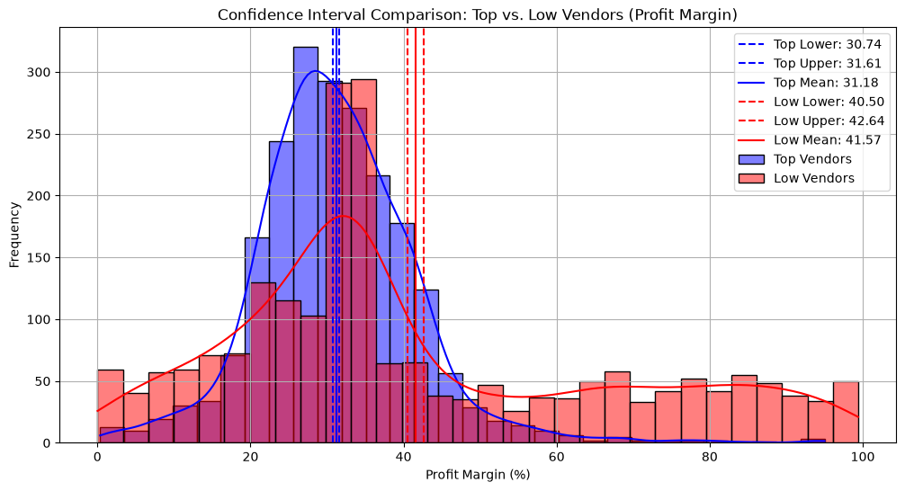
Figure 11: Profit margin distributions with 95% confidence intervals
The intervals do not overlap: low-sales vendors maintain higher margins, possibly through premium pricing or niche products, while high-sales vendors earn lower margins on high volume.

9.2 Hypothesis test
- H0: no difference in mean profit margin between top and low performers.
- H1: the mean profit margins are different.
A two-sample Welch's t-test (equal_var = False) gave t = −17.6695 and p-value ≈ 0.0000 (< 0.05). H0 is rejected: the difference in profit margins is statistically significant.

10. Dashboard
The results of the notebook analysis were summarised in a one-page dashboard so that managers can see vendor and brand performance at a glance without reading code. The dashboard is based on the vendor_sales_summary table created by get_vendor_summary.py (exported as vendor_sales_summary.csv).

10.1 Filtered rows used in the dashboard (Power Query)
The Power Query Editor was used to load the table and apply the same cleaning rules as the notebook (section 7.2). Only records that are profitable and actually sold are kept, so that loss-making rows and products with zero sales do not distort the totals. Each filter appears as a step under Applied Steps in the Query Settings pane.
Applied step | Purpose
Source | Loads vendor_sales_summary (21 columns, more than 10,000 rows).
Promoted Headers | Uses the first row as column names.
Changed Type | Sets the correct data type for every column (whole number, text, decimal).
Filtered Rows | Keeps rows where TotalSalesQuantity > 0, GrossProfit > 0 and ProfitMargin > 0.

Power Query (M) formula of the filter step:
= Table.SelectRows(#"Changed Type", each [TotalSalesQuantity] > 0 and [GrossProfit] > 0 and [ProfitMargin] > 0)
After filtering, 8,564 qualifying rows remain (119 vendors and 7,707 brands, as shown in the dashboard subtitle), the same dataset used for all analysis in sections 8 and 9.
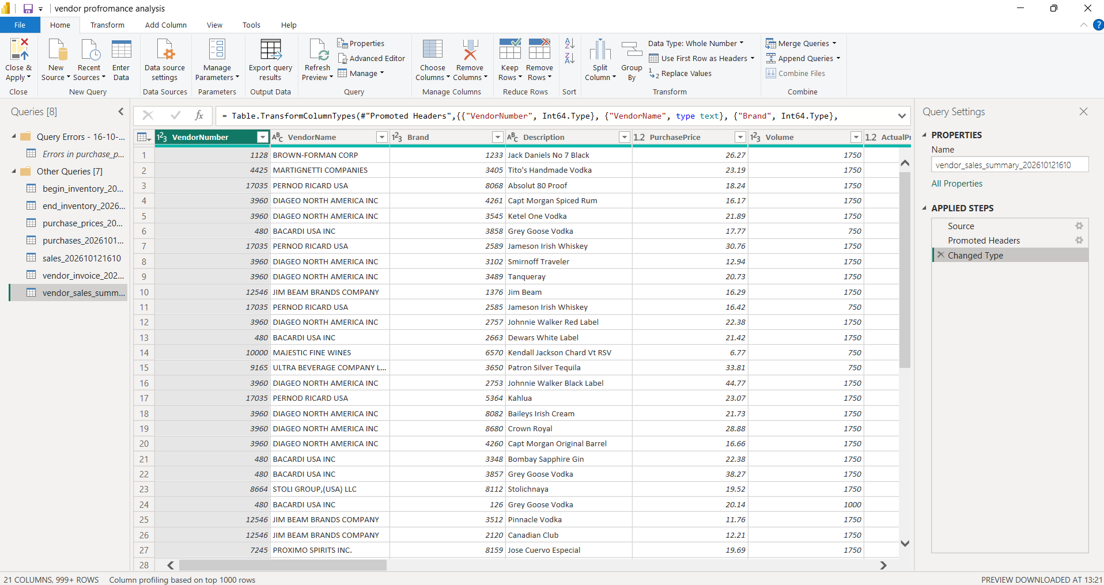
Figure 12: Power Query Editor with the vendor_sales_summary table loaded and its Applied Steps
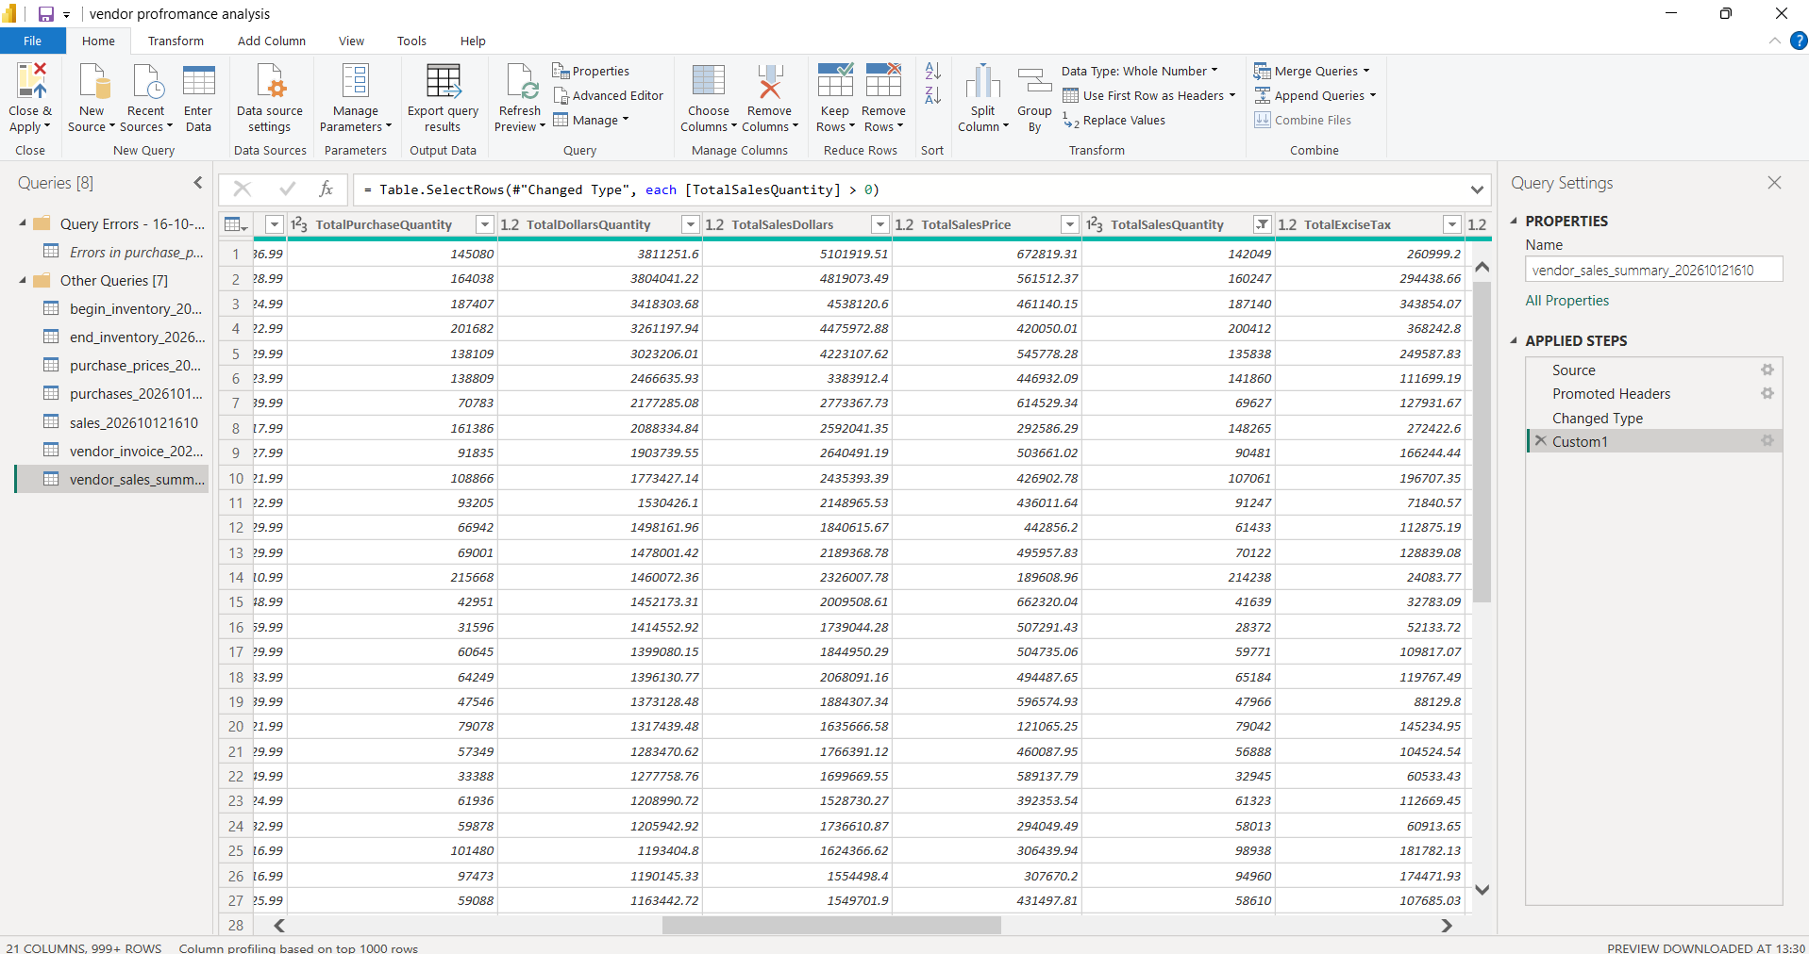
Figure 13: Power Query Editor showing the row filter (Table.SelectRows) applied as a step; the filter icon on TotalSalesQuantity marks the filtered column

10.2 Dashboard
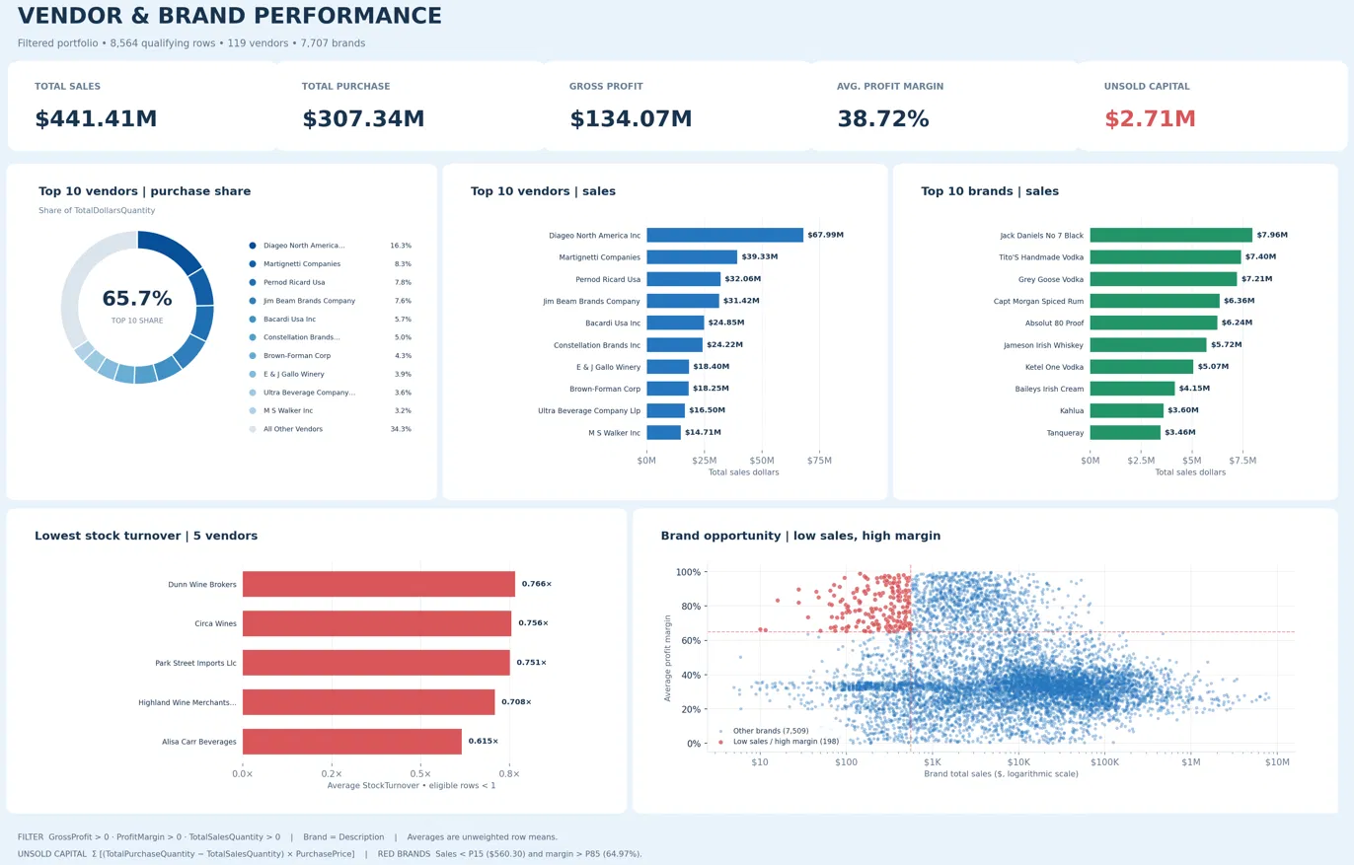
Figure 14: Vendor & Brand Performance dashboard
Dashboard components
Visual | What it shows
KPI cards | Total Sales $441.41M, Total Purchase $307.34M, Gross Profit $134.07M, average Profit Margin 38.72%, Unsold Capital $2.71M.
Top 10 vendors | purchase share (donut) | Top 10 vendors account for 65.7% of purchase dollars; Diageo leads with 16.3%, followed by Martignetti (8.3%) and Pernod Ricard (7.8%).
Top 10 vendors | sales (bar) | Diageo $67.99M, Martignetti $39.33M, Pernod Ricard $32.06M, Jim Beam $31.42M, Bacardi $24.85M.
Top 10 brands | sales (bar) | Jack Daniels No 7 Black $7.96M, Tito's Handmade Vodka $7.40M, Grey Goose $7.21M, Capt Morgan $6.36M, Absolut 80 Proof $6.24M.
Lowest stock turnover (bar) | Lowest average stock turnover: Dunn Wine Brokers 0.766, Circa Wines 0.756, Park Street Imports 0.751, Highland Wine Merchants 0.708, Alisa Carr Beverages 0.615.
Brand opportunity (scatter) | Brand total sales (log scale) against average profit margin; red points are the 198 low-sales, high-margin brands (7,509 others in blue) that are candidates for promotion or pricing changes.

Definitions used: Unsold Capital = Σ((TotalPurchaseQuantity − TotalSalesQuantity) × PurchasePrice); Purchase share = vendor TotalDollarsQuantity ÷ all TotalDollarsQuantity × 100; Avg. Profit Margin is the unweighted mean of row-level ProfitMargin; red brands have sales below the 15th percentile ($560.30) and margin above the 85th percentile (64.97%).
Reading the dashboard: sales and purchases are concentrated in a few large vendors, the slowest-turnover vendors hold stock that is not selling, and the red brands in the scatter plot sell little but earn high margins. These match the findings of the notebook analysis.

11. Key Findings and Recommendations
Finding | Recommendation
198 brands have low sales but high margin | Run promotions, improve visibility or test lower prices to raise volume.
Top 10 vendors = 65.69% of purchases | Negotiate volume discounts; diversify to reduce supply risk.
Large orders cost ~72% less per unit | Keep bulk buying for fast-moving items; avoid it for slow movers.
Several vendors have turnover below 0.85 | Cut order quantities and clear stock with discounts.
$2.71M capital is locked in unsold stock | Improve demand forecasting; use smaller, more frequent orders.
Top vendors earn significantly lower margin (31% vs 42%) | Review pricing, freight and costs for high-volume vendors; bundle products.

12. Limitations and Future Work
- Freight is a vendor-level total and is not allocated to individual brands, so brand-level profit is overstated by freight and excise tax not being subtracted.
- Filtering to positive-profit rows removes loss-making products from the later analysis; a separate study of those losses would be valuable.
- The analysis is a single-period snapshot; trend and seasonality are not covered.
- Possible extensions: time-series forecasting, an interactive Power BI/Tableau dashboard reading vendor_sales_summary, and a vendor-scoring model.
Note on the notebook: the EDA notebook connects to 'invertory.db' (spelling) while the scripts use 'inventory.db'; aligning the name avoids an empty-database error.

13. Conclusion
The project built an end-to-end pipeline from raw CSV files to a clean vendor-level analytical table and used it to answer six business questions. It shows that sales and procurement are highly concentrated in a few vendors, that bulk buying greatly lowers unit cost, that about $2.7M of capital sits in unsold stock, and that low-sales vendors earn significantly higher margins than top sellers. These insights can guide vendor negotiation, pricing, promotion and inventory-planning decisions.

