**SQL ASSIGNMENT OUTPUTS**

QUES 1 Print the names of the employees who have highest no of leaves.

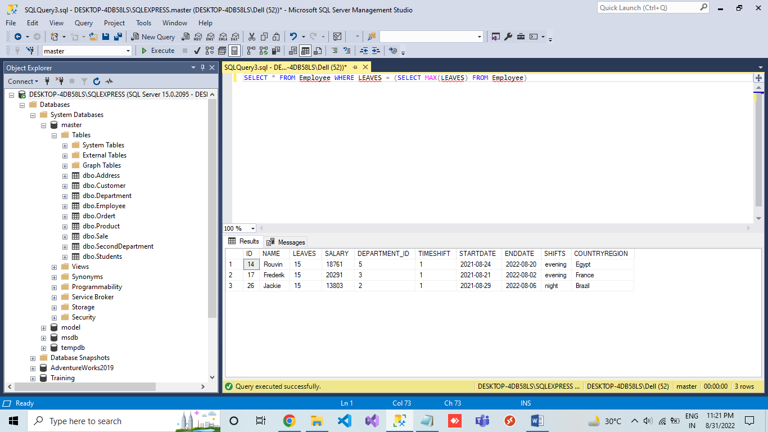

QUES 2 Print the names of the employees that took the second highest leaves

get the 2nd highest no of leaves.

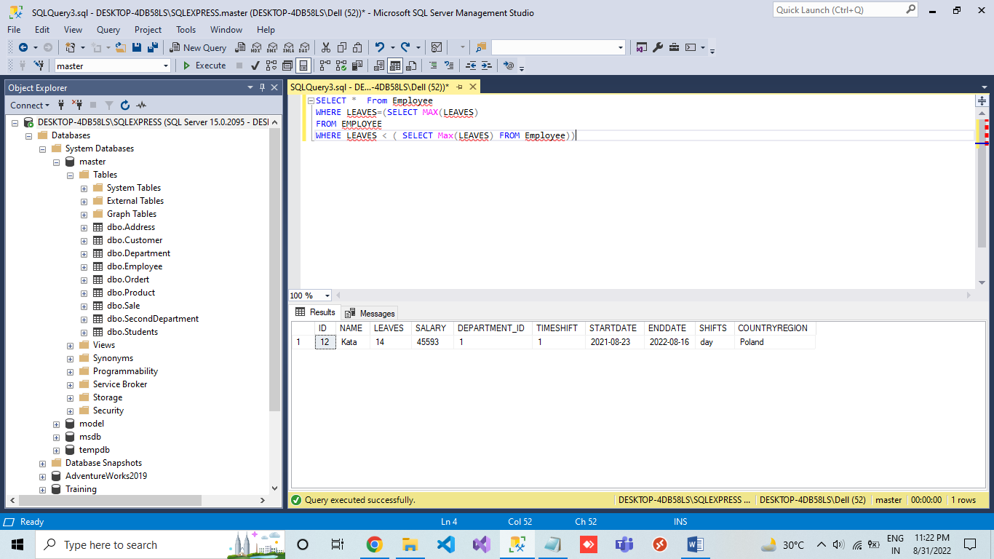

QUES 3 Print n-th highest salary.

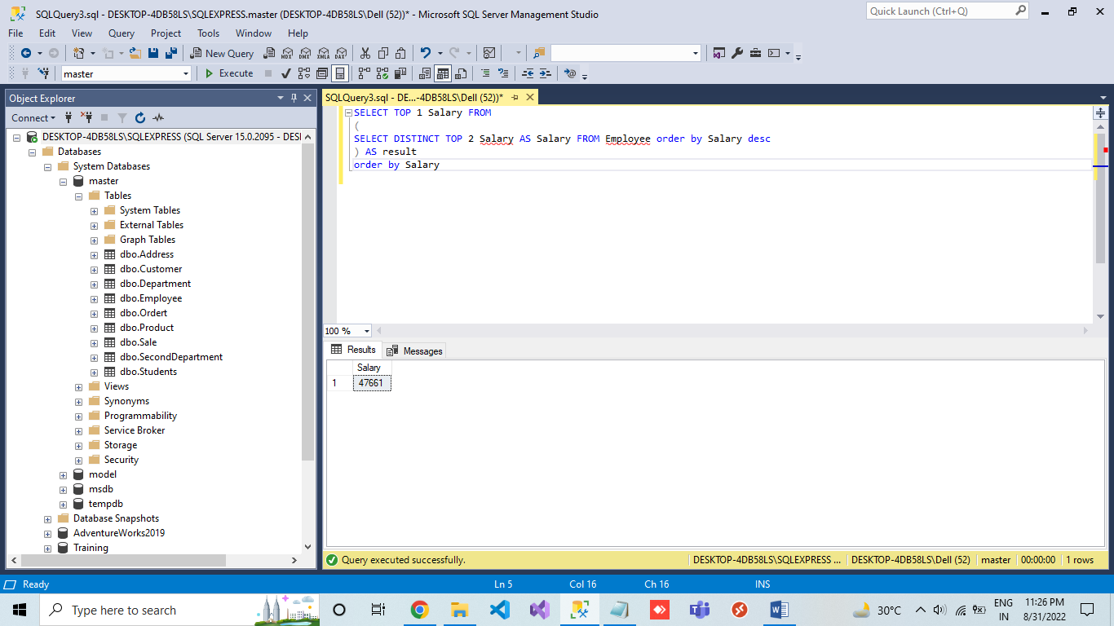

QUES 4 Print Name of the employee, Department name, StartDate, EndDate - Ordered by Employee, StartDate ascending.

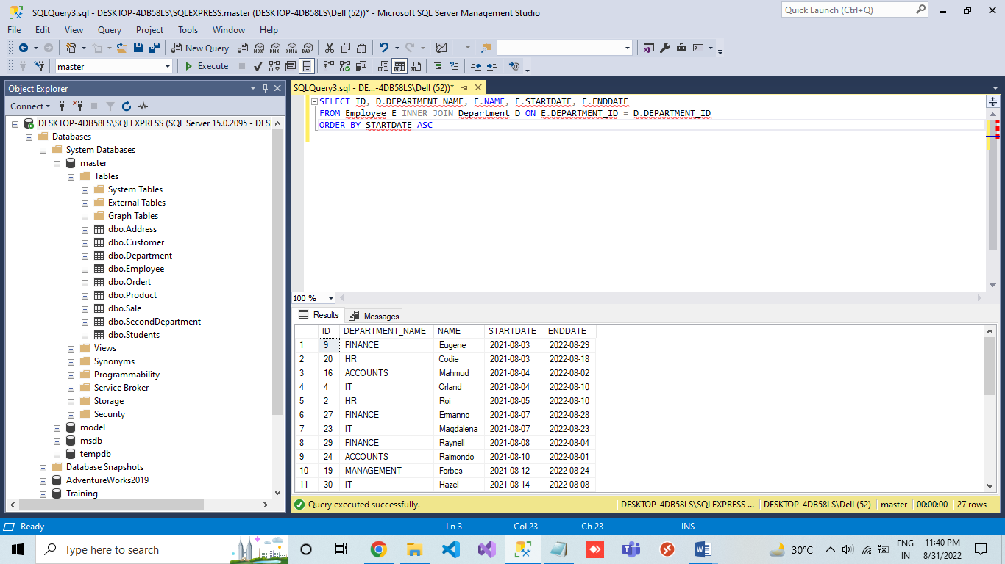

QUES 5 Print the Employees that are assigned to more than one department.

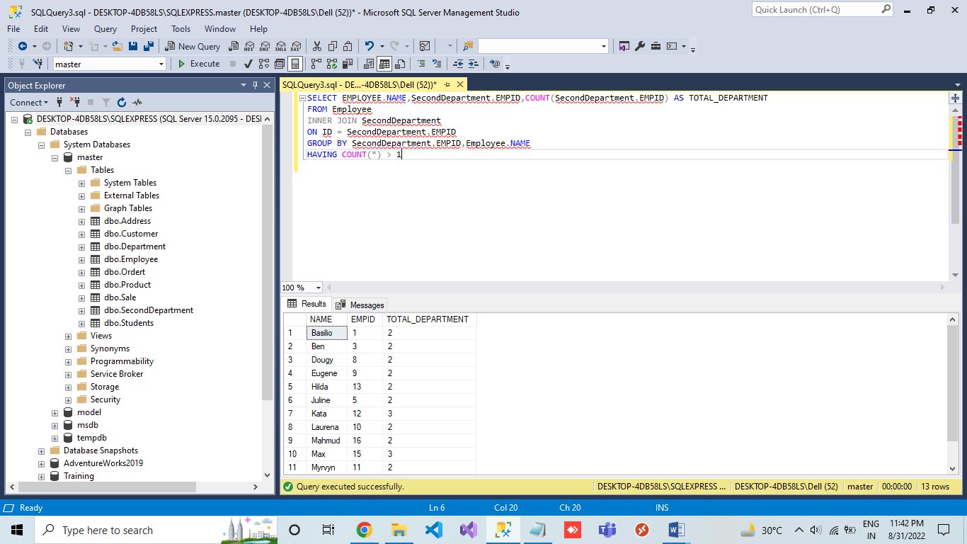

QUES 6 Print the number of employees that are not assigned to any deparment.

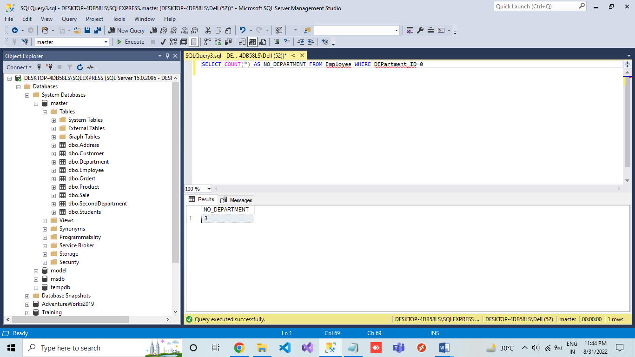

QUES 7 Print the number of employees by their shift [Number of employees working day, evening, and night]

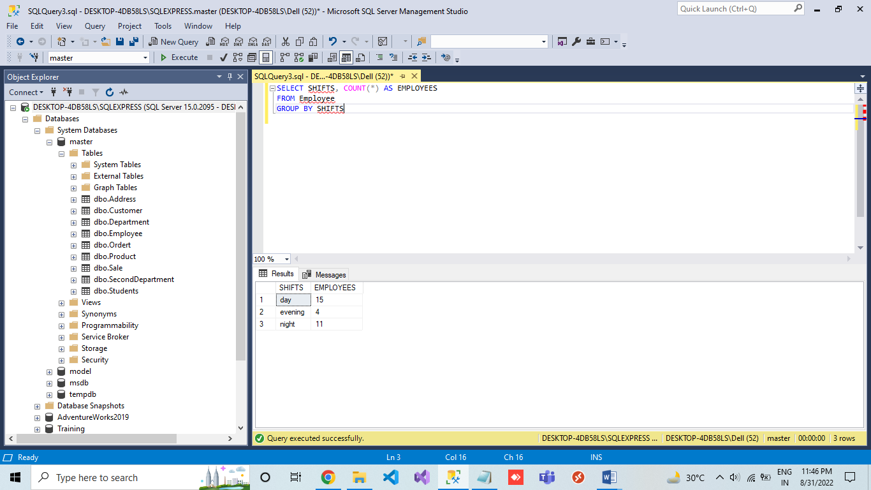

QUES 8 Print Number of Emplyoees by CountryRegionName.

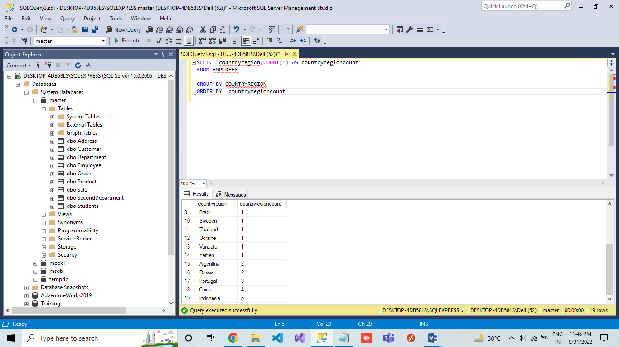

QUES 9 Print the name of the Coutry Region with the highest number of employees.

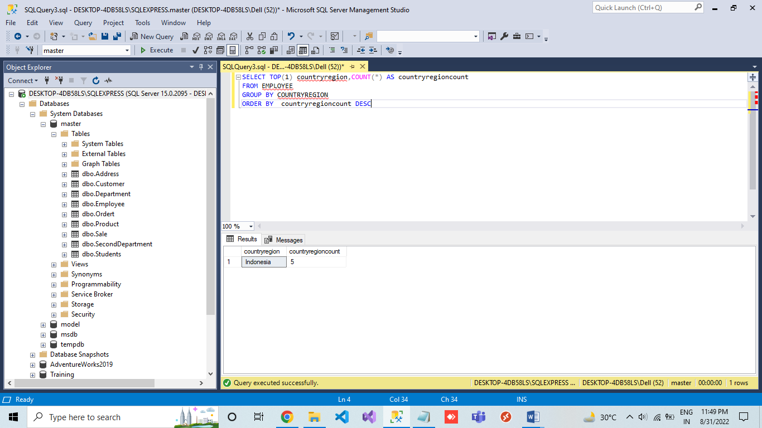

QUES 10 Print the employee with their Home address detail

First Name, Last name, AddressType = Home, Line1, Line2, City, State, Postal Code and Country.

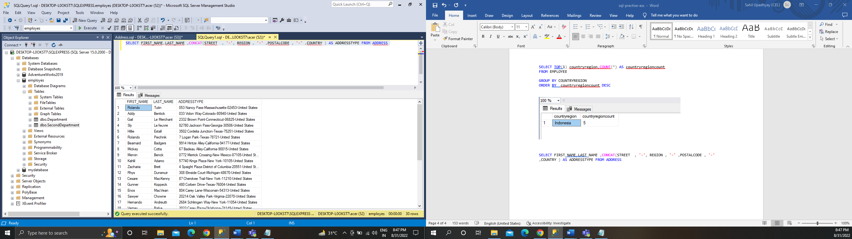

QUES 11 Print the number of employees that don't have shipping address.

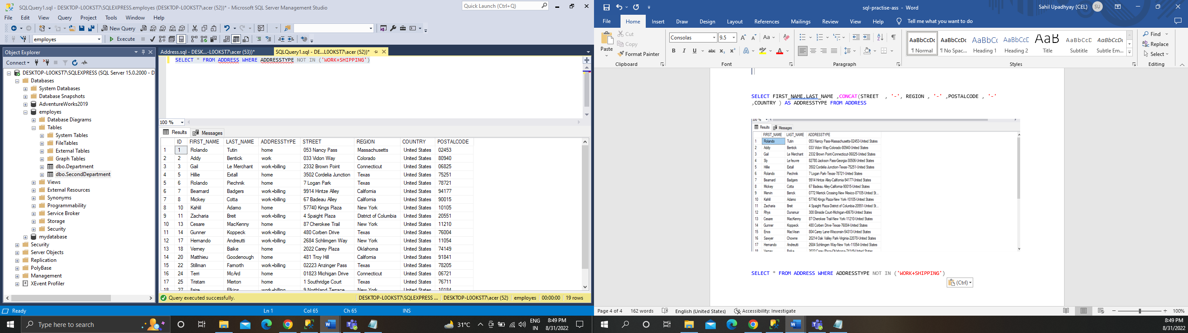

QUES 12 Print the number of employees that have Home + Billing addresses.

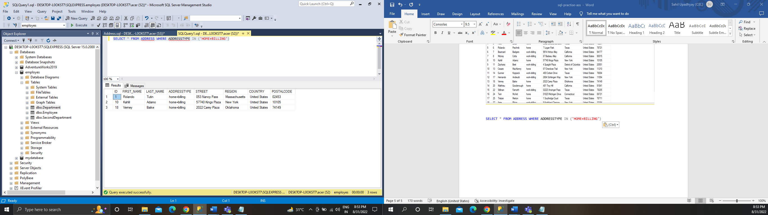

QUES 13 Print the count of employees that are living in Texas state.

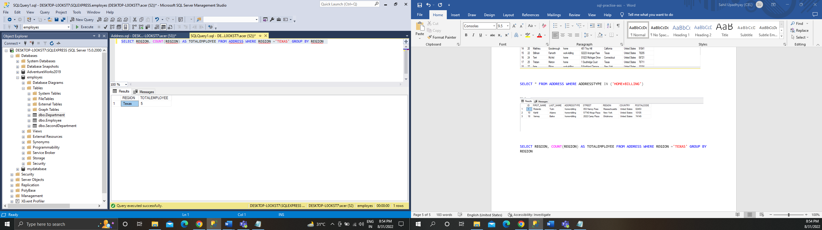

QUES 14 Get the customers and their Sale value ( total due ).

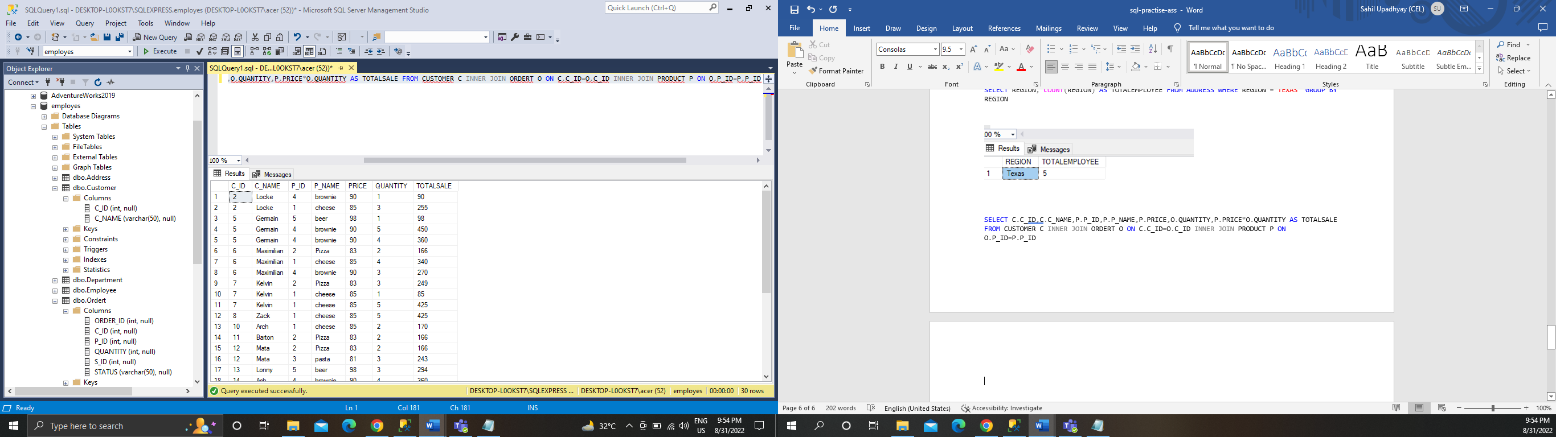

QUES 15 Get the names of the salespersons that did the highest sale.

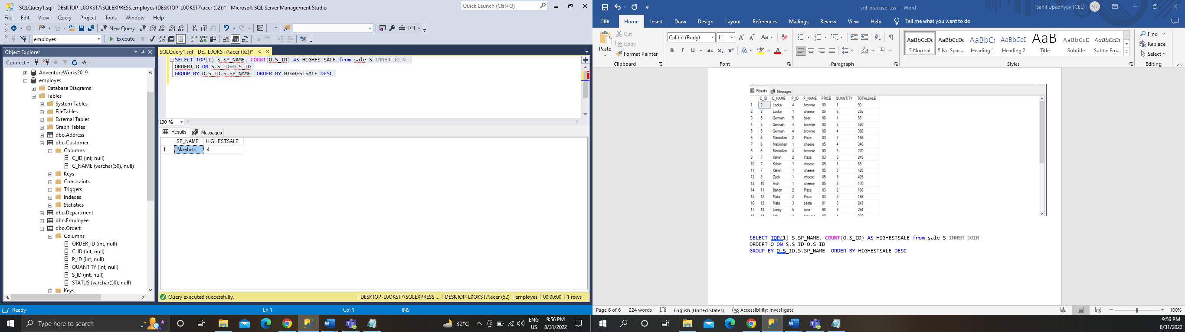

QUES 16 Number of sales by Online vs non-online.

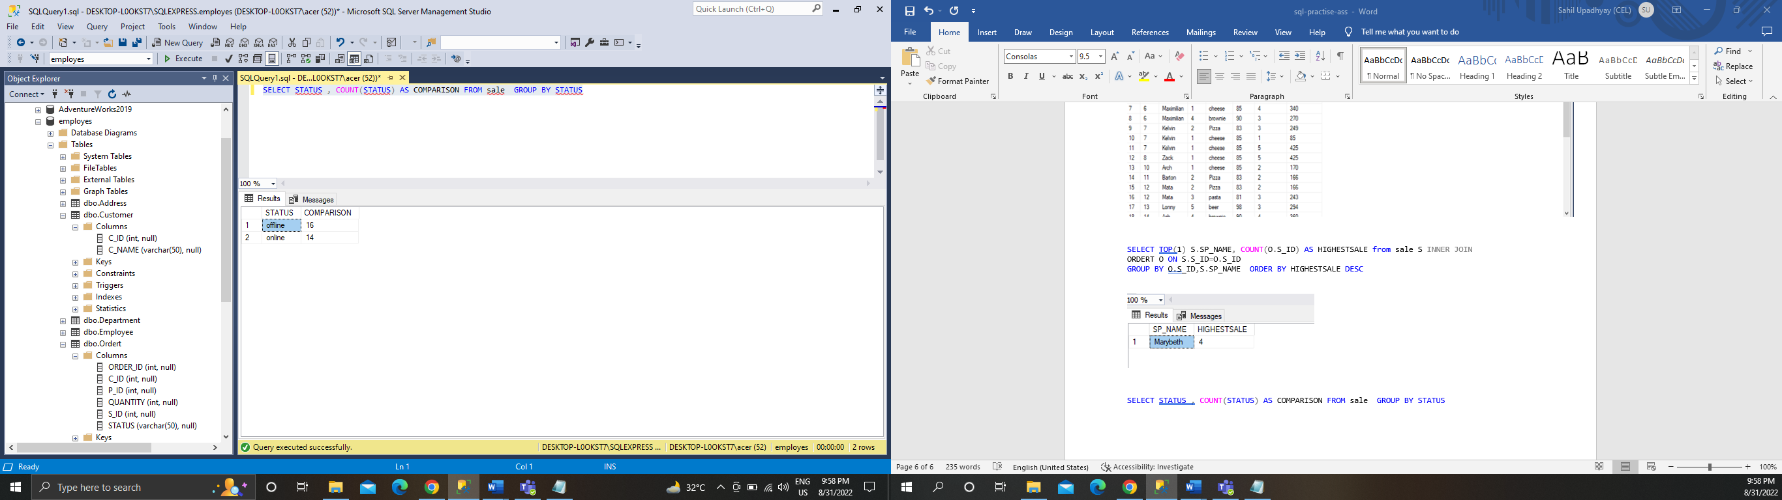

QUES 17 Number of sales by their status.

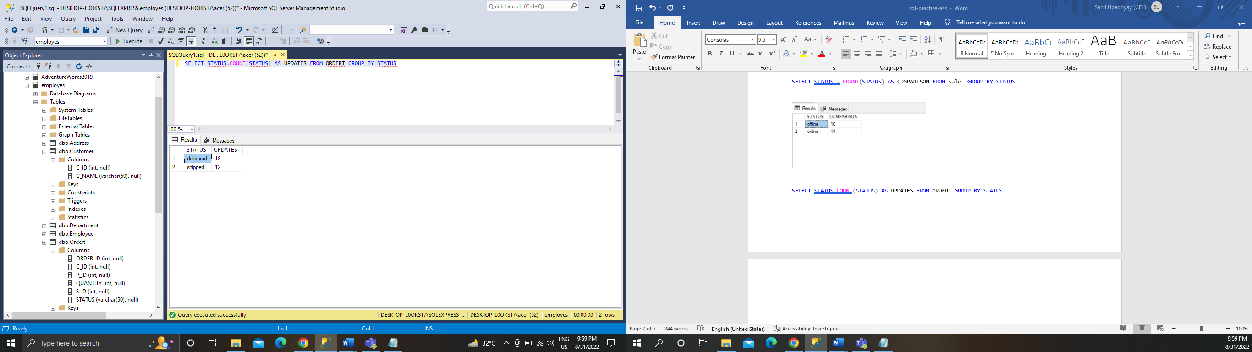

QUES 18 Print the number of customers by Product.

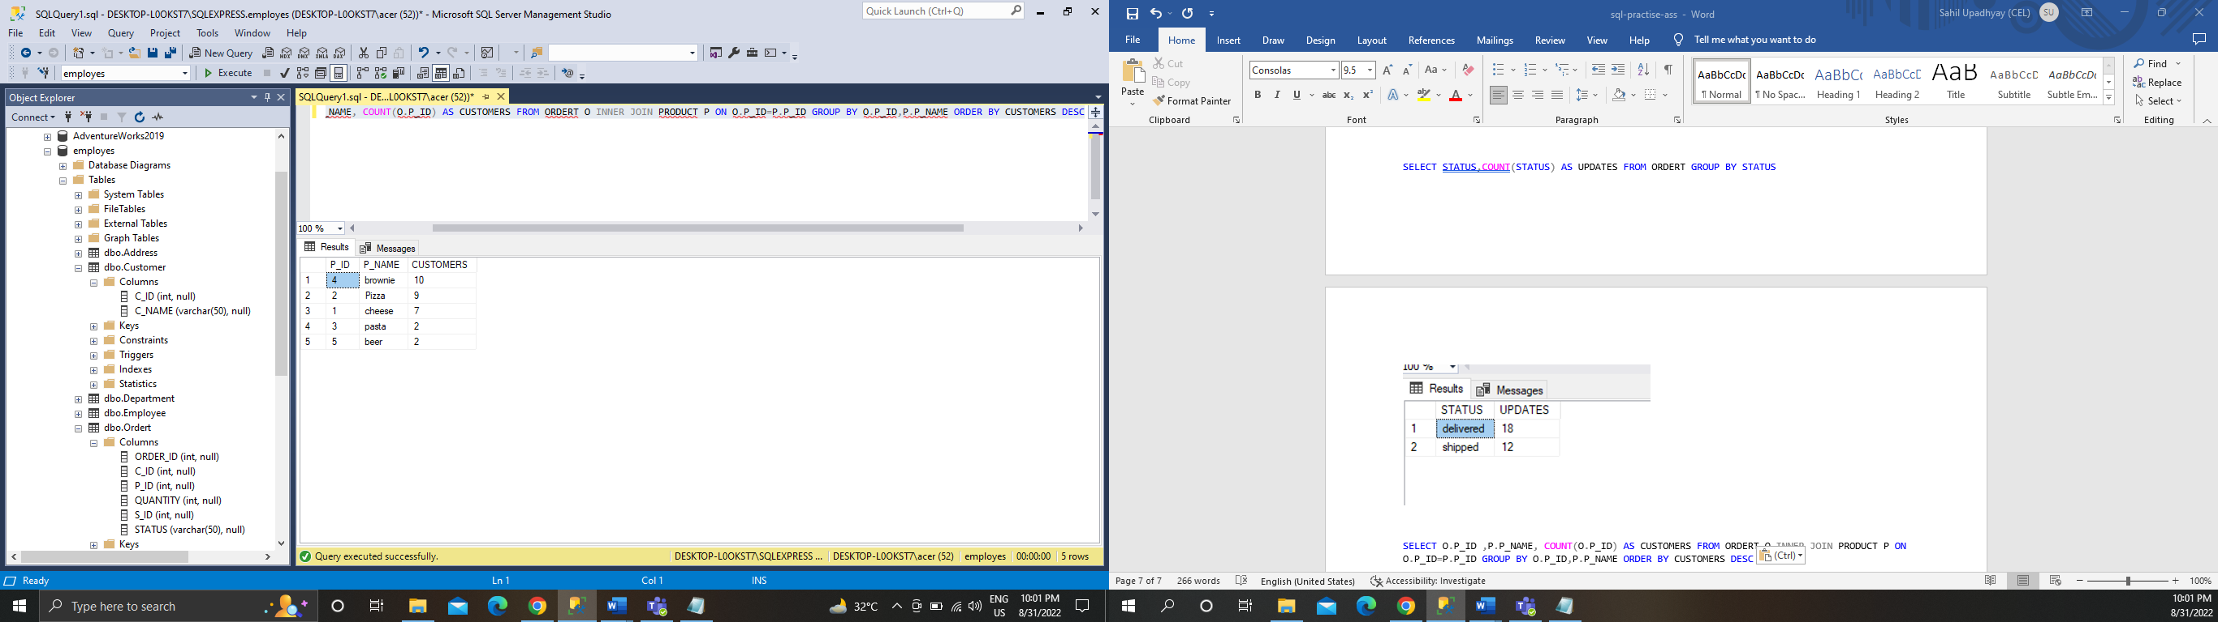

QUES 19 Print the most popular product.

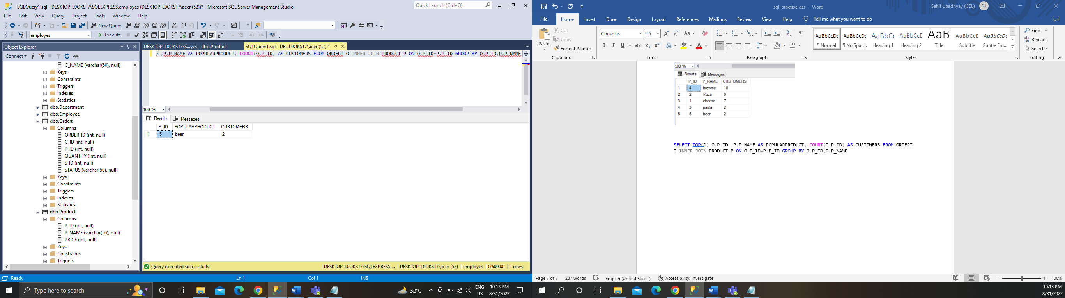

QUES 20 Print the products by their revenue.

