Pocketful Mobile App: Usability Flaws & Experience Review
Submitted as part of the Product Management task – Feature Evaluation & Competitive Analysis

Objective
As part of the product evaluation process, this document identifies key usability and UX flaws in the Pocketful mobile app. The review is based on firsthand usage, real-world test flows, and benchmarking against industry UX expectations (e.g., Zerodha, Groww, Robinhood). Each flaw is mapped to observed behaviour, risk to user trust, likely root cause, and severity.

Summary of Identified Flaws
# | Title | Severity | Risk Type
1 | Generic Error Messaging on Missing Technical Data | Medium–High | Trust Leak
2 | UI Hierarchy Breakdown in Options Trading | High | Cognitive Friction
3 | Cold Start Lag on High-Speed Devices | High | Platform Performance
4 | Margin Field Flicker Without Loading State | Medium–High | Execution Anxiety
5 | Inconsistent Order Lifecycle & Cancel UX | High | Trade Reliability

Detailed Flaw Descriptions
Flaw #1: Generic Error Messaging on Missing Technical Data
Observed Behaviour
When visiting the Technicals tab for certain instruments, the app displays a vague "Something went wrong! Internal Server Error" message with no clarification or fallback, despite other symbols loading fine.
Impact
- Breaks trust in platform reliability
- Leaves user unsure whether to retry, wait, or abandon
Root Cause (Likely)
- Missing data for that instrument; error not differentiated from global failure
- Lack of Contextual Error Handling and Fallbacks Across Data Surfaces
“Multiple areas in the app - including system-level toasts - return unhelpful Error code (500): Something went wrong messages without user guidance. This signals not just data unavailability, but weak error stratification across the app’s UX layer.”

Severity: Medium–High
(Reference: Appendix A – Screenshot 1)

Flaw #2: UI Hierarchy Breakdown in Options Trading Screens
Observed Behaviour
The global navbar (Orders / Watchlist / Portfolio) remains persistently visible during options trading, interfering with trade-critical controls like expiry filters, Buy/Sell, and Basket Mode.
Impact
- Clutters screen during a high-cognitive-load task
- Makes Buy/Sell actions feel less intentional
Root Cause (Likely)
Lack of semantic zoning for high-focus, execution-oriented screens
Severity: High
(Reference: Appendix A – Screenshot 2)

Flaw #3: Cold Start Lag Even on High-End Devices & Fast Networks
Observed Behaviour
App takes significantly longer to launch (compared to peers like Zerodha) even on Google Pixel 8 Pro and 100 Mbps broadband. Sometimes requires force-close to respond. Performs better on 5G.
Impact
- Poor first-load experience
- Erodes confidence in app responsiveness
Root Cause (Likely)
Cold-start hydration blocks rendering; backend tightly coupled to UI load
Severity: High

Flaw #4: Margin Field Flickers Without Loading Feedback
Observed Behaviour
Switching to Intraday tab causes the “Margin Required” field to briefly flash as empty (--) before loading. Other fields update smoothly.
Impact
- Creates doubt about funding
- May delay or interrupt high-speed trades
Root Cause (Likely)
Async margin calculation not handled with graceful placeholder UI
Severity: Medium–High
(Reference: Appendix A – Screenshot 3)

Flaw #5: Inconsistent and Unclear Order Lifecycle Undermines User Trust
Observed Behaviour
- Orders can be placed despite ₹0 balance and are later rejected (or cancelled with error 500 toast message in desktop)
- “AMO” shown without explanation (inconsistent tcase usage in several areas)
- Cancel button location varies across views
Impact
- Creates false sense of order success
- Confuses new traders unfamiliar with trade terminology
- Breaks interaction flow with inconsistent actions
Root Cause (Likely)
Lack of validation and educational tooling; modal inconsistencies
Severity: High
(Reference: Appendix A – Screenshot 4)

Flaw #Desktop: Brand & Trust Leakage in Authentication Flow (Desktop Login)
Observed behaviour
During Google sign-in, users are redirected to a generic OAuth screen that displays the destination as a raw Firebase project domain (pktfl-88122.firebaseapp.com), with no visible Pocketful branding or contextual explanation.
Why this matters for users
- Authentication is a high-sensitivity moment in a financial app.
- Exposing non-brand, infrastructure-level identifiers reduces perceived trust and can cause hesitation or abandonment.
- Lack of context on why sign-in is required makes the flow feel abrupt and transactional.
Likely root cause (hypothesis)
- Default Firebase OAuth configuration used without a customized, branded consent experience.
- Engineering-led implementation not fully wrapped in a user-facing trust layer.
Severity
Medium – Does not block functionality but impacts trust, conversion, and perceived product maturity.
Enhancement: Implement a fully branded OAuth consent flow using custom domains and scope descriptions (“Continue to Pocketful”), and avoid exposing internal project identifiers in user-facing URLs.
(Reference: Appendix A – Screenshot 5)

Closing Thought
These flaws aren’t just surface-level issues — they reflect deeper interaction gaps that could cause user churn, order hesitation, or long-term brand distrust. Addressing them systematically will not only strengthen reliability but also elevate Pocketful’s experience to be on par with top-tier competitors.

Top 5 Feature Enhancements for Pocketful
Feature 1: Error Recovery Wizard with Proactive Debugging
Problem it solves:
- Error handling states: "Something went wrong! Internal Server Error" with no recovery path
- Generic error states break trust and increase abandonment during critical moments
The Feature: Replace all error states with an intelligent Error Recovery System:
When Technical Analysis fails to load:
┌──────────────────────────────────────┐
│ ⚠️ Technical Analysis Unavailable │
│ │
│ What happened: │
│ • Data provider timeout │
│ │
│ What you can do: │
│ ✓ View Fundamental Analysis instead │
│ ✓ Check Price Chart (working) │
│ ✓ Notify me when fixed │
│ │
│ [Try Again] [Use Alternatives] │
│ │
│ ℹ️ Issue reported to our team │
└──────────────────────────────────────┘
Key Components:
- Contextual Explanations:
  - No more "Internal Server Error"
  - Explain in user terms: "Our data partner is having issues"
- Alternative Pathways:
  - Always offer 2-3 alternative actions
  - Don't leave users stuck
- Proactive Issue Detection:
  - If margin API is slow → pre-emptively show estimated margin with disclaimer
  - If order placement fails → immediately show order queue status, retry option
- Transparent Status Page:
  - A "System Health" page accessible from settings
  - Shows real-time status of: Order execution, Market data, Margin calculations, Withdrawal processing
  - During outages: Set expectations with ETAs
Advanced Feature - Error Pattern Learning:
- Track which errors specific users encounter frequently
- Proactively warn: "You've had issues with this instrument before - try refreshing data first"
- Surface workarounds based on success patterns
Why this creates differentiation:
- Zerodha's minimalist philosophy means sparse error handling
- Groww focuses on simplicity but lacks sophisticated recovery
- Pocketful can be the "reliable friend" that helps you when things go wrong
Engagement Impact: Reduces error-related abandonment. increases user-reported satisfaction during failures

Feature 2: Context-Aware Smart Home with Intent Detection
Problem it solves:
Users with different intents (quick trading, portfolio review, learning) face the same overwhelming interface
The Feature: An ML-powered home screen that adapts based on:
- Time-of-Day Intelligence:
  - Pre-market (7-9 AM): Shows market preview, overnight news, IPO updates
  - Market hours (9:15 AM-3:30 PM): Action-focused layout with quick trade buttons, active positions front-and-centre
  - Post-market (3:30 PM+): Analysis mode with P&L summary, execution quality report, educational content
- User State Awareness:
  - New user → Onboarding checklist, educational pockets, demo trading
  - KYC pending → Clear status with time estimate, alternate actions (watchlist, learning)
  - Active trader → Heat map of watchlist, quick re-order buttons, position alerts
  - Long-term investor → Portfolio performance, SIP status, rebalancing suggestions
- Behaviour Pattern Recognition:
  - If user typically checks options at 9:20 AM → Surface option chain quick access
  - If user always checks specific stocks → Create a persistent mini-widget
Why this creates differentiation:
- Groww treats everyone as investors; Zerodha treats everyone as active traders
- Pocketful can be the platform that "understands you" through behavioural intelligence
- This addresses the "beginner-friendly vs trader-focused" tension in their positioning
Key Metric: Reduces time-to-primary-action, increases daily active engagement

Feature 3: Transparent Status Explainers with Social Proof Layer
Problem it solves:
Financial apps use jargon without context, assuming user knowledge
The Feature: Every status indicator, metric, or label gets an inline context tooltip with:
- Plain English Explanation:
  - "0.0x Subscribed" → 💡 "This means demand is currently lower than available shares. IPOs typically see more subscriptions closer to the deadline."
- Social Context:
  - Shows peer behaviour: "2,847 Pocketful users have applied"
  - Historical benchmark: "Similar IPOs at this stage averaged 0.3x"
- Actionable Guidance:
  - "Good time to apply" or "High demand - apply early"
  - Links to: "Why subscription rate matters →"
Extended to Other Confusing Areas:
- Option Greeks: "Delta 0.65" → "This option moves ₹0.65 for every ₹1 move in Nifty"
- Margin calculations: Shows breakdown instead of just final number
Implementation Pattern:

IPO Card:
┌─────────────────────────────┐
│ IREDA IPO │
│ 0.0x Subscribed (i) │← Tap opens overlay
│ │
│ [Apply Now] │
└─────────────────────────────┘

Overlay:
┌─────────────────────────────┐
│ What does 0.0x mean? │
│ │
│ Subscription rate shows │
│ demand vs available shares. │
│ │
│ 📊 2,847 users applied │
│ ⏰ 3 days left │
│ 💡 Apply before rush hours │
└─────────────────────────────┘
Why this creates differentiation:
- Zerodha assumes trader expertise; Groww oversimplifies
- Pocketful becomes the "teaching broker" that builds confidence through understanding
- Aligns with their "workshops and education" brand promise
Engagement Impact: Increases IPO application rates, reduces support queries

Feature 4: Resilient Offline Mode with Smart Degradation
Problem it solves:
India's mobile data infrastructure is inconsistent; traders in tier-2/3 cities are underserved
The Feature: A comprehensive offline-first architecture with three tiers:
Tier 1 - Cached Critical Data:
- Last known prices (with timestamp warning: "Price as of 2:34 PM")
- Portfolio holdings and average prices
- Watchlist with delayed data
- Order history
- Crucially: Allow users to prepare orders offline, queue for execution when online
Tier 2 - Progressive Loading:
- Load text/numbers first, charts later
- Show skeleton screens instead of blank pages
- Display partial data with clear indicators: "Live data loading..."
Tier 3 - Smart Connection Management:
- Detect connection quality on app launch
- Offer "Lite Mode" toggle for 2G/slow connections (disables heavy animations, auto-refresh)
- Retry failed requests with exponential backoff
- Local notification: "Order placed successfully" even if confirmation screen fails to load
Critical UX Addition: A persistent connection indicator that's honest:
┌─────────────────────────┐
│ 🟡 Slow Connection │
│ Using cached data │
│ [Switch to Lite Mode] │
└─────────────────────────┘
Why this creates differentiation:
- Democratizes trading for users beyond metro cities
- Robinhood faced similar issues scaling to millions - resilience is a competitive moat
Engagement Impact: Reduces bounce rate in low-network scenarios, expands TAM to tier-2/3 cities

Feature 5: Algorithmic Strategy Engine
- Description: Provide an in-app algo-strategy template/automation tool. This would let technically-inclined users configure simple trading rules or templates (e.g. “buy when 5-day SMA crosses above 20-day SMA”) and run them using Pocketful’s APIs. Traders could also link to external engines via webhooks or use smart backtesting. OpenAlgo, for example, offers a unified API across 23+ brokers and “ready-to-use strategy templates” for fast prototyping. Pocketful – already boasting free SmartAPIs – can expose strategy templates or conditional orders on mobile, effectively letting users “automate trading to react faster”.
- Target Users: Algorithmic and quantitative traders, “pluggable” bot users, and any trader who wants semi-automated trades (especially intraday/algo-savvy users).
- Why It Matters: With Pocketful’s ultra-fast execution and free API, offering algo tools keeps sophisticated users engaged on the platform. Users get institutional-style automation without leaving the app. SEBI regulates algo trading, but Pocketful can comply by limiting templates to simple IF-THEN rules and requiring user consent. Educating users on risk (stop-loss, position limits) – as FYERS notes for algo strategies – will ensure compliance. This feature signals mature product thinking by bridging manual and automated trading.
- How to Implement: Add an “Algo” section under Analysis or Orders. Provide pre-built templates (momentum, mean-reversion, breakout) users can customize (indicators, thresholds, quantity). The app would call Pocketful’s API to backtest (or simulate) the strategy on historical data. Users could then activate it live on market data. Alternatively, allow linking TradingView alerts via webhook: a generated alert triggers Pocketful orders. The UI would reuse the existing API authentication and orders infrastructure.

Competitive Differentiation Analysis
Pocketful vs. Zerodha vs. Groww
Current Market Positioning
Zerodha (Market Leader - ~40% market share):
- Strength: Trader-first platform, robust execution, educational ecosystem (Varsity)
- Weakness: Intimidating for beginners, minimal hand-holding, sparse mobile UX
- User Persona: Experienced traders, active F&O participants, self-directed learners
Groww (Fastest Growing - ~25% market share):
- Strength: Beginner-friendly, beautiful UI, seamless mutual fund integration
- Weakness: Limited advanced trading features, lacks depth for serious traders
- User Persona: First-time investors, SIP-focused, millennials/Gen-Z
Pocketful (Emerging Player):
- Strength: Hybrid positioning (beginner + advanced), PACE Group legacy, algo trading DNA
- Weakness: Execution reliability issues, unclear value proposition, inconsistent UX quality
- User Persona: Aspirational - trying to serve everyone, succeeding with neither segment fully

Gap Analysis: Where Pocketful is Losing
Gap 1: Trust & Reliability
Platform | Order Execution Confidence | Error Handling | Network Resilience
Zerodha | ⭐⭐⭐⭐⭐ Industry gold standard | ⭐⭐⭐ Functional but minimal | ⭐⭐⭐⭐ Proven at scale
Groww | ⭐⭐⭐⭐ Reliable for simple orders | ⭐⭐⭐⭐ Friendly error messages | ⭐⭐⭐ Good for mainstream users
Pocketful | ⭐⭐ Flickering margins, silent failures | ⭐ Generic error states | ⭐ Fails where competitors succeed

Evidence: Flaws #1, #5 directly prove this gap Consequence: Traders won't risk real money on an unreliable platform, regardless of features

Gap 2: Cognitive Clarity
Platform | Information Architecture | Onboarding Quality | Progressive Disclosure
Zerodha | ⭐⭐⭐ Dense but organized | ⭐⭐ Assumes knowledge | ⭐⭐ Sink-or-swim approach
Groww | ⭐⭐⭐⭐⭐ Clean, intuitive | ⭐⭐⭐⭐⭐ Excellent for beginners | ⭐⭐⭐⭐⭐ Contextual guidance
Pocketful | ⭐⭐ Overloaded screens | ⭐⭐⭐ Mixed signals | ⭐ Ambiguous order screen

Consequence: Users feel overwhelmed, unsure of next steps, leading to low engagement

Gap 3: Personalization & Intelligence
Platform | Adaptive UX | AI/Algo Features | User Intent Recognition
Zerodha | ⭐ One-size-fits-all | ⭐⭐ Basic screeners | ⭐ None
Groww | ⭐⭐ Portfolio-based recommendations | ⭐⭐⭐ Smart SIP suggestions | ⭐⭐ Basic segmentation
Pocketful | ⭐⭐ Static layouts | ⭐⭐ Has algo-trading but not surfaced well | ⭐ Treats all users identically
Opportunity: Leverage PACE Group's 25+ years of trading data and algo expertise to build intelligent features neither competitor has

Strategic Opportunities for Pocketful
Opportunity 1: "The Reliable Innovator" Positioning
The Problem:
- Zerodha = Reliable but boring
- Groww = Innovative but limited
- Pocketful can own "Reliable Innovation" - cutting-edge features that actually work
How to Achieve:
- Fix foundational issues first (Features #1, #3, #4 from my recommendations)
- Then layer innovation (Features #2, #5)
- Market the transformation: "Built on 25 years of institutional trading infrastructure"
Proof Points:
- PACE's same-day payout capability
- Algo-trading heritage
- Institutional-grade risk management
Marketing Angle: "Where serious traders build wealth with confidence"

Opportunity 2: The "Explainer Broker" for the Next 100M Indians
Market Context:
- India has 140M demat accounts but only ~30M active traders
- The next wave is from tier-2/3 cities with limited financial literacy
- Neither Zerodha (too complex) nor Groww (too simplified) serves this segment well
Pocketful's Advantage:
- Already has educational workshops (mentioned in deck)
- Hybrid model allows onboarding beginners and growing them into traders
- Regional presence through 300+ PACE locations
How to Capitalize:
- Implement Feature #3 (Transparent Status Explainers) aggressively
- Combine with Feature #4 (Offline Mode) for tier-2/3 accessibility
- Create vernacular content and voice-based trading
Differentiation: "The only broker that teaches you while you trade"

Opportunity 3: Leverage Algo-Trading DNA for Retail
Current State:
- Pocketful mentions algo-trading as a feature
- Not integrated into the retail experience
The Vision: Democratize algo-trading for retail users:
"Smart Order Assistant"
- Beginners select: "Buy when price drops 5%"
- System creates conditional order automatically
- No coding required
"Copy Trading Lite"
- Follow Vijay Kedia's portfolio (already mentioned in deck)
- But add: "Auto-rebalance when he trades" feature
- Transparency: Show his returns, not just holdings
"Personal Trading Patterns"
- ML analyses user's successful trades
- Suggests: "You typically profit when you buy Bank Nifty on Mondays"
- Gentle nudges based on behavioural finance
Why Competitors Can't Do This:
- Zerodha's API is developer-focused, not retail
- Groww lacks the algo infrastructure
- Pocketful has PACE's institutional algo systems to adapt

Specific Competitive Advantages to Exploit
1. PACE Group Legacy (Underutilized)
Current Problem: Corporate deck mentions PACE extensively, but mobile app has zero brand connection
Opportunity:
- Add "Powered by PACE's institutional infrastructure" messaging in high-stress moments (order placement)
- Show execution stats: "99.97% order success rate" (if true)
- During errors, reassure: "Your money is protected by PACE's 25-year track record"
Competitive Edge: Groww and Zerodha are pure-play digital; Pocketful has institutional credibility

2. Relationship Manager Access (Real Differentiator)
From Deck: "Dedicated RM - FREE to all customers"
Current Problem: This is buried in marketing materials, not surfaced in app during critical moments
Opportunity: Integrate RM access into error states and complex workflows:
┌────────────────────────────────┐
│ Having trouble with F&O margin? │
│ │
│ [Chat with Your RM] │
│ Avg response time: 2 minutes │
│ │
│ Or [Watch Tutorial] │
└────────────────────────────────┘
Why This Wins:
- Zerodha deliberately avoids RMs (cost structure)
- Groww offers call support but not dedicated RMs
- This humanizes Pocketful during digital moments of confusion

3. "Pockets" Feature (Unique, But Poorly Executed)
From Deck: "Expert curated thematic baskets"
Current Problem:
- Unclear differentiation from Groww's "Collections"
- Not prominent enough in user journey
- Lacks social proof and transparency
Opportunity - Reinvent as "Learning Pockets":
- Each Pocket comes with educational content
- Show historical performance with disclaimers
- Add "Practice Mode" - simulate investing in a Pocket before committing real money
- Social layer: "347 users invested in this Pocket today"
Competitive Edge:
- Groww's collections are passive
- Zerodha has Coin but it's separate
- Pocketful can make Pockets the onboarding funnel: Learn → Simulate → Invest

Recommended Competitive Strategy
Phase 1: Fix Trust (0-3 Months)
Goal: Ensure Pocketful is as reliable as Zerodha
- Implement Features #1, #4 (Recovery Wizard, Offline Mode)
- Publicly communicate improvements: "We've fixed 127 reliability issues based on user feedback"
- Prove it: Show uptime stats, order success rates
Success Metric: Reduce error-related support tickets. NPS score for reliability exceeds Groww

Phase 2: Establish Clarity (3-6 Months)
Goal: Make Pocketful easier to understand than Groww, more approachable than Zerodha
- Implement Features #2, #3 (Smart Home, Transparent Explainers)
- Integrate educational content at every confusing point
- Leverage PACE's workshop expertise into in-app learning
Success Metric: Time-to-first-trade for new users drops, feature discovery rate increases

Phase 3: Innovate Differentiation (6-12 Months)
Goal: Own a unique positioning neither competitor can easily replicate
- Retail algo-trading features (Smart Order Assistant, Copy Trading)
- Advanced personalization using PACE's data moats
- Regional expansion with vernacular and offline capabilities
Success Metric: User retention surpasses Groww, trading frequency approaches Zerodha levels

Summary: The Pocketful Opportunity
The Current Problem: Pocketful is positioned between Zerodha and Groww but lacks the execution reliability to compete.
The Strategic Path Forward:
- First, match table stakes: Fix reliability issues
- Then, differentiate on clarity: Become the "teaching broker"
- Finally, leverage unique advantages: PACE's institutional infrastructure, algo DNA, and RM network
The Winning Positioning: "Pocketful: Institutional-grade reliability, retail-friendly experience, intelligent by default"
Why This Wins:
- Zerodha can't offer RMs at scale (cost model)
- Groww can't build algo infrastructure quickly (no legacy)
Pocketful has both ingredients but needs better product execution

Appendix A
Screenshot 1
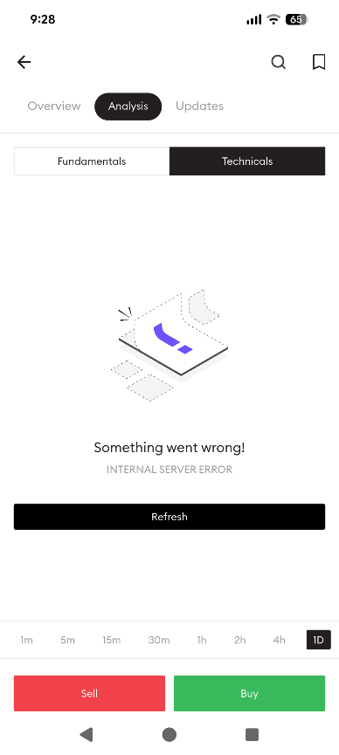

Screenshot 2
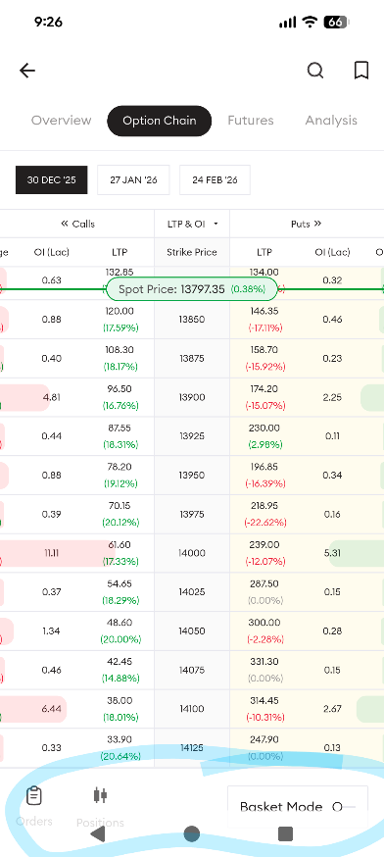
Screenshot 3
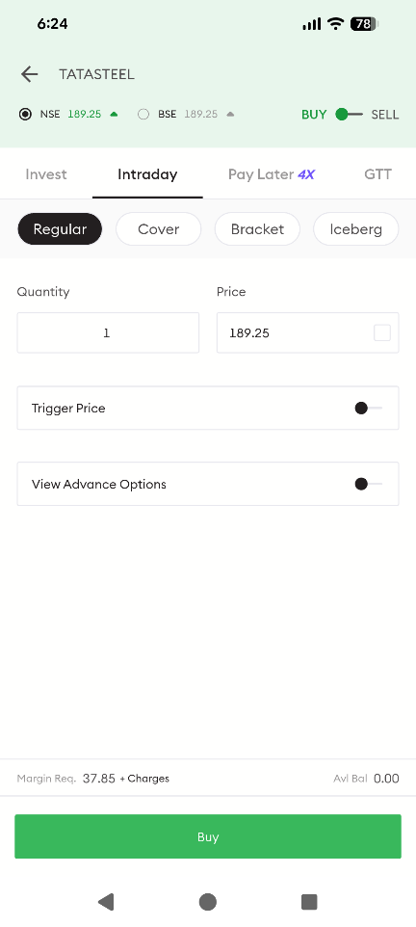

Screenshot 4
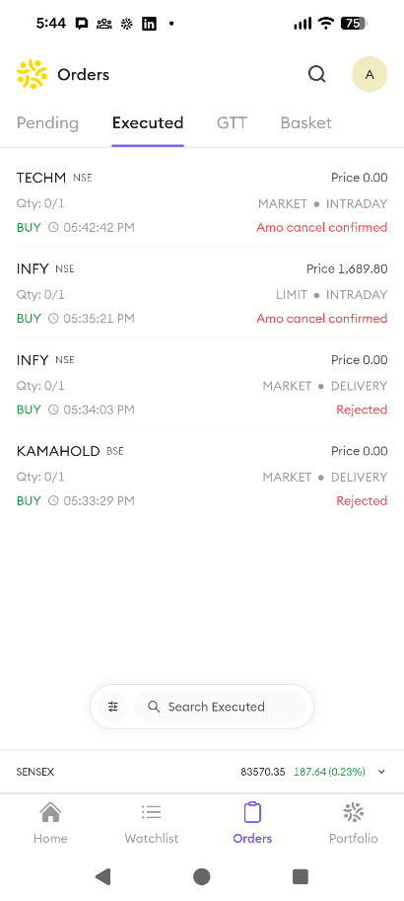

Screenshot 5
