# Software Requirements Specification

# for

# Course Information Monitoring System

Version 1.0

Prepared by Joshua M Fernandes and Abhijith B.S

PESIT

20/3/2015

Table of Contents

Table of Contents ii

Revision History ii

1. Introduction 1

1.1 Purpose 1

1.2 Document Conventions 1

1.3 Intended Audience and Reading Suggestions 1

1.4 Product Scope 1

1.5 References 1

2. Overall Description 2

2.1 Product Perspective 2

2.2 Product Functions 2

2.3 User Classes and Characteristics 2

2.4 Operating Environment 2

2.5 Design and Implementation Constraints 2

2.6 User Documentation 2

2.7 Assumptions and Dependencies 3

3. External Interface Requirements 3

3.1 User Interfaces 3

3.2 Hardware Interfaces 3

3.3 Software Interfaces 3

3.4 Communications Interfaces 3

4. System Features 4

4.1 System Feature 1 4

4.2 System Feature 2 (and so on) 4

5. Other Nonfunctional Requirements 4

5.1 Performance Requirements 4

5.2 Safety Requirements 5

5.3 Security Requirements 5

5.4 Software Quality Attributes 5

Appendix A: Glossary 5

Revision History

|  |  |  |  |
| --- | --- | --- | --- |
| **Name** | **Date** | **Reason For Changes** | **Version** |
| **SRS** | 20/3/15 | Newly Created | 1.0 |
|  |  |  |  |

# Introduction

## Purpose

The Course Management System(CMS) is a system which integrates itself with the educational department, automating the task of monitoring the progress carried out by the faculties and staff and helps the head of the department monitor the progress and help him/her make decisions and evaluate the staff performance.

## Document Conventions

**CIMS:**

its a Web application which provides ease of tracking course information to the HOD and students,expanded to Course Information Monitoring System

**Faculty:**

He/She has the authority to add/modify and maintain the Course Information related Data

with corresponding interface for faculties.

**HOD:**

it is the **Head of the Department** for whom this application is to benefit most,who can generate reports on faculties and monitor the Course Information progress.

**DB:**

Database,. A database management system that provides a flexible and efficient database

platform to maintain records and generate reports based on the stored info from the database.

**PHP:**

PHP is a server-side scripting language designed for web development but also used as a general-purpose programming language.

**Aptana:**

Aptana Studio is an open source integrated development environment (IDE) for building web applications. Based on Eclipse, it supports JavaScript, HTML, DOM and CSS with code-completion, outlining, JavaScript debugging, error and warning notifications and integrated documentation.

**Apache:**

Apache is a freely available Web server that is distributed under an "open source" license. Version 2.0 runs on most UNIX-based operating systems

**UML:**

Unified Modeling Language is a standard language for writing software blueprints. The

UML may be used to visualize, specify, construct and document

**XML:**

Extensible Markup Language is a text based format that let developers describe, deliver

and exchange structured data between a range of applications to client for display and manipulation.

## Intended Audience and Reading Suggestions

This Software Requirements Specification (SRS) is intended for use of the CIMS developers.

It is also for use by users and auxiliary developers of CIMS, as background reference material.

It is also used by the Project lead to measure the progress of the project against this document.

It is used by the End-users to get a brief idea about the features of the project and if it serves their purpose and help them identify the ambiguity and solve it at earliest.

## Product Scope

The Course Management System(CMS) will provide the head of Department, teachers and students an on-line application that will allow them to track the work flow of the syllabus. It will provide teachers and students with information on how much of the course has been completed and how much is left.

## References

**Software Engineering** ,7th edition by Ian Somerville

**Wikipedia** - www.wikipedia.com

**Database Management Systems** – Navathe.

# Overall Description

## Product Perspective

The product to be developed is a first of its kind,envisioned and required by the department to help monitor the faculties progress which was not possible manually and was unfeasible to do manually.

This product is a self-contained and can be extended further to provided new services to the department.

This SRS describes the requirements of the system as a whole and each of the services provided by the product.

It also lists the interfaces to be implemented and their inter-connections.

## Product Functions

It will be driven by three interfaces;

1. One for the head of the department, who will be able to keep of track of every subject and teacher and how much progression has been made.
2. A second interface for teachers to update and keep track of how much of the syllabus is complete.
3. Third interface for students to check how much is completed based on which semester they are in.
4. It provides a facility for the faculties to publish notifications for the students, like the assignments and their deadlines.

## User Classes and Characteristics

**HOD-** this type of user will be able to track the progress of the faculties and run queries and generate report against the DB

**Faculty-** This type of user will be able to add/update/edit the chapters and units completed and publish notifications for the students.

**Students-** This type of user will be able to see the state of the completion of the Course topics.

## Operating Environment

Apache Server, Linux OS, mySQL DB

## Design and Implementation Constraints

1. GUI is only in English.
2. Login and password is used for the identification of users.
3. Only registered Faculties and HOD will be authorized to use the services to add and edit.
4. Any student will be able to view only.
5. Limited to HTTP/HTTPS.
6. This system works on single server.

## User Documentation

The Documentation of the project and the manual will be provided with the software along with the deployment.

## Assumptions and Dependencies

The project assumes that the faculties will maintain up-to-date information about the course progress that they make.

The project depends on the Apache server and the server up time to make the resource available 99.9%

# External Interface Requirements

## User Interfaces

* + 1. **Head Of the Department**

Allow the hod to select faculty member that will display overall progress of the teacher with respect to every subject. In the same interface will allow them to select a semester along with the subject to keep track of specific subject. Will also include a button to refresh the database for the next semester. An additional interface for the hod will provide a view of the test portion for each semester with respect to the test number.

* + 1. **Faculty**

Will present the faculty member with its overall report in the first page, along with the ability to either add a new subject, edit a subject, update current date’s progress, set test portions or select particular semester/subject.

The Add new subject will allow the faculty the ability to add a subject based on semester and subject name and provide texts boxes with chapter name and number of hours.

The edit a subject will allow the faculty to edit either the number of hours or the chapter description along with feature to add more chapters or delete existing ones.

The update current date’s progress will allow them to update what chapter was completed today and how many hours was taken for which semester/subject.

Set test portions will allow them to select chapter from a list of completed portions to include in a particular test.

Selecting a particular semester/subject will provide them a view of their current progress; by generating reports of how much time has passed and how much progress has been made.

* + 1. **Student**

Students will be able to enter their semester and track all the subjects progress and view Test portions for the subject if available.

## Hardware Interface

|  |  |  |  |
| --- | --- | --- | --- |
| ***Client Side*** | | | |
|  | *Processor* | *RAM* | *Disk Space* |
| ***Internet Explorer – 6 or above*** | *All Intel or AMD - 1 GHZ* | *256 MB* | *100 MB* |

|  |  |  |  |
| --- | --- | --- | --- |
| **Server*Side*** | | | |
|  | *Processor* | *RAM* | *Disk Space* |
| ***Apache Server*** | *All Intel or AMD - 2 GHZ* | *2GB* | *1 GB* |
| ***MySql*** | *512 MB* | *500MB(Excluding Data Size)* |

## Software Interfaces

**3.3.1 Client on Internet**

Web Browser, Operating System (any)

**3.3.2 Client on Intranet**

Web Browser, Operating System (any)

**3.3.3 Web Server**

Apache(WAMP,XAMP), Operating System (any)

**3.3.4 Data Base Server**

MySql, Operating System (any)

**3.3.5 Development End**

LAMP(Linux, Apache, HTML, XML, AJAX,PHP), MySql, OS (Windows),

## Communications Interfaces

1. It uses the any Modern Web browser capable of running Java-script on client side.

2. It makes use of HTTP Protocol.

3. The system services should be accessible throughout the Local Area Network which is available to each of the faculties on their computer systems.

# System Features

## Use Case

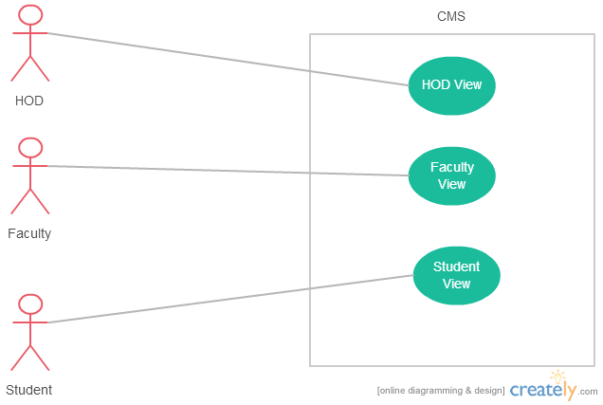

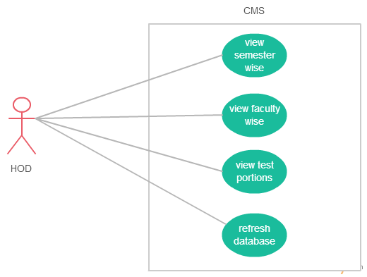

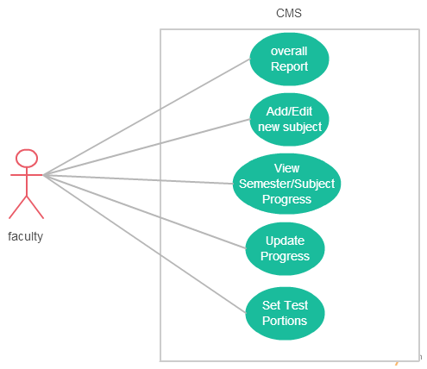

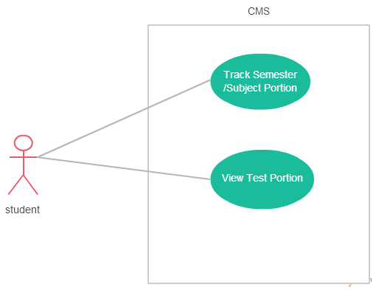

## DFD

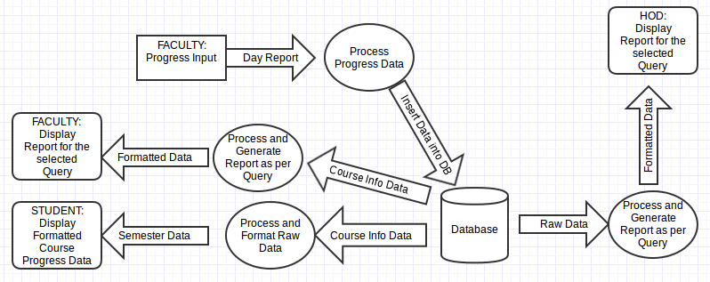

## Ability for the HOD to monitor and generate reports.

The HOD will be able to keep of track of every subject and teacher and how much progression has been made.

And he/she will be able to generate reports against the database which helps her in decision making and in evaluation of faculties.

* 1. **The Faculty should be able to update progress and manipulate Course information of the subject she handles**

The Faculty should be able to add Chapters and units under them and manipulate them which are reflected in the DB

**4.5 The system should provid a interface of students to check thier course progress corresponding to their Semester.**

**4.6 The system It provides a facility for the faculties to publish notifications for the students, like the assignments and their deadlines.**

# Other Nonfunctional Requirements

## Performance Requirements

.  (1) Static numerical requirements:

*(a)  The number of terminals to be supported : 20+*

*(b)  The number of simultaneous users to be supported : 20+*

*(c)  Number of files and records to be handled : 10*

*(d)  Sizes of tables and files : 100mb*

*(2)  The numbers of transactions and tasks will be 5 per second and 95% of the transactions*

*shall be processed in less than 1 s on a normal workload conditions and the numbers of transactions and tasks will be 20 per second and 95% of the transactions shall be processed in less than 5 s on a peak workload conditions*

## Safety Requirements

Data will be transmitted with the use HTTP protocols and use inbuilt browser security measures.

## Security Requirements

Users will be authenticated based on provided login details. Faculty members will not be able to track other faculty member’s progress or view reports. Highest clearance will be provided to the hod.

## Software Quality Attributes

### *5.4.1 Availability*

Is available anywhere in campus when connected to the intranet. Will display a 404 page incase of loss of connection. No data will be lost and no commits will be made until complete transaction is made to the server.

### *5.4.2 Usability*

The system is easy to handle and navigates in the most expected way with no delays. The system program reacts accordingly and transverses quickly between its states.

Appendix A: Glossary

**CIMS**

Course Information Monitoring System

**Syllabus:** An outline or otherbrief statement of the main points of a discourse,the subjects of a course of lectures, the contents of a curriculum, etc.

**Semester**

A division constituting half of the regular academic year, lasting typically from 15 to 18 weeks.