COMPANY NAME: Pure on technology.

Pure On Technology(here after called as company) is a Bangalore based company delivering end to end water solution since 2007. Buying any water treatment system can be intimidating and confusing, usually because companies use sales persons trying to sell to meet their sales targets/commission.
For more details of the company refer website:

http://www.pureontechnology.com

Current system/Problem:

This company not only deals sales of the water purifiers, but also offers the service for the customers who has got the filters from the company but also the customers who has got the filters installed by other dealers.

the company has track of all the services made for the customers by doing a manual entry in the History card.

The history card looks like

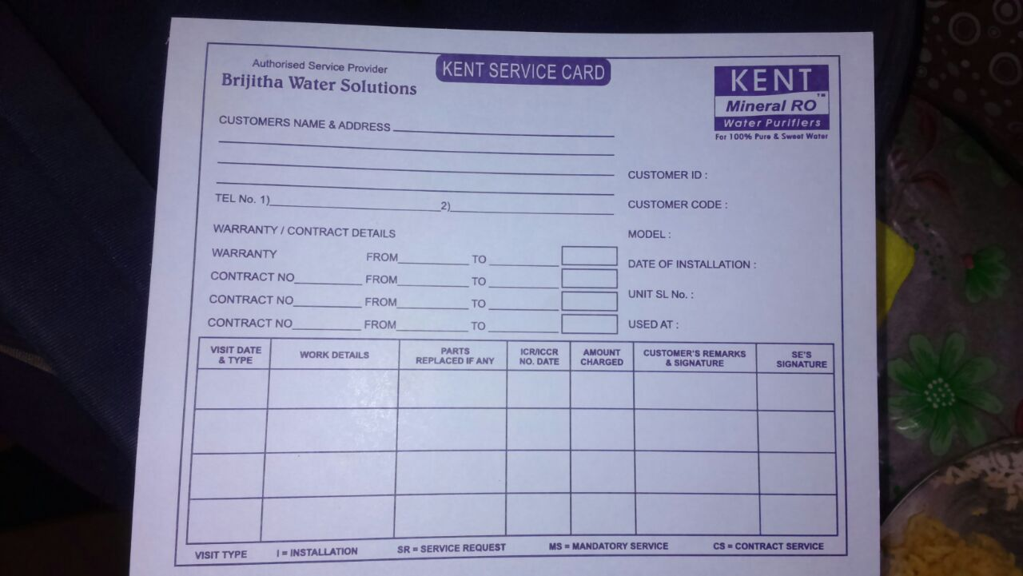

These service card has all the details of the customer from the customer's name and address to the last service he has made from the executive and the filter details he/she has installed.

When the customer calls the service center it is a hard task to find the customer's history card from bunch of the history cards.

To Over come these Problem.

The company needs a Windows application which works offline, and can be istalled in many computers in the company.

This Windows application should digitize the history card/service card.

When the service center gets the call from a customer:

The customer care executive should search the service card by his name and address to find his service card.

and record the complaint or the service request made by the caller or customer.(the complaint can be recorded with the data type provided at the end of the document).

The search should be efficeint so that the record should be found within a 30 seconds of the call.

PROJECT DETAILS

This windows application has 2 users
  - Administrator
  - Executive(customer care executive)

ADMINISTRATOR

Administrator must have ultimate access of the application
where he can view all the customers, modify, add or delete.

EXECUTIVE

Executive can only add a new customer and can view the customers details and record a new complaint lodged by the customer.

The Required data to be recorded are

Adding of a new Customer

Customer number (Primary key)
Customer Name
Phone no.
Alternate no.
Door No.
Street name
Area name
Pincode
Model of the filter
installation date
unit slno
used at – Home or Office
Warranty date

History card

customer number(foreign key)
visit date
visiting type [ installation or service ]
work details (usually have the work history, a text area is required with minnimum of 150
characters)
Parts replaced (text size of 50 characters)
ICCR/ICCR date (usualy alpha numeric character of size 50)
Amount charged
Executive attended.

The company has Requested how the search of the customer should be done.

- Once the customer calls, the executive asks for the the customers name.
- When the customer name is typed in the text box and search button is pressed.
A dropdown box with all the addresses of the customer name should be displayed.(there can be one or more customer with same name)
- once by hearing the address of the customer the executive selects the address matching and presses the search button.
- Then the details of the customer should be displayed
(the view of service card same as the picture is preffered by the company).

