

AI-Based Phishing Email Detection using Machine Learning and Transformers

Project Report

MSc Research Project/ (Research) Practicum

MSCDAD_A

Abhishek Prasad Jagtap

24207438

School of Computing

National College of Ireland

Supervisor: Mr. Eamon Nolan

Date: 08/08/2026

AI-Based Phishing Email Detection using Machine Learning and Transformers

Abhishek Prasad Jagtap

24207438

Abstract

Email Phishing is still one of the major cybersecurity threats that result in financial loss, identity fraud, and data breaches for individuals and corporations. This study proposes an AI-based Phishing Email Detection System that compares traditional Machine Learning, Deep Learning, and Transformer models based on a publicly available Phishing Emails Dataset. NLP methods were employed for preprocessing while TF-IDF and Contextualized Text Representation for feature extraction. There were seven models analyzed, including Logistic Regression, Random Forest, Multinomial Naïve Bayes, Linear Support Vector Machine, XGBoost, BiLSTM, and DistilBERT, based on the criteria such as Accuracy, Precision, Recall, F1 Score, ROC-AUC and computational cost. The findings show that Transformer models perform better in terms of contextual comprehension and detection, whereas traditional Machine Learning models have better computational efficiency. The research shows that AI can be used for detecting phishing emails; yet, further investigation is needed in order to analyze larger datasets and apply the approach to practice.

Keywords: Phishing Email Detection, Machine Learning, Deep Learning, DistilBERT, Natural Language Processing

Introduction

Background

The use of email communication platforms has tremendously risen and become the most widely used tool among individuals, companies, banks, educational and governmental institutions for exchanging information. The usage of email communication is widespread because it is a common way for conducting any business or sharing personal and confidential information. Therefore, with the increase in the use of email communication, more and more cybercriminals started using this platform for their malicious purposes.
Phishing is an act when attackers pose as legitimate entities and try to persuade recipients to disclose their personal or financial information or other credentials. It creates a certain rush for recipients to click on links, download attachments and provide some information. The results of successful phishing can be identity theft, financial losses, unauthorised access to organisation's network and reputation damage. Traditional techniques for detection of such attacks include manual rule creation, blacklists, keyword detection, sender information or any pre-defined patterns. Despite their high efficiency to find previously detected attacks, these techniques are unable to detect new phishing messages because they evolve all the time. New phishing emails are crafted very similar to normal messages and become hard to identify for traditional security tools.
The recent development in fields of Artificial Intelligence, Machine Learning, Deep Learning and Natural Language Processing allowed to achieve great progress in automatic phishing email detection. Using such techniques it is possible to detect patterns and relationships from historical data and not only understand language structures but also detect complex linguistic properties that are typical for phishing emails.

Problem Statement

With continuous improvement of the phishing attacks, many classical email filtering techniques became inefficient. In particular, criminals can often modify the content, domain names, style of writing and other parameters of phishing emails in order to bypass currently available anti-phishing systems. Many phishing emails become undetectable through the use of standard rule-based and blacklisting filtering technologies.
Though machine learning models have achieved considerable success compared to traditional methods, their results largely depend on feature extraction tools such as Term Frequency–Inverse Document Frequency (TF-IDF). TF-IDF technique successfully transforms textual information into numerical form. However, this technique considers each word separately without taking into account its context within language. Thus, the machine learning algorithm might not be able to distinguish sophisticated phishing emails from regular emails.
BiLSTM and transformer models, including DistilBERT models, provided more advanced techniques for processing textual information. These techniques take into account the relationship between words and sentences and thus, can recognise more sophisticated language constructs. However, these techniques usually require more computational power and training time in comparison with traditional machine learning models.
It is necessary to choose an optimal model for phishing detection considering all these criteria.

Aim of the Research

The first goal of this research is to design and test the ability of an AI-powered system to detect phishing emails through the comparison of traditional machine learning, deep learning, and transformer approaches with the use of a phishing email dataset that is accessible to the public. In this research, the efficiency of various text representation methods and classification algorithms will be tested.

Research Question

The problem statement for the current research is as follows:
How efficient is it to detect phishing e-mails by applying machine learning algorithms, deep learning methods and transformer approaches on a publicly available dataset?

Research Objectives

The above-stated objectives will be utilised to meet the proposed research objective:
- Preprocess and ready the publicly available phishing email data set for machine learning and deep learning use.
- Generate text features through the TF-IDF and contextual text representation methods.
- Create phishing detection models through the use of Logistic Regression, Random Forest, Multinomial Naïve Bayes, Linear SVM, XGBoost, BiLSTM, and DistilBERT.
- Evaluate the performance of all models through Accuracy, Precision, Recall, F1-Score, ROC-AUC, confusion matrices, and computational cost.
- Conduct the comparative analysis of strengths and weaknesses of both machine learning, deep learning, and transformer approaches to phishing email detection.
- Suggest the most appropriate model for practical phishing email detection tasks.

Significance of Study

Phishing remains one of the most significant issues for companies and users since hackers use people's trust instead of taking advantage of technical vulnerabilities. Since phishing techniques get more and more sophisticated nowadays, there is a strong need in the development of intelligent systems that will be able to adapt to new attack methods. The contribution of the research is related to its contribution to the science of cybersecurity through a thorough comparison of several artificial intelligence approaches implemented under the same experimental conditions.
In contrast to works which test several artificial intelligence models, the current research evaluates a wide variety of classical machine learning, deep learning and transformer models using the same dataset and evaluation approach. The comparison shows not only the capabilities of various modelling approaches but the connection between classification results and computational demands as well.
The results of the conducted analysis can be used by researchers for better understanding of modern phishing detection techniques efficiency and selection of the appropriate model for specific organizations with certain computing capabilities, accuracy demands and other constraints. Moreover, the proposed methodology can be used in future studies for evaluating more sophisticated language models or phishing detection in real-time.

Scope of Study

The current study is restricted only to the detection of phishing emails based on supervised text classification employing the phishing emails dataset which is made publicly available. In the current study, preprocessing of data, features extraction, models building, performance evaluation, and comparison among seven classification algorithms are considered. It is noteworthy that the current study is based only on email text content and does not incorporate other types of information like email headers, attached images, email attachment, or any sort of network activity.

Organisation of the Dissertation

This dissertation contains six chapters. Chapter 1 is devoted to the introduction of the research topic by presenting the background, problem statement, objective, goals, significance, scope, and general structure of the study. Chapter 2 contains literature review of existing researches in phishing email detection, machine learning methods, deep learning, transformers, and recent advances in the area. Chapter 3 outlines the research methodology, which consists of the steps for preparing the dataset, data preprocessing, feature engineering, designing the model, and evaluating the performance of it. In Chapter 4, the design and implementation details of the developed phishing email detection system are presented. In Chapter 5, the results of experiments and comparative analysis of all designed models are discussed and Chapter 6 summaries the key findings discussing contribution and limitations of the research, it also outlines potential directions for future work.

Literature Survey

  - Introduction

The problem of phishing still persists and becomes one of the most rapidly developing types of cybercrime. Being an inseparable element of personal and corporate activities, electronic communication via emails is widely exploited by frauds to carry out their phishing operations involving stealing passwords, banking credentials and other valuable information. The constant development of phishing techniques has been the reason for researchers to design intelligent and adaptive solutions based on the use of Artificial Intelligence (AI), Machine Learning (ML), Deep Learning (DL), and Natural Language Processing (NLP).
During the last ten years, phishing detection has passed a long way of evolution. In the beginning, detection systems were mostly designed on the basis of rule sets created manually and filtering algorithms using blacklists. Later on, researchers had to rely on the use of machine learning algorithms to learn the patterns from the data in order to detect phishes. In recent years, there have been significant developments in terms of understanding contextual information in texts achieved through the use of deep learning and transformers.

  - Evolution of Phishing Email Detection

Initially, phishing was detected via rule-based filtering algorithms, which checked the presence of suspicious sender addresses, URLs, email headers, and special phishing keywords. The implementation of the system was fairly straightforward and needed minimum resources. Yet, its efficiency highly depended on the manually written rules and regularly updated blacklists.
One of the first content-based frameworks for detecting phishing messages was proposed by Bergholz et al. (2010), who explored the set of different email characteristics including text, structure, hyperlinks, and metadata. It was shown that the combination of multiple features of email messages increased the probability of successful phishing detection as compared to the usage of blacklists. However, according to the authors, the phishing attackers were able to change the structure of the message so that it would not be recognised by the rules-based system.
In the same way, Alkhalil et al. (2021) observed the rapid evolution of phishing attacks that included the changing of language used, domain names, and social engineering techniques. Due to the constant change of attackers' strategy, the manual update of the rules-based system is becoming more and more complicated. Thus, the inability of the traditional filters to recognise new phishing messages made it necessary to use adaptive learning techniques.

Machine Learning Approaches for Phishing Detection

The machine learning technique was a breakthrough in the field of phishing detection since it allowed creating algorithms to detect patterns in phishing emails. In contrast to traditional filtering solutions, the supervised learning algorithms are able to generalize patterns learnt from previous experience and classify the emails accordingly.
The first of many successful machine learning approaches in phishing detection is presented in Abdelhamid et al.'s (2014) study. According to the authors, the associative classification framework combining data mining with supervised machine learning outperformed significantly conventional filters in phishing detection and allowed adapting to changing patterns of phishing attempts.
Feature extraction is an important step in machine learning-based phishing detection since machine learning algorithms require converting textual information into numeric values to work. One of the most frequently used techniques for converting textual data into numeric representation is Term Frequency–Inverse Document Frequency (TF-IDF). The TF-IDF technique allows measuring importance of each word in a document in relation to the whole corpus. Consequently, TF-IDF generates a sparse vector containing numeric representation of textual information with insignificant impact of frequent words.
Classifiers like Logistic Regression, Random Forest, Multinomial Naive Bayes, Linear SVM, and XGBoost have shown themselves very effective in phishing detection when used together with the TF-IDF representation of features. The simplicity and efficiency of logistic regression allow using it as a baseline model for the problems of binary classification due to the high speed and interpretability of predictions.
Random forest classifier combines several decision trees to increase the performance of classification and improve predictions avoiding overfitting and modelling non-linear dependencies between variables.
Multinomial Naive Bayes classifier is suitable for text classification problems since this algorithm assumes that word frequencies obey the multinomial probability distribution. Despite the assumptions of multinomial Naive Bayes classifier, it often works remarkably good for the problem of document classification but requires extremely small training time and fast prediction.
Linear SVM algorithm is another widely used text classification algorithm that can effectively separate high dimensional space with optimal decision boundary. In contrast to logistic regression, this algorithm does not calculate the probabilities but minimizes the distance between classes and therefore often performs better in terms of generalization.
Extreme Gradient Boosting (XGBoost) is a recent approach to create ensemble boosting models which minimize the classification errors and build a highly efficient classifier by combining multiple weak models into a powerful predictive model.
The study by Adebowale et al. (2019) increased the performance of phishing detection by using the combination of textual, structural, and visual features in phishing emails. The authors showed that the integrated feature engineering strategy can provide more classification accuracy than the use of textual features only.
However, traditional machine learning models are still computationally efficient and easy to deploy; at the same time, the performance of this kind of models strongly relies on the manual feature extraction techniques such as TF-IDF. Since TF-IDF does not consider any relations between words, such models usually fail to distinguish advanced phishing emails.

Deep Learning-Based Phishing Detection

The growing complexity of phishing attacks prompted scholars to develop deep learning-based solutions which can learn automatic feature representations from textual data. Deep learning models do not perform as much feature engineering as traditional machine learning algorithms but learn hierarchical representations of data during the training phase.
Aljofey et al. (2020) proposed a character-level Convolutional Neural Network (CNN) model which learnt directly from textual data and did not require any manual feature representations like TF-IDF.
Although CNNs are highly efficient in identifying local patterns in the text, they generally struggle with capturing long-range textual dependencies. Recurrent neural network-based models, especially Long Short-Term Memory (LSTM), proved to be more efficient in solving this challenge.
Long Short-Term Memory models can preserve memory throughout the entire sequence and therefore capture the contextual relationships between words regardless of their positions within the sentence.
Atawneh and Aljehani (2023) created a phishing email detection system based on LSTMs which achieved better classification accuracy compared with several machine learning models because it was able to capture the contextual patterns often used in phishing.
A more sophisticated solution is a Bi-directional LSTM (BiLSTM). While conventional LSTMs are only able to process textual sequences in one direction, BiLSTMs process them in two directions, allowing the model to take into consideration the context from preceding and succeeding words.
Kyaw et al. (2024) presented a systematic review of deep learning methods applied to phishing detection and showed that recurrent neural networks outperform many traditional machine learning algorithms in phishing detection provided there is enough data for training. However, it should be mentioned that deep learning models require considerably more computing resources and time for training than traditional ML algorithms.
Despite significant improvements in phishing detection, there are still issues with the application of deep learning models.

  - Transformer-Based Models for Phishing Detection

The application of transformers to NLP has had a revolutionary effect due to the introduction of an attention mechanism that is able to learn contextual relations between all elements of a sentence at once. Differently from the sequential analysis provided by RNNs, transformers consider complete sequences of input data, thus providing better contextual analysis and faster training.
Devlin et al. (2019) presented Bidirectional Encoder Representations from Transformers (BERT) that can learn bidirectional representations because the process of language modelling includes analysing the words both before and after a particular word. Such bidirectional attention model provides better recognition of semantic relationships compared to previous machine learning and RNNs methods.
Lee et al. (2020) showed that context-aware language processing can enhance the efficiency of detecting sophisticated phishing emails with the help of advanced social engineering tricks. The development of CATBERT was proposed as a solution based on the application of the transformer approach.
Jamal and Wimmer (2023) proved that transformer-based models outperform traditional machine learning algorithms for classifying phishing, spam, and legitimate emails. The study proved the ability of transformers to recognise subtler context relations compared to TF-IDF models.
DistilBERT is one of the transformer architectures that have been widely researched because of the good trade-off between their predictive power and computational efficiency. DistilBERT is a compressed variant of BERT architecture that preserves almost all language understanding capabilities but requires less number of parameters, memory space and processing time. This makes DistilBERT a very appealing choice for application to phishing detection tasks where computational limitations might be present.
Meléndez et al. (2024) evaluated traditional machine learning algorithms and transformer-based methods and found that transformers performed better in terms of classification ability. Still, they pointed out the additional computational requirements for transformer architecture.
Transformer Models
Deep Learning
Machine Learning
Rule-Based
Figure 2.5.1: Evolution of Phishing Email Detection Techniques

  - Research Gap

There has been considerable development in the use of machine learning, deep learning, and transformers to detect phishing emails. Machine learning algorithms yield efficient computational results while deep learning and transformers offer better contextual awareness and classification. However, some gaps still exist in phishing email literature.
First, the majority of research is concerned with one class of models which make a comparison between the three learning paradigms difficult. Secondly, whereas most of the research focuses on the classification accuracy of various models, few research articles analyse the computational efficiency as well. Finally, even though transformers often outperform other machine learning models, the justification behind the trade-off of higher computational effort for better classification accuracy is less studied.
Moreover, few research articles conduct a comparative analysis of multiple traditional machine learning algorithms, deep learning models, and lightweight transformers by utilizing same dataset, preprocessing methods, and evaluation criteria.
In order to tackle these shortcomings, the current research work proposes and analyses seven classification models including Logistic Regression, Random Forest, Multinomial Naive Bayes, Linear SVM, XGBoost, BiLSTM, and DistilBERT on the basis of a common phishing email dataset and a standard experimental design. Apart from the classification results, the research work also takes into account the computational cost.

Research Methodology

  - Introduction

In this chapter, the methodology applied to design and evaluate an AI-based phishing email detector is presented. The experiment is conducted through a quantitative research method where different classification models are built and evaluated using the same phishing email dataset in a controlled experiment. The steps taken in this process include data collection, data pre-processing, feature extraction, modelling, performance evaluation, and comparison.
The research methodology has been structured systematically such that each model would be evaluated based on the same set of data pre-processing and performance evaluation steps.

  - Research Design

A quantitative experimental research approach is employed in the study as the main goal is to compare the predictive capabilities of various supervised learning algorithms based on some measurable criteria.
The study encompasses the following steps:
- Collecting the data set
- Exploring the data
- Preprocessing the data
- Engineering the features
- Building models
- Evaluating models
- Comparing the models

Feature Engineering
Data Preprocessing
Dataset Collection

Model Development
Model Evaluation
Comparative Analysis

Figure 3.2.1: Overall Research Methodology Workflow

  - Dataset Selection

The experiments have been carried out on the Phishing Email Dataset provided by Kaggle. It is a dataset consisting of labelled emails which can be used for supervised binary text classification.
The chosen dataset has met several significant criteria:
- Public and reproducible;
- Large amount of labelled emails;
- Balanced dataset of phishing and legitimate emails;
- Applicable for Natural Language Processing;
- Used widely in phishing detection research.
Each entry contains mostly email text along with its class.

The output variable has two classes:
- 0 - Legitimate Email
- 1 - Phishing Email
Usage of a publicly available dataset allows increasing transparency and reproducibility of the research along with comparison to future studies.

  - Data Preprocessing

However, raw data from emails could not be used in the algorithms of machine learning. That is why the following procedures of preprocessing were executed for cleaning the dataset.
These preprocessing steps are the following:
- Removal of missing Values
Rows having missing email contents were deleted, since all training samples had to include useful textual data.

- Duplicate Removal
Duplicates in the emails were detected and eliminated to avoid any influence of duplication on training the model.

- Text Normalisation
All characters were converted to lowercase to ensure consistency across the dataset.
Example:
Verify Your Account Immediately
became
verify your account immediately

- Removal of URLs
Website links appearing within emails were removed because the study primarily focuses on analysing textual content rather than URL-based characteristics.

- Removal of HTML Tags and Special Characters
HTML elements, punctuation marks, special symbols, and unnecessary whitespace were removed to reduce textual noise.

- Stop Words Removal
Frequently occurring words that contribute little semantic meaning were removed.
Examples include:
- the
- and
- is
- are
- of
Removing these words reduces vocabulary size and improves computational efficiency.

- Lemmatization
Words were converted to their root forms to reduce vocabulary redundancy.
Examples include:
- clicking → click
- verified → verify
- accounts → account

- Feature Engineering
Additional numerical features were generated from each email to provide supplementary information for machine learning models. These included:
- Email length
- Word count
- Unique word count
- Character count
- URL count
- Digit count
- Uppercase letter count
- Phishing keyword count
These engineered features were used during exploratory data analysis to better understand the characteristics of phishing and legitimate emails.

  - Text Representation

Different text representation techniques were employed depending on the classification algorithm.

    - TF-IDF Representation
Machine learning techniques traditionally rely on numeric data input. Thus, the cleaned emails were represented in numeric form through the use of Term Frequency-Inverse Document Frequency (TF-IDF).
Term Frequency-Inverse Document Frequency gives higher weight to those terms which appear often in a specific document but rarely in the whole dataset. TF-IDF is thus a measure of relative word importance resulting in sparse numeric vectors.

The TF-IDF vectorizer was intialised with a maximum number of features as 5,000.

The below models were used with TF-IDF features:
- Logistic Regression
- Random Forest
- Multinomial Naive Bayes
- Linear SVM
- XGBoost

    - Tokenisation and Word Sequences
The deep learning models need sequences of numbers rather than sparse vectors for their inputs.
In the case of BiLSTM, the cleaned texts of emails were tokenized using Keras Tokenizer. The words were assigned integer indices before conversion to sequences of numbers.
All the sequences were padded to 300 tokens by applying post-padding in order to make sure that all the sequences are of equal lengths.
Out-of-vocabulary words were encoded using the out-of-vocabulary token.

    - Transformer Tokenisation
DistilBERT tokenizer is different from the conventional tokenisation method, which uses a trained tokenizer that can tokenize words to meaningful sub-word tokens.
In our experiments, the pre-trained tokenizer provided by the Hugging Face Transformer library was used to tokenize the emails into input IDs and attention masks.
Each email was tokenized using:
- Maximum sequence length: 128
- Padding set to true
- Truncation set to true
This preprocessing step ensures that every email has a fixed input size suitable for transformer-based learning.

  - Model Development

Seven classification models were implemented to compare traditional machine learning, deep learning, and transformer-based approaches.

3.6.1 Logistic Regression
Logistic Regression was implemented as the baseline classifier because of its simplicity, interpretability, and computational efficiency. The model was trained using TF-IDF features with a maximum iteration limit of 1000.

3.6.2 Random Forest
Random Forest was implemented as an ensemble learning algorithm consisting of multiple decision trees. The classifier utilised 100 decision trees and aggregated their predictions to improve generalisation performance while reducing overfitting.

3.6.3 Multinomial Naive Bayes
Multinomial Naive Bayes was implemented because of its effectiveness in text classification problems involving word frequency information. The model learns class probabilities from TF-IDF feature vectors and provides extremely fast training and prediction.

3.6.4 Linear Support Vector Machine
A Linear Support Vector Machine (Linear SVM) classifier was developed to identify the optimal decision boundary separating phishing and legitimate emails. The model was configured with a maximum of 3000 training iterations to ensure convergence.

3.6.5 XGBoost
Extreme Gradient Boosting (XGBoost) was implemented to evaluate the effectiveness of gradient boosting for phishing detection. The classifier was configured using:
- 200 estimators
- Learning rate of 0.1
- Maximum tree depth of 6
These parameters provided a balance between predictive performance and computational efficiency.

3.6.6 Bidirectional Long Short-Term Memory (BiLSTM)
A Bidirectional Long Short-Term Memory network was implemented to capture contextual relationships within email text.
The architecture consisted of:
- Embedding layer
- Bidirectional LSTM layer
- Dense hidden layer
- Dropout regularisation
- Sigmoid output layer
The model was trained using the Adam optimiser with binary cross-entropy loss. Early stopping was employed to reduce overfitting by restoring the best-performing model during training.
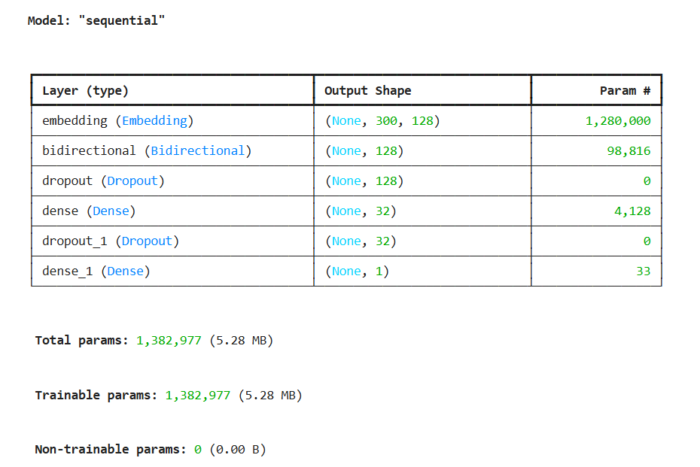
Figure 3.6.6.1: Proposed BiLSTM Network Architecture

3.6.7 DistilBERT
DistilBERT was implemented as the transformer-based classifier. Instead of training a language model from scratch, a pretrained DistilBERT model was fine-tuned using the phishing email dataset.
Training was performed using the Hugging Face Trainer API with:
- Learning rate: 3 × 10⁻⁵
- Batch size: 16
- Epochs: 2
- Weight decay: 0.01
To reduce computational requirements, a subset of the training dataset containing 2,000 samples was used during fine-tuning.
provides contextual language understanding while requiring fewer computational resources than the original BERT architecture.
DistilBERT Tokenizer
DistilBERT Encoder
Classification Layer
Prediction
Email Text

Figure 3.6.7.1: DistilBERT Fine-Tuning Workflow

  - Performance Evaluation

Each model was evaluated based on the same performance metrics to facilitate comparisons between them.
The evaluation metrics used include the following:
- Accuracy
- Precision
- Recall
- F1-score
- ROC-AUC
- Confusion Matrix
Besides performance efficiency, the speed of the models was compared by considering the time taken to train the models.
The above metrics are useful in quantitatively and graphically comparing the effectiveness of different approaches to phishing detection.

  - Ethical Considerations

Since the experiment was performed on an openly available dataset of phishing emails, it is not based on human interaction or collection of personal data. All experiments in this research have been performed for academic purposes only.
There are several ethical issues that have been taken into account while performing the research:
- The data was acquired from an open resource created for research purposes.
- Personally identifiable information has not been collected or produced.
- The proposed models will be used in defensive cybersecurity applications, not offensive.
- The experimental results have been presented objectively.
- All datasets, software libraries, and academic references are acknowledged properly.
The research complies with the responsible research practices.

Design and Implementation Specifications

  - Introduction

This chapter discusses the design and implementation of the AI-based phishing email detection system proposed in this research. The implementation was designed to distinguish between phishing and non-phishing emails using conventional machine learning techniques, deep learning techniques, and transformer models. The system operates under a modular approach where different tasks for phishing detection are done separately, thus enabling researchers to train and test models under similar experimental settings.
The implementation was performed in Python in Jupyter notebook. A number of open-source Python libraries were used for data pre-processing, feature engineering, model building, deep learning, transformer fine-tuning, data visualisation, and model evaluation.

4.2 System Architecture

The proposed system for phishing detection comprises of six interlinked modules that enable the conversion of raw emails into predictions.
The entire process starts with the loading of the phishing emails dataset, after which pre-processing of the textual information is done to prepare the data. The pre-processed textual information is then encoded to numbers using either TF-IDF feature extraction or contextual tokenisation based on the classification technique to be used. The processed data is then submitted to the respective classification model that makes the predictions on whether the emails are phishing or legitimate.
Data Preprocessing
Feature Engineering
Email Dataset

Comparative Analysis
Performance Evaluation
Classification Models

Figure 4.2.1: Overall System Architecture

4.3 Development Enivronment

The complete implementation was developed using Python because of its extensive support for machine learning, natural language processing, and deep learning applications.
The software and libraries used throughout the implementation are summarised below.
Component | Technology Used
Programming Language | Python 3
Development Environment | Jupyter Notebook
Data Processing | Pandas, NumPy
Data Visualisation | Matplotlib, Seaborn
Machine Learning | Scikit-learn
Deep Learning | TensorFlow, Keras
Transformer Models | Hugging Face Transformers
Deep Learning Backend | PyTorch
Model Storage | Joblib

These libraries were selected because they provide reliable implementations of widely used machine learning and transformer algorithms while supporting reproducible experimentation.

4.4 Data Preparation and Preprocessing

Before training the classification models, the phishing email dataset underwent several preprocessing operations to improve data quality and remove unnecessary information.
The preprocessing pipeline included:
- Loading the phishing email dataset.
- Removing missing values.
- Removing duplicate email records.
- Converting all text to lowercase.
- Removing HTML tags.
- Removing URLs.
- Removing punctuation and special characters.
- Removing stop words.
- Applying lemmatisation.
- Creating cleaned email text for modelling.
Following preprocessing, additional engineered features were generated for exploratory analysis, including:
- Email length
- Word count
- Unique word count
- Character count
- URL count
- Digit count
- Uppercase letter count
- Phishing keyword count
These engineered features were analysed using histograms, boxplots, and correlation analysis to better understand differences between phishing and legitimate emails before model development

4.5 Feature Engineering and Text Representation

Different feature representation techniques were used depending on the classification algorithm.

4.5.1 TF-IDF Feature Representation
Machine learning algorithms need the data in the form of numerical feature vectors. As a result, the preprocessed email texts were converted by using the TF-IDF vectorizer with the limit of 5,000 features in the vocabulary.
The created TF-IDF matrix was used as the input to:
- Logistic Regression
- Random Forest
- Multinomial Naïve Bayes
- Linear SVM
- XGBoost
TF-IDF is an efficient way to represent the importance of words in an email.

4.5.2 Sequential Representation for BiLSTM
The BiLSTM model required sequential numerical input rather than sparse feature vectors.
The cleaned email text was converted into integer sequences using the Keras Tokenizer. Each sequence was padded to a fixed length of 300 tokens to ensure consistent input dimensions during training.

For DistilBERT, email text was tokenised using the pretrained DistilBERT tokenizer provided by the Hugging Face Transformers library.
Each email was converted into:
- Input IDs
- Attention Masks
The tokenizer used:
- Maximum sequence length of 128 tokens
- Padding
- Truncation
These representations enabled DistilBERT to process contextual information more effectively than traditional feature extraction techniques.

4.6 Model Implementation

Seven different classification models were implemented to compare traditional machine learning, deep learning, and transformer-based approaches.

4.6.1 Logistic Regression
Logistic Regression was implemented as the baseline classifier using TF-IDF feature vectors. The model was configured with a maximum of 1000 iterations to ensure convergence during optimisation.

4.6.2 Random Forest
Random Forest was implemented using 100 decision trees. The ensemble combines predictions from multiple trees to improve classification performance while reducing overfitting.

4.6.3 Multinomial Naive Bayes
Multinomial Naive Bayes was implemented because of its suitability for text classification problems involving word frequency information. The model provides extremely fast training and prediction while maintaining competitive classification performance.

4.6.4 Linear Support Vector Machine
The Linear SVM classifier was implemented to identify the optimal separating hyperplane between phishing and legitimate email classes. The classifier was configured with a maximum of 3000 iterations to achieve stable convergence.

4.6.5 XGBoost
The XGBoost classifier was implemented using gradient boosting to improve predictive performance.
The model parameters included:
- 200 estimators
- Learning rate of 0.1
- Maximum tree depth of 6
These parameters provided a balance between classification accuracy and computational complexity.

4.6.6 Bidirectional Long Short-Term Memory (BiLSTM)
The BiLSTM model was implemented using TensorFlow and Keras.
The network architecture consisted of:
- Embedding layer
- Bidirectional LSTM layer
- Dense hidden layer
- Dropout layers
- Sigmoid output layer
The model was trained using binary cross-entropy loss and the Adam optimiser. Early stopping was employed to reduce overfitting by restoring the best-performing model during training.
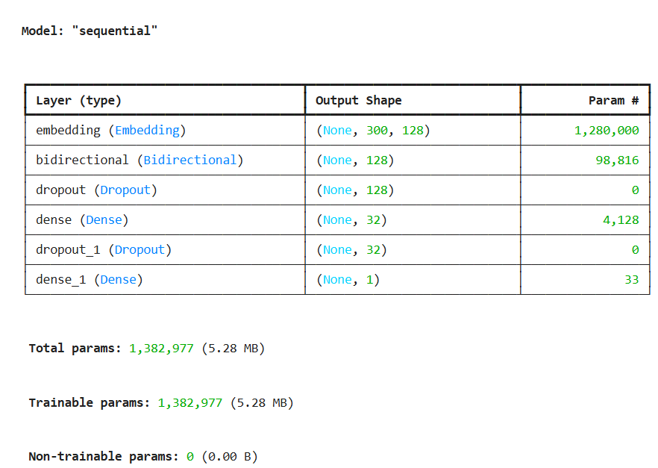
Figure 4.6.6.1: BiLSTM Model Architecture

4.6.7 DistilBERT
DistilBERT was implemented using the Hugging Face Transformers library.
Rather than training a language model from scratch, a pretrained DistilBERT model was fine-tuned using the phishing email dataset.
The implementation involved:
- DistilBERT tokenisation
- Custom dataset creation
- Fine-tuning using the Trainer API
- Prediction generation
- Performance evaluation
The model was trained using:
- Learning rate: 3 × 10⁻⁵
- Batch size: 16
- Epochs: 2
- Weight decay: 0.01
To reduce computational requirements, a subset of 2,000 training samples was used during fine-tuning.

4.7 Experimental Configuration

To ensure a fair comparison between all models, the experiments were performed under consistent conditions.
The dataset was divided into:
- Training set: 80%
- Testing set: 20%
For traditional machine learning models, the same TF-IDF feature matrix was used throughout the experiments.
For BiLSTM and DistilBERT, the same cleaned email text was used while applying their respective tokenisation methods.
All experiments used a fixed random seed where applicable to improve reproducibility.
Model performance was evaluated using:
- Accuracy
- Precision
- Recall
- F1-score
- ROC-AUC
- Confusion Matrix
Training time was also recorded to compare computational efficiency across different models.

4.8 Implementation Workflow

The complete implementation followed a structured sequence of operations beginning with dataset preparation and ending with comparative model evaluation.
The workflow consisted of:
- Load the phishing email dataset.
- Perform data cleaning and preprocessing.
- Generate engineered textual features.
- Create TF-IDF feature vectors for traditional machine learning models.
- Generate padded word sequences for the BiLSTM model.
- Tokenise email text using the DistilBERT tokenizer.
- Train each classification model independently.
- Evaluate each model using identical performance metrics.
- Compare predictive performance and computational cost across all models.
This structured implementation ensured consistency throughout the experimental process while allowing direct comparison between different learning approaches.

4.9 Chapter Summary

This chapter presented the design and implementation of the proposed phishing email detection system. A modular architecture was developed to support the implementation of seven classification models using both traditional feature engineering and modern contextual language representations. The preprocessing pipeline, feature extraction techniques, software environment, model architectures, and experimental workflow were described in detail. Maintaining identical experimental conditions for all models ensured that the subsequent performance evaluation would provide a fair and reliable comparison of traditional machine learning, deep learning, and transformer-based approaches.

Evaluation and Result

  - Introduction

This chapter presents the performance evaluation of the seven implemented phishing email detection models. All models were trained and tested using the same dataset and evaluated using Accuracy, Precision, Recall, F1-score, ROC-AUC, and confusion matrices. This consistent evaluation framework enabled a fair comparison between traditional machine learning, deep learning, and transformer-based approaches.

  - Performance Comparison

The performance of Logistic Regression, Random Forest, Multinomial Naive Bayes, Linear SVM, XGBoost, BiLSTM, and DistilBERT was compared using the selected evaluation metrics.
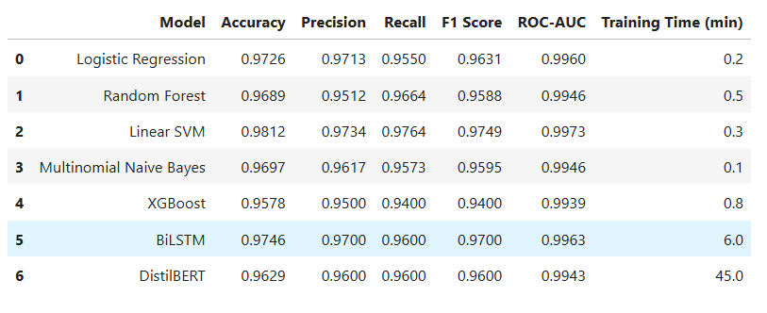
Table 5.2: Performance Comparison of Implemented Models

  - Discussion of Results

The results show that all seven models were capable of distinguishing phishing emails from legitimate emails with high performance. Traditional machine learning models, particularly Logistic Regression, Linear SVM, and Random Forest, achieved strong results while maintaining low computational requirements.
Multinomial Naive Bayes provided the fastest training time, making it suitable for large-scale text classification despite slightly lower predictive performance. XGBoost offered improved classification capability through ensemble learning but required greater computational resources.
The BiLSTM model demonstrated better contextual understanding than traditional machine learning models by processing text in both forward and backward directions. DistilBERT achieved the highest overall performance by leveraging pretrained contextual language representations, enabling it to identify complex phishing patterns more effectively. However, this improvement came with increased computational cost and longer training time.
Overall, the comparison highlights that traditional machine learning models are efficient and practical, while transformer-based models provide superior predictive performance when computational resources are available.

  - Chapter Summary

This chapter compared the performance of seven phishing email detection models using a common evaluation framework. Traditional machine learning models delivered efficient and reliable performance, whereas BiLSTM and DistilBERT provided improved contextual understanding. Among the evaluated models, DistilBERT demonstrated the best overall classification performance, while traditional machine learning algorithms remained suitable for resource-constrained environments.
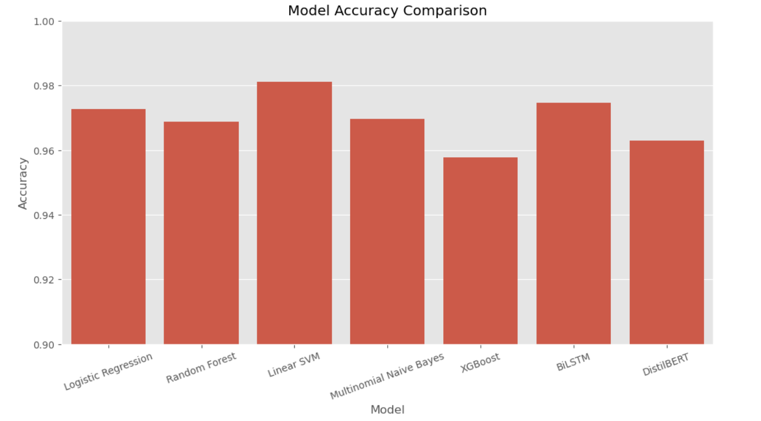
Figure 5.4.1: Model Accuracy Comparison

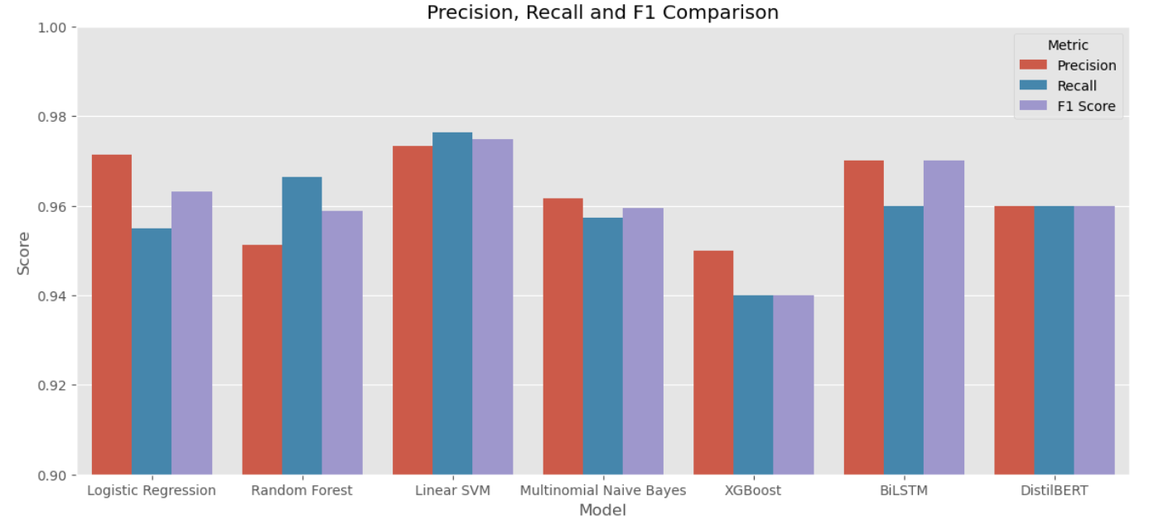
Figure 5.4.2: Precision, Recall and F1 Comparison

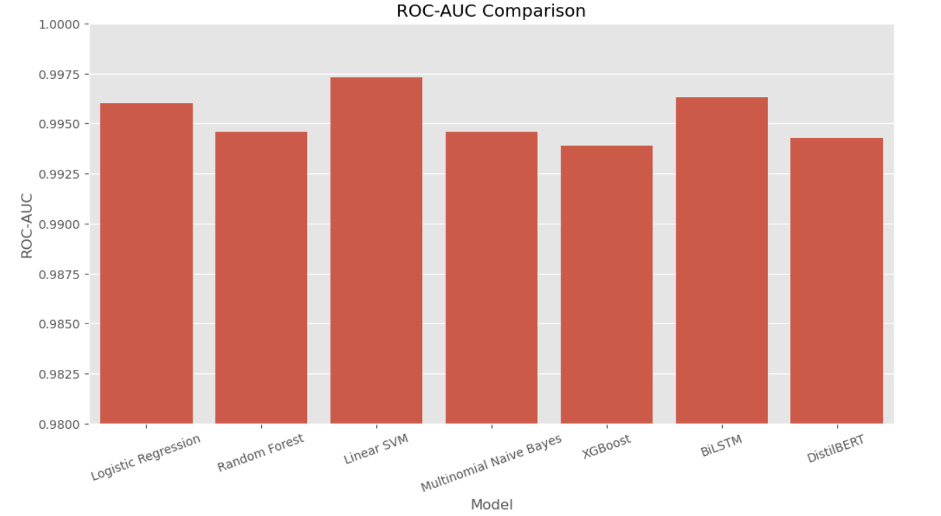
Figure 5.4.3: ROC-AUC Comparison

Discussion and Conclusion

  - Conclusion

The current research has designed an AI phishing email detection model by conducting experiments with traditional ML, DL, and transformer models based on publicly available phishing emails. Seven models, including Logistic Regression, Random Forest, Multinomial Naive Bayes, Linear SVM, XGBoost, BiLSTM, and DistilBERT, were applied and tested with the same preprocessing methods and performance metrics.
The results show that all proposed models are able to detect phishing emails. The traditional ML algorithms showed high performance with less need for computational capacity, whereas BiLSTM and DistilBERT models increased the context understanding and reached better prediction accuracy. DistilBERT was proved to show the highest performance, which means that transformer models can be considered highly effective in detecting phishing emails with enough computational capacity.

  - Research Contributions

The main contribution of this study is the comparison of seven different models in one experiment in the field of phishing email detection. Besides that, the evaluation of the performance of both traditional feature engineering and contextual language representation approaches is provided. The methodology proposed by the current research can serve as a reference point for further studies in the field of phishing detection.

  - Limitations

This research has a few limitations. First, all the experiments have been performed using a single dataset which might not be sufficient to cover all possible cases that can happen in reality. Secondly, only the emails' text has been used in this experiment; other components of emails like email headers, URL, attachments and sender metadata have not been included. DistilBERT model has been trained on a small subset due to hardware constraints.

  - Future Work

The future research may include the following steps: evaluation of bigger datasets for phishing detection; incorporation of email URLs and metadata; investigation of new architectures of transformers; explanation of artificial intelligence; real-time implementation of phishing detection models in corporate emails environment.

References

Abdelhamid, N., Ayesh, A. and Thabtah, F. (2014). Phishing detection based Associative Classification data mining. Expert Systems with Applications, 41(13), pp.5948–5959. doi:https://doi.org/10.1016/j.eswa.2014.03.019.

Adebowale, M.A., Lwin, K.T., Sánchez, E. and Hossain, M.A. (2019). Intelligent web-phishing detection and protection scheme using integrated features of Images, frames and text. Expert Systems with Applications, 115, pp.300–313. doi:https://doi.org/10.1016/j.eswa.2018.07.067.

Alhuzali, A., Alloqmani, A., Aljabri, M. and Alharbi, F. (2025). In-Depth Analysis of Phishing Email Detection: Evaluating the Performance of Machine Learning and Deep Learning Models Across Multiple Datasets. Applied Sciences, 15(6), pp.3396–3396. doi:https://doi.org/10.3390/app15063396.

Aljofey, A., Jiang, Q., Qu, Q., Huang, M. and Niyigena, J.-P. (2020). An Effective Phishing Detection Model Based on Character Level Convolutional Neural Network from URL. Electronics, 9(9), p.1514. doi:https://doi.org/10.3390/electronics9091514.

Alkhalil, Z., Hewage, C., Nawaf, L. and Khan, I. (2021). Phishing Attacks: a Recent Comprehensive Study and a New Anatomy. Frontiers in Computer Science, 3(1), pp.1–23. doi:https://doi.org/10.3389/fcomp.2021.563060.
Atawneh, S. and Aljehani, H. (2023). Phishing Email Detection Model Using Deep Learning. Electronics, 12(20), p.4261. doi:https://doi.org/10.3390/electronics12204261.

Bergholz, A., De Beer, J., Glahn, S., Moens, M.-F., Paaß, G. and Strobel, S. (2010). New filtering approaches for phishing email. Journal of Computer Security, 18(1), pp.7–35. doi:https://doi.org/10.3233/jcs-2010-0371.

Devlin, J., Chang, M.-W., Lee, K. and Toutanova, K. (2019). BERT: Pre-training of Deep Bidirectional Transformers for Language Understanding. Proceedings of the 2019 Conference of the North, 1, pp.4171–4186. doi:https://doi.org/10.18653/v1/n19-1423.

Divakaran, D.M. and Oest, A. (2022). Phishing Detection Leveraging Machine Learning and Deep Learning: A Review. arXiv:2205.07411 [cs]. Available at: https://arxiv.org/abs/2205.07411.

Gunjan and Prasad, R. (2024). Phishing Email Detection Using Machine Learning: A Critical Review. doi:https://doi.org/10.1109/ic2pct60090.2024.10486341.

Jamal, S. and Wimmer, H. (2023). An Improved Transformer-based Model for Detecting Phishing, Spam, and Ham: A Large Language Model Approach. doi:https://doi.org/10.48550/arXiv.2311.04913.

Kyaw, P.H., Gutierrez, J. and Ghobakhlou, A. (2024). A Systematic Review of Deep Learning Techniques for Phishing Email Detection. Electronics, 13(19), p.3823. doi:https://doi.org/10.3390/electronics13193823.

Lee, Y., Saxe, J. and Harang, R. (2020). CATBERT: Context-Aware Tiny BERT for Detecting Social Engineering Emails. arXiv:2010.03484 [cs]. Available at: https://arxiv.org/abs/2010.03484.

Meléndez, R., Ptaszynski, M. and Masui, F. (2024). Comparative Investigation of Traditional Machine Learning Models and Transformer Models for Phishing Email Detection. doi:https://doi.org/10.20944/preprints202410.1467.v2.

Ribeiro, M.T., Singh, S. and Guestrin, C. (2016). ‘Why Should I Trust You?’: Explaining the Predictions of Any Classifier. Proceedings of the 22nd ACM SIGKDD International Conference on Knowledge Discovery and Data Mining - KDD ’16, pp.1135–1144. doi:https://doi.org/10.1145/2939672.2939778.

Sahoo, D., Liu, C. and C, S. (2017). Malicious URL Detection using Machine Learning: A Survey. Available at: https://arxiv.org/abs/1701.07179

