# Probability

**Probability** is the likelihood that an event will occur and is calculated by dividing the number of favourable outcomes by the total number of possible outcomes. The simplest example is a coin flip. When you flip a coin there are only two possible outcomes, the result is either heads or tails. And so, the probability of getting heads is 1 out of 2, or ½, or 50%.

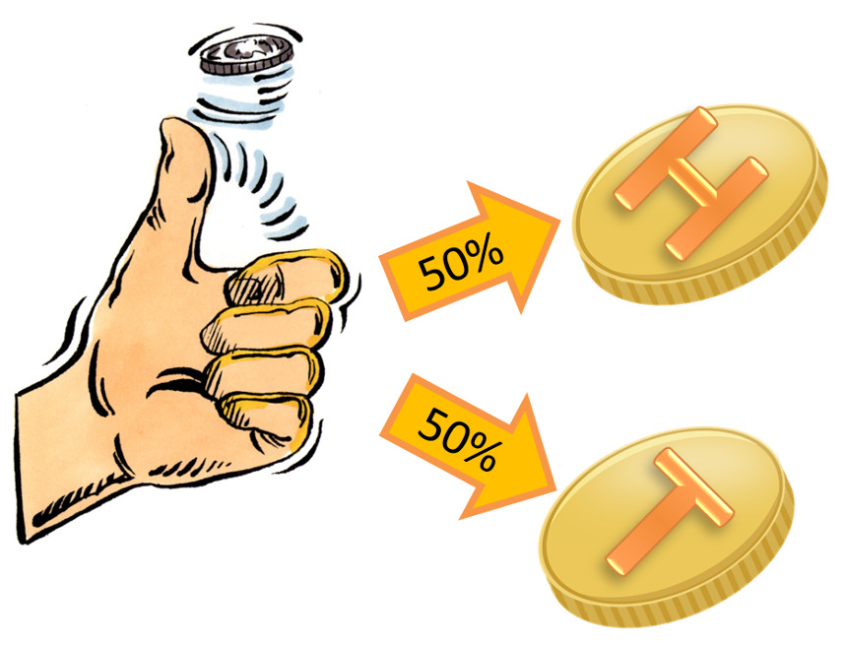

## Probability Distribution

A probability distribution is a table or an equation that links each outcome of a statistical experiment with its probability of occurrence.

A probability distribution is a statistical function that describes all the possible values and likelihoods that a [random variable](http://www.investopedia.com/terms/r/random-variable.asp) can take within a given range. This range will be between the minimum and maximum statistically possible values, but where the possible value is likely to be plotted on the probability distribution depends on a number of factors. These factors include the [distribution's](http://www.investopedia.com/terms/d/distribution.asp) mean, [standard deviation](http://www.investopedia.com/terms/s/standarddeviation.asp), [skewness](http://www.investopedia.com/terms/s/skewness.asp) and [kurtosis](http://www.investopedia.com/terms/k/kurtosis.asp).

Read more: [Probability Distribution](http://www.investopedia.com/terms/p/probabilitydistribution.asp" \l "ixzz4rzOw9qQn) [http://www.investopedia.com/terms/p/probabilitydistribution.asp#ixzz4rzOw9qQn](http://www.investopedia.com/terms/p/probabilitydistribution.asp" \l "ixzz4rzOw9qQn)

### Probability Distribution Prerequisites

To understand probability distributions, it is important to understand variables. random variables, and some notation.

* A variable is a symbol (*A*, *B*, *x*, *y*, etc.) that can take on any of a specified set of values.
* When the value of a variable is the outcome of a [statistical experiment](http://stattrek.com/Help/Glossary.aspx?Target=Statistical_experiment), that variable is a random variable.

Generally, statisticians use a capital letter to represent a random variable and a lower-case letter, to represent one of its values. For example,

* X represents the random variable X.
* P(X) represents the probability of X.
* P(X = x) refers to the probability that the random variable X is equal to a particular value, denoted by x. As an example, P(X = 1) refers to the probability that the random variable X is equal to 1.

An example will make clear the relationship between random variables and probability distributions. Suppose you flip a coin two times. This simple statistical experiment can have four possible outcomes: HH, HT, TH, and TT. Now, let the variable X represent the number of Heads that result from this experiment. The variable X can take on the values 0, 1, or 2. In this example, X is a random variable; because its value is determined by the outcome of a statistical experiment.

A cumulative probability refers to the probability that the value of a random variable falls within a specified range.

**Uniform Distribution.** Suppose the random variable X can assume k different values. Suppose also that the P(X = xk) is constant. Then,

                                                                    P(X = xk) = 1/k

# Probability Distributions: Discrete vs. Continuous

All probability distributions can be classified as discrete probability distributions or as continuous probability distributions, depending on whether they define probabilities associated with discrete variables or continuous variables.

## Discrete Probability Distributions

If a [random variable](http://stattrek.com/Help/Glossary.aspx?Target=Random_variable) is a discrete variable, its [probability distribution](http://stattrek.com/Help/Glossary.aspx?Target=Probability_distribution) is called a discrete probability distribution.

Following are some discrete probability distributions:

* [Binomial probability distribution](http://stattrek.com/Lesson2/Binomial.aspx)
* [Hypergeometric probability distribution](http://stattrek.com/Lesson2/Hypergeometric.aspx)
* [Multinomial probability distribution](http://stattrek.com/Lesson2/Multinomial.aspx)
* [Negative binomial distribution](http://stattrek.com/online-calculator/negative-binomial.aspx)
* [Poisson probability distribution](http://stattrek.com/Lesson2/Poisson.aspx)

## Binomial Distribution

A binomial random variable is the number of successes *x* in *n* repeated trials of a binomial experiment. The [probability distribution](http://stattrek.com/Help/Glossary.aspx?Target=Probability_distribution)

## 

of a binomial random variable is called a binomial distribution.

**Binomial Formula.** Suppose a binomial experiment consists of *n* trials and results in *x* successes. If the probability of success on an individual trial is *P*, then the binomial probability is:

b(*x*; *n, P*) = nCx * Px * (1 - P)n - x  
or  
b(*x*; *n, P*) = { n! / [ x! (n - x)! ] } * Px * (1 - P)n - x

## Hypergeometric Distribution

A hypergeometric random variable is the number of successes that result from a hypergeometric experiment. The [probability distribution](http://stattrek.com/Help/Glossary.aspx?Target=Probability_distribution) of a hypergeometric random variable is called a hypergeometric distribution.

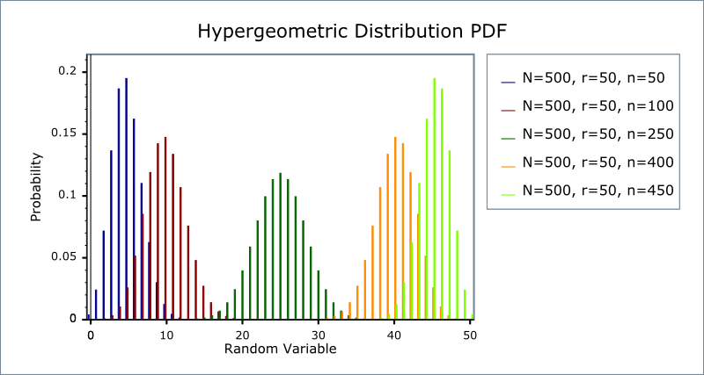

Given *x*, *N*, *n*, and *k*, we can compute the hypergeometric probability based on the following formula:

**Hypergeometric Formula.** Suppose a population consists of *N* items, *k* of which are successes. And a random sample drawn from that population consists of *n* items, *x* of which are successes. Then the hypergeometric probability is:

h(*x*; *N*, *n*, *k*) = [ kCx ] [ N-kCn-x ] / [ NCn ]

## Multinomial Distribution

A multinomial distribution is the [probability distribution](http://stattrek.com/Help/Glossary.aspx?Target=Probability_distribution) of the outcomes from a multinomial experiment. The multinomial formula defines the probability of any outcome from a multinomial experiment.

**Multinomial Formula.** Suppose a multinomial experiment consists of *n* trials, and each trial can result in any of *k* possible outcomes: E1, E2, . . . , Ek. Suppose, further, that each possible outcome can occur with probabilities p1, p2, . . . , pk. Then, the probability (P) that E1 occurs n1 times, E2 occurs n2 times, . . . , and Ek occurs nk times is

P = [ n! / ( n1! * n2! * ... nk! ) ] * ( p1n1 * p2n2 * . . . * pknk )

where n = n1 + n2 + . . . + nk.

## Poisson Distribution

A Poisson random variable is the number of successes that result from a Poisson experiment. The [probability distribution](http://stattrek.com/Help/Glossary.aspx?Target=Probability_distribution) of a Poisson random variable is called a Poisson distribution.

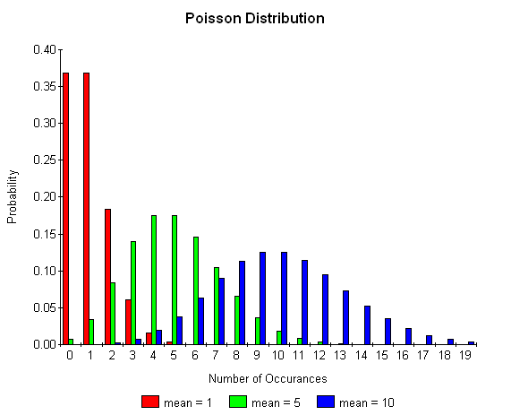

Given the mean number of successes (μ) that occur in a specified region, we can compute the Poisson probability based on the following formula:

**Poisson Formula.** Suppose we conduct a Poisson experiment, in which the average number of successes within a given region is μ. Then, the Poisson probability is:

P(*x*; μ) = (e-μ) (μx) / x!

where *x* is the actual number of successes that result from the experiment, and *e* is approximately equal to 2.71828.

## Continuous Probability Distributions

If a [random variable](http://stattrek.com/Help/Glossary.aspx?Target=Random_variable) is a continuous variable, its [probability distribution](http://stattrek.com/Help/Glossary.aspx?Target=Probability_distribution) is called a continuous probability distribution.

Following are some discrete probability distributions:

* [Normal probability distribution](http://stattrek.com/Lesson2/Normal.aspx)
* [Student's t distribution](http://stattrek.com/Lesson3/TDistribution.aspx)
* [Chi-square distribution](http://stattrek.com/Lesson3/ChiSquare.aspx)
* [F distribution](http://stattrek.com/Lesson3/FDistribution.aspx)

# Normal Distribution

The normal distribution refers to a family of [continuous probability distributions](http://stattrek.com/Help/Glossary.aspx?Target=Continuous probability distribution) described by the normal equation.All normal distributions look like a symmetric, bell-shaped curve, as shown below.

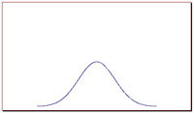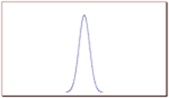

**Normal equation.** The value of the random variable *Y* is:

Y = { 1/[ σ * sqrt(2π) ] } * e-(x - μ)2/2σ2

where *X* is a normal random variable, μ is the mean, σ is the standard deviation, π is approximately 3.14159, and *e* is approximately 2.71828.

The random variable *X* in the normal equation is called the normal random variable. The normal equation is the [probability density function](http://stattrek.com/Help/Glossary.aspx?Target=Probability density function) for the normal distribution.

# Student t Distribution

The t distribution (aka, Student’s t-distribution) is a probability distribution that is used to estimate population parameters when the sample size is small and/or when the population variance is unknown.

When a sample of size *n* is drawn from a population having a normal (or nearly normal) distribution, the sample mean can be transformed into a t statistic, using the equation presented at the beginning of this lesson. We repeat that equation below:

t = [ x - μ ] / [ s / sqrt( n ) ]

where x is the sample mean, μ is the population mean, s is the standard deviation of the sample, n is the sample size, and degrees of freedom are equal to n - 1.

# Chi-Square Distribution

The distribution of the chi-square statistic is called the chi-square distribution. In this lesson, we learn to compute the chi-square statistic and find the probability associated with the statistic.

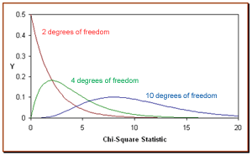

Suppose we conduct the following [statistical experiment](http://stattrek.com/Help/Glossary.aspx?Target=Statistical_experiment). We select a random sample of size *n* from a normal population, having a standard deviation equal to σ. We find that the standard deviation in our sample is equal to *s*.

Given these data, we can define a [statistic](http://stattrek.com/Help/Glossary.aspx?Target=Statistic), called chi-square, using the following equation:

Χ2 = [ ( n - 1 ) * s2 ] / σ2

The distribution of the chi-square statistic is called the chi-square distribution. The chi-square distribution is defined by the following [probability density function](http://stattrek.com/Help/Glossary.aspx?Target=Probability_density_function):

Y = Y0 * ( Χ2 ) ( v/2 - 1 ) * *e*-Χ2 / 2

where Y0 is a constant that depends on the number of degrees of freedom, Χ2 is the chi-square statistic, *v* = *n* - 1 is the number of [degrees of freedom](http://stattrek.com/Help/Glossary.aspx?Target=Degrees_of_freedom), and *e* is a constant equal to the base of the natural logarithm system (approximately 2.71828). Y0 is defined, so that the area under the chi-square curve is equal to one.

# F Distribution

The F distribution is the probability distribution associated with the f statistic. In this lesson, we show how to compute an f statistic and how to find probabilities associated with specific f statistic values.

## The f Statistic

The *f* statistic, also known as an *f* value, is a [random variable](http://stattrek.com/Help/Glossary.aspx?Target=Random_variable) that has an F distribution.

Here are the steps required to compute an *f* statistic:

* Select a random sample of size *n*1 from a normal population, having a standard deviation equal to σ1.
* Select an independent random sample of size *n*2 from a normal population, having a standard deviation equal to σ2.
* The *f* statistic is the ratio of *s*12/σ12 and *s*22/σ22.

The following equivalent equations are commonly used to compute an *f* statistic:

*f* = [ *s*12/σ12 ] / [ *s*22/σ22 ]  
*f* = [ *s*12 * σ22 ] / [ *s*22 * σ12 ]  
*f* = [ Χ21 / *v*1 ] / [ Χ22 / *v*2 ]  
*f* = [ Χ21 * *v*2 ] / [ Χ22 * *v*1 ]

where σ1 is the standard deviation of population 1, *s*1 is the standard deviation of the sample drawn from population 1, σ2 is the standard deviation of population 2, *s*2 is the standard deviation of the sample drawn from population 2, Χ21 is the [chi-square statistic](http://stattrek.com/Help/Glossary.aspx?Target=Chi_square_statistic) for the sample drawn from population 1, *v*1 is the [degrees of freedom](http://stattrek.com/Help/Glossary.aspx?Target=Degrees_of_freedom) for Χ21, Χ22 is the chi-square statistic for the sample drawn from population 2, and *v*2 is the degrees of freedom for Χ22 . Note that degrees of freedom *v*1 = *n*1 - 1, and degrees of freedom *v*2 = *n*2 - 1 .

A continuous probability distribution differs from a discrete probability distribution in several ways.

* The probability that a continuous random variable will assume a particular value is zero.
* As a result, a continuous probability distribution cannot be expressed in tabular form.
* Instead, an equation or formula is used to describe a continuous probability distribution.