M3 Baseline Simulator and Verification Evidence
Differentiable Self Calibration for Fourier Ptychography
Team 25 | Abhishek Jain, Aarya Anup, Saeed Javadizadeh, Raymond Yao
Repository. https://github.gatech.edu/[OWNER]/project-team-25 | Commit to grade: [ADD SHORT COMMIT]
Changes since M2. The M3 cold run keeps the 7 x 7 illumination set but reduces the object from 256 x 256 to 64 x 64, uses one fixed synthetic seed, and omits real-data and multi-seed claims. This is the smallest version that runs quickly while testing the same fixed-versus-joint calibration question.

Team Contributions
Member | Contribution statement to confirm before submission
Abhishek Jain | [Add verified contribution.]
Aarya Anup | [Add verified contribution.]
Saeed Javadizadeh | [Add verified contribution.]
Raymond Yao | [Add verified contribution.]

1 How to Run It
Environment. Run from the repository root. No download, account, absolute path, or external dataset is required.
Command | Observed time | Expected result
conda activate cse6730 | < 1 s | Activates the course environment.
python -m pytest -q | about 1 s | Last line: 3 passed; writes verification JSON records.
python scripts/make_figures.py | about 17 s | Writes results/m3_first_result.png and results/m3_summary.json.
Fresh-clone check. The packaged ZIP was unpacked and rerun on October 22, 2026: pytest reported 3 passed in 0.31 s and the figure rebuilt in 17.1 s. Independent teammate confirmation: [add name/date].

2 Verification Evidence
Check and failure rule. On a 32 x 32, 3 x 3 LED, noise-free case, compare analytic loss gradients for dx, dy, and theta with centered finite differences. The check fails if the maximum relative error at h = 10^-4 exceeds 10^-4 or does not decrease as h is refined.
Finite-difference step h | Maximum relative error | Result
10^-2 | 1.329 x 10^-3 | Refine
10^-3 | 1.329 x 10^-5 | Pass
10^-4 | 1.329 x 10^-7 | Pass
Evidence and scope. tests/test_gradient.py runs this check under pytest and records results/gradient_check.json. The error falls by about 100x per tenfold refinement and the finest result is 752 times below the threshold. This supports the implemented pose derivatives; it does not validate the optical assumptions, optimizer convergence, or experimental accuracy.

3 Baseline and First Result
Baseline. The NumPy baseline models a coherent thin object, circular known pupil, 49 intensity frames, and a rigid LED pose (dx, dy, theta). Both arms use the same amplitude-loss optimizer; the fixed arm holds pose at zero and the joint arm estimates pose after 25 warm-up iterations. Pupil aberration, per-LED errors, real data, grid refinement, and repeated seeds are deferred to M4.
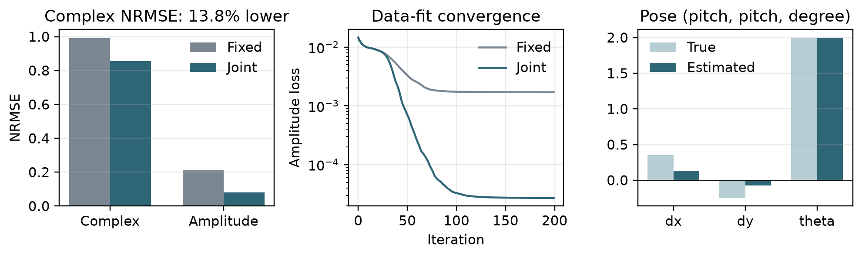
Figure 1. Fixed nominal geometry versus joint pose estimation for seed 20261022.
Quantity | Fixed | Joint | Change
Aligned complex-object NRMSE | 0.9925 | 0.8553 | 13.8% lower
Amplitude NRMSE | 0.2099 | 0.0805 | 61.6% lower
Final amplitude loss | 1.708 x 10^-3 | 2.694 x 10^-5 | 98.4% lower
Interpretation. For this one reduced case, joint calibration lowers the planned complex-object QoI and recovers rotation (1.999 degrees versus 2.000 degrees true). It does not yet establish the M1 claim: translation remains biased, absolute complex NRMSE is high, and ten matched seeds plus grid refinement are still required.

4 Technical Risks
Risk | How we will notice it | Response
Global translation is confounded with an object phase ramp. | dx or dy stays biased while loss falls and rotation converges; repeat across the 10 M2 seeds by Oct 30. | Fix an object-phase gauge or add a calibrated target/phase prior; report pose only after a known-answer identifiability test.
The nonconvex optimizer depends on initialization. | Fixed and joint NRMSE or pose estimates vary materially over 10 matched starts. | Use matched multi-start runs, retain the best verified loss per arm, and report medians with bootstrap intervals.
Unknown pupil aberration is absorbed as LED pose. | Recovered pose changes or residuals remain structured when low-order pupil terms are enabled. | Compare ideal, supplied, and jointly estimated pupils; add only identifiable Zernike terms to the M4 model.

5 Graduate Extension Check
What ran. scripts/extension_prototype.py evaluates analytic derivatives of one defocus-like and one astigmatism-like pupil coefficient and compares them with centered finite differences. It runs in about 0.05 s; pytest also executes it.
Evidence. The maximum relative derivative error was 1.03 x 10^-8, below the 10^-4 M2 threshold; results/extension_gradient_check.json records both gradients. This verifies the two-parameter pupil phase derivative only, not joint recovery from intensity data.
Next step. Insert both coefficients into the imaging loss, then recover nonzero synthetic coefficients within 10% while keeping pose degradation below 0.02 LED pitch and 0.02 degree. This depends on first resolving the translation-phase gauge and stabilizing the pose-only baseline.

Before Submission
Required final entries. Replace the four contribution placeholders, repository owner, short commit, and fresh-clone tester/date. Push that default-branch commit, add the five course collaborators, and complete the individual Canvas peer evaluation.

