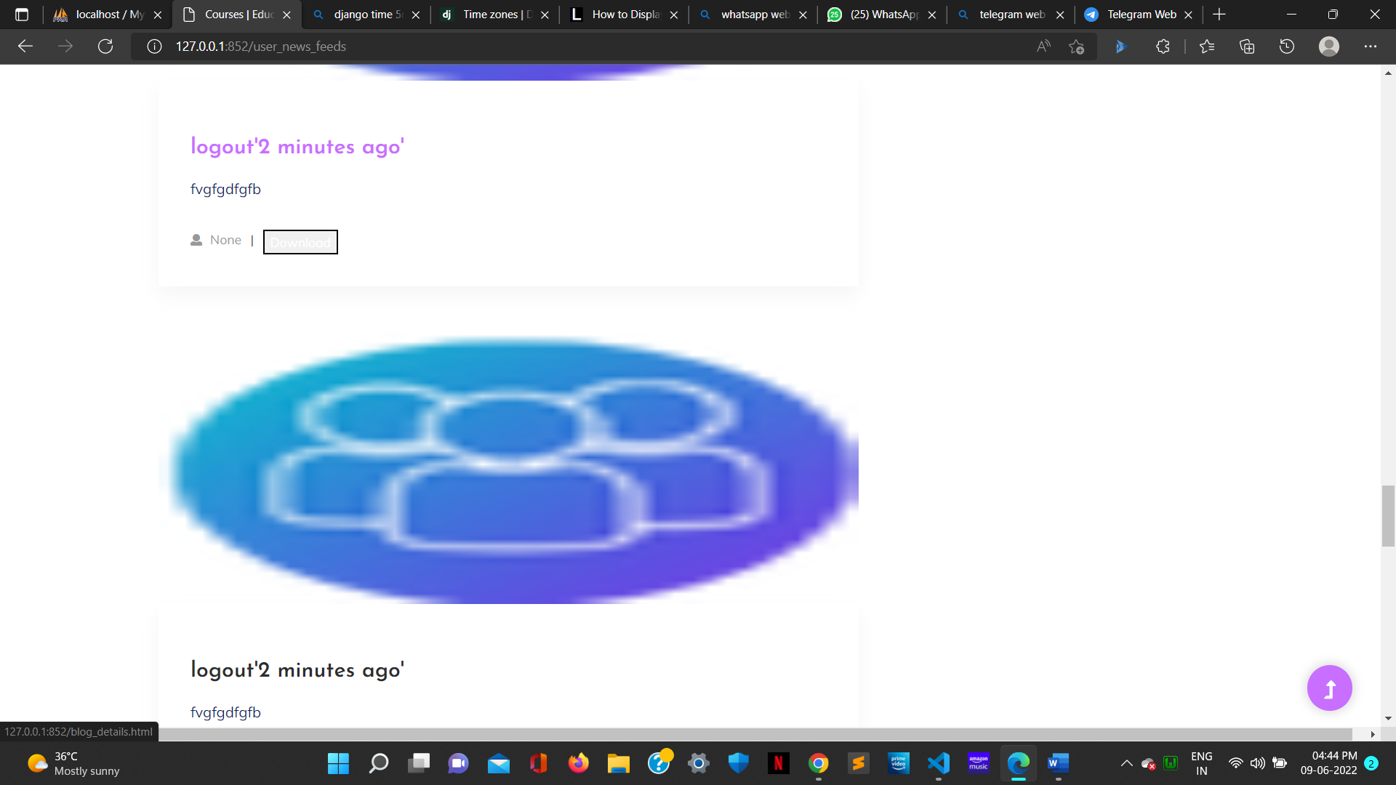

def __str__(self):

        return self.upload_id

    def whenpublished(self):

        now = timezone.now()

        diff= now - self.upload_date_time

        if diff.days == 0 and diff.seconds >= 0 and diff.seconds < 60:

            seconds= diff.seconds

            if seconds == 1:

                return str(seconds) +  "second ago"

            else:

                return str(seconds) + " seconds ago"

        if diff.days == 0 and diff.seconds >= 60 and diff.seconds < 3600:

            minutes= math.floor(diff.seconds/60)

            if minutes == 1:

                return str(minutes) + " minute ago"

            else:

                return str(minutes) + " minutes ago"

        if diff.days == 0 and diff.seconds >= 3600 and diff.seconds < 86400:

            hours= math.floor(diff.seconds/3600)

            if hours == 1:

                return str(hours) + " hour ago"

            else:

                return str(hours) + " hours ago"

        # 1 day to 30 days

        if diff.days >= 1 and diff.days < 30:

            days= diff.days

            if days == 1:

                return str(days) + " day ago"

            else:

                return str(days) + " days ago"

        if diff.days >= 30 and diff.days < 365:

            months= math.floor(diff.days/30)

            if months == 1:

                return str(months) + " month ago"

            else:

                return str(months) + " months ago"

        if diff.days >= 365:

            years= math.floor(diff.days/365)

            if years == 1:

                return str(years) + " year ago"

            else:

                return str(years) + " years ago"

from django.db import models

from django.utils import timezone

from django.contrib.auth.models import User

import math

