**Last Updated: 27th March 2022, 2:57am**

**Research Paper Work**

**On E-STICK For Visually Impaired**

**(Documentation)**

**This document**

**Personal Draft #3**

**Belongs to Aryan Dwivedi & Abhijay Rajvansh under honourable faculty**

**Dr. P. Velmurugan**

**[to be updated]**

**Project Title: E-STICK FOR BLIND PEOPLE**

**Name of the organization: _DO_**

**Address: _DO_**

**Legal Holder of the Project: -**

**Project Location: -**

**Target Group: -**

**Project Budget: -**

[All Basic Information]

**TARGET AREA BACKGROUND & PROBLEMS:**

Currently there are thousands of blind people all over the globe. These include people from low sight-seeing to complete loss of visual. They find it very difficult while crossing the road or reaching to their respective destination with the help any other individual. The traditional stick cannot help to detect the obstacles in front or the potholes in the way. It is outdated. Hence there is a need to update it using today's technology.

The idea behind this project was to come up with smart solutions to help the visually impaired lead normal lives, and so we focused the smart stick for blind people on three core areas which are walking, identification and navigation — three areas where visually impaired people struggle the most.

The whole system is composed of a e-stick with voice recognition that are interlinked with a processing unit. All of the e-stick features are accessible through the smart phone device at an initial stage. The user basically chooses what programme they want to use — for example walking — and can access it with their voice command. However, an internet connection must be provided at time for navigation.

Besides allowing us to carry out routine tasks at our respective workplaces, assistive technology also enables people with visual impairments to be more independent at its place. They can get step-by-step walking directions to unfamiliar places, record important information and so much more with special standalone devices designed for people with no or low vision. This devices will be able to inheritate functions like smart watches, motion detectors, temperature check, and many more that help us live independent and healthy lives.

“Just like facial recognition, the e-stick can will also be able to identify any objects that comes in the way. This is to give visually impaired people more special awareness of what is happening in their surroundings, and so they can now identify things such as small obstacles” .

**NEED OF THE PROJECT:**

This project will bring processes, and tools together, information exchange to promote development for the betterment of mankind. It helps people to solve their problems, reduce excess time, save lives, and help to interact and exchange information.

New development in technologies regarding vision is driving the world and making it more efficient and better. As in 21st century, we are bound with technology in day-to-day activity. Due to this, Businesses & Industries are spreading globally. Even though, they are getting in operation efficiently with ease. The education and communication systems are becoming more advanced. Software like Zoom, Skype, Microsoft Teams, and Google Meet are changing styles of study and communication. There are so many reasons showing the importance of technology in human life.

This project will impact the way **individuals communicate, learn, and think**. It helps society and those who are needy and determines how people interact with outer world and each other on a daily basis. Technology for especially abled people plays an important role in society today. It has positive effects on the world and it impacts daily lives.

“Technology is inevitable in our everyday lives, so why not get developed and live with it.”

Combining software and hardware to enhance someone’s life not only gives satisfaction but develops the thinking ability as well.

**Our Purpose:**

Our purpose is being agents of social change in India through new technologies.

**Our Mission:**

The smart stick for the blind as the name suggests is a device for the visually impaired to guide the user to respective destination and avoiding to collide with the obstacles. It uses two **ultrasonic sensors** **HC SR 04** to detect the depth below or the obstacles in between. Along with that it uses Arduino as the main controller. And 1sheeld as the **Bluetooth interface between the controller and smartphone**. Whenever there is any obstacle in front. The sensor will detect the distance from the obstacle and send to the controller. The controller will then convert in **audio format.**

The smart stick for the blind as the name suggests is **a device for the visually impaired to guide the user to respective destination and avoiding to collide with the obstacles**.

**AGENDA:**

1. By making equipped machines of enhanced tech patterns and trying to create a hybrid form of tool.
2. A community with good levels demonstrates a life transforming encounter during challenges.
3. Technology leads to good and effective judicial, political and social structures in a community.

**ADDITIONAL DETAILS:**

1. Portable

2. Efficient

3. Low cost

4. Futuristic

5. Low power consumption

**OBJECTIVES:**

The said project has the following objective:

* To impart special training on communication skills between blind user with outer world.
* To improve the mobility skills like walking, navigating.
* To give special inputs on managing the daily living skills.
* To tone the other functional senses through special instruction on multi-sensory training.
* To provide for special orientation education with reference to the physical training which will make them to expect more.
* To cope with the normal people levels to prepare and provide opportunities for educational integration that would eventually lead to' social integration.
* To involve the parents and encourage them in a participative role for their abled children so that somewhere they can live a normal life.
* To prepare the blind people for a new & better world.

To provide support services for visually impaired people so that they can travel easily.

**VENUE:**

* [ to be updated ]

Laboratories & Machinery work area

**DURATION:**

* [ to be calculated ]

**BENEFICIARIES:**

* This project will benefit lakhs of visually impaired person across the country by providing resource-full medium as per their need of their day-to-day life.
* Use of skills, knowledge, process, and technique to achieve a specific objective or goal. The objective or goal is to increase production capacity, scientific investigation, achieve efficiency, and more. In simple words, technology is the advancement in the manual process using machines to achieve good efficiency, healthy life, less effort, and to do work.

**METHODOLOGY:**

**The hardware orientation of this project comprises of the following components:-**

After collection of several data on desired field of interests, and preparing basic structure :

# Structuring Model:

# Raspberry Pi 4 Model B with 8GB Ram: Smarter Kit (Latest)

# Additional component: Camera module V2 with Ccable

* Following specifications:

• Model-Raspberry Pi 4 Model-B

• Processor- Broadcom BCM2711, quad-core Cortex-A72 (ARM v8) 64-bit SoC @ 1.5GHz

• RAM Memory - 4 GB LPDDR4 SDRAM

**HC-SR04 Ultrasonic Sensors:**

* Initialising the hardware component HC-SR04 (as a motion detector),

So that while machine is in motion it can sense the obstacles in the way.

* Another sensor is used to detect the absolute depth.

**Blueprint:-**

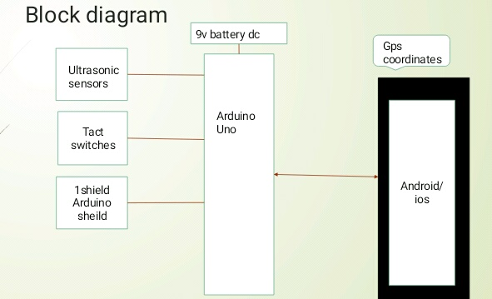

**Arduino AKX00002:**

Details: Arduino 101 Communication Kit Arduino R3 Shield Arduino IDE Project Kit

**The software orientation of this project comprises of the following components:-**

**Designing Environment:**

Laser Tracking System -Using OpenCV 3.1 and Raspberry PI 4 model B.

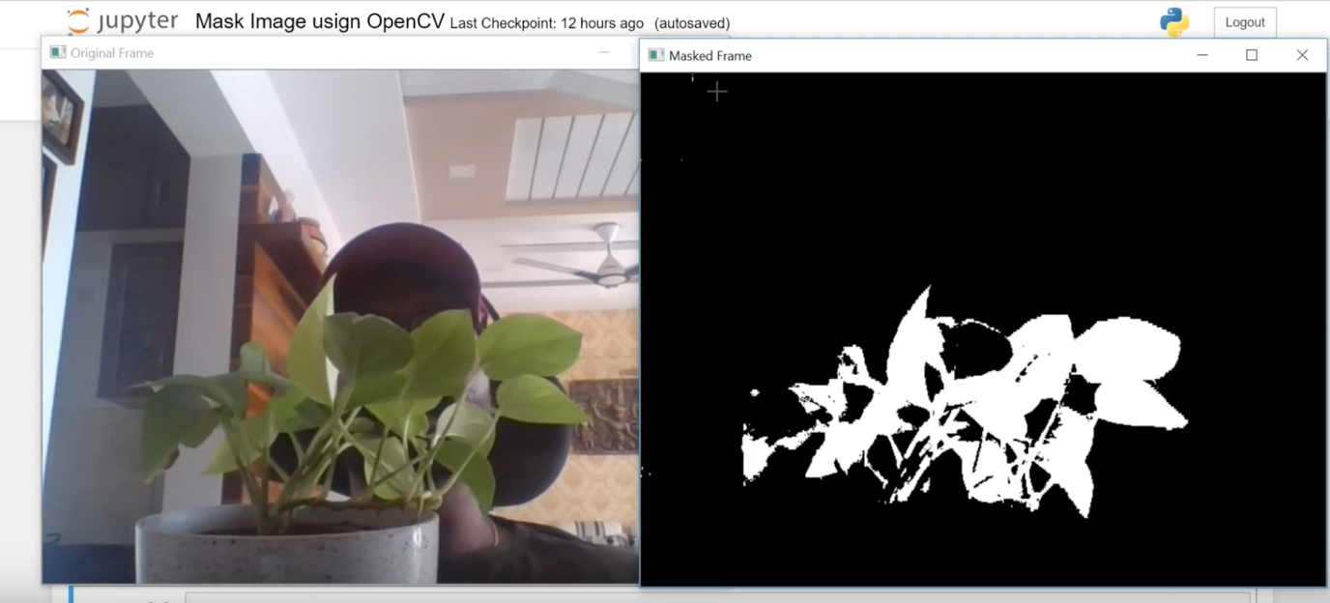

Image Masking Using OpenCV | Mask Image | Computer Vision

