POSTMAN Understanding Docs

Application Programming Interface (API)

> We can say that API is an interface or we can say a common platform wherein a software development organization can let its application as a whole or some parts of the application accessible to the third part development team so that it can use its features, send/receive data, process data and generate results.

> We can say that With API, the development team is able to concentrate on its core design/development task without actually being involved with the pulling/pushing of the data. The remote server will give us the required data we seek for our further processing.

> Also, At times, API also comes with API key to ensure authorization while calling the API, so that the server can identify the genuine user specifically incase of sensitive data.

POSTMAN TOOL

We can say that POSTMAN is a software tool that we can use for API Testing, find bugs in it and analyze loopholes with the same,if any.

Benefits we can say are that we as a developer/tester don’t have to write any HTTP network code, rather Postman will interact with the concerned API.

Concept used in Postman are mainly two things →

a) API
b) HTTP – Its nothing but a set of standard protocols for the transmission of the data on WWW.

We can use Postman by the following two methods→

> Installing of the Postman app in our PC
> Directly using the Postman API online.

Postman Basic Layout →

It has the following constraints:

Untitled Request Section

In this, we can put any choose any method for the request setup like GET, POST, PUT, HEAD, DELETE etc,.

Request Point URL

Here we can put any URL for which we want the API details and then start

Params

Here we can give Key Value pairs if the request sending needs any of the parameters.

Authorization

This is needed if we want to access the API because it verifies that do new have the permission from the server to access the data.

Headers

We can say that this is important as it forms a link for both side communication between server and client.

Body

Here in this area, we can tell the datatype than can be sent with a request

Pre-Request Script

This is we can say is executed before we send any request

Test Section

From here, we can check that whether the API is working correctly or not.

Response Section

This section we can say it contains an HTTP response from the server. Generally response sent by the server is in the form of object, so Postman provides us with various options to enlist and view his response object sent as a part of response from server like JSON, XML, HTML etc,.

Types Of Request Methods we use in Postman

GET -> We can use it to access the data from the API

POST → This can be used to transmit Sensitive data

DELETE → Removes or deletes the pre existing data

PUT → Updates the existing data

A Simple Demo API Request Sending

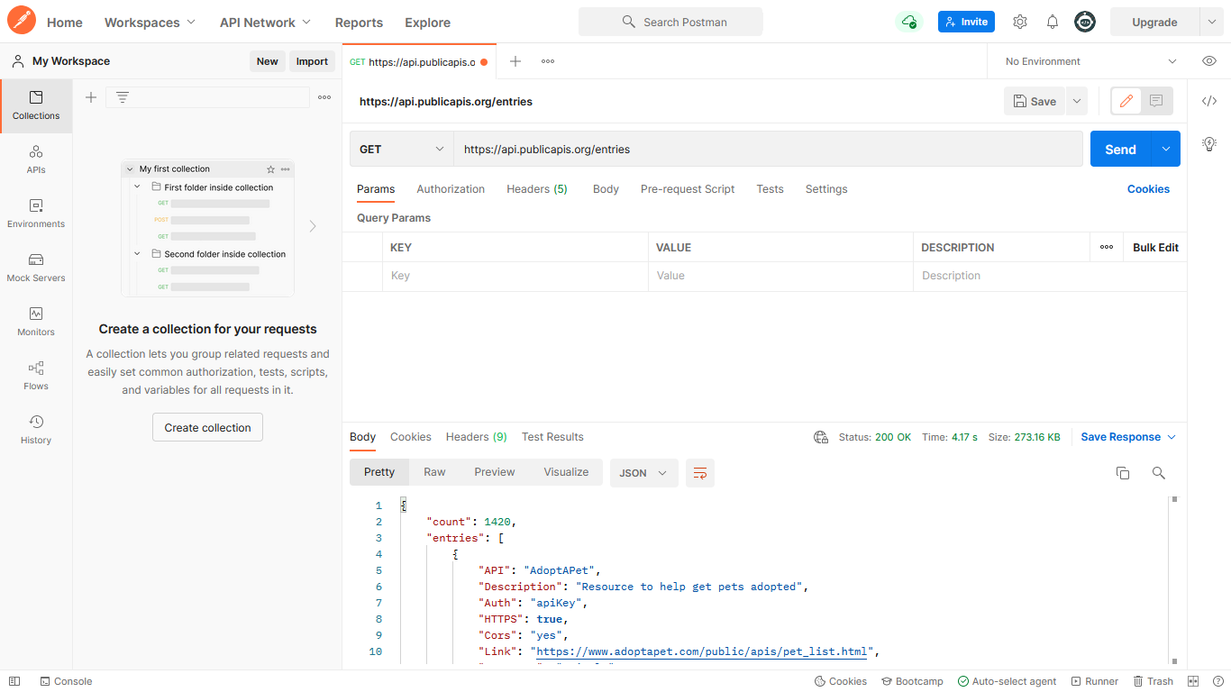

We can also create a Collection which is simply a group of API requests we hit in Postman. This is how we can do it. Acts as a container for a no. of given APIs.

Creating a collection named ‘MyCollection’

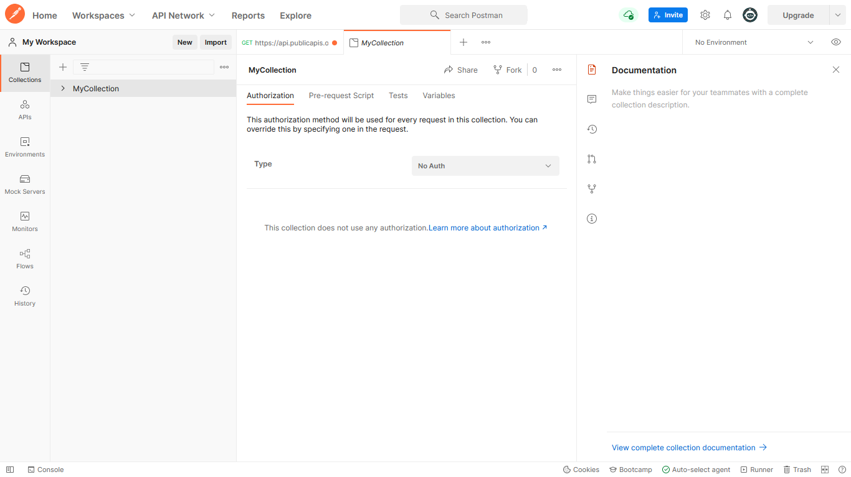

Exploring Authorization in Postman

Here we can say that the Authorization simply means to check and verify whether the user is authorized to access the API is he trying to.

Some of the important authorization methods are →

1. NoAuth - It simply means No Authentication required here.

2. API Key – This is the key which is asked everytime a client is accessing the API

3. Basic Auth - It basically allows us to send username, password with the request for API Login

4. DigestAuth - Two step verification both from the client and the server, wherein a server in this case sends a unique no everytime it receives a request.

5. O Auth – Authorization available for to access 3rd party API data

Obtaining JSON data format response

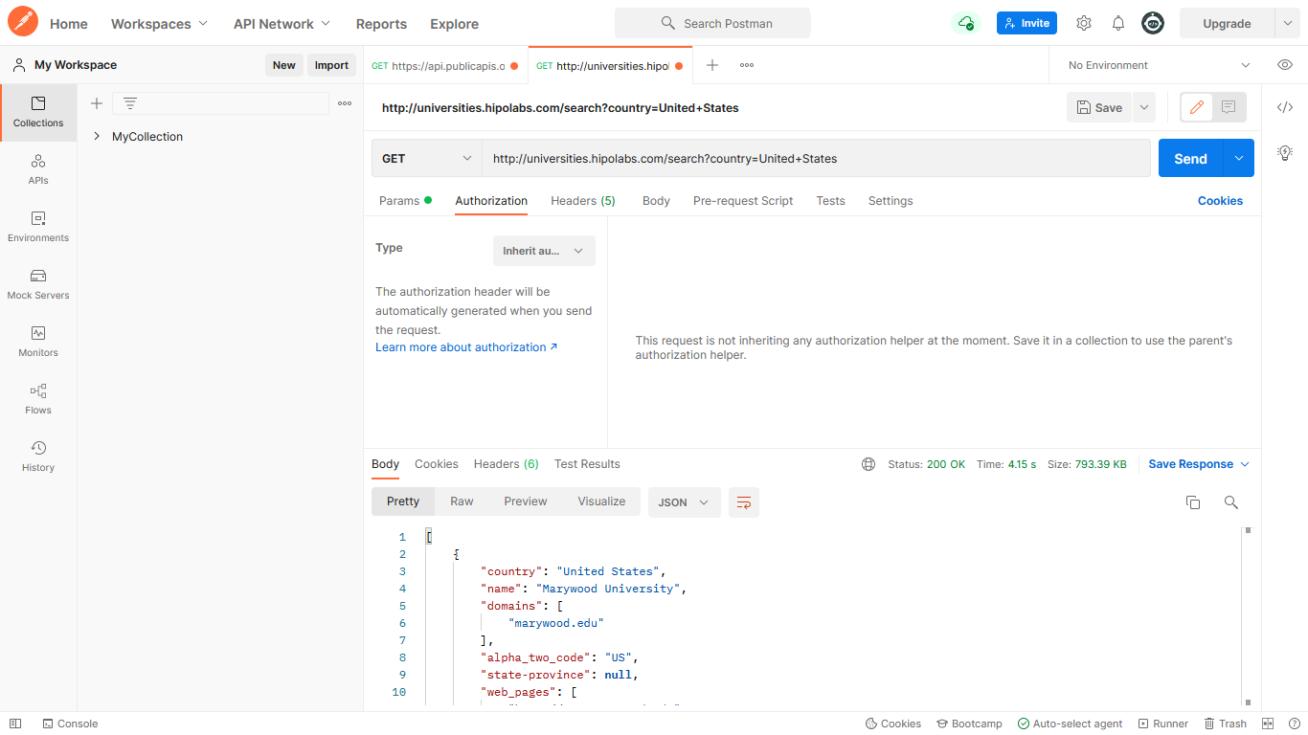

The Status Code 200 received that the Server responded properly to the client.

The Status code from the Server can be divided as :

1xx informational response – the request was received, continuing process
2xx successful – the request was successfully received, understood, and accepted
3xx redirection – further action needs to be taken in order to complete the request
4xx client error – the request contains bad syntax or cannot be fulfilled
5xx server error – the server failed to fulfill an apparently valid request

Lets have a look on each of the section:

Body Section

This section highlights under Response section, the HTML Page received as a part of response

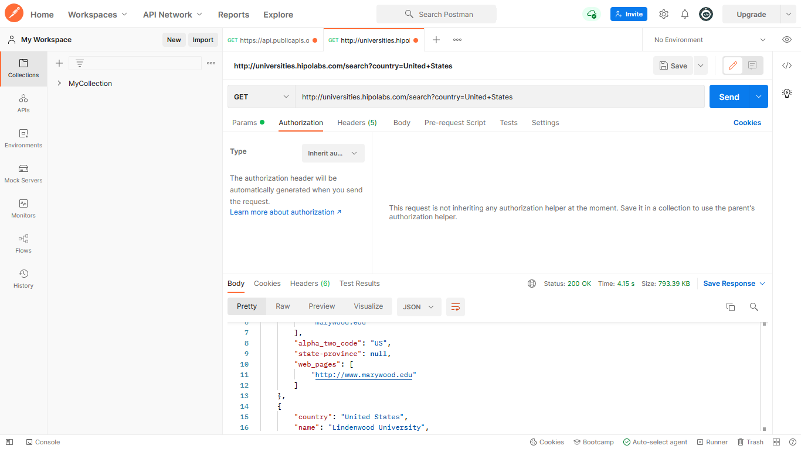
Cookies Section

No Cookies are set here by the Server

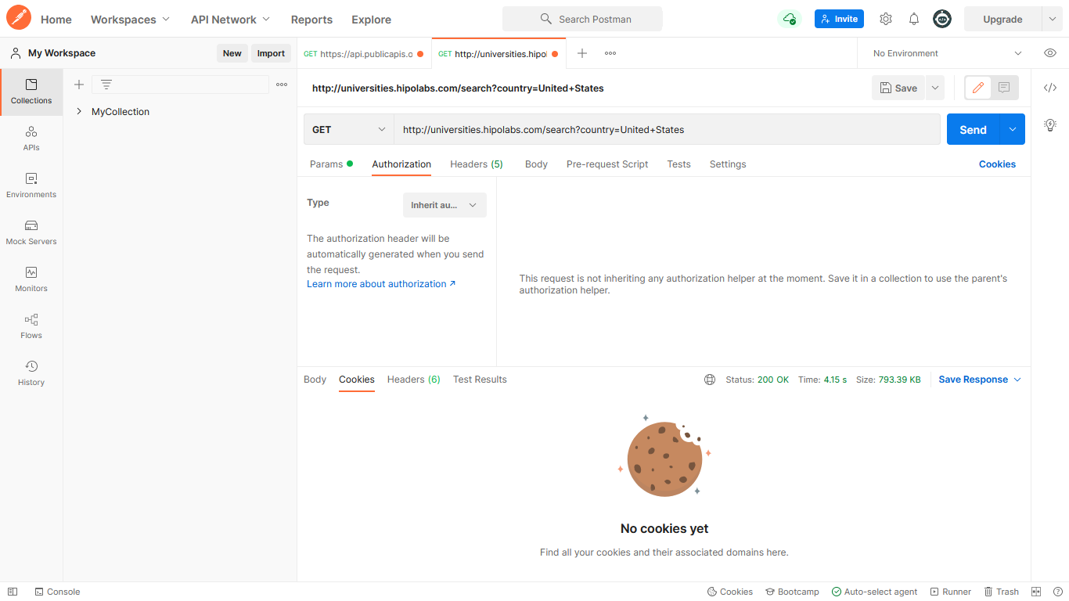

Headers Sent by server as a part of response

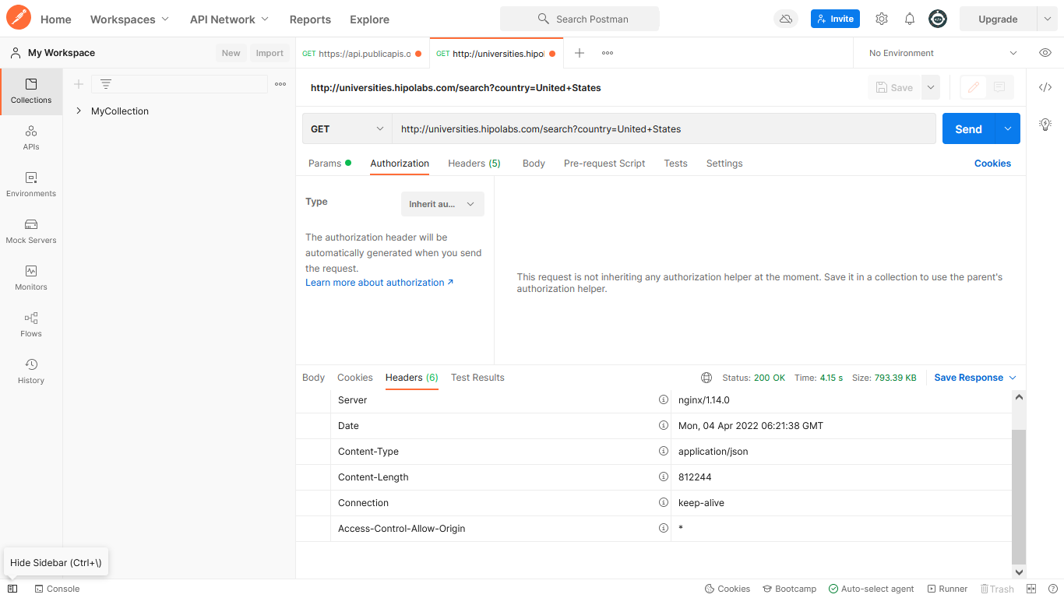

With this, we can also see the time of receipt of response from server, and the size of the response as below :

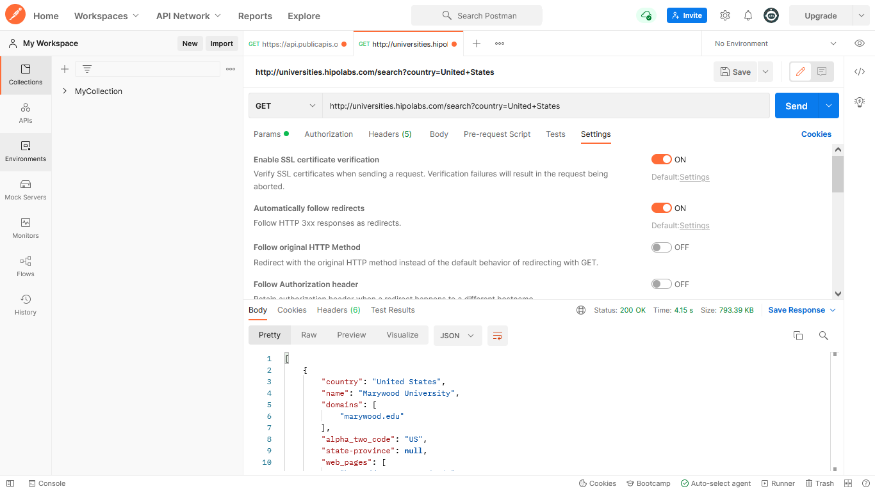

Request Parameters in POSTMAN

A URL generally contains additional parameters which is sent to the server for processing. For example, ‘q’ is the key and ‘coding brains’ is the value, again there is also a key value pair called ‘client = firefox’ which represents client as key and Type of Browser(in this case, Firefox) as value.
Therefore, we can say that in this case it contains multiple parameters(K-V pairs)

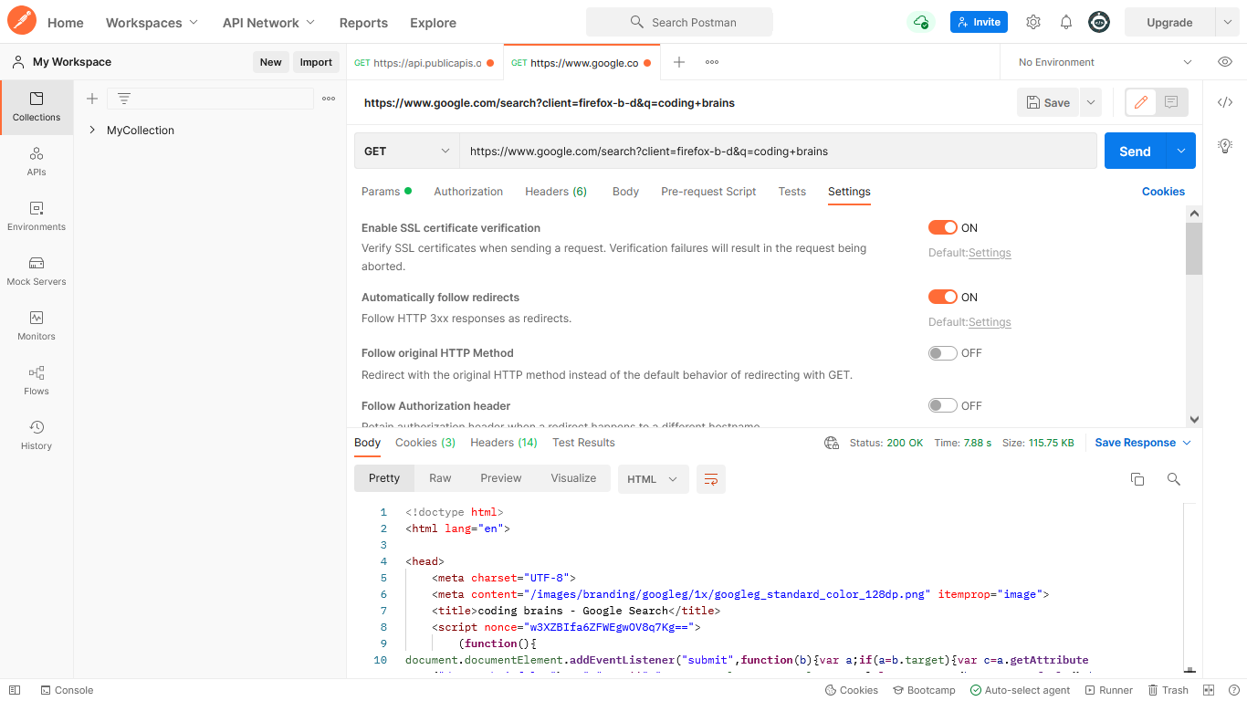

This is also visible under Params Section Under Response Section.

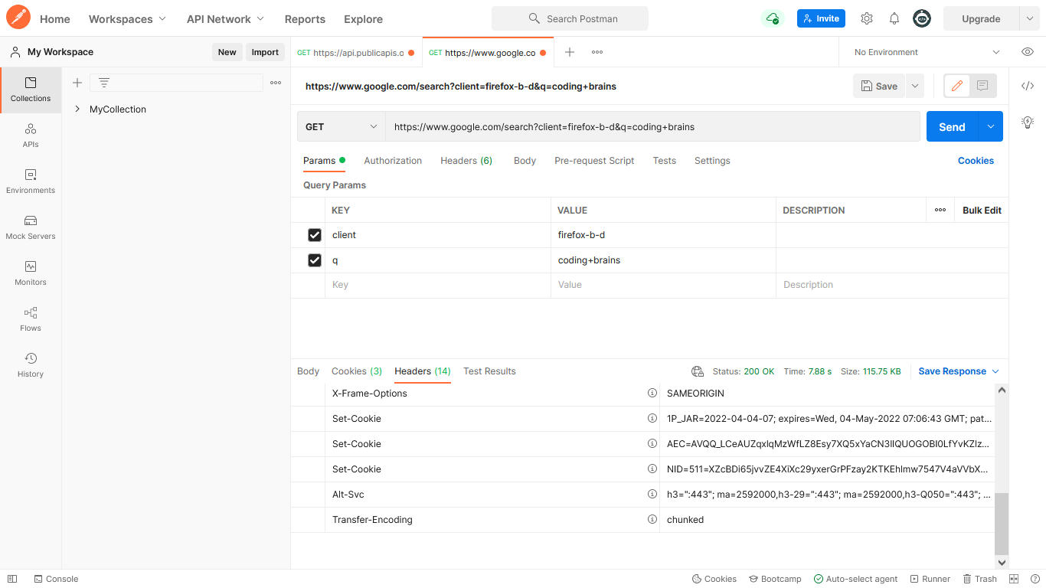

Sending POST Requests

What happens if we tend to send GET request incase where the server is accepting POST request?????

