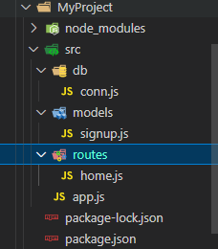

1. Create a folder (MyProject)

i. Install express

ii. install mongoose

iii. insert nodemon in package.json

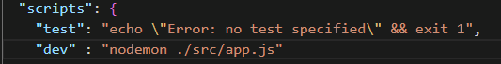

2. Create src folder: My Project -> src

i. Inside src, Create db folder

a. create conn.js file (for establishing connection with database)

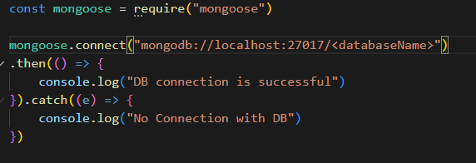

ii. Inside src, Create models folder

1. create xyz.js (create schema , model for your databse)

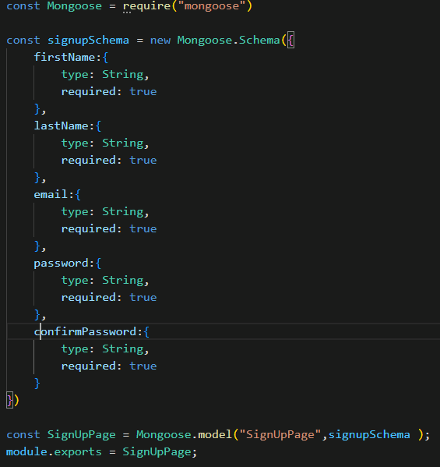

iii. Inside src, Create routes folder:

1. create abc.js (inster router functionalities here)

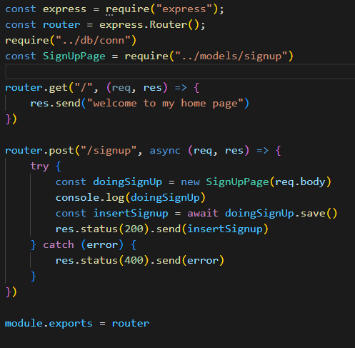

iv. Inside src, create app.js



Look for MyProject in NodeJS repo in my github.