INDUSTRIAL TRAINING REPORT
On
“VISTA — Vision-based Intelligent Stevenson Thermometer Analyzer”

Submitted in partial fulfillment of the requirements for the award of the degree of
BACHELOR OF TECHNOLOGY
in
ELECTRONICS AND COMMUNICATION ENGINEERING

By
ABHIJEET RASTOGI
and
MOHAK JOSHI

Under the Guidance of
____________________________
India Meteorological Department (IMD), New Delhi

2026

ABSTRACT
This industrial training project presents a Raspberry Pi-based digital image-processing system for automated observation of a thermometer installed inside a Stevenson Screen. The primary objective is to reduce dependence on manual visual reading by acquiring thermometer images through a camera, processing the relevant image region, estimating the mercury level, converting its pixel position into temperature, displaying the result, and recording the measurement digitally.
The implemented system uses Picamera2 for image acquisition and OpenCV and NumPy for image processing. Five consecutive frames are averaged to reduce short-term image noise. The frame is then processed using bilateral filtering, grayscale conversion, CLAHE-based contrast enhancement, and sharpening. A narrow Region of Interest (ROI) around the thermometer column is extracted. A stored reference ROI is compared with the live ROI using absolute image difference. The resulting difference image is reduced to a one-dimensional vertical profile, which is smoothed and analyzed using an adaptive threshold based on background intensity and image contrast.
The mercury position is detected by searching for a sustained threshold crossing across multiple consecutive rows. A row-correction framework is also included. The corrected pixel position is converted to temperature using a two-point linear calibration. The calculated temperature is shown on a live graphical interface and recorded in a CSV file at a 30-second interval.
The supplied implementation represents a working prototype. A formal numerical accuracy percentage is not claimed in this report because the source project does not contain a completed statistical validation study. Experimental comparison with a calibrated reference thermometer is recommended for future work.

TABLE OF CONTENTS
Chapter / Section | Page No.
Certificate | i
Declaration | ii
Acknowledgement | iii
Abstract | iv
Chapter 1 – Company Profile | 1
Chapter 2 – Work Undertaken | 4
Chapter 3 – Project Carried Out | 6
Chapter 4 – Learning Outcomes | 15
Chapter 5 – Conclusion | 18
References | 19

LIST OF FIGURES
Figure No. | Title
1.1 | Overall system architecture
1.2 | Image-processing pipeline
1.3 | Mercury detection and temperature conversion flow
1.4 | Graphical user interface

LIST OF TABLES
Table No. | Title
1.1 | Hardware components
1.2 | Software libraries and roles
1.3 | Key configuration parameters
1.4 | Challenges, observations and solutions

CHAPTER 1

COMPANY PROFILE

1.1 India Meteorological Department (IMD)
The India Meteorological Department (IMD) is India's national meteorological service and operates under the Ministry of Earth Sciences, Government of India. IMD is responsible for meteorological observations, weather forecasting, climatological services, warnings, and several specialized atmospheric and environmental services.
Meteorological observations depend on reliable instruments, data acquisition, processing, and interpretation. The use of digital systems and automation can support the collection of consistent observations and reduce dependence on manual transcription.

1.2 Relevance of the Project to IMD
The project developed during the training addresses one aspect of meteorological observation: automatic interpretation of a thermometer reading. By using a camera and image processing, the system demonstrates how conventional visual instruments can be interfaced with digital computing hardware for automated observation and logging.

1.3 Technical Environment
The project combines embedded computing, camera interfacing, image processing, GPIO control, graphical user-interface development, and data logging. The Raspberry Pi acts as the central compute platform, while the camera provides the image input and the software performs the measurement pipeline.

CHAPTER 2

WORK UNDERTAKEN

2.1 Role During Training
The training work involved the development and refinement of a digital image-processing prototype for thermometer observation. The work required understanding the physical observation setup, configuring a Raspberry Pi camera, selecting a suitable ROI, developing image-processing operations, tuning detection thresholds, implementing temperature calibration, creating a GUI, and implementing automatic data logging.

2.2 Tools and Technologies Used
Tool / Technology | Application in Project
Raspberry Pi 4B | Embedded computing and execution platform
Picamera2 | Camera configuration and frame acquisition
OpenCV | Image filtering, enhancement, difference processing and visualization
NumPy | Frame averaging and numerical profile calculations
Python | Main application programming language
RPi.GPIO | LED control through GPIO
Tkinter | Graphical user interface
CSV / datetime | Measurement logging
threading | Concurrent camera processing and logging

2.3 Skills Acquired
- Raspberry Pi camera configuration and image acquisition
- Digital image preprocessing using OpenCV
- ROI-based image analysis
- Difference-image and one-dimensional profile analysis
- Adaptive threshold design
- Pixel-to-temperature calibration
- GPIO-based hardware control
- Python GUI development using Tkinter
- CSV-based automated data logging
- Debugging and parameter tuning for an embedded vision application
CHAPTER 3

PROJECT – VISTA — Vision-based Intelligent Stevenson Thermometer Analyzer

3.1 Project Introduction
The project aims to automate thermometer observation in a Stevenson Screen using a camera and image-processing algorithm. The system captures the thermometer image, focuses on a narrow ROI, compares the live ROI with a stored reference, detects the mercury level, calculates temperature, and logs the result.

3.2 Project Objectives
- Automate the observation of the thermometer level.
- Develop a robust image-processing pipeline for the narrow thermometer ROI.
- Reduce image noise and improve local contrast.
- Use reference-image comparison to highlight relevant changes.
- Detect the mercury level using a row-wise profile and adaptive threshold.
- Convert the detected pixel position into a temperature reading.
- Provide real-time visual feedback through a GUI.
- Maintain a timestamped digital record of measurements.

3.3 Problem Statement
Manual observation of a thermometer requires a person to visually inspect the instrument and record the reading. This process is not ideal for continuous automated monitoring because it requires human presence and can introduce reading or transcription errors. The project therefore investigates a camera-based approach in which the position of the mercury column is inferred from image data and converted into a digital temperature value.

3.4 Rationale
A camera-based approach makes it possible to digitize a conventional visual instrument without replacing the thermometer itself. The Raspberry Pi provides a compact platform capable of camera acquisition, image processing, display, hardware control, and data logging in a single system.

3.5 System Architecture / Flow
The implemented system can be represented as:
Camera → Frame Averaging → Image Preprocessing → ROI Extraction → Reference Comparison → Absolute Difference → 1D Vertical Profile → Adaptive Threshold → Mercury Detection → Temperature Calibration → Display → CSV Logging
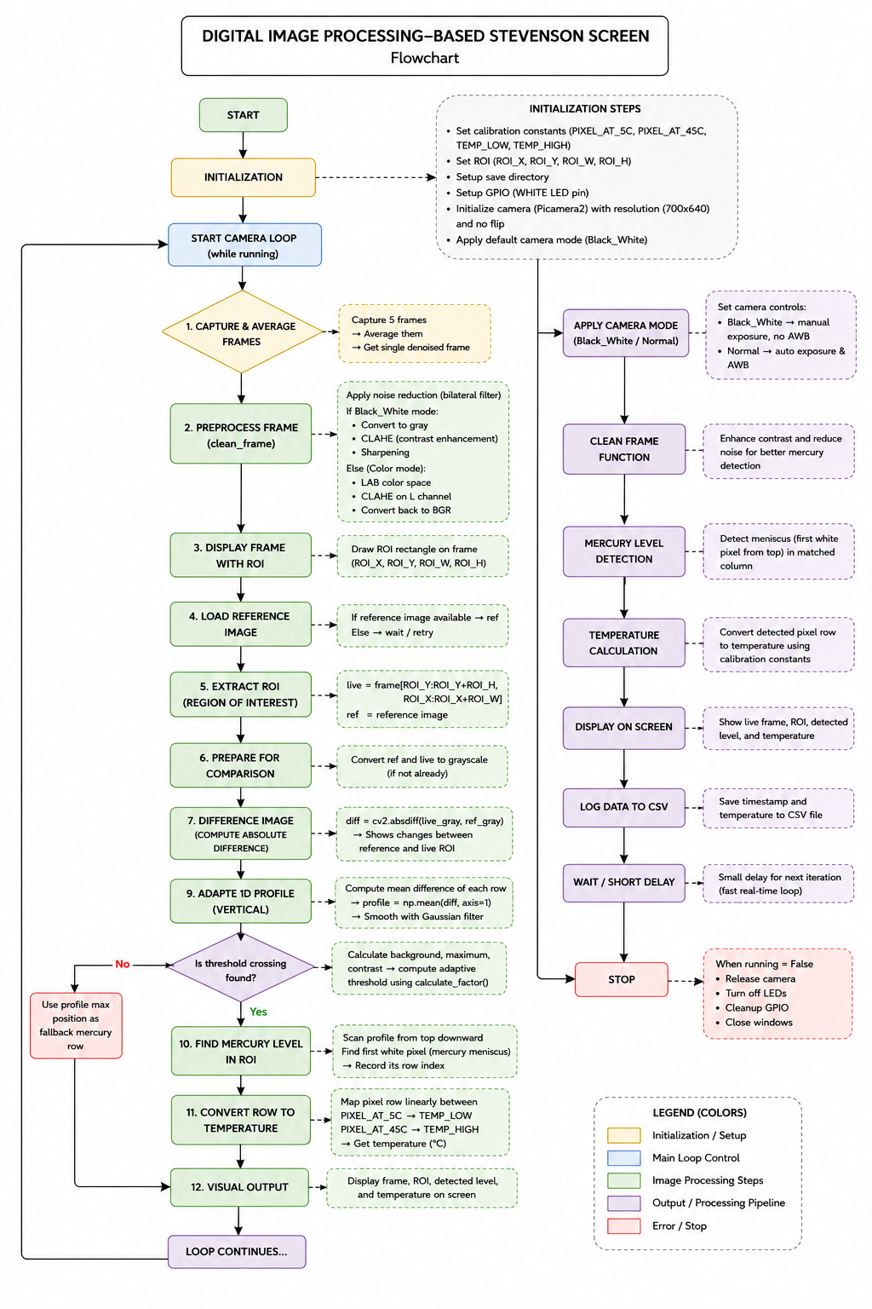
Figure 1.2: Detailed image-processing flow based on the implemented project.

3.6 Hardware Components
Component | Specification / Use
Raspberry Pi 4B | Main processing platform
Camera module | Image acquisition through Picamera2
Stevenson Screen | Enclosure for thermometer observation
Thermometer | Source of temperature indication
White LED | Controlled illumination; GPIO BCM 18
Display | Live preview and GUI

3.7 Software and Libraries
Library / Module | Role
cv2 | Filtering, enhancement, difference image, display
numpy | Frame averaging and profile operations
picamera2 | Camera acquisition
libcamera | Camera transform/configuration
RPi.GPIO | GPIO and LED control
tkinter | GUI
csv | Data storage
datetime | Timestamp generation
threading | Concurrent execution
os / time | File management and timing

3.8 Implementation Details

3.8.1 Camera Initialization
The camera is initialized using Picamera2 with a 700 × 640 RGB888 video configuration. The configured transform uses no horizontal or vertical flip in the supplied code. The camera is started before the processing loop begins.

3.8.2 Frame Averaging
For every processing iteration, five frames are captured. Each frame is converted to a floating-point array, the five arrays are averaged, and the result is converted back to an 8-bit image. This reduces short-term random variation before subsequent processing.

3.8.3 Image Preprocessing
The preprocessing stage applies a bilateral filter. In Black_White mode, the frame is converted to grayscale, CLAHE is used for local contrast enhancement, and a sharpening kernel is applied. The resulting grayscale image is converted back to BGR for compatibility with the display pipeline.

3.8.4 Region of Interest
The current ROI is defined by ROI_X=323, ROI_Y=1, ROI_W=9, and ROI_H=620. This narrow vertical ROI concentrates the algorithm on the thermometer column and reduces unnecessary processing of the surrounding Stevenson Screen.

3.8.5 Reference Image
The user can capture the current ROI as a reference image through the GUI. The reference is stored as REFERENCE.png. During normal processing, the reference is loaded and compared with the current live ROI.

3.8.6 Reference and Live Image Preparation
The reference and live ROI are converted to grayscale when necessary and Gaussian blurred using a 5 × 5 kernel. Blurring reduces small high-frequency variations before the difference operation.

3.8.7 Absolute Difference
The core comparison operation is an absolute pixel-wise difference between the reference and live grayscale images. This produces a difference image that emphasizes changes between the reference condition and the current thermometer image.

3.8.8 One-Dimensional Vertical Profile
The mean difference value is calculated for every image row. The resulting one-dimensional profile represents how strongly each vertical position differs from the reference. The profile is smoothed using a Gaussian filter.

3.8.9 Adaptive Threshold
The background level is estimated using the mean of the first 20 profile values. A peak estimate is obtained from the mean of the highest five profile values. Contrast is calculated as peak minus background. The calculate_factor() function then selects a threshold factor according to the background and contrast ranges.

3.8.10 Mercury Level Detection
The profile is scanned from top to bottom. The implementation requires seven consecutive rows to be at or above the threshold before accepting a mercury row. This consecutive-row condition is intended to reduce false detections caused by isolated noise. If no valid crossing is detected, the maximum profile location is used as a fallback.

3.8.11 Row Correction
The detected mercury row is passed to row_factor(), which interpolates correction values from the ROW_FACTOR table. In the supplied configuration, all correction values are zero, so the current table does not change the detected row.

3.8.12 Display and Logging
The calculated temperature is drawn on the live preview. A separate logging thread writes the date, time, and temperature to temperature_log.csv every 30 seconds.

3.9 Calibration
The supplied calibration settings are shown below.
Parameter | Current value
PIXEL_AT_5C | 505
PIXEL_AT_45C | 63
TEMP_LOW | 12 °C
TEMP_HIGH | 45 °C

The code uses a linear mapping of the form:
Temperature = TEMP_LOW + ((PIXEL_AT_5C − Mercury_Row) / (PIXEL_AT_5C − PIXEL_AT_45C)) × (TEMP_HIGH − TEMP_LOW)
An important implementation note is that the variable name PIXEL_AT_5C suggests a 5 °C calibration point, while TEMP_LOW is currently set to 12 °C. The report therefore treats these as the configured calibration endpoints rather than asserting that the system has been experimentally calibrated from 5 °C to 45 °C.

3.10 Adaptive Threshold Factor
The adaptive threshold factor is selected using background intensity and contrast. The supplied code defines three broad background categories and four contrast conditions within each category. This allows the final threshold to vary according to the observed scene.

3.11 Graphical User Interface
Control | Function
LED ON | Turns on the white LED and selects White RGB mode.
BLACK & WHITE | Selects Black_White mode and disables automatic exposure/white balance.
LED OFF | Turns off the white LED.
TAKE REFERENCE PHOTO | Captures and stores the current ROI as the reference.
SCREENSHOT | Stores the current ROI with a user-entered temperature label.
QUIT | Stops processing, turns off the LED, cleans GPIO and closes the GUI.

3.12 Data Logging
The logging function creates temperature_log.csv when necessary, writes the header Date, Time, Temperature (°C), and appends the current non-zero temperature. The logging interval is 30 seconds.
Example format:
Date, Time, Temperature (°C)
2026-08-09, 09:30:00, 30.4
2026-08-09, 10:00:00, 30.6

3.13 Results and Observations
The supplied implementation demonstrates the complete flow from image acquisition to digital temperature output. The system includes a continuous camera loop, preprocessing, reference comparison, mercury-level detection, temperature conversion, live visualization, and periodic logging.
The project source code does not contain a formal experimental accuracy study. Therefore, no unsupported numerical accuracy claim is included in this report. Accuracy should be determined by comparing the system output against a calibrated reference thermometer over a suitable set of temperature points and environmental conditions.

3.14 Challenges Faced and Solutions
Challenge / Observation | Implemented approach / Solution
Frame-to-frame image variation | Five-frame averaging before processing.
Image noise | Bilateral and Gaussian filtering.
Low/local contrast | CLAHE and sharpening.
Large image area | Narrow ROI around thermometer column.
Changing background/contrast | Adaptive threshold factor based on measured background and contrast.
False detections from isolated peaks | Seven consecutive rows required for mercury detection.
Small positional bias | ROW_FACTOR interpolation framework.
Need for automated records | CSV logging thread with 30-second interval.
Different illumination modes | GUI controls for LED and Black_White/White RGB operation.

3.15 Limitations
- The numerical accuracy of the system has not been formally established.
- The calibration variable naming and configured temperature endpoint require clarification before final validation.
- The current row correction offsets are zero.
- The narrow ROI requires stable camera placement.
- The main detection path depends on a valid reference image.
- Adaptive threshold ranges require empirical tuning.
- The fallback maximum-profile method can return a position even when a sustained threshold crossing is not found.

3.16 Future Scope
- Perform multi-point calibration against a certified reference thermometer.
- Quantify MAE, maximum error, repeatability, and detection failure rate.
- Test robustness under different lighting and camera positions.
- Record background, contrast, threshold, mercury row, and temperature for offline analysis.
- Add confidence flags for threshold-based versus fallback detections.
- Automate reference-image quality checking.
- Optimize CPU usage and quantify processing latency on Raspberry Pi 4B.
- Move calibration and threshold settings into a separate configuration file.
- Develop long-term monitoring and visualization of the logged temperature data.

CHAPTER 4

LEARNING OUTCOMES

4.1 Technical Skills Gained
- Embedded Linux and Raspberry Pi application development
- Camera interfacing using Picamera2
- OpenCV-based image filtering and enhancement
- NumPy-based numerical image analysis
- ROI selection and image differencing
- One-dimensional signal/profile extraction from images
- Adaptive threshold design and parameter tuning
- Temperature calibration from image coordinates
- GPIO control for illumination
- Tkinter GUI development
- Multithreading for concurrent processing and logging
- CSV-based data acquisition and storage

4.2 Problem-Solving Skills
The project required iterative debugging and tuning because image-processing performance depends on illumination, camera positioning, contrast, and the physical appearance of the thermometer. The development process involved identifying the useful image region, reducing noise, selecting appropriate profile statistics, designing an adaptive threshold, and introducing a row-correction framework.

4.3 Understanding of Digital Image Processing
The project provided practical experience in converting a visual measurement problem into a sequence of numerical image operations. In particular, it demonstrated how filtering, contrast enhancement, subtraction, spatial averaging, thresholding, and coordinate calibration can be combined to extract a physical measurement from an image.

4.4 Embedded-System Exposure
Because the application executes on a Raspberry Pi, the project also provided exposure to resource-constrained computing, hardware interfaces, camera configuration, GPIO control, real-time display, and periodic data logging.

4.5 Industry Exposure
The work demonstrated the importance of translating a physical measurement requirement into a repeatable software pipeline. It also highlighted the need for calibration, validation, error analysis, documentation, and maintainability when developing an engineering prototype.

4.6 Gaps Identified and Next Steps
Area | Gap / Observation | Next Step
Accuracy validation | No formal accuracy study in current code. | Conduct reference-thermometer experiments.
Calibration | Endpoint naming/configuration needs clarification. | Recalibrate and document exact endpoints.
Robustness | Thresholds are empirically defined. | Test across lighting and temperature conditions.
Data analysis | Current CSV stores only final measurements. | Log intermediate detection features.
Detection confidence | Fallback detection is not explicitly flagged. | Add confidence/status output.

CHAPTER 5

CONCLUSION
The VISTA — Vision-based Intelligent Stevenson Thermometer Analyzer project demonstrates a practical approach to automating thermometer observation using a Raspberry Pi and camera. The implemented software integrates image acquisition, multi-frame averaging, preprocessing, ROI extraction, reference-image comparison, difference-image analysis, vertical profile generation, adaptive thresholding, mercury-level detection, temperature calibration, graphical display, and CSV logging.
The project successfully converts a visual thermometer-reading task into a digital processing pipeline. The use of a narrow ROI reduces unnecessary computation, while frame averaging and filtering improve the stability of the image. The adaptive threshold mechanism allows the detection threshold to respond to measured background and contrast conditions.
The prototype provides a foundation for further development toward a more robust automated meteorological observation system. Before claiming a specific measurement accuracy, however, the system should undergo controlled calibration and validation against a reference thermometer. Future work should also quantify error, repeatability, detection confidence, robustness to illumination changes, and long-term performance.
Overall, the training project provided practical experience at the intersection of embedded systems, computer vision, Python programming, instrumentation, and meteorological observation. It demonstrates how digital image processing can be applied to automate a conventional measurement task while retaining the original physical sensing instrument.

REFERENCES
1. OpenCV Documentation — Image processing, filtering, thresholding and image comparison functions.
2. NumPy Documentation — Numerical array processing and statistical operations.
3. Picamera2 Documentation — Raspberry Pi camera interface and configuration.
4. Raspberry Pi Documentation — Raspberry Pi hardware and camera/software environment.
5. Python Documentation — Python standard library, threading, CSV, datetime and Tkinter.
6. India Meteorological Department (IMD) — Official meteorological organization information and services.
7. Project source code: final_stevenson_code.py — supplied implementation used as the primary technical basis of this report.

APPENDIX A

KEY CONFIGURATION PARAMETERS
Parameter | Value
FRAME_W × FRAME_H | 700 × 640
ROI_X, ROI_Y | 323, 1
ROI_W × ROI_H | 9 × 620
PIXEL_AT_5C | 505
PIXEL_AT_45C | 63
TEMP_LOW | 12 °C
TEMP_HIGH | 45 °C
Required consecutive rows | 7
White LED GPIO | BCM 18
CSV interval | 30 seconds
Reference file | REFERENCE.png
Log file | temperature_log.csv

