Gradient-Based Mercury Level Detection (First Derivative Edge Detection)

Morphological Noise Removal and Mercury Column Enhancement

Adaptive Binary Image Generation and Morphological Refinement

Absolute Difference Image of Mercury (reference image and live image)

Row Wise Thresholding 1

Row Wise Thresholding 2

Fixed Thresholding Value (in accurate detection of mercury at different lightening conditions)

Imprecise Mercury Detection without adaptive thresholding



Precise Mercury Detection with Adaptive Contrast Based Thresholding

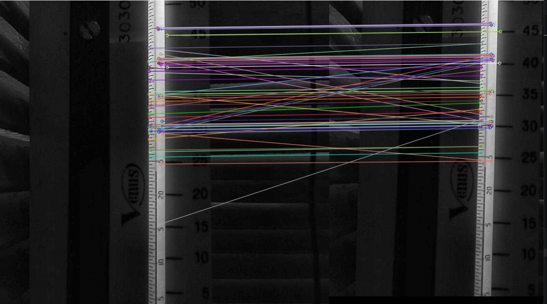
ORB Feature-Based Registration

(works only when mercury level is same of both reference and live image)

Template Matching



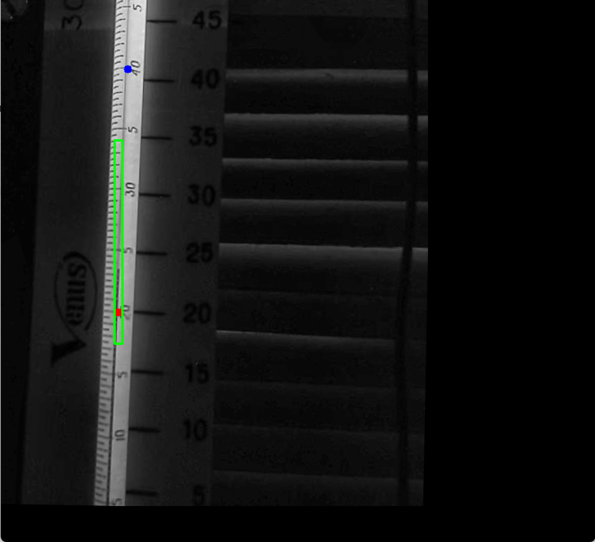

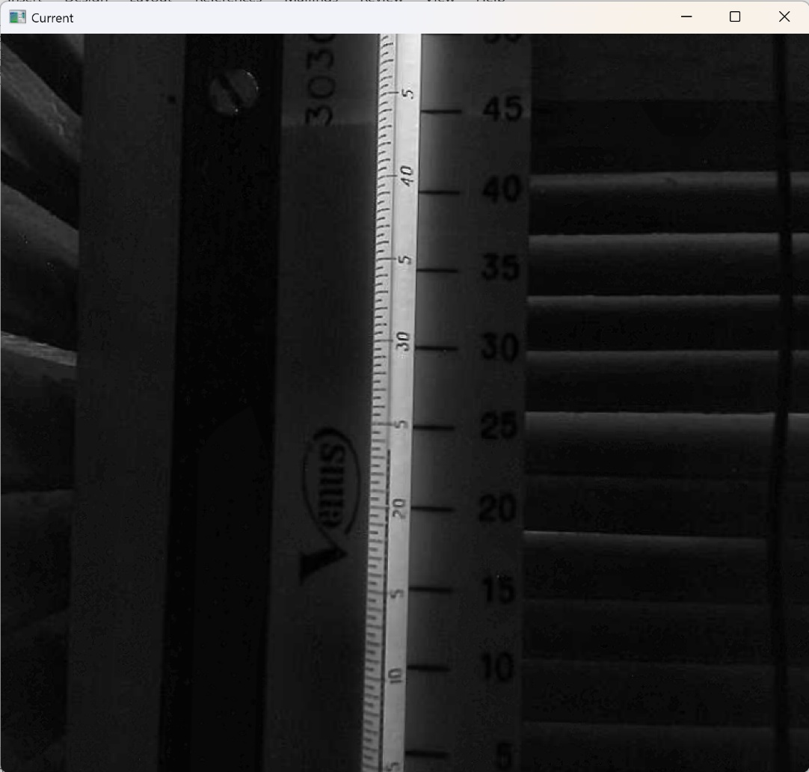
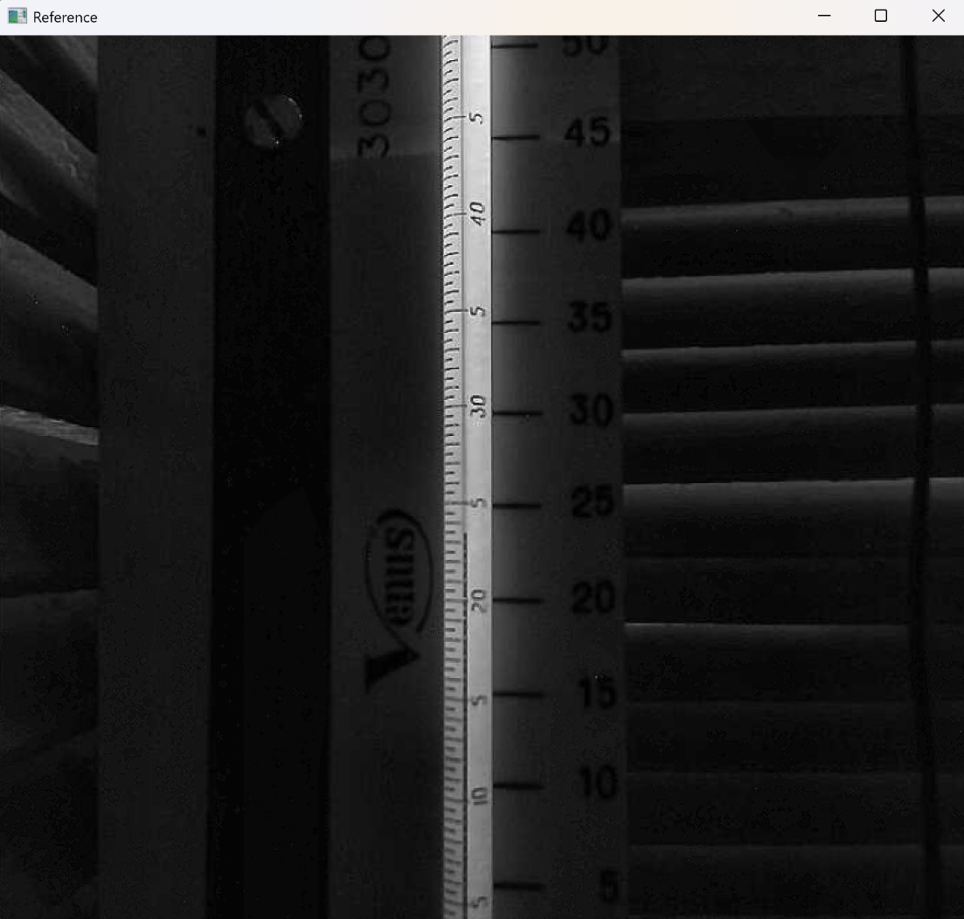
ECC Image Registration

