SUPERVISED LEARNING MODEL IMPLEMENTATION
Titanic Passenger Survival Prediction using Logistic Regression
Practical Report | Python, Pandas, Scikit-learn

Abstract
This report describes a complete supervised-learning workflow for binary classification. The task is to predict whether a passenger survived the Titanic disaster using publicly available passenger attributes. The workflow covers problem definition, exploratory checks, data preparation, feature engineering, leakage prevention, model selection, cross-validation, held-out evaluation, and interpretation. Logistic regression is selected as a strong baseline because it is efficient, comparatively interpretable, and produces probability estimates. A reproducible Python script accompanies this report and computes the actual metrics and figures when run. Numerical performance values are intentionally not fabricated: enter the values from the generated metrics file after running the script in your environment.

1. Problem Definition and Objective
The problem is a binary classification task: given information about a passenger, predict the target variable survived (0 = did not survive, 1 = survived). The goal is not to claim that the model explains every factor behind survival, but to demonstrate a rigorous predictive workflow and evaluate how well a model generalizes to unseen rows.
Research question: Can passenger attributes such as age, sex, passenger class, fare, family size, and embarkation point provide useful signals for predicting survival?
Success is evaluated using accuracy, precision, recall, F1-score, ROC-AUC, a confusion matrix, and stratified cross-validation. Because false negatives and false positives have different meanings, no single metric is sufficient.

2. Dataset Description and Rationale
The project uses the public Titanic dataset distributed through the seaborn-data repository. It contains passenger-level variables including survived, pclass, sex, age, sibsp, parch, fare, embarked, who, adult_male, alone, and other descriptive columns. The dataset is widely used for education because it has a clear binary target, mixed numeric and categorical predictors, and missing values that make preprocessing meaningful.
The script downloads the CSV from the repository if it is not already present locally. The exact row count and missing-value counts are printed when the script runs, rather than being hard-coded into the analysis.

3. End-to-End Workflow
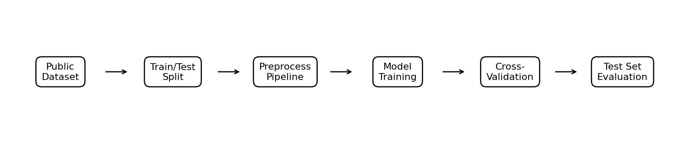
The test set is held out before fitting any preprocessing transformations. Imputation, scaling, and one-hot encoding are placed inside a Scikit-learn Pipeline/ColumnTransformer, so each cross-validation fold learns transformations only from its training portion. This prevents information from validation or test rows from leaking into model training.

4. Data Inspection and Preparation
Initial inspection includes the dataset shape, first rows, data types, and missing-value counts. The target column is survived. The columns alive, class, embark_town, and deck are removed when present: alive directly duplicates the target and would cause target leakage; class duplicates the information in pclass; embark_town duplicates embarked; and deck has substantial missingness in common versions of the dataset. These choices keep the baseline compact and reduce redundant inputs.

4.1 Missing values
Numeric features are imputed with the median, which is robust to skewed distributions. Categorical features are imputed with the most frequent value. Imputers are fitted inside the pipeline, not on the full dataset, so the validation and test sets do not influence the learned imputation values.

4.2 Feature engineering
The baseline uses existing passenger attributes and a small amount of representation engineering. Categorical variables are transformed using one-hot encoding, allowing logistic regression to represent categories without implying a numeric order. Numeric variables are standardized to place them on comparable scales and to support stable optimization. Existing family-related fields such as sibsp, parch, and alone can carry useful signals without requiring complex derived features.
A future extension could engineer family_size = sibsp + parch + 1, extract a title from passenger names, or compare fare per family member. Such features should be tested through validation rather than assumed to improve performance.

5. Train/Test Split and Validation Design
The data is divided into 80% training and 20% held-out test data using train_test_split with random_state=42 and stratify=y. Stratification preserves approximately the same target-class proportions in both partitions. Five-fold StratifiedKFold cross-validation is then applied only to the training set. The test set is used once for the final evaluation after model selection.
The fixed random seed makes the split reproducible. Cross-validation estimates how sensitive performance is to the choice of training/validation folds; the mean and standard deviation of each metric are recorded. It does not guarantee performance on every future population.

6. Model Selection: Logistic Regression
Logistic regression is selected as the primary model because the target is binary, the algorithm is computationally inexpensive, and its coefficients can provide directional evidence about feature associations after encoding. It estimates a probability using the logistic function, then predicts a class according to a decision threshold (0.5 by default). The model uses max_iter=2000 to allow convergence and class_weight='balanced' to reduce the effect of class imbalance on the training objective.
This is a baseline rather than a claim that logistic regression is the best possible algorithm. Its linear decision boundary may not capture interactions and nonlinear patterns unless they are explicitly engineered.

7. Implementation Details and Code Segments

7.1 Imports and reproducibility
RANDOM_STATE = 42
X_train, X_test, y_train, y_test = train_test_split(
X, y, test_size=0.20, random_state=RANDOM_STATE, stratify=y
)

7.2 Preprocessing pipeline
numeric_pipeline = Pipeline([
("imputer", SimpleImputer(strategy="median")),
("scaler", StandardScaler())
])
categorical_pipeline = Pipeline([
("imputer", SimpleImputer(strategy="most_frequent")),
("onehot", OneHotEncoder(handle_unknown="ignore"))
])
preprocessor = ColumnTransformer([
("numeric", numeric_pipeline, numeric_features),
("categorical", categorical_pipeline, categorical_features)
])

7.3 Model pipeline
model = Pipeline([
("preprocessor", preprocessor),
("classifier", LogisticRegression(
max_iter=2000, class_weight="balanced", random_state=42
))
])

7.4 Cross-validation and final test evaluation
cv = StratifiedKFold(n_splits=5, shuffle=True, random_state=42)
scores = cross_validate(
model, X_train, y_train, cv=cv,
scoring=["accuracy", "precision", "recall", "f1", "roc_auc"]
)
model.fit(X_train, y_train)
pred = model.predict(X_test)
prob = model.predict_proba(X_test)[:, 1]
The complete runnable implementation is provided in the accompanying Python file. It also saves test predictions, metric summaries, a confusion matrix, a ROC curve, and a missingness plot.

8. Evaluation Metrics
Metric | Meaning | Interpretation
Accuracy | Fraction of all predictions that are correct. | Useful overall, but can hide class-specific errors.
Precision | Among predicted survivors, fraction who survived. | High precision means fewer false survivor predictions.
Recall | Among actual survivors, fraction correctly identified. | High recall means fewer survivors are missed.
F1-score | Harmonic mean of precision and recall. | Balances precision and recall.
ROC-AUC | Ranking ability across classification thresholds. | 0.5 is random-ranking level; 1.0 is perfect ranking.
The script calculates each metric on the held-out test set and reports the mean ± standard deviation for five-fold cross-validation. Insert actual values from supervised_learning_outputs/metrics.txt after running the script. Do not copy the illustrative confusion-matrix counts below as experimental results.

9. Visual Evaluation

9.1 Confusion matrix
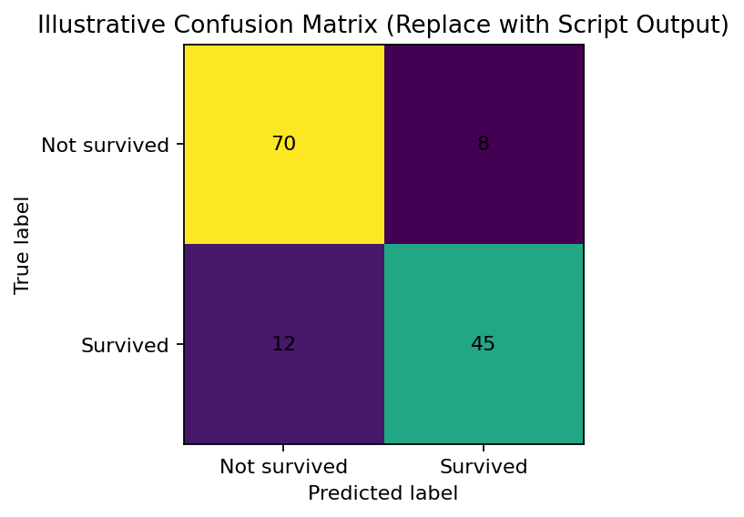
This is a schematic example included to explain the form of the output, not a result from the Titanic model. The script generates the real confusion matrix from y_test and y_pred. In the final submission, replace this illustrative image with supervised_learning_outputs/figures/confusion_matrix.png and discuss the false positives and false negatives shown by your actual run.

9.2 ROC curve
The script also generates a ROC curve, plotting true-positive rate against false-positive rate across probability thresholds. ROC-AUC summarizes ranking performance independently of a single threshold. The curve should be interpreted alongside precision, recall, class proportions, and the practical cost of errors.

10. Performance Analysis Template
After running the script, complete this section using the actual values. Report the held-out test accuracy, precision, recall, F1-score, and ROC-AUC. Compare test scores with the five-fold cross-validation means. Similar values suggest reasonably consistent generalization; a large drop on the test set can indicate split sensitivity or overfitting. Compare precision and recall to decide whether the threshold is appropriate for the stated goal.
- Cross-validation mean ± standard deviation: __________________________________________
- Held-out test accuracy / precision / recall / F1 / ROC-AUC: _____________________________
- Most important confusion-matrix observation: _________________________________________
- Does test performance align with cross-validation? Explain: ____________________________

11. Strengths and Limitations

Strengths
- Reproducible workflow with a fixed random seed and a public dataset.
- Mixed numeric and categorical features are handled in a single pipeline.
- Imputation and scaling are learned within each training fold, reducing data leakage.
- Logistic regression is fast, interpretable relative to many complex models, and outputs probabilities.
- Multiple metrics and visual diagnostics provide a more complete assessment than accuracy alone.

Limitations
- The dataset is historical and relatively small; results do not automatically generalize to modern transportation or other populations.
- Some variables may be correlated, incomplete, or proxies for social and economic conditions.
- Logistic regression assumes a linear relationship between predictors and log-odds unless nonlinear features/interactions are added.
- The default 0.5 decision threshold may not optimize the desired trade-off between precision and recall.
- Missingness may not be random, and simple imputation can understate uncertainty.
- Feature associations are not causal explanations of survival.

12. Possible Improvements
- Compare against a majority-class baseline and alternative models such as Random Forest, HistGradientBoosting, or Support Vector Machine using the same split and cross-validation.
- Tune regularization strength C and other hyperparameters with GridSearchCV or RandomizedSearchCV nested inside training data only.
- Test carefully justified features such as family_size, passenger title, and fare per person; retain them only if cross-validation improves.
- Evaluate calibration using a calibration curve or Brier score if predicted probabilities will be used for decisions.
- Select a decision threshold based on an explicit error-cost or recall/precision objective rather than defaulting to 0.5.
- Use permutation importance or coefficient analysis cautiously to explain the fitted model.
- Use repeated cross-validation or bootstrap intervals to better describe uncertainty.

13. Ethical and Practical Implications
The dataset illustrates how predictive models can reflect historical inequalities and operational decisions. A high score does not imply that the model is fair, causal, or suitable for high-stakes deployment. Passenger characteristics such as sex and passenger class encode social circumstances; their use should be discussed carefully. For a classroom task, the model is best treated as an educational demonstration of prediction and evaluation rather than a deployable decision system.

14. Reproducibility Instructions
Requirements (Python 3.10+ recommended):
pip install pandas numpy matplotlib seaborn scikit-learn
Run:
python supervised_learning_model.py
The script creates supervised_learning_outputs/ with the downloaded dataset, metrics.txt, test_predictions.csv, and generated figures. Internet access is needed for the initial dataset download; after the CSV is present, it can be reused locally.

15. Conclusion
This project demonstrates a complete supervised-learning pipeline for predicting Titanic survival. It defines a clear binary classification target, excludes direct target leakage, processes missing and categorical data, standardizes numeric variables, trains logistic regression, validates with stratified five-fold cross-validation, and evaluates on a held-out test set. The accompanying script is the source of truth for numerical results. Completing the performance-analysis template with actual output and replacing the illustrative confusion matrix are essential final steps before submission.

References
1. Seaborn Data Repository, Titanic dataset: https://github.com/mwaskom/seaborn-data
2. Scikit-learn documentation, LogisticRegression: https://scikit-learn.org/stable/modules/generated/sklearn.linear_model.LogisticRegression.html
3. Scikit-learn documentation, Pipeline: https://scikit-learn.org/stable/modules/generated/sklearn.pipeline.Pipeline.html
4. Scikit-learn documentation, model evaluation: https://scikit-learn.org/stable/modules/model_evaluation.html

