EXPLORATORY DATA ANALYSIS
AND VISUALIZATION
Titanic Passenger Dataset | Python, Pandas, Matplotlib & Seaborn

1. Abstract
This report presents an exploratory data analysis (EDA) of the public Titanic passenger dataset. The purpose is to understand the dataset's structure, summarize important variables, investigate survival patterns, identify potential anomalies, and communicate findings through clear visualizations. Python is used with Pandas for data inspection and aggregation, Matplotlib for chart construction, and Seaborn for statistical plots. The analysis focuses on survival outcome, sex, passenger class, age, fare, and relationships among numeric variables. The report also explains data transformations, limitations, and the difference between association and causation.

2. Objectives
- Load a publicly available dataset and inspect its dimensions, columns, and data types.
- Calculate descriptive statistics and identify missing values and duplicate records.
- Visualize survival outcomes and compare survival rates across passenger groups.
- Explore age and fare distributions, potential outliers, and numeric correlations.
- Interpret patterns carefully and document reproducible Python code and outputs.

3. Dataset Description and Source
The Titanic dataset contains passenger-level information from the Titanic voyage, including survival status, passenger class, sex, age, number of siblings/spouses aboard, number of parents/children aboard, ticket fare, cabin, and embarkation details. The analysis uses the public CSV maintained in the seaborn-data repository:
https://raw.githubusercontent.com/mwaskom/seaborn-data/master/titanic.csv
The exact number of rows, missing-value counts, and statistics should be confirmed by running the supplied Python script against the downloaded CSV. Different Titanic dataset versions may differ in column definitions or record counts.

4. Tools and Libraries
- Pandas: loading CSV data, tabular inspection, grouping, aggregation, and missing-value checks.
- Matplotlib: figure creation, labels, titles, annotations, and saving plots.
- Seaborn: statistical plots and heatmap styling.
- Pathlib and urllib: creating output folders and downloading the public CSV.

5. EDA Methodology

5.1 Loading and inspecting the data
The CSV is loaded into a Pandas DataFrame. The shape, first records, data types, descriptive statistics, missing-value counts, and duplicate-row count are inspected. These checks help identify the kinds of variables available and any data-quality issues that should influence later interpretation.
Code snippet:
df = pd.read_csv("data/titanic.csv")
print(df.shape)
print(df.head())
print(df.dtypes)
print(df.describe(include="all").T)
print(df.isna().sum())
print("Duplicates:", df.duplicated().sum())

5.2 Univariate analysis
Univariate analysis examines one variable at a time. A count plot summarizes the number of passengers who survived versus those who did not. A histogram shows the distribution of passenger ages, while a box plot displays fare spread and potential extreme values. Missing ages should be considered when interpreting the age distribution.

5.3 Bivariate analysis
Bivariate analysis compares two variables. Survival rates are calculated by sex and passenger class using groupby() and mean(), because the survived column is coded as 0 (did not survive) or 1 (survived). The mean of this binary variable is therefore the proportion of passengers who survived. Rates are multiplied by 100 for presentation.
survival_by_sex = df.groupby("sex")["survived"].mean() * 100
survival_by_class = df.groupby("pclass")["survived"].mean() * 100

5.4 Correlation analysis
A correlation matrix is calculated for numeric variables and displayed as a heatmap. Correlation coefficients range from -1 to +1: positive values indicate that variables tend to increase together, negative values indicate an inverse relationship, and values near zero indicate little linear association. Correlation does not establish causation, and encoded category values such as passenger class require careful interpretation.

6. Visualizations and Interpretation
The charts below illustrate the principal comparisons used in this analysis. The Python script generates the same types of figures directly from the downloaded dataset and saves them under outputs/figures. Re-run the script and replace the illustrative report figures with the generated versions if your dataset's calculated values differ.

6.1 Overall survival outcome
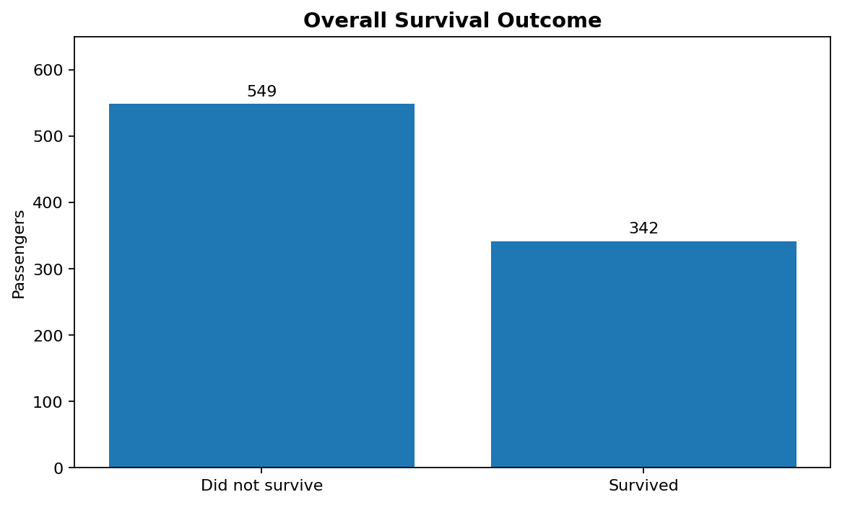
Interpretation: In the commonly used 891-record Titanic dataset, 342 passengers survived and 549 did not. The unequal counts show that non-survival was more common in the dataset. This overall view provides context for the group comparisons that follow.

6.2 Survival rate by sex
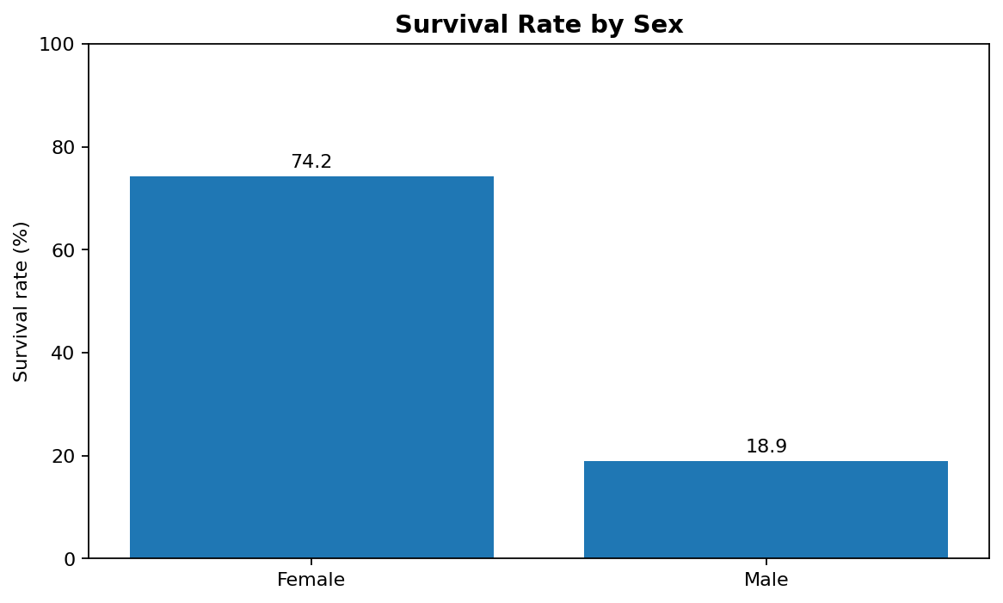
Interpretation: The commonly used Titanic data show a substantially higher survival rate among female passengers than male passengers. This pattern is consistent with the historical evacuation priority often summarized as “women and children first.” It is a descriptive association, not proof that sex alone caused the outcome; age, class, location, and access to lifeboats may also have influenced survival.

6.3 Survival rate by passenger class
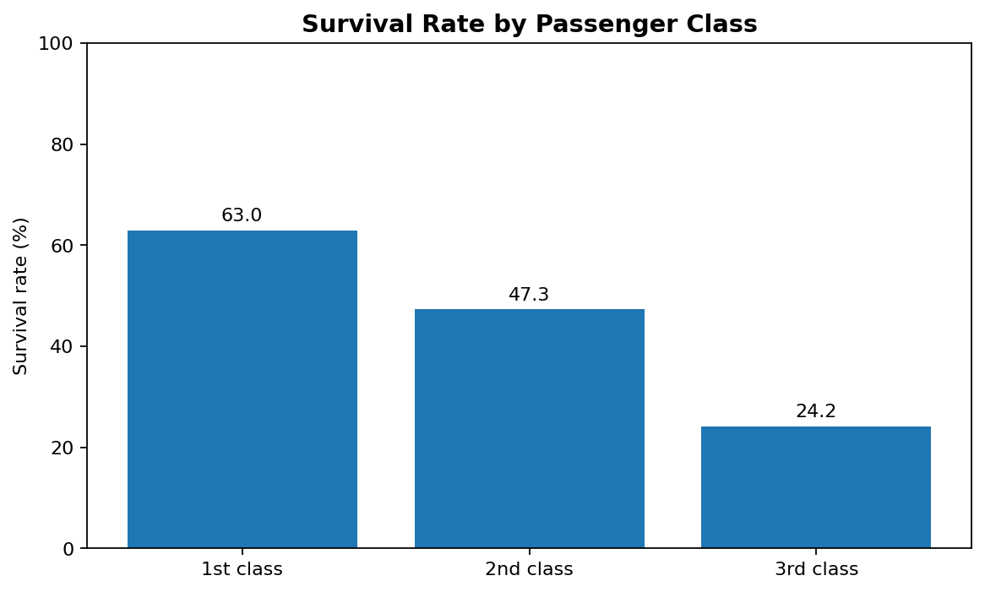
Interpretation: Survival rates generally decline from first class to third class. Passenger class may reflect differences in cabin location, access to information, mobility, and proximity to evacuation routes, as well as socioeconomic status. The chart alone cannot separate the effects of these factors.

6.4 Correlation heatmap
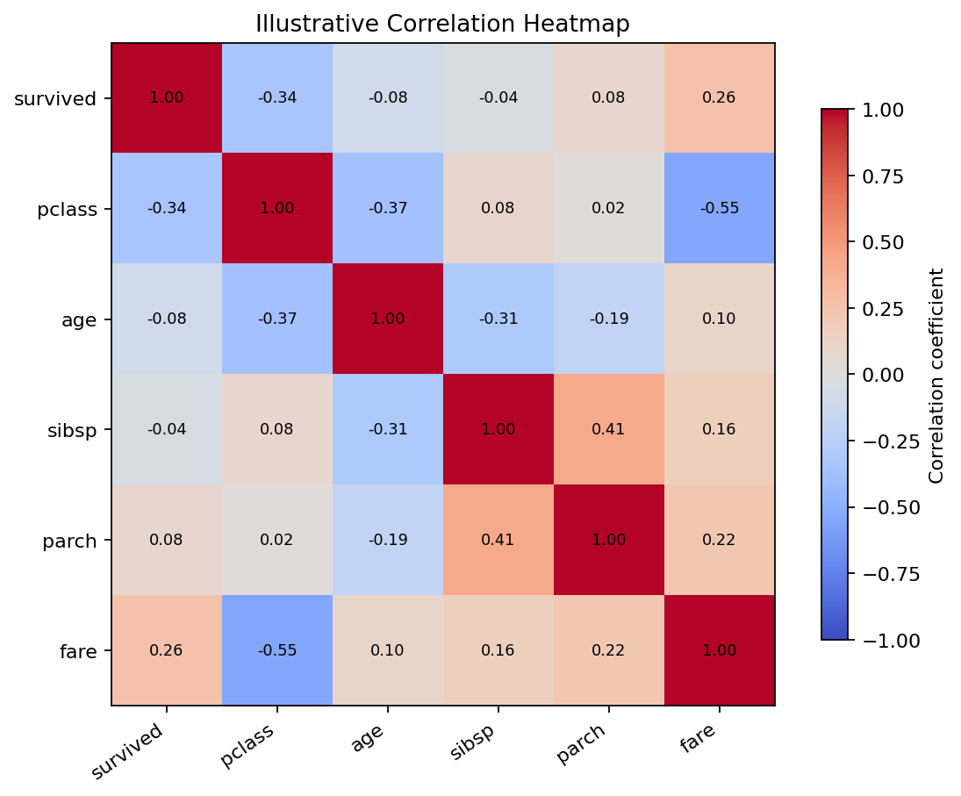
Interpretation: The heatmap demonstrates how pairwise numeric relationships can be inspected at once. In Titanic analyses, passenger class and fare often show a negative association because the first class is coded as 1 and third class as 3, while higher fares are more common among first-class passengers. Survival also tends to be associated with class and fare. The displayed heatmap is illustrative; the supplied script computes the actual correlations from the CSV.

6.5 Age and fare distributions
The script creates an age histogram with a density curve and a fare box plot. The age chart helps reveal which age ranges are represented most frequently and whether the distribution is skewed. The fare box plot can reveal a long upper tail and high-value observations. Extreme fares may be genuine group or ticket effects, so they should not be removed automatically.

7. Data Transformations and Aggregations
- Survival rate: grouped mean of the binary survived field, multiplied by 100 to obtain percentages.
- Numeric correlation: pairwise correlations calculated only on numeric columns.
- Missing-value handling for a separate analysis copy: age is filled with its median; embark_town is filled with its mode when that column and a valid mode exist.
- The raw downloaded CSV is preserved. A separate cleaned_titanic.csv is exported so the original values remain available for verification.
Imputation is used only to make a separate analysis copy and does not imply that the missing values are known. The median is less sensitive to extreme values than the mean, while the mode is a simple categorical replacement. For formal modelling, imputation choices should be validated and applied without data leakage.

8. Key Findings
- The dataset is suitable for exploring survival outcomes and passenger characteristics.
- Survival outcomes are unevenly distributed, with more non-survivors than survivors.
- Survival rates differ substantially by sex in the commonly used Titanic dataset.
- Survival rates generally decrease as passenger class moves from first to third class.
- Age and fare distributions can be skewed, and fare values may contain high-end outliers.
- Correlations can highlight relationships but cannot explain causality by themselves.

9. Limitations and Critical Discussion
The dataset represents one historical event and should not be treated as representative of all maritime disasters or populations. Some passenger attributes are missing, and the dataset does not capture every relevant factor such as exact location during evacuation, health, or access to lifeboats. Group differences may be confounded by other variables. Visual patterns are descriptive and should be followed by suitable statistical tests or carefully designed models if inferential conclusions are required. Correlation is not causation.

10. Conclusion
This EDA demonstrates a repeatable workflow for inspecting a public dataset, summarizing its variables, identifying data-quality concerns, and using visualizations to communicate patterns. The analysis highlights meaningful differences in Titanic survival by sex and passenger class, while also showing why distributions, outliers, missing values, and correlations must be interpreted carefully. The included Python script automates data acquisition, summary statistics, chart generation, and export of an analysis-friendly copy. Running the script produces data-driven outputs that can be checked and used to update the report.

11. How to Run the Python Code
- Install Python 3.9 or later.
- Install dependencies: pip install pandas matplotlib seaborn
- Save titanic_eda.py and run: python titanic_eda.py
- Ensure an internet connection is available for the first dataset download.
- Review outputs/eda_summary.txt, outputs/figures/, and outputs/cleaned_titanic.csv.

12. References
Seaborn-data repository, Titanic dataset CSV:
https://github.com/mwaskom/seaborn-data/blob/master/titanic.csv
Pandas documentation: https://pandas.pydata.org/docs/
Matplotlib documentation: https://matplotlib.org/stable/
Seaborn documentation: https://seaborn.pydata.org/

