UNSUPERVISED LEARNING
AND CLUSTERING ANALYSIS
Wine Dataset | K-Means and Hierarchical Clustering

1. Abstract
This report demonstrates unsupervised learning through clustering on the publicly available Wine dataset distributed by scikit-learn. The objective is to group observations with similar chemical characteristics without using their known cultivar labels during model fitting. The workflow includes data inspection, feature standardization, selection of a cluster count, K-Means clustering, hierarchical clustering, dimensionality reduction for visualization, and cluster profiling. The report explains the rationale behind the algorithms, presents illustrative figures, and discusses how the resulting groups can support exploratory research and quality segmentation. Exact metrics and figures are generated by the accompanying Python script.

2. Objectives
- Understand unsupervised learning and clustering concepts.
- Prepare numerical features for distance-based clustering.
- Choose a cluster count using the elbow method and silhouette score.
- Apply K-Means and hierarchical clustering and compare their results.
- Visualize clusters and profile their characteristics in original feature units.
- Discuss practical implications, assumptions, and limitations.

3. Dataset Selection
The Wine dataset contains 178 observations and 13 numerical measurements of wine chemical composition, including alcohol, malic acid, ash, alkalinity of ash, magnesium, total phenols, flavanoids, nonflavanoid phenols, proanthocyanins, color intensity, hue, OD280/OD315 of diluted wines, and proline. It is a standard public dataset available through scikit-learn and originates from chemical analysis of wines grown in the same region in Italy but derived from three cultivars.
The dataset is appropriate for clustering because it contains multiple numeric features that can be compared after scaling. The cultivar labels are kept separate and are not used as model inputs. They are only optionally compared with cluster assignments after fitting to provide an external reference for evaluation.
Dataset documentation: https://scikit-learn.org/stable/datasets/toy_dataset.html#wine-dataset

4. Tools and Libraries
- Pandas and NumPy: tabular data handling and numerical operations.
- Scikit-learn: dataset loading, StandardScaler, KMeans, AgglomerativeClustering, PCA, and evaluation metrics.
- Matplotlib and Seaborn: annotated charts and cluster visualization.
- SciPy: hierarchical linkage and dendrogram generation.

5. Methodology

5.1 Data inspection
The workflow loads the public dataset and inspects its shape, feature names, descriptive statistics, and missing values. The standard Wine dataset is already numeric and complete, so categorical encoding and missing-value imputation are not required. It is still important to verify these assumptions rather than assume every public dataset is clean.
from sklearn.datasets import load_wine
import pandas as pd
wine = load_wine()
X = pd.DataFrame(wine.data, columns=wine.feature_names)
print(X.shape)
print(X.describe().T)
print(X.isna().sum())

5.2 Feature standardization
The features use different measurement scales. For example, proline can have values in the hundreds or thousands, while hue has values close to one. Since K-Means and Ward hierarchical clustering rely on distances, large-scale variables could dominate the results if features were not standardized. StandardScaler transforms each feature to approximately zero mean and unit variance.
from sklearn.preprocessing import StandardScaler
scaler = StandardScaler()
X_scaled = scaler.fit_transform(X)

5.3 Selecting the number of clusters
The elbow method compares K-Means inertia across candidate values of k. Inertia measures the within-cluster sum of squared distances; it decreases as more clusters are added, so the goal is to look for a point where improvement begins to diminish. The silhouette score measures how well each observation fits within its assigned cluster compared with neighboring clusters, with higher values generally indicating better separation. Neither metric should be treated as an automatic answer; interpretability and domain context also matter. This report uses k = 3 as a useful starting point for the Wine dataset, then the script calculates diagnostics for k = 2 through 10.
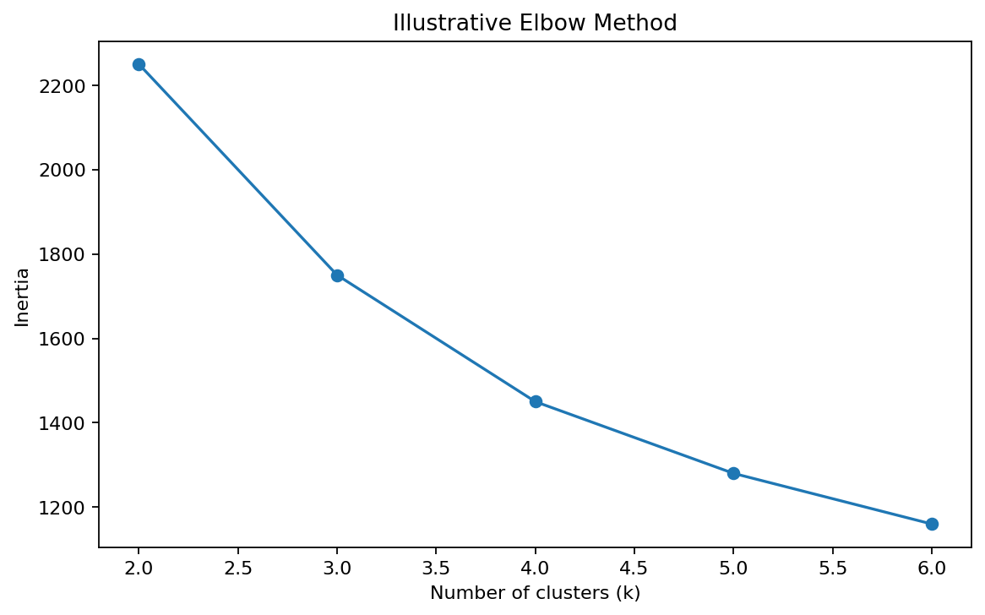
Figure 1. Illustrative elbow curve. Run the Python script to generate the actual curve from the Wine data.

5.4 K-Means clustering
K-Means partitions observations into k clusters by assigning each observation to its nearest centroid and repeatedly updating centroids to reduce within-cluster squared distances. The script uses n_clusters=3, random_state=42 for reproducibility, and n_init=20 to run multiple centroid initializations and reduce sensitivity to an unlucky starting point.
from sklearn.cluster import KMeans
kmeans = KMeans(n_clusters=3, random_state=42, n_init=20)
kmeans_labels = kmeans.fit_predict(X_scaled)

5.5 Hierarchical clustering
Agglomerative hierarchical clustering starts with individual observations and merges the closest groups until the requested number of clusters remains. Ward linkage merges groups in a way that minimizes the increase in within-cluster variance. A dendrogram visualizes merge distances and helps inspect the nested structure. The script uses three clusters to make a direct comparison with K-Means. Hierarchical clustering is useful as a complementary method, although it can be sensitive to distance choices and does not revise earlier merges.
from sklearn.cluster import AgglomerativeClustering
hierarchical = AgglomerativeClustering(n_clusters=3, linkage="ward")
hierarchical_labels = hierarchical.fit_predict(X_scaled)

5.6 Visualizing clusters with PCA
Principal Component Analysis (PCA) projects the standardized 13-dimensional feature space into two components so clusters can be plotted in two dimensions. PCA is used only for visualization; clustering is performed on all standardized features. The two-dimensional projection necessarily loses some information, so apparent overlap in the plot does not always mean the original 13-dimensional clusters are identical.
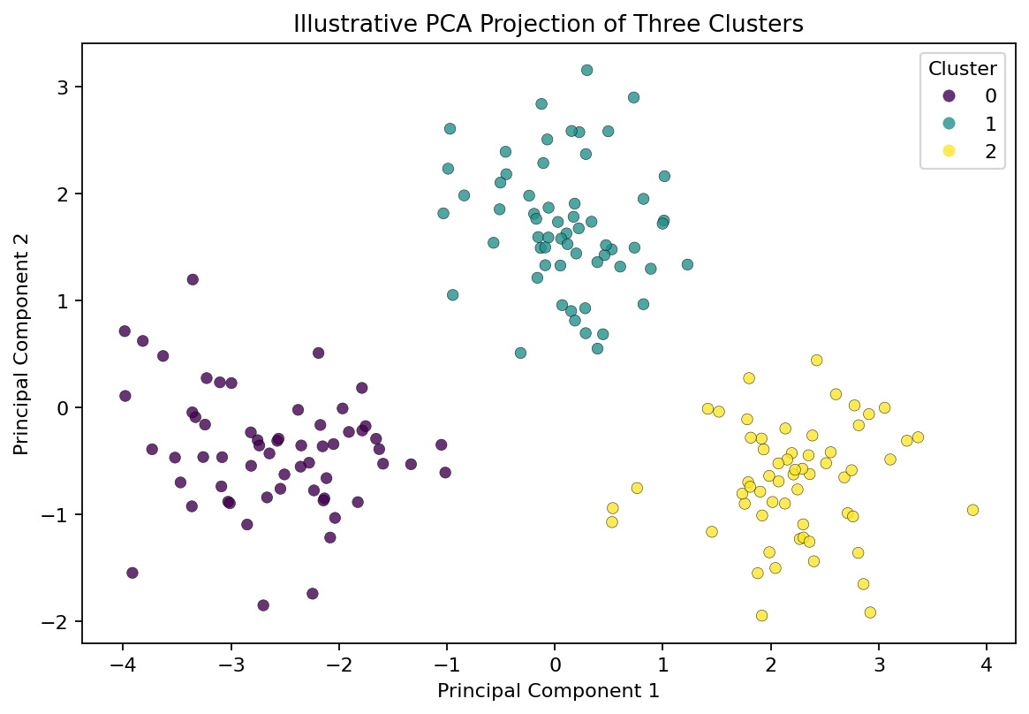
Figure 2. Illustrative PCA scatter plot showing three groups. The accompanying script generates the actual data-derived plot.

6. Results and Cluster Interpretation
The script saves cluster assignments for each observation and calculates cluster profiles by taking the mean of each original feature within each K-Means cluster. This allows clusters to be described in meaningful measurement units rather than standardized values. Cluster IDs such as 0, 1, and 2 are arbitrary labels; cluster 0 is not inherently better or lower than cluster 1.
- Cluster 0: interpret its profile by identifying features whose means are higher or lower than the overall dataset. These differences may indicate one chemical composition pattern.
- Cluster 1: compare its alcohol, phenols, color intensity, hue, and proline values with the other groups to identify a distinct profile.
- Cluster 2: inspect which measurements distinguish it from the other two groups. Avoid assigning a cultivar name based only on the cluster number.
The exact cluster sizes and feature means are dataset-dependent outputs. After running the script, use outputs/clustering_metrics.txt and outputs/wine_clusters.csv to replace these generic profile descriptions with the measured values. This avoids reporting fabricated numerical results.

7. Evaluation and Comparison
The silhouette score is calculated for both algorithms to assess cohesion and separation. The adjusted Rand index (ARI) is also calculated by comparing cluster assignments with the dataset's known cultivar labels after clustering has finished. ARI is an external reference metric, not a training objective; it is included only to understand how closely the unsupervised groups align with the known classes. A score should be interpreted in context and does not make clustering a supervised model.
The elbow and silhouette plots help assess alternative values of k. K-Means often works well when clusters are compact and roughly spherical in scaled feature space. Hierarchical clustering provides a dendrogram and can reveal nested relationships, but its result depends on linkage and distance. Compare metrics, profiles, and plots rather than selecting a method from one score alone.

8. Potential Applications
- Wine production and quality research: identify groups with similar chemical profiles for further investigation.
- Product segmentation: group products or batches based on measurable attributes.
- Exploratory science: discover structure in data when labels are unavailable or not trusted.
- Quality control: investigate observations that lie far from cluster centers or do not fit common profiles.
Clusters are not direct quality grades. A chemical profile alone does not establish consumer preference, price, safety, or sensory quality. Any operational use would require domain expertise and independent validation.

9. Limitations
- The Wine dataset is small and comes from a particular historical sampling context; results may not generalize to all wines.
- Distance-based methods are sensitive to feature scaling, outliers, and the selected distance/linkage.
- K-Means requires a chosen k and favors compact, approximately spherical clusters.
- PCA plots show only two components and may hide structure in the remaining dimensions.
- Cluster IDs are arbitrary and should be interpreted through feature profiles, not numeric labels.
- Unsupervised clusters reveal similarity, not causal relationships.

10. Conclusion
This project demonstrates a complete unsupervised clustering workflow using standardized chemical measurements from a public Wine dataset. K-Means provides a centroid-based partition, while agglomerative clustering offers a hierarchical alternative. The elbow method and silhouette scores support selection of cluster count, PCA helps visualize high-dimensional data, and cluster profiles make the groups interpretable. The main lesson is that clustering is an exploratory tool: meaningful conclusions require checking quantitative metrics, examining feature profiles, and considering the dataset's limitations. The supplied script produces reproducible outputs for detailed interpretation.

11. How to Run the Python Code
- Install Python 3.9 or later.
- Install libraries: pip install pandas numpy matplotlib seaborn scikit-learn scipy
- Save unsupervised_clustering_analysis.py and run: python unsupervised_clustering_analysis.py
- Review outputs/clustering_metrics.txt and outputs/wine_clusters.csv.
- Open outputs/figures/ to view the data-derived plots.

12. References
- Scikit-learn Wine dataset documentation: https://scikit-learn.org/stable/datasets/toy_dataset.html#wine-dataset
- Scikit-learn K-Means documentation: https://scikit-learn.org/stable/modules/clustering.html#k-means
- Scikit-learn clustering evaluation: https://scikit-learn.org/stable/modules/clustering.html#clustering-performance-evaluation
- Pandas documentation: https://pandas.pydata.org/docs/
- Matplotlib documentation: https://matplotlib.org/stable/

