DEEP LEARNING APPLICATION IN DATA SCIENCE
Handwritten Digit Classification using a Convolutional Neural Network
Practical Project Report | Python, TensorFlow/Keras, Scikit-learn

Abstract
This project demonstrates a practical deep-learning workflow for classifying handwritten digits from the public MNIST dataset. A Convolutional Neural Network (CNN) is implemented using TensorFlow/Keras. The report explains the task, data preparation, architecture, training strategy, evaluation metrics, and limitations. The implementation normalizes image pixels, separates training and validation data, uses Adam optimization and categorical probability output, and applies early stopping with best-weight restoration. The accompanying script calculates the actual test metrics and generates training curves and a confusion matrix. Results are intentionally not fabricated; the final report should be updated with the measured values after running the script.

1. Problem Statement and Objective
The task is multi-class image classification: given a 28 × 28 grayscale image of a handwritten digit, predict one of ten labels (0 through 9). The objective is to learn visual patterns such as edges, curves, loops, and stroke combinations that distinguish digits. This is a suitable deep-learning problem because convolutional layers can learn spatial features directly from pixels.
Primary question: Can a compact CNN learn to classify unseen MNIST digit images accurately while maintaining a manageable training cost? The untouched test set is used only after training and model selection.

2. Dataset Description
MNIST is a widely used public benchmark of handwritten digits. TensorFlow/Keras provides a built-in loader that retrieves 60,000 training images and 10,000 test images, each 28 × 28 pixels, with labels from 0 to 9. The script reserves the final 6,000 images from the supplied training partition as a validation set and trains on the remaining 54,000. The official test partition is held out for final evaluation.
The dataset is compact enough for CPU-based experimentation, while still demonstrating image tensors, convolution, pooling, regularization, optimization, and multi-class evaluation.

3. Workflow
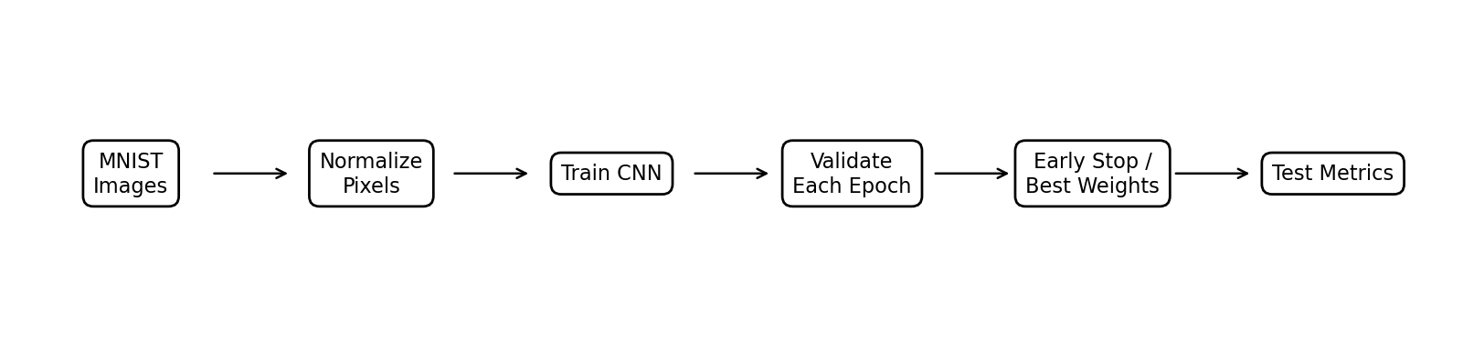
The test data is not used for architecture tuning or early stopping. Validation loss is monitored during training, and the best validation-loss weights are restored before final test evaluation.

4. Data Preparation

4.1 Pixel normalization
Raw pixel intensities range from 0 to 255. They are converted to float32 and divided by 255, producing values in [0, 1]. This stabilizes gradient-based optimization and avoids unnecessarily large input values. A final channel dimension is added so each image has shape (28, 28, 1), as expected by Conv2D.

4.2 Label representation
Labels remain integer class IDs (0–9), so sparse_categorical_crossentropy is used. This avoids creating one-hot target vectors while still training a ten-class softmax output layer.

5. CNN Architecture and Rationale
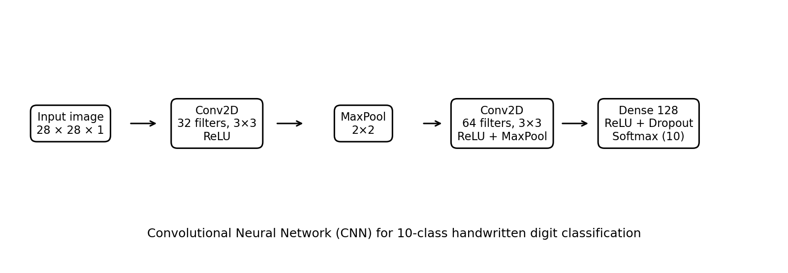
Layer | Configuration | Purpose
Input | 28 × 28 × 1 | Receives grayscale image pixels.
Conv2D | 32 filters, 3×3, ReLU, same padding | Learns local edges and simple visual patterns.
MaxPooling2D | 2×2 | Reduces spatial dimensions and computation.
Conv2D | 64 filters, 3×3, ReLU, same padding | Learns more complex combinations of features.
MaxPooling2D | 2×2 | Further compresses feature maps.
Flatten | Vector conversion | Prepares learned maps for dense classification.
Dense | 128 units, ReLU | Combines extracted features.
Dropout | 0.30 | Randomly drops activations during training to reduce overfitting.
Output | 10 units, softmax | Produces a probability distribution over digits 0–9.
The CNN is chosen over a plain dense network because convolutions preserve local spatial structure and share weights across image locations. ReLU provides a simple nonlinear activation. Max pooling reduces computation and adds some tolerance to small shifts. Dropout is included as a regularizer. The ten-unit softmax layer is appropriate for mutually exclusive classes.

6. Training Configuration
Setting | Choice and rationale
Optimizer | Adam with learning rate 0.001; an adaptive and widely used baseline.
Loss | Sparse categorical cross-entropy for integer labels and ten-class output.
Batch size | 128; balances gradient stability and memory use.
Maximum epochs | 15; provides enough iterations while early stopping can end training sooner.
Early stopping | Monitor validation loss with patience=3 and restore best weights.
Checkpoint | Save the model with the best validation loss for reproducibility.
Random seed | 42; improves repeatability of initialization and data operations where supported.

7. Key Code Examples

7.1 Load and normalize the dataset
(x_train_full, y_train_full), (x_test, y_test) = keras.datasets.mnist.load_data()
x_train = (x_train_full[:-6000].astype("float32") / 255.0)[..., np.newaxis]
x_val = (x_train_full[-6000:].astype("float32") / 255.0)[..., np.newaxis]
x_test = (x_test.astype("float32") / 255.0)[..., np.newaxis]

7.2 Define the model
model = keras.Sequential([
layers.Input(shape=(28, 28, 1)),
layers.Conv2D(32, 3, padding="same", activation="relu"),
layers.MaxPooling2D(2),
layers.Conv2D(64, 3, padding="same", activation="relu"),
layers.MaxPooling2D(2),
layers.Flatten(),
layers.Dense(128, activation="relu"),
layers.Dropout(0.30),
layers.Dense(10, activation="softmax")
])

7.3 Compile and train
model.compile(optimizer=keras.optimizers.Adam(1e-3),
loss="sparse_categorical_crossentropy",
metrics=["accuracy"])
model.fit(x_train, y_train, validation_data=(x_val, y_val),
epochs=15, batch_size=128, callbacks=callbacks)
The complete script contains callback definitions, test evaluation, classification metrics, and figure generation.

8. Evaluation Metrics
- Test accuracy: Fraction of test images assigned the correct digit label.
- Test loss: Average sparse categorical cross-entropy; lower values generally indicate better probabilistic fit.
- Precision: For each digit, proportion of predictions for that digit that are correct.
- Recall: For each digit, proportion of actual examples of that digit correctly identified.
- F1-score: Harmonic mean of precision and recall, reported per class and in aggregate.
- Confusion matrix: Shows which digits are confused with other digits.
The script reports test accuracy and loss, a per-class precision/recall/F1 table, and a confusion matrix. Use the values in deep_learning_outputs/metrics.txt as the measured results. Do not substitute assumed or benchmark values, because training environment, library versions, and the selected best epoch may affect results.

9. Training Diagnostics and Results Interpretation
Training and validation loss/accuracy curves are generated. If training loss continues to decrease while validation loss rises, the model may be overfitting. If both losses remain high, the model may be underfitting or optimization may be inadequate. A small and stable gap between training and validation curves is generally more reassuring, although it does not replace final test evaluation.
Inspect the confusion matrix to identify visually similar digits that are frequently confused. Such errors can arise from differences in handwriting, stroke thickness, rotation, or ambiguous image shapes. The report should name the most frequent confusions seen in the actual output rather than assuming them.

10. Challenges and Mitigations
- Overfitting: Use dropout, validation monitoring, early stopping, and best-weight restoration.
- Resource constraints: Use a compact CNN, moderate batch size, and small grayscale images; GPU acceleration is optional.
- Training instability: Normalize pixels, use Adam, and monitor validation loss.
- Data leakage: Keep the official test partition out of training and model-selection decisions.
- Reproducibility: Set random seeds and save the best model and metric outputs.
- Class-specific errors: Review per-class metrics and confusion matrix rather than accuracy alone.

11. Strengths and Limitations

Strengths
- CNN layers learn spatial features directly from pixels.
- The architecture is compact and suitable for a first end-to-end deep-learning project.
- Normalization, validation, early stopping, and checkpointing provide a disciplined training workflow.
- Per-class metrics and a confusion matrix reveal error patterns hidden by aggregate accuracy.

Limitations
- MNIST is a relatively clean benchmark and does not represent all real-world handwriting, scanners, or image quality conditions.
- The validation set is a fixed slice of the supplied training data; repeated experiments can help quantify variability.
- The model may still confuse ambiguous digits and may be sensitive to shifts, rotation, or unusual writing styles.
- A high test score on MNIST does not establish safety or reliability for consequential applications.
- The report does not claim the model is state of the art; the architecture is intentionally a compact baseline.

12. Improvements and Extensions
- Use data augmentation (small rotations, translations, or zoom) to improve robustness to handwriting variation.
- Compare CNN variants with different filter counts, kernel sizes, dropout rates, and learning rates using validation data only.
- Add learning-rate scheduling or batch normalization if training curves suggest instability or slow convergence.
- Use a more systematic experiment log and compare multiple random seeds.
- Evaluate calibration if confidence scores will be consumed by downstream systems.
- Test on a separate, more challenging handwriting dataset to assess domain generalization.

13. Practical Applications and Implications
Handwritten digit recognition is a simplified example of optical character recognition. Related methods can support postal-code reading, digitization of forms, bank cheque processing, and archival data entry. Real deployments require testing on representative data, privacy controls, monitoring for distribution shift, and a human review path for uncertain predictions.

14. Reproducibility Instructions
Install dependencies:
pip install tensorflow scikit-learn matplotlib numpy
Run the script:
python deep_learning_mnist.py
The first run downloads MNIST and may take time depending on internet speed. Outputs are written to deep_learning_outputs/, including metrics.txt, the saved best model, training_curves.png, and confusion_matrix.png. If TensorFlow is unavailable for your Python version or platform, use a supported Python environment or virtual environment.

15. Conclusion
This project demonstrates the complete deep-learning process for a ten-class image classification task. It prepares public image data, defines a compact CNN, trains with Adam and sparse categorical cross-entropy, uses validation loss to control overfitting, and evaluates final performance on an untouched test set. The accompanying script provides reproducible metrics and figures. Before submission, run the experiment, insert the measured results into the report, and discuss the actual error patterns revealed by the plots.

References
1. LeCun, Y., Cortes, C., and Burges, C. J. C. The MNIST Database of Handwritten Digits: http://yann.lecun.com/exdb/mnist/
2. TensorFlow/Keras, MNIST dataset API: https://www.tensorflow.org/api_docs/python/tf/keras/datasets/mnist
3. TensorFlow/Keras, Sequential model: https://www.tensorflow.org/guide/keras/sequential_model
4. TensorFlow/Keras, EarlyStopping callback: https://www.tensorflow.org/api_docs/python/tf/keras/callbacks/EarlyStopping
5. Scikit-learn, classification metrics: https://scikit-learn.org/stable/modules/model_evaluation.html

