DATA CLEANING AND PREPROCESSING
Python Case Study: Titanic Passenger Dataset
Project Report • Python • Pandas • NumPy • Matplotlib

This report documents a reproducible approach to acquiring a public dataset, profiling data quality, handling missing and implausible values, screening outliers, and preparing a cleaned data file. The companion Python source code runs the workflow and generates the actual diagnostics.

1. Executive Summary
The Titanic dataset is a useful teaching dataset because it contains numeric and categorical fields, missing age and cabin/deck information, a small amount of missing embarkation information, and a skewed fare distribution. The workflow keeps a raw copy, profiles the source, normalizes text, removes exact duplicate rows, checks known categories and impossible negative numeric values, imputes selected missing fields, flags potential outliers, and adds family-related features.
A key principle is that unusual values are not automatically mistakes. Cleaning decisions are documented and should be revisited based on the analysis objective. The script is designed to be run locally so the tables and charts are calculated from the exact dataset retrieved at execution time.

2. Objectives and Scope
- Acquire a public dataset from a reproducible URL.
- Explore shape, columns, data types, summary statistics, duplicates, missing values, and category consistency.
- Handle missing values with explicit, defensible rules.
- Detect impossible values and potential outliers without blindly deleting records.
- Export raw and cleaned CSV files plus diagnostic outputs.
- Discuss the implications and limitations of preprocessing choices.

3. Dataset Selection and Collection
Dataset: Titanic passenger records. Fields commonly include survival outcome, passenger class, sex, age, number of siblings/spouses aboard, number of parents/children aboard, fare, embarkation port, and cabin/deck information.
Public source: https://raw.githubusercontent.com/mwaskom/seaborn-data/master/titanic.csv
The source is a public CSV mirror in the seaborn-data GitHub repository. The script uses pandas.read_csv() to retrieve the file over HTTPS and saves an unchanged copy before any transformations. This keeps an auditable baseline.
DATA_URL = "https://raw.githubusercontent.com/mwaskom/seaborn-data/master/titanic.csv"
raw = pd.read_csv(DATA_URL)
raw.to_csv(OUTPUT_DIR / "titanic_raw.csv", index=False)
Reproducibility note: a branch URL can change if the repository is updated. For a formal research submission, record the retrieval date and pin the dataset to a specific commit or store a checksum.

4. Tools and Environment
- Python 3.10+ recommended.
- pandas for data loading, profiling, transformation, and CSV export.
- NumPy for numerical operations and missing-value representation.
- Matplotlib for quality-control charts.
- python-docx is used to create this report, but is not needed to run the cleaning script.
python -m venv .venv
source .venv/bin/activate # Linux/macOS
# Windows: .venv\\Scripts\\activate
pip install pandas numpy matplotlib
python titanic_data_cleaning.py

5. Initial Data Exploration
The first stage establishes a baseline before changing any values. The code checks dimensions, data types, descriptive statistics, missing-value counts, and exact duplicate rows.
print(raw.shape)
print(raw.info())
print(raw.describe(include="all").T)
print(raw.isna().sum().sort_values(ascending=False))
print("Exact duplicate rows:", raw.duplicated().sum())
For the commonly distributed seaborn Titanic CSV, the dataset is typically 891 rows by 15 columns, with missing values concentrated in age, deck, and embarked. The exact values are deliberately computed by the script rather than hard-coded, because a remote dataset can change.
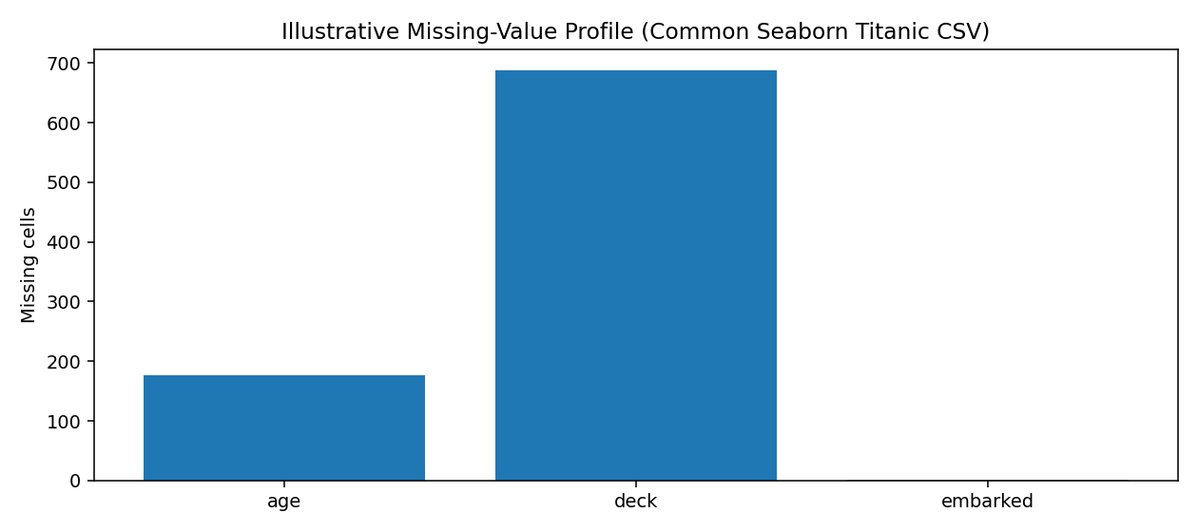
Figure 1. Reference illustration of the common missingness pattern, not a live output from this report-generation environment. Run the script to create a chart based on the retrieved file.

6. Cleaning and Preprocessing Procedures

6.1 Standardizing text fields
Leading and trailing whitespace is removed from string columns. Empty strings and common placeholders such as NA and N/A are converted to proper missing values. This prevents blanks from being treated as valid categories.
for col in df.select_dtypes(include=["object", "string"]).columns:
df[col] = df[col].astype("string").str.strip()
df[col] = df[col].replace({"": pd.NA, "NA": pd.NA, "N/A": pd.NA})

6.2 Duplicate records
Only exact duplicate rows are removed. The workflow does not deduplicate by name or ticket because repeated names or tickets can be legitimate. Exact duplicates are counted in the audit summary. If a future project has a reliable primary key, duplicate handling should be based on that key and domain rules.
df = df.drop_duplicates().reset_index(drop=True)

6.3 Missing values: age
Age is numeric and may vary by passenger class and sex. The script fills missing ages using the median within each class/sex group, then uses the overall median as a fallback if a group has no observed age. Median is more robust to extreme values than the mean.
group_medians = df.groupby(["pclass", "sex"], observed=False)["age"].transform("median")
df["age"] = df["age"].fillna(group_medians)
df["age"] = df["age"].fillna(df["age"].median())
Trade-off: imputation preserves rows but reduces uncertainty and may create repeated values around group medians. For predictive modelling, fit imputation rules only on the training partition to avoid data leakage.

6.4 Missing values: embarkation port
Embarked is categorical, so the mode is used rather than a numeric mean. This is a simple fallback for a small number of missing entries, but it may overrepresent the most frequent category.
mode = df["embarked"].mode(dropna=True)
if not mode.empty:
df["embarked"] = df["embarked"].fillna(mode.iloc[0])

6.5 Missing values: cabin/deck
Cabin/deck information has high missingness. Guessing cabin labels would create unsupported information, so the script creates a binary cabin_known indicator and removes the original high-missingness column. This preserves whether information was recorded, but that indicator may reflect documentation practices rather than a passenger characteristic.
df["cabin_known"] = df[cabin_col].notna().astype("int8")
df = df.drop(columns=[cabin_col])

6.6 Erroneous values and category validation
The workflow checks known categories such as sex, embarkation port, and passenger class. Unexpected categories are changed to missing so they can be investigated instead of silently accepted. Negative age, fare, sibling/spouse counts, or parent/child counts are also treated as implausible and changed to missing.
for col in ["age", "fare", "sibsp", "parch"]:
invalid = df[col].notna() & (df[col] < 0)
df.loc[invalid, col] = np.nan
The provided Titanic source is generally curated, so these rules may detect zero invalid values. That is still useful: validation rules protect the workflow if a future source version contains malformed records. Every validation rule should be adapted to the actual dataset schema.

6.7 Outlier detection and treatment
The Tukey IQR rule flags values below Q1 − 1.5×IQR or above Q3 + 1.5×IQR. It is applied to age, fare, sibling/spouse counts, and parent/child counts. The script stores a binary flag rather than deleting all flagged observations.
q1, q3 = df["fare"].quantile(.25), df["fare"].quantile(.75)
iqr = q3 - q1
upper = q3 + 1.5 * iqr
df["fare_outlier_flag"] = (df["fare"] > upper).astype("int8")
df["fare"] = df["fare"].clip(lower=0, upper=upper)
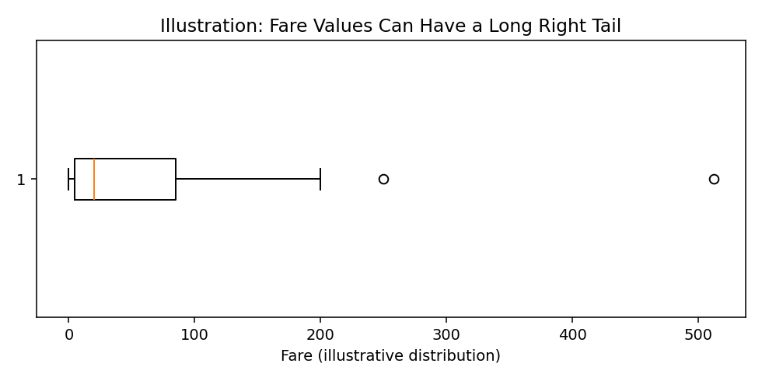
Figure 2. Conceptual illustration of a long right tail in fare values. The Python script creates the actual boxplot from the downloaded data.
Interpretation: IQR flags identify unusual observations, not necessarily errors. High fares may be genuine. Fare capping is a modelling choice intended to reduce the influence of the extreme tail in the model-ready copy. The untouched raw CSV preserves original values, and the outlier flag supports sensitivity analysis.

6.8 Feature engineering and data types
Family size is calculated as sibsp + parch + 1. A recomputed alone indicator is one when family size equals one. These features can simplify exploratory analysis, but are derived from existing columns and therefore are not independent information.
df["family_size"] = df["sibsp"] + df["parch"] + 1
df["is_alone_recomputed"] = (df["family_size"] == 1).astype("int8")
Boolean indicators are converted to integer types for consistent export. One-hot encoding, scaling, and train/test splitting are left to a later modelling pipeline because the correct treatment depends on the target algorithm.

7. Validation and Output Review
The script writes the raw CSV, cleaned CSV, a JSON quality summary, and PNG charts. Review row counts, remaining missing values, dtypes, outlier bounds, and sample transformed records. Compare the raw and cleaned data to verify that each change is expected.
cleaned, audit = clean_dataset(raw)
cleaned.to_csv(OUTPUT_DIR / "titanic_cleaned.csv", index=False)
print(json.dumps(audit, indent=2, default=str))
print(cleaned.isna().sum().sort_values(ascending=False))
- Check that the downloaded dataset has the expected columns.
- Confirm that row loss is limited to exact duplicate removal.
- Verify that age and embarked missingness are handled as expected.
- Review IQR bounds and outlier counts rather than assuming every flagged row is invalid.
- Inspect the generated plots and quality summary after every run.

8. Potential Impact on Subsequent Analysis

Imputation
Retains more rows than deleting incomplete records, but reduces natural variation and can bias estimates if missingness is systematic.

Cabin indicator
Avoids inventing values, but missingness may encode data collection or historical record-keeping patterns.

Outlier flags and fare capping
Makes unusual values visible and can reduce their influence on some models, but capping changes the original distribution. Compare capped and uncapped results.

Duplicate removal
Prevents exact repeats from receiving extra weight; overly broad deduplication could remove legitimate observations.

Derived family features
Can improve interpretability, but correlate with source variables and should be evaluated for usefulness.

Encoding and scaling
Should be fitted within a training-only pipeline to prevent test-set information leakage.

9. Challenges and Responses
- High missingness in cabin/deck: retained a known/unknown indicator rather than fabricating cabin numbers.
- Outliers may be valid: flagged them and capped fare only in the cleaned modelling copy rather than deleting observations indiscriminately.
- Potential data loss: removed only exact duplicate rows and imputed selected fields.
- Reproducibility: placed the URL and transformation rules in one script and saved raw and cleaned outputs separately.
- Data leakage risk: documented that future learned preprocessing should be fitted only on training data.

10. Limitations and Further Improvements
- Pin the dataset to a specific Git commit and record retrieval date plus SHA-256 checksum.
- Add automated tests for schema, row counts, missingness, allowed categories, and repeatability.
- Compare median imputation with more advanced methods if the research question needs uncertainty estimates.
- Run sensitivity analysis using raw fare, capped fare, and log-transformed fare.
- Use scikit-learn Pipeline and ColumnTransformer for model-specific encoding and scaling.
- Document domain-specific reasons before dropping or transforming any column.

11. How to Run the Python File
pip install pandas numpy matplotlib
python titanic_data_cleaning.py
The script creates a titanic_cleaning_output folder containing titanic_raw.csv, titanic_cleaned.csv, data_quality_summary.json, and diagnostic PNG images. An internet connection is required for the first download. If network access is unavailable, download the CSV manually and change the script to read a local file path.

12. Conclusion
This project provides a documented workflow from acquisition to cleaned output. It demonstrates that data cleaning requires judgment: missing values, outliers, and inconsistent entries must be handled in a way that fits the intended analysis. Preserving raw data, recording transformations, retaining outlier flags, and validating outputs make the process transparent and reproducible.

Appendix A. Deliverables
- Data_Cleaning_and_Preprocessing_Report.docx — report with methodology, code snippets, rationale, challenges, limitations, and illustrations.
- titanic_data_cleaning.py — runnable Python implementation that downloads the dataset and generates the actual cleaned data and diagnostic artifacts.

