Titanic Passenger Survival and Passenger Segmentation
End-to-End Data Science Pipeline using Python

Executive Summary
This capstone integrates the core stages of a practical data science project: acquiring a public dataset, checking and cleaning data, engineering features, performing exploratory data analysis, training a supervised model, applying unsupervised clustering, evaluating results, and translating findings into recommendations. The case study uses the Titanic passenger dataset. Logistic Regression is used to predict the binary survival target, while K-Means groups passengers by selected demographic and travel attributes without using the target during cluster fitting. The accompanying Python script computes actual metrics and produces data-driven charts. This report distinguishes methodological expectations from measured results; numerical claims should be filled from the output generated by running the script.

1. Problem Statement and Project Objectives
Data science helps convert raw data into evidence for prediction and decision-making. This project addresses two complementary questions: (1) Can passenger attributes predict whether a passenger survived? and (2) Can passengers be grouped into interpretable segments based on travel and demographic attributes? The first is a supervised classification problem; the second is an unsupervised learning problem.
- Acquire and inspect a publicly available dataset using Python.
- Identify data-quality issues and prepare suitable features.
- Use descriptive statistics and visualizations to explore patterns.
- Build and validate a supervised classification model.
- Use clustering to discover groups without using survival labels during fitting.
- Critically evaluate results, limitations, ethical considerations, and possible next steps.

2. Methodological Approach
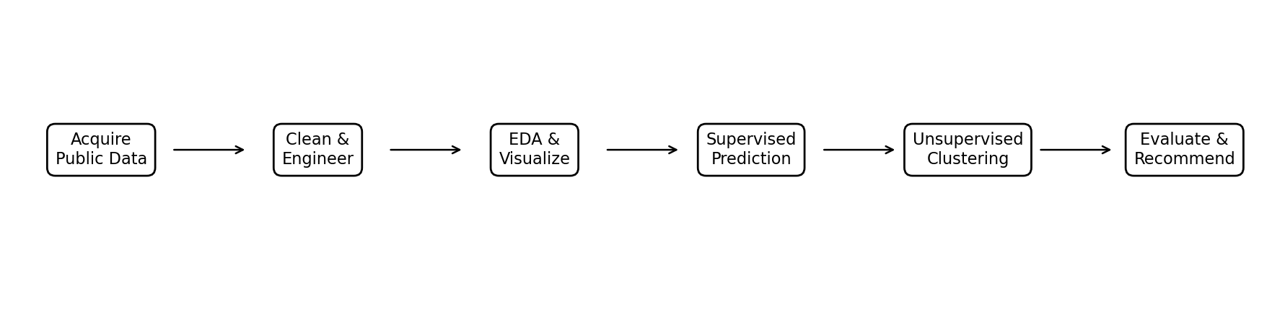
The workflow is designed to keep evaluation honest. The supervised test split is held out from model training and cross-validation. Imputation, scaling, and categorical encoding are fitted inside a pipeline to avoid preprocessing leakage. The clustering algorithm is fitted without the survival target. The target may be examined after clustering to describe cluster outcomes, but it is not an input to K-Means.

3. Data Acquisition and Description
The dataset is the public Titanic CSV hosted in the seaborn-data GitHub repository. It includes a survival indicator and attributes such as passenger class, sex, age, fare, family travel counts, embarkation point, and cabin-related information. It is suitable for an educational capstone because it contains numeric and categorical data, missing values, a binary target, and opportunities for both prediction and segmentation.
The script downloads the CSV from https://raw.githubusercontent.com/mwaskom/seaborn-data/master/titanic.csv on the first run and saves a local copy. It prints dataset shape, sample rows, data types, and missing-value counts, and exports a data-quality report with data type, missing percentage, and number of unique values.

4. Data Cleaning and Feature Engineering

4.1 Data quality assessment
Missingness is inspected before transformations. Missing age and embarkation values are handled within the model pipeline using median imputation for numeric variables and most-frequent imputation for categorical variables. This is a pragmatic baseline; it should not be assumed that missingness is random.

4.2 Leakage prevention and redundant columns
The target is survived. The field alive directly expresses the same outcome and is excluded from predictors. Other overlapping columns such as class, embark_town, who, adult_male, and alone are excluded in this baseline to reduce redundancy when their information overlaps with retained fields. This makes the model less likely to exploit duplicated representations rather than learning from the intended inputs.

4.3 Feature engineering
Two simple features are engineered: family_size = sibsp + parch + 1 and is_alone, a binary indicator of family_size equal to one. Family size may describe whether a passenger travelled with relatives. Numeric features are standardized for Logistic Regression and K-Means; categorical variables are one-hot encoded for classification. Transformations are selected for a clear baseline rather than excessive complexity.

5. Exploratory Data Analysis (EDA)
The script generates charts for target distribution, survival proportion by sex, survival proportion by passenger class, age distribution by outcome, and a numeric correlation heatmap. These plots help assess class balance, compare groups, inspect age patterns, and identify potentially correlated numeric inputs.
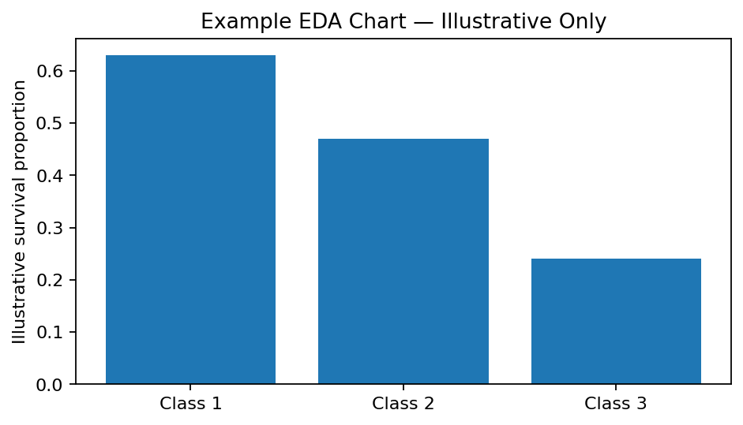
The chart above is illustrative only and is not computed from the dataset. Replace it with the generated figures under capstone_outputs/figures/ when reporting findings. Interpret the actual chart values, not the illustrative bars. The Python script is the source of truth for data-derived plots.

5.1 EDA questions to address
- How many observations belong to each survival class?
- How do observed survival proportions differ by sex and passenger class?
- How does age distribution vary across survival outcomes?
- Which numeric features appear correlated, and could that affect interpretation?
- Which columns have the most missing data, and how might that affect conclusions?

6. Supervised Learning: Survival Prediction

6.1 Model choice
Logistic Regression is selected as an interpretable baseline for binary classification. It is efficient, supports probability predictions, and provides a useful benchmark before trying more complex algorithms. The class_weight='balanced' setting can reduce the influence of class imbalance, although it may shift the precision-recall trade-off.

6.2 Training and validation
The dataset is split into 80% training and 20% testing with stratification and random_state=42. Five-fold StratifiedKFold cross-validation is performed on the training partition. After cross-validation, the pipeline is fitted on the full training partition and evaluated on the held-out test set.
X_train, X_test, y_train, y_test = train_test_split(
X, y, test_size=0.20, random_state=42, stratify=y
)
classifier = Pipeline([
("preprocessor", preprocess),
("model", LogisticRegression(
max_iter=2000, class_weight="balanced", random_state=42
))
])

6.3 Evaluation metrics
The script reports accuracy, precision, recall, F1-score, and ROC-AUC. It also exports a classification report, confusion matrix, and ROC curve. Accuracy describes total correctness; precision and recall describe different types of class-specific errors; F1 balances precision and recall; ROC-AUC measures ranking ability across thresholds. The most appropriate metric depends on the intended use and the cost of false positives and false negatives.

7. Unsupervised Learning: Passenger Segmentation
K-Means clustering is applied to age, fare, sibsp, parch, pclass, and family_size. Numeric missing values are imputed with the median and features are standardized because K-Means uses distances that are sensitive to scale. The number of clusters is set to k=3 as an interpretable exploratory choice, not as a claim that three groups are objectively correct. A silhouette score is reported as one measure of separation, and a PCA projection is generated to visualize the clusters in two dimensions.
The survival label is not used to fit the clusters. After fitting, the script reports cluster-level average features and survival proportions as descriptive summaries only. Cluster IDs are arbitrary labels; cluster 0 is not inherently better or worse than cluster 1.
cluster_pipe = Pipeline([
("imputer", SimpleImputer(strategy="median")),
("scale", StandardScaler())
])
Z = cluster_pipe.fit_transform(data[cluster_cols])
kmeans = KMeans(n_clusters=3, random_state=42, n_init=20)
cluster_ids = kmeans.fit_predict(Z)
silhouette = silhouette_score(Z, cluster_ids)

8. Results and Performance Analysis
The script writes supervised metrics and the K-Means silhouette score to capstone_outputs/evaluation_report.txt. Cluster averages are written to cluster_profiles.csv, and individual cluster assignments are written to passengers_with_clusters.csv. These generated outputs must be used to complete the result statements below.
- Supervised test accuracy / precision / recall / F1 / ROC-AUC: ______________________________
- Cross-validation mean and variability: _________________________________________________
- Most important confusion-matrix observation: __________________________________________
- K-Means silhouette score (k=3): _______________________________________________________
- Describe the main differences between clusters using cluster_profiles.csv: ________________
- Does the PCA visualization show clear separation or substantial overlap? _________________
For the supervised model, compare test metrics with cross-validation averages. A large difference may suggest split sensitivity or overfitting. For clustering, a low silhouette score can indicate overlapping groups, while a higher score suggests more separated groups; neither score alone proves that clusters are meaningful. Domain interpretation and stability across different k values are also important.

9. Insights and Recommendations
- Use actual EDA charts to identify the strongest observed differences by passenger group, and clearly distinguish association from causation.
- Treat the Logistic Regression model as a baseline; compare it with tree-based models under the same cross-validation protocol before claiming it is best.
- Use cluster profiles to describe passenger segments in plain language, but avoid assigning a label based only on a single feature or cluster ID.
- Report the full set of metrics and error patterns, not accuracy alone.
- Document missing-data handling and leakage prevention so results can be reproduced and audited.

10. Challenges, Successes, and Reflection

Challenges
- Missing values require deliberate treatment and can introduce uncertainty.
- Mixed data types require different preprocessing operations.
- Duplicate or outcome-derived fields can create target leakage.
- Model evaluation must keep test data separate from training and tuning.
- K-Means is sensitive to feature scale and to the selected number of clusters.
- Aggregate metrics can hide class-specific mistakes and cluster overlap.

Successes
- A reproducible, end-to-end pipeline combines acquisition, EDA, preprocessing, modeling, and evaluation.
- A supervised and an unsupervised method provide complementary views of the same dataset.
- Plots and exported CSV files make results easier to inspect and communicate.
- The code separates data transformation from model estimation and helps prevent leakage.
Reflection: The most important lesson is that a data science project is not just selecting an algorithm. Data quality, thoughtful feature design, valid evaluation, visualization, and cautious interpretation are all necessary. A technically successful model can still have limited generalizability or be inappropriate for a high-stakes use case.

11. Ethics and Limitations
The Titanic dataset is historical and small relative to modern production datasets. It reflects social conditions and emergency decisions specific to one event. Sex and passenger class are socially meaningful attributes and may act as proxies for unequal access or treatment. Predictive associations do not establish causality. The project is an educational demonstration and should not be treated as a model for real-world emergency or individual-risk decisions.

12. Future Work
- Compare Logistic Regression with Random Forest and gradient-boosted models using cross-validation.
- Tune hyperparameters with GridSearchCV using training data only.
- Compare cluster counts using silhouette scores and stability checks; test alternative algorithms such as hierarchical clustering.
- Add confidence intervals or repeated cross-validation to better quantify uncertainty.
- Improve feature engineering with title extraction or fare-per-person features and test their value empirically.
- Package the analysis as a notebook or dashboard with documented environment and dataset version.

13. Reproducibility and Execution
Install dependencies:
pip install pandas numpy matplotlib seaborn scikit-learn
Run:
python data_science_capstone.py
Outputs are written to capstone_outputs/. Key files include data_quality_report.csv, evaluation_report.txt, cluster_profiles.csv, passengers_with_clusters.csv, and figures for EDA, model evaluation, and PCA cluster visualization. Internet access is needed for the first dataset download.

14. Conclusion
This capstone integrates the core Python data science lifecycle using a public dataset. It demonstrates data acquisition, data-quality assessment, cleaning, feature engineering, EDA, supervised prediction, unsupervised segmentation, model evaluation, and communication of findings. The workflow emphasizes reproducibility, leakage prevention, multiple evaluation metrics, and cautious interpretation. To finalize the submission, execute the script, replace the illustrative EDA chart with actual generated figures, and complete the results section using the measured outputs.

References
1. Seaborn Data Repository, Titanic dataset: https://github.com/mwaskom/seaborn-data
2. Scikit-learn, Pipeline and ColumnTransformer: https://scikit-learn.org/stable/modules/compose.html
3. Scikit-learn, LogisticRegression: https://scikit-learn.org/stable/modules/generated/sklearn.linear_model.LogisticRegression.html
4. Scikit-learn, KMeans: https://scikit-learn.org/stable/modules/generated/sklearn.cluster.KMeans.html
5. Scikit-learn, model evaluation: https://scikit-learn.org/stable/modules/model_evaluation.html

