CYBERSECURITY LAB REPORT
NETWORK INTRUSION
DETECTION SYSTEM
Configure Rules and Alerts with Snort
PRACTICAL PROJECT REPORT
SNORT 3 • KALI LINUX • ICMP RULE DETECTION

Project focus: configuring a custom ICMP detection rule, monitoring authorized lab traffic, and observing alerts.

Report Overview
This report documents a small, controlled Network Intrusion Detection System (NIDS) lab using Snort on Kali Linux. The report retains the project’s actual scope and reported observations while presenting them in a cleaner, evidence-led format.

Contents
- 1. Introduction and Objectives
- 2. Tools and Lab Requirements
- 3. Understanding Snort
- 4. Implementation and Configuration
- 5. Testing and Observed Results
- 6. Conclusion

Project at a glance
Project | Network Intrusion Detection System
Detection engine | Snort 3.12.2.0
Operating system | Kali Linux
Interface monitored | eth0
Custom rule | ICMP traffic alert in local.rules
Observed alert | “Lab ICMP traffic detected”

1. Introduction and Objectives
A Network Intrusion Detection System (NIDS) monitors network traffic to identify suspicious activities. It examines network packets and generates alerts when traffic matches predefined detection rules. This project demonstrates the basic working of a NIDS using Snort in a Kali Linux virtual machine.

Objectives
- Understand the basic working of a Network Intrusion Detection System.
- Install and configure Snort.
- Create a basic network traffic detection rule.
- Monitor authorized lab traffic.
- Observe and document detection alerts.

2. Tools and Lab Requirements
- Kali Linux virtual machine
- VMware Workstation
- Snort Intrusion Detection System
- Terminal
- An isolated or otherwise authorized lab network

3. Understanding Snort
Snort is an open-source network security tool that monitors and analyzes network packets. It uses rules to identify selected traffic patterns and can generate alerts when matching packets are detected.
In this lab, a custom ICMP rule was used to watch for matching ICMP traffic. ICMP is commonly used by utilities such as ping, which makes it useful for a simple, observable detection test.

4. Implementation and Configuration
The following evidence images are taken from the original project document. Each image is paired with a concise explanation so the report reads as a practical walkthrough.

Evidence 1 — Installing Snort
Snort was installed on Kali Linux using the terminal. The tool is used to monitor network traffic and detect selected activity.
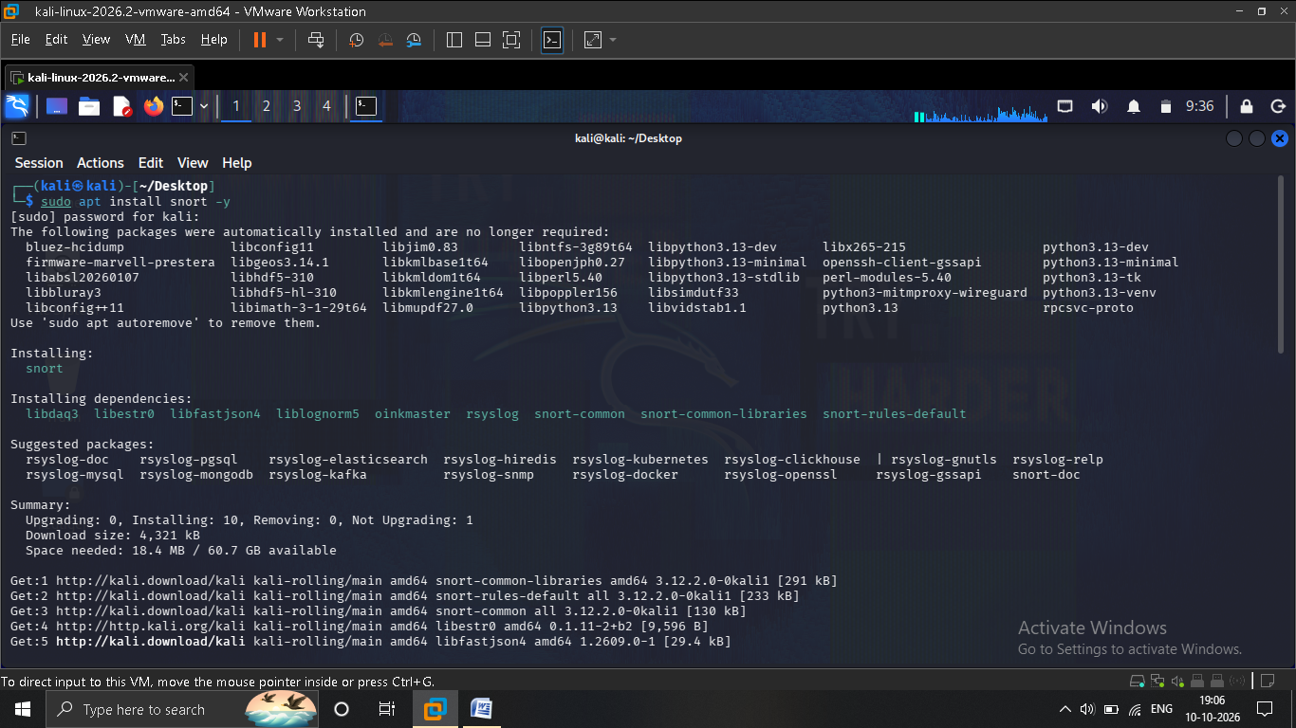

Evidence 2 — Checking the Snort version
The installed version was checked to confirm the installation. The project records Snort version 3.12.2.0.
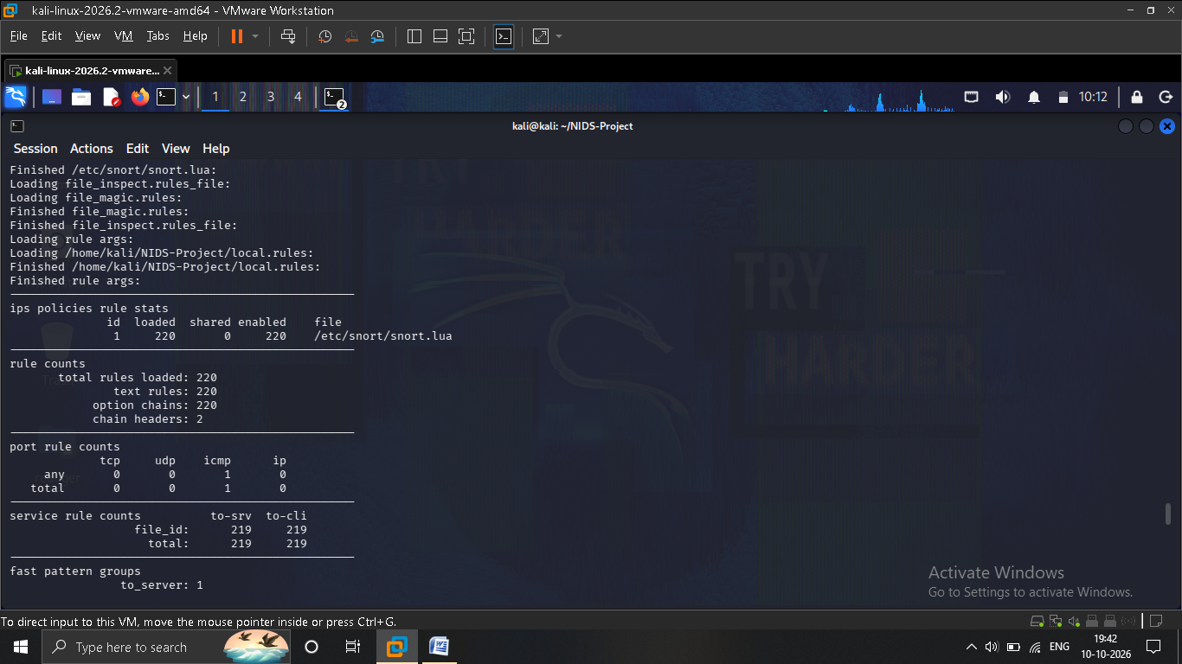

Evidence 3 — Creating the detection rule
A custom ICMP detection rule was created in local.rules. The rule is intended to generate an alert when matching ICMP traffic is observed.
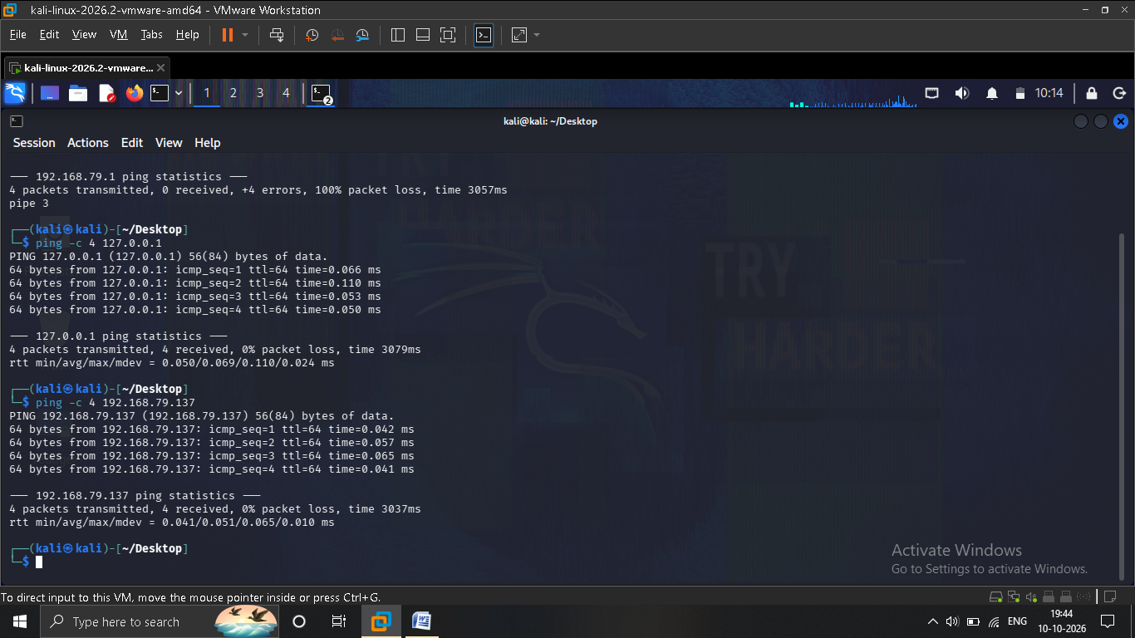

Evidence 4 — Starting monitoring
Snort was launched to monitor the eth0 interface with the lab configuration.
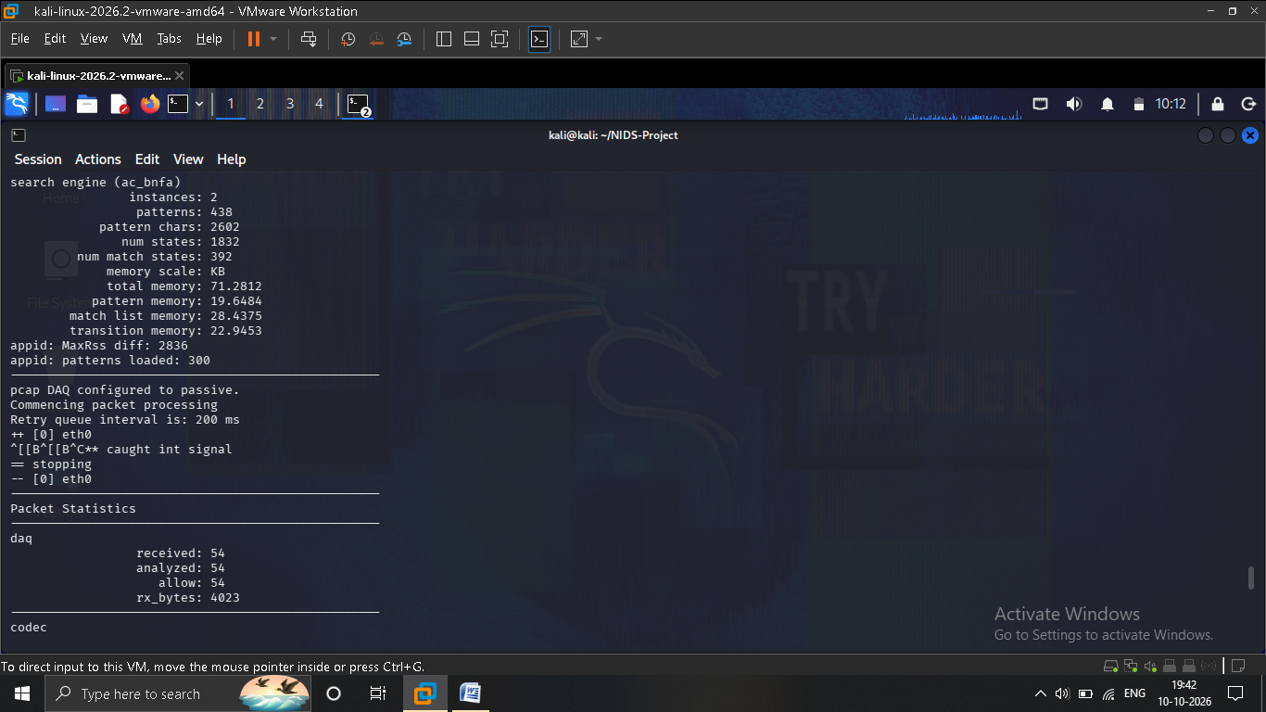

Evidence 5 — Generating test traffic
Test traffic was generated with ping in a second terminal to exercise the detection rule.
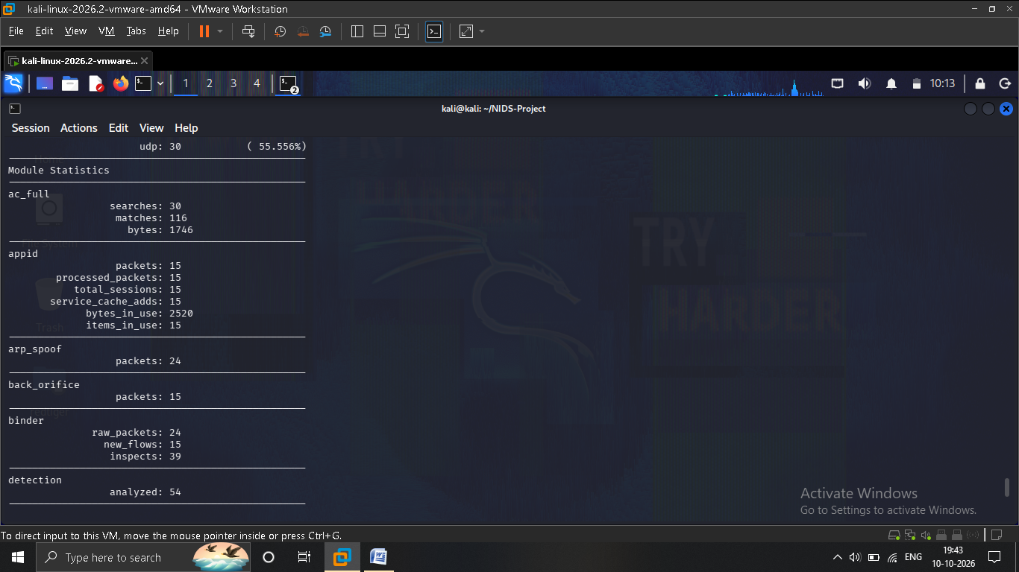

Evidence 6 — Reviewing terminal output
The terminal output was reviewed to determine whether matching packets and alerts were observed.
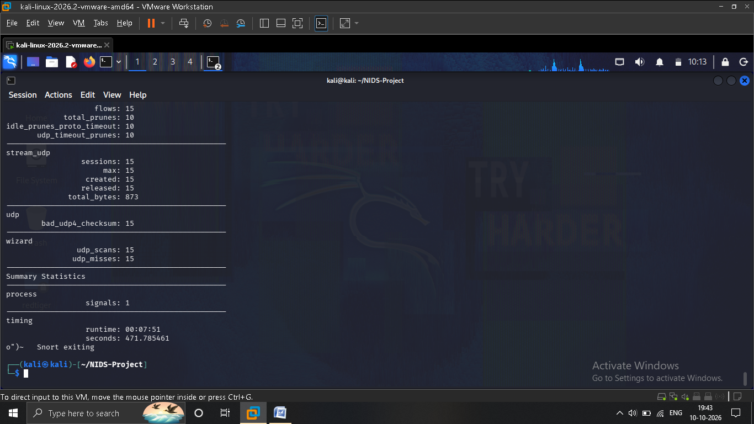

5. Testing and Observed Results
Snort 3.12.2.0 was configured on Kali Linux and monitored traffic through the eth0 interface. The custom ICMP detection rule was loaded successfully.
The original notes contain two observations: one monitoring pass recorded 54 packets without a confirmed custom-rule alert in that particular output; a later testing section reports alerts with the message “Lab ICMP traffic detected” for ICMP traffic observed between 192.168.79.137 and 8.8.8.8. The later result states that the custom rule detected matching traffic and generated alerts.

Result
The reported successful test detected matching ICMP traffic and generated the configured alert.

What this demonstrates
- A NIDS can inspect traffic visible on its monitored interface.
- A custom rule can be used to look for a specific protocol or traffic pattern.
- Testing should include both generating traffic and verifying the resulting alert output.

6. Conclusion
The project demonstrated the basic working of a Network Intrusion Detection System using Snort on Kali Linux. A custom ICMP rule was configured and, during the reported successful test, generated alerts for matching network traffic. The exercise provided practical exposure to rule configuration, packet monitoring, and reviewing detection output.

Project takeaway
A useful detection workflow is to define a clear rule, generate authorized test traffic, monitor the correct interface, and verify alerts in the output. A lack of alerts in one test should be investigated rather than assumed to mean the rule is working.

End of Report

