Customer Churn Analysis Report
IBM Telco Customer Dataset

Author: Abhijeet Kumar Sinha
Tools: MySQL · Python · Pandas · Matplotlib · Seaborn
May 2026
Project At a Glance
Total Customers | Churned Customers | Churn Rate
7,032 | 1,869 | 26.58%

1. Executive Summary

This report presents a comprehensive analysis of customer churn behavior for a telecom company using the IBM Telco Customer Churn Dataset. The analysis was conducted using MySQL for querying and aggregation, and Python (Pandas, Matplotlib, Seaborn) for exploratory data analysis and visualization.

The primary objective was to identify the key drivers of churn and produce actionable business insights to support customer retention strategies. The dataset contains 7,032 customer records with attributes spanning demographics, contract type, internet service, monthly charges, payment method, and tenure.

The analysis reveals that churn is heavily influenced by contract flexibility, internet service type, payment method, and how long a customer has been with the company. These insights can guide targeted interventions to reduce churn and protect revenue.

2. Dataset Overview

Dataset: IBM Telco Customer Churn Dataset

Attribute | Details
Total Records | 7,032 customers
Total Columns | 21 features
Target Variable | Churn (Yes / No)
Key Features | Contract, InternetService, MonthlyCharges, Tenure, PaymentMethod
Tools Used | MySQL, Python, Pandas, Matplotlib, Seaborn, Jupyter Notebook

3. Churn Distribution

Out of 7,032 total customers, 1,869 churned (26.58%) and 5,163 stayed (73.42%). This imbalance is important to note — while a 26.58% churn rate is substantial, it means the business retains nearly 3 out of every 4 customers. The focus should be on the patterns within the churned segment.

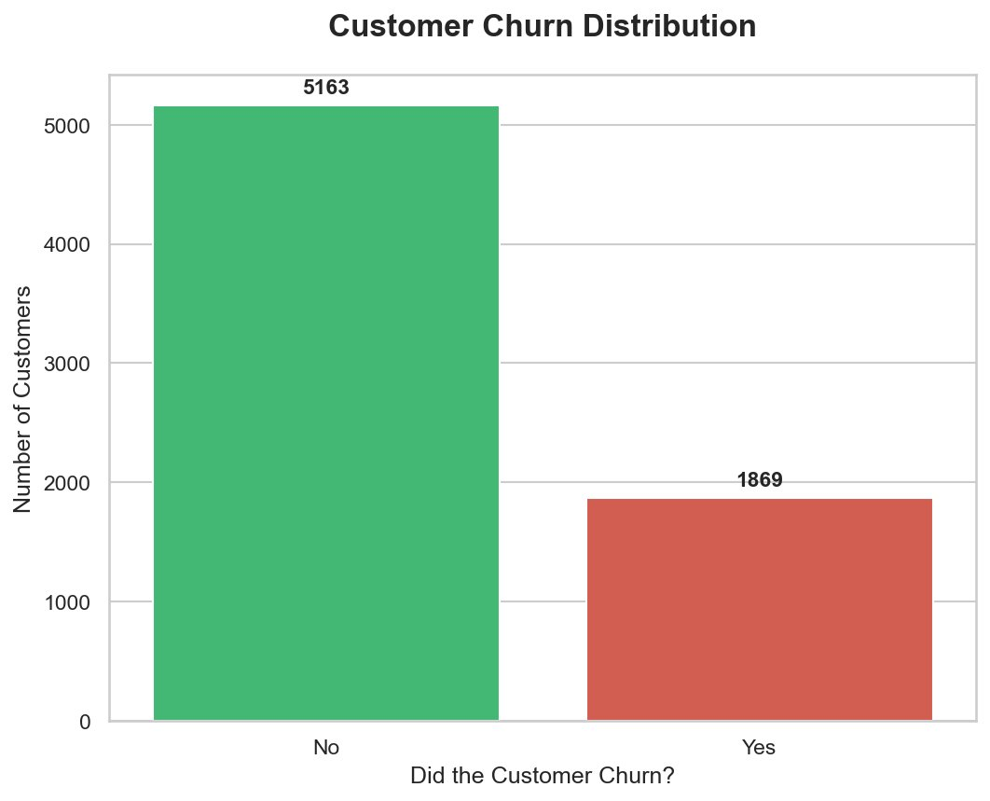
Figure 1: Customer Churn Distribution — 5,163 retained vs 1,869 churned.

4. Churn by Contract Type

Contract type is the single strongest predictor of churn in this dataset. The data shows a dramatic gradient across the three contract types:
- Month-to-month: 42.71% churn rate — nearly 4 in 10 customers leave
- One year: 11.28% churn rate — a 4× improvement over month-to-month
- Two year: 2.85% churn rate — the most loyal customer segment

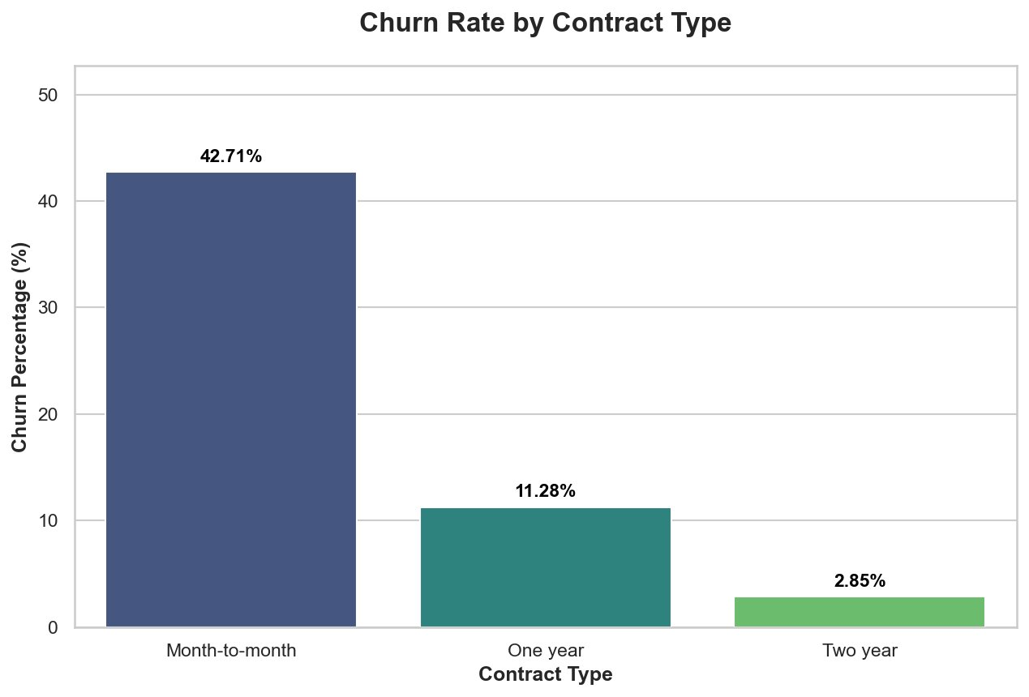
Figure 2: Churn Rate by Contract Type — month-to-month contracts dominate churn.

Business Implication: Incentivizing customers to upgrade from month-to-month to annual or biennial contracts is likely to be the single most effective retention lever available.

5. Churn by Internet Service Type

Internet service type reveals another sharp divide in churn behavior:
- Fiber Optic: 41.9% churn rate — the highest risk service type
- DSL: 19.0% churn rate — moderate risk
- No Internet Service: 7.4% churn rate — lowest risk

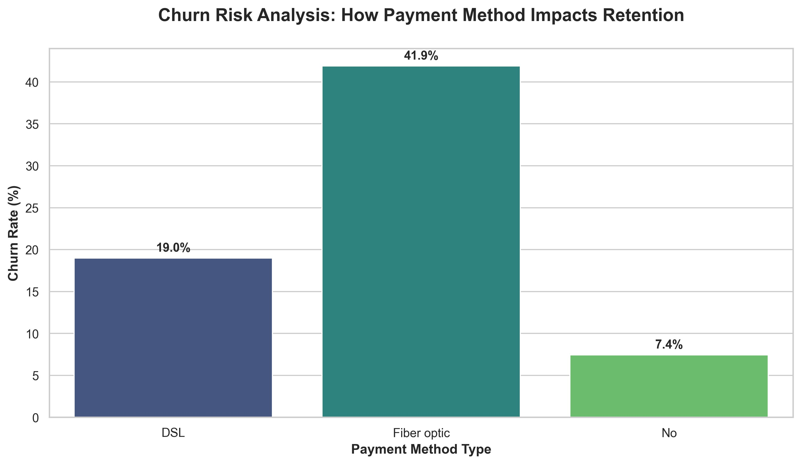
Figure 3: Churn Rate by Internet Service Type — fiber optic customers churn at more than twice the rate of DSL customers.

The elevated churn in fiber optic users likely reflects price sensitivity and unmet quality expectations, since fiber optic is the premium, higher-priced service. Combined with the payment method findings below, these customers represent the highest-risk segment in the dataset.

6. Churn by Payment Method

Payment method is a significant behavioral signal — customers who pay manually tend to churn at much higher rates than those on automatic payment plans:
- Electronic Check: 45.29% churn rate — highest of all payment methods
- Mailed Check: 19.20% churn rate
- Bank Transfer (Automatic): 16.73% churn rate
- Credit Card (Automatic): 15.25% churn rate — lowest churn

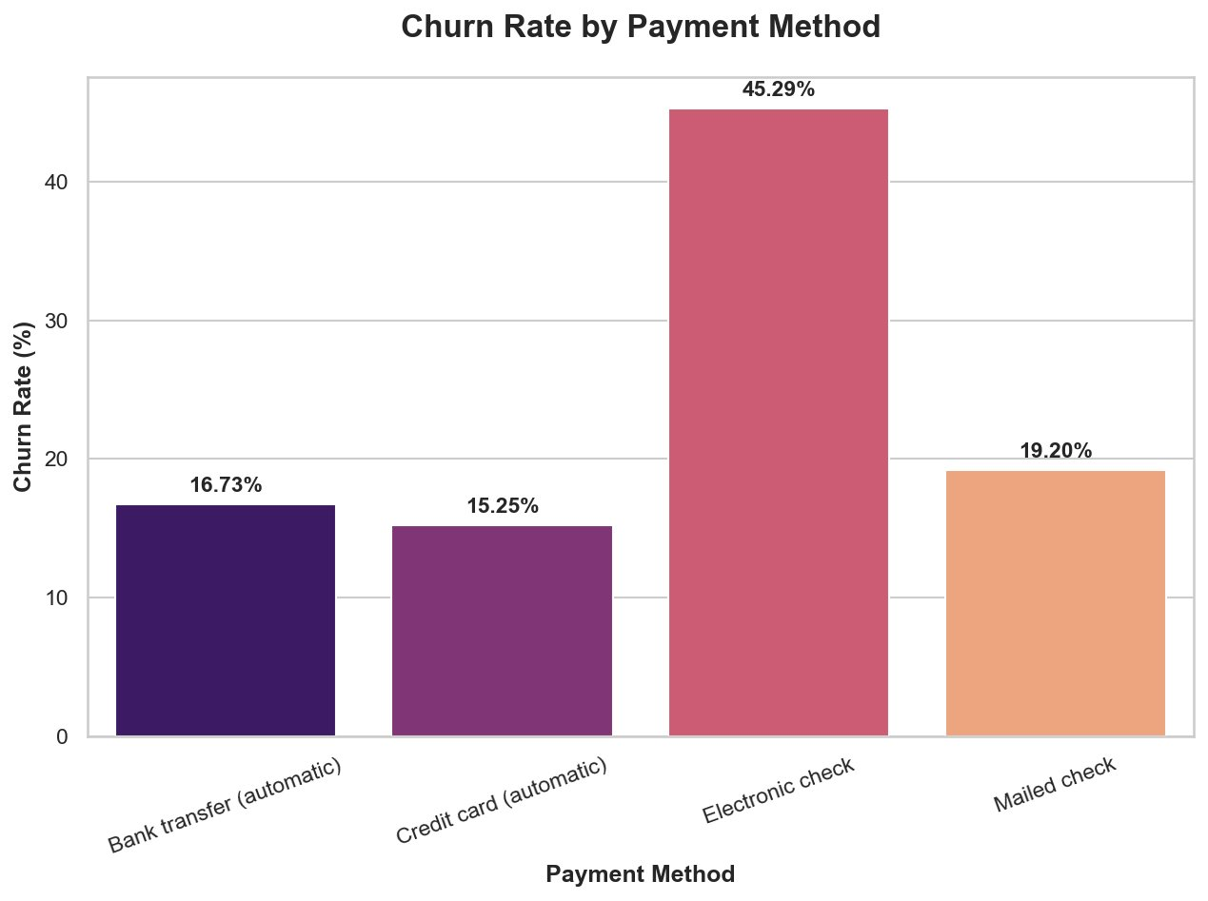
Figure 4: Churn Rate by Payment Method — electronic check users have the highest churn risk.

Business Implication: Electronic check users are likely disengaged or in a trial mindset. Encouraging auto-payment enrollment through incentives (e.g., a small discount) could reduce churn in this segment significantly.

7. Monthly Charges vs. Churn

Churned customers had notably higher monthly charges compared to those who stayed. The median monthly charge for churned customers was approximately $80, versus $64 for retained customers. The interquartile range for churned customers is also compressed in the upper range ($57–$94), suggesting that high-billing customers are disproportionately at risk.

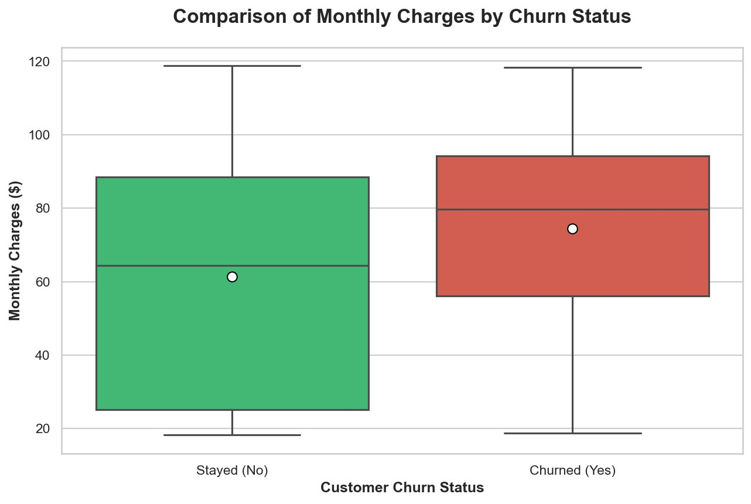
Figure 5: Comparison of Monthly Charges by Churn Status — churned customers had higher median bills.

This finding, combined with the fiber optic and electronic check signals, suggests that a 'high bill + manual payment + no long-term contract' combination is the highest-risk customer profile in the dataset.

8. Customer Tenure vs. Churn

Tenure — how long a customer has been with the company — is strongly inversely correlated with churn. Customers who left had a median tenure of around 10 months, while those who stayed had a median of approximately 38 months.

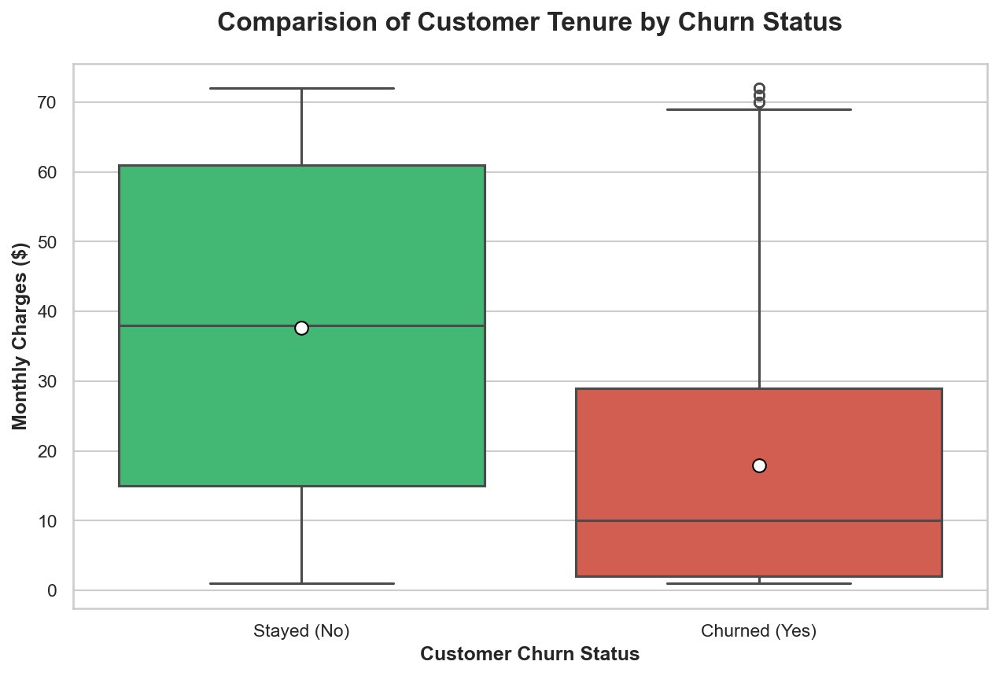
Figure 6: Customer Tenure by Churn Status — churned customers had significantly shorter tenure.

The segmentation analysis from the SQL queries further confirms this:
- New Customers (<1 year): Highest churn probability
- Regular Customers (1–4 years): Moderate retention
- Loyal Customers (4+ years): Very low churn risk

Business Implication: The first year of a customer relationship is the most critical for retention. Onboarding programs, early-tenure incentives, and proactive check-ins can substantially reduce early-stage churn.

9. Correlation Analysis

The correlation heatmap provides a quantitative view of how numeric variables relate to churn (Churn_bin = 1 for churned, 0 for stayed):

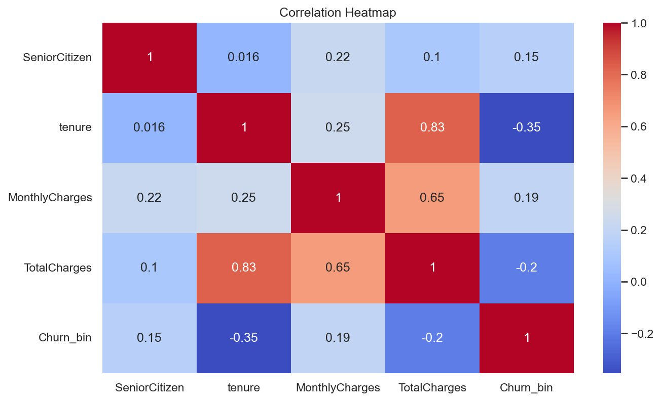
Figure 7: Correlation Heatmap — tenure has the strongest negative correlation with churn.

Variable | Correlation with Churn
Tenure | -0.35 (strong negative — longer tenure = less churn)
MonthlyCharges | +0.19 (positive — higher bill = more churn)
TotalCharges | -0.20 (negative — driven by tenure relationship)
SeniorCitizen | +0.15 (slight positive — seniors churn slightly more)

Key finding: Tenure is the most numerically significant predictor among continuous variables, reinforcing the importance of early retention efforts.

10. High-Risk Customer Profile

Combining all analysis dimensions, the highest-risk customer can be characterized as follows:

Dimension | High-Risk Profile | Low-Risk Profile
Contract | Month-to-month | Two year
Internet Service | Fiber Optic | DSL or None
Payment Method | Electronic Check | Credit Card (Auto)
Tenure | < 12 months | 48+ months
Monthly Charges | > $70/month | < $40/month

The SQL analysis identified that the Month-to-month + Fiber Optic combination has the single highest churn rate of any segment combination in the dataset. Customers matching all five high-risk criteria above should be treated as immediate intervention targets.

11. Revenue Impact

The churn problem is not just a customer count issue — it has direct financial consequences:
- Total monthly revenue from all customers combined represents the baseline.
- Revenue lost due to churned customers (those who left) represents a significant recurring monthly loss.
- Loyal customers (4+ years) generate the highest total revenue segment despite being a smaller group.

Retention is inherently more cost-efficient than acquisition. Reducing the churn rate even by 5 percentage points — from 26.58% to ~21% — would retain hundreds of additional customers and meaningfully improve monthly recurring revenue.

12. Key Insights & Recommendations

12.1 Key Findings
- Month-to-month contracts have a 42.71% churn rate — 15× higher than two-year contracts
- Fiber optic internet service customers churn at 41.9%, the highest of any service type
- Electronic check payment users have a 45.29% churn rate — 3× higher than automatic payment users
- Churned customers had a median tenure of ~10 months vs ~38 months for loyal customers
- Higher monthly charges are positively correlated with churn (correlation: +0.19)
- Senior citizens show slightly elevated churn (+0.15 correlation)

12.2 Recommendations
- Contract Upgrade Campaign: Offer discounts or perks to month-to-month customers who commit to a one- or two-year plan. Even moving a fraction of this segment to annual contracts can dramatically reduce churn.
- Fiber Optic Retention Program: Investigate service quality pain points (speed, reliability, support) for fiber optic subscribers. Proactive outreach and satisfaction surveys can catch at-risk customers early.
- Auto-Pay Enrollment Drive: Incentivize electronic check users to switch to automatic payment. A small monthly credit for auto-pay enrollment is a proven retention tactic.
- First-Year Onboarding Focus: Implement a structured 90-day and 6-month onboarding program for new customers. The data shows the highest churn risk is in the first 12 months.
- High-Value Customer Monitoring: Use the window function ranking (from SQL analysis) to track high-spending customers and flag those with short tenure or month-to-month contracts for proactive outreach.
- Senior Citizen Outreach: Given the slightly elevated churn among senior customers, consider dedicated support programs or simplified plan options for this demographic.

13. Future Improvements

- Build a machine learning classification model (Logistic Regression, Random Forest, XGBoost) to predict individual customer churn probability scores
- Create an interactive Power BI or Tableau dashboard for real-time churn monitoring
- Perform advanced feature engineering — adding interaction terms such as (high bill × short tenure × month-to-month)
- Expand the dataset with customer support ticket data to identify service quality as a churn predictor
- Deploy a churn prediction API integrated into the CRM system for automated early-warning alerts

14. Project Structure & Tools

Component | Details
Dataset | IBM Telco Customer Churn (7,032 rows, 21 columns)
SQL Analysis | MySQL — 4 sections: Data Understanding, Churn Analysis, Revenue Analysis, Customer Behavior
Python EDA | Jupyter Notebook — Pandas, Matplotlib, Seaborn
Visualizations | 8 charts covering distribution, contract, internet, payment, tenure, charges, heatmap
Key SQL Techniques | CTEs, Window Functions (RANK), CASE WHEN, GROUP BY, AVG aggregations

Report prepared by Abhijeet Kumar Sinha | Customer Churn Analysis Project | May 2026

