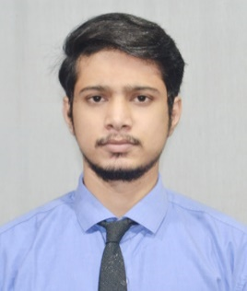**RESUME**

**ABHIJEET KUMAR SINHA**

+91 8670900329

Email Id: [abhijeetsinha0410@gmail.com](mailto:abhijeetsinha0410@gmail.com)

**OBJECTIVE**

To work in an organization which can help me in enhancing my skills, strengthening my knowledge and increase my abilities for the organizational growth as well as myself.

**EXPERIENCE**

**Data Analyst** (4 month)

**Intelligent Image Management Inc**, Kolkata.

**EDUCATIONAL QUALIFICATION**

* B.Tech in Electronics & Communication Engineering from 2021

Brainware Group of Institutions-SDET.

* ICSE(12th) from The St. Xavier’s School, Malda. 2016
* ICSE(10th) The St. Xavier’s School, Malda. 2014

**OTHER ACADAMIC DETAILS**

* Project on Embedded System & Robotics.
* Project on IOT based Smart Public Distribution System.

**TECHNICAL SKILLS**

* HTML, CSS, JavaScript, Basic (JAVA & C language).

**STRENGTH & HOBBIES**

* Hard & Smart Working
* Honest & Punctual
* Good Communication Skill (English, Hindi, Bengali)
* Football, Cricket, PC Games.

**PERSONAL DETAILS**

Father’s Name : Ashok Prasad Ram

Date of Birth : 04-11-1997

Address : 121, Greenpark Block A, Jessor Road Lake Town, Kolkata.

Date…………………… (Abhijeet Kumar Sinha)