CS545 Software Design Patterns

Assignment 1 Due Date: March 7, 2018 [Abhijeet Sharma (B15102)]

It is assumed that all of you are familiar with functionality of an elevator. You are assigned a role of System Analyst and you are required to create all artifacts which are inputs to the design of an elevator controller. The artifacts include Actors, Use case(s) & relationships between them, System Sequence Diagram(s), & Domain model. You may refer Applying UML & Design Patterns for help.

USE Case Diagram
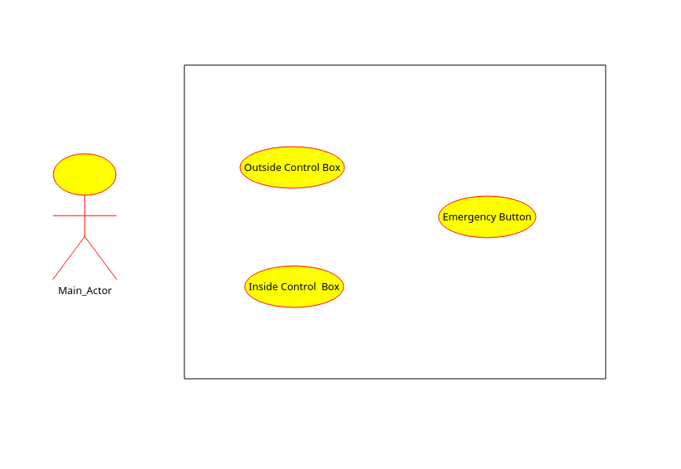
FIG-1 USE-CASE Diagram of Elevator

In above diagram, I have defined three use-case,

- Outside Control Box : - The use case includes a control pannel just outside the gate of lift on every floor, it would have two buttons, up and down.
- Inside Control Box : - This use case is a control box situated inside lift. It contains buttons mapped for every floor.
- Emergency Button : - This emergency button will stop all automatic lift functions when pressed . It should be invoked during emergency.

Note :
    - My implementation of elevator system, is a very basic one.
    - Door should be open manuallly.
    - Door should be closed manually.

Domain Model
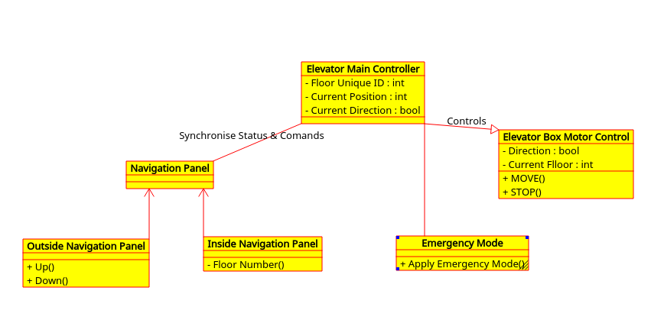
Fig-2 Domain Model of Elevator system

In fig 2 I have defined a main class “Elevator Main Controller” which specialises into one subclasses “Elevator Box Motor Control” . The “Elevator Main Controller” has three attributes Floor Unique ID(int) , Current Position (int) and Current Direction (bool). The “Elevator Box Motor Control” has two attributes simlar to main Controller class , but it also has two fucntions Move() & Stop() which will respectively move and stop our lift motors and lift.

The “Navigation Panel ” is a compotion of Outside Navigation Panel and Inside Navigation Panel which all together gives functionality to control lift y actor.

