Different booting mode -

* Emergency Mode: This mode will help to trouble the OS If any issue occurred and due to this server is not booting like control+d issue.
* Rescue Mode: This mode will bring the system in single user mode with limited access to trouble the OS issue. Ex.
* Troubleshooting Mode: In this mode we will boot the system by CD and then will go to rescue mode to troubleshoot the system. EX. Grub configuration issue.

How to go to this mode.

In grub screen press e on kernel then type systemd.unit=rescue.target then ctrl+x.

1. **Grub configuration corrupted or deleted issue.**

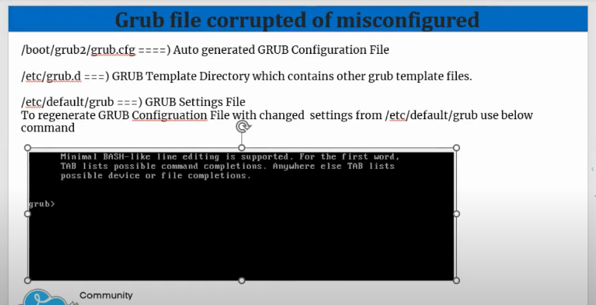

To fix this issue we have to boot the system with CD and have to install/recover the /boot/grub2/grub.conf file.

* This is rescue mode under troubleshoot mode.
* Attach CD and then reboot
* Press 1 for continue.
* Change the root file system as suggested chroot /mnt/sysroot
* List the disk name convention using lsblk.
* Then install the grub2 - grub2-install /dev/sda
* Grub2-mkconfig -o /boot/grub2/grub.cfg
* Exit and exit
* Now system will boot.

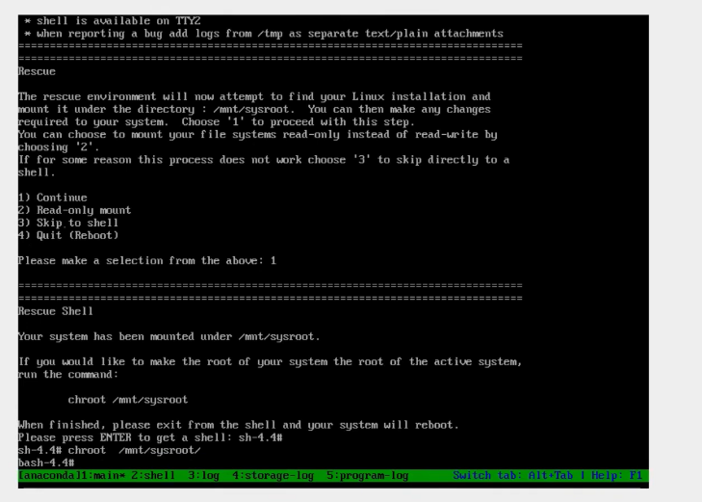

2. MBR Corrupted or Missing

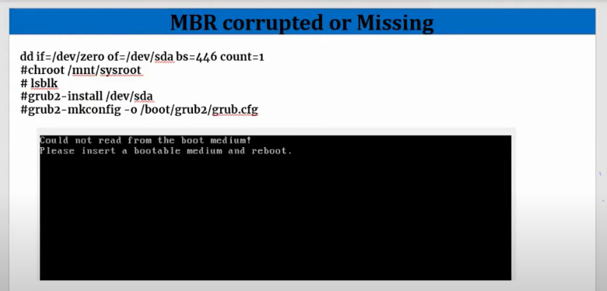

Generate the issue manually by running below command

Dd if=/dev/zero of=/dev/sda bs=446 count=1

Execute and the reboot.

**Fix**

* This is rescue mode under troubleshoot mode.
* Attach CD and then reboot
* Press 1 for continue.
* Change the root file system as suggested chroot /mnt/sysroot
* List the disk name convention using lsblk.
* Then install the grub2 - grub2-install /dev/sda
* Grub2-mkconfig -o /boot/grub2/grub.cfg
* Exit and exit
* Now system will boot. Same as recover grub config file.

**3. Control D Error**

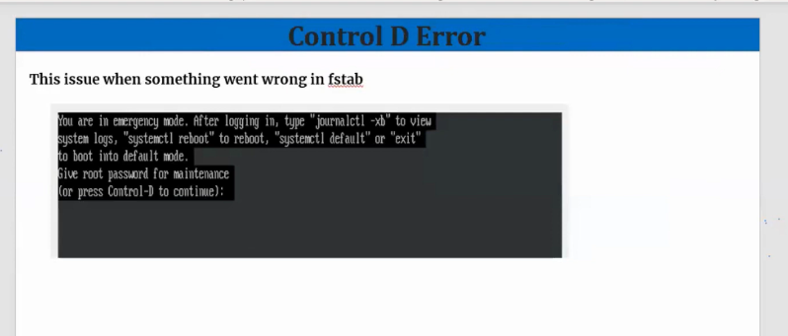

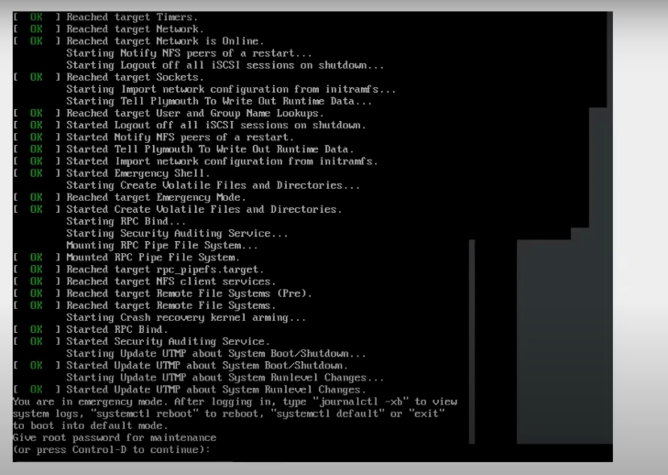

This issue will come when any issue related to file system like disk missing wrong entry in fstab file.

Fix:

1. Give the root password and login.
2. Edit the fstab file correctly and fix the file system issue
3. Reboot; done
4. Kernel panic Issue.
   1. This issue will come if any hardware issue
   2. Initramfs file corrupted or deleted
   3. After update kernel have some issue

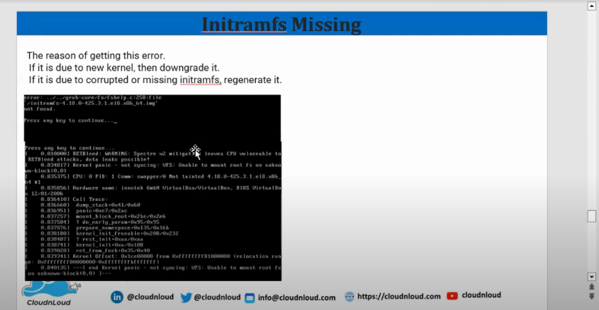

Fix:

1. If hardware issue, then have to identify the hardware
2. If update kernel updates this issue coming, then while booting select the previous kernel and boot and remove the corrupted kernel and again install.
3. If initramfs is corrupted, then regenerate the initramfs or if it’s deleted then install it by using command.

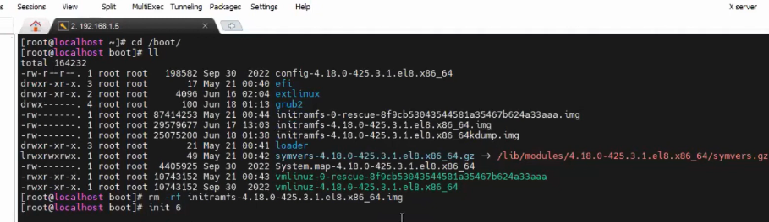

* Manually create the issue by delete the /boot/initramfs file

Then boot the system in rescue mode in grub screen choose rescue kernel to boot

Then perform below steps.

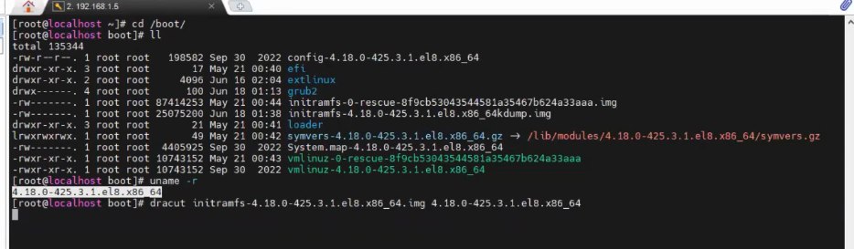

Then reboot.

Fixed

If initramfs corrupted, then perform below steps

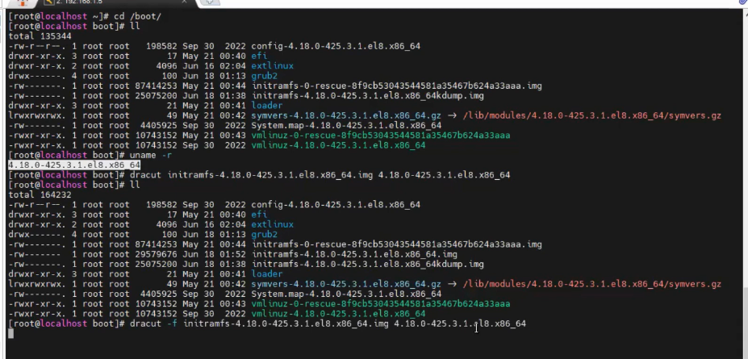

Then reboot.

Fixed

1. **If critical file missing**

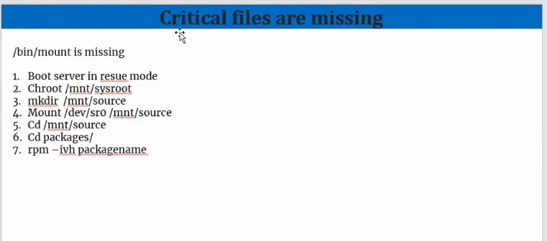

Reboot the system

Fixed

