**H-Conv-Buck**

DCDCBuck_S_60_L40.bit : load 40% Soucce: 60%

DC-DC proposed: Tested on dec 5 & 6:

DC-DC proposed: updated constants module.

Values used as of 12th Dec

Location of bitstream:

G:\My Drive\PSU\Work\GRA\AP-GP\repo\ap-gp-codebase\H-conv-buck\bitstream\DCDCBuck_prop_S_60_L40.bit

@ 300Vin Vbus= 500, 6A Iin, RL= 4X22Ohm, C tiny = 6.5nF, Is = 6A, IL= 9A

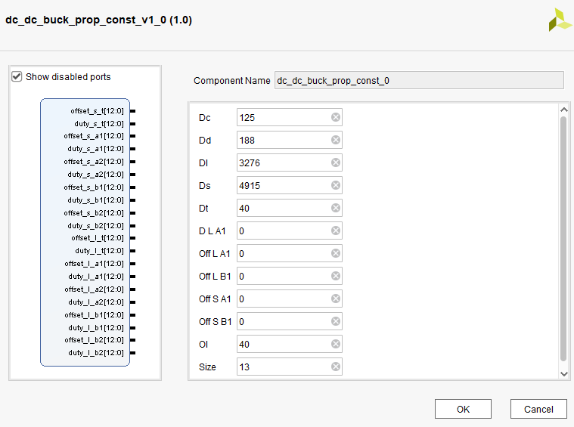

@ 300Vin Vbus= 500, 2.5A Iin, RL= 56Ohm, C tiny = 6.5nF, Is = 2.5A, IL= 3.5A

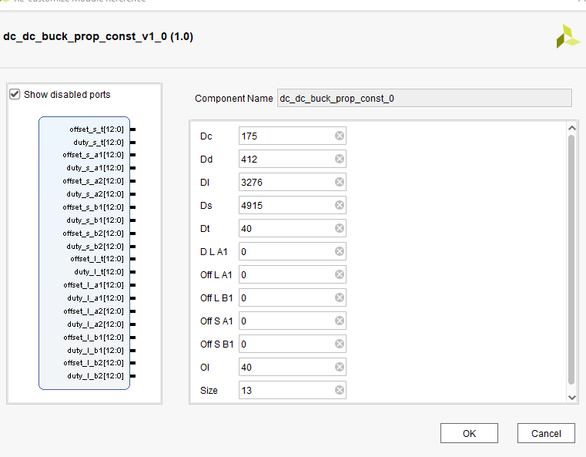

DCDCBuck_15khz-300Vin-2.5AIin_Ctiny6.5uF_v2.bit

