EAST WEST INSTITUTE OF TECHNOLOGY
(An Autonomous Institute under VTU, Belagavi)
#63, Off Magadi Main Road, Vishwaneedam Post, Near Anjananagar,
Bengaluru - 560091.
Department of Information Science and Engineering
Academic Year: 2025-26

An Innovative project work report
on

AI-BASED CURRENCY CLASSIFIER
FOR VISUALLY IMPAIRED USERS

Submitted in partial fulfillment of the requirements for the award of the degree of
BACHELOR OF ENGINEERING
In
INFORMATION SCIENCE AND ENGINEERING

Submitted by
[Team Member 1 Name] [USN]
[Team Member 2 Name] [USN]
[Team Member 3 Name] [USN]
[Team Member 4 Name] [USN]

Under the Guidance of
[Guide Name]
Assistant Professor, Department of Information Science and Engineering

EAST WEST INSTITUTE OF TECHNOLOGY
(An Autonomous Institute under VTU, Belagavi)
#63, Off Magadi Main Road, Vishwaneedam Post, Near Anjananagar,
Bengaluru - 560091

CERTIFICATE OF PROJECT COMPLETION
This is to certify that the students listed above have successfully completed the course BSDID208 - Innovation and Design Thinking Laboratory Project Work for the Academic Year 2025-26, as prescribed under the 2025 Scheme.
The project entitled "AI-BASED CURRENCY CLASSIFIER FOR VISUALLY IMPAIRED USERS" was undertaken and completed under the guidance of:
Project Guide: [Guide Name]
Designation & Department: Assistant Professor, Department of Information Science and Engineering
The team has satisfactorily completed the project work and fulfilled all the requirements as specified in the curriculum.
Project Guide | Examiner | Head of Department
[Guide Name]  Signature Signature Signature  Date: DD/MM/YYYY Date: DD/MM/YYYY Date: DD/MM/YYYY | [Examiner Name]  Signature Signature Signature  Date: DD/MM/YYYY Date: DD/MM/YYYY Date: DD/MM/YYYY | [HOD Name]  Signature Signature Signature  Date: DD/MM/YYYY Date: DD/MM/YYYY Date: DD/MM/YYYY

ACKNOWLEDGEMENT
We would like to express our sincere gratitude to East West Institute of Technology for providing an excellent academic environment and the necessary facilities to successfully carry out this project.
We extend our heartfelt thanks to our respected Principal and Dean for their constant encouragement, support, and guidance in fostering academic excellence and innovation.
We also express our sincere gratitude to the Head of the Department, Department of Information Science and Engineering, for continuous encouragement, guidance, and support throughout the project work.
Our sincere thanks go to our project guide, [Guide Name], Assistant Professor, Department of Information Science and Engineering, for invaluable guidance, constructive suggestions, patience, and continuous support, which greatly contributed to the successful completion of this project.
We are also grateful to our parents for their unwavering support, motivation, and encouragement throughout our academic journey. Finally, we thank our teammates for their cooperation, dedication, and collaborative efforts, which played a significant role in the successful completion of this project.
Regards,
[Team Member 1 Name]

DECLARATION
We hereby declare that the project entitled "AI-BASED CURRENCY CLASSIFIER FOR VISUALLY IMPAIRED USERS" submitted to the Department of Information Science and Engineering is an original work carried out by us under the guidance of [Guide Name], Assistant Professor, Department of Information Science and Engineering.
We affirm that the work presented in this report has not been submitted, in part or full, for any other degree at this or any other institution. All sources of information and references used in this report have been duly acknowledged.
We take full responsibility for the content and authenticity of this project report.
[Team Member 1 Name]
[USN]

ABSTRACT
Cash transactions remain common across India, and visually impaired users often face difficulty identifying the denomination of currency notes quickly and confidently. This project addresses that need by developing an accessible currency classifier that captures a note image through a camera, processes the frame, identifies the denomination, and gives both visual and spoken feedback.
The solution is implemented in two complementary forms. The desktop version uses Python, OpenCV, NumPy, and pyttsx3 to perform template-based recognition from a webcam feed and announces the detected denomination aloud. The web version uses HTML, CSS, and JavaScript to access the device camera and send the captured image to a Roboflow inference endpoint, with browser speech synthesis providing immediate audio output.
Together, these modules create a practical accessibility-focused system that is easy to use, low cost, and suitable for demonstration in controlled environments. The project shows how computer vision and voice feedback can be combined to support independent cash handling for visually impaired users while also leaving room for future upgrades such as deep learning, offline mobile deployment, and counterfeit-note detection.

TABLE OF CONTENTS
Particulars | Page No.
Acknowledgement | i
Declaration | ii
Abstract | iii
Table of Contents | iv
List of Figures | v
List of Tables | vi
1 Introduction | 01 - 02
2 Review of Literature | 03 - 04
3 Methodology | 05 - 07
4 Project Overview | 08 - 09
5 Results & Discussion | 10 - 11
6 Conclusion and Scope for Future Work | 12
7 References | 13

LIST OF FIGURES
Sl. No. | Description | Page No.
1 | Currency Classifier Workflow | 08
2 | System Architecture and Module Integration | 09

LIST OF TABLES
Sl. No. | Description | Page No.
1 | Test Scenarios and Observations | 11

CHAPTER 1
INTRODUCTION
Currency recognition is an important everyday task, especially in a country like India where cash transactions are still widely used in shops, markets, travel, and small businesses. For visually impaired users, identifying the denomination of a note quickly and accurately can be difficult because notes differ in size, design, color, and texture, and those differences are not always easy to distinguish by touch alone. A reliable recognition system can reduce dependence on others and improve confidence during daily transactions.
The project titled AI-Based Currency Classifier for Visually Impaired Users was developed to provide a simple and accessible way to identify Indian currency notes using a camera feed. The system is designed to display the detected denomination on screen and also speak the value aloud, making the result accessible even when the user cannot see the display clearly.
The desktop version uses OpenCV-based template matching. It captures the live webcam frame, converts the image to grayscale, compares it against stored template images, and selects the note with the highest similarity score. If the best match crosses the confidence threshold, the note denomination is highlighted on the screen and announced through a text-to-speech engine. This makes the project lightweight and easy to demonstrate on a standard laptop without requiring a powerful GPU or complex training pipeline.
In addition to the local desktop approach, a web version is included for broader usability. The browser-based interface uses the device camera and sends the captured frame to a Roboflow inference API. The browser then speaks the detected denomination using speech synthesis. This dual approach makes the project flexible, because it can work offline in template-based mode or online in cloud-assisted mode depending on the available setup.
Existing Technologies Used
The project uses a combination of established computer vision and web technologies. Python is used for the desktop logic, while OpenCV handles webcam capture, grayscale conversion, and template matching. NumPy supports image-array manipulation, and pyttsx3 provides offline text-to-speech output. For the browser version, HTML, CSS, and JavaScript are used to create the interface, access the camera, capture frames, and communicate with the Roboflow detection endpoint.
The dataset folder follows a simple naming convention where template images are stored as 10.jpg, 20.jpg, 50.jpg, 100.jpg, 200.jpg, and 500.jpg. This naming makes it easy for the program to map each stored image to a currency denomination. The web version additionally relies on the browser speech synthesis API, which is convenient for quick demonstrations and does not require a separate local voice engine.

CHAPTER 2
REVIEW OF LITERATURE
1. A large number of banknote recognition systems have used classical image-processing approaches such as edge detection, texture comparison, shape matching, and template matching. These methods are attractive because they are simple to implement and can run on modest hardware. However, they are sensitive to lighting, blur, and the exact positioning of the note in front of the camera.
2. More recent research has moved toward deep learning and convolutional neural networks for currency recognition. These models generally provide better robustness against rotation, partial occlusion, and background noise, but they require more data, more training time, and stronger compute resources. For student projects, this often makes them harder to deploy quickly in a classroom environment.
3. Assistive technology research consistently emphasizes the value of voice feedback for visually impaired users. Systems that provide spoken output reduce the need for visual confirmation and make the recognition process more independent. This is especially useful in point-of-sale situations where the user may need to confirm a denomination immediately.
4. Browser-based vision systems have also become more common because they allow a camera-enabled interface to run without installing a heavy desktop application. Such systems are useful for demonstrations, mobile devices, and cross-platform access, although they may depend on network connectivity when cloud inference services are used.
5. Overall, the literature suggests that a practical currency-classification solution should balance accuracy, speed, simplicity, and accessibility. The present project follows that direction by combining a lightweight desktop recognizer with an optional web-based scanning interface.

CHAPTER 3
METHODOLOGY
3.1 Literature Survey
A focused survey of currency-recognition and visually assisted computer vision systems was carried out before the implementation phase. The survey helped identify the strengths of simple template matching for a small fixed dataset and also showed the limitations of such approaches when the input image is tilted, blurred, or poorly lit.
3.2 Motivation for the Project
The main motivation for this project was the need for an affordable and easy-to-use note classifier that can assist visually impaired users during daily cash handling. Existing commercial solutions are often expensive, unavailable offline, or require specialized devices. This project aims to offer a practical classroom-level solution that runs on a normal laptop or browser and gives immediate audio feedback.
3.3 System Components and Tools
The system uses Python, OpenCV, NumPy, and pyttsx3 for the desktop module. On the web side, HTML, CSS, JavaScript, and the browser speech synthesis API provide the interface and voice output. The optional cloud path uses a Roboflow detection endpoint. The dataset folder contains template note images that are matched against live webcam frames.
Component | Purpose
OpenCV | Capture webcam frames and perform template matching
pyttsx3 | Offline speech output for denomination announcements
HTML/CSS/JS | Browser interface for the scanning experience
Roboflow API | Optional cloud-based inference for the web module
NumPy | Array operations for image processing
3.4 Core Detection Logic
1. Capture a frame from the webcam.
2. Convert the frame to grayscale.
3. Compare the frame with each stored currency template.
4. Select the denomination with the highest similarity score.
5. If the score crosses the threshold, draw a bounding box and speak the result.
6. In the web version, send the frame to the Roboflow endpoint and speak the best class returned by the model.
3.5 Development Process
Development started with the desktop recognizer, because it was the quickest way to test the core idea. The template images were organized in the dataset folder and the matching threshold was tuned experimentally. After the desktop flow worked, the web interface was added so that the project could be demonstrated in a browser using a camera-enabled device.
3.6 Testing
Testing was carried out using different currency denominations, multiple note positions, and different lighting conditions. The system was checked for correct denomination display, proper voice output, and safe repeated scanning behavior. The desktop version worked best when the note was front-facing and clear, while the web version performed well when the camera frame contained a sharp note image and the network connection was stable.

CHAPTER 4
PROJECT OVERVIEW
4.1 Planning and Design
The project was planned as a small but complete accessibility tool. The first design decision was to keep the recognition process lightweight so that it could run on a regular laptop without special hardware. The second decision was to include voice output so that the result would remain useful even when the user could not read the screen. The third decision was to provide both desktop and web options, since different users may prefer different devices.
4.2 Logical Flow
The logical flow starts from camera capture, moves to preprocessing, then to matching or inference, and ends with the visual and spoken result. In the desktop module, the frame is compared against stored note templates. In the web module, the frame is posted to a Roboflow model, and the response is interpreted as the most likely denomination. The result is then displayed in the interface and spoken immediately so that the user gets both visual and audio confirmation.
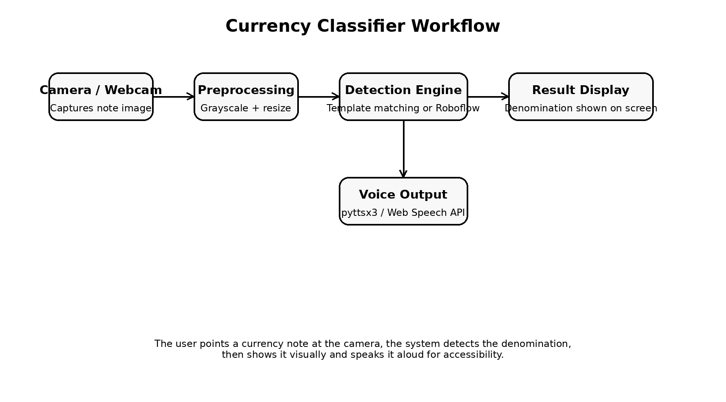
Figure 1: Currency Classifier Workflow
4.3 Execution Process
The desktop application was executed by loading templates from the dataset folder, opening the webcam, and continuously checking each frame for the highest template match. When a match exceeded the threshold, the note denomination was displayed with a bounding box and announced using the speech engine. The browser version followed a similar user flow but captured a frame from the live video stream and sent it to the Roboflow endpoint.
4.4 From Design to Prototype
Through this step-by-step process, the planned idea was turned into a functional prototype. The result is a working accessibility-oriented classifier that can recognize common denominations, speak the detected value, and serve as a strong base for future machine learning upgrades.
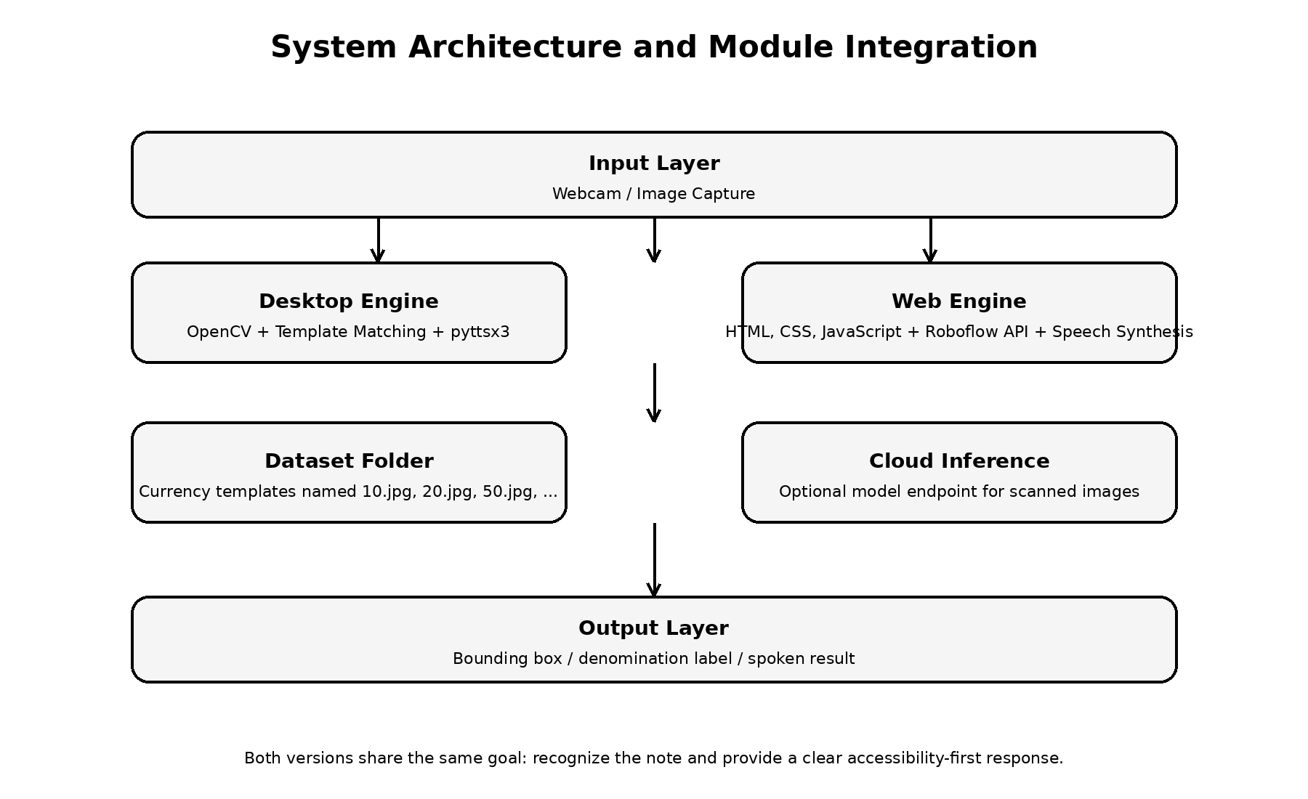
Figure 2: System Architecture and Module Integration

CHAPTER 5
RESULTS & DISCUSSION
The project produced a functional currency-classification prototype that can detect common denominations when the note is clearly visible and the camera feed is stable. The desktop module gives immediate on-screen feedback and speaks the denomination through the local voice engine. The web module offers a more modern interface and can be used from camera-enabled browsers with optional cloud inference.
Test Scenario | Observation
Clear, front-facing note | Denomination detected correctly and spoken aloud
Slightly tilted note | Usually detected, but confidence may reduce
Low-light image | Recognition becomes less stable
Blurred or partially covered note | Detection may fail or return a weaker match
Web mode with good camera feed | Interface is smooth and result is displayed immediately
The main strength of the project is accessibility. It reduces dependence on manual note identification and provides both visual and spoken results. The main limitation is that the desktop recognizer depends heavily on note templates and image quality, which means its accuracy drops when the input is rotated, poorly lit, or very different from the stored examples. The optional web module improves flexibility, but it depends on network access and the availability of the inference service.
Overall, the project demonstrates that a practical accessibility tool can be built with modest resources. Even though it is not yet a large-scale deep learning system, it serves as a reliable prototype for cash assistance and can be expanded into a more robust product later.

CHAPTER 6
CONCLUSION AND SCOPE FOR FUTURE WORK
The AI-Based Currency Classifier for Visually Impaired Users successfully achieves its core goal of identifying Indian currency notes and giving spoken feedback to the user. By combining computer vision, simple template matching, and a voice interface, the project offers a low-cost and practical accessibility solution that can be demonstrated on a normal laptop or in a browser.
Future improvements can make the system much stronger. A trained deep learning model can replace template matching for better accuracy under different angles and lighting conditions. A mobile app version can improve convenience, offline support can remove the dependency on the internet for the web flow, and multilingual speech output can make the tool useful to more users. The system can also be extended with counterfeit-note detection and support for additional currencies and denominations.

CHAPTER 7
REFERENCES
1. OpenCV Documentation. Available at: https://docs.opencv.org/
2. pyttsx3 Documentation. Available at: https://pyttsx3.readthedocs.io/
3. Roboflow Documentation. Available at: https://docs.roboflow.com/
4. W3C Web Speech API Documentation. Available at: https://developer.mozilla.org/
5. Gonzalez, R. C., and Woods, R. E., Digital Image Processing, Pearson.
6. Szeliski, R., Computer Vision: Algorithms and Applications, Springer.
7. Python Documentation. Available at: https://docs.python.org/

