Q1. Consider the following Entities and Relationship

Customer (cust_no,cust_name,address,city)

Loan (loan_no,loan_amt)

Relation between Customer and Loan is Many to Many

Constraints: Primary Key, Foreign Key, loan_amt should be>0

|  |
| --- |
|  |

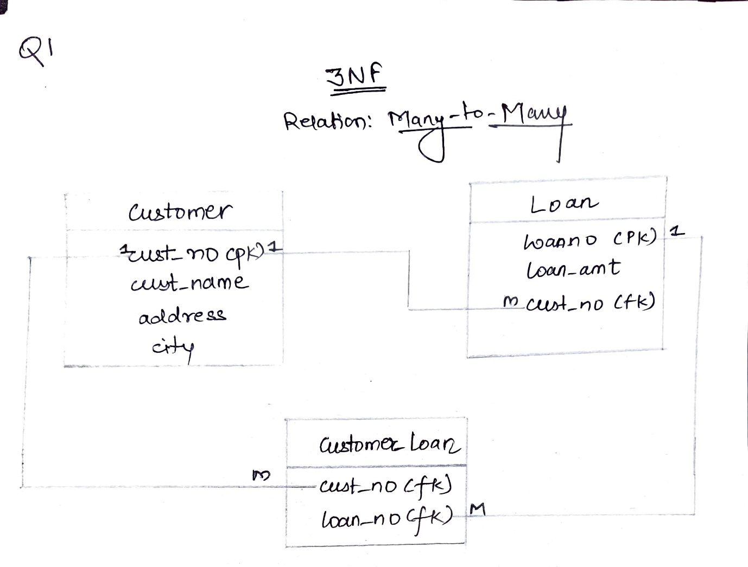

Solution:

SQL> create table Customer

2 (cust_no number(5) primary key,

3 cust_name varchar2(50) NOT NULL,

4 address varchar2(100) NOT NULL,

5 city varchar2(30) NOT NULL);

Table created.

SQL> create table Loan

2 (loan_no number(6) primary key,

3 loan_amt number(10) NOT NULL CHECK (loan_amt>0),

4 cust_no number(5) references Customer(cust_no));

Table created.

SQL> create table Customer_Loan

2 (cust_no number(5) references Customer(cust_no),

3 loan_no number(6) references Loan(loan_no));

Table created.

SQL> describe Customer;

Name Null? Type

----------------------------------------- -------- ----------------------------

CUST_NO NOT NULL NUMBER(5)

CUST_NAME NOT NULL VARCHAR2(50)

ADDRESS NOT NULL VARCHAR2(100)

CITY NOT NULL VARCHAR2(30)

SQL> describe Loan;

Name Null? Type

----------------------------------------- -------- ----------------------------

LOAN_NO NOT NULL NUMBER(6)

LOAN_AMT NOT NULL NUMBER(10)

CUST_NO NUMBER(5)

SQL> describe Customer_Loan;

Name Null? Type

----------------------------------------- -------- ----------------------------

CUST_NO NUMBER(5)

LOAN_NO NUMBER(6)

SQL> insert into Customer values (10001,'Abhijeet Gawas','Dighi Pune-15','Pune');

1 row created.

SQL> insert into Customer values (10002,'Chaitainya Joshi','Nigdi Pradhikaran Pune-39','Pune');

1 row created.

SQL> insert into Customer values (10003,'Amon Rane','Borivali Andheri East','Mumbai');

1 row created.

SQL> insert into Customer values (10004,'Pratiksha Waikar','Deravali Old Panvel','Mumbai');

1 row created.

SQL> insert into Customer values (10005,'Mayank Kulkarni','Niphad','Nashik');

1 row created.

SQL> insert into Customer values (10006,'Manisha Kendre','Igatpuri','Nashik');

1 row created.

SQL> insert into Customer values (10007,'Momita Banerji','Ajara','Kolhapur');

1 row created.

SQL> insert into Customer values (10008,'Prateek Joshi','Shahuwadi','Kolhapur');

1 row created.

SQL> insert into Customer values (10009,'Mansi Adhikari','Shahuwadi','Kolhapur');

1 row created.

SQL> insert into Customer values (10010,'Shyam Lalit','Manmad','Nashik');

1 row created.

SQL> select * from Customer;

CUST_NO CUST_NAME

---------- --------------------------------------------------

ADDRESS

--------------------------------------------------------------------------------

CITY

------------------------------

10001 Abhijeet Gawas

Dighi Pune-15

Pune

10002 Chaitainya Joshi

Nigdi Pradhikaran Pune-39

Pune

CUST_NO CUST_NAME

---------- --------------------------------------------------

ADDRESS

--------------------------------------------------------------------------------

CITY

------------------------------

10003 Amon Rane

Borivali Andheri East

Mumbai

10004 Pratiksha Waikar

Deravali Old Panvel

CUST_NO CUST_NAME

---------- --------------------------------------------------

ADDRESS

--------------------------------------------------------------------------------

CITY

------------------------------

Mumbai

10005 Mayank Kulkarni

Niphad

Nashik

10006 Manisha Kendre

CUST_NO CUST_NAME

---------- --------------------------------------------------

ADDRESS

--------------------------------------------------------------------------------

CITY

------------------------------

Igatpuri

Nashik

10007 Momita Banerji

Ajara

Kolhapur

CUST_NO CUST_NAME

---------- --------------------------------------------------

ADDRESS

--------------------------------------------------------------------------------

CITY

------------------------------

10008 Prateek Joshi

Shahuwadi

Kolhapur

10009 Mansi Adhikari

Shahuwadi

Kolhapur

CUST_NO CUST_NAME

---------- --------------------------------------------------

ADDRESS

--------------------------------------------------------------------------------

CITY

------------------------------

10010 Shyam Lalit

Manmad

Nashik

10 rows selected.

SQL> insert into Loan values (1001,1500000,10001);

1 row created.

SQL> insert into Loan values (1002,1700000,10002);

1 row created.

SQL> insert into Loan values (1003,1750000,10003);

1 row created.

SQL> insert into Loan values (1004,2650000,10004);

1 row created.

SQL> insert into Loan values (1005,1250000,10005);

1 row created.

SQL> insert into Loan values (1006,250000,10006);

1 row created.

SQL> insert into Loan values (1007,50000,10007);

1 row created.

SQL> insert into Loan values (1008,120000,10008);

1 row created.

SQL> insert into Loan values (1009,20000,10009);

1 row created.

SQL> insert into Loan values (1010,5000000,10010);

1 row created.

SQL> select * from Loan;

LOAN_NO LOAN_AMT CUST_NO

---------- ---------- ----------

1001 1500000 10001

1002 1700000 10002

1003 1750000 10003

1004 2650000 10004

1005 1250000 10005

1006 250000 10006

1007 50000 10007

1008 120000 10008

1009 20000 10009

1010 5000000 10010

10 rows selected.

SQL> insert into Customer_Loan values (10001,1001);

1 row created.

SQL> insert into Customer_Loan values (10002,1002);

1 row created.

SQL> insert into Customer_Loan values (10003,1003);

1 row created.

SQL> insert into Customer_Loan values (10004,1004);

1 row created.

SQL> insert into Customer_Loan values (10005,1005);

1 row created.

SQL> insert into Customer_Loan values (10006,1006);

1 row created.

SQL> insert into Customer_Loan values (10007,1007);

1 row created.

SQL> insert into Customer_Loan values (10008,1008);

1 row created.

SQL> insert into Customer_Loan values (10009,1009);

1 row created.

SQL> insert into Customer_Loan values (10010,1010);

1 row created.

SQL> select * from Customer_Loan;

CUST_NO LOAN_NO

---------- ----------

10001 1001

10002 1002

10003 1003

10004 1004

10005 1005

10006 1006

10007 1007

10008 1008

10009 1009

10010 1010

10 rows selected.

Q1. Find Details of All Customers whose Loan is greater than 10 Lakhs.

Sol:

SQL> select Customer.cust_no, Customer.cust_name, Customer.address, Customer.city, Loan.loan_amt

2 from Customer,Loan, Customer_Loan

3 where Customer.cust_no = Customer_Loan.cust_no and Loan.loan_no=Customer_Loan.loan_no and Loan.loan_amt>1000000;

CUST_NO CUST_NAME

---------- --------------------------------------------------

ADDRESS

--------------------------------------------------------------------------------

CITY LOAN_AMT

------------------------------ ----------

10001 Abhijeet Gawas

Dighi Pune-15

Pune 1500000

10002 Chaitainya Joshi

Nigdi Pradhikaran Pune-39

Pune 1700000

CUST_NO CUST_NAME

---------- --------------------------------------------------

ADDRESS

--------------------------------------------------------------------------------

CITY LOAN_AMT

------------------------------ ----------

10003 Amon Rane

Borivali Andheri East

Mumbai 1750000

10004 Pratiksha Waikar

Deravali Old Panvel

CUST_NO CUST_NAME

---------- --------------------------------------------------

ADDRESS

--------------------------------------------------------------------------------

CITY LOAN_AMT

------------------------------ ----------

Mumbai 2650000

10005 Mayank Kulkarni

Niphad

Nashik 1250000

10010 Shyam Lalit

CUST_NO CUST_NAME

---------- --------------------------------------------------

ADDRESS

--------------------------------------------------------------------------------

CITY LOAN_AMT

------------------------------ ----------

Manmad

Nashik 5000000

6 rows selected.

Q2. List All Customer whose name start with ‘ba’

SQL> select * from Customer where Customer.cust_name like 'ba%';

no rows selected

Q3. List name of all customer in descending order who has taken loan in Nashik City

SQL> select Customer.cust_no, Customer.cust_name

2 from Customer, Loan, Customer_Loan

3 where Customer.cust_no = Customer_Loan.cust_no and Loan.loan_no = Customer_Loan.loan_no

4 order by Customer.cust_name desc;

CUST_NO CUST_NAME

---------- --------------------------------------------------

10010 Shyam Lalit

10004 Pratiksha Waikar

10008 Prateek Joshi

10007 Momita Banerji

10005 Mayank Kulkarni

10009 Mansi Adhikari

10006 Manisha Kendre

10002 Chaitainya Joshi

10003 Amon Rane

10001 Abhijeet Gawas

10 rows selected.

Q4. Display Customer Details having maximum Loan Amount

SQL> select Customer.cust_no, Customer.cust_name, Customer.address, Customer.city, Loan.loan_amt

2 from Customer, Loan, Customer_Loan

3 where Customer.cust_no=Customer_Loan.cust_no and Loan.loan_no = Customer_Loan.loan_no

4 and Loan.loan_amt = (select max(loan_amt) from Loan);

CUST_NO CUST_NAME

---------- --------------------------------------------------

ADDRESS

--------------------------------------------------------------------------------

CITY LOAN_AMT

------------------------------ ----------

10010 Shyam Lalit

Manmad

Nashik 5000000

Q5. Calculate Total of All Loan Amount

SQL> select sum(Loan.loan_amt) from Loan;

SUM(LOAN.LOAN_AMT)

------------------

14290000

SQL> commit;

Commit complete.