1. Write a Pandas program to select distinct department id from employees file.

OUTPUT:-



1. Write a Pandas program to display the ID for those employees who did two or more jobs in the past.

OUTPUT:-



1. Write a Pandas program to display the details of jobs in descending sequence on job title.

OUTPUT:-

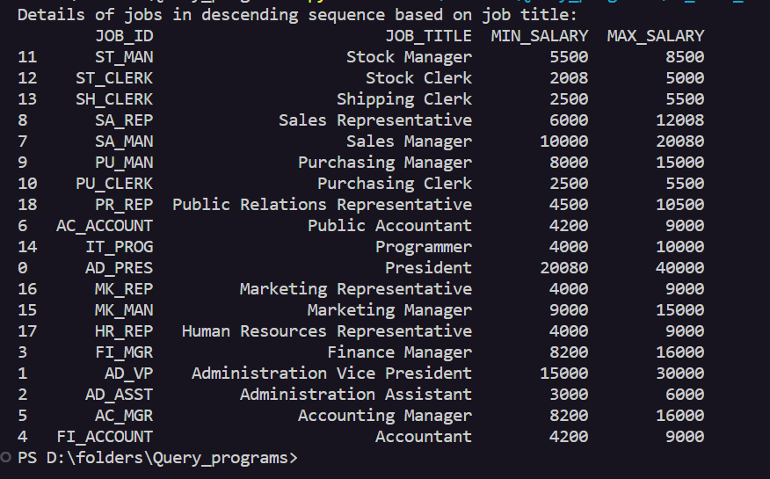

1. Write a Pandas program to create a line plot of the historical stock prices of Alphabet Inc. between two specific dates.

OUTPUT:-

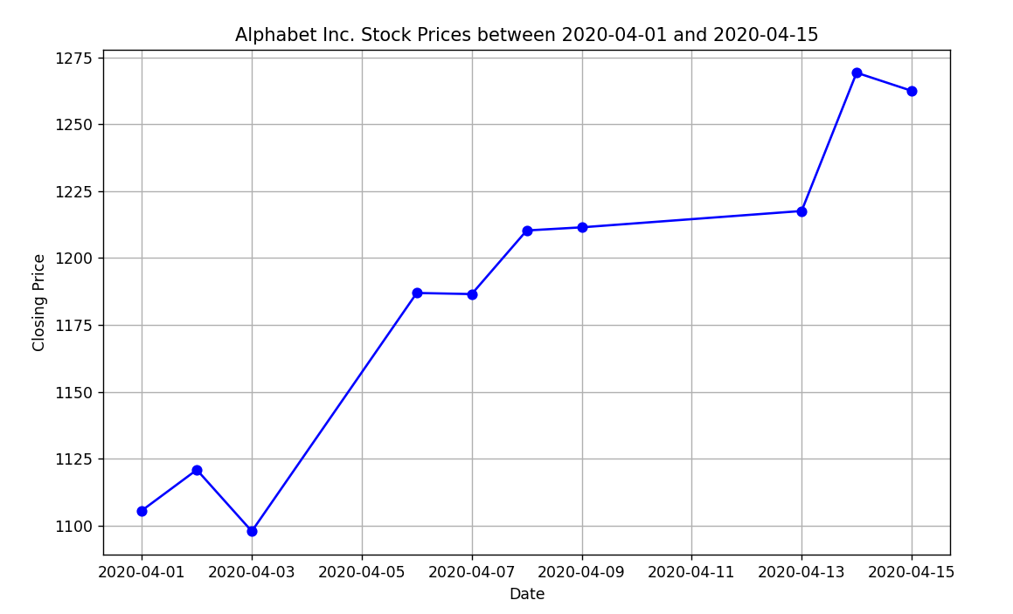

1. Write a Pandas program to create a bar plot of the trading volume of Alphabet Inc. stock between two specific dates.

OUTPUT:-

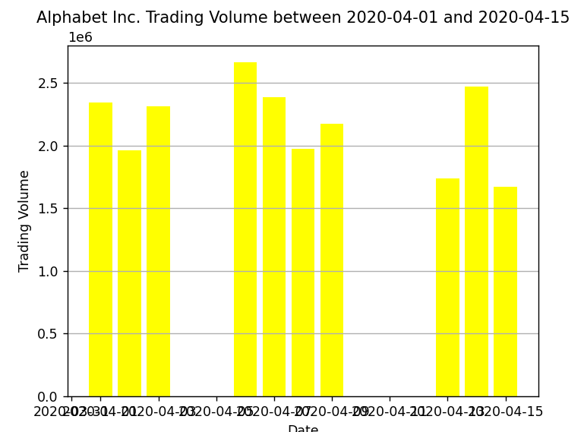

1. Write a Pandas program to create a scatter plot of the trading volume/stock prices of Alphabet Inc. stock between two specific dates.

**alphabet_stock_data:**

OUTPUT:-

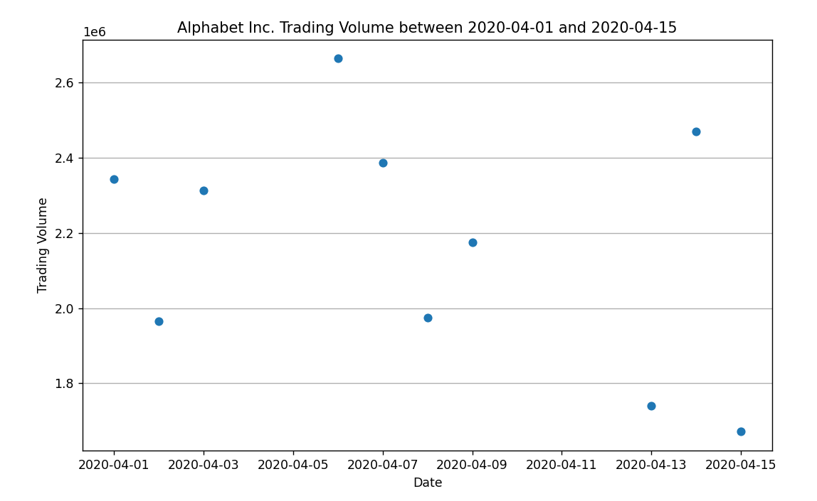

1. Write a Pandas program to create a Pivot table and find the maximum and minimum sale value of the items.(refer sales_data table)

OUTPUT :-

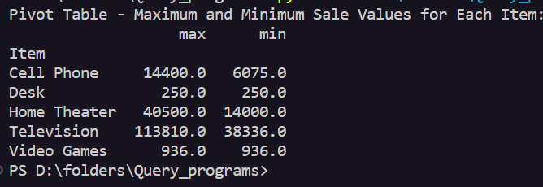

1. Write a Pandas program to create a Pivot table and find the item wise unit sold. .(refer sales_data table)

OUTPUT:-

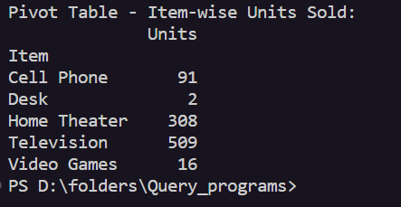

1. Write a Pandas program to create a Pivot table and find the total sale amount region wise, manager wise, sales man wise. .(refer sales_data table)

OUTPUT :-

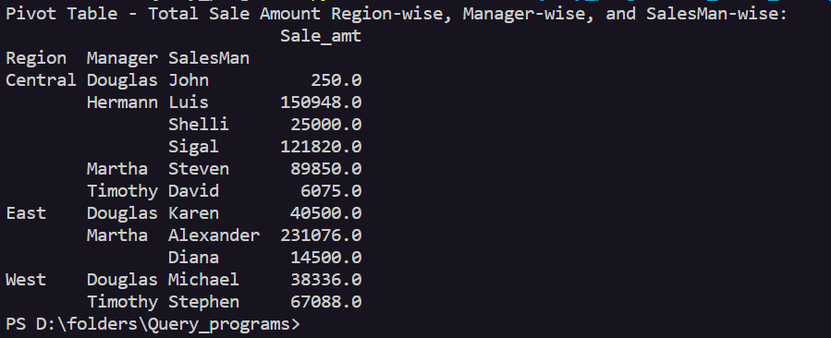

10.Create a dataframe of ten rows, four columns with random values. Write a Pandas program to highlight the negative numbers red and positive numbers black.

OUTPUT:-

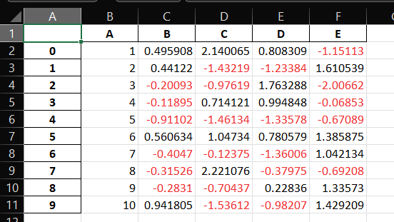

11.Create a dataframe of ten rows, four columns with random values. Convert some values to nan values. Write a Pandas program which will highlight the nan values.

Output:-

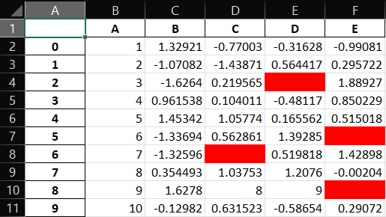

12.Create a dataframe of ten rows, four columns with random values. Write a Pandas program to set dataframe background Color black and font color yellow.

Output :-

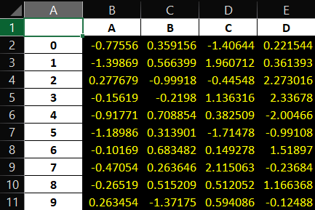

13.Write a Pandas program to detect missing values of a given DataFrame. Display True or False.

Output :-

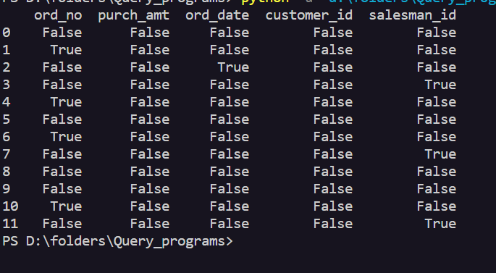

14. Write a Pandas program to find and replace the missing values in a given DataFrame which do not have any valuable information.

Output :-

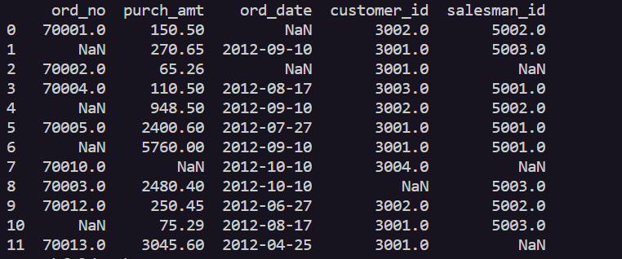

15.Write a Pandas program to keep the rows with at least 2 NaN values in a given DataFrame.

Output :-

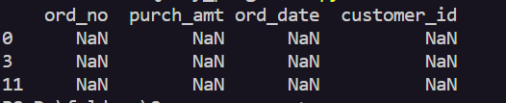

16.Write a Pandas program to split the following dataframe into groups based on school code. Also check the type of GroupBy object.

Output :-

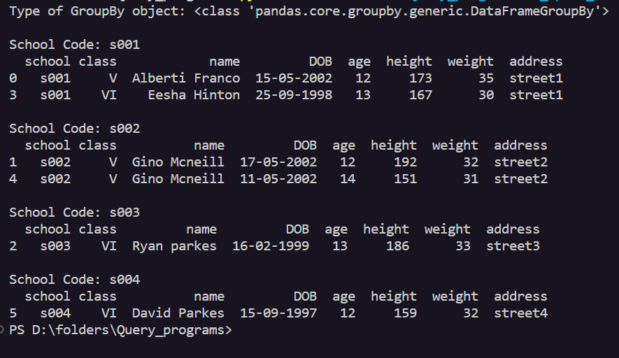

17.Write a Pandas program to split the following dataframe by school code and get mean, min, and max value of age for each school.  
Output :-

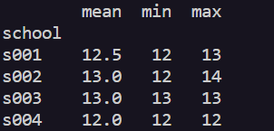

18.Write a Pandas program to split the following given dataframe into groups based on school code and class.

Output :-

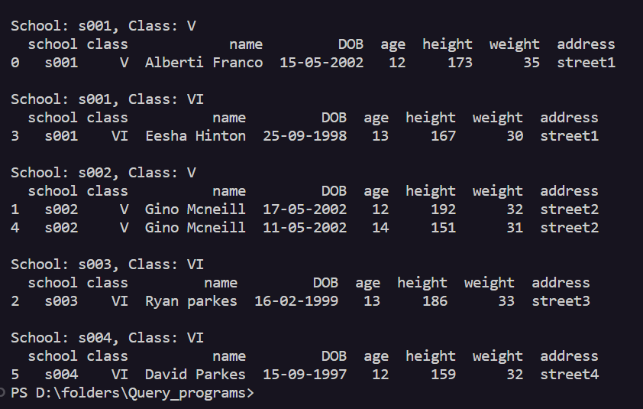

19.Write a Pandas program to display the dimensions or shape of the World alcohol consumption dataset. Also extract the column names from the dataset.

Output :-

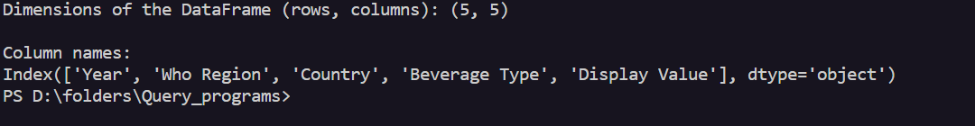

20.Write a Pandas program to find the index of a given substring of a DataFrame column.

Output :-



21.Write a Pandas program to swap the cases of a specified character column in a given DataFrame.

Output:-

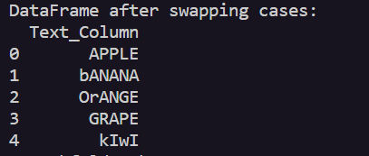

22.Write a Python program to draw a line with suitable label in the x axis, y axis and a title.

Output :-

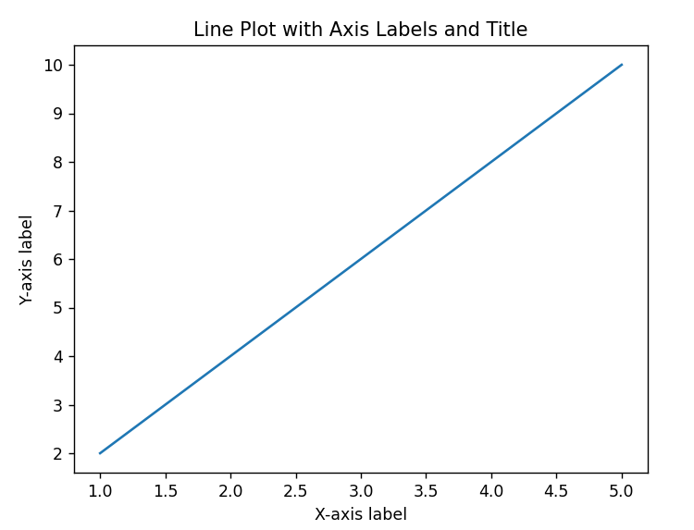

23.Write a Python program to draw a line using given axis values taken from a text file, with suitable label in the x axis, y axis and a title.  
Test Data:  
test.txt  
1 2  
2 4  
3 1

Output :-

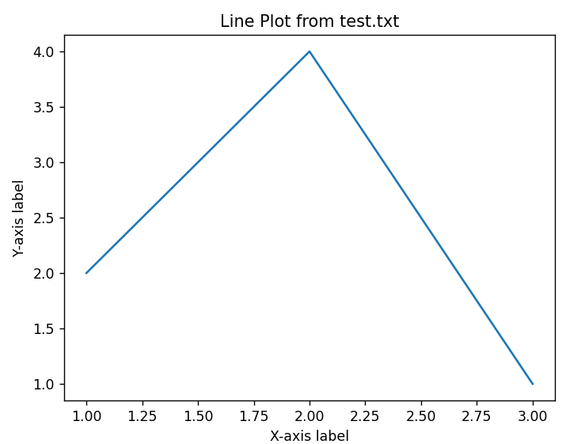

24.Write a Python program to draw line charts of the financial data of Alphabet Inc. between October 3, 2016 to October 7, 2016.  
Sample Financial data (fdata.csv):  
Date,Open,High,Low,Close  
10-03-16,774.25,776.065002,769.5,772.559998  
10-04-16,776.030029,778.710022,772.890015,776.429993  
10-05-16,779.309998,782.070007,775.650024,776.469971  
10-06-16,779,780.47998,775.539978,776.859985  
10-07-16,779.659973,779.659973,770.75,775.080017

Output :-

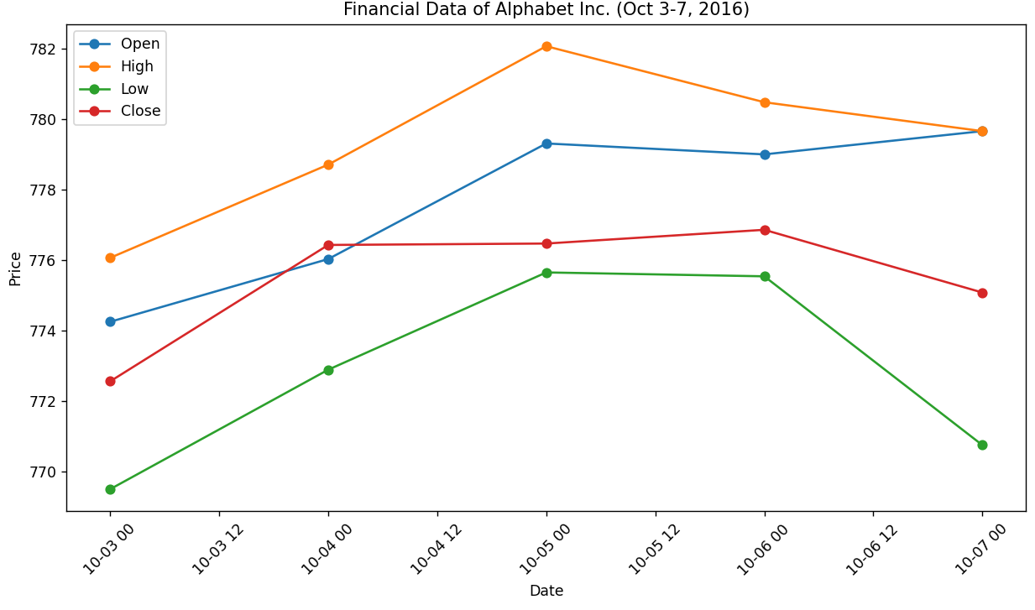

25.Write a Python program to plot two or more lines with legends, different widths and colors.

Output :-

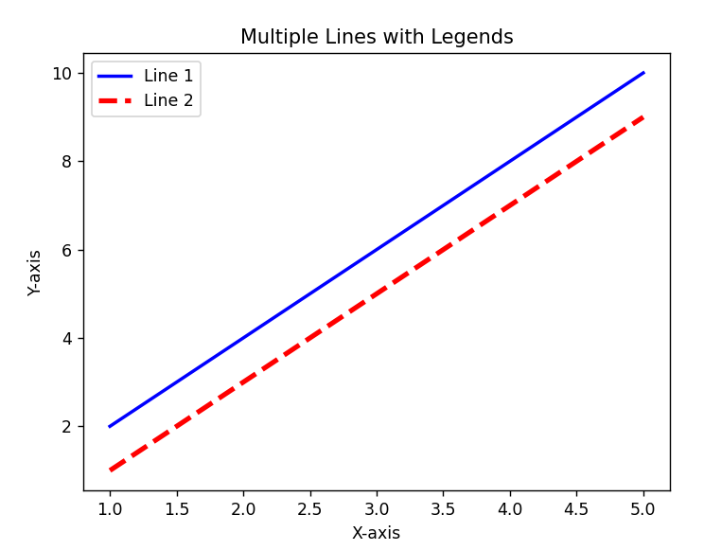

26.Write a Python program to create multiple plots.

Output :-

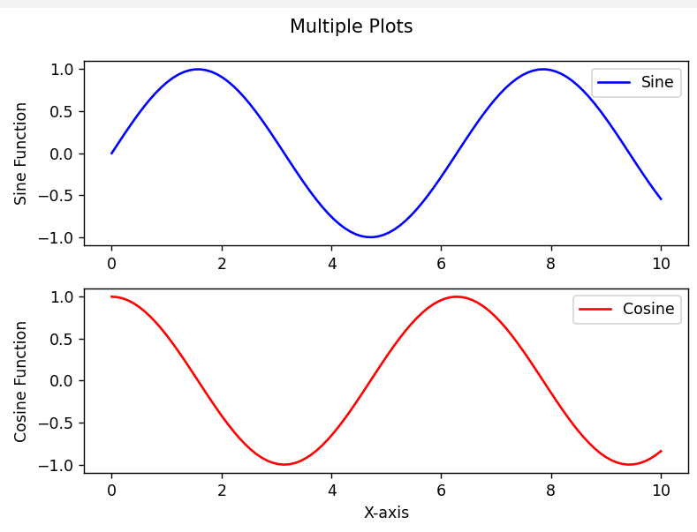

27.Write a Python programming to display a bar chart of the popularity of programming Languages.  
Sample data:  
Programming languages: Java, Python, PHP, JavaScript, C#, C++  
Popularity: 22.2, 17.6, 8.8, 8, 7.7, 6.7

Output :-

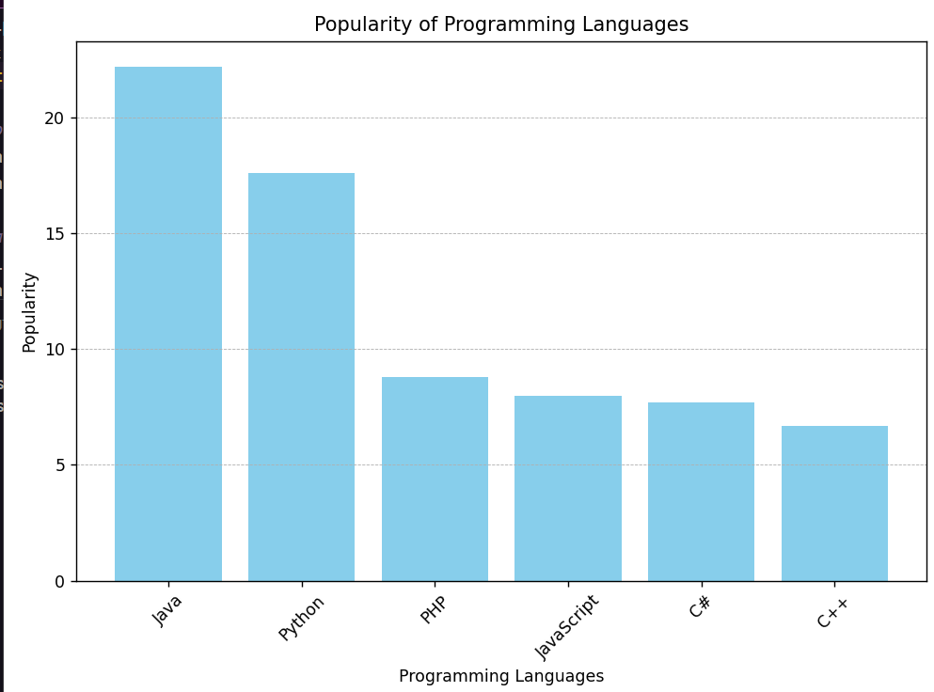

28.Write a Python programming to display a horizontal bar chart of the popularity of programming Languages.  
Sample data:  
Programming languages: Java, Python, PHP, JavaScript, C#, C++  
Popularity: 22.2, 17.6, 8.8, 8, 7.7, 6.7

Output :-

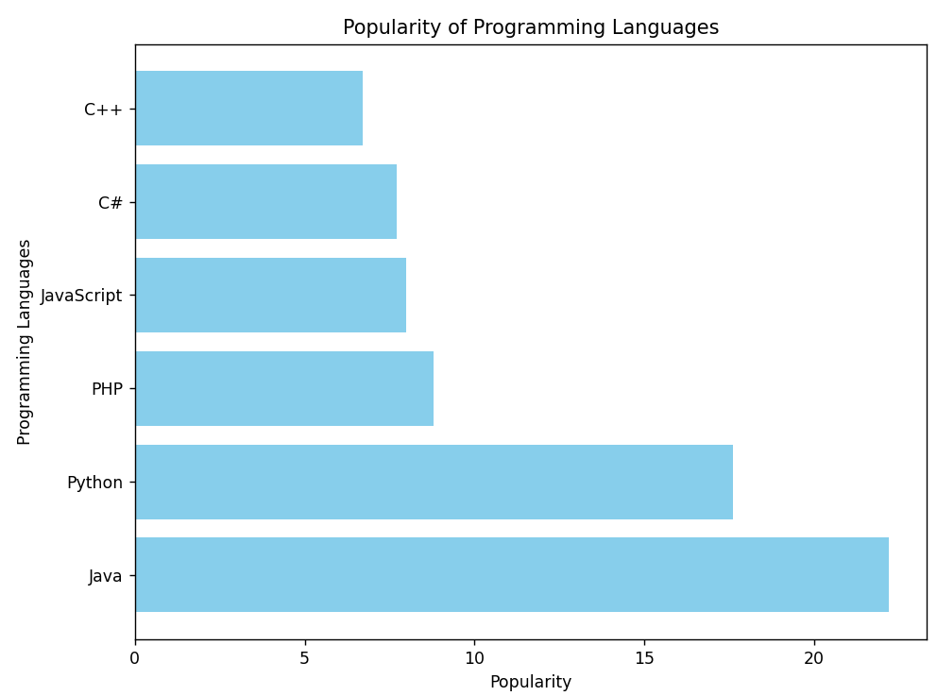

29.Write a Python programming to display a bar chart of the popularity of programming Languages. Use different color for each bar.  
Sample data:  
Programming languages: Java, Python, PHP, JavaScript, C#, C++  
Popularity: 22.2, 17.6, 8.8, 8, 7.7, 6.7

Output :-

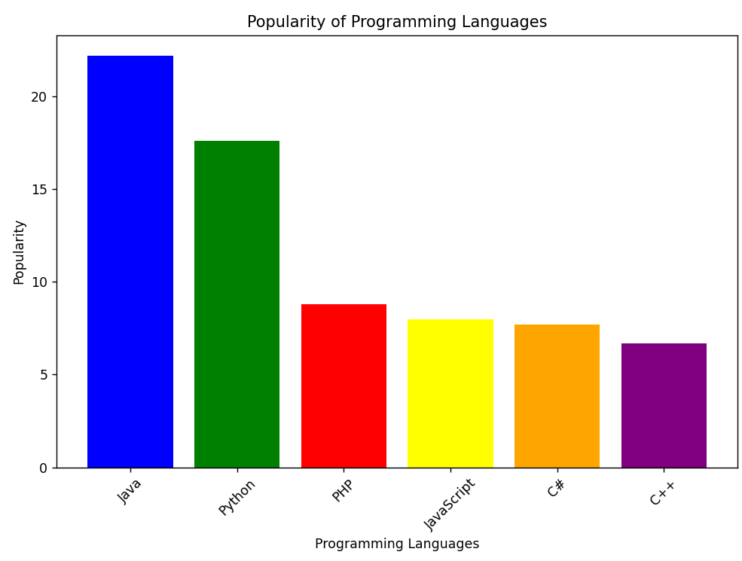

30.Write a Python program to create bar plot of scores by group and gender. Use multiple X values on the same chart for men and women.  
  
Sample Data:  
Means (men) = (22, 30, 35, 35, 26)  
Means (women) = (25, 32, 30, 35, 29)

Output :-

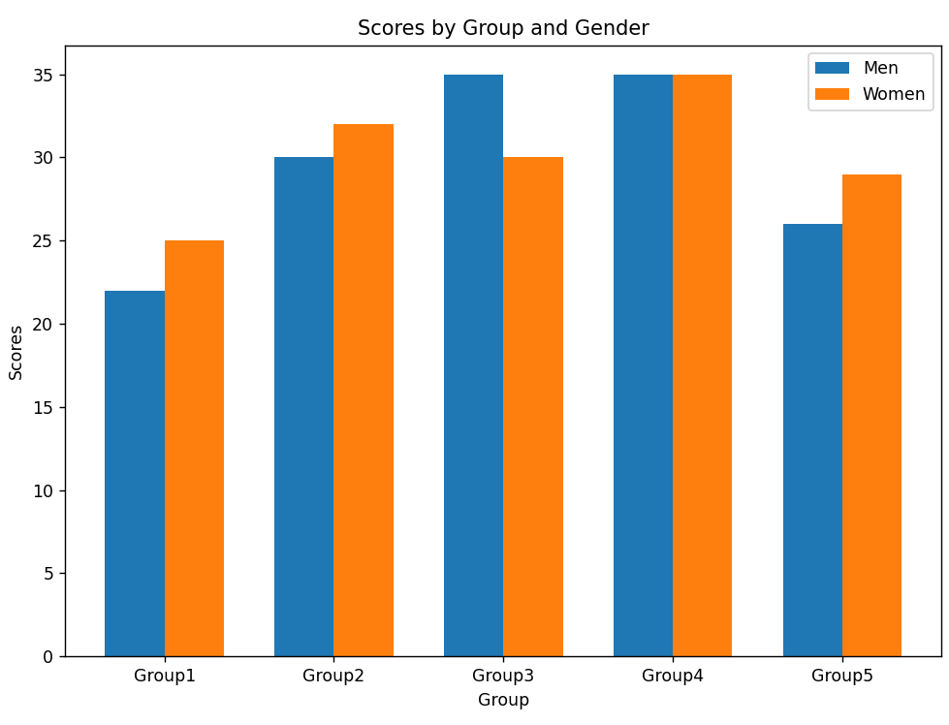

31.Write a Python program to create a stacked bar plot with error bars.  
Note: Use bottom to stack the women?s bars on top of the men?s bars.  
Sample Data:  
Means (men) = (22, 30, 35, 35, 26)  
Means (women) = (25, 32, 30, 35, 29)  
Men Standard deviation = (4, 3, 4, 1, 5)  
Women Standard deviation = (3, 5, 2, 3, 3)

Output :-

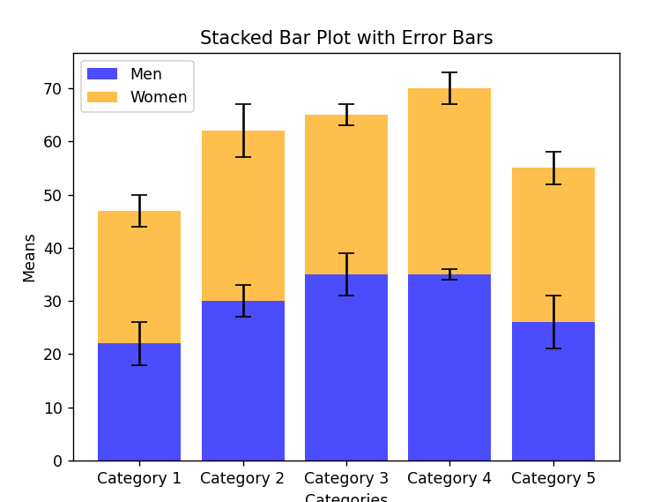

32.Write a Python program to draw a scatter graph taking a random distribution in X and Y and plotted against each other.

Output :-

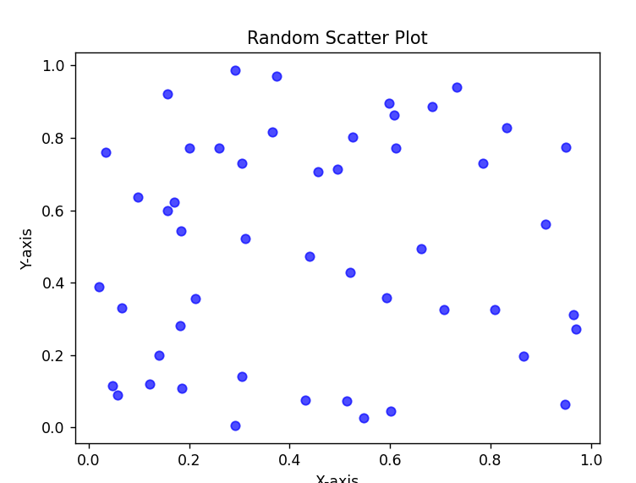

33.Write a Python program to draw a scatter plot with empty circles taking a random distribution in X and Y and plotted against each other.

Output :-

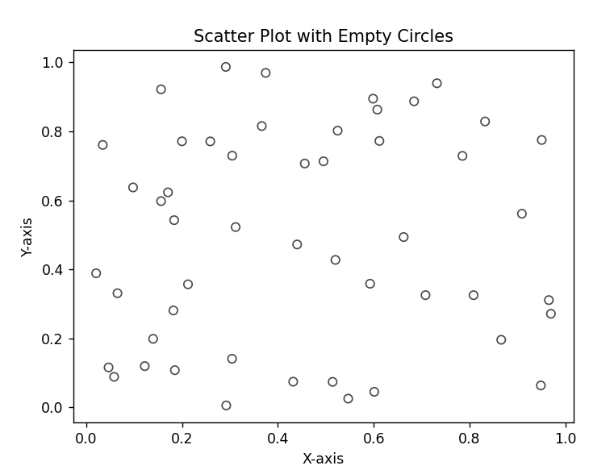

34.Write a Python program to draw a scatter plot using random distributions to generate balls of different sizes.

Output :-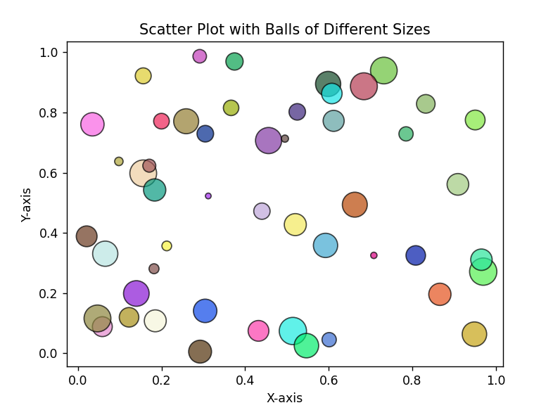

35.Write a Python program to draw a scatter plot comparing two subject marks of Mathematics and Science. Use marks of 10 students.  
Sample data:

Test Data:  
math_marks = [88, 92, 80, 89, 100, 80, 60, 100, 80, 34]  
science_marks = [35, 79, 79, 48, 100, 88, 32, 45, 20, 30]  
marks_range = [10, 20, 30, 40, 50, 60, 70, 80, 90, 100]

Output :-

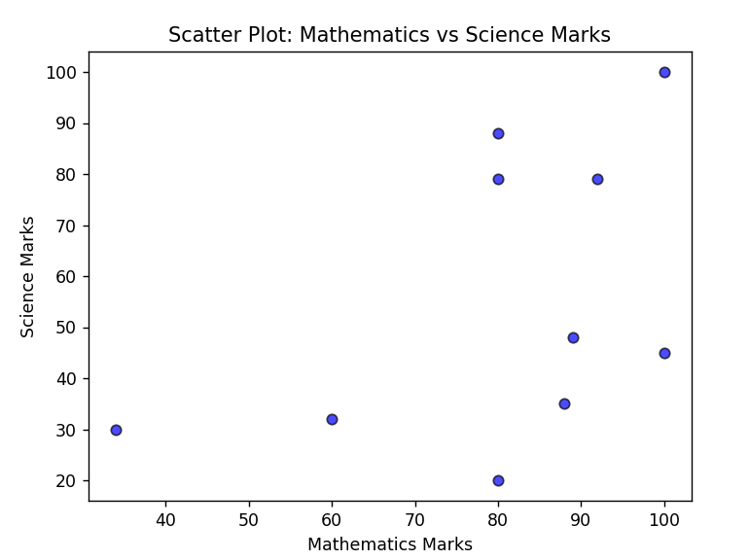

36.Write a Python program to draw a scatter plot for three different groups comparing weights and heights.

Output :-

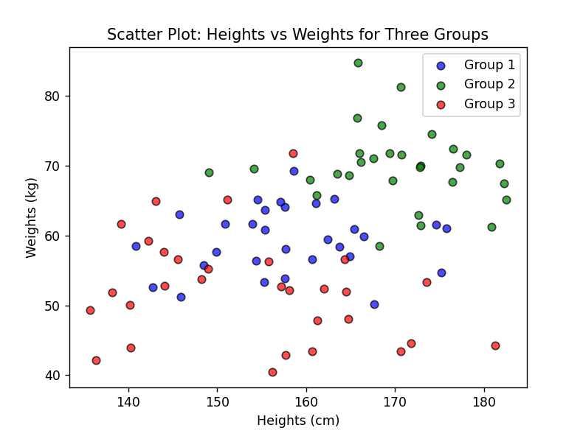

37.Write a Pandas program to create a dataframe from a dictionary and display it.  
Sample data: {'X':[78,85,96,80,86], 'Y':[84,94,89,83,86],'Z':[86,97,96,72,83]}

Output :-

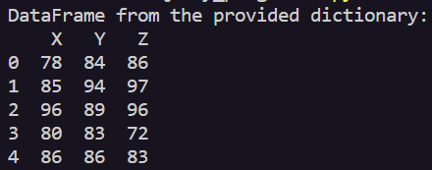

38.Write a Pandas program to create and display a DataFrame from a specified dictionary data which has the index labels.  
Sample Python dictionary data and list labels:  
exam_data = {'name': ['Anastasia', 'Dima', 'Katherine', 'James', 'Emily', 'Michael', 'Matthew', 'Laura', 'Kevin', 'Jonas'],  
'score': [12.5, 9, 16.5, np.nan, 9, 20, 14.5, np.nan, 8, 19],  
'attempts': [1, 3, 2, 3, 2, 3, 1, 1, 2, 1],  
'qualify': ['yes', 'no', 'yes', 'no', 'no', 'yes', 'yes', 'no', 'no', 'yes']}  
labels = ['a', 'b', 'c', 'd', 'e', 'f', 'g', 'h', 'i', 'j']

Output :-

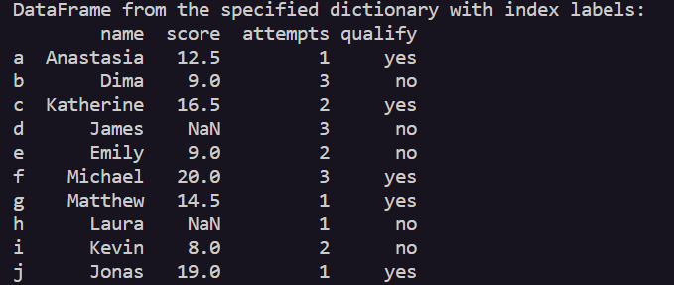

39.Write a Pandas program to get the first 3 rows of a given DataFrame.  
Sample Python dictionary data and list labels:  
exam_data = {'name': ['Anastasia', 'Dima', 'Katherine', 'James', 'Emily', 'Michael', 'Matthew', 'Laura', 'Kevin', 'Jonas'],  
'score': [12.5, 9, 16.5, np.nan, 9, 20, 14.5, np.nan, 8, 19],  
'attempts': [1, 3, 2, 3, 2, 3, 1, 1, 2, 1],  
'qualify': ['yes', 'no', 'yes', 'no', 'no', 'yes', 'yes', 'no', 'no', 'yes']}  
labels = ['a', 'b', 'c', 'd', 'e', 'f', 'g', 'h', 'i', 'j']

Output :-

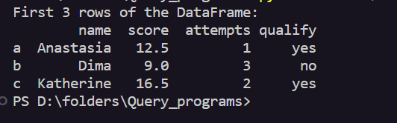

1. Write a Pandas program to select the 'name' and 'score' columns from the following DataFrame.  
   Sample Python dictionary data and list labels:  
   exam_data = {'name': ['Anastasia', 'Dima', 'Katherine', 'James', 'Emily', 'Michael', 'Matthew', 'Laura', 'Kevin', 'Jonas'],  
   'score': [12.5, 9, 16.5, np.nan, 9, 20, 14.5, np.nan, 8, 19],  
   'attempts': [1, 3, 2, 3, 2, 3, 1, 1, 2, 1],  
   'qualify': ['yes', 'no', 'yes', 'no', 'no', 'yes', 'yes', 'no', 'no', 'yes']}  
   labels = ['a', 'b', 'c', 'd', 'e', 'f', 'g', 'h', 'i', 'j']

Output :-

