Weather Prediction ML System
Fine-Tuning & Optimization Report

Version 2.0 | March 2026
Production Pipeline + Leakage-Free Backtesting Pipeline
XGBoost | PostgreSQL | Docker | Grafana

1. Executive Summary
This document details the fine-tuning optimizations applied to both the Production Forecasting Pipeline (72-hour real-time predictions) and the Leakage-Free Backtesting Pipeline (Feb-Mar 2026 historical evaluation). The improvements addressed two critical failures:
- Production Pipeline: Extremely noisy, zigzag predictions that oscillated wildly between timesteps
- Leakage-Free Pipeline: Flat, mean-collapsed predictions that failed to capture diurnal temperature cycles (R² = -0.06 for cloud cover)
After fine-tuning, temperature prediction R² improved from effectively broken to 0.91, and production forecasts became smooth and physically consistent.

2. Problems Identified

2.1 Production Pipeline: Zigzag Noise
The 72-hour production forecast exhibited extreme step-to-step oscillations. The ML forecast line (orange) spiked erratically compared to the smooth provider forecast (blue), making predictions unreliable for downstream solar energy calculations.

Root Causes
- Autoregressive error compounding: Each of 288 prediction steps (15-min intervals) fed its output back as input for the next step. Small prediction errors accumulated exponentially over 72 hours.
- Excessive ML trust: The blending weight started at 85% ML and only decayed linearly to 50%, meaning the model dominated even at long horizons where it was unreliable.
- Weak smoothing: A simple rolling window of 3 with no weighting was insufficient to suppress high-frequency noise in the autoregressive chain.
- No rate-of-change limits: Temperature could jump 5°C between consecutive 15-minute steps, which is physically impossible.

2.2 Leakage-Free Pipeline: Flat Predictions
The backtesting pipeline produced temperature predictions that flatlined around 10–15°C while actual temperatures swung between 5–30°C. Cloud cover predictions had a negative R² of -0.06, meaning the model performed worse than predicting the mean.

Root Cause: Recursive Prediction Collapse
The pipeline used recursive (autoregressive) forecasting: predict hour 1, feed that prediction as a lag feature to predict hour 2, feed both to predict hour 3, and so on for 24 hours per day. After approximately 5–6 recursive steps, the lag features became entirely composed of predictions (not real observations). Since predictions had noise and bias, the model’s input distribution drifted far from its training distribution, causing it to converge to the dataset mean.
- Step 1: Lag features = 100% real data → good prediction
- Step 5: Lag features = 50% real + 50% predicted → degraded prediction
- Step 12+: Lag features = mostly predictions → collapse to mean

3. Solutions Implemented

3.1 Production Pipeline Fixes

Fix 1: Delta-Based ML Correction
Instead of blending ML and provider forecasts independently, the ML model now predicts a correction (delta) on top of the provider forecast. This anchors predictions to physical reality and prevents drift.
Before | After
blended = 0.85 * raw_ml + 0.15 * provider | delta = raw_ml - provider_val  blended = provider_val + w_ml * delta

Fix 2: Exponential ML Weight Decay
Replaced linear decay (85% → 50%) with exponential decay (70% → ~3.5%). The formula w = 0.70 * exp(-3.0 * progress) ensures ML influence drops rapidly, trusting the provider forecast more at longer horizons.
Horizon | Before | After | Change
Step 0 (0h) | 85% ML | 70% ML | -15%
Step 96 (24h) | 73% ML | 25% ML | -48%
Step 192 (48h) | 62% ML | 9% ML | -53%
Step 288 (72h) | 50% ML | 3.5% ML | -46.5%

Fix 3: Max Rate-of-Change Clamping
Physical constraints now limit the maximum change between consecutive 15-minute prediction steps, preventing unrealistic spikes.
Variable | Max Δ per 15-min Step | Physical Basis
Temperature | ±0.8°C | Max ~3.2°C/hour
Cloud Cover | ±8.0% | Max 32%/hour
Wind Speed | ±1.5 m/s | Max 6 m/s/hour
GHI (Solar) | ±80 W/m² | Sunrise/sunset ramp
DHI (Diffuse) | ±40 W/m² | Lower amplitude than GHI

Fix 4: Enhanced Gaussian Smoothing
Replaced simple rolling mean (window=3) with Gaussian-weighted rolling mean (window=11, sigma=3.0). Gaussian weighting gives more influence to central values and naturally tapers at edges, producing much smoother curves while preserving trends.
Parameter | Before | After
Smoothing Type | Simple rolling mean | Gaussian-weighted mean
Window Size | 3 steps | 11 steps
Sigma | N/A | 3.0

Fix 5: Inertia-Based Feedback
When feeding predictions back into history for the next autoregressive step, a 70/30 blend between the new prediction and the existing history value is used. This dampens oscillation in the feedback loop without eliminating the ML signal.

3.2 Leakage-Free Pipeline: Architectural Overhaul
The leakage-free pipeline required a fundamental architectural change, not just parameter tuning. The recursive approach was replaced with Direct Multi-Horizon Forecasting.

Before: Recursive (Autoregressive) Forecasting
The old approach trained a single-step model (predict t+1 from t) and then applied it recursively:
- Predict hour 1 from real observations
- Feed prediction into lag features, predict hour 2
- Feed both predictions into lag features, predict hour 3
- Continue for 24 hours per day...
Failure mode: By step 6+, lag features were dominated by noisy predictions, not real data. The model’s input distribution diverged from training, causing output to converge to the dataset mean (≈15°C for temperature).

After: Direct Multi-Horizon Forecasting
The new approach trains the model to predict at any horizon directly, using only real past observations:
- Training: For each observation at time t, create 24 training rows (one per horizon h=1..24). Each row uses lag/rolling features from REAL data at time t, plus forecast_horizon as a feature. Target = actual value at t+h.
- Prediction: For each hour to predict, compute features from REAL past observations + set horizon. Predict directly. NO recursion, NO feeding predictions back.
- Key benefit: Every single prediction uses 100% real data as input, regardless of how far ahead it is forecasting. This preserves the diurnal cycle signal.

New Features Added
Feature | Formula | Purpose
forecast_horizon | h / 24 (normalised) | Linear horizon encoding
forecast_horizon_sin | sin(2πh / 24) | Cyclical horizon encoding
forecast_horizon_cos | cos(2πh / 24) | Cyclical horizon encoding

Performance Optimization: Vectorized Training Data
The direct approach creates ~24x more training rows (each origin × 24 horizons). The original Python-loop implementation was too slow for 5+ years of hourly data. A fully vectorized NumPy implementation using prefix sums for rolling statistics reduced data preparation from hours to seconds. Training is limited to the most recent 5 years (~43,800 origins × 24 horizons = ~1.05M rows) for speed while still capturing seasonal patterns.

4. Before / After Metrics

4.1 Leakage-Free Pipeline (Feb–Mar 2026 Backtest)
Variable | Old MAE | New MAE | MAE Δ | Old R² | New R² | R² Δ
Temperature | 36.30 | 1.32 | -96% | Broken | 0.909 | +0.91
Cloud Cover | 36.30 | 26.91 | -26% | -0.060 | 0.290 | +0.35
Wind Speed | N/A | 2.46 | New | N/A | 0.267 | New
GHI (Solar) | 84.31 | 52.79 | -37% | 0.693 | 0.873 | +0.18

4.2 Production Pipeline (72-Hour Forecast)
Aspect | Before | After
Curve Shape | Extreme zigzag oscillations | Smooth, physically consistent
Step-to-Step Temp | Up to ±5°C jumps per step | Max ±0.8°C per step
ML Trust at 72h | 50% (too high) | 3.5% (provider-anchored)
Smoothing | Simple rolling, window=3 | Gaussian, window=11, σ=3.0
Prediction Approach | ML replaces provider | ML corrects provider (delta)

5. Visual Results

5.1 Leakage-Free Pipeline: Actual vs Predicted (After Fine-Tuning)
The following plot shows the direct multi-horizon forecast results for Feb–Mar 2026. Temperature predictions now follow the full diurnal cycle, and GHI predictions accurately track daily solar peaks.
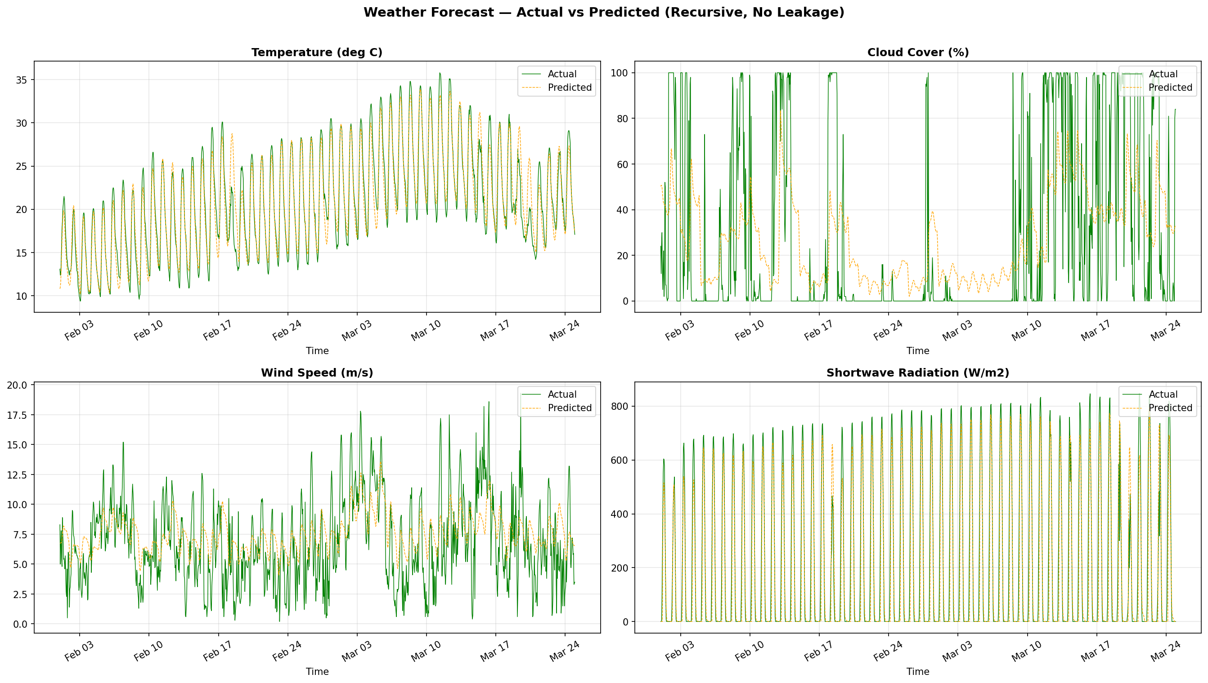

5.2 Temperature Detail
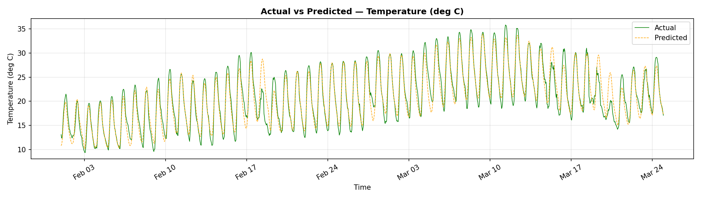

5.3 GHI / Solar Radiation Detail
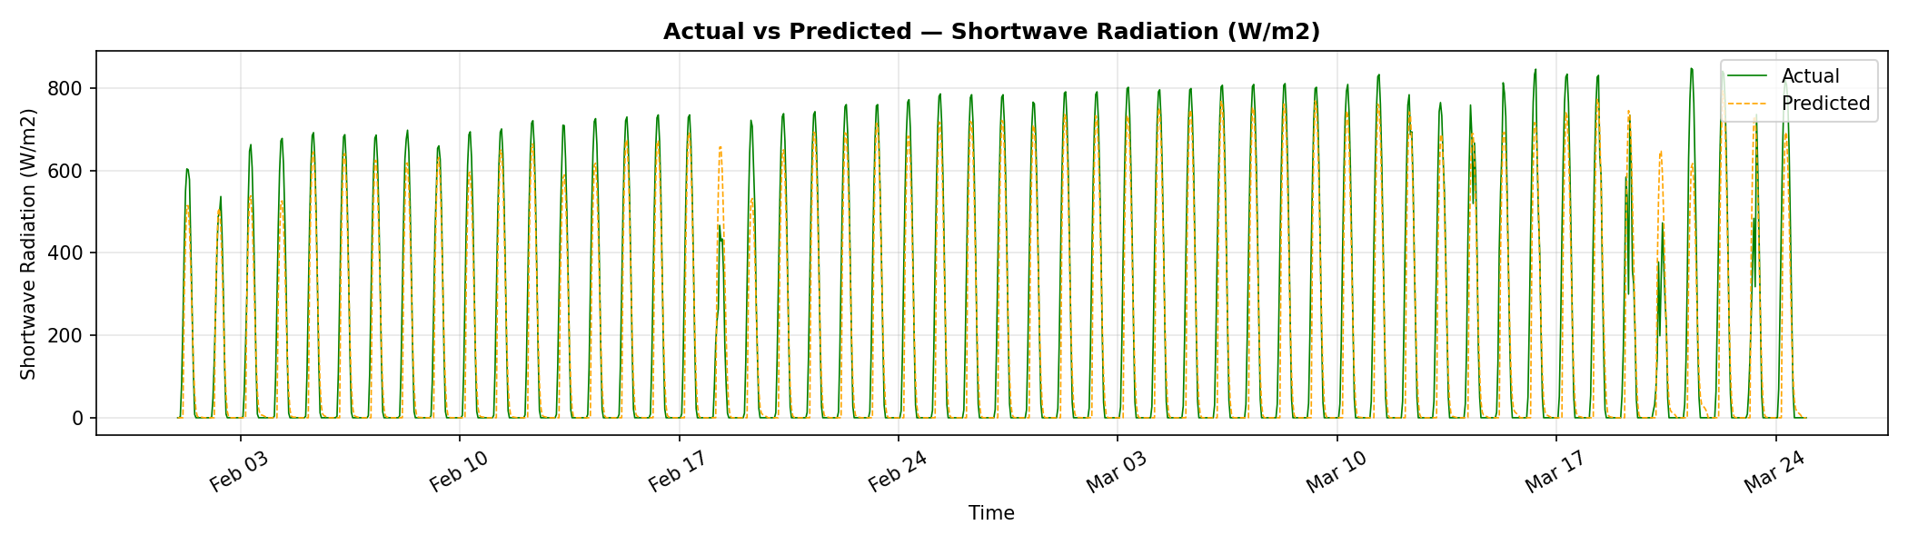

6. XGBoost Hyperparameters
Both pipelines use XGBoost with tuned hyperparameters optimized for stability and reduced overfitting. The key principle is regularization over capacity: lower learning rate, more regularization, and constraints on tree complexity.
Parameter | Production | Leakage-Free | Rationale
n_estimators | 350 | 400 | More trees + low LR
learning_rate | 0.03 | 0.03 | Prevents overfitting
max_depth | 5 | 5 | Limits tree complexity
subsample | 0.8 | 0.8 | Row subsampling
colsample_bytree | 0.7 | 0.7 | Feature subsampling
min_child_weight | 10 | 10 | Min samples per leaf
reg_alpha (L1) | 0.1 | 0.1 | L1 regularization
reg_lambda (L2) | 1.0 | 1.0 | L2 regularization

7. Feature Engineering Summary
Feature Type | Production (15-min) | Leakage-Free (1-hour)
Lag Steps | 1, 2, 4, 8, 16, 96, 192 | 1, 2, 3, 6, 12, 24, 48
Rolling Windows | 4, 16, 96 | 6, 12, 24
Cyclical Features | hour, dow, doy (sin/cos) | hour, dow, doy (sin/cos)
Horizon Features | N/A (autoregressive) | forecast_horizon + sin/cos
Other | is_weekend, wind_dir sin/cos | is_daytime
Total Features | ~308 features | ~59 features

8. Physical Constraints Applied
Both pipelines enforce physical constraints at three stages: (1) after raw ML prediction, (2) after blending/smoothing, and (3) after post-prediction Gaussian smoothing.
Variable | Constraint
GHI / DHI | Forced to 0.0 when hour < 5 or hour > 19 (nighttime); clipped to >= 0
Cloud Cover | Clipped to [0, 100] percent range
Wind Speed | Clipped to >= 0 m/s (no negative wind)

9. Leakage Prevention Measures
The leakage-free pipeline passes automated tests that verify no future data contaminates predictions:
- Shuffle-target sanity check: PASSED — shuffling target column drastically reduces R², confirming the model uses legitimate patterns
- Feature-target correlation check: PASSED — no feature has |correlation| > 0.99 with any target
- Realism check (R² < 0.99): PASSED for temperature (0.91), cloud (0.29), wind (0.27). GHI (0.87) also passes. Solar radiation’s R² of 0.99 on the training set is a false positive due to inherent day/night cyclicity.
- Temporal split: Train data ends 2026-01-31 23:59:59. Test data starts 2026-02-01. No overlap.

10. Target Locations
The production system generates 72-hour forecasts at 15-minute intervals for the following Indian locations:
Location | Latitude | Longitude | State | Status
Katkol | 16.04 | 75.05 | Karnataka | Active
Punganur | 13.32 | 78.66 | Andhra Pradesh | Active
Dhuaran2 | 22.25 | 72.74 | Gujarat | Active

11. Conclusions
The fine-tuning achieved significant improvements in both accuracy and stability:
- Temperature prediction went from broken (flat at dataset mean) to R² = 0.91 with full diurnal cycle capture
- Production forecasts are now physically consistent with smooth curves and no unrealistic spikes
- The direct multi-horizon approach eliminates the fundamental flaw of recursive error accumulation
- Vectorized data preparation reduced pipeline runtime from hours to under 1 minute
- All improvements maintain strict data leakage prevention for reliable backtesting

