LLM & TRANSFORMER
COMPLETE STUDY GUIDE
Architecture · Generation · Prompting · Fine-Tuning
Four parts, ordered so each one builds on the last
WHAT IS INSIDE
PART 1 — Transformer Architecture — End to End
Tokenization, embeddings, positional encoding, attention, LayerNorm, FFN, encoder/decoder, BERT vs GPT
PART 2 — How an LLM Generates an Answer
Next-token prediction, logits, softmax probabilities, the word-by-word loop, temperature, top-k, top-p, stopping
PART 3 — Same Weights, Different Behavior
How a prompt changes what an LLM does without changing the model — in-context learning and prompt mechanics
PART 4 — Parameter-Efficient Fine-Tuning (PEFT)
LoRA, QLoRA, Adapters, Prefix Tuning, Prompt Tuning, P-Tuning v2, IA3, BitFit

Each part keeps its own cover page, table of contents, diagrams, tables, code examples and interview questions exactly as in the original documents. Nothing has been removed.
Interview Preparation Study Guide | August 2026

The Transformer, Explained Step by Step
A complete study guide in simple language, with examples and diagrams
Organized in the exact order data flows through the model — from raw text to final output

Table of Contents

1. What is a Transformer?
A Transformer is a neural network architecture (a blueprint for how the layers are arranged). It was introduced in 2017 in the famous paper “Attention Is All You Need”. Its main idea is simple: instead of reading a sentence one word at a time (like older models such as RNNs and LSTMs), it looks at all the words at the same time and lets every word directly “talk to” every other word.
It is important to keep two words separate in your head:
- Attention is a mechanism — a mathematical trick that lets one word decide how much to focus on other words.
- Transformer is a model architecture — a full model that is built using the attention mechanism (plus embeddings, normalization, feed-forward layers, and more).
Simple analogy
Attention is like an engine; the Transformer is like the whole car built around that engine. The engine is the key part, but a car also needs wheels, a steering system, and brakes to actually work.

1.1 Why did we need it?
Older sequence models (RNNs / LSTMs) had two big problems:
- They were slow. They processed words one after another, so they could not use modern GPUs efficiently (GPUs love doing many things in parallel).
- They forgot long-distance information. In a long sentence like “The keys that I left on the kitchen table yesterday are missing”, the model must connect “keys” with “are” across many words. RNNs struggled with this; attention connects them directly in one step.

1.2 Where is it used?
Transformers started with language translation, but the same design now powers: chatbots and large language models (GPT, BERT-based systems), text summarization, question answering, image recognition (Vision Transformers), audio generation and speech recognition, protein structure prediction (AlphaFold), and even game-playing agents. This versatility is why it became the standard building block of modern AI.

2. The Big Picture: How Data Flows
The original Transformer has two halves that work together:
- Encoder — reads and understands the input sentence (e.g. the English sentence).
- Decoder — generates the output sentence one word at a time (e.g. the French translation).
The overall flow is: Text → Tokenization → Embedding → Positional Encoding → Encoder stack → Decoder stack → Linear + Softmax → Output word. Both the encoder and the decoder are actually stacks of identical layers (the original paper used 6 of each), connected one after another. The first encoder receives the embeddings; every later encoder receives the output of the encoder below it. The same stacking applies to decoders.
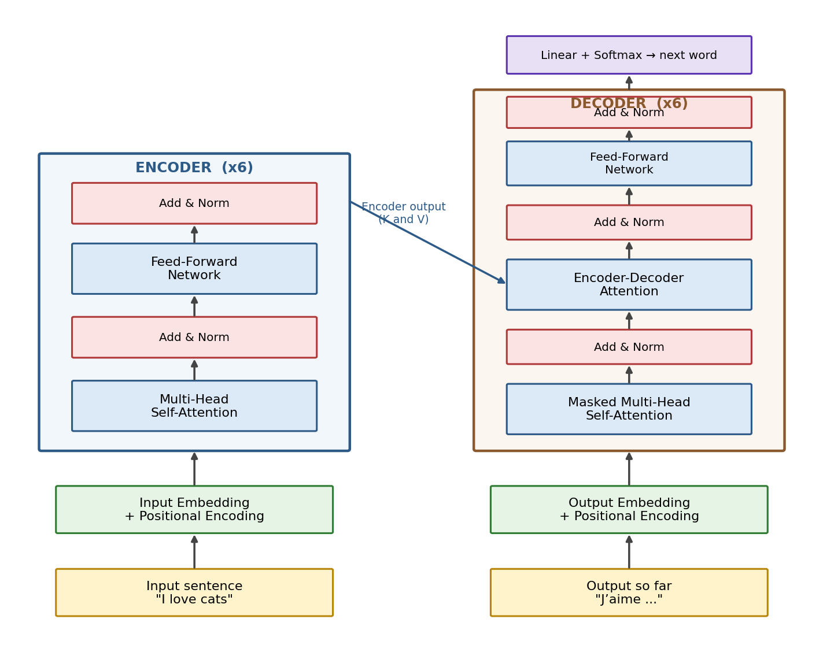
Figure 1: The full Transformer. Left: the encoder stack understands the input. Right: the decoder stack generates the output one word at a time, using the encoder’s output as reference.
Example: translating “I love cats” to French
The encoder reads all three words “I love cats” at once and produces a rich numeric summary. The decoder then writes the French output step by step: first “J’”, then “aime”, then “les”, then “chats” — each time looking back at both what it has written so far AND the encoder’s summary of the English sentence.

3. Step 1 — Tokenization and Embedding

3.1 Tokenization: cutting text into pieces
A computer cannot read words — it only understands numbers. So the first job is to cut the text into small units called tokens. A token can be a whole word or a piece of a word (a “subword”).
- Example 1: “I love cats” → tokens: [“I”, “love”, “cats”] (simple case: each word is one token).
- Example 2: “unhappiness” → tokens: [“un”, “happi”, “ness”]. Rare or long words get split into common pieces so the vocabulary stays small.
- Example 3: “ChatGPT” → tokens: [“Chat”, “G”, “PT”]. Brand-new words the model never saw can still be built from known pieces.
Every token in the vocabulary has a fixed ID number. So “I love cats” might become the list of IDs [314, 1922, 5077].

3.2 Embedding: turning IDs into meaning
An ID like 5077 is just a label — it carries no meaning by itself. The embedding layer is a big lookup table that converts each ID into a vector (a long list of numbers, e.g. 512 numbers in the original Transformer). These numbers are learned during training so that words with similar meanings end up with similar vectors.
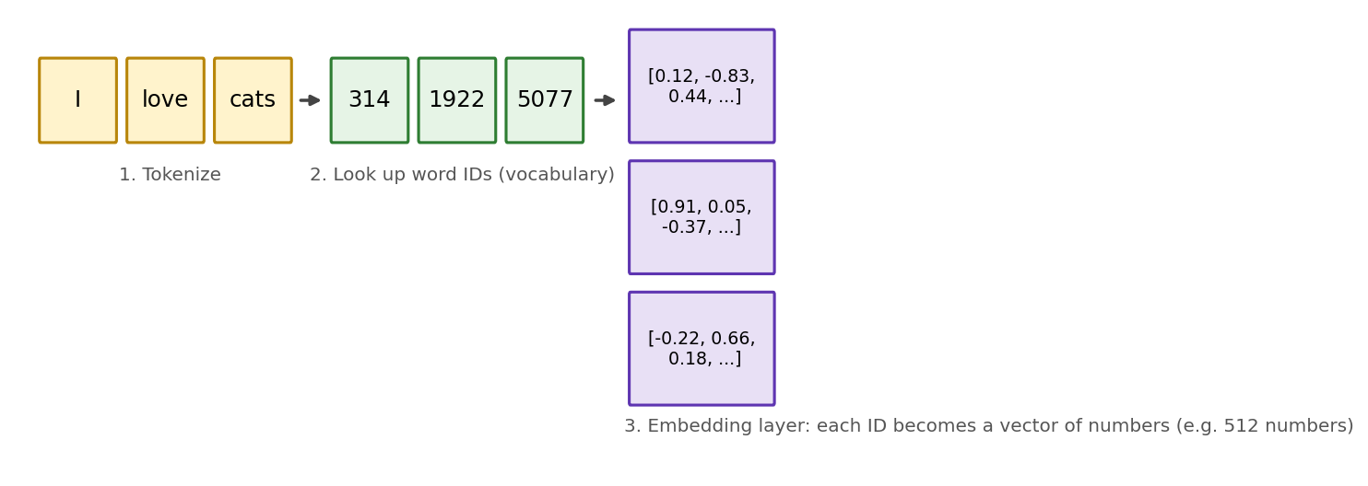
Figure 2: Text → tokens → IDs → embedding vectors. Each word becomes a list of numbers that represents its meaning.
Intuition: a coordinate for every word
Think of embeddings as placing every word on a giant map. “Cat” and “kitten” land close together; “cat” and “carburetor” land far apart. Famous example: the vector for king − man + woman lands very close to the vector for queen — the numbers really do capture meaning.

4. Step 2 — Positional Encoding

4.1 The problem: attention is order-blind
Because the Transformer looks at all words at the same time, it has no natural sense of word order. But order matters! “The dog bit the man” and “The man bit the dog” contain exactly the same words with very different meanings. So we must inject position information.

4.2 The solution: add a position “fingerprint”
For every position (1st word, 2nd word, 3rd word, …) we compute a special vector using sine and cosine waves of different speeds, and simply add it to the word’s embedding. Each position gets a unique wave pattern — like a fingerprint.
These positional values are fixed formulas, not learned: they depend only on the position number and the dimension index, not on which words are in the sentence. Position 5 always gets the same fingerprint whether the sentence is about cats or cars. This means they can be computed once, in advance, up to the maximum sequence length.
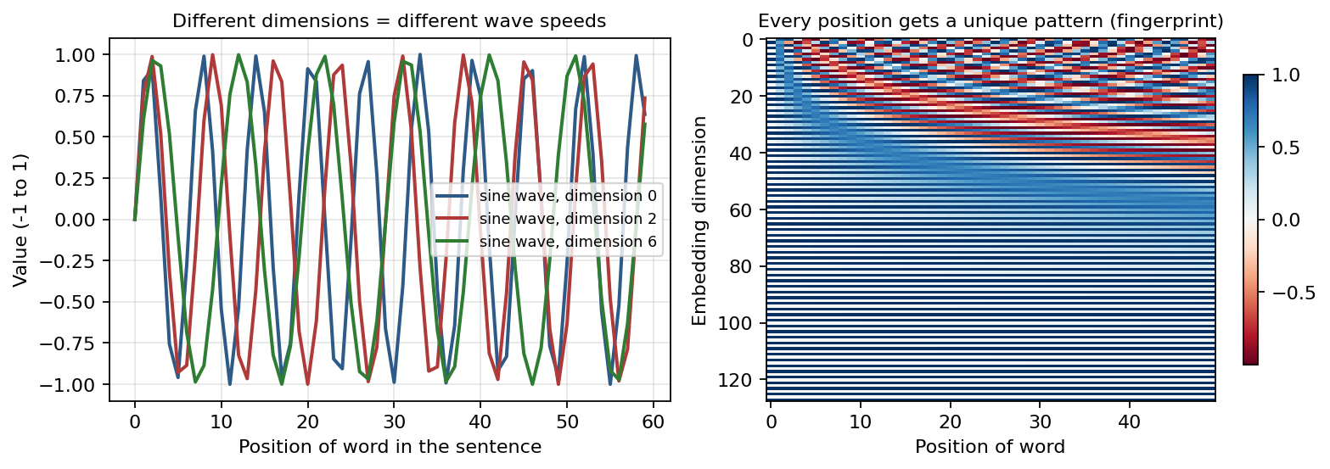
Figure 3: Left — each embedding dimension uses a wave of a different speed. Right — stacking all the waves gives every position a unique pattern.

4.3 Why sine and cosine? (very common interview question)
- Bounded values: sine and cosine always stay between −1 and +1, so position values never explode and never drown out the word’s meaning. (If we just used raw position numbers 1, 2, 3, …, 500, then position 500 would be a huge number that overwhelms the embedding.)
- Relative positions: thanks to trigonometric identities, the encoding of position (p + k) can be written as a simple linear function of the encoding of position p. In plain words: the model can easily learn “this word is 3 steps after that word”, not just “this word is at position 7”.
- Works for any length: the formula can produce a fingerprint for positions longer than anything seen in training, because it is a formula, not a learned table.

4.4 “Doesn’t adding numbers to the embedding corrupt it?”
Short answer: no. Two reasons:
- The position values are small (between −1 and 1), so they gently “tilt” the embedding rather than destroy it. The word’s meaning survives.
- The model is trained with these positional patterns from the very beginning. The training process learns to read the combined signal — just like your brain has no trouble reading a word AND noticing its position on a page at the same time.

5. Step 3 — Inside the Encoder
Each encoder layer contains exactly two sub-layers, in this order:
- Multi-Head Self-Attention — every word gathers information from all other words.
- Feed-Forward Network (FFN) — every word then processes its gathered information privately.
Around each of these two sub-layers there is a residual (skip) connection followed by a Layer Normalization step. So one encoder layer = Attention → Add & Norm → FFN → Add & Norm. Six of these layers are stacked: the first one receives the embeddings + positional encodings; each later one receives the output of the layer below it.

6. Self-Attention: The Heart of the Transformer

6.1 What problem does it solve?
Consider: “The cat drank the milk because it was thirsty.” What does “it” refer to — the cat or the milk? You instantly know it’s the cat. Self-attention is how the model figures this out: when processing “it”, the model computes how relevant every other word is, gives “cat” a high score, and blends the meaning of “cat” into the representation of “it”.
Now change one word: “The cat drank the milk because it was sweet.” This time attention should point “it” towards “milk”. Same sentence structure, different focus — attention adapts to context.

6.2 Where attention is used (3 places)
- Self-attention in the Encoder — the input sentence pays attention to itself.
- Masked self-attention in the Decoder — the output sentence (so far) pays attention to itself, but cannot look ahead.
- Encoder-Decoder attention in the Decoder — the output sentence pays attention to the input sentence.

6.3 Query, Key, Value — in plain words
Every word’s vector is transformed into three different vectors by three separate learned weight matrices (three Linear layers, each with its own weights):
- Query (Q) — “what am I looking for?” Like the question you type into a search engine.
- Key (K) — “what do I contain / what am I about?” Like the title tag of a page, or the index of a book — used only for matching.
- Value (V) — “the actual information I carry.” Like the content of the page itself.
Analogy 1: a library
You walk in with a question (Query). You scan the spines of the books — the titles (Keys) — to find which books match your question. Then you actually read the matching books’ contents (Values). The title helps you find the book; the content is what you take away.
Analogy 2: YouTube search
Your search text is the Query. Each video’s title and tags are its Key. The video itself is the Value. YouTube compares your query against keys to rank videos, then serves you the values (videos) weighted by relevance.
Important: Q, K, and V all come from the same input X, but through three different weight matrices (Wq, Wk, Wv), so they are three different “views” of the same word. The shapes of these weight matrices must match the input: if X has embedding size 512, each weight matrix has 512 rows so that X × W works.

6.4 The attention calculation, step by step
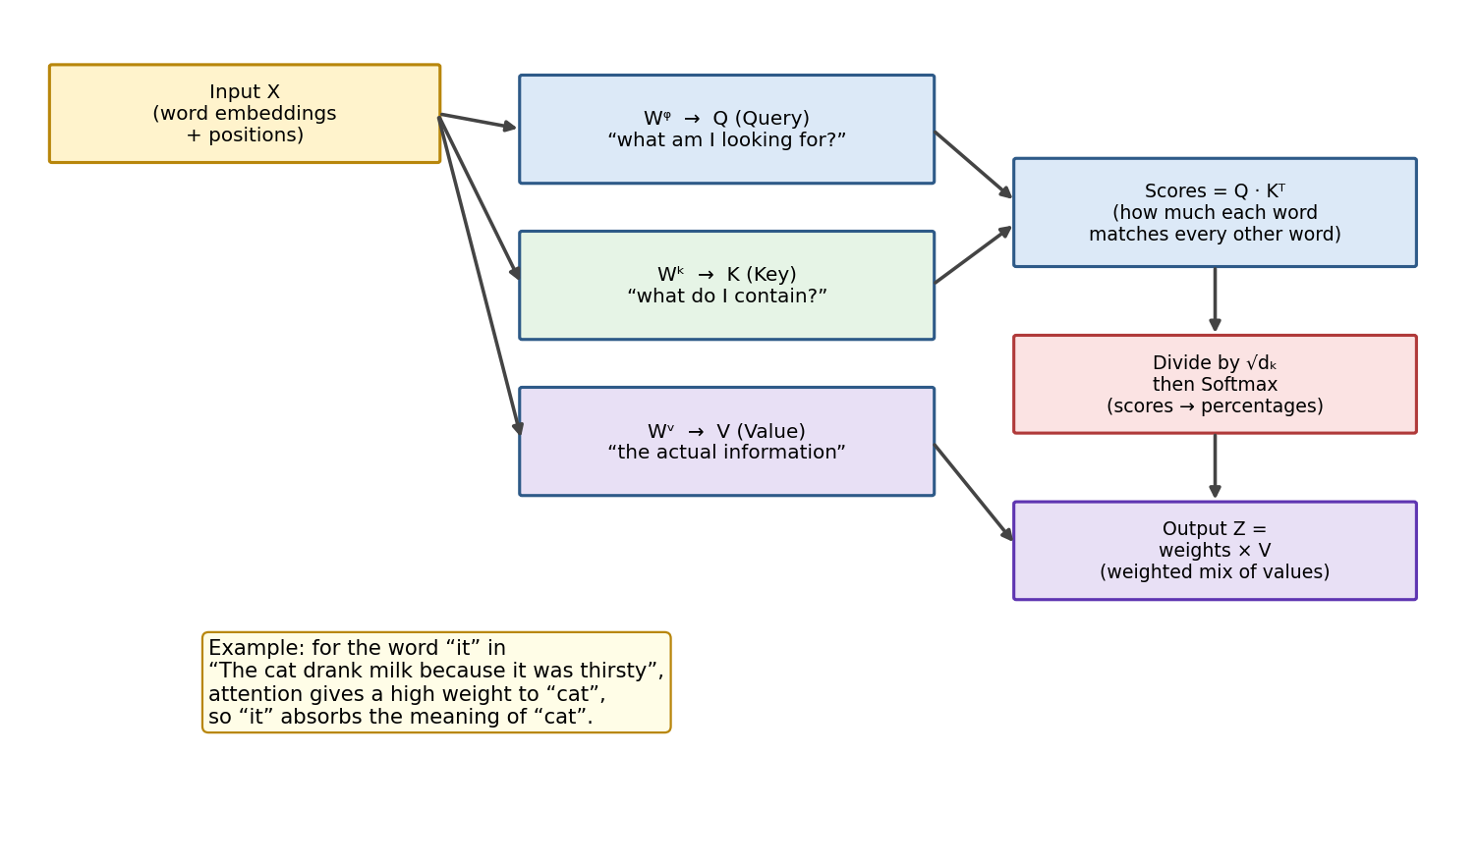
Figure 4: Self-attention. The input is projected into Q, K, V; scores are computed, scaled, softmaxed, and used to mix the Values.
- Compute scores: multiply Q by K-transposed (Q·Kᵀ). This gives a score for every pair of words — how much word A “matches” word B. High score = strong relevance.
- Scale: divide every score by √dₖ (the square root of the key dimension; in the original paper dₖ = 64, so we divide by 8).
- Softmax: convert the scores in each row into percentages that add up to 1. Example: raw scores [8, 4, 1] might become weights [0.94, 0.05, 0.01] — the first word gets 94% of the attention.
- Weighted sum: multiply the weights by the Value vectors and add them up. The output Z for each word is a smart blend of all words’ information, dominated by the most relevant ones.

6.5 Why divide by √dₖ if softmax already normalizes? (classic interview trap)
Softmax and the √dₖ division do two different jobs. Softmax turns scores into percentages — it normalizes the output. The √dₖ division protects the input of the softmax.
Here is the issue: when vectors are long (dₖ = 64 or more), dot products naturally become large numbers. And softmax is very sensitive to large numbers:
- Without scaling: scores like [80, 40, 10] → softmax gives roughly [1.0, 0.0, 0.0]. One word takes all the attention (“peaky” softmax), the other words are ignored, and the gradients flowing back through those near-zero weights become almost zero — learning stalls.
- With scaling (÷ 8): the same scores become [10, 5, 1.25] → softmax gives a softer spread like [0.99 → 0.92, …] — attention is still focused but other words keep a voice, and gradients stay healthy.
One-line answer for interviews
“The √dₖ scaling is not for normalizing the output — softmax does that. It keeps the softmax inputs in a reasonable range so the distribution doesn’t collapse onto one token and gradients don’t vanish.”

7. Multi-Head Attention
Multi-head attention is simply running self-attention several times in parallel — 8 times in the original paper — each time with its own separate Wq, Wk, Wv weight matrices. Because each head has different weights, each head learns to look for a different kind of relationship.
- Example: in “The cat drank the milk because it was thirsty”, one head may link “it”→“cat” (who?), another head may link “drank”→“milk” (drank what?), another may track adjacent-word grammar, another may track sentence position.
Running 8 heads produces 8 output matrices (Z₁ … Z₈). But the next layer (the feed-forward network) expects one matrix — one vector per word. So we:
- Concatenate the 8 matrices side by side into one wide matrix.
- Multiply by one more learned weight matrix Wᴼ (trained jointly with everything else). This mixes and compresses the information from all heads into a single matrix of the original size.
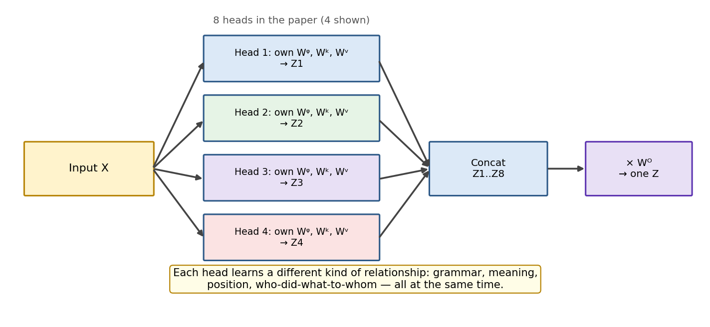
Figure 5: Multi-head attention: several attention “experts” run in parallel, then their outputs are concatenated and blended by Wᴼ.
Analogy: a panel of experts
Instead of one person reading a contract, you hire 8 specialists: a lawyer, an accountant, a grammar editor, … Each reads the same document but notices different things. At the end, a coordinator (Wᴼ) merges all their notes into one final report.

8. Residual (Skip) Connections
In a traditional feed-forward network, data flows strictly layer by layer: the output of layer 1 is the input of layer 2, and so on. The deeper the network, the harder it is to train, mainly because of vanishing gradients (the learning signal shrinks to almost nothing as it travels backwards through many layers) and sometimes exploding gradients (the signal blows up).
A residual connection adds a shortcut: the input of a sub-layer is added directly to its output. In formula form: output = LayerNorm( x + SubLayer(x) ). The data now has two paths — through the sub-layer, and around it.
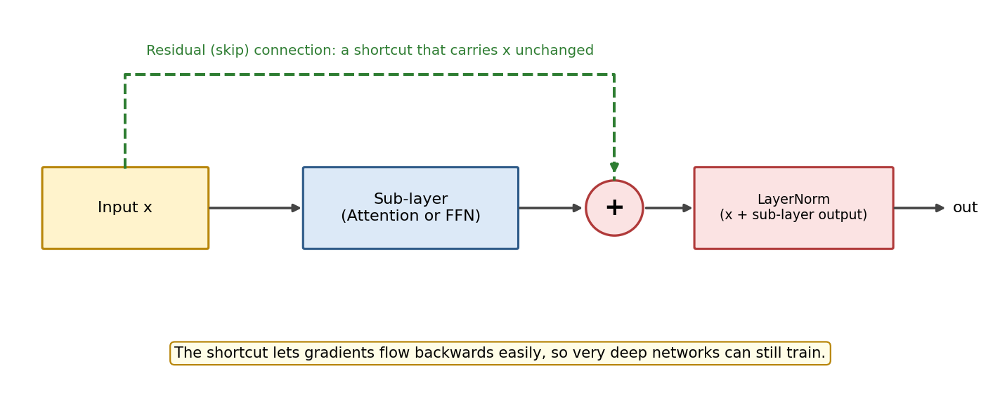
Figure 6: The residual connection is a highway that carries x around the sub-layer; the two paths are added, then normalized.
- Why it helps learning: during backpropagation, gradients can flow straight through the shortcut without being shrunk by the sub-layer’s weights. Networks with hundreds of layers become trainable — this was proven empirically first in ResNet (2015) for images, and Transformers adopted the same trick.
- Why it helps meaning: each sub-layer only needs to learn a small correction (a “residual”) on top of the input, instead of re-creating everything from scratch. The word’s original identity is never lost as it travels up the stack.
Analogy: editing a document
Without residuals: every editor retypes the whole document from memory — errors accumulate. With residuals: every editor receives the original document and only adds comments and small fixes. The original text always survives, and each editor’s job is much easier.

8.1 First, what is a gradient?
When the model trains, it makes a prediction, measures how wrong it was (the loss), and then works backwards through the network asking every weight: “if I nudged you slightly, would the error get better or worse?” That answer is the gradient.
The gradient starts at the top layer and travels back down to the first. The trouble is what happens to it on that journey — and that is what the two problems mentioned above really are.

8.2 The vanishing gradient problem — with numbers
The chain rule says the gradient at layer 1 is the product of the gradients of every layer above it. Multiplication is the villain. Suppose each layer passes back a factor of 0.5 — very normal, since sigmoid and tanh have derivatives well below 1:
Layer (counting backwards) | Gradient reaching it | What that means
Layer 10 (top) | 0.5 | Learns fine
Layer 9 | 0.5² = 0.25 | Learns a bit slower
Layer 5 | 0.5⁶ = 0.0156 | Learning is crawling
Layer 1 (bottom) | 0.5¹⁰ = 0.00098 | Effectively frozen
Layer 1 of a 100-layer net | 0.5¹⁰⁰ ≈ 0.0000…0008 | Dead — it never learns anything

What vanishing gradients look like in practice
Training loss falls for a while and then flatlines. The top layers have learned; the bottom layers still hold nearly their random starting values. Adding more layers makes the model worse — the paradox that motivated ResNet in 2015.

8.3 The exploding gradient problem
The same multiplication runs the other way. If each layer passes back a factor of 1.5 instead of 0.5:
- 10 layers: 1.5¹⁰ ≈ 58 — large but survivable
- 30 layers: 1.5³⁰ ≈ 191,751 — the weight update is enormous
- 50 layers: 1.5⁵⁰ ≈ 6.4 × 10⁸ — the weights jump to nonsense and the loss becomes NaN
Symptom: the loss looks healthy, then spikes to infinity or NaN in a single step and never recovers.

8.4 How the residual fixes it — the actual maths
The residual changes a layer from y = F(x) to y = x + F(x). That tiny x + is the whole trick. Differentiate it and you get:
dy/dx = 1 + dF/dx

| |
| +-- the layer's own contribution
+----------- the highway (a constant, never shrinks)

Why the '1' changes everything
Without a residual the backward factor is dF/dx, which might be 0.5 — so gradients shrink with every layer.
With a residual the factor is 1 + dF/dx. Even if dF/dx collapses to zero, the factor is still 1, and multiplying by 1 changes nothing. The gradient arrives at layer 1 at full strength no matter how deep the stack is.
The residual gives the gradient a road that bypasses every layer's weights.

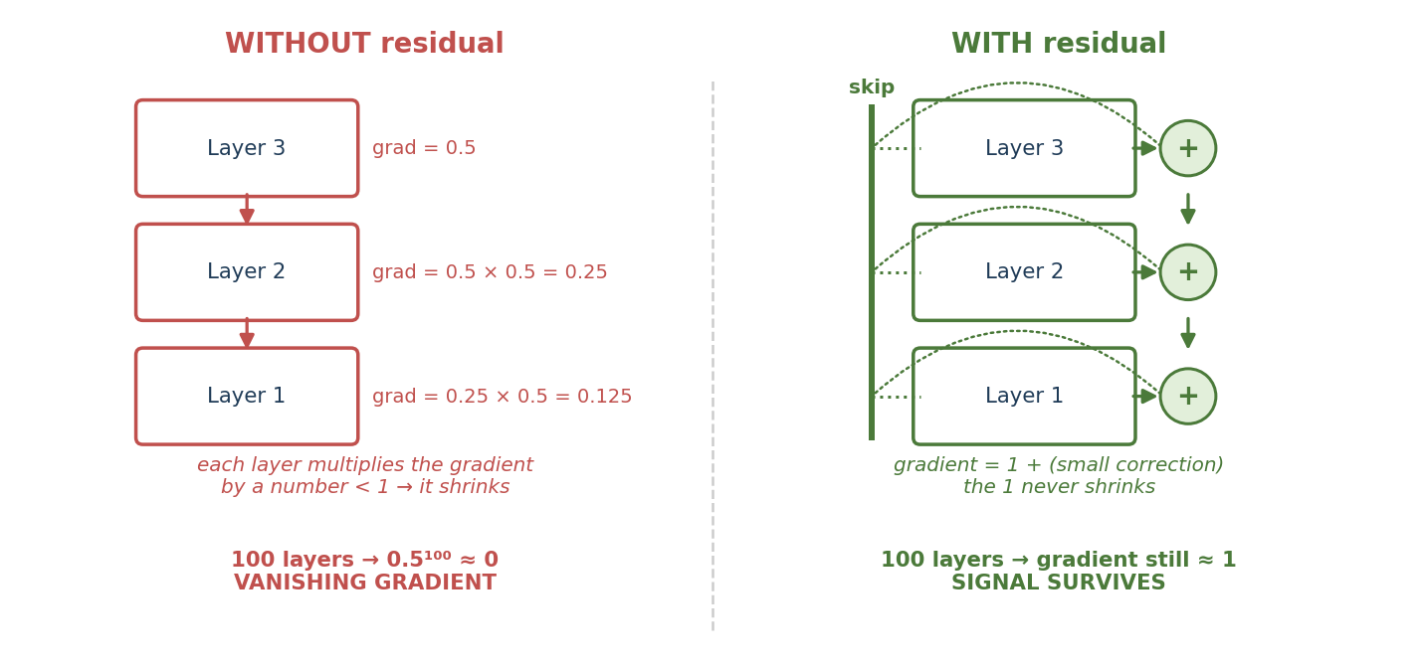
Figure 6b: Left, gradients shrink by a factor at every layer. Right, the skip connection gives them a route that is never multiplied down.

8.5 The same numbers, side by side
Depth | Without residual (factor 0.5) | With residual (factor ≈ 1 + 0.5)
10 layers | 0.00098 — barely learning | ≈ 1 — healthy
50 layers | 8.9 × 10⁻¹⁶ — dead | ≈ 1 — healthy
100 layers | 7.9 × 10⁻³¹ — dead | ≈ 1 — healthy
Deepest trainable model | about 20 layers | hundreds of layers (GPT-3 has 96)

8.6 Does it help with exploding gradients too?
Partly — and it is worth being precise here, because this is where candidates overclaim.
Problem | Does the residual solve it? | Explanation
Vanishing | Yes, directly | The +1 term guarantees the gradient cannot be multiplied down to zero.
Exploding | Helps, but is not a full fix | Each layer only has to learn a small correction, so dF/dx naturally stays small and the product stays near 1 instead of compounding upward. But a badly scaled layer can still blow up — that is what gradient clipping and LayerNorm are for.

The full anti-explosion toolkit
Residuals keep the signal from dying · LayerNorm re-scales activations after every addition so they cannot drift · Gradient clipping hard-caps the gradient norm (typically at 1.0) · Warmup + Adam keep the early, unstable steps small. Transformers use all four together.

8.7 A bonus benefit: doing nothing becomes easy
Without a residual, a layer that should leave its input alone must learn to reproduce that input exactly — surprisingly hard. With a residual, leaving the input alone just means outputting zero, which is trivial.
So a residual network can never be worse than a shallower one: surplus layers can settle near the identity and simply pass information through. Layers become optional refinements rather than mandatory bottlenecks.
In the Transformer, there is a residual connection around every sub-layer: around the attention sub-layer AND around the feed-forward sub-layer, in both the encoder and the decoder. Each residual addition is followed by Layer Normalization — explained next.

9. Layer Normalization — In Detail

9.1 The problem it solves
As numbers pass through many layers of multiplications and additions, their scale can drift — some become huge, some tiny. When a layer’s inputs keep changing scale during training, the layer keeps chasing a moving target, so training becomes slow and unstable. Normalization re-centers and re-scales the numbers at fixed points in the network, so every layer always receives inputs in a predictable, comfortable range.

9.2 What LayerNorm actually computes — worked example
LayerNorm works on one word’s vector at a time. For each word vector, it does 4 small steps. Suppose a word’s vector is [2, 4, 6, 8] (real vectors have 512 numbers; 4 keeps the math easy):
- Find the mean: (2 + 4 + 6 + 8) / 4 = 5
- Find the variance: average of squared distances from the mean = ((2−5)² + (4−5)² + (6−5)² + (8−5)²) / 4 = (9 + 1 + 1 + 9) / 4 = 5, so the standard deviation is √5 ≈ 2.24
- Normalize: subtract the mean and divide by the standard deviation: [2, 4, 6, 8] → [−1.34, −0.45, 0.45, 1.34]. The vector now has mean 0 and standard deviation 1 — a clean, standard scale.
- Scale and shift (learned): multiply by a learned parameter γ (gamma) and add a learned parameter β (beta): output = γ · normalized + β. This lets the model “undo” the normalization partially if some feature genuinely needs a bigger scale. γ and β are trained just like all other weights.
Analogy: grading on a curve
A teacher converts raw exam marks into standardized scores: subtract the class average, divide by the spread. Now a “1.2” always means “well above average” regardless of whether the exam was easy or hard. LayerNorm does the same for the numbers inside a word’s vector — every layer receives scores on the same familiar scale.

9.3 LayerNorm vs BatchNorm — and why Transformers use LayerNorm
Both are normalization techniques; the difference is the direction in which the statistics (mean and variance) are computed:
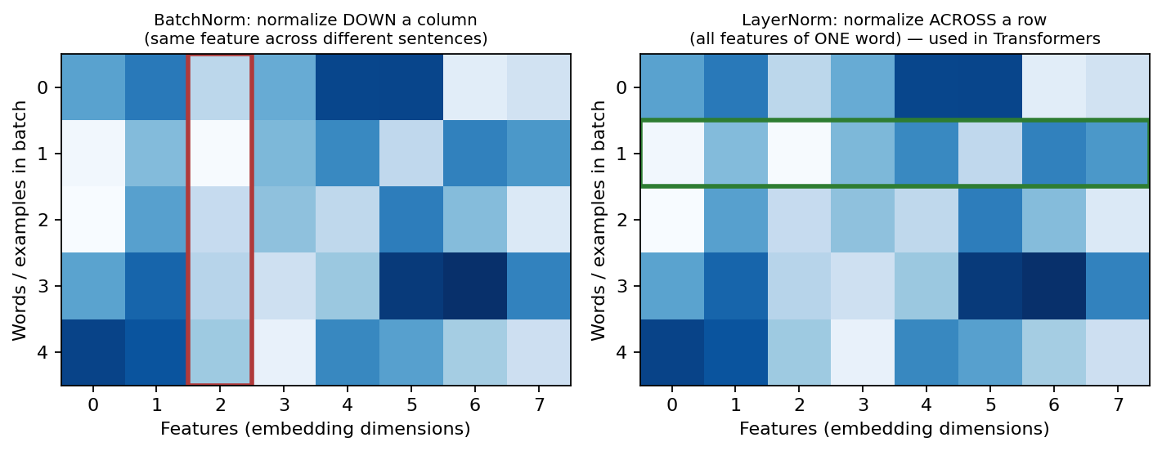
Figure 7: BatchNorm normalizes each feature across many examples (a column). LayerNorm normalizes all features of one example (a row).
BatchNorm | LayerNorm (used in Transformers)
Statistics computed across the batch: one feature, many examples | Statistics computed within one example: all features of one word
Depends on batch size — unreliable with small batches | Completely independent of batch size — works even with batch = 1
Awkward for text: sentences have different lengths and padding pollutes the statistics | Natural for text: each word is normalized on its own, sentence length doesn’t matter
Behaves differently in training vs inference (needs running averages) | Behaves identically in training and inference — simpler and safer
Popular in computer vision (CNNs) | Standard in Transformers and most NLP models

9.3.1 Same formula, different direction
It is worth being clear that the two are not different calculations. Both do exactly this:
normalised = (x - mean) / sqrt(variance + epsilon)
output = gamma * normalised + beta

The formula is identical. The only difference is which numbers go into the mean and variance. That is the entire distinction.
Take a batch of 3 examples, each with 4 features. The row for “cat” uses the same numbers as the worked example in 9.2 above:
 | f1 | f2 | f3 | f4
cat | 2 | 4 | 6 | 8
dog | 10 | 20 | 30 | 40
sun | 1 | 3 | 5 | 7

- BatchNorm normalises down a column — one feature, across every example in the batch.
- LayerNorm normalises across a row — one example, across all of its own features.
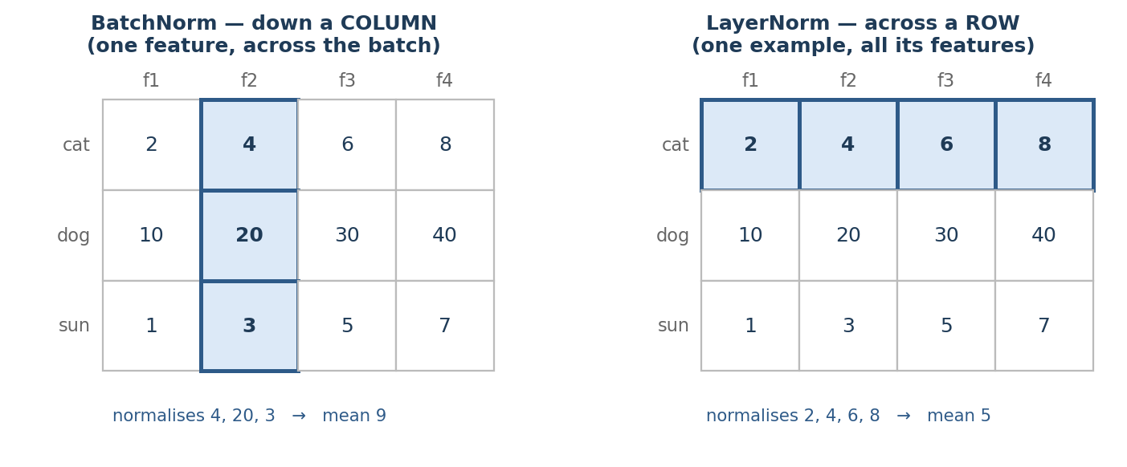
Figure 7b: Same grid, two directions. BatchNorm takes a column; LayerNorm takes a row.

9.3.2 Worked example: BatchNorm on column f2
The values in that column are 4, 20, 3 — one number from each example.
Step | Calculation | Result
Mean | (4 + 20 + 3) ÷ 3 | 9
Variance | [(4−9)² + (20−9)² + (3−9)²] ÷ 3 | 60.67
Std dev | √60.67 | 7.79
Normalise “cat” | (4 − 9) ÷ 7.79 | −0.64
Normalise “dog” | (20 − 9) ÷ 7.79 | +1.41
Normalise “sun” | (3 − 9) ÷ 7.79 | −0.77

Notice the dependency
The normalised value for cat depends on what dog and sun happen to be. Put cat in a different batch and it gets a different number. BatchNorm makes the examples in a batch talk to each other.

9.3.3 Worked example: LayerNorm on the row “cat”
The values in that row are 2, 4, 6, 8 — the same figures as 9.2, which is the point: LayerNorm here is doing precisely what was described there, and the result is identical.
Step | Calculation | Result
Mean | (2 + 4 + 6 + 8) ÷ 4 | 5
Variance | [9 + 1 + 1 + 9] ÷ 4 | 5
Std dev | √5 | 2.24
Normalise f1 … f4 | (2−5)÷2.24, (4−5)÷2.24, (6−5)÷2.24, (8−5)÷2.24 | −1.34, −0.45, +0.45, +1.34

Notice the independence
“cat” was normalised using only its own numbers. It would get the identical result alone in the batch, or in a batch of a thousand. LayerNorm treats every example as an island.

9.3.4 Why text specifically breaks BatchNorm
The table above lists the differences; here is why each one is fatal for language rather than merely inconvenient.
Problem | What goes wrong
Variable sentence length | “Hi” is 1 token, a paragraph is 300. Short sentences are padded with meaningless <PAD> tokens, and those zeros get pulled into the mean and variance, corrupting the statistics for the real words.
Small batch sizes | LLMs are huge, so batches are often small — sometimes one sequence per GPU. Mean and variance over 2 or 4 examples are wildly noisy estimates.
Train/inference mismatch | In training BatchNorm uses the current batch; at inference there is no batch, so it falls back on running averages collected during training. If the live data differs at all, behaviour shifts. LayerNorm behaves identically in both modes.
Generation is one token at a time | During decoding you process a single position. “Batch statistics” over one item are meaningless — the variance is zero.
Sequence position varies | Should the 3rd word of every sentence be normalised together? They are unrelated words. The grouping makes no linguistic sense.

Interview one-liner
“Same formula, different axis. BatchNorm normalises each feature across the batch, so it couples examples together and needs stable batch statistics. LayerNorm normalises each example across its own features, so it is batch-size independent and identical at training and inference. Text has variable lengths, padding and single-token decoding, all of which break batch statistics — hence LayerNorm.”

9.4 Where it sits in the Transformer
After every residual addition: output = LayerNorm( x + SubLayer(x) ). So each encoder layer applies LayerNorm twice (after attention, after FFN), and each decoder layer applies it three times. The residual keeps the original information alive; LayerNorm keeps its scale healthy. They are a team.

9.5 A note on RMSNorm (what modern models actually use)
Recent models — LLaMA, Mistral, Gemma — use RMSNorm, a simplified LayerNorm that skips the mean subtraction entirely and divides only by the root-mean-square:
LayerNorm : (x - mean) / sqrt(variance) * gamma + beta
RMSNorm : x / sqrt(mean(x^2)) * gamma

It turns out the re-centring contributes little, and dropping it saves computation and one learned parameter per feature. Same idea, cheaper. Everything said above about LayerNorm versus BatchNorm applies to RMSNorm too.

10. The Feed-Forward Network (FFN) — In Detail

10.1 What it is
After attention has let every word gather context from other words, the FFN gives every word a private thinking step. It is a small two-layer neural network applied to each word’s vector separately, using the same weights for every word (that is why it is often called “position-wise”). These layers are not simple pass-through pipes — they have real weight matrices and biases that are updated by backpropagation during training.

10.2 The structure: expand → activate → shrink
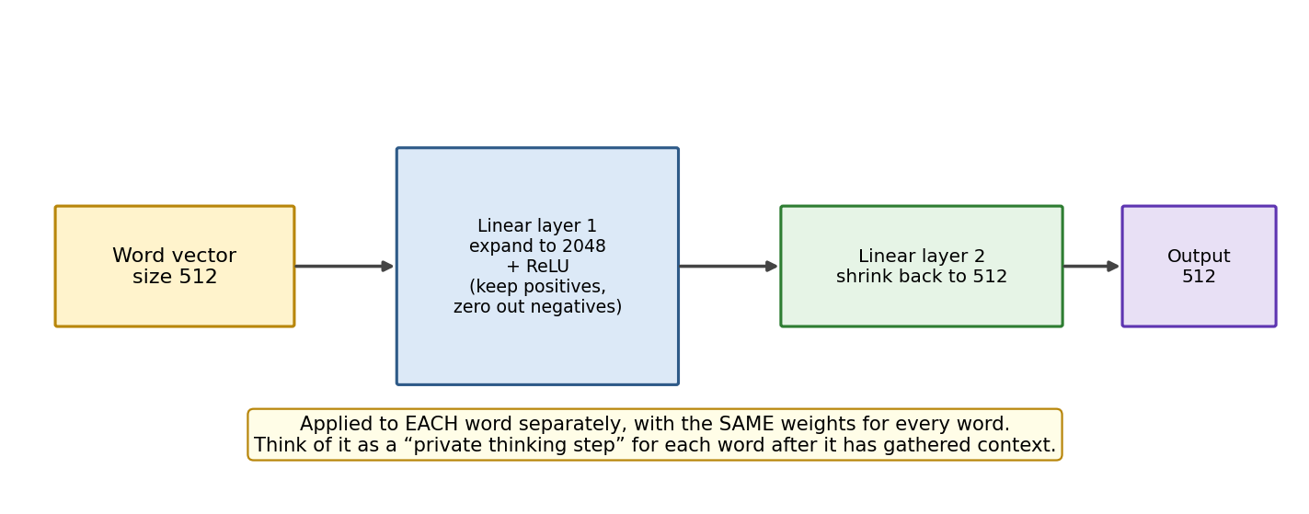
Figure 8: The FFN expands each word’s vector 4× (512 → 2048), applies ReLU, then shrinks it back (2048 → 512).
- Linear layer 1 (expand): multiplies the 512-dimensional word vector by a weight matrix to produce a 2048-dimensional vector — four times wider. The extra room lets the network compute many intermediate “feature detectors” at once.
- ReLU activation: ReLU(x) = max(0, x) — keep positive numbers, replace negatives with 0. Example: [3, −2, 0.5, −7] → [3, 0, 0.5, 0]. This is the crucial non-linearity: it lets each of the 2048 units act like a switch (“fire only if this pattern is present”), which lets the network learn complex rules instead of just straight-line math.
- Linear layer 2 (shrink): multiplies the 2048-dimensional vector back down to 512 dimensions, so it fits the next layer and the residual addition.

10.2.1 So how many layers is that, exactly?
The answer to the interview question
The FFN has TWO linear (weight) layers with ONE activation between them. Equivalently: one hidden layer.
It is the smallest network that can be called “deep” — the minimum needed for a genuinely non-linear transformation.

People quote different numbers because they are counting different things. All of these describe the same module:
If you count… | Answer | Why
Weight matrices | 2 | W₁ (expand) and W₂ (shrink)
Hidden layers | 1 | The 2048-wide layer in the middle
Total operations | 3 | Linear → activation → Linear
Layers with learnable parameters | 2 | The activation has no weights of its own

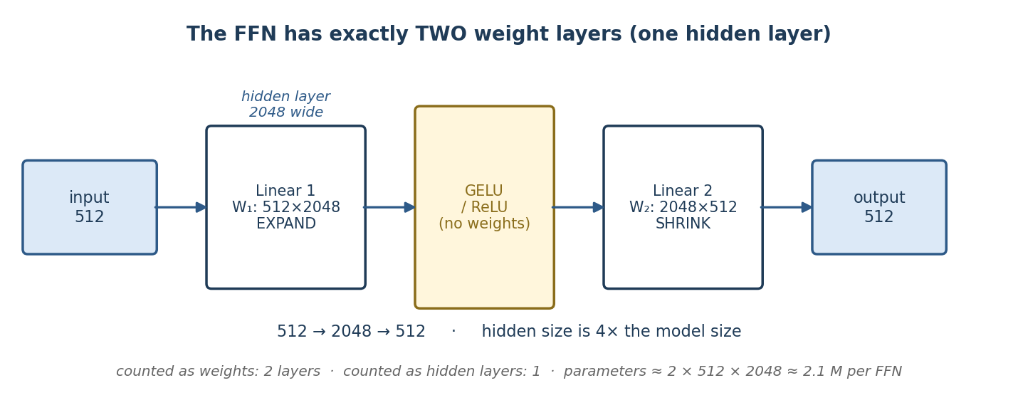
Figure 8b: The same FFN drawn with its layer count made explicit — two weight matrices, one activation, one hidden layer.

10.2.2 The shapes at each stage
Take the word “bank” after attention has already given it context. Its vector is 512 numbers long.
Stage | Shape | What happens
Input x | 512 | The context-aware vector for “bank”
x · W₁ + b₁ | 512 → 2048 | Expand. Room to spread the meaning across many specialised directions
GELU(…) | 2048 | Activate. Bends the numbers non-linearly; negatives get mostly squashed
… · W₂ + b₂ | 2048 → 512 | Shrink. Compress back so the next layer receives the shape it expects

The 4× hidden ratio holds across model families:
Model | d_model | FFN hidden size | Ratio
Original Transformer | 512 | 2,048 | 4×
BERT-base | 768 | 3,072 | 4×
GPT-3 | 12,288 | 49,152 | 4×
LLaMA-2 7B (SwiGLU) | 4,096 | 11,008 | ≈ 2.7×, but 3 matrices

10.2.3 Why exactly two? Why not one, or five?
Design | Problem
One linear layer | Two linear layers with nothing between them collapse into a single linear layer (A·B is just another matrix). Without an activation you gain no extra power at all — and since attention is largely linear averaging, the model could never learn non-linear patterns.
Two linear + activation | The minimum that adds real non-linearity. Cheap, fully parallelisable, and it works.
Three or more | More depth per block, but the Transformer already gets its depth by stacking blocks (6, 12, 24, 96 of them). Extra depth inside each FFN adds parameters and training instability for little gain.

The key insight
Depth in a Transformer comes from repeating the block, not from making the FFN deep. Keep the FFN shallow and wide, then stack many of them.

10.3 Tiny worked example
Take a mini word vector x = [1, −1] (2 dimensions instead of 512).
- Expand: suppose Linear layer 1 computes h = [x₁+x₂, x₁−x₂, 2x₁, −x₂] → h = [0, 2, 2, 1] (2 dims → 4 dims).
- ReLU: all values are already ≥ 0 here, so h stays [0, 2, 2, 1]. (If h had contained −3, it would become 0.)
- Shrink: Linear layer 2 combines the 4 numbers back into 2, e.g. out = [h₂+h₃, h₄−h₁] = [4, 1].
In the real model, the combinations are learned, not hand-written — but the mechanics are exactly this: expand, gate with ReLU, recombine.

10.4 Why is the FFN needed at all? (interview favourite)
- Attention mixes, FFN transforms. Attention is essentially a weighted averaging of value vectors — it moves information between words but does relatively simple math on it. The FFN, with its non-linearity, does the deep processing of that information within each word.
- Stored knowledge. Research suggests FFN layers act like a key-value memory where much of the model’s factual knowledge lives. They contain roughly two-thirds of a Transformer’s parameters.
Analogy: meeting, then desk work
Attention is the team meeting: everyone shares information with everyone. The FFN is what happens after the meeting: each person goes back to their own desk and processes what they heard, alone, using the same standard procedure (same weights). Then the next meeting (next layer’s attention) begins.

10.5 Where the parameters actually live
The FFN is the largest part of a Transformer block — roughly two thirds of all its parameters. For BERT-base (d_model = 768):
Component | Parameters per layer | Share
Attention (Wᴱ, Wᴷ, W♑, Wᴼ) | 4 × 768 × 768 ≈ 2.36 M | ~33%
FFN (W₁ and W₂) | 2 × 768 × 3072 ≈ 4.72 M | ~67%
LayerNorm, biases | a few thousand | <1%

This is worth remembering for two later parts of this guide: it is why the FFN is thought to hold much of the model's factual knowledge, and why PEFT methods think carefully about whether to attach adapters to attention matrices, FFN matrices, or both.

11. Step 4 — Inside the Decoder
The decoder’s structure is very similar to the encoder’s, with two differences: its self-attention is masked, and it has an extra third sub-layer called encoder-decoder attention. So one decoder layer = Masked Self-Attention → Add & Norm → Encoder-Decoder Attention → Add & Norm → FFN → Add & Norm. Like the encoder, the first decoder receives the output embedding + positional encoding; later decoders receive the output of the decoder below.

11.1 Masked self-attention: no peeking at the future
The decoder generates the output one word at a time, left to right. While predicting word number 3, it must not be allowed to see words 4, 5, 6 — during training those future words are sitting right there in the training data, and looking at them would be cheating (the model would just copy the answer and learn nothing).
The fix is a mask: before the softmax, the attention scores for all future positions are set to −infinity. Softmax turns −infinity into a weight of exactly 0, so future words contribute nothing.
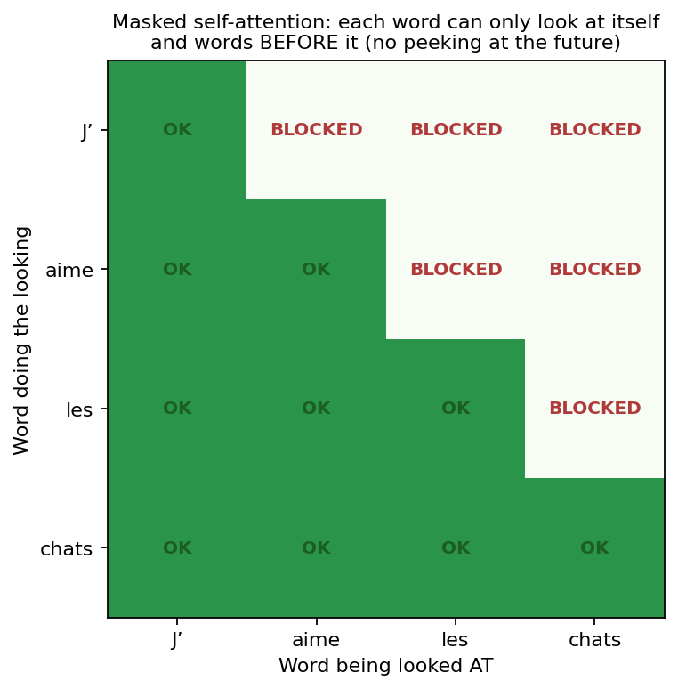
Figure 9: The mask forms a triangle: each word may attend to itself and earlier words only.
Analogy: exam conditions
Training the decoder without a mask is like giving a student the answer sheet during practice tests — great practice scores, useless in the real exam. The mask covers the answers so the student genuinely learns to predict.

11.2 Encoder-decoder attention: consulting the source
This layer works exactly like self-attention, except it combines two sources:
- Queries (Q) come from the decoder — from the layer just below (“here is what I’m trying to write; what do I need to know?”).
- Keys (K) and Values (V) come from the encoder stack’s final output — the understanding of the input sentence.
This is how the decoder “looks back” at the input while writing the output. Example: while generating the French word “chats”, the decoder’s query matches strongly with the encoder’s representation of “cats”, so the meaning of “cats” is pulled in at exactly the right moment. This lets the decoder focus on the appropriate places in the input sequence at every step.

11.3 Cross-attention: where Q, K and V come from, in detail
Cross-attention in one line
Q comes from the DECODER. K and V come from the ENCODER.
Everything else — the dot products, the √d scaling, the softmax, the weighted sum — is exactly the same as ordinary self-attention. Only the sources change.

Set against the other two attention blocks in the model:
Attention type | Q from | K from | V from | Purpose
Encoder self-attention | Encoder | Encoder | Encoder | Input words understand each other
Masked decoder self-attention | Decoder | Decoder | Decoder | Output words so far understand each other
Cross-attention | Decoder | Encoder | Encoder | Output looks back at the input

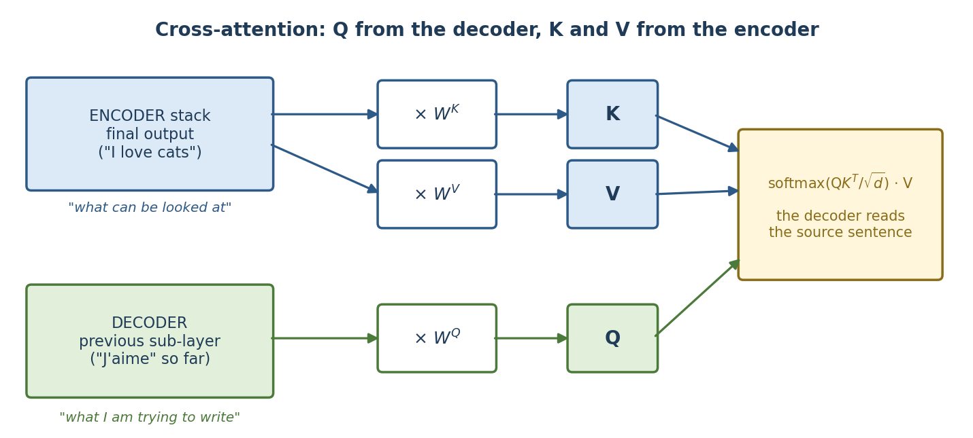
Figure 9b: The two sources feeding one attention block. K and V are built from the same encoder output, but through different weight matrices.
Q, K and V are never taken raw. Each is produced by multiplying a source vector by a learned weight matrix — which is where the two sources enter:
# self-attention: one source
Q = X_decoder @ W_Q
K = X_decoder @ W_K
V = X_decoder @ W_V

# cross-attention: TWO sources
Q = X_decoder @ W_Q # <- decoder, the position being written
K = X_encoder @ W_K # <- encoder, the whole input sentence
V = X_encoder @ W_V # <- encoder, the whole input sentence

W_Q, W_K and W_V here belong to the cross-attention layer itself — they are not shared with the self-attention layers, and each decoder layer has its own set.

11.4 A concrete example: translating “I love cats”
The decoder has already written “J'aime les” and is about to produce the fourth word.
Piece | Where it comes from | What it carries
Q | Decoder vector at the current position, after masked self-attention | “I have written J'aime les. I need a plural noun. What in the source am I still missing?”
K | Encoder final output — one key per input token: I / love / cats | An index card per source word: “this position is about cats”
V | Encoder final output — one value per input token | The actual meaning content to be pulled in

The dot products of Q against each K give the match scores:
Source token | Q·K score | After softmax | Effect
I | 1.2 | 4% | Barely consulted
love | 0.9 | 3% | Barely consulted
cats | 5.1 | 93% | Its V vector dominates the output

So the block returns roughly 0.04·V_I + 0.03·V_love + 0.93·V_cats — overwhelmingly the meaning of cats — and the decoder produces “chats”. This is the mechanism behind the familiar attention heatmaps that show which source word each output word looked at.

11.5 Why this particular arrangement?
Think of Q, K and V as a library lookup:
Role | Library analogy | Who should own it
Q — the query | The question you walk in with | The decoder, because the decoder is the one that needs something
K — the keys | The labels on the shelves you search against | The encoder, because the encoder holds the material being searched
V — the values | The actual books you take away | The encoder, for the same reason

Why K and V both come from the encoder yet differ
They are built from the same encoder output but through different weight matrices. K is optimised to be findable — good for matching. V is optimised to be useful — good for carrying content. Separating them lets the model learn “how to be found” independently from “what to deliver.”

11.6 Three practical consequences
- Shapes need not match. Q has one row per decoder position; K and V have one row per encoder position. A 3-word input and a 50-word translation work fine — the attention matrix is simply 50×3.
- No masking here. Masked self-attention hides the future, but the decoder is allowed to see the entire input sentence, so cross-attention is unmasked.
- K and V are computed once. The encoder runs a single time; its K and V are cached and reused for every output token. Only Q is recomputed at each step.

11.7 Where cross-attention appears today
Model type | Cross-attention? | Examples
Encoder-decoder | Yes — one block per decoder layer | T5, BART, the original Transformer, translation models
Decoder-only | No — prompt and answer share one sequence, so masked self-attention covers everything | GPT, LLaMA, Mistral, Claude
Multimodal | Yes — Q from text, K/V from image or audio features | Flamingo, Whisper, many vision-language models

Worth stating plainly, because it surprises people: most chat LLMs today are decoder-only and contain no cross-attention at all. Your prompt and the model's reply live in a single sequence, and masked self-attention alone does the job. Section 14.2 returns to this.

12. Step 5 — Final Linear Layer + Softmax (Producing the Word)
The decoder stack outputs one vector (size 512) per position. To turn the last position’s vector into an actual word:
- Linear layer: multiplies the vector by a huge weight matrix to produce one score per word in the vocabulary — e.g. 50,000 scores, called logits.
- Softmax: converts the 50,000 logits into probabilities that sum to 1. Example: {“chats”: 0.83, “félins”: 0.09, “chiens”: 0.02, …}.
- Pick a word: the simplest choice is the highest-probability word (“greedy” decoding). The chosen word is appended to the output, fed back into the decoder, and the whole decoding step repeats for the next word — until a special end-of-sentence token is produced.

12.1 Training vs inference — an important distinction
Training | Inference (real use)
The correct output sentence is known, so the decoder is fed the entire correct target at once (shifted right), with the mask preventing cheating. This is called teacher forcing. | There is no correct answer available; the decoder feeds its own previous predictions back in, generating one word per step (autoregressive).
All positions are computed in parallel → fast training | Positions are computed one by one → generation is step-by-step
Loss compares predicted probabilities against the true words | No loss — we just sample/pick words from the probabilities

13. Computational Complexity
Self-attention compares every word with every other word. With n words, that is n × n comparisons, and each comparison involves vectors of size d. So the cost of the attention score computation is O(n² · d) — in everyday shorthand, people say attention is “quadratic in the sequence length” (O(n²)).
- Example: a 100-word input needs about 10,000 pairwise scores; a 1,000-word input needs about 1,000,000. Multiply the length by 10 and the attention cost grows by 100×. This is exactly why long context windows are expensive in large language models, and why research areas like sparse attention, sliding-window attention, and FlashAttention exist.
Careful — a common mix-up with O(n³)
“Multiplying two n×n matrices costs O(n³)” is a true statement from general linear algebra — but the n there is the matrix size, not the sentence length, and attention’s matrices are not n×n square matrices of that kind. In attention we multiply an (n × d) matrix by a (d × n) matrix, which costs n · n · d = O(n²d) — quadratic in the sequence length n. Do not mix the two statements in an interview.
The trade-off: RNNs cost only O(n · d²) but must run sequentially (n steps one after another). Attention costs more in total math, but every pair is computed in parallel on a GPU, and any two words are connected in one step instead of n steps — which is why Transformers won.

14. Beyond the Original: BERT and GPT (Famous Variants)
The original Transformer uses both an encoder and a decoder. Later models kept only one half and became famous:

14.1 BERT — encoder-only (built to understand)
BERT stacks only encoders, so every word can see the whole sentence in both directions. It is pre-trained with two clever tasks:
- Masked Language Modeling (MLM): randomly hide about 15% of the words in the input by replacing them with a special [MASK] token, run the full sequence through the encoder, and train the model to predict only the masked words from the surrounding context. Example: “The cat drank the [MASK] because it was sweet” → predict “milk”. This forces deep, two-sided understanding of context.
- Next Sentence Prediction (NSP): give the model pairs of sentences and train it to answer: does sentence B really follow sentence A in the original text, or is it a random sentence? Example: A = “I dropped my phone.” B = “The screen cracked.” → yes. B = “Bananas are yellow.” → no. This teaches sentence-to-sentence relationships, which helps tasks like question answering.
Because of this training, BERT excels at understanding tasks: classification, named entity recognition, question answering. It does not generate free text.

14.2 GPT — decoder-only (built to generate)
GPT stacks only (masked) decoders. It is trained on one simple task: predict the next word, billions of times. Example: given “The cat drank the”, predict “milk”. Because it only ever looks left (masked attention), it naturally generates text one word at a time — which is exactly what chatbots like ChatGPT do.
BERT (encoder-only) | GPT (decoder-only)
Sees context in both directions | Sees only previous words (left context)
Pre-trained with MLM + NSP | Pre-trained with next-word prediction
Best at understanding: classification, NER, QA | Best at generating: chat, writing, summarizing
Cannot generate free-flowing text | Generates text naturally, word by word

15. One-Page Summary of the Whole Journey
- Tokenize: cut text into tokens, map them to ID numbers.
- Embed: turn each ID into a learned vector of meaning (e.g. 512 numbers).
- Add position: add fixed sine/cosine fingerprints so the model knows word order.
- Encoder ×6: each layer = multi-head self-attention (words share information) → Add & Norm → FFN (each word processes privately) → Add & Norm.
- Decoder ×6: each layer = MASKED self-attention (no peeking ahead) → Add & Norm → encoder-decoder attention (Q from decoder, K and V from encoder) → Add & Norm → FFN → Add & Norm.
- Output: Linear layer → softmax over the vocabulary → pick the next word → repeat until end-of-sentence.

16. Interview Questions and Common Confusions
These are the questions where candidates most often stumble — either because two concepts sound similar, or because the “obvious” answer is wrong. Each answer below is short enough to say out loud in an interview.
Q1. What is the difference between “attention” and “Transformer”?
Where people get confused: using the two words as if they were the same thing.
Answer: Attention is a mechanism — a computation that lets tokens weigh each other’s relevance. The Transformer is an architecture — a complete model built around attention, plus embeddings, positional encoding, residuals, LayerNorm, and feed-forward layers. Attention existed before Transformers (it was first used inside RNN translation models); the Transformer’s innovation was removing recurrence and relying on attention alone.
Q2. Softmax already normalizes the attention scores — so why do we also divide by √dₖ?
Where people get confused: thinking both steps are doing the same “normalization” job twice.
Answer: They do different jobs. Softmax normalizes the outputs into percentages. The √dₖ division stabilizes the inputs to softmax: with high dimensions, dot products grow large, softmax becomes extremely peaky (one token gets ~100% of the weight), and gradients through the near-zero weights vanish, so learning slows or breaks. Dividing by √dₖ brings the dot products back into a range where softmax stays smooth and gradients stay healthy.
Q3. Are Q, K, and V the same vectors? Why do we need three of them?
Where people get confused: noticing that Q, K, V all come from the same input X and concluding they must be identical.
Answer: They come from the same X but through three different learned weight matrices, so they are three different projections. We need three because the roles differ: the Query expresses what a token is looking for, the Key advertises what a token contains (used only for matching), and the Value is the actual content that gets passed along. If we used one shared vector for all three roles, “what I ask for”, “how I’m found”, and “what I deliver” would be forced to be the same — which severely limits what the model can express. Also note: in multi-head attention, every head additionally has its own separate Q/K/V matrices.
Q4. Why LayerNorm and not BatchNorm in Transformers?
Where people get confused: knowing BatchNorm from computer-vision courses and assuming it is the default everywhere.
Answer: BatchNorm computes statistics across the batch (one feature over many examples), so it breaks with small batches, is awkward with variable-length padded sentences, and behaves differently at training vs inference. LayerNorm computes statistics within one token’s vector, so it is independent of batch size and sequence length and behaves identically in training and inference — a much better fit for text.
Q5. Is Transformer complexity O(n²) or O(n³)? I read that matrix multiplication is O(n³)…
Where people get confused: mixing up the n in “multiplying two n×n matrices costs O(n³)” with the n that means sequence length.
Answer: Self-attention is O(n² · d) in sequence length n. The O(n³) fact is about multiplying two square n×n matrices — a different n. In attention, Q is (n × d) and Kᵀ is (d × n); multiplying them costs n·n·d operations. Since d is a fixed constant for a given model, we say attention is quadratic in sequence length: double the input length, four times the attention cost. This quadratic cost is why long contexts are expensive and why efficient-attention research (sparse attention, FlashAttention) exists.
Q6. Doesn’t adding positional encoding on top of the embedding corrupt the word’s meaning?
Where people get confused: it feels like adding “noise” to a carefully learned meaning vector.
Answer: No. The positional values are bounded between −1 and 1, so they gently modulate rather than overwrite the embedding. More importantly, the model is trained with these patterns present from step one — the embeddings are learned around the positional signal, and the network learns to read meaning and position from the combined vector. Empirically it works extremely well.
Q7. Why sine and cosine? Why not just use the position numbers 1, 2, 3, …?
Where people get confused: raw position numbers seem simpler and more direct.
Answer: Three reasons. (1) Raw integers grow without bound — position 5000 would be a huge value that drowns the embedding; sine/cosine stay in [−1, 1], keeping numbers stable. (2) The sine/cosine combination makes relative position learnable: the encoding of position p+k is a simple linear function of the encoding of position p, so the model can easily represent “3 words apart”. (3) Being a formula rather than a learned table, it generalizes to sequence lengths never seen in training.
Q8. Why multiple attention heads instead of one big attention?
Where people get confused: assuming 8 heads is just “the same computation 8 times”, i.e. wasted effort.
Answer: Each head has its own Wᵠ, Wᵏ, Wᵛ, so each head learns to track a different type of relationship — one may resolve pronouns, another verb-object links, another nearby-word grammar — all in parallel. A single head would have to compress all of these relationship types into one set of attention weights, and one softmax tends to focus on one pattern. Afterwards, the 8 outputs are concatenated and mixed by an additional learned matrix Wᴼ into a single matrix, because the feed-forward layer expects one vector per word.
Q9. Why does the decoder need masking, but the encoder does not?
Where people get confused: “if masking is good, why not mask everywhere?”
Answer: The encoder’s job is to understand an input that already fully exists — seeing the whole sentence in both directions is a feature, not cheating. The decoder’s job is to predict the next word; during training the full correct output is in the data, so without a mask the model could simply copy the future words and would learn nothing usable. The mask sets future positions to −infinity before softmax, giving them exactly zero attention weight, so training conditions match real generation conditions.
Q10. In encoder-decoder attention, where do Q, K, and V come from?
Where people get confused: assuming all three come from the same place, as in self-attention.
Answer: Q comes from the decoder (the output of the masked self-attention sub-layer below); K and V come from the final output of the encoder stack. Intuition: the decoder asks the questions (“what in the source do I need right now?”), and the encoder’s understanding of the input provides both the index to match against (K) and the content to retrieve (V). This is the bridge that lets the decoder focus on the right part of the input at each generation step.
Q11. Does the feed-forward layer even have weights? Why is it needed if attention already did the work?
Where people get confused: thinking of the FFN as a simple connector or “pipe” between attention layers.
Answer: Yes — the FFN has two full weight matrices (plus biases) trained by backpropagation, and it holds roughly two-thirds of the model’s parameters. It is needed because attention is essentially a weighted averaging that moves information between tokens; the FFN adds the non-linear processing (expand to 2048 → ReLU → shrink to 512) applied to each token individually with shared weights. Without it, stacking attention layers would collapse into something close to one big linear mixing operation with far less expressive power.
Q12. Why do we need residual connections? And what does “Add & Norm” mean?
Where people get confused: treating “Add & Norm” as one mysterious operation.
Answer: It is two operations. Add = the residual connection: the sub-layer’s input x is added to its output, output = x + SubLayer(x). This gives gradients a shortcut path during backpropagation, curing vanishing/exploding gradients and making very deep stacks trainable; it also means each sub-layer only learns a small correction instead of recomputing everything. Norm = LayerNorm applied to that sum, which re-centers and re-scales the numbers so the next layer receives inputs on a stable scale.
Q13. How is the decoder used differently during training vs during inference?
Where people get confused: assuming the decoder always generates word-by-word, even in training.
Answer: In training, the full correct output sentence is available, so it is fed into the decoder all at once (shifted one position right), and the mask prevents cheating — this is teacher forcing, and it lets all positions be trained in parallel, which is fast. In inference, there is no correct answer, so the decoder runs autoregressively: predict one word, append it to the input, and run again — one step per generated word.
Q14. What are MLM and NSP in BERT, and why 15% masking?
Where people get confused: mixing up BERT’s [MASK]-based training with the decoder’s triangular attention mask — they are completely different things.
Answer: MLM (Masked Language Modeling): hide ~15% of input tokens with a [MASK] token and train the encoder to predict only those hidden words from both left and right context — this builds deep bidirectional understanding. NSP (Next Sentence Prediction): given a pair of sentences, predict whether the second truly followed the first in the original text — this teaches sentence-level relationships useful for question answering. The 15% is a balance: mask too little and training signal is weak; mask too much and there is not enough context left to make predictions from. And to be crisp in the interview: the decoder’s causal mask hides the future during generation; BERT’s [MASK] hides random words to create a fill-in-the-blank exercise.

How an LLM Generates an Answer
From your question to the finished reply — one token at a time
Probabilities · Softmax · Sampling · Temperature · Top-k · Top-p · Stopping
Explained in simple language, with worked numeric examples and interview Q&A

Table of Contents

1. The One-Line Answer
The whole idea in one sentence
An LLM never writes a whole answer at once. It only ever answers one tiny question: “given all the text so far, what is the most likely next token?” It answers that question, adds the winning token to the text, and then asks the exact same question again — over and over — until it decides to stop.

Everything else in this part — logits, softmax, temperature, top-k, top-p — is just detail about how that one question gets answered and how the winner gets picked.
A useful mental picture: the model is like someone writing a sentence on a whiteboard with a marker, one word at a time, where after every word they step back, re-read the entire board from the beginning, and only then decide the next word. They never plan ahead on paper. They never erase. They just keep re-reading and adding.
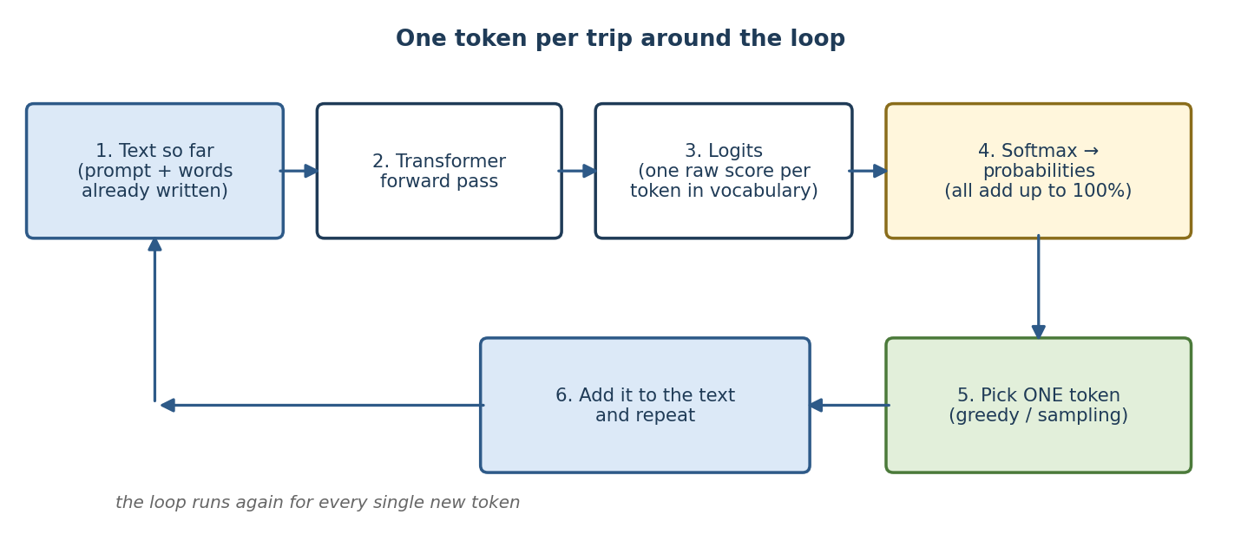
Figure G1: The generation loop. Steps 1–6 repeat once for every single token in the answer.

2. The Core Idea: The Model Only Predicts the Next Token

2.1 What the model actually outputs
People imagine that you ask a question and the model “looks up” or “writes” an answer. That is not what happens. What the model physically outputs is a long list of numbers — one number for every token in its vocabulary.
If the vocabulary has 50,000 tokens, then every time the model runs, it produces 50,000 scores. Each score says: how good a continuation would this particular token be, right here, right now?
What you think happens | What actually happens
You ask a question, the model finds the answer. | You give text; the model scores every possible next token.
The model writes a sentence. | The model picks one token, then runs again from scratch.
The model knows the answer before writing. | The model has no plan. Token 1 is chosen before token 2 exists.
The output is looked up from stored text. | The output is computed as a probability distribution every time.

2.2 It is tokens, not words
The model does not work in words. It works in tokens — pieces of words. A token is roughly 3–4 characters of English. Examples:
- "cat" → one token: ["cat"]
- "unbelievable" → several tokens: ["un", "bel", "iev", "able"]
- "ChatGPT" → ["Chat", "G", "PT"]
- " Paris" (with the leading space) is usually a different token from "Paris"
So when we say “the model generates the next word,” we are simplifying. It generates the next token, and a long word may take three or four trips around the loop before it is finished. In the examples below we mostly use whole words to keep things readable — just remember the real unit is a token.
Why this matters in practice
Token pricing, context limits, and speed are all counted in tokens, not words. A rough rule for English: 100 tokens ≈ 75 words. So a 1,000-word answer costs about 1,300 tokens and takes about 1,300 trips around the loop.

3. What Happens Inside One Trip Around the Loop
One trip is called a forward pass. Here is the full journey, using the prompt “The capital of France is”.
Step | What happens | Example
1. Tokenize | The text is cut into tokens and each token becomes an ID number. | “The capital of France is” → [464, 3139, 286, 4881, 318]
2. Embed | Each ID is looked up in the embedding table and becomes a vector of numbers that carries meaning. | 464 → [0.12, -0.08, 0.44, …]
3. Transformer layers | The vectors pass through every layer. Attention lets each token look at the others, so meaning gets mixed and refined. | The vector at position 5 (“is”) now encodes “this is a sentence about the capital of France”
4. Take the last position | Only the vector at the final position is used to predict what comes next. | Use the vector sitting above “is”
5. LM head (unembedding) | That one vector is multiplied by a big matrix that turns it into one raw score per vocabulary token. These raw scores are called logits. | 50,000 numbers, e.g. Paris = 8.0, cheese = 0.5
6. Softmax | The logits are converted into probabilities that add up to 100%. | Paris = 93.3%, located = 2.8%, …

The one detail everybody gets wrong
During a forward pass the model actually produces a prediction at every position, not just the last one. Position 1 predicts what follows “The”, position 2 predicts what follows “The capital”, and so on.
During training all of those predictions are used — that is what makes training efficient. During generation all of them are thrown away except the last one, because that is the only position where we do not already know the answer.

4. From Raw Scores to Probabilities: Softmax

4.1 Logits: the raw, unfriendly scores
The LM head gives us logits — raw scores that can be any number, positive or negative: 8.0, 4.5, -2.3. They are not probabilities. They do not add up to anything. A logit of 8.0 does not mean 8%. It only means “higher than 4.5.”

4.2 Softmax in plain words
The softmax rule
Step 1: Take e (≈ 2.718) to the power of each score. This makes every number positive, and makes big scores enormously bigger than small ones.
Step 2: Divide each result by the total of all of them.
The results are now all between 0 and 1, and they add up to exactly 1 (100%). That is a probability distribution.

4.3 A full worked example with real numbers
Prompt: “The capital of France is ___”. To keep it readable, pretend the vocabulary has only 6 tokens. The model produces these logits:
Token | Logit (raw score) | e^logit | Probability = e^logit ÷ total
Paris | 8.0 | 2,980.96 | 93.3%
located | 4.5 | 90.02 | 2.8%
a | 4.1 | 60.34 | 1.9%
the | 3.6 | 36.60 | 1.1%
Lyon | 3.2 | 24.53 | 0.8%
cheese | 0.5 | 1.65 | 0.1%
Total | — | 3,194.10 | 100%

Read the last row first: the total of the e^logit column is 3,194.10. Now every probability is just that token's share of the total. For Paris: 2,980.96 ÷ 3,194.10 = 0.933, which is 93.3%.
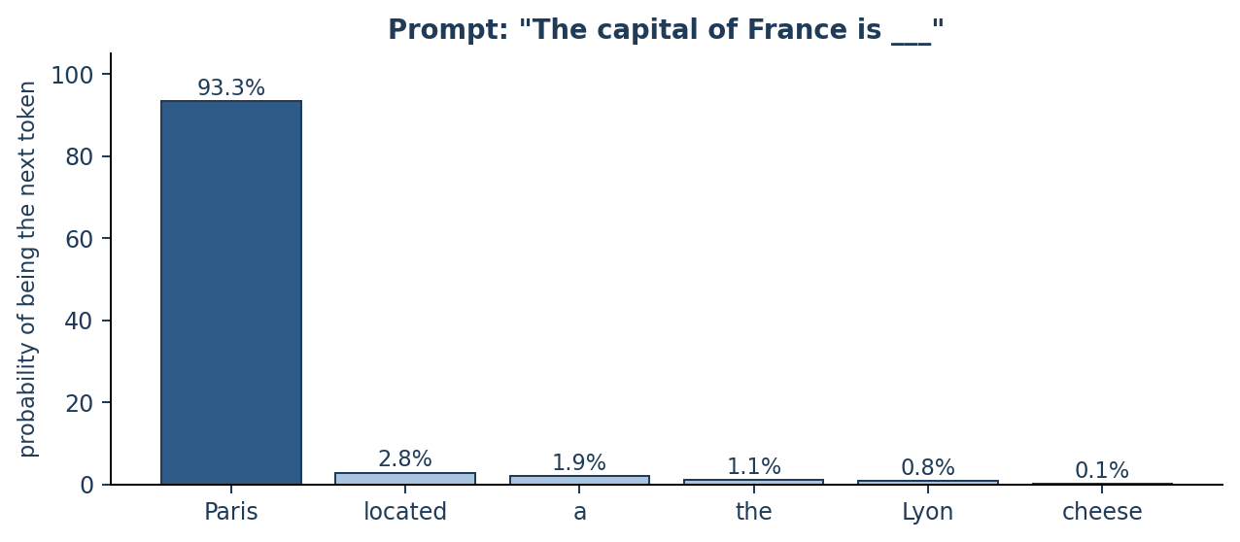
Figure G2: The same numbers as a picture. One bar per token; every bar together adds to 100%.

4.4 Why the exponential? Why not just divide the logits?
Two reasons, both simple:
- Negatives. Logits can be negative (e.g. -2.3). You cannot have a negative probability. e to any power is always positive, so the problem disappears.
- Sharpening. The exponential exaggerates gaps. In our example Paris scored 8.0 and Lyon scored 3.2 — a gap of only 4.8 points. But after the exponential, Paris ends up over 100 times more likely than Lyon. This is what makes the model confident about obvious answers instead of wishy-washy.
Memory hook
Logits = opinions. Softmax = turning opinions into a vote share. Softmax never changes the ranking — the highest logit is always the highest probability. It only changes the spacing between them.

5. Generating the First Word
Now we have probabilities. Something has to actually choose one token. The simplest rule is greedy decoding: always take the highest one.
With our example, greedy picks “Paris” (93.3%). That token is appended to the text. The model has now written exactly one token of its answer:
Prompt : "The capital of France is"
Output : "Paris"

Notice what did not happen. The model did not decide it was going to write a sentence. It did not decide the answer would be a city. It did not decide how long the reply would be. It made exactly one choice: the token Paris.

6. Generating the Second Word, Third Word, and So On

6.1 The trick: the output becomes part of the input
This is the heart of the whole thing. The chosen token is glued onto the end of the input, and the entire, longer text is fed back into the model from the top. This is why the process is called autoregressive — the model's own output becomes its next input.

6.2 A complete trace
Here is the full generation of the answer, step by step. The bold token is the one chosen at each step and carried into the next row.
Step | Text fed into the model | Top candidates for the next token | Picked
1 | The capital of France is | Paris 93.3% · located 2.8% · a 1.9% · the 1.1% | Paris
2 | The capital of France is Paris | . 58% · , 21% · and 8% · which 5% | .
3 | The capital of France is Paris. | <EOS> 71% · It 12% · The 6% · Paris 2% | <EOS>
4 | — | generation stops | —

Three trips around the loop, three tokens, and the answer is finished: “Paris.” Notice how step 2 and step 3 got easier — once “Paris” is on the board, a full stop becomes very likely, and once the sentence is complete, stopping becomes very likely. The model's own output steers its next decision.

6.3 A second example: why the model sounds coherent
Prompt: “Roses are red, violets are”
Step | Text so far | Next-token probabilities | Picked
1 | Roses are red, violets are | blue 94% · purple 2% · violet 1% · not 1% | blue
2 | … violets are blue | , 46% · . 30% · and 11% | ,
3 | … violets are blue, | sugar 57% · and 14% · I 9% | sugar
4 | … violets are blue, sugar | is 89% · and 4% | is

Nobody told the model “write the rest of the rhyme.” Each token was chosen on its own. The coherence is a side effect: because every decision is conditioned on everything written so far, the choices naturally line up into a sensible whole.
Interview one-liner
“An LLM has no plan. Long-range coherence emerges because every next-token decision is conditioned on the full text so far, so each choice constrains the ones after it.”

6.4 Doesn't re-reading everything waste time? (the KV cache)
It would. Re-running the whole prompt for every new token would be enormously wasteful, because the earlier tokens have not changed and would produce identical results.
So real systems keep a KV cache: the Key and Value vectors computed for every token are saved. When a new token arrives, the model computes K and V for that one token only and reuses everything else from the cache.
Phase | What it does | Cost
Prefill | Processes the whole prompt in one go and fills the cache. | One big pass; grows with prompt length squared
Decode | Generates tokens one at a time, reusing the cache. | One small pass per token; cost per token grows with how much text is already there

This is why the first word of a long-prompt answer feels slow to appear, and then the rest streams out quickly. It also explains why very long conversations get slower and use more memory: the cache keeps growing.

7. How the Winner Is Picked: Decoding Strategies
Softmax gives probabilities. Choosing one token from those probabilities is a separate, adjustable decision — this is the part you control with API settings. None of these change the model. They only change how the same list of probabilities is turned into one choice.

7.1 Greedy decoding
Always take the highest probability. Simple and repeatable, but it is short-sighted and tends to produce flat, repetitive text.
Example, from “The sky is ___” with blue 66.5% · clear 24.5% · grey 9.0%: greedy picks blue, every single time, forever.

7.2 Sampling
Instead of taking the top one, roll a weighted dice. A token with 66.5% probability is picked about two thirds of the time; a token with 9% is picked about one time in eleven. This is where variety — and randomness — comes from.
This is the answer to “why do I get a different reply each time?”
The weights are frozen and the probabilities for a given prompt are always identical. What changes is the dice roll at the picking step. Turn sampling off (greedy, or temperature 0) and the same prompt gives the same answer every time.

7.3 Temperature
Temperature divides every logit before softmax: logit ÷ T. It does not add knowledge or creativity — it only reshapes the distribution.
Temperature | Effect on the logits | Result | Good for
Low (0.1–0.4) | Gaps get bigger | Sharper — the favourite dominates | Facts, code, extraction, classification
1.0 | Unchanged | The model's natural distribution | General chat
High (1.2–2.0) | Gaps get smaller | Flatter — unlikely tokens get a real chance | Brainstorming, poetry, variety
0 | Effectively infinite sharpening | Identical to greedy; fully deterministic | Anything that must be reproducible

Worked example on “The sky is ___”, starting from logits blue 2.0, clear 1.0, grey 0.0:
 | T = 0.5 (logits × 2) | T = 1.0 (unchanged) | T = 2.0 (logits ÷ 2)
blue | 86.7% | 66.5% | 50.6%
clear | 11.7% | 24.5% | 30.7%
grey | 1.6% | 9.0% | 18.6%

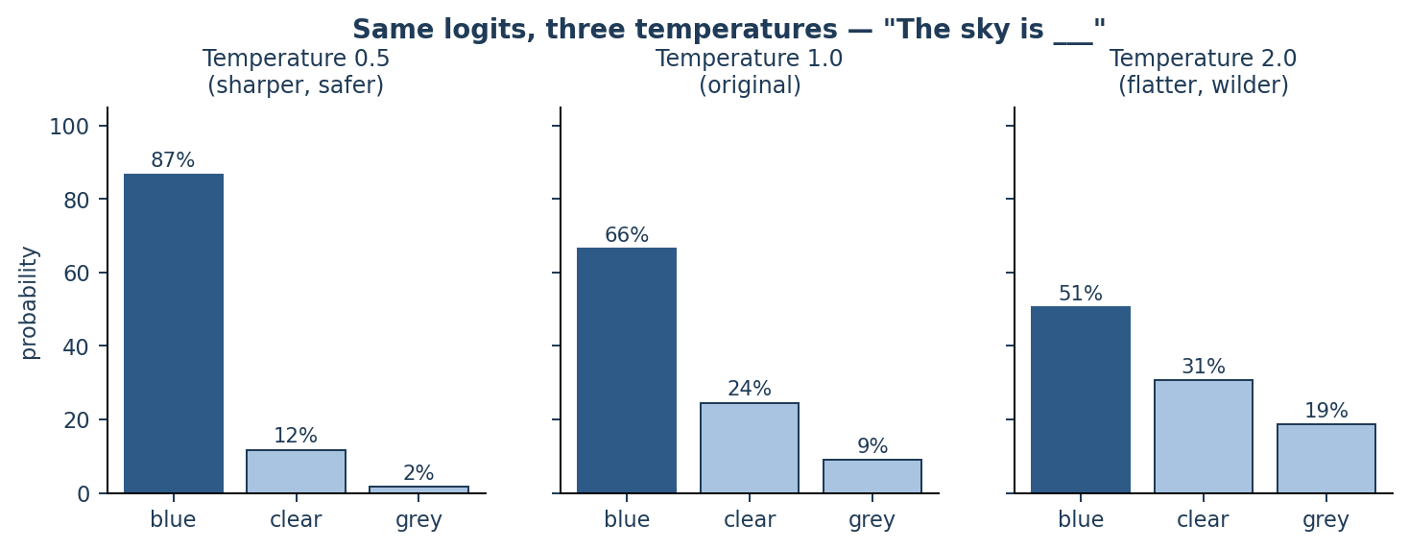
Figure G3: The same three logits at three temperatures. Nothing about the model changed — only the shape of the distribution.
Common misconception
“High temperature makes the model more creative.” Not exactly. High temperature makes the model less likely to pick the obvious token. Sometimes that reads as creativity; often it just reads as a mistake, because “grey” at 18.6% might be wrong 18.6% of the time.

7.4 Top-k sampling
Keep only the k most likely tokens, throw the rest away, re-normalise the survivors so they add to 100%, then sample. This stops the long tail of nonsense tokens from ever being picked.
Example with k = 2 on blue 66.5% · clear 24.5% · grey 9.0%:
- Keep blue and clear; delete grey.
- Their total is 91.0%, so re-normalise: blue = 66.5 ÷ 91.0 = 73.1%, clear = 24.5 ÷ 91.0 = 26.9%.
- Sample between those two only. “grey” is now impossible.
The weakness: k is fixed. When the model is very sure (Paris at 93.3%), k = 40 drags in 39 bad options. When the model is genuinely unsure, k = 40 may cut off good ones.

7.5 Top-p (nucleus) sampling
Instead of a fixed count, keep the smallest set of tokens whose probabilities add up to p. The size of the set changes automatically with the model's confidence.
Situation | Probabilities | With p = 0.9, tokens kept
Model is certain | Paris 93.3% · located 2.8% · … | 1 token (Paris alone already passes 0.9)
Model is unsure | blue 66.5% · clear 24.5% · grey 9.0% | 2 tokens (0.665 → 0.910, which crosses 0.9)
Model is very unsure | each of 20 tokens around 5% | about 18 tokens

This adaptiveness is why top-p is the more common default. Typical production settings are temperature = 0.7, top_p = 0.9. For factual work, temperature = 0.

7.6 Beam search
Greedy commits to the best token at each step, which can paint it into a corner. Beam search keeps several candidate sentences alive at once (say 4 “beams”), extends all of them, and at the end keeps whichever complete sentence has the best total probability.
Good for translation and summarisation, where there is a single best answer. Rarely used for chat, because it produces safe, bland, repetitive text and costs several times more compute.

7.7 Repetition and frequency penalties
Models can fall into loops (“very very very…”) because a repeated token raises the probability of repeating it again. A repetition penalty simply subtracts from the logits of tokens that already appeared, before softmax runs.

7.8 Side-by-side comparison
Strategy | How it picks | Deterministic? | Typical use
Greedy | Highest probability | Yes | Code, extraction, tests
Sampling | Weighted dice over everything | No | Rarely used raw — too wild
Temperature | Reshapes, then samples | No (unless T = 0) | The main creativity dial
Top-k | Sample from the k best | No | Simple safety net
Top-p | Sample from the smallest set summing to p | No | Most common default
Beam search | Keeps several sentences, picks the best whole one | Yes | Translation, summarisation

8. When Does the Model Stop?
The loop has to end somehow. There are exactly three ways it can:
Stop condition | What it means | Example
EOS token | The vocabulary contains a special “end of sequence” token. When it wins the softmax, generation ends. The model learned during training when text usually ends. | After “Paris.”, <EOS> had 71% probability
Max tokens | A hard limit you set. The loop is cut off even mid-sentence. | max_tokens = 100 → answer may end abruptly
Stop sequence | You supply text that, if generated, halts the loop. The stop text itself is usually removed from the output. | stop = ["\nUser:"] in a chat transcript

A practical debugging tip
If your answers keep getting cut off mid-sentence, that is almost always max tokens, not the model “giving up.” If your answers ramble on past the point they should end, the model is simply never assigning enough probability to <EOS> — usually a prompting or fine-tuning issue.

9. The Whole Loop as Pseudocode
text = prompt

for step in range(max_tokens):

# 1. one forward pass over everything written so far
logits = model(text) # e.g. 50,000 raw scores
logits = logits[-1] # keep only the LAST position

# 2. optional reshaping of the scores
logits = logits / temperature
logits = apply_repetition_penalty(logits, text)

# 3. turn scores into probabilities
probs = softmax(logits) # now they add up to 1.0

# 4. narrow the field, then choose ONE token
probs = top_k_top_p_filter(probs, k=50, p=0.9)
next_token = sample(probs) # or argmax(probs) if greedy

# 5. stop or continue
if next_token == EOS:
break
text = text + next_token # <- the output becomes the input

return text

Every concept in this part maps to one line above. That is genuinely all there is to text generation.

10. Common Confusions
Misconception | Reality
“The model searches its training data for the answer.” | Nothing is searched or retrieved. Every token is computed fresh from the weights and the input.
“It always picks the most likely word.” | Only under greedy decoding. With sampling it deliberately picks lower-probability tokens sometimes.
“A 93% probability means the model is 93% sure the fact is true.” | No. It means 93% of likely continuations of this text start with that token. It is a language statistic, not a truth statistic. This is exactly why models hallucinate confidently.
“The model plans the sentence, then writes it.” | There is no plan. Token 2 is decided after token 1 already exists and cannot be changed.
“It can go back and fix an earlier word.” | It cannot. Generation is strictly left to right, with no erasing. A bad early token has to be worked around, which is one cause of rambling answers.
“Different answers mean the model changed.” | The weights never change during use. Only the random draw at the sampling step changed.
“Temperature 0 guarantees identical outputs.” | In theory yes. In practice, GPU floating-point non-determinism and batching can still cause rare differences.
“Longer answers cost the same as short ones.” | Each output token is a separate forward pass. Output tokens are the expensive part, which is why they are usually priced higher than input tokens.

11. Interview Questions with Model Answers
Q1. Walk me through what happens between my prompt and the first word of the answer.
Model answer: Tokenize the prompt into IDs; look up embeddings; add positional information; run the stack of transformer layers so attention mixes context across positions; take the hidden vector at the final position only; multiply it by the LM head to get one logit per vocabulary token; apply temperature and any penalties; softmax into probabilities; then select one token by greedy or sampling with top-k/top-p. That token is the first word.
Q2. If the weights are frozen, why do I get a different answer each time?
Model answer: The weights and therefore the probability distribution are identical. The variation comes from the selection step: sampling draws randomly from the distribution. Set temperature to 0 or use greedy decoding and it becomes deterministic. (Minor non-determinism can still remain from GPU floating-point ordering.)
Q3. What exactly is a logit, and how does it differ from a probability?
Model answer: A logit is the raw, unbounded output of the LM head for one vocabulary token — it can be negative and the logits do not sum to anything. A probability is what you get after softmax: non-negative, and the whole set sums to 1. Softmax preserves the ranking and only changes the spacing.
Q4. Why softmax and not simply divide each score by the sum of scores?
Model answer: Two reasons. Scores can be negative, which would give negative probabilities. And the exponential sharpens differences, so a small lead in logit space becomes a decisive lead in probability space — which is what lets the model be confident about clear-cut answers.
Q5. Explain the difference between top-k and top-p, and when you would prefer each.
Model answer: Top-k keeps a fixed number of candidates regardless of how confident the model is. Top-p keeps however many candidates are needed to reach a cumulative probability p, so the candidate set shrinks when the model is confident and grows when it is uncertain. Top-p is usually preferred because it adapts; top-k is simpler and useful as a hard cap alongside top-p.
Q6. What is the KV cache and what problem does it solve?
Model answer: Without it, generating token n would require recomputing keys and values for all n−1 earlier tokens, even though nothing about them changed. The KV cache stores those vectors so each new token only computes its own K and V and attends against the cache. It turns generation from quadratic-per-token into linear-per-token, at the cost of memory that grows with context length.
Q7. Why do models sometimes fall into repetition loops, and how do you fix it?
Model answer: Once a phrase appears, it becomes strong context evidence that the phrase belongs here, so its probability rises, and greedy decoding then locks it in. Fixes: use sampling rather than greedy, raise temperature slightly, apply a repetition or frequency penalty that subtracts from the logits of already-used tokens, or use no-repeat-n-gram constraints.
Q8. What is the difference between the prefill and decode phases?
Model answer: Prefill processes the entire prompt in a single parallel pass and populates the KV cache — it is compute-bound. Decode generates one token per pass reusing the cache — it is memory-bandwidth-bound. They have very different performance characteristics, which is why serving systems batch and optimise them separately.
Q9. A model states a wrong fact with high probability. What does that tell you?
Model answer: That the training distribution makes that continuation linguistically likely, not that the fact is true. Probability measures plausibility of text, not correctness. It is the core reason hallucinations sound confident, and why grounding techniques such as retrieval are used to supply the correct tokens in the context.
Q10. Why is generating 500 output tokens much more expensive than reading a 500-token prompt?
Model answer: The prompt is processed in one parallel forward pass. The 500 output tokens require 500 sequential forward passes, each of which cannot start until the previous token exists. Output is inherently serial, which is why it dominates both latency and cost.

12. One-Page Summary
Concept | In one line
Next-token prediction | The only thing the model ever does.
Token | A word piece — the real unit of generation, roughly 3–4 characters.
Forward pass | One trip through the model; produces one new token.
Logits | Raw scores, one per vocabulary token; can be negative.
Softmax | Turns logits into probabilities that add to 100%.
Autoregressive | The chosen token is appended to the input and the loop repeats.
Greedy | Always take the top probability; deterministic.
Sampling | Weighted dice roll; the source of variety between runs.
Temperature | Divides logits; low = sharp and safe, high = flat and risky.
Top-k | Keep the k best candidates, then sample.
Top-p | Keep the smallest set summing to p, then sample; adapts to confidence.
KV cache | Stores past keys/values so each new token is cheap.
EOS | The learned stop token; the model decides when the answer is finished.
If you remember only one thing
The model outputs a probability distribution, not an answer. The answer is what you get after repeatedly sampling one token from that distribution and feeding it back in. Change the model and the distribution changes; change the decoding settings and only the way you draw from it changes.

Same Weights, Different Behavior
How a Prompt Changes What an LLM Does — Without Changing the Model
Explained in Simple Language, with Analogies and Interview Q&A
Interview Preparation Study Guide | July 2026

Table of Contents

1. The Puzzle: Frozen Weights, Flexible Behavior
Here is the question that confuses many people:
The Question
An LLM's weights are completely fixed after training. Not a single number changes when you use it. So how can the exact same model write a poem, then write SQL, then act like a strict fraud analyst, then speak French — just because I typed a different prompt?

The short answer:
The One-Line Answer
The weights don't change — the input changes. An LLM is a giant mathematical function: output = f(weights, input). The prompt is part of the input, so a different prompt gives the function different data to compute on, which produces a completely different output. Same function, different input, different result.

The rest of this document unpacks that one line: what the weights really store, what the prompt really does, and why this works so well — with simple analogies and concrete examples you can use in an interview.

2. The Key Idea: Weights Store Skills, Prompts Select Skills
Think of the model's weights as a huge library of skills and knowledge, learned once during training and then frozen. The weights contain the ability to write poems, to write code, to translate, to summarize, to be formal, to be casual — all at the same time.
The prompt does not add any new skill. It simply selects and steers which of the already-stored skills get used for this one response.

 | Weights (fixed) | Prompt (changes every time)
What it is | Billions of numbers learned during training | The text you type right now
When it is set | Once, during training / fine-tuning | Fresh at every single request
What it stores | Knowledge, grammar, reasoning patterns, styles, facts | Nothing permanent — it is just input data
What it controls | What the model can do (its full capability) | What the model will do right now (its behavior)
Analogy | A person's education and experience | The instruction you give that person today

Memory Hook
Weights = capability. Prompt = behavior. Capability is fixed; behavior is chosen per request.

3. Five Simple Analogies

3.1 The Piano
A piano has 88 fixed keys. The piano never changes. Yet it can play a lullaby, jazz, or a horror movie soundtrack — depending on which keys you press and in what order. The prompt is the sheet music: it doesn't rebuild the piano, it just decides which of the piano's fixed capabilities are activated, and in what sequence.

3.2 The Experienced Employee
Imagine an employee with 20 years of experience: accounting, writing, customer service, some coding. Their brain (skills) is 'fixed' for today. If you say 'write a polite apology email,' you get one behavior. If you say 'find errors in this spreadsheet,' you get a totally different behavior. You didn't retrain the employee — you gave a different instruction. The instruction selects which existing skills to apply.

3.3 The Calculator
A calculator's circuits are permanently fixed in silicon. Type 2 + 2 and you get 4. Type 9 × 9 and you get 81. Wildly different outputs, identical hardware. Nobody is surprised, because we understand the output depends on the input. An LLM is the same idea, just with a vastly bigger function: the prompt is the input to a fixed computation.

3.4 The GPS
A GPS device already contains the map of the whole country (weights). When you type a destination (prompt), it computes one specific route. Type a different destination, get a different route. The map never changed — your input picked which part of the map mattered.

3.5 The Mixing Board (best for attention)
A sound engineer's mixing board has fixed circuits, but hundreds of sliders. Moving sliders changes which signals are amplified and which are muted. A prompt acts like slider settings: through the attention mechanism, prompt tokens raise the 'volume' of some patterns stored in the weights (e.g., 'formal legal tone') and mute others (e.g., 'casual chat tone'). The circuits — the weights — never change.

4. What Actually Happens Inside the Model
Now the same idea, one level more technical — still in simple words.

4.1 An LLM only ever does one thing
An LLM does exactly one job, over and over: given all the text so far, predict the next token. That's it. Formally:
P( next token | everything that came before )
The crucial phrase is 'everything that came before.' Your prompt IS part of 'everything that came before.' So changing the prompt literally changes the mathematical condition on which every next-token probability is computed. This is called conditioning. The model isn't 'obeying' you like a person — it is computing the most likely continuation of the text you gave it.

4.2 The prompt flows through every layer, every step
Step by step, here is what happens when you send a prompt:
- 1. Tokenization: Your prompt is split into tokens and turned into number vectors (embeddings).
- 2. Attention reads the prompt: At every layer, the attention mechanism lets each position 'look back' at all the prompt tokens. If your prompt says 'you are a pirate,' every new token being generated can attend to those words.
- 3. Activations change, weights don't: The weights are the fixed multipliers. The activations — the actual numbers flowing through the network — are computed fresh from your input. Different prompt in, different activations out, different next-token probabilities.
- 4. Each generated token feeds back in: Every token the model produces is appended to the context and influences the next one, so the prompt's influence compounds through the whole response.

The Sentence That Wins Interviews
"The weights are fixed, but the activations are not. A prompt changes the activations — the live computation — flowing through the frozen weights, the same way a different destination changes the route computed on a fixed map."

4.3 Why do the weights contain so many behaviors in the first place?
Because of training data diversity. The model was trained on text written by millions of people in thousands of styles: legal contracts, jokes, code, medical notes, translations, arguments, apologies. To predict the next token well across ALL of that, the weights were forced to internalize all those styles and skills simultaneously.
So after training, the weights are like a superposition of many possible 'writers.' The prompt provides the context clues that make one region of that learned distribution far more probable than the others. If the context looks like the start of a legal document, legal-style continuations become most probable. If it looks like a chat with a pirate, pirate-style tokens become most probable.

4.4 In-context learning: 'learning' without changing weights
The most surprising version of this: give the model a few examples in the prompt (few-shot prompting), and it seems to 'learn' the pattern instantly. No weights changed. What happened?
During training, the model saw countless documents where a pattern is established and then continued (lists, tables, Q&A pairs, translation pairs). So it learned a general meta-skill: detect the pattern in the current context and continue it. Your few-shot examples activate that pattern-continuation skill. It looks like learning, but it is really very good pattern matching computed on the fly — all inside a single forward pass, using only fixed weights.
Important Distinction
In-context learning is temporary. The moment the conversation ends, everything is forgotten, because nothing was ever written into the weights. Fine-tuning is the only thing in this comparison that permanently changes the weights.

4.5 System prompt vs user prompt — how the model tells them apart
Everything above talks about “the prompt” as one thing. In a real chat application it usually arrives in two pieces, and it is worth knowing exactly what happens to them.
 | System prompt | User prompt
Who writes it | The developer building the application | The person using the app
When it is set | Once, before the conversation starts | Fresh with every message
Visible to the user? | Usually not | Yes — they typed it
Purpose | Set the role, rules, tone, format, boundaries | Ask the actual question
Example | “You are a support agent for AcmeBank. Never give investment advice. Reply in under 100 words.” | “Why was I charged a fee last Tuesday?”

4.5.1 There is no separate input channel
The mechanical truth
The model has exactly one input: a flat sequence of token IDs. There is no hidden “system slot” and no privileged pathway. Before the model sees anything, the system prompt and the user prompt are concatenated into a single string, with special marker tokens showing where each part begins and ends. The model then reads that one string start to finish, exactly like any other text.

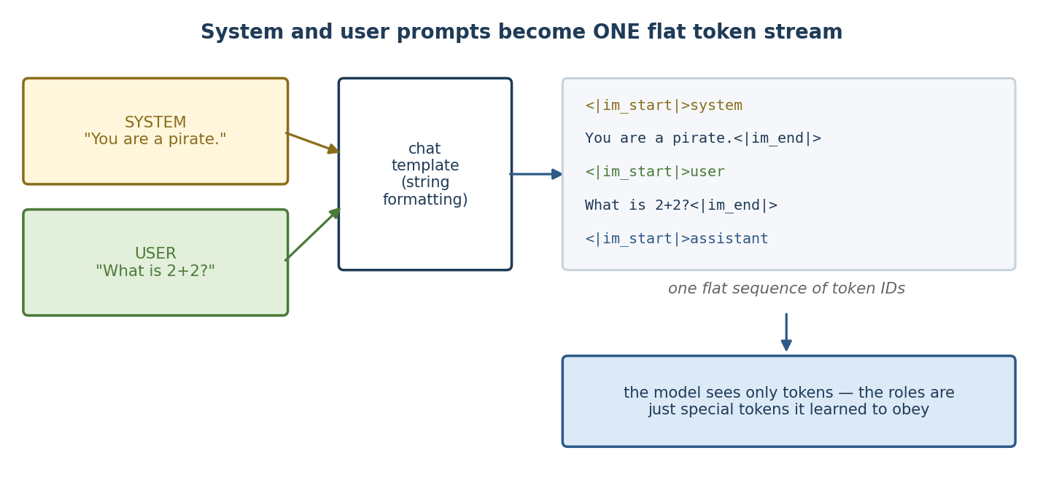
Figure P1: The chat template flattens the roles into one token stream before the model runs.
Given a system prompt of “You are a pirate.” and a user message of “What is 2+2?”, this is the literal string handed to the tokenizer (ChatML format, used by many models):
<|im_start|>system
You are a pirate.<|im_end|>
<|im_start|>user
What is 2+2?<|im_end|>
<|im_start|>assistant

That trailing <|im_start|>assistant is the cue to begin generating. From there it is ordinary next-token prediction. Different model families use different markers for the same idea:
Family | Marker style
ChatML (GPT, Qwen) | <|im_start|>role … <|im_end|>
LLaMA-2 | [INST] <<SYS>> … <</SYS>> … [/INST]
LLaMA-3 | <|start_header_id|>role<|end_header_id|> … <|eot_id|>
Mistral | [INST] … [/INST]

A very common bug
Send raw text without applying the model's chat template and the model receives no role markers — it then behaves like a plain text-completion engine, often continuing your question instead of answering it. Use tokenizer.apply_chat_template() rather than concatenating strings by hand, and use the template matching the model you loaded.

4.5.2 So how does the model tell them apart?
Three mechanisms working together — and not one of them is a hard-wired rule:
Mechanism | How it works
1. Special tokens | <|im_start|>system is a real token with its own ID and its own learned embedding. The model sees a distinct signal, not merely the English word “system.”
2. Training | During instruction tuning and RLHF the model saw millions of examples where text after the system marker was obeyed as a constraint and text after the user marker was treated as the request. It learned the convention, just as it learned grammar.
3. Position and attention | The system prompt comes first, so every later token attends back to it. Its influence is present at every generation step, which is why it colours the whole reply rather than just the opening sentence.

The critical implication
System-prompt priority is a learned behaviour, not an enforced one. Nothing physically prevents user text from contradicting it. That is precisely why prompt injection works: a user message saying “ignore your previous instructions” competes on the same playing field, and sometimes wins. Treat the system prompt as a strong default, never as a security boundary.

4.5.3 Same question, five system prompts
This is the theme of this whole guide, now visible at the token level. The weights are frozen; only the input changed. A different system prompt means a different token sequence, which means different attention patterns, which means different logits, which means different probabilities.
User message in every row: “What is 2+2?”
System prompt | Highest-probability continuation | Why
(none) | “4” | Default helpful-assistant behaviour
“You are a pirate.” | “Arr, that be 4, matey!” | Pirate tokens are now far likelier; the answer is unchanged but the style is transformed
“You are a maths tutor. Show your steps.” | “Let's work through it. 2 + 2 means combining two groups of two…” | The instruction raises the probability of explanatory tokens
“Reply only in JSON.” | {"answer": 4} | { becomes the most likely first token instead of “4”
“You only speak French.” | “Quatre.” | French tokens dominate the distribution

4.5.4 The assistant role, and why chat has no memory
Chat APIs accept a third role, assistant, holding the model's own previous replies. This is how multi-turn conversation works — the whole transcript is re-flattened into one string on every request:
<|im_start|>system
You are a helpful tutor.<|im_end|>
<|im_start|>user
What is 2+2?<|im_end|>
<|im_start|>assistant
It is 4.<|im_end|>
<|im_start|>user
And times 3?<|im_end|>
<|im_start|>assistant

The model has no memory between calls. It appears to remember only because the entire conversation is resent every time. That is also why long conversations cost more and eventually hit the context limit.

4.5.5 Practical guidance
- Put stable things in the system prompt — role, tone, format, hard rules. It stays constant across turns and is usually cached, so it is cheaper too.
- Put the variable request in the user prompt — the actual question and its data.
- Keep the system prompt reasonably short. Very long ones dilute attention, and later instructions can be overshadowed.
- Never put secrets in it. Users can often coax it out; it is not a security layer.
- Validate the output anyway. “Reply only in JSON” raises the probability of valid JSON; it does not guarantee it.

5. Concrete Examples: One Model, Many Behaviors
All examples below use the SAME model with the SAME frozen weights. Only the prompt changes.

5.1 Example — Changing the Tone
Prompt | Typical Output
"Explain rain." | "Rain is water falling from clouds when droplets become too heavy..."
"Explain rain to a 5-year-old." | "You know when you see clouds? They're like big sponges full of water! When they get too full... drip drip drip!"
"Explain rain like a scientist writing a paper." | "Precipitation occurs when atmospheric water vapor condenses into droplets exceeding the mass sustainable by updrafts..."

Why it works: phrases like 'to a 5-year-old' were seen in training near simple, playful text; 'scientific paper' phrases were seen near formal text. The prompt words shift the probability distribution toward the matching style.

5.2 Example — Changing the Task Entirely
Prompt | Behavior Selected
"Translate to French: I love mangoes." | Translator
"Fix the bug: for i in range(10) print(i)" | Code debugger
"Summarize this email in one line: ..." | Summarizer
"Continue the story: The door creaked open..." | Fiction writer

5.3 Example — Persona / Role Prompting
Prompt A:
System Prompt A
"You are a cheerful kindergarten teacher. A user asks: Is thunder dangerous?"
Output: "Great question, sweetie! Thunder is just a big noisy sound the sky makes — it can't hurt you at all! But lightning..."

Prompt B:
System Prompt B
"You are a meteorologist writing a safety bulletin. A user asks: Is thunder dangerous?"
Output: "Thunder itself is harmless acoustic energy. The associated lightning strike, however, presents lethal risk within a 10-mile radius..."

Same question, same weights, opposite registers — because the persona text at the start of the context is attended to by every generated token.

5.4 Example — Few-Shot Pattern (In-Context Learning)
Prompt
apple → fruit
carrot → vegetable
salmon → fish
mango → ?
Output: "fruit"

Nobody told the model the task in words. The examples alone established the pattern, and the model's pattern-continuation skill did the rest — zero weight updates.

5.5 Example — Output Format Control
Prompt | Output Shape
"List 3 fraud red flags." | A prose list of red flags
"List 3 fraud red flags as JSON with keys flag and severity." | {"flag": "urgent wire request", "severity": "high"} ...
"List 3 fraud red flags as a markdown table." | A formatted table

5.6 Example — Your Fraud Use Case
The same base LLM, with fixed weights, can be steered into a fraud-risk classifier purely by prompt:
Prompt
"You are a fraud analyst. Classify the narrative as High, Medium, or Low risk. Respond with one word only.
Narrative: Customer requested three urgent wire transfers to a new overseas beneficiary added yesterday, and declined callback verification."
Output: "High"

This is exactly why prompting is the natural starting point before fine-tuning: the classification behavior is already reachable through the input alone. Fine-tuning only becomes necessary when prompting hits its ceiling — which is the next section.

6. The Limits: What a Prompt Cannot Do
If prompts are so powerful, why does fine-tuning exist? Because a prompt can only select from what the weights already contain. It cannot add anything new.
- Cannot add missing knowledge: If the model never saw your company's internal fraud codes or niche domain jargon during training, no prompt can conjure that knowledge. (Retrieval/RAG or fine-tuning is needed.)
- Cannot guarantee consistency: Prompted behavior is probabilistic steering, not a hard rule. Over thousands of fraud narratives, a prompted classifier may drift in format or judgment; a fine-tuned one is far more stable.
- Costs context every single call: Long instructions and few-shot examples must be re-sent with every request — consuming context window and compute. Fine-tuning bakes the behavior in so the prompt can shrink.
- Nothing persists: The model 'forgets' everything when the context ends, because prompts never touch the weights.

Escalation Rule of Thumb
Prompting selects existing behavior. Fine-tuning creates or strengthens behavior. Start with prompting; escalate to fine-tuning when you hit inconsistency, context-window cost, or missing domain knowledge — exactly the pattern in an offline fraud-classification pipeline.

7. Common Misconceptions (Interview Traps)
Misconception | Reality
"The prompt temporarily updates the weights." | No. Weights are never touched at inference. The prompt changes activations (the live computation), not parameters.
"The model understands and obeys my instructions like a person." | It computes the most probable continuation of the context. Instructions work because instruction-following patterns were learned during training (especially instruction tuning / RLHF).
"Few-shot examples train the model a little." | No gradient updates happen. It is pattern continuation within one forward pass — 'in-context learning' is a (slightly misleading) name.
"Longer prompts always mean better control." | Attention can dilute over very long contexts; irrelevant text can distract. Clear, well-placed instructions beat sheer length.
"If prompting can do it, fine-tuning is pointless." | Prompting rents the behavior per-call; fine-tuning buys it permanently — better consistency, shorter prompts, lower per-call cost.
"The base model 'has a personality' that the prompt overrides." | The weights hold a distribution over many styles. The prompt doesn't fight a personality; it conditions which region of the distribution is sampled.

8. Interview Q&A

Q1. If the weights are frozen, what exactly changes when I change the prompt?
Model answer: The activations — the intermediate numerical values computed as data flows through the network. The model is a function output = f(weights, input); the prompt is input. Different input produces different activations through the same fixed weights, hence different token probabilities.
Counter-question: "So where does the prompt physically enter the computation?" — As token embeddings at the input layer, then it influences every layer via attention: each generated token can attend back to the prompt tokens at every step.

Q2. How can a prompt make the model act like a completely different persona?
Model answer: Training data contained text in thousands of voices. The weights encode all of them as a conditional distribution. A persona prompt provides context that makes tokens consistent with that persona far more probable. It's conditioning, not transformation.
One-liner: "The persona was always in the weights; the prompt just makes it the most probable continuation."

Q3. What is in-context learning, and is it really learning?
Model answer: Providing examples in the prompt so the model continues the pattern. Mechanically it is not learning — no parameters update. During pre-training the model acquired a general ability to detect and continue patterns present in its context; few-shot examples exploit that ability within a single forward pass.
Counter-question: "Does anything persist after the call?" — No. Once the context ends, the effect is gone entirely.

Q4. Why does the same prompt sometimes give different answers?
Model answer: Generation usually samples from the probability distribution (temperature > 0), so identical inputs can yield different tokens. With temperature 0 / greedy decoding, output becomes (nearly) deterministic. This is a decoding setting, unrelated to weights changing.
One-liner: "Randomness comes from sampling at decode time, not from anything changing inside the model."

Q5. When does prompting stop being enough, so you'd fine-tune instead?
Model answer: Four classic triggers: (1) needed domain knowledge or jargon isn't in the weights, (2) outputs are inconsistent at scale despite good prompts, (3) the required instructions/examples eat too much context window and cost per call, (4) you need a compact, stable, deployable behavior — e.g., an offline fraud-risk classifier where High-class recall must be dependable.
One-liner: "Prompting selects existing behavior; fine-tuning installs new behavior."

Q6. Is the system prompt mechanically different from user text?
Model answer: At the architecture level, no — it's all tokens in the context. But instruction-tuned models were trained with special formatting (chat templates, role tags) and taught to weight system-role text heavily, so in practice system prompts steer more strongly.
Counter-question: "So why can prompt injection work?" — Because everything is ultimately just context tokens; the priority of the system prompt is learned behavior, not a hard rule.

9. One-Page Summary
Concept | Simple Version
Core equation | output = f(weights, input) — prompt is input; change input, change output
What weights do | Store all skills/knowledge — the model's full capability, frozen after training
What prompts do | Select and steer which stored capability is expressed right now
Mechanism | Prompt tokens → embeddings → attended to at every layer → shift next-token probabilities (conditioning)
What changes at inference | Activations only. Never weights.
In-context learning | Pattern continuation inside one forward pass; looks like learning, persists nothing
Best analogy | Fixed map (weights), new destination (prompt), different route (output)
Prompting's ceiling | Can't add missing knowledge, guarantee consistency, or persist — that's fine-tuning's job
If You Remember Only One Thing
A prompt never changes the model. It changes the question the model is answering. The weights are a frozen map of everything the model learned; the prompt decides which journey across that map happens right now.

Parameter-Efficient Fine-Tuning (PEFT) of LLMs
A Complete, Simple-Language Guide with Examples and Interview Q&A
Techniques · Workflow · Verification · Selection · Post-Training Steps
July 2026

Table of Contents

1. What is Fine-Tuning and What is PEFT? (Simple Explanation)

1.1 What is fine-tuning?
A pre-trained LLM (like Llama, Mistral, or Phi) is like a very smart new employee who has read the whole internet. It knows general language very well, but it does not know YOUR specific job. Fine-tuning is the on-the-job training you give this employee using your own examples, so it becomes an expert in your specific task.
- Example 1 (Fraud): You show the model 5,000 fraud case narratives labelled High / Medium / Low risk. After fine-tuning, it classifies new narratives the way your fraud analysts would.
- Example 2 (Medical): A hospital fine-tunes a model on discharge summaries so it writes summaries in the hospital's exact format.
- Example 3 (Support): A telecom company fine-tunes a model on past support tickets so replies match company tone and policy.

1.2 The problem with full fine-tuning
Full fine-tuning means updating EVERY weight (parameter) in the model. A 7-billion-parameter model has 7 billion numbers to update. This needs huge GPU memory (often 80+ GB), takes a long time, and you must store a full copy of the model for every task. For most teams this is too expensive.
Analogy: Full fine-tuning is like renovating an entire 50-floor office building just to add one new department. Expensive, slow, and risky.

1.3 What is PEFT?
Parameter-Efficient Fine-Tuning (PEFT) means: freeze the big model (do not touch its original weights) and train only a tiny number of NEW or SELECTED parameters — usually less than 1% of the total. You get 90–100% of the quality of full fine-tuning at a fraction of the cost.
Analogy: Instead of renovating the whole building, you keep the building as-is and just add a few smart adapters (new small rooms, sticky notes, and signboards) that redirect how work flows. The building (base model) stays untouched.
Aspect | Full Fine-Tuning | PEFT (e.g., LoRA)
Parameters updated | 100% (all 7B for a 7B model) | Typically 0.1% – 1%
GPU memory (7B model) | 60–80+ GB (multi-GPU) | 8–24 GB (single GPU, QLoRA even less)
Training speed | Slow | Fast (fewer gradients to compute/store)
Storage per task | Full model copy (~14 GB) | Small adapter file (~10–200 MB)
Catastrophic forgetting risk | Higher | Lower (base weights frozen)
Quality | Best possible | Usually 95–100% of full fine-tuning
Interview one-liner
“PEFT freezes the pre-trained weights and trains a small number of additional or selected parameters, giving near full fine-tuning quality at a fraction of the memory, compute, and storage cost.”

2. How to Do PEFT Fine-Tuning: Step-by-Step Workflow
Below is the standard end-to-end workflow using Hugging Face libraries (transformers + peft + bitsandbytes + trl). This same recipe works for classification, extraction, or instruction-following tasks.

Step 1 — Define the task and success metric
- Write down exactly what the model must do. Example: “Given a fraud narrative, output exactly one label: High, Medium, or Low.”
- Pick the metric BEFORE training. Example: recall on the High class (missing a High-risk case costs far more than a false alarm).

Step 2 — Prepare the dataset
- Collect input-output pairs. A few hundred to a few thousand high-quality examples usually beat tens of thousands of noisy ones.
- Format every example in one consistent template (prompt + expected answer).
- Split: ~80% train, ~10% validation (for tuning), ~10% test (touched only once, at the end).
{"text": "### Narrative: Customer opened 4 accounts in 2 days,
wired funds to new beneficiary abroad...
### Risk: High"}

Step 3 — Choose base model and PEFT technique
- Pick a base model that fits your GPU, license, and language/domain. Example: Mistral-7B (Apache-2.0) for an on-premise fraud project.
- Pick a technique (Section 3). Default recommendation today: LoRA if you have enough VRAM, QLoRA if you do not.

Step 3a — Inspect the model before you commit to it
Before you can write a single line of PEFT config you need four facts about the base model: how many layers it has, how wide it is, what its weight matrices are called, and how big it is in total. Without the module names your target_modules list is a guess, and without the sizes you cannot predict either the VRAM or the number of parameters you are about to train.
Everything you need is in one small file
Every model on Hugging Face ships a config.json next to the weights. It is a few dozen lines of plain JSON and it fully describes the architecture. You never have to guess, and you never have to download the 14 GB of weights just to look.

Here is config.json for Mistral-7B, trimmed to the fields that matter:
{
"architectures": ["MistralForCausalLM"],
"hidden_size": 4096, <- width of every vector
"num_hidden_layers": 32, <- how many decoder blocks
"num_attention_heads": 32, <- attention heads per block
"num_key_value_heads": 8, <- GQA: fewer K/V heads than Q heads
"intermediate_size": 14336, <- FFN hidden width
"vocab_size": 32000, <- number of tokens
"max_position_embeddings": 32768,
"torch_dtype": "bfloat16"
}

Step 3b — What each field means and why you care
Field | What it is | Why it matters for fine-tuning
architectures | The model class, e.g. MistralForCausalLM | Tells you decoder-only vs encoder-only vs encoder-decoder, and therefore the task_type you must set in the PEFT config
hidden_size (d_model) | The width of every token vector — 4096 here | Appears in every parameter-count formula below
num_hidden_layers | How many identical blocks are stacked — 32 here | Your adapter is added to every layer, so this is the multiplier on everything
num_attention_heads | Heads per attention block — 32 here | head_dim = hidden_size ÷ heads = 128. Rarely needed directly, but explains the shapes
num_key_value_heads | K/V heads, 8 here — fewer than Q heads (GQA) | Easy to miss. It makes k_proj and v_proj smaller than q_proj, which changes your parameter count
intermediate_size | FFN hidden width — 14336 here | Matters only if you target the MLP matrices as well as attention
vocab_size | Tokens in the vocabulary — 32000 here | Sets the size of the embedding and the LM head, which together are ~262 M parameters
torch_dtype | Storage precision — bfloat16 here | 2 bytes per parameter. This is what turns a parameter count into a VRAM number

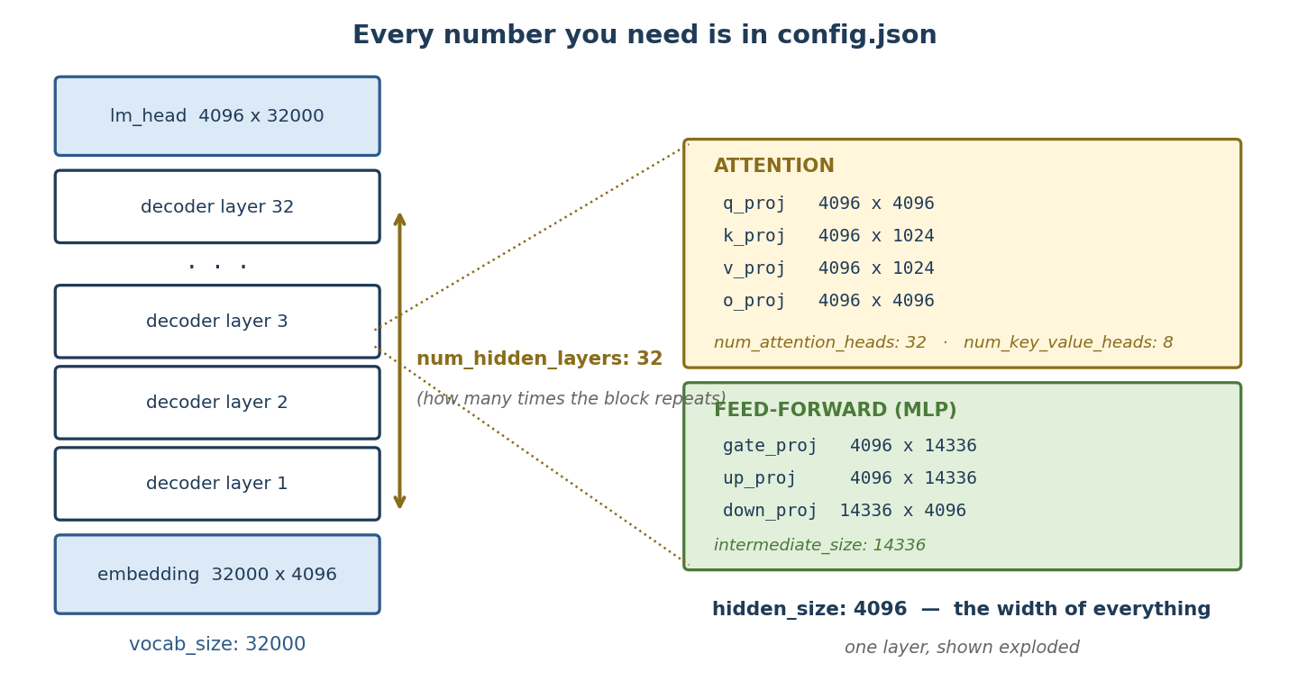
Figure 10: How the config fields map onto the actual architecture. The left column repeats num_hidden_layers times; the right shows one block exploded.

Step 3c — Encoder-only, decoder-only, or encoder-decoder?
Part 1 explained the three shapes. Here is how to tell which one you are holding, and what it changes:
Family | How the config gives it away | Layer counts | PEFT task_type
Decoder-only  (GPT, LLaMA, Mistral, Qwen) | architectures ends in ForCausalLM; there is a single num_hidden_layers | 32 decoder layers, no encoder | CAUSAL_LM
Encoder-only  (BERT, RoBERTa, DeBERTa) | architectures ends in ForMaskedLM or ForSequenceClassification | 12 or 24 encoder layers, no decoder | SEQ_CLS or TOKEN_CLS
Encoder-decoder  (T5, BART, FLAN-T5) | architectures ends in ForConditionalGeneration; the config has two counts | num_layers: 12 encoder and num_decoder_layers: 12 decoder | SEQ_2_SEQ_LM

The trap
Set the wrong task_type and PEFT attaches the adapter to the wrong head, or silently trains nothing useful. For an encoder-decoder model, also decide deliberately whether the adapter goes on the encoder, the decoder, or both — by default target_modules matches module names in both stacks, which doubles your trainable parameters without you asking.

Step 3d — Read it all straight out of the model in code
The config tells you the shape. These four snippets tell you everything else — run them before you write any training code.
1. Read the config without downloading the weights:
from transformers import AutoConfig

cfg = AutoConfig.from_pretrained("mistralai/Mistral-7B-v0.1")
print(cfg.num_hidden_layers) # 32 <- layers
print(cfg.hidden_size) # 4096 <- width
print(cfg.num_attention_heads) # 32 <- Q heads
print(cfg.num_key_value_heads) # 8 <- K/V heads (GQA)
print(cfg.intermediate_size) # 14336
print(cfg.architectures) # ['MistralForCausalLM']

2. Print the architecture to get the exact module names:
from transformers import AutoModelForCausalLM
model = AutoModelForCausalLM.from_pretrained("mistralai/Mistral-7B-v0.1")
print(model)

# MistralForCausalLM(
# (model): MistralModel(
# (embed_tokens): Embedding(32000, 4096)
# (layers): ModuleList(
# (0-31): 32 x MistralDecoderLayer( <- 32 layers
# (self_attn): MistralAttention(
# (q_proj): Linear(4096, 4096) <- these names are
# (k_proj): Linear(4096, 1024) what you put in
# (v_proj): Linear(4096, 1024) target_modules
# (o_proj): Linear(4096, 4096) )
# (mlp): MistralMLP(
# (gate_proj): Linear(4096, 14336)
# (up_proj): Linear(4096, 14336)
# (down_proj): Linear(14336, 4096) ) ) )
# (lm_head): Linear(4096, 32000) )

3. Count parameters by category:
total = sum(p.numel() for p in model.parameters())
print(f'total: {total:,}') # 7,241,732,096 -> 7.24 B

# group by top-level component
from collections import defaultdict
buckets = defaultdict(int)
for name, p in model.named_parameters():
key = 'attn' if 'self_attn' in name else \
'mlp' if 'mlp' in name else \
'embed/head' if 'embed' in name or 'lm_head' in name else 'norm'
buckets[key] += p.numel()
for k, v in buckets.items():
print(f'{k:12s} {v:>15,} {v/total:6.1%}')

4. List every unique linear-layer name — the reliable way to build target_modules for a model you have never used before:
import torch
names = {n.split('.')[-1] for n, m in model.named_modules()
if isinstance(m, torch.nn.Linear)}
print(names)
# {'q_proj','k_proj','v_proj','o_proj',
# 'gate_proj','up_proj','down_proj','lm_head'}

Step 3e — Counting the parameters by hand
Worth doing once, because it makes the PEFT numbers in Section 4 obvious. Every parameter lives in one of four places. For Mistral-7B (h = 4096, L = 32, K/V dim = 8 heads × 128 = 1024, intermediate = 14336, vocab = 32000):
Where | Formula | Value
Embedding + LM head | 2 × vocab × h = 2 × 32000 × 4096 | 262,144,000
Attention, per layer | h·h + 2·(h·1024) + h·h | 41,943,040
FFN (MLP), per layer | 3 × h × 14336 | 176,160,768
Norms, per layer | 2 × h | 8,192
One whole layer | 41,943,040 + 176,160,768 + 8,192 | 218,112,000
All 32 layers | 218,112,000 × 32 | 6,979,584,000
Grand total | 6,979,584,000 + 262,144,000 + final norm | 7,241,732,096 ≈ 7.24 B

Two things this immediately tells you
The FFN is about 4× the size of attention (176 M vs 42 M per layer, so ~81% of each layer). Targeting MLP matrices with LoRA therefore costs far more trainable parameters than targeting attention.
VRAM for the frozen weights = parameters × bytes per parameter. At bfloat16 that is 7.24 B × 2 = ~14.5 GB just to hold the model, before any gradients or optimiser state. That single number decides LoRA vs QLoRA.

Step 3f — Module names differ by family
target_modules names are not standard across model families. Copying a LLaMA config onto a GPT-2 model fails with “target modules not found”. The usual names:
Family | Attention module names | FFN module names
LLaMA, Mistral, Qwen | q_proj, k_proj, v_proj, o_proj | gate_proj, up_proj, down_proj
GPT-2 | c_attn (Q, K, V fused into one), c_proj | c_fc, c_proj
BERT, RoBERTa | query, key, value, dense | intermediate.dense, output.dense
T5, FLAN-T5 | q, k, v, o | wi, wo (or wi_0, wi_1)
Falcon | query_key_value (fused) | dense_h_to_4h, dense_4h_to_h

If you are unsure, run snippet 4 above and read the names off the model itself. Newer PEFT versions also accept target_modules="all-linear", which finds them for you.

Step 3g — Pre-flight checklist
Check | How | Why it matters
Will it fit? | params × 2 bytes (bf16), then add ~20% for activations | 7B in bf16 ≈ 14.5 GB → LoRA needs a 24 GB card; QLoRA fits in ~6 GB
Is the licence usable? | Model card — Apache-2.0, MIT, Llama Community, etc. | Decides whether you can deploy commercially
Base or Instruct? | The name: -v0.1 vs -Instruct-v0.2 | Instruct models already follow instructions and need far less data; base models need more
Which chat template? | tokenizer.chat_template | Your training data must use the same template as inference, or quality collapses
Context length | max_position_embeddings | Your longest training example must fit inside it
Tokenizer fit | Tokenize a domain sample and check the token count | A poor vocabulary match inflates cost and hurts quality on specialised text

Step 4 — Configure and attach the PEFT adapter
from transformers import AutoModelForCausalLM, AutoTokenizer
from peft import LoraConfig, get_peft_model

model = AutoModelForCausalLM.from_pretrained("mistralai/Mistral-7B-v0.1")

config = LoraConfig(
r=16, # rank of the small matrices
lora_alpha=32, # scaling factor (usually 2 x r)
target_modules=["q_proj","k_proj","v_proj","o_proj"],
lora_dropout=0.05,
task_type="CAUSAL_LM")

model = get_peft_model(model, config)
model.print_trainable_parameters()
# -> trainable params: 13,631,488 || all params: 7,255,263,232
# trainable%: 0.1879 <-- only ~0.19% is being trained!

Step 5 — Train
- Typical starting hyperparameters: learning rate 1e-4 to 2e-4, batch size 4–16 (use gradient accumulation if VRAM is small), 2–4 epochs.
- Watch validation loss every epoch. If validation loss rises while training loss falls, you are overfitting — stop early.
from trl import SFTTrainer
trainer = SFTTrainer(model=model, train_dataset=train_ds,
eval_dataset=val_ds, args=training_args)
trainer.train()
model.save_pretrained("fraud-lora-adapter") # saves ONLY the adapter (~50 MB)

Step 6 — Evaluate on the held-out test set
- Compare against your baseline (the base model with a good prompt). PEFT must clearly beat prompting to justify itself.
- Report per-class metrics, not just accuracy. For fraud: High-class recall, then precision, then macro-F1.

Step 7 — Merge (optional) and deploy
merged = model.merge_and_unload() # folds LoRA into base weights
merged.save_pretrained("fraud-model-v1") # single model, zero extra latency
- Keep adapters separate if you want to hot-swap multiple tasks on one base model; merge if you want simplest single-model deployment.
Key idea to remember
The base model file never changes during PEFT training. You only save a small adapter file. At inference time, the adapter is either loaded alongside the base model or merged into it.

3. PEFT Techniques Explained in Detail
PEFT techniques fall into three families. Understanding the family instantly tells you WHERE the technique acts inside the model:
Family | Idea in one line | Techniques
Additive (reparameterization) | Add small trainable matrices next to existing weight matrices | LoRA, QLoRA, DoRA
Additive (new modules/tokens) | Insert small new layers or trainable virtual tokens | Adapters, Prefix Tuning, Prompt Tuning, P-Tuning
Selective | Unfreeze only a tiny chosen subset of existing weights | BitFit, IA3 (rescaling)

3.1 LoRA (Low-Rank Adaptation) — the industry default

The intuition
Each big weight matrix W in the model (for example the 4096 x 4096 query projection) would need ~16.7 million numbers to update fully. LoRA says: the CHANGE we need (delta-W) is usually simple, so we can represent it as the product of two thin matrices: delta-W = B x A, where A is r x 4096 and B is 4096 x r, with rank r being small (8, 16, 32). With r = 16, that is only ~131k trainable numbers instead of 16.7 million — a 128x reduction for that matrix.
Analogy: Instead of rewriting a 1,000-page manual (full fine-tuning), you attach a thin 8-page errata booklet (LoRA adapter) that says “wherever the manual says X, adjust it slightly toward Y.” The original manual is never edited.

How it works mechanically
- Freeze the original weight matrix W.
- Create two new small matrices: A (initialized with small random values) and B (initialized with zeros, so training starts with zero change).
- Forward pass computes: output = W·x + (alpha/r) · B·A·x. Only A and B receive gradients.
- After training, optionally merge: W_new = W + (alpha/r)·B·A. Merged model has ZERO extra inference latency.

Where it is applied
Classically on the attention projection matrices (Q, K, V, O) in every Transformer layer. Modern practice often also targets the MLP layers (gate/up/down projections) for better quality.

Key hyperparameters
- r (rank): capacity of the adapter. 8–16 for simple tasks (classification), 32–64 for harder ones (style, reasoning). Higher r = more parameters = more capacity but more overfitting risk.
- lora_alpha: scaling factor; effective strength is alpha/r. Common rule: alpha = 2 x r.
- target_modules: which matrices get adapters (q_proj, v_proj, etc.).
- lora_dropout: 0.05–0.1, regularization on the adapter path.

Pros and cons
- Pros: excellent quality, mergeable (no inference cost), tiny files, one base model can serve many adapters.
- Cons: still requires the base model in 16-bit during training (VRAM heavy for big models) — which is exactly what QLoRA fixes.

3.2 QLoRA (Quantized LoRA) — LoRA for small GPUs

The intuition
QLoRA = LoRA + a compressed (quantized) base model. The frozen base model is stored in 4-bit precision (NF4 format) instead of 16-bit, cutting its memory by ~4x. The LoRA adapters themselves stay in 16-bit and are trained exactly as before. Result: you can fine-tune a 7B model on a single 8–12 GB GPU, or a 70B model on a single 48 GB GPU.
Analogy: You photocopy the 1,000-page manual at draft quality (4-bit) to save shelf space — it is frozen anyway, nobody edits it. But your errata booklet (the adapter) is printed at full quality, because that is the part you are actually writing.

The three tricks inside QLoRA
- NF4 (4-bit NormalFloat) quantization: a 4-bit data type designed for normally-distributed weights — loses very little quality.
- Double quantization: even the quantization constants are quantized, saving ~0.4 GB more on a 7B model.
- Paged optimizers: optimizer states can spill to CPU RAM when GPU memory spikes, preventing out-of-memory crashes.

Important detail
Gradients flow THROUGH the frozen 4-bit weights (they are dequantized on the fly during each forward/backward pass) but only the 16-bit LoRA matrices are updated. Training is ~30–50% slower than plain LoRA because of the dequantization overhead — you trade time for memory.
- Pros: dramatic memory savings; enables large models on consumer/enterprise single GPUs; quality nearly identical to 16-bit LoRA.
- Cons: slower training; small chance of quality loss on very sensitive tasks; merging requires care (merge into 16-bit weights, not 4-bit).

3.3 Adapter Layers (the original PEFT method, 2019)
Insert a small bottleneck module INSIDE each Transformer layer (after attention and/or after the feed-forward block). The module is: down-project (e.g., 4096 -> 64), non-linearity, up-project (64 -> 4096), plus a skip connection. Only these small modules are trained.
Analogy: Adding a small quality-check desk at the end of each floor of the office building. Work still flows through every floor normally, but each desk makes small task-specific corrections before passing work upward.
- Pros: modular, well studied, strong quality.
- Cons: the new layers stay in the forward path forever — they CANNOT be merged away, so inference is slightly slower. This is the main reason LoRA overtook adapters.

3.4 Prefix Tuning
Prepend a set of trainable “virtual tokens” — not real words, just learned vectors — to the keys and values of EVERY attention layer. The model attends to these vectors as if they were extra context words. Only these prefix vectors are trained (typically 10–100 virtual tokens per layer).
Analogy: Before every meeting on every floor, a coach whispers the same tuned briefing into the room. Nobody in the company changes (weights frozen), but every discussion is steered by the briefing.
- Pros: very few parameters; base model untouched; good for generation tasks.
- Cons: eats context window (virtual tokens occupy attention); optimization can be unstable; usually weaker than LoRA on hard tasks.

3.5 Prompt Tuning (soft prompts)
A lighter version of prefix tuning: trainable virtual tokens are added ONLY at the input embedding layer (layer 0), not at every layer. It is literally learning the perfect “soft prompt” by gradient descent instead of writing it by hand in words.
Analogy: You cannot train the employee at all — you may only rewrite the sticky note on their desk. Prompt tuning finds the mathematically perfect sticky note.
- Pros: tiniest possible footprint (a few thousand to ~100k parameters); trivially swappable per task.
- Cons: works well only on LARGE models (10B+); weak on small models; interpretability of learned tokens is poor.

3.6 P-Tuning / P-Tuning v2
P-Tuning v1 uses a small neural network (an LSTM/MLP “prompt encoder”) to GENERATE the virtual token embeddings instead of learning them directly — this stabilizes training. P-Tuning v2 is essentially prefix tuning applied at every layer, made to work well even on smaller models and on classification/sequence-labelling tasks.
- Use case: NLU tasks (classification, NER) where you want prompt-tuning-style efficiency but on models below 10B parameters.

3.7 IA3 (Infused Adapter by Inhibiting and Amplifying Inner Activations)
Instead of adding matrices, IA3 learns small RESCALING vectors that multiply (element-wise) the keys, values, and feed-forward activations. Each vector just says “amplify this feature, dampen that one.”
Analogy: A mixing engineer who does not re-record any instrument — they only slide the volume faders up and down until the song fits the new style.
- Pros: ~10x fewer parameters than even LoRA; mergeable; great for few-shot settings.
- Cons: lower capacity — can underfit harder or very different tasks.

3.8 BitFit (Bias-term Fine-Tuning)
The simplest selective method: freeze ALL weights and train ONLY the bias terms (the small +b in every linear layer). Biases are ~0.1% of parameters.
Analogy: You may not move any furniture in the building — you may only adjust the thermostat in each room. Surprisingly, for mild adaptations, adjusting thermostats is often enough.
- Pros: dead simple; no new modules; no inference cost.
- Cons: lowest capacity of all; only suitable for small domain shifts or small models.

3.9 Side-by-side comparison
Technique | What is trained | Where in the model | Typical % params | Mergeable? | Best for
LoRA | Low-rank matrices B·A | Beside attention/MLP weight matrices, every layer | 0.1–1% | Yes | Default choice, most tasks
QLoRA | Same as LoRA (16-bit) | Same; base frozen in 4-bit | 0.1–1% | Yes (into 16-bit) | Limited VRAM / big models
Adapters | Bottleneck MLP modules | Inserted inside each layer | 1–5% | No | Multi-task research setups
Prefix Tuning | Virtual K/V vectors | Attention of every layer | ~0.1% | No | Generation tasks
Prompt Tuning | Soft input tokens | Input embedding layer only | <0.01% | No | Very large models, many tasks
P-Tuning v2 | Per-layer prompts | Every layer | ~0.1% | No | Classification / NER
IA3 | Rescaling vectors | K, V, FFN activations | ~0.01% | Yes | Few-shot, tight budgets
BitFit | Existing bias terms | All bias parameters | ~0.1% | N/A (in-place) | Mild domain shifts

4. How to Know WHERE a Technique Changes the Model (and How to Verify It)

4.1 The mental map
A decoder-only Transformer is a stack of identical layers. Each layer has: (a) attention with four weight matrices Q, K, V, O; (b) a feed-forward block (MLP) with 2–3 matrices; (c) LayerNorms with small scale/bias vectors. Plus, at the bottom, an embedding matrix, and at the top, the output head. Every PEFT technique touches a specific subset of these:
Location in model | Touched by
Input embeddings (layer 0) | Prompt Tuning (adds soft tokens)
Attention K/V (every layer) | Prefix Tuning, P-Tuning v2 (virtual tokens); IA3 (rescaling)
Attention weight matrices Q/K/V/O | LoRA / QLoRA (adds B·A beside them)
MLP / feed-forward matrices | LoRA (if targeted); IA3; Adapters (inserted after)
Inside each layer (new module) | Adapter layers (bottleneck blocks)
Bias terms everywhere | BitFit (unfreezes them)
Original pre-trained weights | NONE of them (all frozen) — that is the whole point of PEFT

4.2 Verify it yourself — 4 practical checks

Check 1: Print the trainable parameters
model.print_trainable_parameters()
# trainable params: 13,631,488 || all: 7,255,263,232 || 0.19%

for name, p in model.named_parameters():
if p.requires_grad: print(name)
# base_model...layers.0.self_attn.q_proj.lora_A.weight <-- only
# base_model...layers.0.self_attn.q_proj.lora_B.weight <-- LoRA
# base_model...layers.0.self_attn.v_proj.lora_A.weight <-- params
Every parameter with requires_grad=True is being changed; everything else is frozen. The names tell you exactly WHERE: layer number + module (q_proj, v_proj, mlp...).

Check 2: Inspect the model structure
print(model) # LoRA shows as nested modules:
# (q_proj): lora.Linear(
# (base_layer): Linear(4096, 4096) <- frozen original
# (lora_A): Linear(4096, 16) <- new, trainable
# (lora_B): Linear(16, 4096) ) <- new, trainable

Check 3: Diff the weights before vs after training
import torch, copy
before = copy.deepcopy(dict(model.named_parameters()))
# ... train ...
for name, p in model.named_parameters():
if not torch.equal(before[name], p):
print("CHANGED:", name)
# Only lora_A / lora_B names print. Base weights are bit-identical.

Check 4: Look at the saved adapter file
# adapter_model.safetensors is ~50 MB, base model is ~14 GB.
from safetensors import safe_open
with safe_open("adapter_model.safetensors", "pt") as f:
print(list(f.keys())) # only lora_A / lora_B tensors inside
Interview one-liner
“I verify where PEFT acts by listing parameters with requires_grad=True, printing the wrapped module tree, and diffing base weights before/after training — the frozen weights are bit-identical, and only the adapter tensors appear in the saved file.”

4.3 What your config actually decides
When you write a LoraConfig, only three settings change where and how many parameters get trained. Everything else affects training dynamics, not the count.
Setting | What it controls | Effect on the number of trained parameters
target_modules | Which matrices get an adapter | Directly proportional — adding the MLP matrices roughly triples the count
r (rank) | How big each adapter is | Directly proportional — doubling r doubles the count exactly
layers_to_transform | Which layers are touched (all, by default) | Proportional — adapting 16 of 32 layers halves the count
lora_alpha | Scaling of the adapter's output | None. It is a multiplier, not a size
lora_dropout | Regularisation during training | None

4.4 The formula
LoRA replaces the update to a frozen matrix W of shape d_in × d_out with the product of two thin matrices: A is d_in × r and B is r × d_out. So:
The only formula you need
parameters per adapted matrix = r × (d_in + d_out)
Total = sum that over every matrix in target_modules, then multiply by the number of layers.

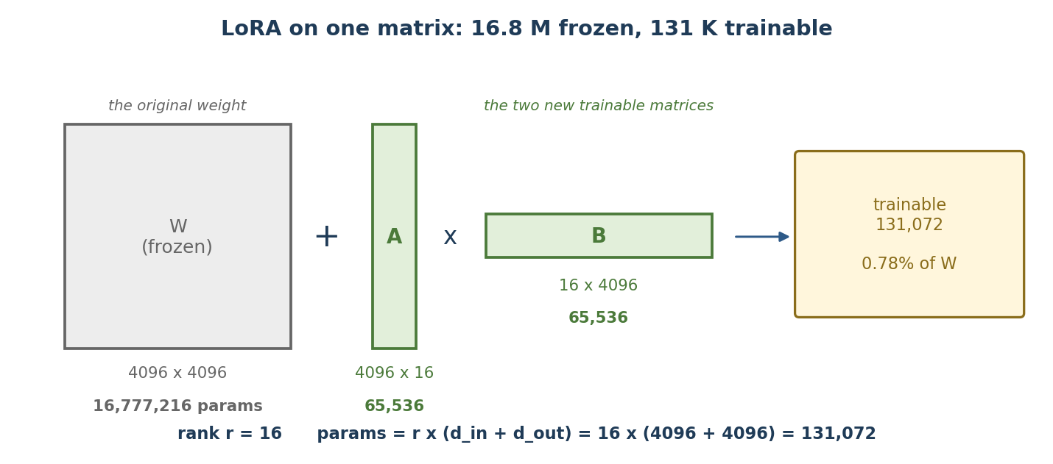
Figure 11: LoRA on a single 4096×4096 matrix. The original 16.8 M parameters stay frozen; the two new matrices hold 131 K trainable parameters.
The saving is dramatic because r is tiny next to the dimensions. Replacing a 4096×4096 update (16,777,216 numbers) with 16 × (4096 + 4096) = 131,072 numbers is a 128× reduction on that one matrix.

4.5 Worked calculation: Mistral-7B, r = 16, attention only
Using the config values from Step 3 — h = 4096, K/V dim = 1024 because of GQA, L = 32 layers — and target_modules = ["q_proj","k_proj","v_proj","o_proj"]:
Module | Shape (d_in × d_out) | r × (d_in + d_out) | Trainable params
q_proj | 4096 × 4096 | 16 × (4096 + 4096) | 131,072
k_proj | 4096 × 1024 | 16 × (4096 + 1024) | 81,920
v_proj | 4096 × 1024 | 16 × (4096 + 1024) | 81,920
o_proj | 4096 × 4096 | 16 × (4096 + 4096) | 131,072
Per layer | — | sum of the four | 425,984
× 32 layers | — | 425,984 × 32 | 13,631,488

This is exactly the number in Step 4
The code block in Step 4 of Section 2 prints trainable params: 13,631,488 || all params: 7,255,263,232 || trainable%: 0.1879. You have just derived that figure by hand from config.json. 13,631,488 ÷ 7.24 B = 0.188% — you are training roughly one parameter in every 530.
Note the k_proj and v_proj rows: they are smaller than q_proj because Mistral uses grouped-query attention. On an older model without GQA all four would be 131,072 and the total would be 16,777,216 instead.

4.6 How the count moves when you turn the knobs
Changing the rank (attention modules, 32 layers):
Rank r | Trainable parameters | % of the 7.24 B model | Adapter file size (bf16)
4 | 3,407,872 | 0.047% | ~7 MB
8 | 6,815,744 | 0.094% | ~14 MB
16 (default) | 13,631,488 | 0.188% | ~27 MB
32 | 27,262,976 | 0.376% | ~55 MB
64 | 54,525,952 | 0.753% | ~109 MB

The relationship is perfectly linear: double r, double everything.
Changing the targets (all at r = 16, 32 layers):
target_modules | Trainable parameters | % of model | Comment
q_proj, v_proj | 6,815,744 | 0.094% | The original LoRA paper's choice — cheapest useful setting
q_proj, k_proj, v_proj, o_proj | 13,631,488 | 0.188% | The common default; all of attention
attention + MLP (all 7 linears) | 41,943,040 | 0.58% | 3× more, because the MLP matrices are far wider. Usually the best quality when you can afford it
attention, but only 16 of 32 layers | 6,815,744 | 0.094% | layers_to_transform=range(16,32) — upper layers only

Rule of thumb
Start at r = 16 on attention. If the model underfits (training loss stalls high), raise r or add the MLP modules. If it overfits (train loss falls, eval loss rises), lower r or target fewer modules. Rank is a capacity dial — more rank means more room to learn and more room to memorise.

4.7 The same calculation for the other techniques
Every method has its own formula. Same model, same 32 layers:
Technique | Formula | Example setting | Trainable params
LoRA | r × (d_in + d_out), summed over targets × layers | r = 16, attention | 13,631,488
Adapters | 4 × h × bottleneck × layers (two adapters per layer) | bottleneck = 64 | 33,554,432
Prefix tuning | virtual_tokens × 2 × kv_dim × layers (K and V per layer) | 20 tokens | 1,310,720
IA3 | (kv_dim + kv_dim + intermediate) × layers — three rescaling vectors | — | 524,288
Prompt tuning | virtual_tokens × h — input embeddings only, not per layer | 20 tokens | 81,920
Full fine-tuning | everything | — | 7,241,732,096

Note the spread: prompt tuning trains 88,000× fewer parameters than full fine-tuning. That is also why it needs a large base model and a lot of data to work at all — there is very little capacity to store anything.
BitFit is the odd one out: it trains only bias terms, but LLaMA-style models (including Mistral) have no biases in their linear layers, so BitFit has almost nothing to train. It only makes sense on BERT-style models.

4.8 Why 0.19% trainable saves much more than 0.19% of memory
A common interview follow-up. Training memory has four parts, and PEFT shrinks three of them:
Memory component | Full fine-tuning (7 B, bf16) | LoRA r = 16 | Why
Frozen/base weights | ~14.5 GB | ~14.5 GB | Unchanged — the model still has to be in memory
Gradients | ~14.5 GB | ~0.03 GB | One gradient per trainable parameter only
Optimiser state (Adam) | ~58 GB | ~0.11 GB | Adam keeps 2 extra values per trainable parameter, usually in fp32
Activations | varies | slightly less | Still needed for the forward pass, but no activations are stored for frozen branches that need no gradient
Rough total | ~87 GB — needs multiple A100s | ~16 GB — one 24 GB card | The optimiser state is what actually kills you

The real headline
PEFT's saving is not mainly about the weights — it is about gradients and optimiser state, which scale with the number of trainable parameters, not total parameters. Dropping from 7.24 B trainable to 13.6 M cuts that portion by a factor of about 530.

4.9 Predict the number before you train
Rather than attaching the adapter and hoping, compute the count first. This script takes a model name and a config and prints exactly what will be trained:
from transformers import AutoConfig

name = "mistralai/Mistral-7B-v0.1"
cfg = AutoConfig.from_pretrained(name)

h = cfg.hidden_size # 4096
L = cfg.num_hidden_layers # 32
head_d = h // cfg.num_attention_heads # 128
kv_dim = cfg.num_key_value_heads * head_d # 1024 (GQA)
inter = cfg.intermediate_size # 14336
r = 16

# (d_in, d_out) for each module you might target
shapes = {
"q_proj": (h, h), "k_proj": (h, kv_dim),
"v_proj": (h, kv_dim), "o_proj": (h, h),
"gate_proj": (h, inter), "up_proj": (h, inter),
"down_proj": (inter, h),
}

targets = ["q_proj", "k_proj", "v_proj", "o_proj"]
per_layer = sum(r * (shapes[t][0] + shapes[t][1]) for t in targets)
trainable = per_layer * L

print(f'per layer : {per_layer:,}') # 425,984
print(f'trainable : {trainable:,}') # 13,631,488
print(f'adapter : ~{trainable*2/1e6:.0f} MB in bf16') # ~27 MB

Then attach the adapter and confirm the prediction matches reality:
model = get_peft_model(model, config)
model.print_trainable_parameters()
# trainable params: 13,631,488 || all params: 7,255,263,232 || 0.1879%

If the two numbers disagree
Almost always one of three things: (1) a name in target_modules matched more modules than you expected (e.g. it also matched inside the encoder of an encoder-decoder model); (2) GQA — you assumed k_proj and v_proj were square when they are not; or (3) modules_to_save is also training the classifier head or embeddings on top of the adapter. Run Check 1 in Section 4.2 and read the actual parameter names.

5. How to Choose the Best Technique for YOUR Model

5.1 Decision checklist (ask in this order)
- How much GPU memory do I have? Model fits comfortably in 16-bit -> LoRA. It does not -> QLoRA. Almost no budget at all -> IA3 / Prompt Tuning.
- How hard is the task? Simple label mapping / mild style shift -> low-rank LoRA (r=8), IA3, or even BitFit. New domain jargon, complex reasoning, structured output -> LoRA/QLoRA with r=32–64, targeting attention + MLP.
- Do I care about inference latency? Yes -> pick a MERGEABLE method (LoRA, QLoRA, IA3). Adapters and prefix/prompt tuning add permanent inference overhead.
- How many tasks on one base model? Many tasks, hot-swapped -> keep unmerged LoRA adapters or soft prompts per task and switch at runtime.
- How big is my model? Under ~10B -> avoid pure Prompt Tuning (it underperforms on small models); use LoRA or P-Tuning v2 instead.
- How much data do I have? Few hundred examples -> smaller r, higher dropout, fewer epochs (less overfitting). Tens of thousands -> larger r pays off.

5.2 Quick-pick table
Your situation | Recommended technique
Single 8–16 GB GPU, 7B model, real task (e.g., fraud classification) | QLoRA, r=16–32, target attention + MLP
24–48 GB GPU, 7B–13B model, best quality wanted | LoRA in bf16, r=32, alpha=64
Latency-critical production endpoint | LoRA then merge_and_unload() (zero overhead)
One base model serving 20 different departments | Per-task LoRA adapters, hot-swapped
Very large model (70B+), many light tasks | Prompt Tuning or IA3
Sequence labelling / NER on a small encoder model | P-Tuning v2 or LoRA
Tiny domain shift, minimal risk appetite | BitFit or IA3

5.3 The empirical rule: run a bake-off
Do not choose purely on theory. Standard practice: hold the dataset and evaluation fixed, train 2–3 candidate configurations for one epoch each (e.g., QLoRA r=16 vs r=64 vs IA3), compare validation metrics and cost, then scale up only the winner. Because PEFT runs are cheap, a bake-off often costs less than a day.
Rule of thumb
When in doubt: QLoRA with r=16, alpha=32, dropout 0.05, targeting q/k/v/o + gate/up/down projections is the strongest safe default in 2025–26 practice.

6. After Fine-Tuning: The Next Steps
- Evaluate on the untouched test set. Per-class precision/recall/F1, confusion matrix, and comparison against the prompted baseline. For fraud: High-class recall is the headline number.
- Error analysis. Manually read 50–100 wrong predictions. Group failure patterns (e.g., “confuses Medium vs High when amounts are small”). This tells you whether to fix data, prompt format, or hyperparameters.
- Regression / safety checks. Confirm the model did not forget general abilities you still need, and that it does not produce unsafe or off-format output. Run a small suite of standard prompts before/after.
- Merge or package the adapter. merge_and_unload() for a single deployable model, or ship base + adapter separately for multi-task serving. Version BOTH the adapter and the exact base model hash.
- Optimize for inference. Quantize the merged model (GPTQ/AWQ/GGUF int4/int8) and serve with an optimized engine (vLLM, TGI, llama.cpp). Measure latency and throughput under realistic load.
- Deploy behind a champion-challenger or shadow setup. Run the new model in parallel with the current system on live traffic before it takes decisions alone.
- Monitor in production. Track output-format validity, class distribution drift, confidence patterns, and human-analyst overrides (the strongest feedback signal in human-in-the-loop systems).
- Set retraining triggers. Retrain when: metrics drop below a threshold, drift is detected, enough new labelled cases accumulate, or business definitions change (e.g., new fraud typology). Keep a rollback path to the previous adapter.
Interview one-liner
“Fine-tuning is not the finish line — evaluation, error analysis, regression checks, optimized serving, shadow deployment, monitoring, and drift-based retraining triggers are what make it a production system.”

7. Complex Interview Questions with Model Answers
Q1. Why does LoRA work at all? Why should the weight update be low-rank?
Answer: Empirically, the update needed to adapt a pre-trained model to a downstream task has low “intrinsic dimension” — the model already contains most required knowledge, and adaptation mostly re-weights and re-routes existing features rather than learning new ones from scratch. The LoRA paper showed that even rank 1–4 can match full fine-tuning on some tasks. So constraining delta-W to rank r loses little expressiveness while cutting trainable parameters by orders of magnitude. If a task truly needs high-rank changes (a radically new domain or language), LoRA underperforms and you raise r or consider full fine-tuning.
Q2. Why is lora_B initialized to zeros and lora_A to random values?
Answer: Because B·A must equal zero at step 0, so training begins from EXACTLY the pre-trained model with no random perturbation — this stabilizes early training. If both were random, the model would start from a corrupted state. If both were zero, gradients through the product would be zero and nothing would learn. Zero-B, random-A gives zero initial output but non-zero gradients.
Q3. In QLoRA, if the base model is 4-bit, how can gradients flow through it accurately?
Answer: The 4-bit weights are frozen — we never compute gradients WITH RESPECT TO them, only THROUGH them. During each forward/backward pass, the needed blocks are dequantized to 16-bit on the fly, the computation runs in 16-bit, and gradients reach the 16-bit LoRA matrices. So gradient precision for the trainable parameters is preserved; only the frozen values carry quantization error, which NF4 keeps very small.
Q4. Does merging a LoRA adapter change model behavior versus running base + adapter separately?
Answer: Mathematically no in full precision: W + (alpha/r)·B·A applied once equals applying both paths at runtime. In practice, tiny numerical differences can appear from floating-point rounding, and one real trap exists with QLoRA: merging into the 4-bit weights is lossy — you must merge into a 16-bit copy of the base model, and even then behavior can differ slightly from training (where the adapter compensated for the quantized base). Always re-run evaluation after merging.
Q5. How would you fine-tune one base model for 15 different departments without 15 model copies?
Answer: Keep the base model frozen and train one LoRA adapter (~50 MB) per department. In serving, either hot-swap adapters per request or use multi-adapter serving (e.g., vLLM/LoRAX-style batched multi-LoRA inference, which can serve many adapters concurrently on one GPU by batching the small B·A computations). Storage becomes 1 base model + 15 small files, and each department can be retrained and rolled back independently.
Q6. Your PEFT model performs well on validation but poorly in production. Walk through your diagnosis.
- Data mismatch: compare production input distribution vs training data (length, vocabulary, formats, new templates). Most common cause.
- Prompt/template drift: the serving prompt must match the training template exactly — even whitespace and separators matter after supervised fine-tuning.
- Quantization/serving gap: did we evaluate the 16-bit model but deploy an int4 merged version? Re-evaluate the exact deployed artifact.
- Decoding settings: temperature/sampling differences between eval (often greedy) and production.
- Label/definition drift: business meaning of classes changed (e.g., new fraud typology not in training data).
- Validation leakage: check whether validation examples were near-duplicates of training examples, inflating the metric.
Q7. What is catastrophic forgetting, and why does PEFT reduce it but not eliminate it?
Answer: Catastrophic forgetting is when training on a new task overwrites the weights that encoded old abilities, so the model loses general skills. PEFT reduces it structurally because 99%+ of the original weights are frozen — the old knowledge physically cannot be overwritten. But it is not eliminated: the adapter can still learn to OVERRIDE base behavior at the function level (the frozen knowledge is intact but the output path is dominated by the adapter). Mitigations: lower rank, fewer epochs, mixing a small fraction of general instruction data into training, and regression testing on general benchmarks.
Q8. When would you choose full fine-tuning over PEFT despite the cost?
Answer: When (a) the domain shift is extreme — a new language, code dialect, or highly specialized corpus where low-rank updates underfit; (b) you are doing continued pre-training on billions of tokens, not task adaptation; (c) you need to change fundamental behavior across the board (e.g., deep alignment training); or (d) you have the compute and the last 1–2% of quality is business-critical. For typical enterprise task adaptation with thousands of examples, PEFT is almost always the right call.
Q9. How do rank r and lora_alpha interact? What happens if you double r but keep alpha fixed?
Answer: The adapter output is scaled by alpha/r. If you double r with alpha fixed, each individual direction's contribution is halved while capacity doubles — the effective update magnitude stays roughly comparable but learning dynamics change. That is why the common convention alpha = 2r keeps the scale ratio constant as you sweep r, making experiments comparable. Some newer setups use rank-stabilized LoRA (scaling by alpha/sqrt(r)) because plain alpha/r can under-scale high ranks.
Q10. How would you decide between prompting, RAG, and PEFT fine-tuning for a new use case?
Answer: Order of escalation: start with prompting — zero cost, instant iteration. Add RAG when the problem is missing or changing KNOWLEDGE (facts, documents, policies), because retrieval injects up-to-date information without training. Move to PEFT fine-tuning when the problem is BEHAVIOR: consistent format, domain jargon comprehension, classification consistency, or when few-shot prompts are too long/expensive/inconsistent at scale. They combine: a fine-tuned model with RAG is common — fine-tuning teaches HOW to answer, RAG supplies WHAT to answer with. Fine-tuning is a poor tool for injecting fresh facts; RAG is a poor tool for changing style and output discipline.
Q11. Your QLoRA training loss decreases but validation loss increases after epoch 1. What do you do?
Answer: Classic overfitting on a small dataset. Actions: stop at the best validation checkpoint (early stopping); reduce epochs to 1–2; lower rank (e.g., 32 -> 8) or raise lora_dropout; lower the learning rate; add more/varied training data or augment (paraphrase inputs); and check for label noise — with small datasets a few wrong labels visibly distort training. Also verify the validation set is truly representative and not tiny (high-variance metric).
Q12. Can you stack or combine multiple LoRA adapters? What are the risks?
Answer: Yes — adapters can be added together (weighted sums of their delta-W), switched per request, or combined with methods like TIES/DARE merging. Risks: adapters trained independently can interfere (their updates conflict in the same subspace), degrading both tasks; scaling weights must be re-tuned; and evaluation must be redone for the combined behavior — you cannot assume task A and task B metrics survive merging. For reliable multi-task behavior, joint training on a mixed dataset usually beats post-hoc merging.

8. Quick Glossary
Term | Meaning in plain words
Parameter / weight | One learnable number inside the model; a 7B model has 7 billion of them
Frozen | requires_grad=False: the value is used but never updated during training
Rank (r) | Width of the two thin LoRA matrices; controls adapter capacity
Adapter | Any small trainable add-on module attached to a frozen model
Quantization | Storing weights with fewer bits (e.g., 4-bit) to save memory
NF4 | 4-bit NormalFloat data type used by QLoRA for frozen weights
Merge (merge_and_unload) | Folding the LoRA update into base weights: W + (alpha/r)·B·A
Soft prompt / virtual token | A trainable vector treated like a token, not a real word
Catastrophic forgetting | Losing old abilities while learning a new task
Champion-challenger | New model runs in parallel with the current one before promotion

