Pivot Table:

Pivot means converting unique values present in rows to columns.
Can be done in two ways:-
1.case when
2.pivot

BASIC OF CASE WHEN :-
Select eid,
Case when eid>10 then ‘manager’
End as manager_result
From table
Here where a new column will be formed with ‘manager_result’ where eid<10 there null value will be enter

Select eid,
Case when eid>10 then ‘manager’
Else ‘no_manager’
End as manager_result
From table

Here null values will be replaced with ‘no_manager’

The number of rows will be equal.

Below if we simply use case when without sum then there.
will be same number of rows as present in the data, it is getting group by that’s why it is getting two rows only.

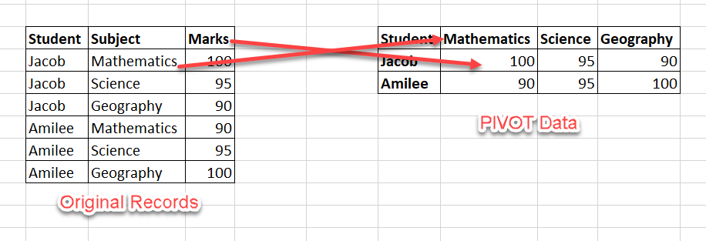

select student,
sum(case when subjects='math' then mark else 0 end)as math,
sum(case when subjects='sci' then mark else 0 end) as sci,
sum(case when subjects='geo' then mark else 0 end) as geo
from tt group by student
PIVOT

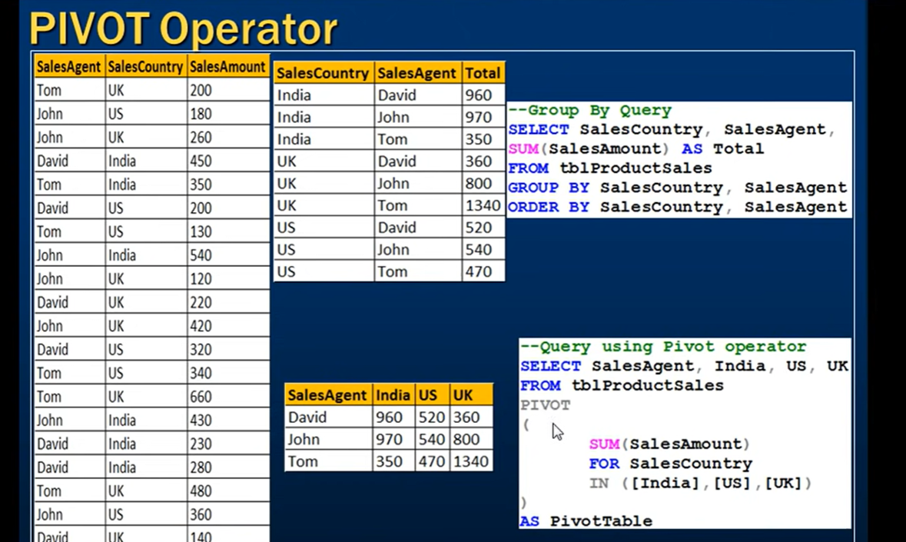

If you are using pivot, then you can see above you need to mention the columns name which you want in the select and there is no group.
There is not any way to PIVOT without aggregating so use max or min to get the value.

UNPIVOT – columns to rows

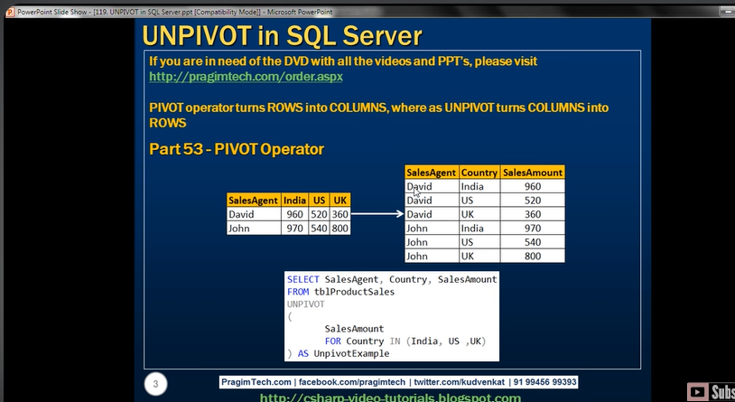

In unpivot just like pivot , we have to mention the name first in select statement

Which we want to give to columns having rows as values from column names and

Also numerical values columns name as well as

Join:-

INNER JOIN: returns rows when there is a match in both tables.
LEFT JOIN: returns all rows from the left table, even if there are no matches in the right table.
RIGHT JOIN: returns all rows from the right table, even if there are no matches in the left table.
FULL JOIN: combines the results of both left and right outer joins.

Cross join vs outer join :-

A CROSS JOIN produces a cartesian product between the two tables, returning all possible combinations of all rows. It has no ON clause because you're just joining everything to everything. i.e you are joining one row of one table with the rest of the all rows of the another tables

Outer join :-

Outer join benefit is that no data will be missed when we use it , if we use inner ,left , right then there is change that some data is missed which is present in some while not in other

The join can be > ,or < etc. it doesn’t need to be = always

If we inner join on columsn having duplicate value then it will become cross join

Index :-

A SQL index is used to retrieve data from a database very fast

only creating a primary key creates a unique SQL index.

cluster index :-

Clustered index determines the storage order of rows in the table, and hence doesn’t require additional disk space.

There can only be one clustered index on a table as the rows in the table will be sorted by the order specified in the clustered index

A Clustered Index is faster than the Non-Clustered Index since it doesn’t involve any extra lookup step.

composite key can be created like PK in cluster index
CREATE CLUSTERED INDEX IX_tblStudent_Gender_Score
ON student(gender ASC, total_score DESC)

Non-Clustered Index :-

We can create multiple non-clustered indexes.

A non-clustered index doesn’t sort the physical data inside the table.

In fact, a non-clustered index is stored at one place and table data is stored in another place.

The table records will be sorted by a clustered index if there is one.

The non cluster index will be sorted according to its definition and will be stored separately from the table.

non cluster format :-
CREATE NONCLUSTERED INDEX IX_tblStudent_Name
ON student(name ASC)

What is an Execution Plan?

An execution plan in SQL Server Management Studio is a graphical representation of the various steps that are involved in

fetching results from the database tables and returns the plan with the best performance.

There are two types of execution plans to be specific –

Estimated Execution Plan - this type of execution plan is just a guess by the query processor.

Once the query is written completely, you can hit “Ctrl + L” and it will generate the estimated execution plan

Actual Execution Plan – The Actual Execution Plan is generated after the query has been executed. It shows the actual operations

Hit “Ctrl + M” and it will generate the actual execution plan after the query has been executed successfully

The plan is interpreted from right-to-left and top-to-bottom

MERGE

To insert/update/delete with one query

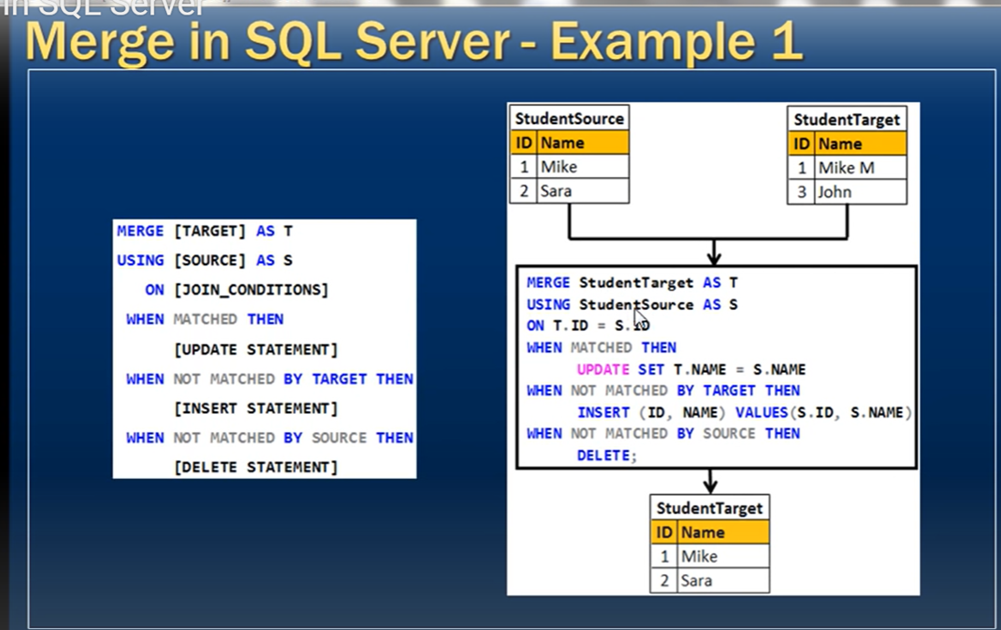

OVER

OVER()

Select col1,col2,sum(col2) over () as abc From tables

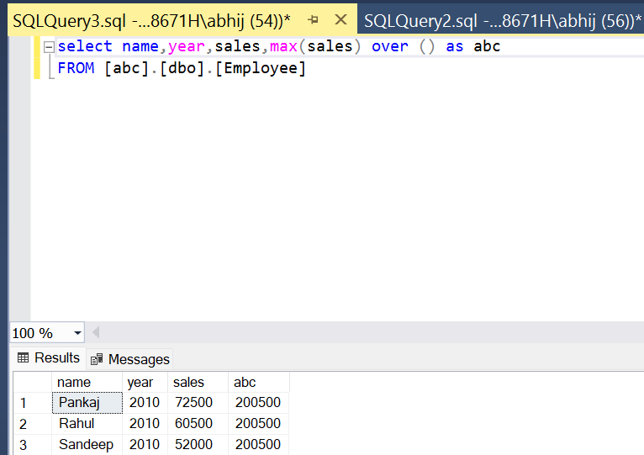

Over () is like groupby but it will give all rows and all columns and same value will repeat in rows

Or

You can think over() is like over complete table

select name,year,sales,max(sales) over() as m
,sum(sales) over () as s

FROM [abc].[dbo].[Employee]

Cumulative addition

Select
c1.ID, c1.SomeValue,
Sum (SomeValue) Over (Order By c1.ID )
From table

Partition By:-

We use SQL PARTITION BY to divide the table set into partitions and perform computation on each subset of partitioned data.

Partion by and order by have same sytax
OVER(PARTITION BY year ORDER BY result DESC)

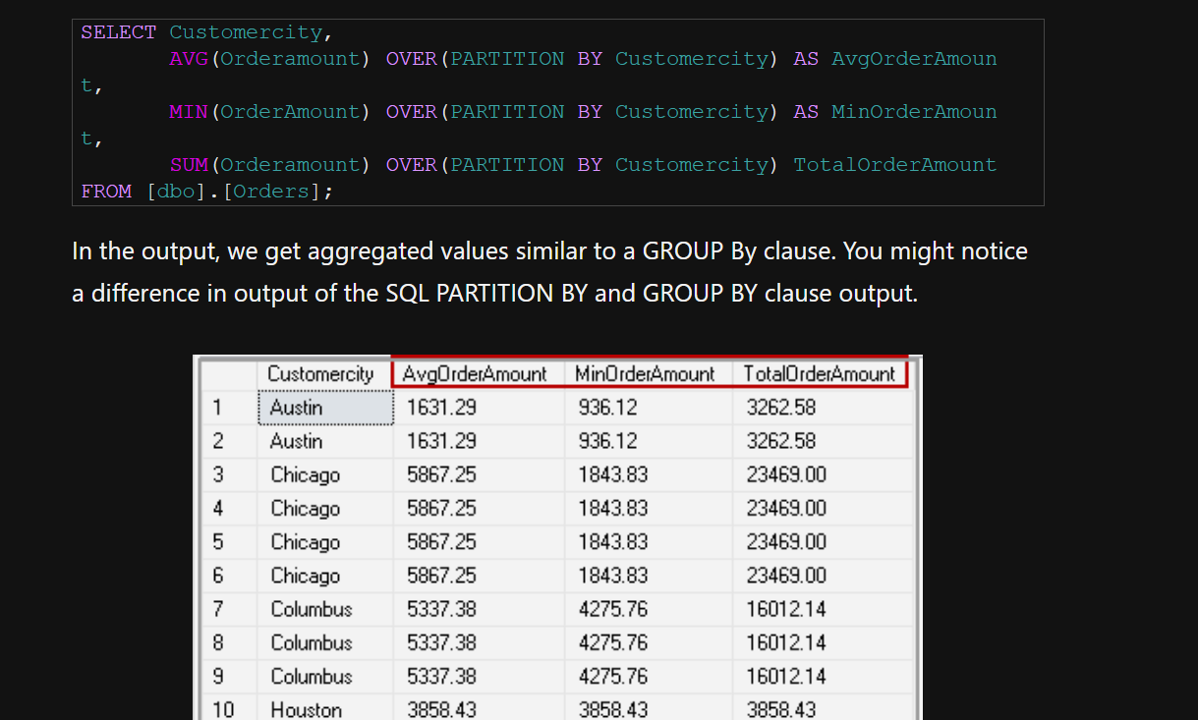

Duplicate values rows are there, if we use distinct then may be equal to group by

Group By | SQL PARTITION BY
We get a limited number of records using the Group By clause | We get all records in a table using the PARTITION BY clause.
It gives one row per group in result set. For example, we get a result for each group of CustomerCity in the GROUP BY clause. | It gives aggregated columns with each record in the specified table.

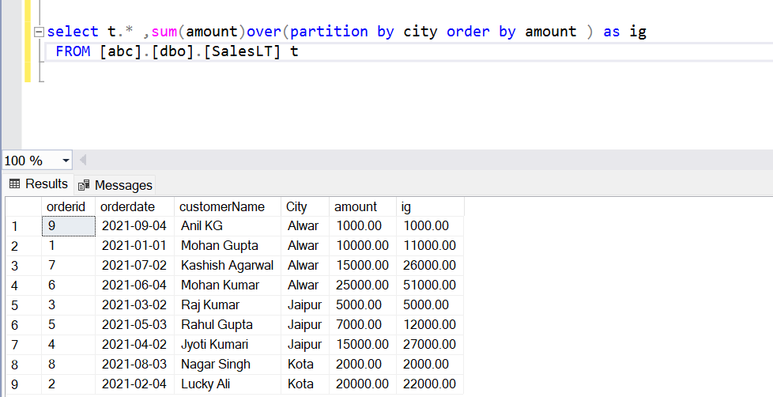

Wanted to order amount by city , used partition but seem like partition cannot worked without aggregation

Rank,dense_rank,row_number(),ntile,lead,lag will only be used by over (order by )

RANK :-
Everything can be done with or without partition.

- RANK() gives you the ranking within your ordered partition. Ties are assigned the same rank, with the next ranking(s) skipped. So, if you have 3 items at rank 2, the next rank listed would be ranked 5.

- DENSE_RANK() just like RANK but No ranks are skipped if there are ranks with multiple items.

3 ) Row_number() It assign sequential integer to each row . The row number
starts with 1 . can be useful to delete duplicate rows.
- NTILE(n): Divides the rows in a result set into n equal groups (or tiles) and
assigns a rank to each row based on the group it belongs to.

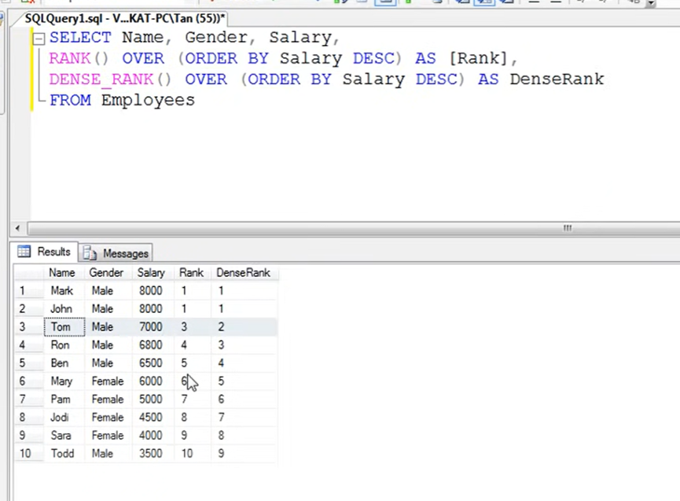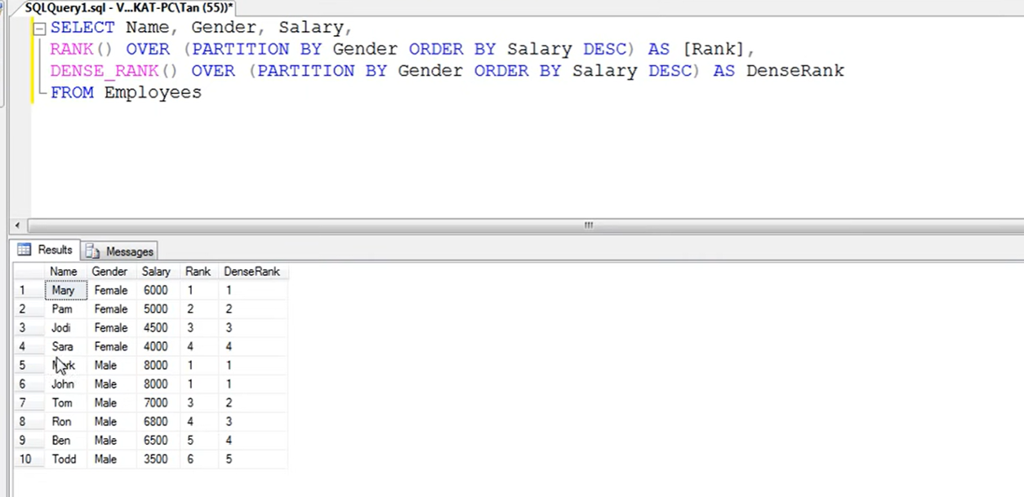
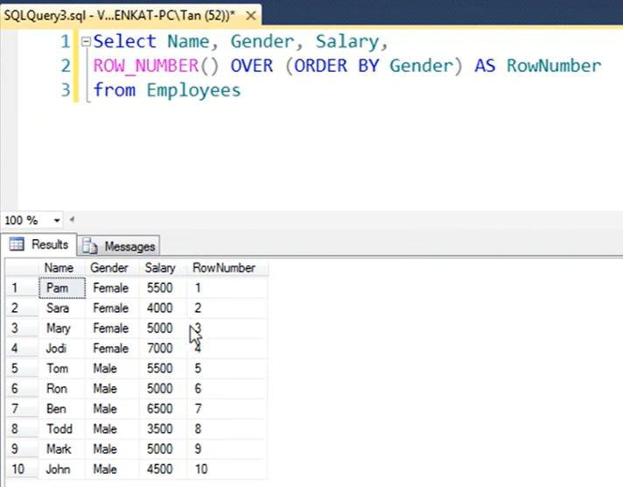

Lag & Lead:-

They have same syntax like rank, dense_rank , row_numbers()
We use a Lag() function to access previous rows data as per defined offset value.
We use a Lead() function to access one rows head data as per defined offset value.
In below screenshot-
Salary is the columns for lead, 2 values means how much look ahead , -1 mean if nothing found then return that , if -1 not specify null will return , if 2 not specify 1 will consider

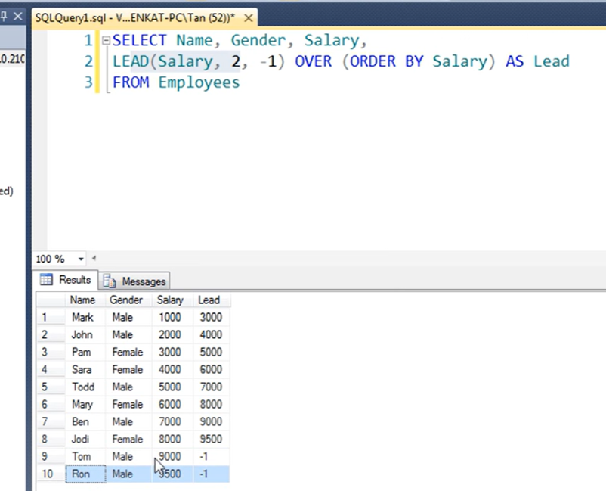

Null values:-

Finding null values:-
Select * from table where columns is null/not null
Note here we are not equating with = sign we are using column is null
How to avoid null values :-
colasec vs isnull
Both are use to avoid null value
COALESCE() can have multiple inputs and it will evaluate in order until one of them is not null such as COALESCE(Col1, Col2, Col3, 'N/A').
ISNULL() can only have one input, however it's been shown to be slightly faster than COALESCE.
Filling null values :-
There are multiple values
UPDATE [table]
SET [column]=0
WHERE [column] IS NULL;

Window functions :-

Window functions are function that perform Aggregate, ranking or Value function over a set of rows
Aggregate Window Functions
SUM(), MAX(), MIN(), AVG(). COUNT()
Ranking Window Functions
RANK(), DENSE_RANK(), ROW_NUMBER(), NTILE()
Value Window Functions
LAG(), LEAD(), FIRST_VALUE(), LAST_VALUE()
Note that all aggregate functions above ignore NULL values except for the COUNT function.

CTE (comman table expresssion)
WITH CTE1
AS ( select * from abc
),
CTE2
AS ( )
Here with is used only once at starting

Nolock ,dirty data

the WITH (NOLOCK) table hint retrieves the rows without waiting for the other queries, that are reading or modifying the same data, to finish its processing. This is similar to the READ UNCOMMITTED transaction isolation level, that allows the query to see the data changes before committing the transaction that is changing it

composite key
If a primary key consists of two or more columns it is called a composite primary key.The pair must then be unique for the table and neither value can be NULL.

Stored procedures

To avoid writing same query again we use store procedures
Create procedures spname
As
begin
Select * from abc
End
But above will be not of useful we have to create where we can give our variable so
Below is the way and how to use it
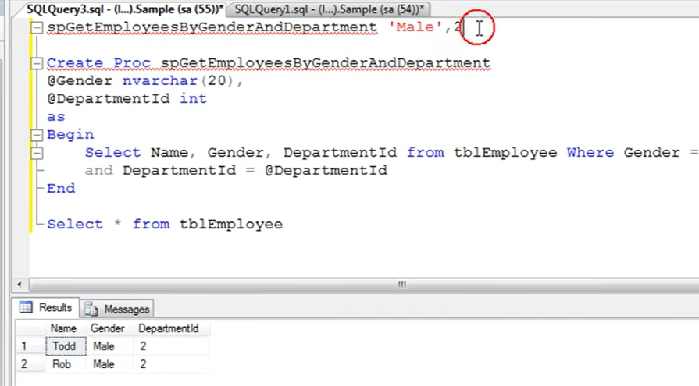

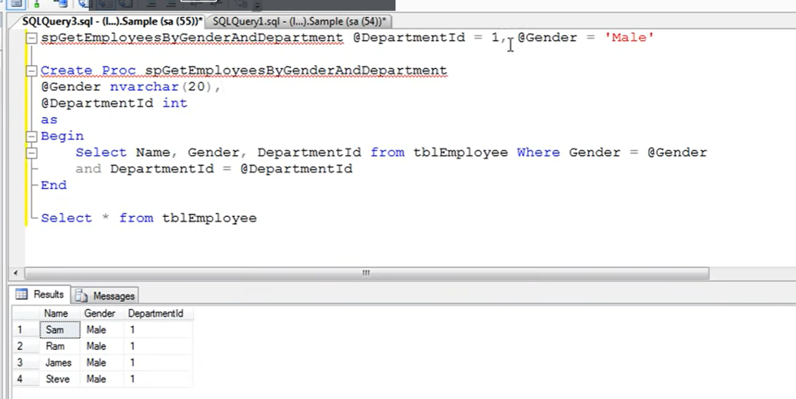

Variable

DECLEAR AND SET :-
DECLARE @model_year int
set @model_year=2
or
DECLARE @model_year int=2
Multiple assignment :-
DECLARE @model_year SMALLINT, @product_name VARCHAR(MAX)
But same cannot be done with ‘SET’ , you have to use ‘SET’ multiple times
To over come this use ‘SELECT’
SELECT @EmpName1 = 'Ali', @EmpName2 = 'Fadi'

Use in statement :-
Select * from a where year=@model_year

PRINT :-
declare @a int

set @a=( SELECT distinct marks
FROM [abc].[dbo].[Grades]
where Marks=100)

print 'the number of output is '+ cast(@a as varchar)

IF ELSE WHILE

IF ELSE are just like normal query in sql except we don’t use ‘:’ anywhere
you can use only IF , else is not mandatory ,BREAK is also use to break loop in mid

IF @a >9
Print ‘a’
ELSE
PRINT ‘B’

WHILE – SQL has only one loop method i.e while
WHILE {condition holds}
BEGIN
{…do something…}
END;

DECLARE @i INTEGER;
SET @i = 1;

WHILE @i <= 10
BEGIN
PRINT CONCAT('Pass...', @i);
IF @i = 9 BREAK;
SET @i = @i + 1;
END;

RAND()-

Returns a float between 0 through 1.
the RAND() uses a seed value and the return value is always the same for a given seed.
SELECT RAND(7)

except

SELECT id, name, company, power FROM Cars1
Except
SELECT id, name, company, power FROM Cars2

Intersect

SELECT id, name, company, power FROM Cars1
intersect
SELECT id, name, company, power FROM Cars2
Result comman between two output

Information and sys.obj tables

INFORMATION_SCHEMA.TABLES
It is an ANSI standard view to display details of the tables in a database.it is implemented in several databases other than MS SQL Server. e.g. MySQL, PostgreSQL, MariaDB,… etc Along with user tables INFORMATION_SCHEMA.TABLES will also list the views
SYS.TABLES
It is Microsoft’s proprietary system catalog view in SQL Server.
SYS.TABLES lists only the tables in the database
As this gives in depth details of the table, it is useful for DBA.

Questions :-

What is the difference between Primary key constraint and Unique key constraint? This question is asked very frequently in interviews.
1. A table can have only one primary key, but more than one unique key
2. Primary key does not allow nulls, where as unique key allows one null

Difference between WHERE and HAVING clause:
1. WHERE clause can be used with - Select, Insert, and Update statements, where as HAVING clause can only be used with the Select statement.
2. WHERE filters rows before aggregation (GROUPING), where as, HAVING filters groups, after the aggregations are performed.
3. Aggregate functions cannot be used in the WHERE clause, unless it is in a sub query contained in a HAVING clause, whereas, aggregate functions can be used in Having clause.

Difference between DELETE, DROP and TRUNCATE

Delete:-
With the help of the “DELETE” command, we can either delete all the rows in one go or can delete rows one by one. Here we can use the “ROLLBACK” command to restore because it does not auto-commit.
DELETE from WHERE ;

Drop:-
It is used to drop the whole table. With the help of the “DROP” command we can drop (delete) the whole structure in one go
Truncate:-
By using this command the existence of all the rows of the table is lost.

Difference Between Char, Nchar, Varchar and Nvarchar

Char and Varchar:-
Char- used to store non unicode character
Varchar – used to store non unicode alphanumeric character

Nchar and nvarchar:-
Same except we use unicode character like arabic,french etc.

STRING_AGG

Select *,string_agg(col) from abc
Group by col

STRING_SPLIT
Select * from abc
cross apply string_split(col name ,’,’)

square [] in like
where name like ‘%[0-9]%’ – where name contain any no at any place , same with ‘%[a-z]%’,
like [^0-9] not 0-b

****NEWID()

The value that NEWID() produces is a randomly generated 16-byte GUID (Globally Unique IDentifier). This is also known as a UUID (Universally Unique IDentifier).
result of newid would be like 6f7f606f-9ed3-48f3-b70e-90d901591203, can be used to generate a unique ID for each row

****VARBINARY

A varbinary column can store anything. It stores the maximum size of up to 2GB. A variable-length datatype, varbinary(max) can be used for media that require large capacity.
image can be stored here

****Everything You Need To Know About SQL Server TempDB

SQL Server TempDB is a special database in SQL Server that stores temporary objects.
It not only provides you with temp storage but also helps improve the performance of the database queries and reduces the workloads of the front-end applications as well.
You rarely use TempDB directly, but it has many functions behind the scenes and it is always in use by SQL Server to ensure the performance and responsiveness of some system and non-system databases.
For example, if a database operation is too large that needs more memory and storage than the database server currently has, the server uses TempDB as the temp storage to help execute the operation. You can think of TempDB as virtual memory.
In TempDB you will find tables, stored procedures, table variables, cursors, or derived tables that contain intermediate results when processing queries.
TempDB is a system database. It's not specific to any SQL Server instance, but it's always created when you start SQL Server.

OPTIMIZE SQL QUERY

TIPS:-
1.Prefer UNION ALL to UNION
2.Drop index before loading bulk data
3.Avoid too many subquery or CTE joins
Joining many subqueries or CTE’s might lead to holding all the rows in memory and requires
constant spilling of data to disk in order to facilitate the join operation and it takes a long time to finish the query.
A solution to this is to load the data or all the subqueries/CTE’s into intermediate/temp tables
4.Use Same Datatype on JOIN
5.advantage of INDEXING
If you find that you’re always filtering by a common set of columns, you should consider indexing those columns.
6.Use Equals Operator (=) instead of LIKE clause
7.Avoid SELECT DISTINCT for large tables
8.join on int column , order by on int columns and at last
9: Trim your data early

A deadlock is a situation where two transactions wait for each other to give up their respective locks.

SET STATISTICS TIME ON
By using STATISTICS TIME ON, we can see the parse time, compile-time, execution time, and completion time of the query.

STATISTICS IO ON

we get the number of physical and logical reads performed to execute the query.

Logical reads: Number of reads that were performed from the buffer cache.

Physical reads: Number of reads that were performed from the storage device as they were not available in the cache.

We should use inner join for merging two or more tables rather than using the WHERE clause. WHERE clause creates the CROSS join/ CARTESIAN product for merging tables. CARTESIAN product of two tables takes a lot of time.

SET STATISTICS IO ON
SELECT p.Name, Color, ListPrice
FROM SalesLT.Product p, SalesLT.ProductCategory pc
WHERE P.ProductCategoryID = pc.ProductCategoryID
SET STATISTICS TIME ON
SELECT p.Name, Color, ListPrice FROM SalesLT.Product p
INNER JOIN SalesLT.ProductCategory pc
ON P.ProductCategoryID = pc.ProductCategoryID

