P-Values
Through the Lens of the
Normal Distribution

Simple language. Visual intuition. Multiple worked examples.
Table of Contents

1. A Quick Reminder About the Normal Distribution
Before we link p-values to the normal distribution, let's make sure the curve itself is clear.
The normal distribution is that classic bell-shaped curve. It shows up everywhere — heights, test scores, measurement errors, daily steps, repeated coffee-shop wait times. Anywhere lots of small random factors add up, you tend to get a bell shape.
THREE THINGS TO REMEMBER
- It is symmetric around the mean (the middle = the average).
- Values near the mean are common. Values far from the mean are rare.
- The width of the curve is controlled by the standard deviation (σ). Bigger σ → wider, flatter bell. Smaller σ → tall and narrow.

The most important rule of thumb — the 68-95-99.7 rule:
Distance from mean | Fraction of values inside
Within 1 standard deviation | About 68%
Within 2 standard deviations | About 95%
Within 3 standard deviations | About 99.7%

So if a value is more than 2 standard deviations away from the mean, it's already in the rare 5%. More than 3? Extremely rare (less than 0.3%).

2. Where Does the P-Value Live on the Curve?
Here is the key idea, in one image. The bell curve shows what's normal to see. The p-value is the shaded area in the tail — everything as extreme as your observation, or more extreme.
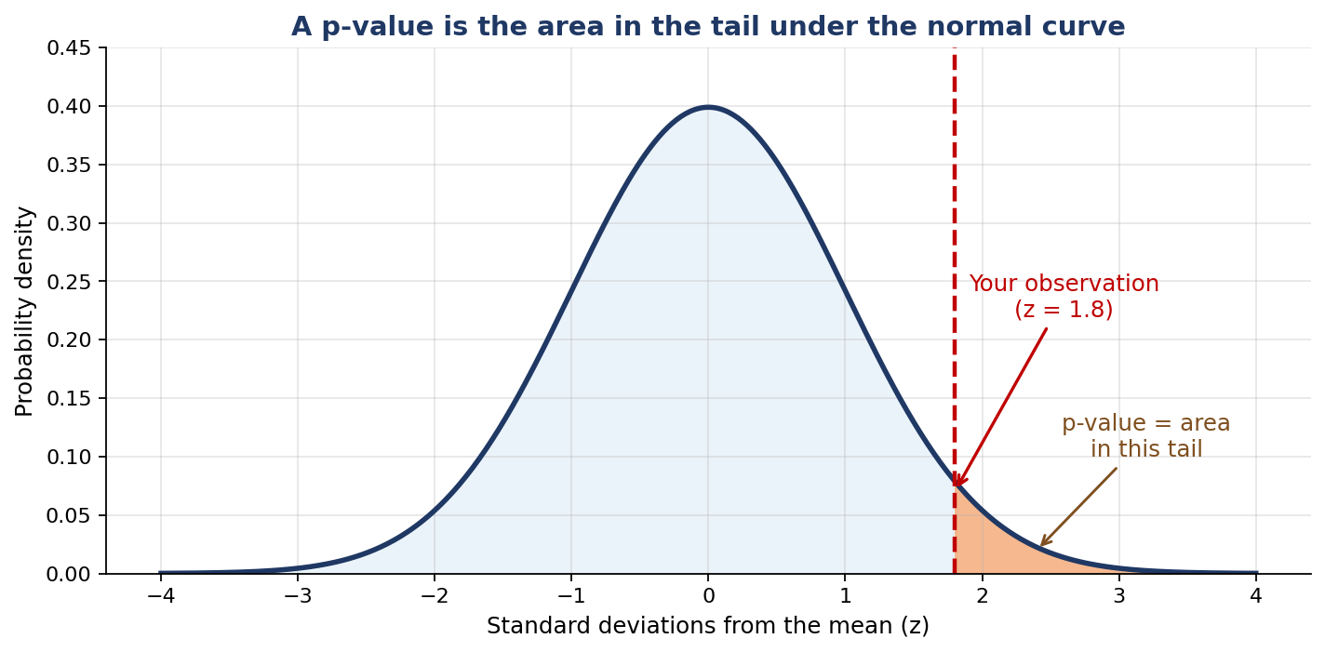
The p-value is the tail area beyond your observed value.
THE INTUITION IN ONE LINE
The further out your data point sits, the smaller the tail behind it — and the smaller the tail, the smaller the p-value.

Why this works
Picture the bell curve as a map of "what's expected if nothing unusual is happening." The peak in the middle is the average outcome. The tails on either side are the rare outcomes.
When you collect data and plot where it falls on the curve, you're asking: how far into the rare zone did I land?
- Landed near the middle? The data is normal. p-value is big. Nothing surprising.
- Landed deep in the tail? The data is unusual. p-value is tiny. Something interesting may be happening.

Z-scores: the bridge between your data and the curve
To use the standard normal curve, we first turn raw numbers into z-scores. A z-score just says: "how many standard deviations is this value away from the mean?"
Formula: z = (your value − mean) / standard deviation
Example: if the mean height of students is 170 cm with σ = 10 cm, and you measure someone at 190 cm:
z = (190 − 170) / 10 = 2.0
This person is 2 standard deviations above the mean. From the 68-95-99.7 rule, only about 2.5% of people are this tall or taller — so the right-tail p-value is roughly 0.025.
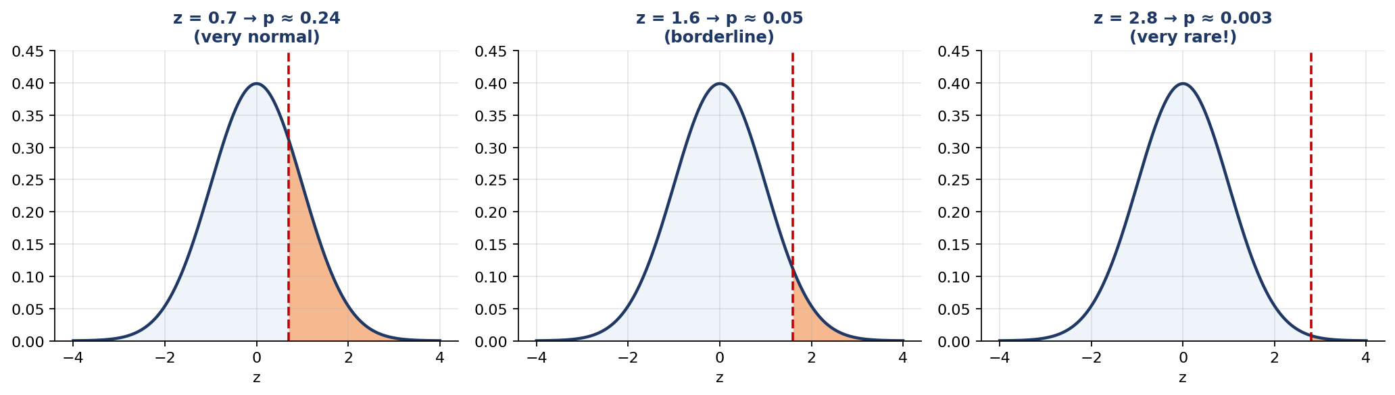
Bigger z-score → smaller tail → smaller p-value.

3. Multiple Simple Examples
Same idea, four different stories. Watch how the z-score and p-value behave.

Example 1 — Is Aman Unusually Tall?
SETUP
- Class average height: 170 cm
- Standard deviation: 8 cm
- Aman's height: 184 cm
Is Aman just a bit tall, or genuinely unusual?

Step 1 — z-score: z = (184 − 170) / 8 = 1.75
Step 2 — read the tail: From the normal distribution, the area beyond z = 1.75 is about 0.04 (or 4%).
Interpretation: If Aman were picked at random from a class where the average is 170, only about 4% of students would be this tall or taller. He's tall enough that we'd call it unusual.

Example 2 — Is the Coffee Machine Pouring Too Little?
SETUP
- Machine claims each cup contains 250 ml on average
- Known standard deviation: 12 ml
- You measure 36 cups. Your sample mean: 245 ml
Is the machine cheating you, or is 245 ml just normal random variation?

When you take the average of multiple cups, the spread shrinks. The standard deviation of the sample mean is σ / √n:
Standard error = 12 / √36 = 12 / 6 = 2 ml
z = (245 − 250) / 2 = −2.5
Tail area beyond z = −2.5: about 0.006 (or 0.6%)
If the machine really averaged 250 ml, getting a sample mean of 245 ml or lower from 36 cups would happen less than 1% of the time. The machine is almost certainly under-pouring.

Example 3 — Is Priya's Test Score Special?
SETUP
- National exam average: 65 marks
- Standard deviation: 15 marks
- Priya scored: 72 marks
Is Priya above average, sure — but is she statistically unusual?

z = (72 − 65) / 15 ≈ 0.47
Tail area beyond z = 0.47: about 0.32 (or 32%)
Roughly a third of students would score 72 or higher just by being slightly above average. So while Priya did beat the average, her score isn't unusual enough to call "rare." The p-value is large, the data sits well within the bell.

Example 4 — Did the Bus Run Late More Often Than Claimed?
SETUP
- Bus company claims average delay = 0 minutes ("always on time")
- Standard deviation of delays: 4 minutes
- You record 25 days. Average delay = 1.6 minutes
Is the company exaggerating its punctuality?

Standard error = 4 / √25 = 0.8 min
z = (1.6 − 0) / 0.8 = 2.0
One-tailed p-value: about 0.023 (or 2.3%)
If the company were genuinely averaging 0 delay, you'd see your kind of result only 2.3% of the time. Evidence suggests the average delay is really higher than 0. The claim looks shaky.
THE PATTERN ACROSS ALL FOUR
Bigger |z| → deeper into the tail → smaller p-value → more reason to doubt the original claim.
Smaller |z| → close to the middle → bigger p-value → the data fits the claim fine.

4. One-Tailed vs Two-Tailed Tests
Sometimes you only care about one direction ("is it too low?"). Sometimes you care about either direction ("is it different at all?"). The shape of the shaded region changes depending on which question you're asking.
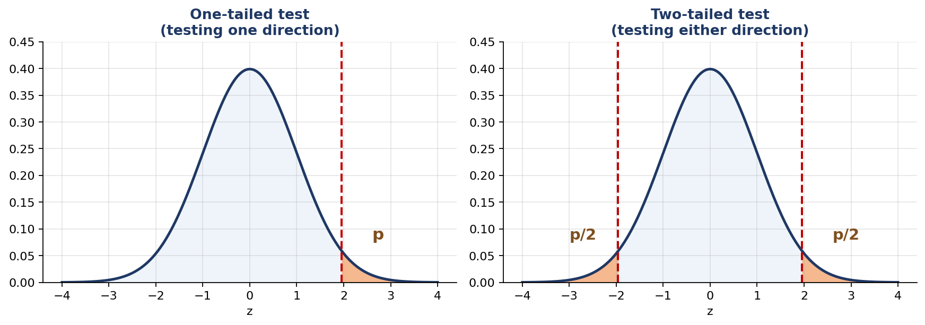
Left: one-tailed (one direction). Right: two-tailed (both directions).

When to use which
Question you're asking | Test type | P-value =
Is the new drug BETTER than the old one? | One-tailed | Right-tail area only
Are the bottles SHORTER than 500 ml? | One-tailed | Left-tail area only
Is the new method DIFFERENT (better OR worse)? | Two-tailed | Sum of both tails
Is the average DIFFERENT from claimed? | Two-tailed | Sum of both tails

RULE OF THUMB
If you don't know which to pick, default to two-tailed. It's safer because it doesn't assume you know the direction in advance.
A two-tailed p-value is exactly twice a one-tailed p-value (for symmetric distributions like the normal).

5. Computing P-Values from the Normal Curve in Python
Two functions from scipy do everything:
- norm.cdf(z) — area to the LEFT of z under the standard normal curve.
- norm.sf(z) — area to the RIGHT of z (this is 1 − cdf, but more accurate for tiny tails).

Example A — one-tailed test
from scipy.stats import norm

# Coffee machine example:
sample_mean = 245
claimed_mean = 250
std_dev = 12
n = 36

standard_error = std_dev / (n ** 0.5)
z = (sample_mean - claimed_mean) / standard_error
print(f'z = {z:.2f}')

# We suspect under-pouring, so use the LEFT tail
p_value = norm.cdf(z)
print(f'one-tailed p-value = {p_value:.4f}')

Example B — two-tailed test
from scipy.stats import norm

z = 2.0 # any z-score

# Two-tailed p-value: doubled tail area
p_value = 2 * norm.sf(abs(z))
print(f'two-tailed p-value = {p_value:.4f}')

Example C — go the other way (p → z)
If someone says "the cutoff for significance is p = 0.05," what z-score does that correspond to?
from scipy.stats import norm

# Two-tailed critical value for alpha = 0.05
z_critical = norm.ppf(1 - 0.05 / 2)
print(f'z* = {z_critical:.3f}') # about 1.96

# One-tailed critical value for alpha = 0.05
z_critical_one = norm.ppf(1 - 0.05)
print(f'z* = {z_critical_one:.3f}') # about 1.645

WHY 1.96 IS FAMOUS
Anytime you see "1.96" in statistics, it's just the z-score where exactly 2.5% of the normal curve lies in each tail — together, exactly 5%. That's the boundary of the famous 95% confidence interval.

6. Z-Score ↔ P-Value Cheat Sheet
Memorize a few of these and you can eyeball most p-values on sight.
|z| | One-tailed p-value | Two-tailed p-value | How surprised?
0.00 | 0.500 | 1.000 | Not at all — bullseye
0.50 | 0.309 | 0.617 | Not at all
1.00 | 0.159 | 0.317 | A little
1.28 | 0.100 | 0.200 | Noticeable
1.645 | 0.050 | 0.100 | Borderline (one-tailed cutoff)
1.96 | 0.025 | 0.050 | Significant (two-tailed cutoff)
2.33 | 0.010 | 0.020 | Very surprising
2.58 | 0.005 | 0.010 | Strong evidence
3.00 | 0.0013 | 0.0027 | Rare event
3.29 | 0.0005 | 0.001 | Highly significant

Decision Recipe (write this down)
1. Write the claim (null hypothesis). What's the mean and standard deviation if the claim were true?
2. Compute the z-score of your data: z = (observed − claimed) / standard error.
3. Decide one-tailed or two-tailed.
4. Look up (or compute) the tail area — that's your p-value.
5. Compare to your threshold (usually 0.05). Smaller? Reject the claim. Larger? Stick with it.
6. Always sanity-check: is the effect size big enough to actually matter in real life?
LAST REMINDER
A p-value is just the answer to one question: "How rare is this kind of data under the bell curve, if the original claim is true?"
When you can see the bell and the shaded tail in your head, p-values stop feeling mysterious.

