Chapter 1. Introduction
In the mid-2020s, AI agents began reshaping the AI landscape as we knew it. When ChatGPT, at the end of 2022, revolutionized the field of large language models (LLMs), AI agents started taking a major step further and were designed to act with autonomy, pursue goals, and even interact with the world. Rather than just generating text, these agents are capable of solving much more challenging problems using advanced reasoning, memorizing complex interactions, and creating entire codebases.
This shift is monumental and not just an incremental improvement. It redefines how we interact with AI. Where LLMs require significant handholding, AI agents are capable of autonomously deciding which actions to take, when to take them, and even how. It’s this agency that makes them such interesting entities and will be a core focus throughout this book.
This book covers AI agents that rely on LLMs. It’s important to note that there are other types of AI agents in practice that do not utilize LLMs. But instead of saying LLM-backed AI agents every time we mention agents in this book, we’ll just use AI agents and wish the reader recalls the type we’re addressing throughout the book.
With coding agents becoming a staple in every software developer’s toolkit, we have just begun to understand the potential this technology has. AI agents, in various forms, are beginning to integrate into all manner of fields, from finance to healthcare, and marketing to scientific research. This pace of improvements in AI, and AI agents in particular, has been daunting.
That is where this book, and particularly this chapter, comes in. This chapter serves as the scaffolding for the rest of the book and will introduce concepts and terms that we’ll use throughout all chapters. Mostly, we’ll give a brief answer to the question “What is an AI agent?” This answer will be your guide throughout all of the upcoming chapters, where each subsequent chapter will uncover an important component of an AI agent. You can expect an intuitive, but in-depth journey, of what makes AI agents so special.
What Is an AI Agent?
The definition of an AI agent is ever-changing as the field progresses and as these entities grow in complexity. Fortunately, as with most technologies, the fundamentals of AI agents are static and a great way to build up to more state-of-the-art techniques. As such, we consider the following definition of AI agents meaningful through both the fundamentals and new advances in this field:
An agent is anything that can be viewed as perceiving its environment through sensors and acting upon that environment through actuators.
Russell & Norvig, Artificial Intelligence: A Modern Approach1
This definition boils down agents to entities that perceive and interact with their environment. It’s broad enough to consider entities other than LLMs, but at the same time, it gives us something structured to work with.
We can deconstruct this definition into the following components that lie at the heart of agents:
Environment
The world the agent interacts with
Sensors
Components of the agent used to observe the environment
Actuators
Tools the agent uses to interact with the environment
Agent program
The “brain” or rules the agent uses to decide how to go from observations to actions
The interaction of all these components is shown in Figure 1-1.
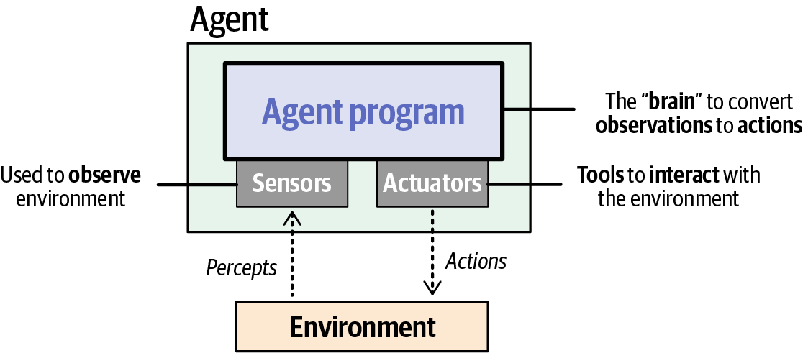
Figure 1-1. An agent perceives its environment through sensors and acts on it via tools or actuators
Let’s clarify this terminology by relating it to LLMs.
In practice, the agent program or brain of an LLM-backed agent is a “reasoning” LLM, a model that is capable of complex thinking. Through additional modules (memory, tools, and planning), this LLM is capable of interacting with its environment. Here, the actuators are the tools of the LLM. Some LLMs can interpret more than text, such as images or sound, and can be considered as the sensors in this system. The last piece missing from this system is the user, who can be part of the environment. Users often initiate the interaction by stating a request for the agent to fulfill.
Together, these aspects are what we believe to be truly fundamental to AI agents as we see them in practice. Figure 1-2 illustrates how all these components are connected. More importantly, this figure does not just elucidate the principles of agents but also tells a story: a story of what agents truly are, how they’re created, and how they behave. The figure serves as the foundation of this book and will be used throughout to build up the agent.
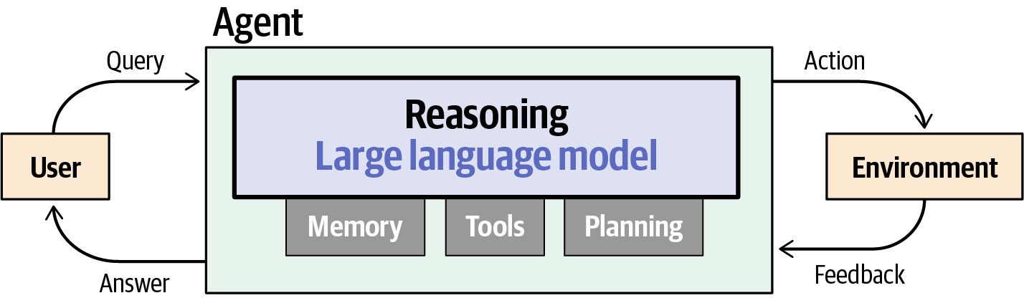
Figure 1-2. Agents operate in regular contact with a user and environment, and use reasoning models, memory, tools, and planning to decide their actions
Let’s go through each component in more detail and clarify how they relate to the book structure.
Large Language Models
To understand what AI agents are, we first need to explore the basic capabilities of an LLM, as the LLM is typically considered to be the “brain” of an agent. Traditionally, an LLM is a model that does nothing more than predict the next word based on a given input text. As shown in Figure 1-3, the LLM first breaks down a given input query into tokens, which are subcomponents of words that allow the model to generalize to words it has not seen before. The LLM processes these tokens, and a prediction is made on what the next token could be.
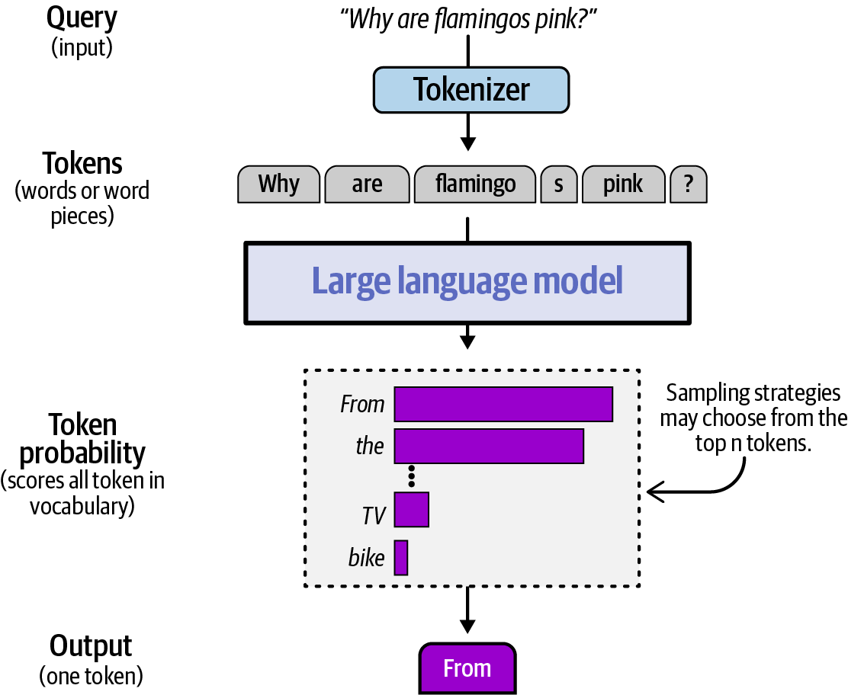
Figure 1-3. LLMs process their input messages by breaking them into tokens and produce their output as tokens—whether it be a message to the user or an action enacted on the environment
The LLM therefore predicts the next token, uses the predicted token to update its input, and then continues the predictions. By doing this iteratively (which is called autoregression), it can create entire answers to the user’s query (shown in Figure 1-4).
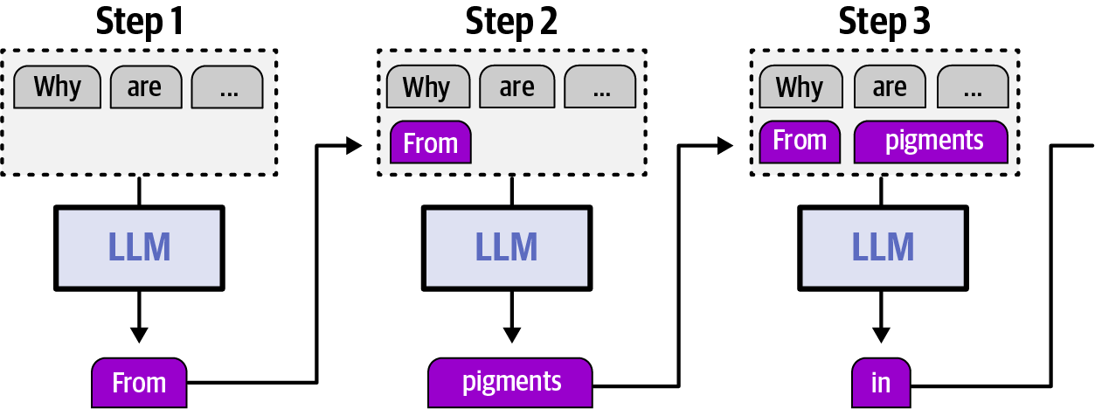
Figure 1-4. LLMs operate in an autoregressive loop, outputting one token at a time
In Chapter 2, we’ll explore in detail how this system, the LLM, works. The common architecture of LLMs, attention, and its many variants, will be explored to give you an understanding of its internal mechanisms.
Reasoning Large Language Models
Arguably, one of the most impactful LLMs is GPT-3.5, which powered the original ChatGPT released in November 2022. As a chat model, GPT-3.5 could hold entire conversations, making it eerily similar to how humans would interact. It’s safe to say that this model changed the world as we know it. Over the years since, OpenAI and many other LLM providers have focused on scaling GPT-3.5-like models to new heights by throwing more data, compute, and parameters at them. This is called train-time scaling (shown in Figure 1-5), where training on more data and making models larger led to reliable, predictable improvements in performance. The idea was that pre-training, the first and most expensive stage of training an LLM, was where the gains came from: the larger your pre-training budget, the better the resulting model.
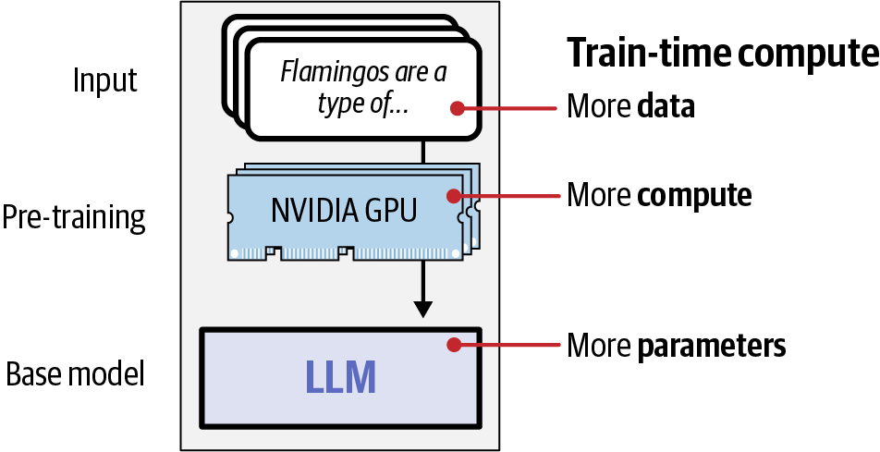
Figure 1-5. A lot of major LLM progress has been due to train-time compute: scaling data, compute, and model size
Although this improved the performance of these models, it uncovered a ceiling effect. Continuously scaling the model’s size is not cost-effective, and soon, training simply became too expensive for the small increase in performance. As it turns out, scaling your model can be done in more ways than one.
A major breakthrough in model performance was achieved with the introduction of LLM reasoning abilities in models such as OpenAI o1 and DeepSeek-R1. Instead of having the model “think” quietly (or implicitly through the model’s parameters) for a fixed amount of time, models were now trained to “think” out loud and spend more time to arrive at a correct answer (by generating reasoning tokens before deriving the answer). As shown in Figure 1-6, reasoning LLMs first generate “thoughts” and leverage that to generate the final answer.
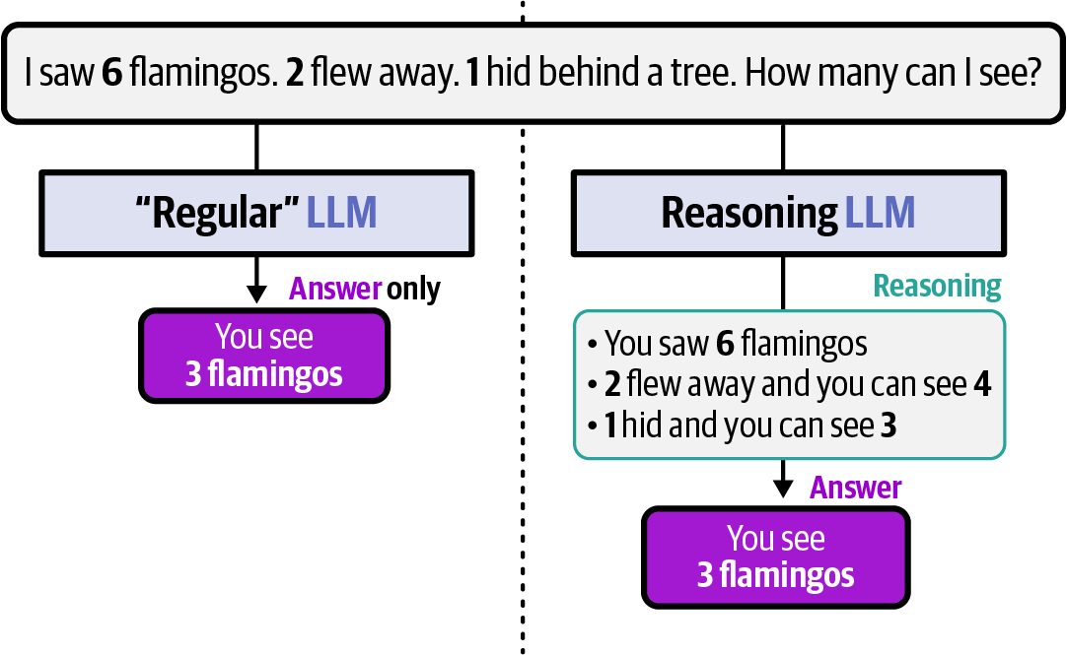
Figure 1-6. Reasoning improves the behavior of LLMs by allowing them to explicitly state and keep track of subproblems of the task at hand
The main idea is that it allows LLMs to write down their thoughts first through their autoregressive behavior before coming to an answer. Instead of spending all of its compute to generate only the answer, the LLM spends additional compute to first generate its “thoughts.” By structuring its thoughts, more complex queries that require multi-step reasoning are easier to solve. In some LLM playgrounds, like ChatGPT, these thoughts are typically hidden from the user or summarized, whereas the answer to the user’s query generally represents a conclusion building on the model’s “thoughts” (Figure 1-7).
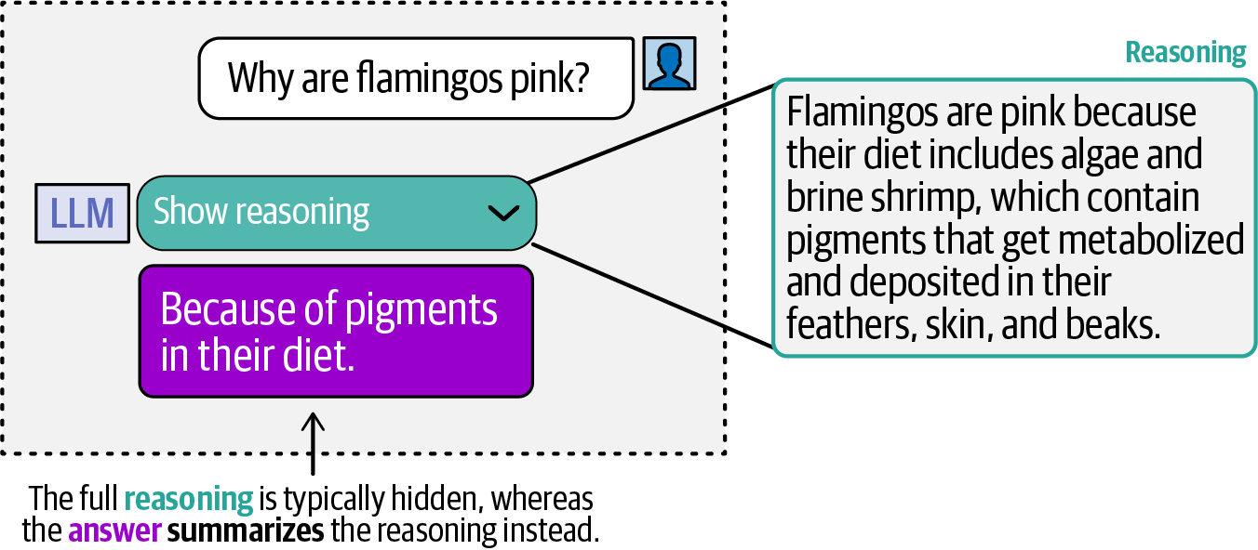
Figure 1-7. The final answers displayed in reasoning-LLM applications and playgrounds are aided by a reasoning trace that may be hidden or summarized
Part of what makes AI agents more capable is their ability to make extensive plans, select the appropriate tools, reflect on their mistakes, and even dynamically revise and update these plans. All of these require advanced reasoning behavior in LLMs. Reasoning LLMs are particularly capable at complex decision-making tasks, breaking down multi-step problems, and generalizing to novel problems. However, if you want fast and cheap responses, “regular” LLMs are preferred.
As such, reasoning LLMs will take a central role throughout most of this book, as reasoning is a key capability enabling these complex behaviors. In Chapter 3, you’ll learn about various ways to create reasoning LLMs. We look at the fundamentals of reasoning LLMs, explore the famous reasoning LLM, DeepSeek-R1, and look beyond at what the future might hold in this field. Chapters 2 and 3 will therefore focus on the “brain” of the agent (Figure 1-8).
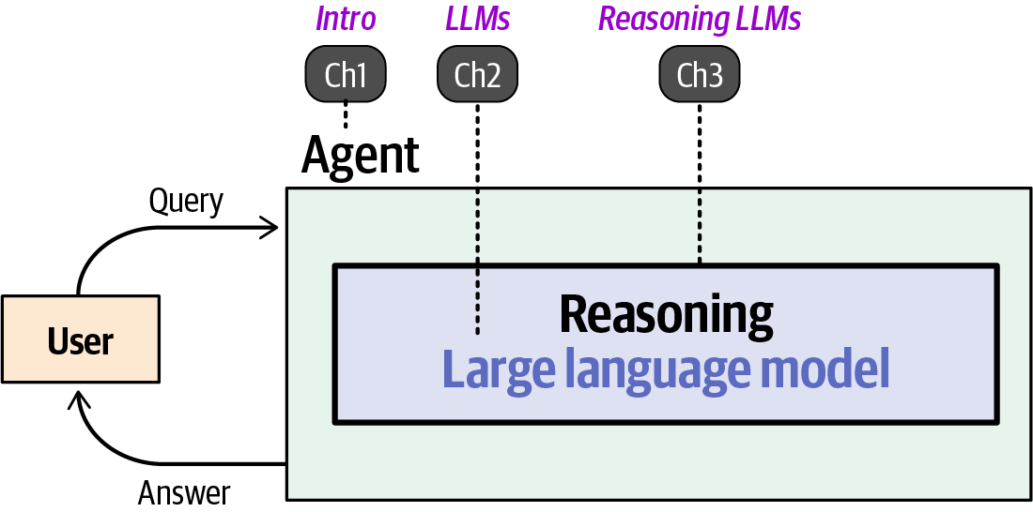
Figure 1-8. The first three chapters of the book focus on introducing agents, LLMs, and reasoning because these are foundational ideas for AI agents
Augmenting the Large Language Model
Although reasoning LLMs are vital to AI agents, they’re still incomplete and miss certain functionalities. As static text-to-text entities, text-based LLMs have no control over their environment, nor do they remember their interactions or learn from them.
Let’s explore how to go from an incredibly capable LLM to one that can remember interactions, interact with its environment, and demonstrate various degrees of autonomy.
Memory
Notice how, so far, we have shown only “single-turn” conversations. These conversations contain a single question and answer pair in the interaction with the LLM. If we were to continue this conversation and ask another question, we would turn it into a “multi-turn” conversation. Multi-turn conversations expose a vital flaw of LLMs, namely that they’re forgetful entities and do not remember past conversations (Figure 1-9). They are stateless, which means that information is not persisted across calls.
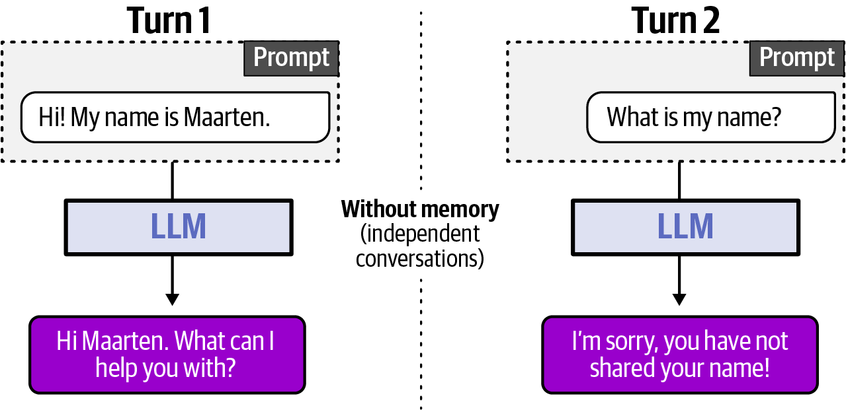
Figure 1-9. An LLM without a memory system to keep track of longer user conversations
Without memory, LLMs are nothing more than answering machines. Ask an LLM a question and get an answer. However, follow it up with another question, and the LLM has no information about the former interaction.
Fortunately, there are many ways we can add memory modules to LLMs to mimic memory. As shown in Figure 1-10, a common way to approach this is by simply adding the previous conversation to the current prompt.
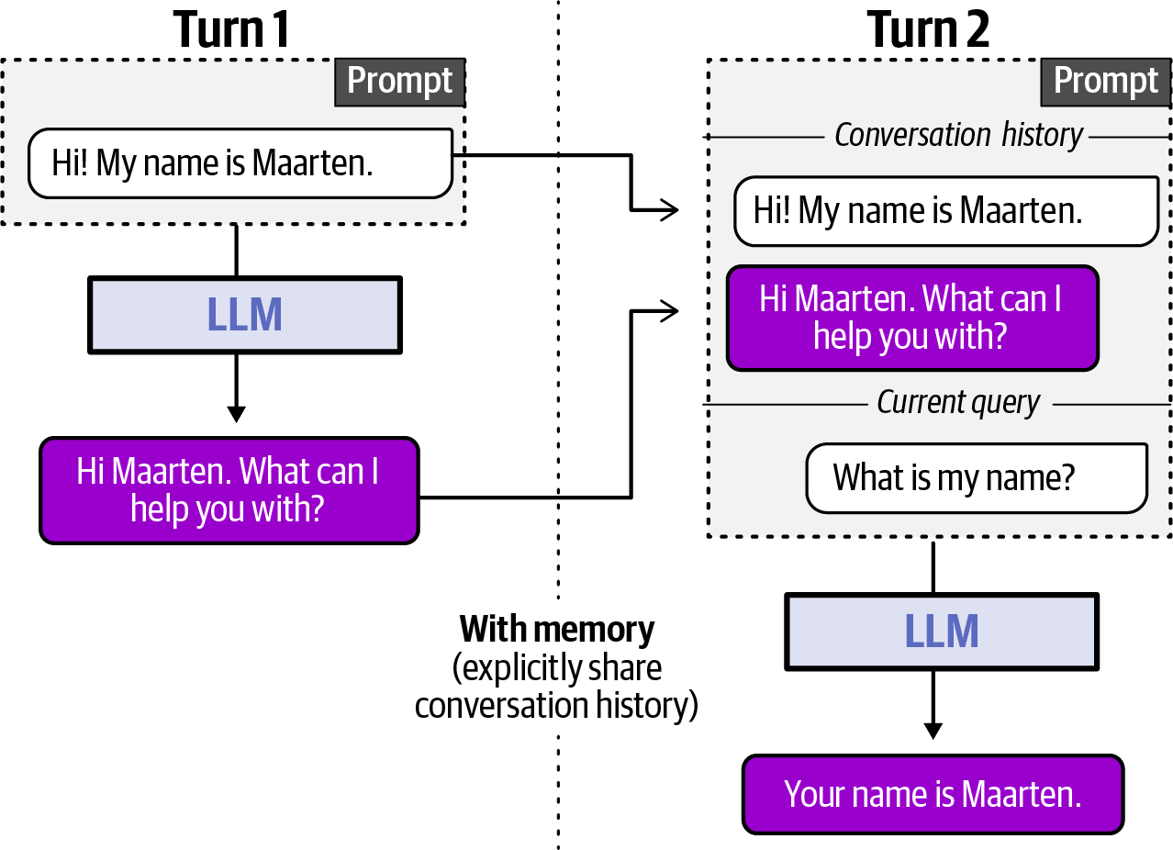
Figure 1-10. Adding conversation history to the LLM input is one of the first ways used to allow the model to glance at previous turns in the chat
In practice, however, memory modules can be quite complex. They share many similarities with human memory systems, such as short-term and long-term memory, but also how we process information. If we receive too much information, it becomes difficult to process, which can lead to poor decision-making. This is called information overload and can be a real problem even for LLMs. As such, memorizing every little detail might hurt the performance of an LLM, so a balance is needed between the amount and quality of the information in the prompt. This is called context engineering and, as shown in Figure 1-11, it attempts to balance the information available and what we give the LLM.
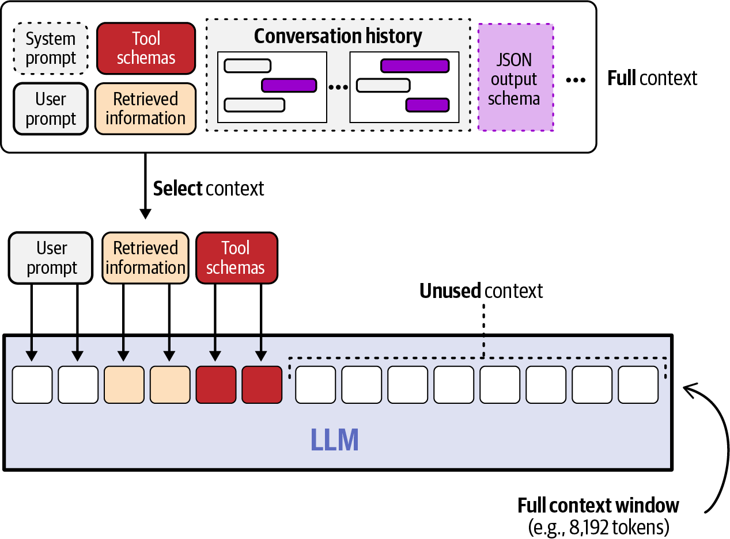
Figure 1-11. It’s essential to carefully design the input we pass to the LLM to help it tackle its present task, called context engineering
Tools
With memory, LLMs remember the conversations they previously had, but they’re not yet capable of interacting with their environment. LLMs can interact with their digital environment through external tools that may enhance their capabilities (like web search, for example). These tools vary in complexity and can range from straightforward calculators and search engines to more advanced tools with access to your command shell and coding environment.
However, LLMs are not capable of using tools by themselves. Fundamentally, LLMs can be seen as software or functions that, upon receiving input text, process it and then output some text. As text-in/text-out functions, LLMs can only describe or show the intent of taking the action when outputting text. This is shown in Figure 1-12, where the LLM, upon receiving the query “What is 5.1 times 7.3?” generates the string “multiply(5.1, 7.3)”. This string merely represents the LLM’s intention to take an action, but the action itself is not taken without outside intervention.
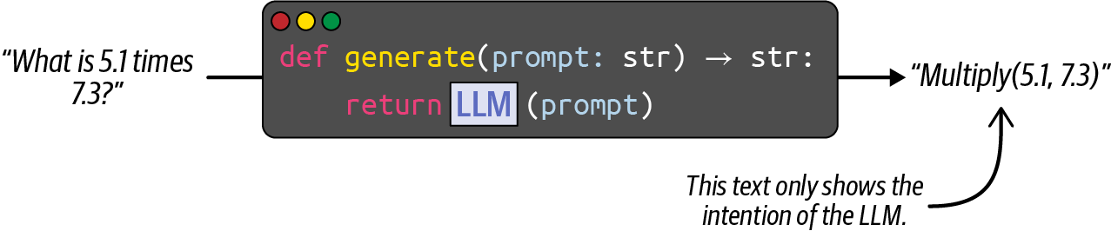
Figure 1-12. LLMs are able to invoke tools by outputting text in a specific format that other software systems parse and execute
The LLM can express the intent to use a tool, but it relies on us to turn that intent into an actual tool call. The user will need to write software to convert that text into an action. For instance, if the LLM’s output were JSON, we would use that to choose the correct tool and fill in its parameters. Those actions would need to be programmed separately (optionally by using existing agent frameworks). Figure 1-13 illustrates these steps, showing a possible representation of the overall flow.
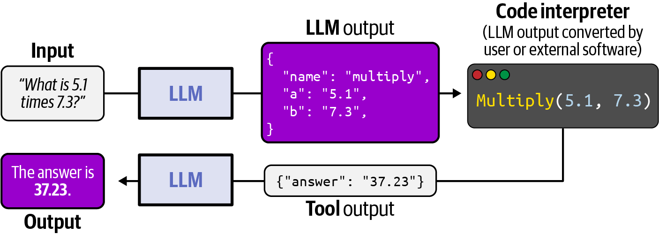
Figure 1-13. The workflow of an LLM calling a tool
There are many ways an LLM can use and learn tools, which we’ll cover in Chapter 5, along with how using the same tools by different LLMs can be standardized with the Model Context Protocol.
Chapters 2 through 5 give us what LLM company Anthropic calls: “the augmented LLM” (Figure 1-14). This LLM is capable of deciding which tools to use, how to use them, and what kind of information to retain. These augmentations (memory and tools) allow for interaction with the environment in meaningful ways.
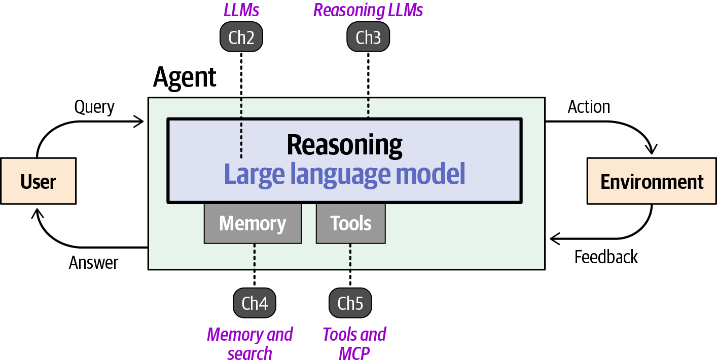
Figure 1-14. Augmenting a reasoning LLM with memory and tools: the “augmented LLM” that serves as the building block we turn into an agent
Planning and reflection
The final ingredient to go from a “regular” LLM to an AI agent is its ability to plan and reflect. These capabilities are important throughout much of an agentic system because the agent will need to decide which steps to take, how to take them, and when. For instance, if the LLM has access to dozens of GitHub API tools, such as looking at pull requests or commits, how does it decide which to use?
This is where planning comes in, which involves breaking down a large task into smaller, actionable steps, referred to as task decomposition. The first step is to typically create a plan to execute when presented with a query (Figure 1-15).
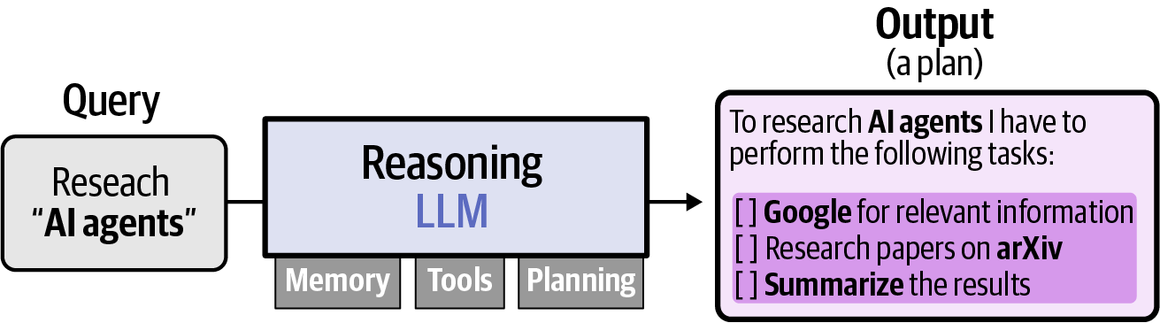
Figure 1-15. Plans enable agents to tackle larger tasks by breaking them down into smaller steps and updating that plan as it’s executed to keep track of progress
By continuously referring back to this plan, the LLM is capable of executing each of these tasks one at a time. Performing them all at once is seldom efficient, and each task might influence another. As shown in Figure 1-16, after completing a specific task, the LLM might still reason about which steps to take next. As such, reasoning is fundamental and often a necessity for your agent to plan out complex behavior.
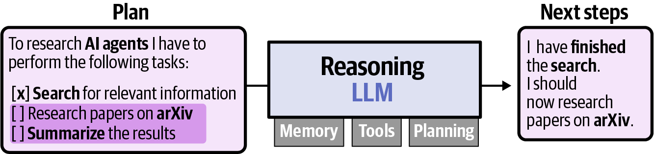
Figure 1-16. After finishing a task, the agent reasons over its current plan to choose the next step, here marking the Google search complete and moving on to research papers on arXiv
But creating a plan is not sufficient. The LLM might discover halfway through its plan that some of its steps might not be appropriate. In our previous example, the LLM would discover that Google and arXiv are insufficient as resources and instead add a task to add Semantic Scholar and PubMed as resources to search.2
By reflecting on past behavior, agents can attempt to uncover their faults and make attempts to fix them. Therefore, the initial plan can be continuously improved. Illustrated in Figure 1-17, planning and reflection create an iterative loop of planning out tasks, taking actions, and reflecting on the output.
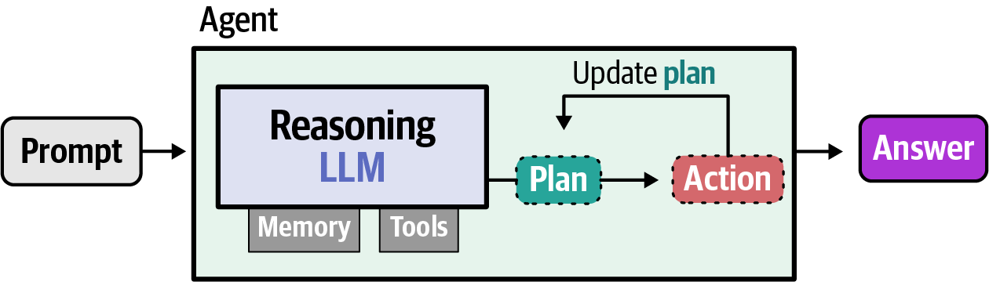
Figure 1-17. Reflection enables the agent to update a plan, often enabling it to adapt to new information uncovered during execution
Together, reasoning LLMs augmented with memory, tools, planning, and reflection are what we consider to be an AI agent. In Chapter 6, we will explore planning and reflection and how they connect all augmentations of the LLM to create the AI agent (Figure 1-18).
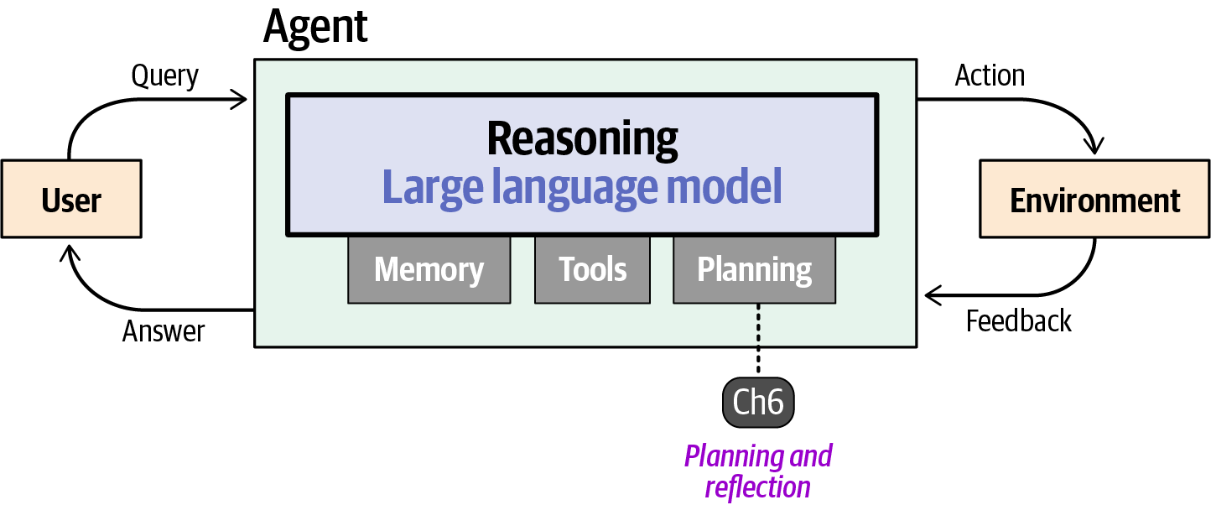
Figure 1-18. Planning and reflection to update plans are key capabilities for agents tackling more difficult problems
An Agentic System
With all these components, a reasoning LLM augmented with memory, tools, and planning, we arrive at the next stage of the agent: the way it behaves inside a system. This covers common use cases, degree of autonomy, ethical considerations, and how these agents and systems can be evaluated.
Autonomy
The AI agent, as we have defined it thus far, has a fair bit of freedom. It can choose between tools, decide to update the initial plan, add additional steps, or stop because it has reached the appropriate response. All of this advanced behavior is the autonomy that is given to the agent. In practice, not all agents will have complete autonomy; guardrails are often necessary so that the model does not take potentially destructive actions (such as deleting important files).
Depending on the AI agent and the system in which it’s integrated, agents can have varying degrees of autonomy. As shown in Figure 1-19, this autonomy can be partial, where the model can execute only a single step but has the freedom to choose from tools, or it can be complete freedom without any guardrails.
Depending on who you ask, a system is more “agentic” the more the LLM has full control over its actions. However, we believe that as long as the agent exhibits goal-directed behavior and makes decisions, we can call it an agent. Autonomy exists on a spectrum, and partial autonomy in orchestrated workflows can still qualify as agency if the agent acts with some degree of independence. Across all chapters, we’ll cover both autonomous systems as well as orchestrated workflows.
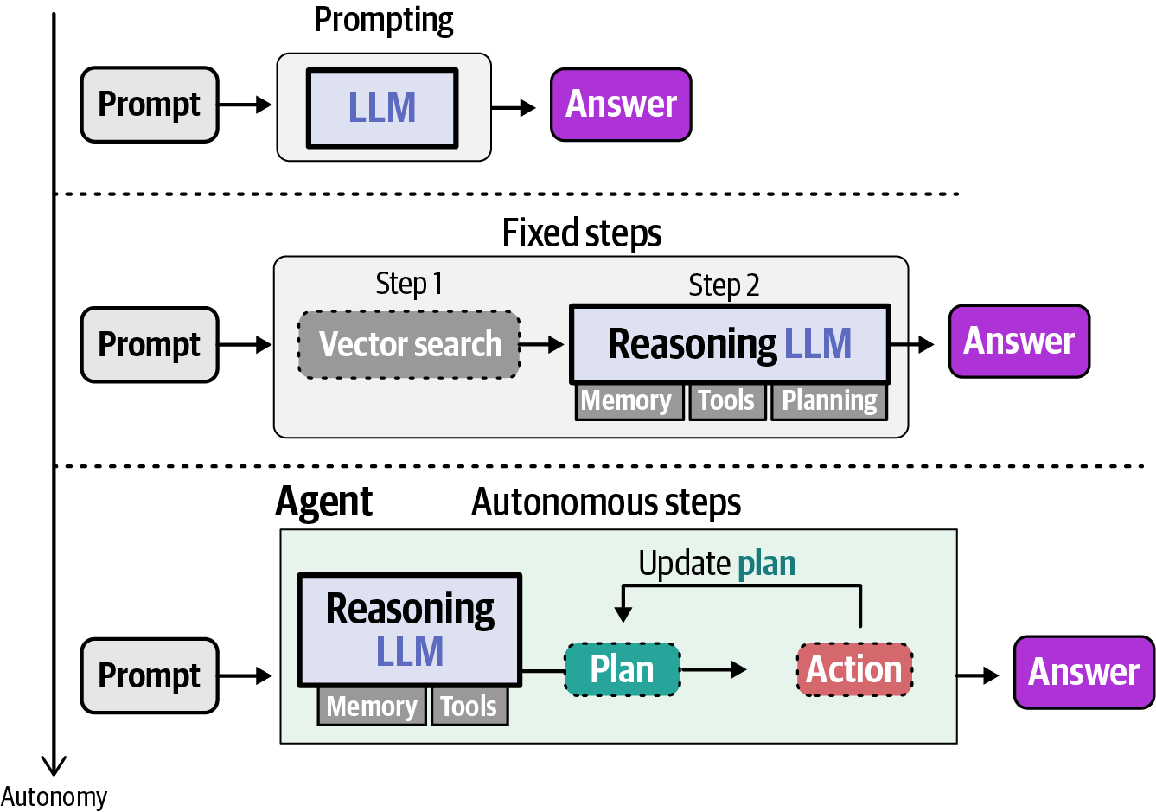
Figure 1-19. AI agents have more autonomy or agency than a single LLM generation or a fixed pipeline
Agentic applications: What makes them so useful?
Agents’ abilities for autonomous behavior make them especially useful for open-ended problems where the exact steps required are not known beforehand. The LLM can reason on how to approach a problem and the number of turns to complete it. This autonomy and self-driving behavior thrives in environments where the goal might be clear, but the path to reach it is not.
As such, agents are often used for the following:
Coding
Coding assistants (such as Antigravity, Claude Code, and Codex) are arguably the most common use case at the time of writing, with companies like Cursor being valued at tens of billions of dollars. With so much knowledge about code, agents are capable of writing it themselves and going through the steps of writing new code but also validating it. This is a use case where the agent truly shines because the goal is quite clear (a specific feature) and often with pre-defined requirements (language, frameworks, etc.) to work toward with some degree of freedom. Problems in the code domain also often benefit from the ability to be automatically verified, which is a useful property at both training and inference time.
Deep research
This is a field where agents are used to perform in-depth analyses on various topics without much intervention by the user. You can ask an agent to research a given topic, and it will, autonomously, search for everything related to that topic on sources such as arXiv, PubMed, and Google Scholar. These agents are not without flaws, but they’re a great starting point whenever you want to dive into a new topic, and they’re gaining popularity across platforms.
Automation
Although you wouldn’t use an agent to diagnose patients or handle claims automatically without any human interaction, there are many useful places where an agent would have a large impact if designed thoughtfully. Standardization and automation of processes are great examples. For instance, hospitals across the world differ in how data is stored (both structured and unstructured). Agents are capable of searching through various data sources to structure the wide array of patient data, allowing for easier research in healthcare.
Responsible agent development and usage
As we explore the incredible capabilities of LLMs, it’s important to keep their societal and ethical implications in mind. This is especially true for agents, which can have a degree of autonomy that might directly impact the digital or physical world. While many think the future of agents is fully autonomous systems, others state that fully autonomous agents should not be developed at all due to the risk of giving away control.3 The field is currently somewhere in the middle. Agents can be amazing entities and help optimize many processes, such as coding agents. However, having an agent diagnose patients without any human intervention is, with the current state of technology, harmful behavior. As with most things, it’s all about the context in which agents are used.4
As such, here are key points to consider:
Human in the loop
As agents become more autonomous, there is a greater need for humans in the loop to authorize, check, and audit the decisions that agents make. This can take many forms, as will be discussed throughout the book, but typically involves a human checking either the output or intermediate steps before continuing.
Guardrails
It’s essential to be careful with the level of autonomy we grant agents. Not only can full autonomy be overkill for the task at hand, but it can often be harmful. A system with many guardrails is often more effective, as it allows steering the agent toward expected behaviors and away from undesired ones.
Misinformation
AI agents are still LLMs, which are prone to confidently generating incorrect information, called hallucinations. Although LLMs are becoming much more capable, additional checks and balances are needed in systems where correct information is critical.
Evaluating agents
Responsible agent development brings us to an important component of building any agent: evaluation. LLMs are already hard to evaluate, usually using benchmarks and scored text outputs, and agents raise the bar further. They reason over multiple steps, call tools, and sequences of actions, so a single quality score for the final text rarely captures whether the agent did its job.
Because an agent acts on its environment instead of producing only text, evaluation has to look at more than the words the agent generates. One lens is the outcome: did the task actually get done, such as the message sent or the record updated? The other is the trajectory: the steps and tool calls the agent took to get there, which can be judged on efficiency and soundness even when the outcome is correct. Chapter 7 treats these as its two main lenses, outcome evaluation and trajectory evaluation.
Two additional properties get dedicated treatment because they don’t surface in a single run. Reliability asks whether an agent succeeds every time, not just once, since its outputs are stochastic. Safety asks whether it avoids harm, whether the risk comes from a malicious user, from manipulated data the agent reads, or from its own mistakes on an ordinary task. Taken together, this is why evaluating an agent is much more than evaluating a model: you are evaluating an entire system.
In Chapter 7 we go deeper on all of this, from reading public benchmarks critically to building an evaluation suite of your own.
The book is organized in two parts: the first covers a single agent on its own, and the second covers what happens when agents work with each other and with the wider world. Together with Chapter 7, Part I will primarily focus on the fundamentals of a single agent, how it’s built, and how it can be evaluated. Part I is visualized in Figure 1-20 and will serve as the common thread throughout Chapter 1 to Chapter 7.
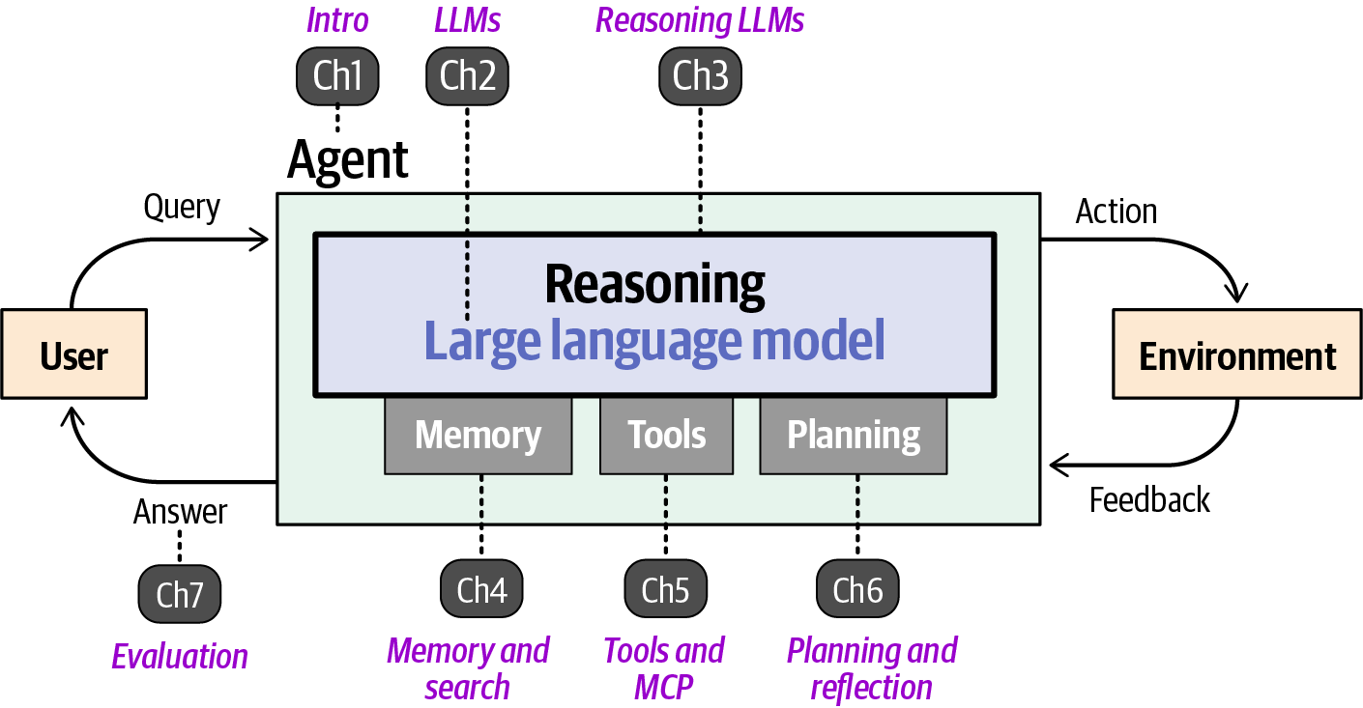
Figure 1-20. Part I covers the major components of a single AI agent
Specializations
The single agent covered in Part I gives you an assistant that, to a certain degree, can autonomously decide how to tackle a given problem. Although it’s already an entity on its own that can achieve amazing results, there are many variants of agents that can take results a step further. Specializations such as multi-modal agents can see the world through more lenses than just text, whereas others, such as coding agents, are created for specific use cases.
In the second part of the book, we’ll explore these specialized agents and their use cases, starting with how systems can be created where multiple agents work together (see Figure 1-21).
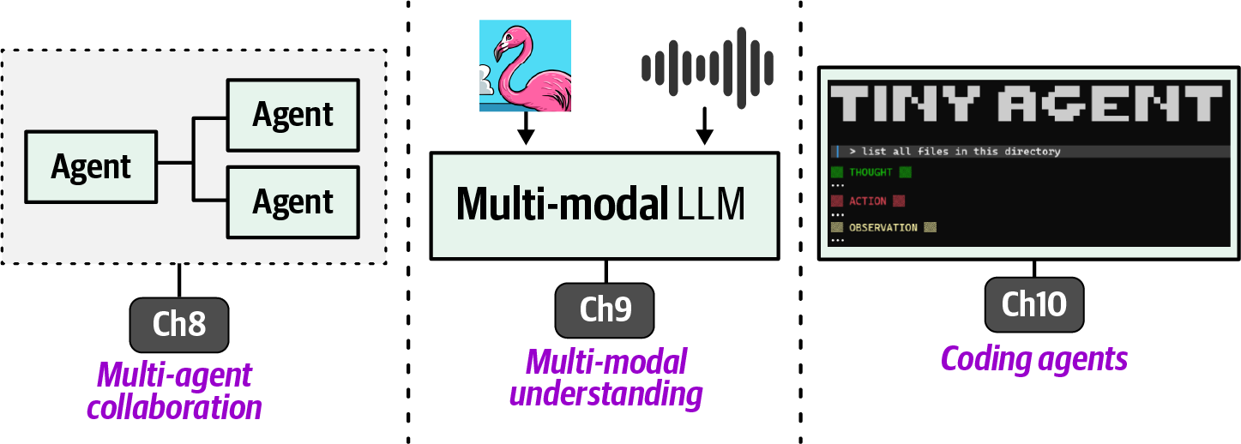
Figure 1-21. Part II of the book covers multi-agent collaboration, multi-modal understanding, and coding agents
Multi-Agent Collaboration
When systems grow larger and tasks are more specialized, we start looking toward multi-agent collaborations. These are systems where multiple different agents are deployed that are each responsible for different tasks. Compared to single-agent systems, multi-agent systems interact with one another and might consult each other’s specialties. The main differences lie in how many agents are deployed and their interactions with one another (Figure 1-22).
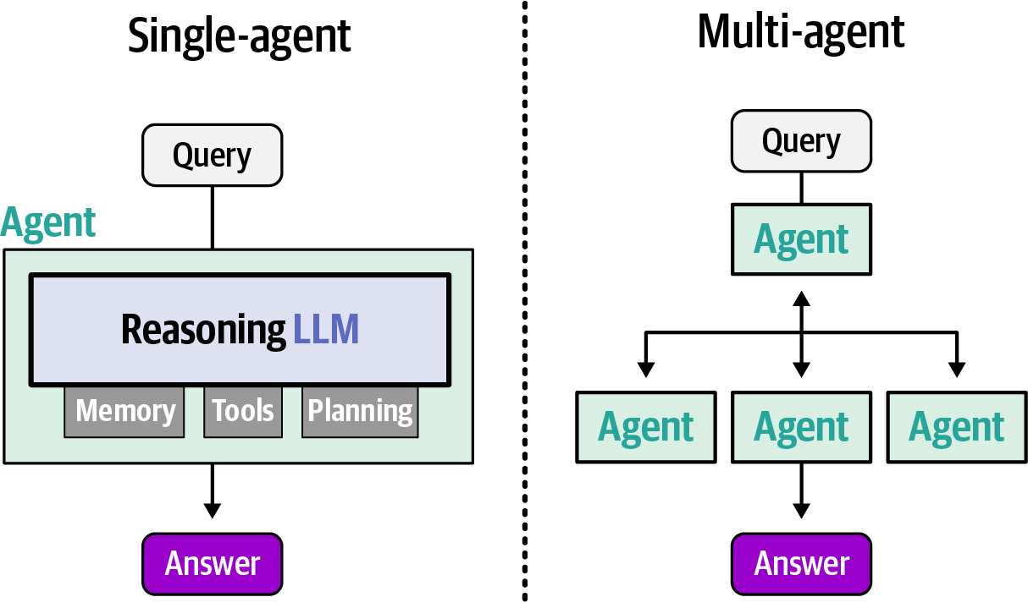
Figure 1-22. Multiple agents can collaborate to solve certain tasks and could achieve better results than those possible by a single agent
These multi-agent systems often contain specialized agents, each equipped with different toolsets. Although workflows may differ, there is often a supervisor agent that manages communication among, and sometimes within, agents. In practice, the supervisor agent tends to have the most capable LLM because the supervisor is in charge of advanced behavior such as planning, decomposing, and assigning tasks (Figure 1-23).
Although the supervisor agent is common, this does not always have to be the case. In practice, there are dozens of multi-agent architectures to explore, some with structured orchestration (like the supervisor) and some with unstructured orchestration.
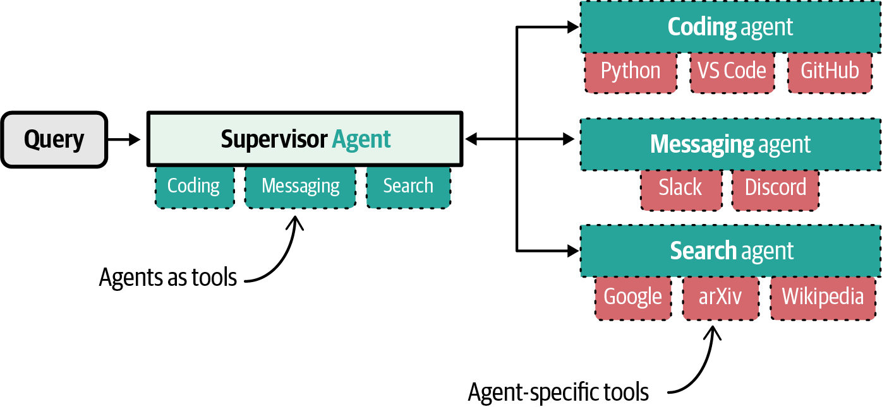
Figure 1-23. One way to design multi-agent collaboration is with a capable supervisor agent delegating tasks to specialized agents each with their own set of relevant tools
In Chapter 8, we explore these multi-agent architectures with concrete examples. You’ll learn how these architectures are created and when they should be used.
The Multi-Modal Agent
Understanding of its environment and the interactions the agent has with it are fundamental to an agent’s behavior. An agent relying on a text-only LLM will do so only through text. The digital world, however, is much more than a place filled with text. An agent might need to optimize the color schemes of your website and will need to “see” it. It can only go so far by reading through the hexadecimal values in your code. Likewise, a traditional agent can reply only in text, but what if the situation requires it to have a voice instead? If your vision deteriorates, or you can’t type because of a repetitive strain injury, being able to talk to your agent through voice becomes necessary. This is where multi-modal agents are gaining traction. The digital world is not composed of a single modality, so interaction with it should not be done only through text.
Whether agents are multi-modal is primarily decided by the nature of their “brains,” namely the LLM. We can consider an agent to be multi-modal if the LLM it uses is capable of processing and/or generating different modalities. This also points us toward the two most important components of what makes an LLM multi-modal—their capabilities for the following:
- Understand multiple modalities
- Generate multiple modalities
When the LLM can reason about several modalities simultaneously, such as text, images, audio, and video, we refer to this multi-modal LLM as being capable of understanding multiple modalities. This can be quite helpful in various situations, such as optimizing a website design, where the LLM needs to be able to “see” what is actually happening. Chapter 9 will explore multi-modal understanding in LLMs through two important components: an encoder for converting modalities into numeric information and a connector to connect those representations to the LLM (Figure 1-24).
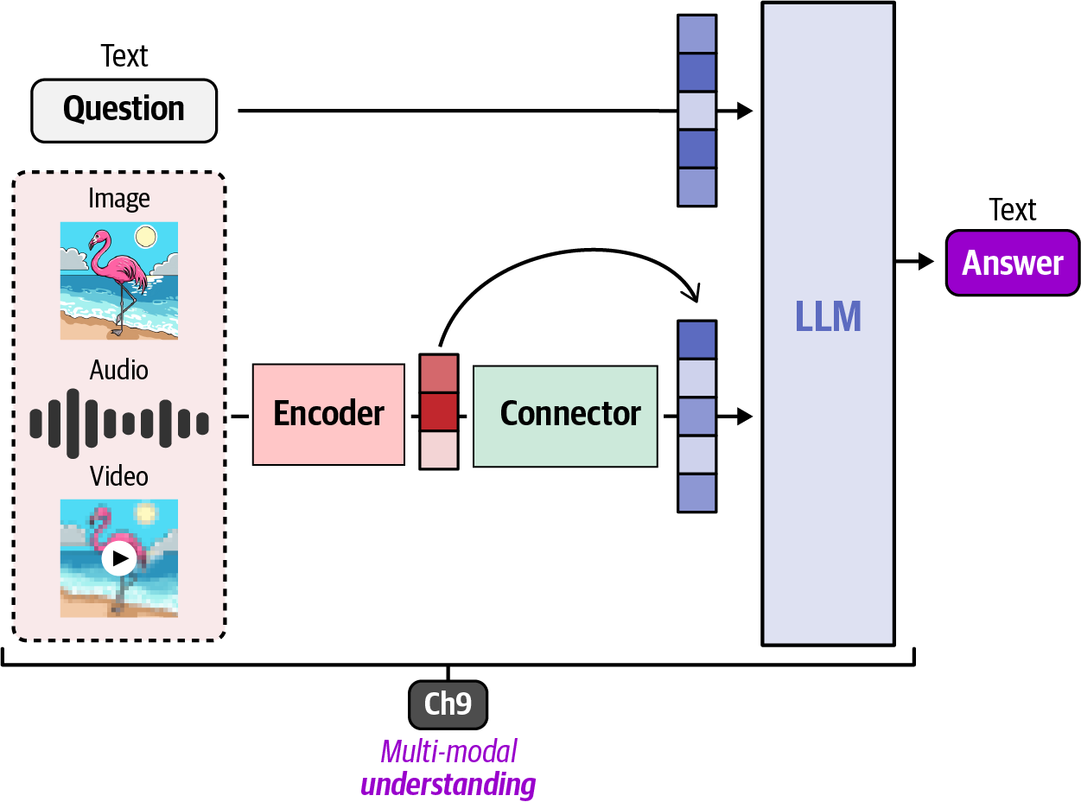
Figure 1-24. AI agents can have better representation of their environments if they can process additional data modalities, such as images, video, and/or audio
For an LLM to generate output in a modality other than text requires a vastly different process than simply understanding multiple modalities. Shown in Figure 1-25, the other side of the process is where a generator is used to generate modalities other than text.
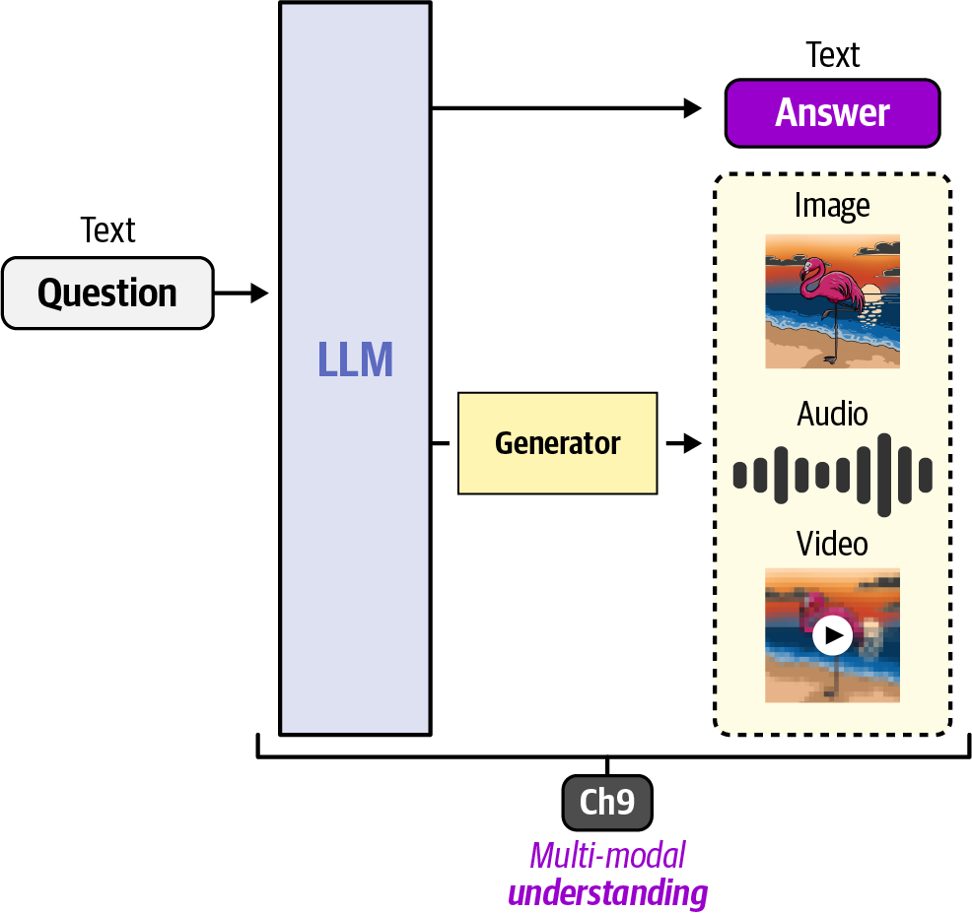
Figure 1-25. Certain multi-modal LLMs can have the capability of generating modalities other than text
The Coding Agent
Another popular variant of agents is the coding agent. Unlike traditional AI assistants, where you have a back-and-forth discussing code, a coding agent can actually run the program in a dedicated environment. Even more, it can read existing codebases, generate new functions, fix bugs, and test what it has created. Increasingly, coding agents are reshaping the nature of software engineering while granting non-software engineers capabilities that would be beyond their reach had they not had access to such agents. This has led to the concept of “vibe coding,” where agents are relied on to build software for non-developers.
Building and using coding agents effectively is the subject of Chapter 10, along with how the underlying code LLMs are trained to power them. Coding benchmarks such as SWE-bench, and how agents are scored on them, are covered in Chapter 7.
The TinyAgent
Although “illustrated” is in the name of this book, wouldn’t it be nice to put some of the principles covered into practice? As you explore various components of AI agents and slowly build up the theoretical foundation of an agent through visuals, you’ll do the same in code.
Specifically, you’ll build up a TinyAgent one step at a time. Using the foundations learned in this book, we’ll explore how to convert them into actual Python code. You can follow along with the notebooks provided in our GitHub repository. There, you’ll find all code along with bonus content that’s not covered in this book. To be able to run this code anywhere, we provided several options to install it as a package, through pip, or uv. This code is what implements the behavior of the TinyAgent and is typically called the agent harness. There are many different types of harnesses that you might come across:
Terminal-based
Agents that run directly in the terminal, such as Claude Code, Gemini CLI, OpenAI Codex CLI, OpenCode, etc.
Code-based
Libraries you write code against to build your own agent, such as LangGraph, Smolagents, Pydantic AI, etc.
Personal assistant
Persistent agents that retain memory and skills across sessions, such as OpenClaw, Hermes Agent, etc.
Hosted
Agents that run in the cloud as a hosted product, such as Replit, v0, Manus, etc.
UI-based
Agents embedded inside a user-friendly interface, such as Antigravity, Cursor, Windsurf, GitHub Copilot, etc.
Note
Interestingly, while writing this overview of agentic harnesses, it feels like this list is already becoming outdated. That’s how fast things can move in this field! So how do you keep up? We believe that as long as you learn the foundations well, it will be easier to navigate new releases, frameworks, and models. After all, all of these harnesses essentially use the same type of agent scaffolding (LLM, memory, tools, etc.). They just flavor them a bit differently.
Note that these harnesses are starting to evolve more into personal assistants. These harnesses focus on making agents persistent and always on. You can chat with your agent via any messaging system (such as WhatsApp, Discord, Slack, or even email) and they can autonomously solve tasks for you. These harnesses tend to give agents the most autonomy, such as checking your email, calendar, personal files, etc.
Arguably, the most famous example is OpenClaw, which gained an astonishing 300,000 stars on GitHub in only a couple of months after its release. OpenClaw is one of the first harnesses that allows users to easily create a persistent personal assistant. Since then, there have been many different alternatives, such as Hermes Agent, that gained popularity (Figure 1-26).
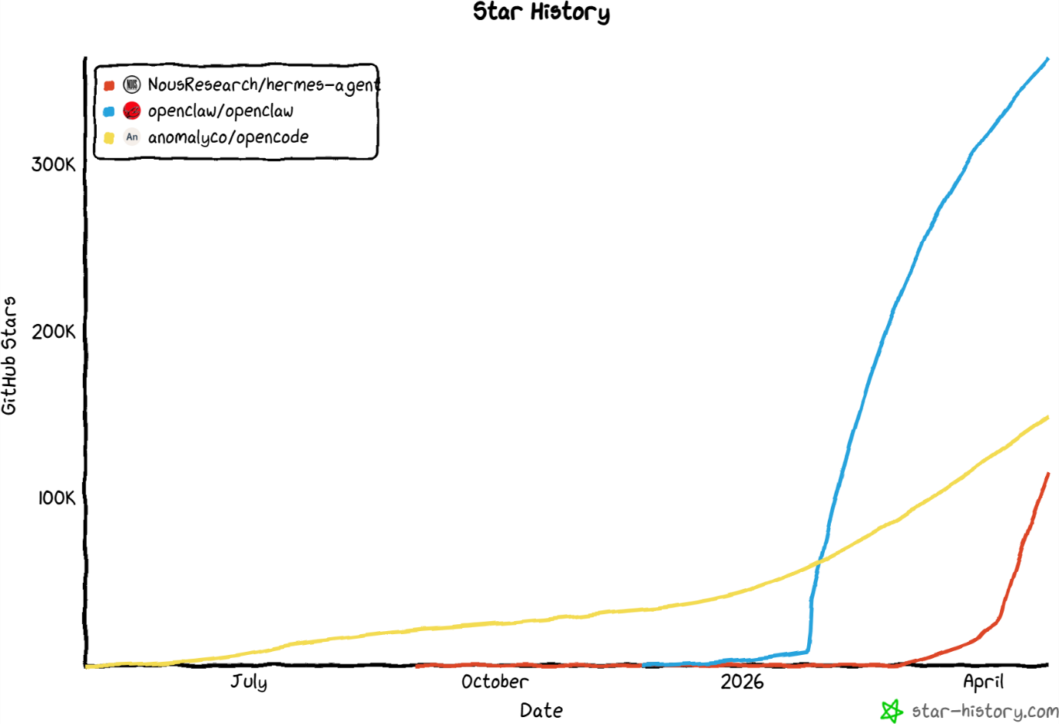
Figure 1-26. The number of stars on GitHub for open source personal assistant harnesses since their release
The harness of the TinyAgent that you’re going to build is mostly code-based and will have a terminal implementation. We focus on the educational nature of this harness and decided that the best way to learn is to build an agent from scratch!
We’re not going to use packages that abstract away the complexities but instead dive deep into them. The TinyAgent will be built with minimal dependencies and we’ll explain everything you implement along the way. To do so, we make use of a highly modular and educational structure that focuses on understanding the vital components of an agent. Figure 1-27 shows some of the components that will be added to the TinyAgent.
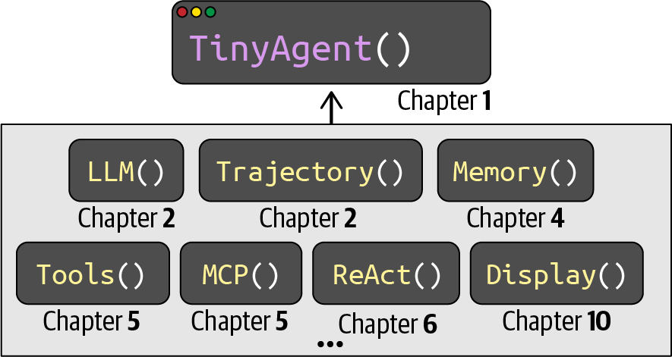
Figure 1-27. A sneak peek into the different modules that we’re going to explore and you’re going to build
In this chapter, you’ll take your first step!
We start with building the TinyAgent class, which is used as the skeleton on which we slowly add components in each chapter. This class is meant to remain small and showcase only the fundamental principles:
class TinyAgent:
"""A minimal, modular, and educational agent framework."""

def __init__(self):
self.llm = None # Chapter 2 & 3: Add LLM
self.memory = None # Chapter 4: Add Memory
self.tools = None # Chapter 5: Add Tools
self.planner = None # Chapter 6: Add Planning

def run(self, task: str) -> str:
"""Run the agent on a task."""
return self._step(task)

def _step(self, task: str) -> str:
"""Perform a single step."""
# Placeholder - will be implemented in later chapters
return f"Received: {task}"

def _execute_action(self, action: str) -> str:
"""Execute a tool action."""
# Placeholder - will be implemented in later chapters
return f"Executed action: {action}"
This scaffolding of the agent does not do anything at the moment other than parroting what you say. The components are as follows:
run
Run the agent on a given task
_step
Perform a single step, which might include an answer or a tool call (Chapter 2)
_execute_action
Execute a single action using a tool (Chapter 5)
Throughout this chapter, you will be able to run your TinyAgent with the following:
agent = TinyAgent()
agent.run("What is 2 + 2?")
Because this (the LLM) is merely a skeleton without a brain, the agent simply returns our question:
'Received: What is 2 + 2?'
The code we explore in this book revolves around a single core entity: building your TinyAgent. Although each chapter is designed to be self-contained, all code across chapters can be run out of order. However, each chapter builds on your TinyAgent and evolves it as you progress through the chapter. The result is essentially a package that you have developed yourself. To track this evolution, at the end of all code in a chapter, we conclude with a summary of what we built. Reviewing this small overview will give you a sense of the changes that were made to your TinyAgent.
What We Built
TinyAgent/
└── agent.py ← New (`TinyAgent` skeleton)
Likewise, as you go through each chapter, your TinyAgent might need some small updates, such as tracking the state of the agent. We have provided various tools that allow you to easily view these differences (or “diffs”) in the illustrated-agents package. We will first explore that in Chapter 2, along with arguably the most important component of an agent, its brain!
Summary
This first chapter serves as the scaffolding of this book. Consider it an overview of what an agent is and how it relates to every upcoming chapter, split up into two main parts.
In Part I, we’ll cover the “brain” of the agent, namely, reasoning LLMs and how they can be augmented with memory, tools, and planning to interact with their environment. They show a degree of autonomy that requires a thorough understanding of the use case to decide when to implement additional guardrails and limit its autonomy or give it full control. This makes evaluation even more important and potentially complex.
In Part II, we will cover various specializations, starting with how agents might interact with each other as specialized entities. Then, we explore how LLMs understand the world through lenses other than text. A special focus will be on images, sound, and video because these are common other modalities the agent might interact with. We end this book with a chapter on coding agents as one of the most common use cases of agentic systems.
In the next two chapters, we’ll cover the fundamentals of LLMs and reasoning LLMs, the “brain” of AI agents.
1 Russell, Stuart and Peter Norvig, Artificial Intelligence: A Modern Approach, 4th ed. (Pearson, 2020).
2 arXiv is an open access archive hosting millions of research papers on computer science and other topics.
3 Mitchell, Margaret et al. 2025. “Fully Autonomous AI Agents Should Not Be Developed.” arXiv, 2502.02649.
4 Gabriel, Iason et al. 2024. “The Ethics o

