NORMAL DISTRIBUTION
A Complete Data Science Field Guide
Understanding, Detecting, Transforming & Applying Distributions

Topics Covered:
✔ What is Normal Distribution & Why It Is Special
✔ Why It Matters in Data Science & Machine Learning
✔ Skewness — Types, Meaning, and Real-World Examples
✔ Kurtosis — Peak Shape, Tail Behavior & What It Tells You
✔ How to Test if Your Data is Normally Distributed
✔ Transformations to Make Non-Normal Data Normal
✔ The "Is Transformation Cheating?" Question Answered
✔ Complex Interview Questions with Detailed Answers

Table of Contents

Section 1: What Is Normal Distribution?

1.1 The Simple Explanation
Imagine you measure the height of 1,000 people. Most people are somewhere in the middle — average height. Very few people are extremely short, and very few are extremely tall. If you draw a bar chart of all these heights, you get a shape that looks like a bell. This is the Normal Distribution — also called the Bell Curve.

📘 Core Idea
A normal distribution is a symmetric, bell-shaped curve where:
• Most values cluster around the centre (the mean)
• Values become progressively rarer as you move away from the centre
• The left and right sides are mirror images of each other

1.2 The Three Magic Properties
A normal distribution has three measures of the "centre" that are all equal:
Measure | What It Is | How It Works
Mean | The mathematical average | Add all values, divide by count
Median | The middle value | Sort data and find the midpoint
Mode | The most frequent value | The peak of the bell curve

✅ Key Insight: Mean = Median = Mode
In a perfect normal distribution, these three values are identical. This symmetry is what makes normal distribution so mathematically beautiful and predictable.

1.3 The 68-95-99.7 Rule (Empirical Rule)
The most powerful property of a normal distribution is how predictable it is. If you know the mean (μ) and standard deviation (σ), you know exactly how data is spread:
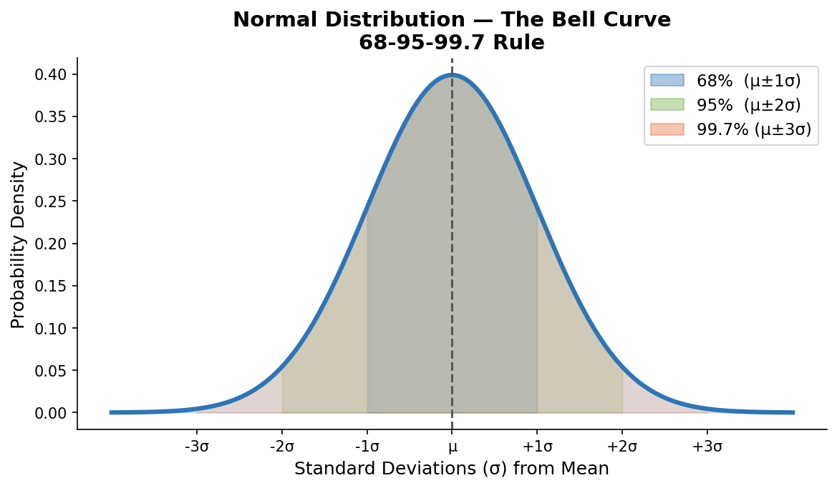
Range | Data Coverage | Real-World Meaning
±1 Standard Deviation | 68% of all data falls here | Out of 1,000 people, ~680 are in this range
±2 Standard Deviations | 95% of all data falls here | Out of 1,000 people, ~950 are in this range
±3 Standard Deviations | 99.7% of all data falls here | Only ~3 in 1,000 are outside this range

1.4 Simple Real-World Examples

Example 1: Human Heights
The average height of adult males in the US is about 5'10" (178 cm) with a standard deviation of about 3 inches.
- 68% of men are between 5'7" and 6'1"
- 95% of men are between 5'4" and 6'4"
- 99.7% of men are between 5'1" and 6'7"
- Being 7'0" tall is extremely rare — nearly 4 standard deviations from the mean

Example 2: Exam Scores
A professor gives an exam. Most students score around 70. Few students fail spectacularly (below 30), and few score perfectly (above 95). The distribution of scores naturally forms a bell curve.

Example 3: Manufacturing
A factory produces bolts that should be 10mm in diameter. Due to tiny variations in machines and materials, some bolts are 9.98mm, some are 10.02mm. These tiny variations follow a normal distribution centred at 10mm.

Section 2: Why Is Normal Distribution Special?

2.1 It Appears Everywhere in Nature
Normal distribution is not just a math concept — it is nature's favourite pattern. It appears in:
- Biology: Heights, weights, blood pressure, IQ scores
- Physics: Measurement errors, thermal noise
- Finance: Daily stock returns (approximately)
- Psychology: Test scores, reaction times
- Engineering: Manufacturing tolerances, signal noise

2.2 The Central Limit Theorem — The Real Magic
⭐ The Central Limit Theorem (CLT)
If you take many random samples from ANY population and calculate the average of each sample, those averages will follow a normal distribution — even if the original data is not normally distributed!

This works when sample size n ≥ 30.

Example: Imagine a dice (clearly not normal — each number 1-6 is equally likely). If you roll a dice 30 times and average the result, and repeat this experiment 1,000 times, the 1,000 averages will form a bell curve!

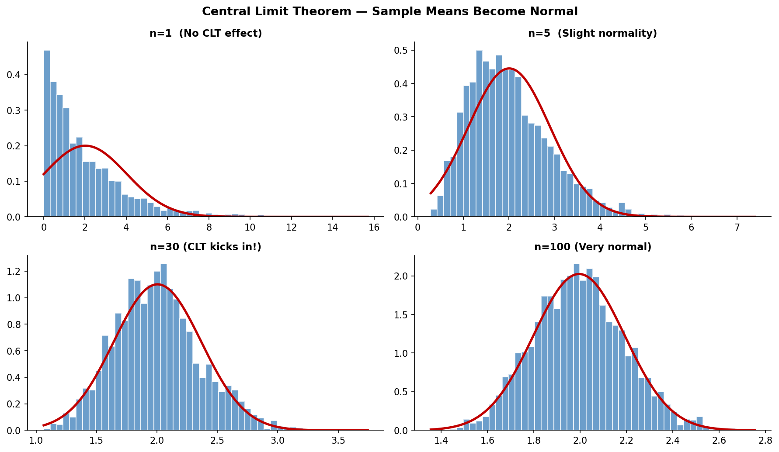
The charts above show this: as sample size increases from n=1 to n=100, the distribution of sample means transforms into a perfect bell curve.

2.3 Mathematical Convenience
Normal distributions have incredibly well-understood mathematical properties:
- The sum of two normal distributions is also normal
- Probabilities can be calculated precisely using Z-scores
- It is completely described by just two numbers: mean and standard deviation
- Most statistical tests (t-tests, ANOVA, linear regression) are built on the assumption of normality

Section 3: Importance in Data Science & Machine Learning

3.1 How Normality Affects Data Cleaning
When data follows a normal distribution, cleaning becomes much more systematic and defensible.

Outlier Detection
With normal data, the 3-sigma rule works perfectly: any value more than 3 standard deviations from the mean is considered an outlier (~0.3% of data). You get a clear, mathematically justified cut-off.

🔍 Example: Detecting Fraudulent Transactions
Average transaction: $45 | Standard deviation: $20
• Normal range: $45 ± 3×$20 = between -$15 and $105
• A transaction of $500 is (500-45)/20 = 22.75 standard deviations away
• This is clearly an outlier → flag as potential fraud

With non-normal data (like income), this rule breaks down — you need robust methods like IQR.

Missing Value Imputation
- Normal data: Impute with mean (it is the most representative value)
- Skewed data: Impute with median (mean is pulled by the tail, misleading)

3.2 How Normality Affects Feature Engineering

Scaling and Standardization
StandardScaler (Z-score normalization) works best on approximately normal features. It centres data at 0 with standard deviation 1. On heavily skewed data, scaling spreads outliers further and distorts model training.

Creating New Features
- Log transforms on skewed features create more informative, balanced features
- Ratio features (e.g., income/expense) are often more normally distributed than raw values
- Interaction features between normal features are easier to interpret

3.3 How Normality Affects Feature Selection
Method | Normality Assumption | What Happens if Violated
Pearson Correlation | Assumes both variables are normally distributed | Works well on normal features; misleading on skewed ones
ANOVA F-test | Assumes normal distribution within groups | Wrong features may be selected if violated
Linear Regression Coefs | Assumes normal residuals | Non-normal → misleading p-values for selection
Chi-Square Test | For categorical data | Less dependent on normality assumptions
Mutual Information | Non-parametric, no normality needed | Good choice for skewed or mixed data

3.4 How Normality Affects Algorithm Choice
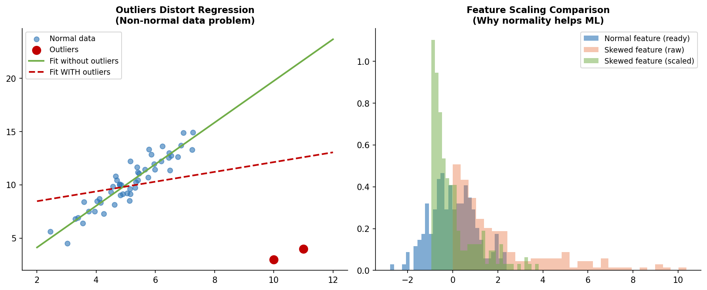
Algorithm | Normality Assumption | Effect if Data Is Not Normal
Linear / Logistic Regression | Assumes normal residuals (not features) | Coefficient estimates unreliable; confidence intervals wrong
Naive Bayes (Gaussian) | Explicitly assumes Gaussian features | Severely wrong predictions if features are skewed
Linear Discriminant Analysis (LDA) | Assumes normally distributed classes | Poor class separation if violated
Decision Trees / Random Forests | No normality assumption | Works well on any distribution
SVM with RBF Kernel | Benefits from scaled, near-normal features | Works but may train slower on very skewed data
Neural Networks | No assumption, but scales help | Benefits from normalized inputs
K-Means Clustering | Assumes spherical (normal-like) clusters | Clusters may be meaningless on skewed data
K-Nearest Neighbours | No assumption, but scaling required | Distance metrics distorted by skewed features

💡 Quick Decision Rule
• If algorithm assumes normality (linear models, LDA, Naive Bayes) → transform skewed features first
• If algorithm is distribution-free (trees, forests, boosting) → skewed data is fine, but scaling may still help
• Always check residuals after fitting, not just input features

Section 4: Skewness — What Is It and What Does It Tell You?

4.1 The Simple Explanation
Skewness measures how asymmetric your data is — how much does it lean to one side? A perfectly normal distribution has zero skewness. Think of skewness as measuring the "tail" of your data: which direction does the tail pull?

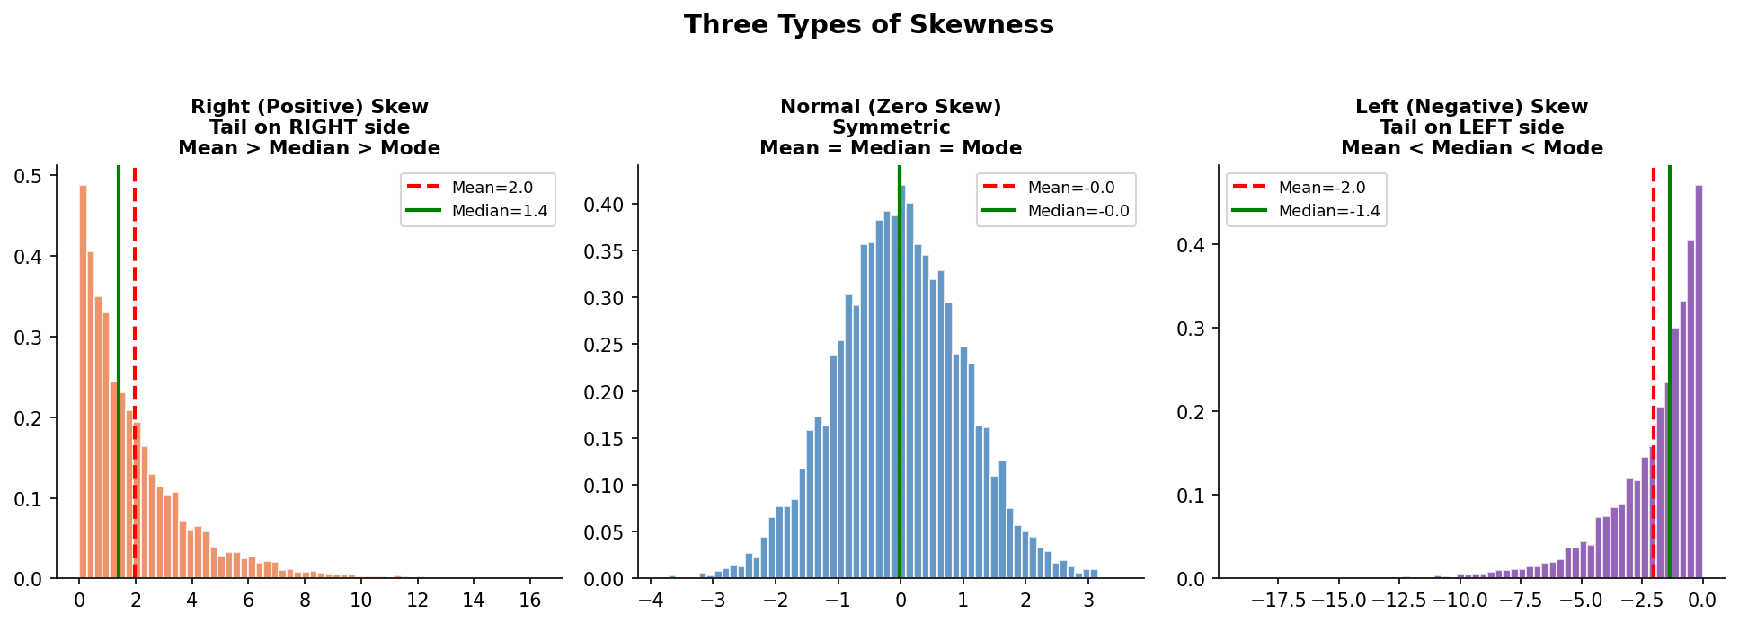

4.2 The Three Types of Skewness

Type 1: Zero Skew (Normal / Symmetric)
🔵 Zero Skewness (Skewness ≈ 0)
What it looks like: Perfectly balanced bell curve. No tail in either direction.
What it tells you: Data is symmetric. Mean = Median = Mode.

Example: Heights of adult men in the same country.
Example: IQ scores across a large population.
Example: Error measurements in a calibrated instrument.

Type 2: Positive Skew (Right Skew)
➡ Positive / Right Skewness (Skewness > 0)
What it looks like: The right tail is longer. Most values are on the left, but a few very high values stretch to the right.
What it tells you: Mean > Median > Mode. Outliers are pulling the mean to the right.

Example: Income in a country — most people earn moderate salaries, but a few billionaires pull the average WAY up.
• Median income (what the "typical person" earns): $55,000
• Mean income (pulled up by billionaires): $95,000
• The mean makes the average American look richer than most actually are!

Example: Property prices in a city with one ultra-luxury neighbourhood.
Example: Social media post shares — most posts get few shares, viral posts get millions.
Example: Medical expenses — most people spend little, but a few with chronic illness spend enormously.

Type 3: Negative Skew (Left Skew)
⬅ Negative / Left Skewness (Skewness < 0)
What it looks like: The left tail is longer. Most values are on the right (high side), but a few very low values stretch to the left.
What it tells you: Mean < Median < Mode. Outliers are pulling the mean to the left.

Example: Age at retirement — most people retire around 60-65 (clustered on the right), but some retire early (pulling the tail left).

Example: Exam scores in an easy test — most students score 80-100, but a few who did not study score very low.
• Mode: 90 (most common score)
• Median: 85
• Mean: 78 (pulled down by the handful who scored 10-20)

Example: Life expectancy in a developing country with high infant mortality.
• Most people who survive childhood live to 60-70+
• But high infant deaths create a left tail of very young ages

4.3 Skewness Values — What the Number Means
Skewness Value | Interpretation | Action Required
Less than -1 | Highly negatively skewed | Strong left tail — transform data
-1 to -0.5 | Moderately negatively skewed | Consider transformation
-0.5 to +0.5 | Approximately symmetric | Treat as approximately normal
+0.5 to +1 | Moderately positively skewed | Consider transformation
Greater than +1 | Highly positively skewed | Strong right tail — transform data

4.4 Python Code to Calculate Skewness
import pandas as pd
import numpy as np
from scipy import stats

# Create example data
salaries = np.random.lognormal(mean=10.5, sigma=0.8, size=1000)

# Method 1: Using pandas
skew_pandas = pd.Series(salaries).skew()
print(f"Skewness (pandas): {skew_pandas:.3f}")

# Method 2: Using scipy
skew_scipy = stats.skew(salaries)
print(f"Skewness (scipy): {skew_scipy:.3f}")

# Interpret the result
if abs(skew_scipy) < 0.5:
print("✅ Approximately symmetric — treat as normal")
elif abs(skew_scipy) < 1:
print("⚠️ Moderate skew — transformation may help")
else:
print("❌ High skew — transformation recommended")

Section 5: Kurtosis — What Shape Is the Peak?

5.1 The Simple Explanation
If skewness tells you about the lean (left or right), kurtosis tells you about the shape of the peak and the thickness of the tails. Is the peak very sharp and thin? Or is it flat and wide? Are there many extreme values (fat tails) or few (thin tails)?

🏔 Easy Analogy for Kurtosis
Imagine a mountain:
• Leptokurtic = Mount Everest — very sharp, pointy peak with heavy foothills (fat tails)
• Mesokurtic = A normal rolling hill — standard bell shape
• Platykurtic = A plateau — flat top, thin tails

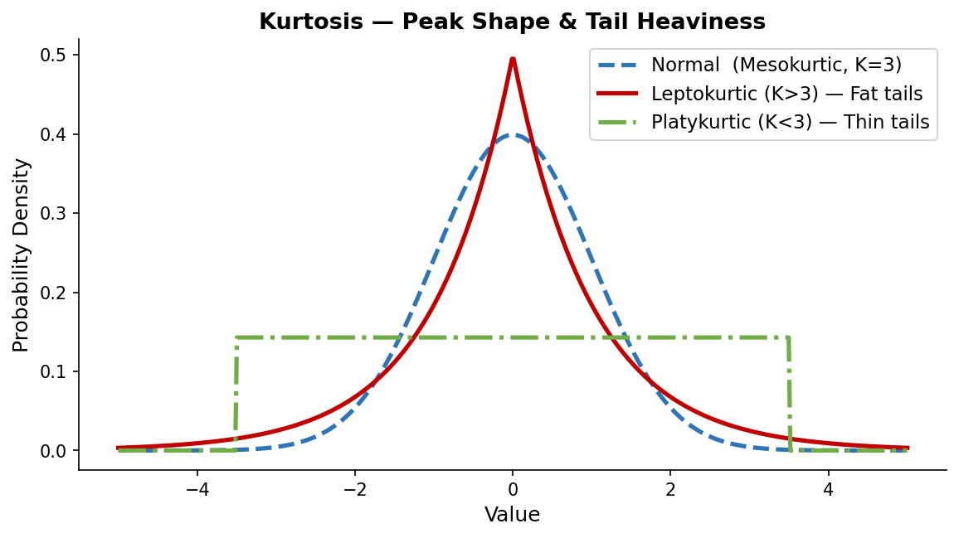

5.2 The Three Types of Kurtosis

Mesokurtic — The Baseline (Kurtosis = 3, Excess = 0)
This is the normal distribution itself. Used as the reference point. All other kurtosis values are compared to this.
- Example: Heights of adult men
- Example: IQ scores

Leptokurtic — Sharp Peak, Fat Tails (Kurtosis > 3, Excess > 0)
📈 Leptokurtic: "More extreme values than expected"
What it means: A sharper, taller peak AND heavier tails than normal distribution.
In plain English: Most values are extremely close to the average, BUT extreme outliers are more common.

Example 1: Daily stock market returns.
• On 99% of days, stock prices barely move (sharp peak at zero return)
• But occasionally there are crashes (-30%) or surges (+20%) — the fat tails
• This is why the 2008 financial crisis was a "100-year event" that happened multiple times in 20 years
• Normal distribution models would say these crashes are impossible — fat tails say they happen!

Example 2: Insurance claims.
• Most claims are small and predictable (the sharp peak)
• But catastrophic events (hurricanes, earthquakes) create extreme claims — fat tails
• If an insurer uses a normal distribution model, they will be UNDERPREPARED for disasters

Platykurtic — Flat Peak, Thin Tails (Kurtosis < 3, Excess < 0)
📉 Platykurtic: "Fewer extreme values than expected"
What it means: A flatter, shorter peak AND thinner tails than normal distribution.
In plain English: Values are more uniformly spread out. Extreme outliers are rare.

Example 1: Rolling a fair dice.
• All values (1-6) are equally likely — very flat distribution
• No sharp peak anywhere, and values cannot go beyond 1 or 6 (thin tails)

Example 2: Age of customers at a theme park.
• Customers are spread fairly evenly from children (5) to adults (65)
• No single age dominates — flat distribution

Example 3: Grades on a standardized test in a district where teachers teach to the test.
• Most students cluster in a wide band of acceptable scores
• Few very high or very low extremes — the tails are compressed

5.3 Kurtosis Values — What the Number Means
Kurtosis Value | Type | Practical Meaning
< 3 (Excess < 0) | Platykurtic | Flat peak, thin tails, fewer outliers than normal. Uniform-like distributions.
= 3 (Excess = 0) | Mesokurtic | Normal distribution. The baseline reference.
> 3 (Excess > 0) | Leptokurtic | Sharp peak, fat tails, more outliers than expected. Common in finance.
> 10 (Excess > 7) | Extreme Leptokurtic | Extremely fat tails. Catastrophic outlier risk. Check for data errors or fraud.

⚠ Excess Kurtosis vs Raw Kurtosis
Most software (Python scipy, pandas) reports EXCESS kurtosis = Raw Kurtosis - 3.
• scipy.stats.kurtosis() → returns EXCESS kurtosis (normal = 0)
• A value of 0 means perfectly normal
• Positive = leptokurtic | Negative = platykurtic

5.4 Python Code for Kurtosis
from scipy import stats
import numpy as np

# Generate example data
stock_returns = np.random.laplace(loc=0, scale=0.01, size=10000) # Fat tails like stocks

# Calculate kurtosis (excess kurtosis by default in scipy)
kurt = stats.kurtosis(stock_returns)
print(f"Excess Kurtosis: {kurt:.3f}")

if kurt > 1:
print("Leptokurtic: Fat tails — watch out for extreme events!")
elif kurt < -1:
print("Platykurtic: Thin tails — fewer extreme values")
else:
print("Mesokurtic: Similar tail behaviour to normal distribution")

Section 6: How to Check if Data Is Normally Distributed
There are four levels of normality testing, from quick visual inspection to rigorous statistical tests. Always use multiple methods — no single test tells the whole story.

6.1 Method 1: Histogram with KDE
The simplest check: plot your data and see if it looks like a bell curve.
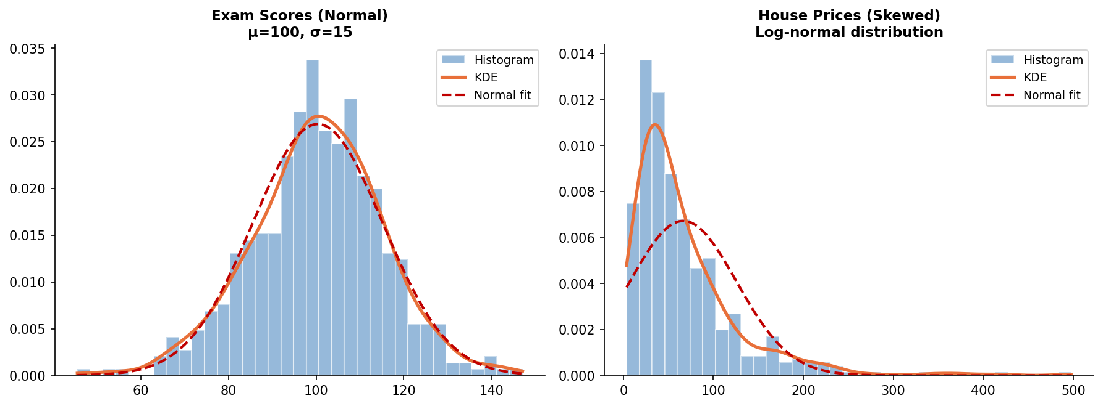
What to look for in a Histogram:
✅ Bell-shaped curve: symmetric, single peak in the middle → likely normal
❌ Multiple peaks: bimodal or multimodal → definitely not normal
❌ Long tail on one side: skewed distribution
❌ Flat shape: uniform or platykurtic distribution

import matplotlib.pyplot as plt
import numpy as np
from scipy.stats import gaussian_kde, norm

def check_normality_visual(data, title="My Feature"):
fig, ax = plt.subplots(figsize=(8, 4))

# Histogram
ax.hist(data, bins=30, density=True, alpha=0.6, color="steelblue", label="Data")

# KDE (smooth estimate of actual distribution)
kde = gaussian_kde(data)
x_range = np.linspace(data.min(), data.max(), 300)
ax.plot(x_range, kde(x_range), color="orange", lw=2, label="KDE (actual)")

# Normal fit (what it WOULD look like if normal)
mu, sigma = data.mean(), data.std()
ax.plot(x_range, norm.pdf(x_range, mu, sigma), color="red",
lw=2, linestyle="--", label="Normal fit (expected)")

ax.set_title(f"{title} | Skew={data.skew():.2f}")
ax.legend()
plt.tight_layout()
plt.show()

6.2 Method 2: Q-Q Plot (Quantile-Quantile Plot)
A Q-Q plot compares your data's quantiles against what a normal distribution's quantiles would be. If data is normal, the points fall on a straight diagonal line.
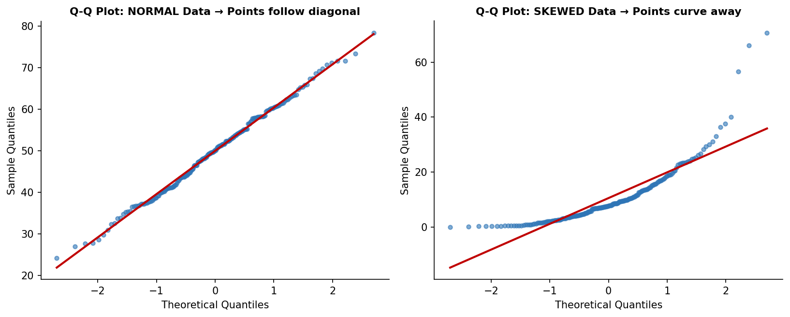
📊 Reading a Q-Q Plot:
✅ Points closely follow the red diagonal line → data is approximately normal
❌ S-shaped curve: data has heavier tails than normal (leptokurtic)
❌ Upward curve on right: right-skewed distribution
❌ Downward curve on left: left-skewed distribution
❌ Staircase pattern: discrete data (not continuous)

import scipy.stats as stats
import matplotlib.pyplot as plt

def qq_plot(data, title="Q-Q Plot"):
fig, ax = plt.subplots(figsize=(6, 5))
(osm, osr), (slope, intercept, r) = stats.probplot(data, dist="norm")
ax.plot(osm, osr, "o", color="steelblue", alpha=0.5, markersize=4)
ax.plot(osm, slope * np.array(osm) + intercept, "r-", lw=2)
ax.set_xlabel("Theoretical Quantiles")
ax.set_ylabel("Sample Quantiles")
ax.set_title(f"{title}\nR²={r**2:.4f}")
plt.tight_layout()
plt.show()

6.3 Method 3: Statistical Tests for Normality
Test | Best Used When | How It Works
Shapiro-Wilk | Best for small samples (n < 50) | W statistic + p-value. p > 0.05 → cannot reject normality
D'Agostino-Pearson | Best for medium to large samples (n > 50) | Combines skewness + kurtosis tests into one
Kolmogorov-Smirnov | For large samples or comparing distributions | Compares empirical CDF to theoretical CDF
Anderson-Darling | Sensitive to tail behaviour | Better at detecting non-normality in tails
Jarque-Bera | Used heavily in finance/econometrics | Based on skewness and kurtosis combined

⚠ Important: What "p > 0.05" Means in Normality Tests
For normality tests, we WANT a HIGH p-value (p > 0.05):
• p > 0.05: "We cannot reject normality" → data may be normal
• p ≤ 0.05: "We REJECT the null hypothesis of normality" → data is NOT normal

Warning: With very large samples (n > 1000), these tests detect even tiny, meaningless deviations from normality.
Always combine statistical tests with visual inspection!

from scipy import stats
import numpy as np

def full_normality_check(data, feature_name="Feature"):",
print(f"\n=== Normality Check: {feature_name} ===")
print(f"Sample size: {len(data)}")
print(f"Skewness: {stats.skew(data):.4f}")
print(f"Kurtosis: {stats.kurtosis(data):.4f} (excess)")

# Shapiro-Wilk (best for n < 2000)
if len(data) <= 2000:
stat, p = stats.shapiro(data)
print(f"Shapiro-Wilk: W={stat:.4f}, p={p:.4f} — {"NORMAL" if p > 0.05 else "NOT normal"}")

# DAgostino-Pearson
stat, p = stats.normaltest(data)
print(f"D'Agostino: stat={stat:.4f}, p={p:.4f} — {"NORMAL" if p > 0.05 else "NOT normal"}")

# Anderson-Darling
result = stats.anderson(data)
print(f"Anderson-Darling: stat={result.statistic:.4f}")
for cv, sl in zip(result.critical_values, result.significance_level):
print(f" Significance {sl}%: critical={cv:.3f} — {"NORMAL" if result.statistic < cv else "NOT normal"}")

Section 7: How to Convert Non-Normal Data to Normal
When your data is skewed or non-normal, you can apply mathematical transformations to make it more normal. The choice of transformation depends on the direction of skewness and the nature of the data.

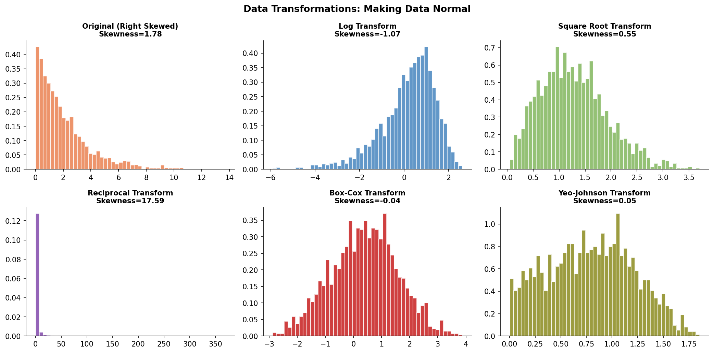

7.1 Log Transformation — Most Common
📐 Log Transformation: log(x)
Best for: Right-skewed data with large positive values.
Requirement: All values must be POSITIVE (> 0). If data has zeros, use log(x + 1).

Real-world use cases:
• Income / salary data
• House prices
• Population sizes
• Website traffic counts
• Any data that grows exponentially

import numpy as np
import pandas as pd

# Example: Transforming salary data
salaries = np.array([30000, 35000, 42000, 55000, 70000, 200000, 500000, 1200000])

# Standard log transform
log_salaries = np.log(salaries)

# If data has zeros: use log(x + 1)
salaries_with_zeros = np.array([0, 1000, 5000, 50000])
log1p_salaries = np.log1p(salaries_with_zeros) # np.log1p is log(1+x)

# In pandas:
df["log_salary"] = np.log(df["salary"])

7.2 Square Root Transformation
√ Square Root Transform: √x
Best for: Moderately right-skewed data. Gentler than log transform.
Requirement: All values must be NON-NEGATIVE (≥ 0).

Real-world use cases:
• Count data (number of customer complaints)
• Poisson-distributed data
• Moderate skew that log over-corrects
# Square root transform
complaints = np.array([0, 1, 2, 5, 8, 25, 100])
sqrt_complaints = np.sqrt(complaints)

# For negative data: use cube root instead
cube_root = np.cbrt(data) # Works with negative values too

7.3 Box-Cox Transformation
⚙ Box-Cox Transform
A powerful, flexible family of transforms that automatically finds the best power (λ).
Requirement: All values must be STRICTLY POSITIVE (> 0).

How it works: Tests many values of λ and picks the one that makes data most normal.
• λ = 0: This becomes a log transform
• λ = 0.5: This becomes a square root transform
• λ = 1: No transformation (original data)
• λ = -1: Reciprocal (1/x) transform
from scipy.stats import boxcox
from scipy.special import inv_boxcox

# Apply Box-Cox (finds best lambda automatically)
transformed_data, best_lambda = boxcox(house_prices)
print(f"Best lambda (λ): {best_lambda:.4f}")

# To reverse the transform (get back original scale):
original_back = inv_boxcox(transformed_data, best_lambda)

7.4 Yeo-Johnson Transformation
🔧 Yeo-Johnson Transform
Works like Box-Cox but ALSO handles zero and negative values.
Requirement: Works on any real-valued data.

Use this instead of Box-Cox when your data contains zeros or negative numbers.
This is implemented in sklearn's PowerTransformer.
from sklearn.preprocessing import PowerTransformer
import numpy as np

# Works with zeros AND negative values
data_with_negatives = np.array([-5, -2, 0, 1, 3, 10, 50, 200])

pt = PowerTransformer(method="yeo-johnson") # or "box-cox" for positive only
transformed = pt.fit_transform(data_with_negatives.reshape(-1, 1))

# To reverse the transformation:
original = pt.inverse_transform(transformed)

7.5 Choosing the Right Transformation
Situation | Recommended Transform | Examples
Right skewed, all positive | Log transform: log(x) | Salary, prices, populations
Right skewed, has zeros | Log(x+1) or Square root | Count data, website visits
Moderate right skew | Square root: √x | Complaint counts, distances
Any skew, all positive | Box-Cox (auto-optimised) | General purpose for positive data
Any skew, zeros or negatives | Yeo-Johnson (auto-optimised) | Temperature change, financial returns
Left skewed | Square, cube, or reflect+log | Test scores in easy tests
Bimodal (two peaks) | Cannot fix with transform | Check if data has two subgroups

Section 8: Is Transforming Data "Cheating"? Does It Give Wrong Results?
🤔 This Is One of the Most Important Questions in Applied Statistics
The short answer: No, transformation is NOT cheating — IF done correctly and interpreted correctly.
The long answer: Read on. This is nuanced and critical to understand.

8.1 What Transformation Actually Does
A transformation does NOT change the data or make up fake information. It changes the SCALE on which you view the data. The actual ordering and relationships between data points remain intact.

🌡 Analogy: Changing Units Is Not Cheating
Imagine you measure temperature in Celsius. Converting to Fahrenheit does not change reality — you just view the same data on a different scale.

Similarly, when we take log(salary), we are not changing who earns more — we are just changing the scale to make differences more symmetric and visible.

8.2 Salary Example — Worked Through Step by Step
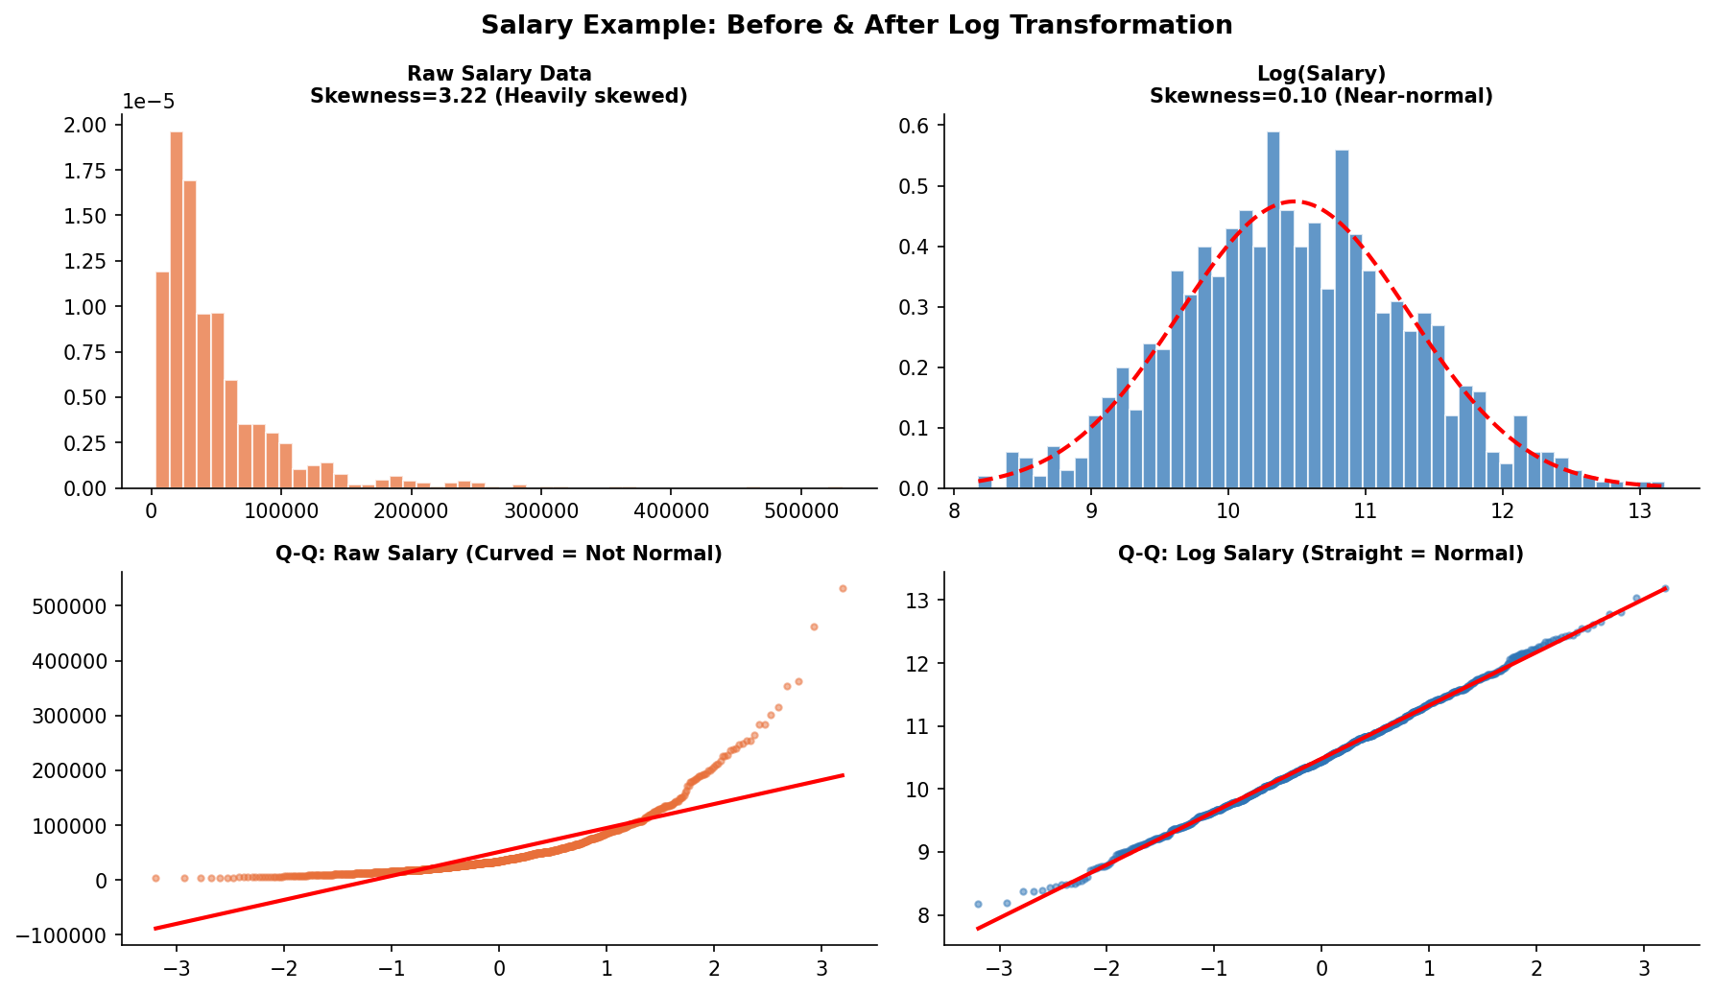

The Original Problem
You have salary data: [30,000, 35,000, 40,000, 45,000, 50,000, 250,000, 500,000, 2,000,000]
- Mean salary: $368,750 (pulled up by 3 high earners)
- Median salary: $47,500 (what the "typical" person earns)
- A linear regression on this data would have TERRIBLE residuals — outliers dominate the model

After Log Transformation
Log values: [10.3, 10.5, 10.6, 10.7, 10.8, 12.4, 13.1, 14.5]
- Now the distribution is symmetric and normal
- Regression works perfectly
- The REAL-WORLD meaning: on the log scale, $30k vs $300k is the same "distance" as $300k vs $3M
- This makes intuitive sense! We think of salary differences in percentages, not absolute dollars

💡 Key Insight: Transformation Reveals a Different Truth
The raw salary data says "$250,000 is 5 times better than $50,000".
The log-transformed data says "$250,000 is a step up from $50,000".

Neither is wrong — they answer DIFFERENT questions.
Raw scale: "How many absolute dollars difference?"
Log scale: "What percentage / multiplicative change?"

For most human decisions (and many statistical models), the log (multiplicative) relationship is more meaningful.

8.3 House Price Prediction — A Complete Example

Scenario
You want to predict house prices using linear regression. House prices are heavily right-skewed (few mansions at very high prices).

# BEFORE transformation — Problem
# Training data: mostly houses $200k-$500k, a few mansions at $5M-$10M

# Result without transformation:
# - The model is dominated by the mansions (they have huge residuals)
# - The model learns to predict based on mansion features
# - For average $300k houses, predictions are terrible

# AFTER log transformation — Solution
import numpy as np
from sklearn.linear_model import LinearRegression

# Transform target variable
df["log_price"] = np.log(df["price"])

# Train model on log scale
model = LinearRegression()
model.fit(X_train, df["log_price"])

# Predict and convert back to original scale
log_predictions = model.predict(X_test)
price_predictions = np.exp(log_predictions) # Reverse the log

# The model now treats all houses fairly — a $10k error on a $100k house
# is treated the same as a $100k error on a $1M house (proportionally)

8.4 When Does Transformation Give Wrong Information?
❌ Transformation CAN mislead if you:
❌ Forget to inverse-transform predictions before reporting them
(e.g., report log($) instead of actual $)

❌ Apply the wrong transform (e.g., log on left-skewed data — makes it worse)

❌ Interpret a log-scale coefficient as a linear one
(a coefficient of 0.5 in log-space means 50% increase, not $0.50 more)

❌ Transform when the skew is caused by data quality issues
(e.g., data entry error of $999,999 when actual is $9,999)
→ Fix the data issue first, do not just transform it away

❌ Transform categorical or count data with many zeros using log
→ log(0) is undefined; use appropriate count models instead

8.5 The Golden Rule of Transformations
✅ Golden Rule: Transform → Model → Inverse-Transform → Interpret

Step 1: Transform your skewed data (e.g., log(x))
Step 2: Build and evaluate your model in the transformed space
Step 3: Inverse-transform all predictions back to the original scale (e.g., exp(prediction))
Step 4: Communicate results in the original, interpretable scale

Example: Model predicts log(salary) = 11.2
→ Inverse: exp(11.2) = $73,130 — this is the actual predicted salary.

The transformation is a tool, not a final destination.

Section 9: Quick Reference Cheat Sheet

9.1 Summary of All Concepts
Concept | Definition / Property | Example / Context
Normal Distribution | Bell-shaped, symmetric curve. Mean = Median = Mode. | 68-95-99.7 rule; basis for most statistical tests
Right (Positive) Skew | Long tail on the right. Mean > Median > Mode. | Income, house prices, viral metrics
Left (Negative) Skew | Long tail on the left. Mean < Median < Mode. | Retirement ages, easy exam scores
Zero Skew | Symmetric. Mean = Median = Mode. | Heights, IQ scores, measurement errors
Leptokurtic | Sharp peak, fat tails. Excess kurtosis > 0. | Stock returns, insurance claims
Platykurtic | Flat peak, thin tails. Excess kurtosis < 0. | Dice rolls, uniform distributions
Mesokurtic | Normal kurtosis. Excess kurtosis = 0. | The baseline normal distribution
Log Transform | log(x). Great for right skew, all-positive data. | Salary, prices, populations
Box-Cox | Auto-finds best power transform. Positive data only. | General purpose positive data
Yeo-Johnson | Like Box-Cox but handles zeros + negatives. | Financial returns, temp changes
Shapiro-Wilk | Normality test for small samples (n < 50). | p > 0.05 → likely normal
Q-Q Plot | Visual normality test. Points on diagonal = normal. | Always use alongside statistical tests
Central Limit Theorem | Sample means become normal regardless of original distribution. | n ≥ 30 rule of thumb

Section 10: Complex Interview Questions & Answers
These are real-world, conceptual questions that test deep understanding — not just memorisation.

Q1: "Your feature has a skewness of 2.5. Should you always transform it before using it in a model? What factors would you consider?"
💬 Strong Answer:
Not necessarily — it depends on the algorithm and what the skewness represents.

Factors to consider:
1. Algorithm choice: If using a tree-based model (Random Forest, XGBoost), skewness usually does not matter — these models split on thresholds and are scale-invariant. No transformation needed.

2. Algorithm choice (continued): If using linear regression, logistic regression, or Gaussian Naive Bayes, high skewness will violate assumptions and degrade performance. Transform.

3. Is skewness real or caused by data issues? Check for: data entry errors, wrong units, mixing two populations. Fix data issues before transforming.

4. Does the skewness have meaning? Income data is skewed because income IS skewed in reality. The skew is not noise — it is a real feature. A log transform here makes sense because log(income) is more meaningful (percentage changes) than raw income.

5. Sample size: With small samples, apparent skewness may just be sampling noise.

Conclusion: Always check algorithm requirements first. If transformation is needed, prefer Box-Cox or Yeo-Johnson as they auto-optimize.

Q2: "Explain how Central Limit Theorem makes normal distribution practically useful even when data is not normally distributed."
💬 Strong Answer:
The CLT is arguably the most important theorem in applied statistics. It states that the sampling distribution of the mean approaches normality as sample size increases, regardless of the underlying population distribution.

Practical implications:

1. Hypothesis testing: When we run a t-test comparing average revenue between two groups, we are comparing SAMPLE MEANS — not individual values. Even if revenue is highly skewed, the sampling distribution of the mean is approximately normal (for n ≥ 30). This is why t-tests work so broadly.

2. Confidence intervals: Standard error-based intervals rely on the CLT. We can construct valid 95% CIs for skewed data as long as sample size is adequate.

3. A/B testing at scale: When an e-commerce site tests two versions, user purchase amounts are extremely skewed (most spend $0, a few spend $500+). But with millions of users, CLT makes the test means normally distributed, making standard z-tests valid.

4. Limitation: CLT requires n ≥ 30 as a rule of thumb, but heavily skewed or heavy-tailed distributions (like leptokurtic ones) may need n ≥ 200+ for the approximation to hold.

Q3: "You log-transform your target variable and train a regression model. The RMSE on the log scale is 0.15. How do you report model accuracy to a business stakeholder who wants to know accuracy in dollars?"
💬 Strong Answer:
This is a critical practical question. You cannot report RMSE of 0.15 to a business person — it means nothing to them.

Step 1: Understand what RMSE on log scale means
• RMSE of 0.15 on log scale ≈ predictions are off by about 15-16% on average (since e^0.15 ≈ 1.16)
• This is the approximate percentage error

Step 2: Convert predictions back and compute dollar error
predictions_log = model.predict(X_test)
predictions_dollars = np.exp(predictions_log) # or np.expm1 if used log1p
actual_dollars = np.exp(y_test_log)

dollar_rmse = np.sqrt(mean_squared_error(actual_dollars, predictions_dollars))
dollar_mape = np.mean(np.abs(actual - pred) / actual) * 100 # % error

Step 3: Report appropriately to stakeholders
"Our model predicts house prices with an average error of ±$24,000, which represents approximately 8% of the typical house price."

Key warning: NEVER report the naive RMSE from log scale — predictions_log will be much smaller numbers (like 11-13 for log of $100K-$400K) and the dollar-scale RMSE will be much larger. Always inverse-transform before computing business metrics.

Q4: "A financial risk model assumes normally distributed returns. In 2008, the model said a loss this large was a "25-sigma event" (basically impossible). What went wrong and how would you fix it?"
💬 Strong Answer:
This is a classic real-world failure of the normality assumption — known as the "fat tails" problem.

What went wrong:
1. Financial returns are NOT normally distributed. They are leptokurtic (fat tails) — extreme events happen far more frequently than a normal distribution predicts.

2. A 25-sigma event in a normal distribution has probability of essentially zero — you would need to wait longer than the age of the universe to see it. But in reality, 10-sigma-equivalent crashes happen every decade.

3. Correlations also break down in crises. The model assumed assets were somewhat independent. In 2008, everything crashed together — correlation went to 1. This is called "tail dependence."

How to fix it:
1. Use fat-tailed distributions: Student's t-distribution (with low degrees of freedom), or Stable distributions that explicitly model fat tails.

2. Use Extreme Value Theory (EVT): Specifically models the behaviour of tail events rather than the entire distribution.

3. Stress testing with historical scenarios: Do not rely on parametric distributions alone. Test against actual historical crises (2008, 2000 dot-com, 1987 Black Monday).

4. Model tail dependence using copulas: Separate marginal distributions from the dependency structure.

5. Limit kurtosis risk: Require that any risk model reports Expected Shortfall (CVaR) not just Value-at-Risk (VaR) — CVaR explicitly accounts for tail losses.

Q5: "In a data science project, you are asked to impute missing values in a salary column that is right-skewed. Your colleague suggests using the mean. Do you agree?"
💬 Strong Answer:
No — for right-skewed salary data, using the mean for imputation is a poor choice.

Why mean imputation fails on skewed data:
• Example: Salary data with values [30k, 35k, 40k, 45k, 50k, 500k, 2M]
• Mean = $385,714 — pulled up massively by 2 high earners
• But 5 out of 7 people earn between $30k-$50k
• Imputing missing values as $385k makes them look like high earners
• This distorts downstream models and analyses

Better alternatives for skewed data:
1. Median imputation: Use $45,000 — much more representative of the "typical" employee

2. Conditional median: Even better — compute median within subgroups (e.g., median salary by job level or department)

3. Model-based imputation (KNN, MICE): Most sophisticated — uses other features to predict the missing salary

4. Log-scale mean: Transform to log scale, impute the mean on the log scale, then back-transform. This gives the geometric mean, which is more appropriate for multiplicative/proportional data like salaries.

Follow-up consideration: Always check if data is Missing At Random (MAR) vs Missing Not At Random (MNAR). If high earners systematically hide their salary, any simple imputation introduces bias.

Q6: "Shapiro-Wilk test gives p = 0.03 on your 500,000 row dataset. Your histogram looks like a perfect bell curve. What is happening and what do you do?"
💬 Strong Answer:
This is a common and important pitfall: statistical significance vs. practical significance.

What is happening:
• With n = 500,000 rows, the Shapiro-Wilk test has enormous statistical POWER
• It can detect even trivially tiny deviations from normality — like a skewness of 0.01
• Even a perfect bell curve has some sampling noise; with 500k rows, that noise becomes statistically significant
• The p-value tells you "this is not a PERFECT normal distribution" — which is true of almost every real dataset

What to do:
1. Trust your visual inspection (histogram, Q-Q plot) over the p-value for large samples

2. Check the actual skewness and kurtosis values: if skewness is -0.05 and kurtosis excess is 0.12, the deviation from normality is practically irrelevant

3. Use effect size, not just p-value: For normality, check if skewness is within ±0.5 and excess kurtosis within ±1 as practical thresholds

4. General principle: With very large samples, statistical tests always reject — use domain knowledge, visualisation, and practical thresholds

5. For model assumptions: Run your model and check RESIDUALS for normality (which is what linear regression actually requires), not the input features

Appendix: Complete Python Code Templates

A.1 Full Normality Analysis Pipeline
import numpy as np
import pandas as pd
import matplotlib.pyplot as plt
import scipy.stats as stats
from sklearn.preprocessing import PowerTransformer

def full_distribution_analysis(series, name="Feature"):
"""
Complete normality analysis for a pandas Series or numpy array.
Returns dictionary of all statistics and a 4-panel diagnostic plot.
"""
data = np.array(series.dropna()) if hasattr(series, "dropna") else np.array(series)

# === Step 1: Descriptive Stats ===
report = {
"name": name,
"n": len(data),
"mean": data.mean(),
"median": np.median(data),
"std": data.std(),
"skewness": stats.skew(data),
"kurtosis": stats.kurtosis(data), # excess kurtosis
}

# === Step 2: Interpret skewness ===
sk = report["skewness"]
report["skew_label"] = ("Highly right-skewed" if sk > 1 else
"Moderately right-skewed" if sk > 0.5 else
"Approximately symmetric" if abs(sk) <= 0.5 else
"Moderately left-skewed" if sk > -1 else
"Highly left-skewed")

# === Step 3: Statistical tests ===
if len(data) <= 5000:
stat, p = stats.shapiro(data[:5000])
report["shapiro_p"] = p
report["shapiro_normal"] = p > 0.05

stat, p = stats.normaltest(data)
report["dagostino_p"] = p
report["dagostino_normal"] = p > 0.05

# === Step 4: Suggest transformation ===
if abs(sk) < 0.5:
report["recommendation"] = "No transformation needed"
elif sk > 0.5 and (data > 0).all():
report["recommendation"] = "Try log or Box-Cox transform"
elif sk > 0.5:
report["recommendation"] = "Try Yeo-Johnson transform"
else:
report["recommendation"] = "Try square, cube, or reflect+log"

# === Step 5: Print Summary ===
sep = "=" * 50
print(f"\n{sep}")
print(f"Distribution Analysis: {name}")
print(sep)
for k, v in report.items():
print(f" {k}: {v}")

return report

A.2 Auto-Transform Pipeline for Machine Learning
from sklearn.preprocessing import PowerTransformer, FunctionTransformer
from sklearn.pipeline import Pipeline
import numpy as np
from scipy import stats

def auto_transform(X_train, X_test, skew_threshold=0.5):
"""
Automatically identifies and transforms skewed features.
Returns transformed train/test sets and a list of applied transforms.
"""
X_train_out = X_train.copy()
X_test_out = X_test.copy()
transformers = {}

for col in X_train.select_dtypes(include=np.number).columns:
sk = stats.skew(X_train[col].dropna())

if abs(sk) < skew_threshold:
transformers[col] = "none"
continue

# Choose method based on data characteristics
has_negative = (X_train[col] <= 0).any()
method = "yeo-johnson" if has_negative else "box-cox"

pt = PowerTransformer(method=method)
X_train_out[col] = pt.fit_transform(X_train[[col]])
X_test_out[col] = pt.transform(X_test[[col]])
transformers[col] = (method, pt)

new_sk = stats.skew(X_train_out[col])
print(f"{col}: {sk:.2f} → {new_sk:.2f} ({method})")

return X_train_out, X_test_out, transformers

End of Document — Normal Distribution: A Complete Data Science Field Guide

