COMPLETE STATISTICS REFERENCE GUIDE
Distributions · Hypothesis Testing · Statistical Inference

Simple Language | Real-World Examples | Common Misconceptions | When to Use Each Method

Topics covered: t-Distribution · Binomial Distribution · Chi-Square Distribution · A/B Testing
Hypothesis Tests · Statistical Significance · p-Values · t-Tests · ANOVA · Chi-Square Tests

Chapter 1: Student's t-Distribution

1.1 What Is the t-Distribution?
The Student's t-distribution is a bell-shaped probability curve that looks like the normal distribution — but with heavier tails. It was invented by William Sealy Gosset in 1908, who published under the pseudonym 'Student' (hence the name). He was working at a Guinness Brewery testing the quality of stout beer with small samples!

The BIG question it answers: You want to test a hypothesis about a population mean, but you have a SMALL sample (< 30) and you DON'T know the true population standard deviation. What do you do?

Answer: Use the t-distribution instead of the normal distribution. It gives wider intervals to account for the extra uncertainty from estimating the standard deviation.

1.2 Degrees of Freedom — The Most Important Concept
Degrees of freedom (df) = how many values in your data are FREE to vary after you have calculated certain statistics.

Simple formula: df = n - 1 (where n = sample size)

Why n-1? Once you calculate the sample mean, only n-1 of your data points can vary freely. The last one is determined by the constraint that values must average to the mean.

Simple Analogy for Degrees of Freedom
Imagine 5 friends agree their lunch bills must average $20. If 4 of them pay $15, $18, $22, and $25, the 5th friend's bill is FIXED at $20 — it cannot vary. So df = 5-1 = 4. Only 4 people were truly 'free' to choose.

How df Changes the Shape
The fewer the degrees of freedom, the heavier the tails — meaning extreme values are more likely. As df increases (larger sample), the t-distribution approaches the normal distribution:

Degrees of Freedom (df) | Sample Size (n) | What it means | Compared to Normal
df = 1 | n = 2 | Extremely small sample | Very heavy tails — almost no certainty
df = 3 | n = 4 | Very small sample | Heavy tails — significant uncertainty
df = 10 | n = 11 | Small sample | Moderate difference from normal
df = 30 | n = 31 | Reasonably sized | Almost identical to normal
df > 100 | n > 101 | Large sample | Practically identical to normal

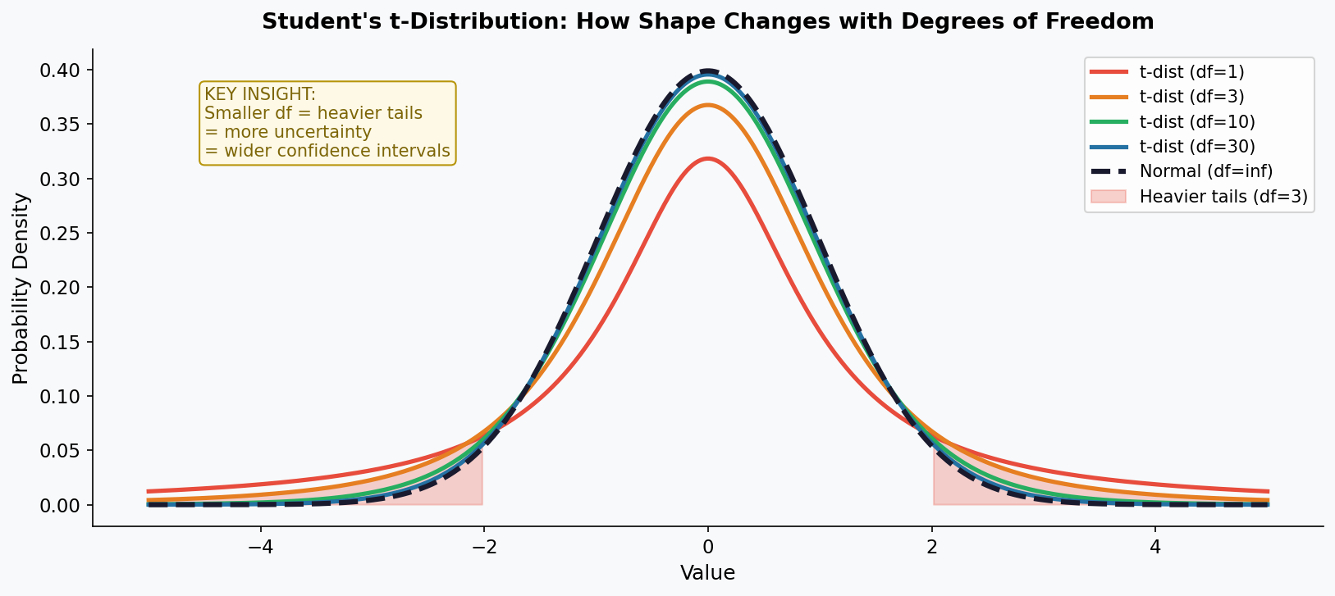

1.3 Confidence Intervals Using the t-Statistic
A confidence interval (CI) is a range of values that we believe contains the true population mean with a certain level of certainty. The t-distribution is used when the sample is small.

Formula:
CI = Sample Mean ± t*(df, alpha/2) × (Standard Deviation / sqrt(n))

t*(df, alpha/2) = the critical t-value from the t-table. For 95% CI with df=10: t* = 2.228. For df=30: t* = 2.042. For normal: z* = 1.96.

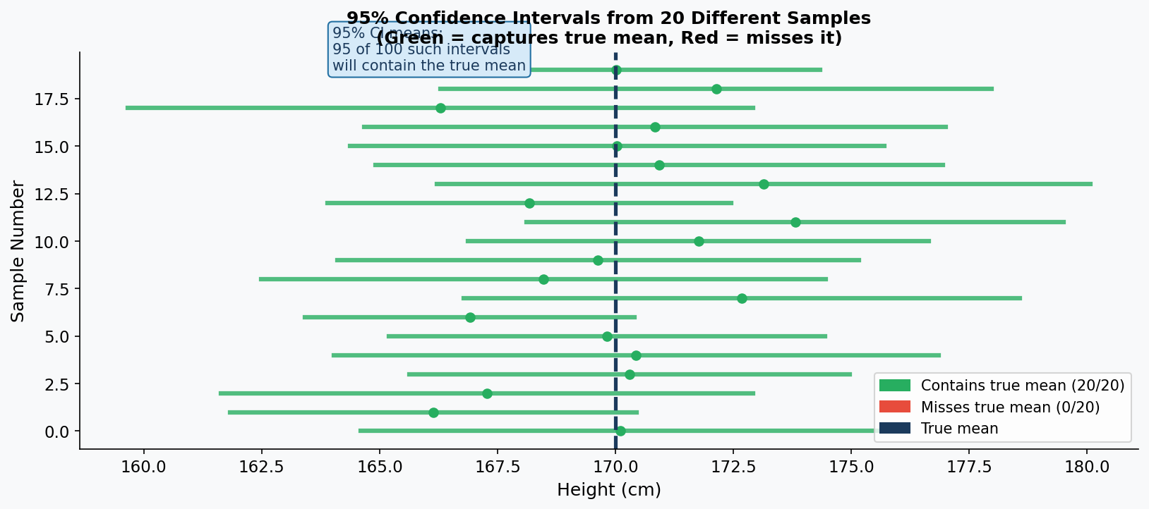

KEY INSIGHT from the chart above: A 95% CI does NOT mean 'there is a 95% chance the true mean is in THIS interval.' The interval is either right or wrong. It means: if you built 100 such intervals from 100 different samples, about 95 of them would contain the true mean.

1.4 Real-World Scenario — Quality Control at a Chocolate Factory
Real-World Scenario: Chocolate Bar Weight Check
A factory claims each chocolate bar weighs 100g. A quality inspector takes a random sample of 10 bars and measures: 98, 101, 99, 102, 97, 103, 100, 98, 101, 99 grams.
Sample mean = 99.8g, Sample SD = 1.87g, n = 10 → df = 9
Question: Is there enough evidence that bars weigh significantly less than 100g?
t-statistic = (99.8 - 100) / (1.87 / sqrt(10)) = -0.338
With df=9, the critical t-value at alpha=0.05 (one-tailed) = -1.833
Since -0.338 > -1.833, we FAIL to reject H0. The bars are fine — the small difference is just random variation.
If the mean were 98g: t = (98-100)/(1.87/sqrt(10)) = -3.38, which IS < -1.833 → Reject H0. Now we'd call the factory!

1.5 When to Use the t-Distribution
Situation | Use t-Distribution? | Why
Small sample (n < 30), unknown population SD | YES — always | Normal distribution underestimates uncertainty
Large sample (n > 100), unknown population SD | Technically yes, but normal is fine | t and normal are almost identical for large n
Known population SD (rare in practice) | NO — use z-distribution | No need to estimate SD, so less uncertainty
Comparing two group means (small samples) | YES — two-sample t-test | See Chapter 7 on t-Tests
Before-and-after measurements (paired data) | YES — paired t-test | Removes individual variation from the equation

1.6 What NOT to Confuse With — Misconceptions

MISCONCEPTION / MYTH | REALITY / TRUTH
The t-distribution is just a smaller, weaker version of the normal distribution. | The t-distribution is actually more appropriate than the normal distribution when your sample is small. It is BETTER, not weaker — it honestly captures the extra uncertainty that comes from small samples. Using the normal distribution with small samples gives FALSELY narrow confidence intervals.

MISCONCEPTION / MYTH | REALITY / TRUTH
Once my sample is above 30, I should always switch to the normal distribution. | The threshold of 30 is a rough rule of thumb, not a law. Many statisticians recommend using the t-distribution by default for any mean-testing, since it handles all sample sizes correctly and becomes identical to normal for large samples anyway. Most software uses t by default.

Chapter 2: Binomial Distribution

2.1 What Is the Binomial Distribution?
The Binomial distribution models the number of successes in a fixed number of independent trials where each trial has only two possible outcomes: SUCCESS or FAILURE. Think of it as counting how many times something happens in repeated yes/no experiments.

Real examples:
- Number of heads in 10 coin flips (heads = success)
- Number of patients who respond to a drug out of 50 treated
- Number of defective products in a batch of 100
- Number of customers who click an ad out of 1000 who see it
- Number of students who pass a test out of 30 in a class

2.2 The Four Required Conditions (B-I-N-S)
Letter | Condition | Example | If violated...
B | Binary outcomes: Only two possible results per trial | Each patient either recovers (1) or does not (0) | Use a different distribution (multinomial)
I | Independent trials: Result of one trial does not affect others | One patient recovering does not change others' chances | Cannot use binomial — trials are correlated
N | Number of trials is fixed: Decided before the experiment | We will test exactly 20 patients, not until 5 recover | Use Negative Binomial distribution instead
S | Same probability: p stays constant for every trial | Each coin flip has exactly 50% chance of heads | Binomial is only approximate — not exact

2.3 The Formula and Parameters
Two parameters define everything:
n = number of trials (how many times you repeat the experiment)
p = probability of success on each trial (stays constant)

P(X = k) = C(n,k) × p^k × (1-p)^(n-k)

In plain English: Probability of getting exactly k successes = (ways to choose k from n) × (probability of k successes) × (probability of n-k failures)

Mean = n × p | Variance = n × p × (1-p) | SD = sqrt(n × p × (1-p))

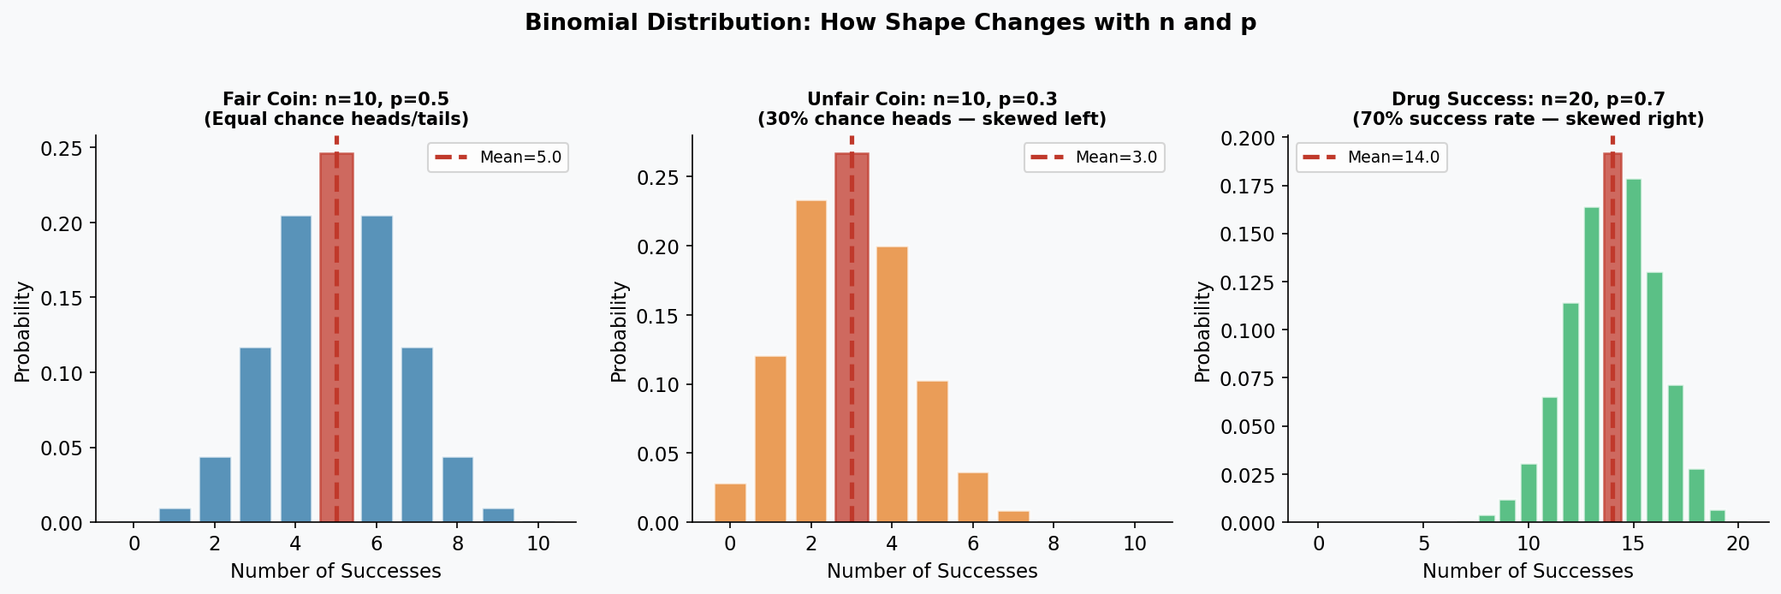

2.4 Three Detailed Examples
Example 1: Drug Clinical Trial
A new drug has a 40% success rate (p=0.4). A doctor gives it to 15 patients (n=15). What is the probability that exactly 8 patients respond?

Step | Calculation | Result
Identify parameters | n=15, p=0.4, k=8 | Fixed
Calculate C(15,8) | 15! / (8! × 7!) = 6435 | Number of ways to choose 8 from 15
Calculate p^k | 0.4^8 = 0.000655 | Prob of 8 successes
Calculate (1-p)^(n-k) | 0.6^7 = 0.02799 | Prob of 7 failures
Final probability | 6435 × 0.000655 × 0.02799 | P(X=8) = 0.118 = 11.8%

Example 2: Quality Control
A factory produces widgets with a 5% defect rate (p=0.05). A box contains 20 widgets (n=20). What is the probability of 0 defects?
P(X=0) = C(20,0) × 0.05^0 × 0.95^20 = 1 × 1 × 0.358 = 35.8%
What about at most 1 defect? P(X ≤ 1) = P(X=0) + P(X=1) = 0.358 + 20 × 0.05 × 0.95^19 = 0.358 + 0.377 = 73.5%

Example 3: Website Conversion Rate
Real-World Scenario: E-Commerce A/B Testing
Your website has a 3% conversion rate (p=0.03). You show your ad to 100 visitors (n=100).
Expected conversions = n×p = 100 × 0.03 = 3 customers (mean)
Variance = 100 × 0.03 × 0.97 = 2.91 → SD = 1.71
P(0 conversions) = 0.97^100 = 0.048 — About 5% chance nobody buys.
P(at least 5 conversions) = 1 - P(X ≤ 4) ≈ 18.5%
Business insight: If you see 10 conversions from 100 visitors, p-value < 0.001 — your rate has likely improved!

2.5 When to Use the Binomial Distribution
USE Binomial when:  - Exactly two outcomes per trial  - Fixed number of trials  - Each trial is independent  - Same probability for each trial  Examples: Pass/Fail tests, coin flips, defect counts, election votes, drug responses | DON'T use Binomial when:  - More than 2 outcomes (use Multinomial)  - Trials are not independent  - Probability changes between trials (e.g., sampling without replacement from small population)  - Counting time between events (use Poisson or Exponential)

2.6 Common Misconceptions

MISCONCEPTION / MYTH | REALITY / TRUTH
Binomial is only for 50/50 situations like coin flips. | Binomial works for ANY probability p between 0 and 1. p=0.01 (very rare events), p=0.7 (likely events), p=0.3 (moderately rare) — all are valid. The shape just becomes skewed when p is far from 0.5.

MISCONCEPTION / MYTH | REALITY / TRUTH
If I flip a coin 10 times and get 8 heads, the next flip is more likely to be tails (the 'gambler's fallacy'). | Each flip is INDEPENDENT. Past outcomes do not change future probabilities. The coin has no memory. P(heads) is always exactly 0.5 on every single flip, regardless of history. The gambler's fallacy is one of the most dangerous misconceptions in probability.

Chapter 3: Chi-Square Distribution

3.1 What Is the Chi-Square Distribution?
The Chi-Square (chi²) distribution is what you get when you square and add together multiple independent standard normal variables. Unlike the normal or t distributions, it is always positive and right-skewed (never goes below zero). It is the foundation for testing whether observed data matches what we would expect.

Chi-Square = Z1² + Z2² + Z3² + ... + Zk²

Where each Z is a standard normal variable. The number of Z-values added = Degrees of Freedom (df)

Three main uses: (1) Goodness-of-Fit Test: Does observed data match expected distribution? (2) Test of Independence: Are two categorical variables related? (3) Variance Testing: Is a population variance equal to a claimed value?

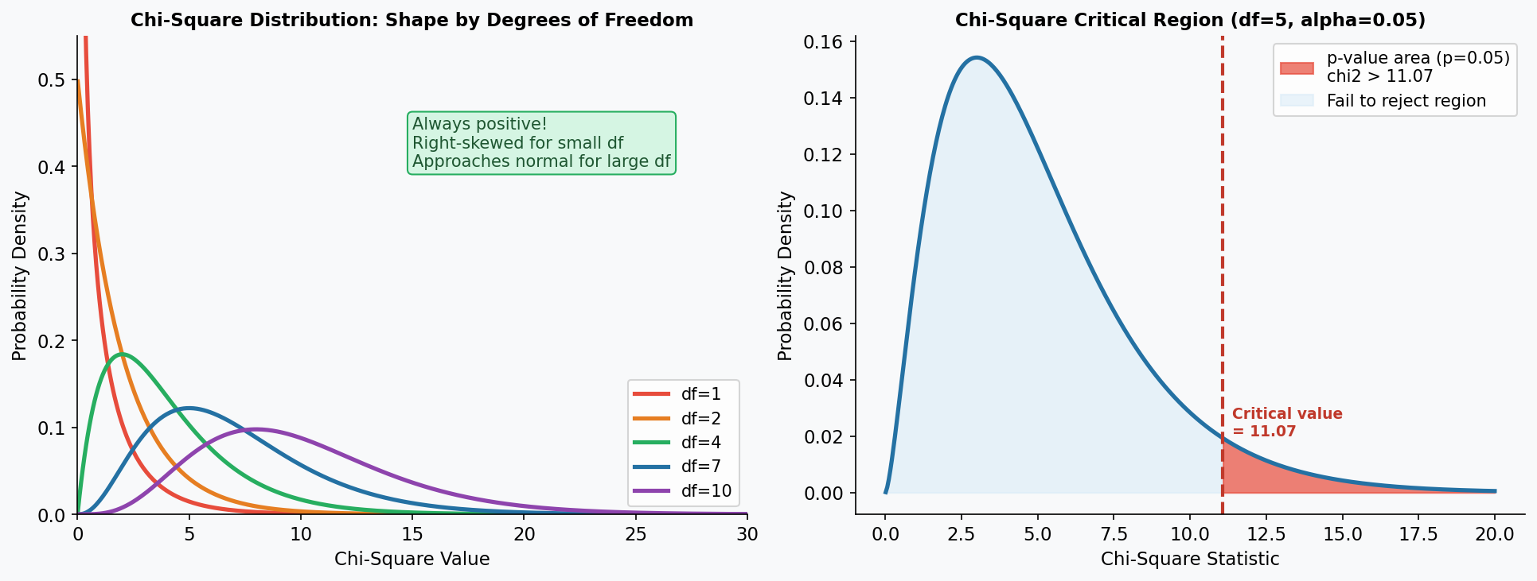

3.2 Key Properties
Property | Value / Behavior | Plain English
Range | Always ≥ 0 | Cannot be negative — it is a sum of squared values
Shape | Right-skewed for small df, approaches normal for large df | Asymmetric — most values cluster near zero, long right tail
Mean | = df | Average chi-square value equals degrees of freedom
Variance | = 2 × df | Spread doubles with each additional degree of freedom
As df increases | Approaches normal distribution | Large df = can use normal approximation

3.3 Real-World Scenario — Dice Fairness Test
Real-World Scenario: Casino Dice Quality Check
A casino suspects a die is loaded (biased). They roll it 120 times and record the outcomes.
If fair, expected count for EACH face = 120/6 = 20 rolls
Observed: Face 1=18, Face 2=22, Face 3=15, Face 4=28, Face 5=16, Face 6=21
Chi-Square = (18-20)²/20 + (22-20)²/20 + (15-20)²/20 + (28-20)²/20 + (16-20)²/20 + (21-20)²/20
= 0.2 + 0.2 + 1.25 + 3.2 + 0.8 + 0.05 = 5.7
With df = 6-1 = 5, critical value at alpha=0.05 is 11.07
Since 5.7 < 11.07 → Fail to reject H0. The die appears to be fair.

3.4 Common Misconceptions

MISCONCEPTION / MYTH | REALITY / TRUTH
The chi-square distribution can produce negative values. | Impossible. Chi-square is formed by squaring normal variables, and squares are always non-negative. The minimum possible chi-square value is 0, which would mean perfect agreement between observed and expected.

MISCONCEPTION / MYTH | REALITY / TRUTH
Chi-square distribution and chi-square test are the same thing. | The chi-square DISTRIBUTION is the probability curve. The chi-square TEST is a statistical procedure that uses this distribution to calculate a p-value. The distribution is the tool; the test is how you use it. Other tests (like the likelihood ratio test) also use the chi-square distribution.

Chapter 4: A/B Testing

4.1 What Is A/B Testing?
A/B testing is a controlled experiment where you compare TWO versions (A and B) of something — a webpage, drug, email, product — to determine which performs better. It is the gold standard for causal inference in business and medicine.

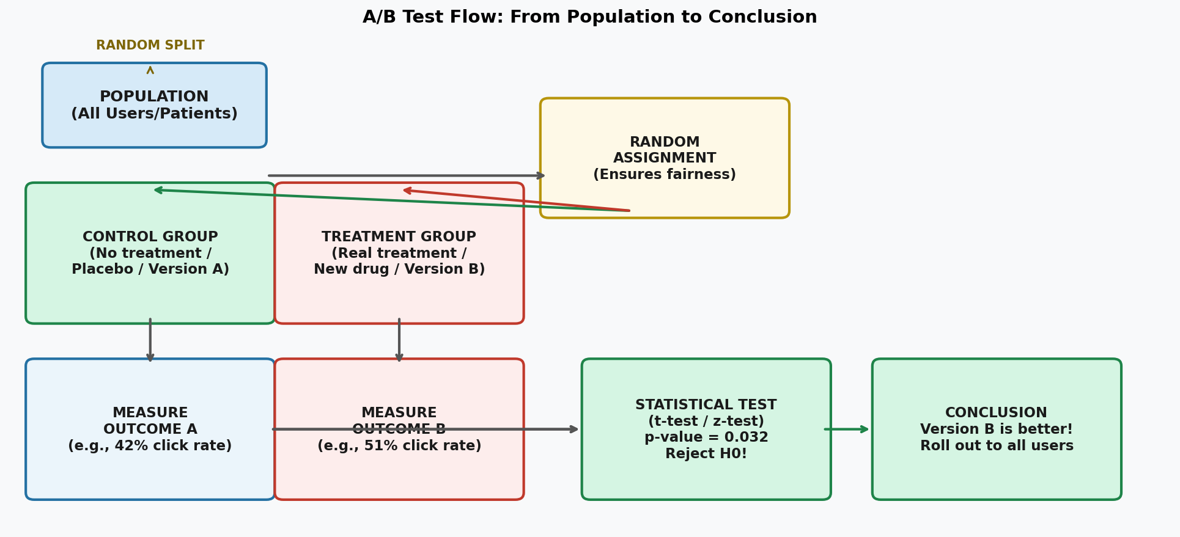

4.2 Core Terminology
Term | Definition | Example
Control Group | The group that receives NO treatment, or the existing baseline version | Patients given a sugar pill (placebo); users who see current website
Treatment Group | The group that receives the NEW treatment or version being tested | Patients given the new drug; users who see the redesigned website
Test Statistic | A single number calculated from data that summarizes the difference between groups | t-statistic, z-statistic, chi-square value, F-statistic
Randomization | Randomly assigning subjects to groups — crucial for eliminating bias | Flip a coin: heads = drug, tails = placebo
Blinding | Participants do not know which group they are in | Patient does not know if they got real drug or placebo
Double-Blind | BOTH the participant AND the researcher administering the test do not know the group assignment | Neither patient nor the nurse knows who gets real drug

4.3 Single-Blind vs Double-Blind: Why It Matters
Single-Blind Study  Only the PARTICIPANT does not know their group. The researcher knows.  Problem: Researcher bias — if the researcher knows who got the real drug, they might unconsciously treat them differently, or record results differently.  Example: A nurse knows Patient A got the real drug and Patient B got placebo. The nurse might give extra encouragement to Patient A, inflating the drug's apparent effect. | Double-Blind Study  NEITHER the participant NOR the researcher knows group assignments until the study ends.  Why better: Eliminates BOTH the placebo effect (patient psychology) AND researcher bias. Gold standard in clinical trials.  Example: Pills look identical. A pharmacist keeps the code. Neither patient nor nurse knows who got real drug. Reduces all psychological effects on both sides.

4.4 Real-World Scenario — Netflix Thumbnail A/B Test
Real-World Scenario: Netflix Thumbnail Optimization
Netflix wants to know: does showing a close-up of a character's face on a movie thumbnail increase watch rates?
Control (A): 50,000 users see the current landscape-scene thumbnail. Watch rate = 4.2%
Treatment (B): 50,000 users see the new face-close-up thumbnail. Watch rate = 5.1%
Absolute difference = 0.9 percentage points. Is this real or just luck?
Run a two-proportion z-test → test statistic z = 8.71, p-value < 0.0001
Conclusion: The face-close-up thumbnail SIGNIFICANTLY increases watch rates. Netflix rolls it out globally.
Business impact: 0.9% × millions of users = massive increase in viewing hours.

4.5 Real-World Scenario — Drug Clinical Trial
Real-World Scenario: Antidepressant Drug Trial (Double-Blind RCT)
200 patients with depression are randomly assigned: 100 to new drug, 100 to identical-looking placebo.
Neither patients nor doctors administering care know who gets what (double-blind).
After 8 weeks, depression scores (HAM-D scale) are measured:
Drug group: mean score = 12.3, SD = 4.1 (lower score = less depression)
Placebo group: mean score = 16.1, SD = 4.4
Run two-sample t-test: t = 6.35, p = 0.00000023 (extremely significant)
Effect size (Cohen's d) = 0.90 — large clinical effect
Conclusion: The drug significantly reduces depression symptoms beyond placebo effect.

4.6 Pitfalls and Misconceptions in A/B Testing

MISCONCEPTION / MYTH | REALITY / TRUTH
If the treatment group does better, the treatment caused the improvement. | Only TRUE if randomization was done properly. Without randomization, confounding variables can explain the difference. Example: if you let patients CHOOSE whether to take the drug, sicker patients might choose the drug, making it look less effective even if it works.

MISCONCEPTION / MYTH | REALITY / TRUTH
Peeking at results during an A/B test and stopping early when you see significance is fine. | This is called 'p-hacking' or 'optional stopping' and INFLATES Type 1 error. If you check significance 10 times during a study, you will falsely find significance far more than 5% of the time. Always pre-specify your sample size and stopping rule BEFORE collecting data.

Chapter 5: Hypothesis Testing — The Framework

5.1 What Is Hypothesis Testing?
Hypothesis testing is a formal decision-making process for using data to evaluate claims about the world. It is the backbone of scientific research. Every time you ask 'Does this drug work?' or 'Is this method better?' you are running a hypothesis test.

The core framework has 5 steps — ALWAYS in this order:

- State the Null Hypothesis (H0) — what you assume to be true by default
- State the Alternative Hypothesis (H1 or Ha) — what you want to detect
- Choose a significance level (alpha) — your threshold for 'surprising enough'
- Collect data and calculate the test statistic and p-value
- Make a decision: Reject H0 or Fail to Reject H0

5.2 Null Hypothesis (H0)
The null hypothesis is always the boring, conservative, 'nothing is happening' claim. It is the assumption we make until we have strong evidence to the contrary — exactly like 'innocent until proven guilty' in a courtroom.

Situation | Null Hypothesis (H0) — The boring default
Testing a new drug | The drug has NO effect on the disease
Comparing website versions | Conversion rates are IDENTICAL for A and B
Checking if a coin is biased | P(heads) = exactly 0.5 — the coin is fair
Studying gender pay gap | Average salaries are EQUAL for men and women
Vaccine efficacy trial | The vaccine provides NO protection
Machine learning feature selection | This feature has ZERO predictive power

5.3 Alternative Hypothesis (H1)
The alternative hypothesis is what you actually believe or hope to detect. It is the claim that something IS happening. You need to choose between a one-tailed (directional) or two-tailed (non-directional) alternative:

Two-Tailed (≠)  H1: Mean ≠ 0  Use when you do not know which direction the effect will be, or do not want to pre-commit.  Example: 'Is the coin biased?' — could be heads-heavy OR tails-heavy | Left-Tailed (<)  H1: Mean < value  Use when you specifically expect a DECREASE.  Example: 'Does the diet REDUCE weight?' — only care if weight goes down | Right-Tailed (>)  H1: Mean > value  Use when you specifically expect an INCREASE.  Example: 'Does the drug INCREASE survival rate?' — only care about improvement

5.4 Real-World Example — School Testing New Curriculum
Real-World Scenario: City-Wide Education Reform
A school district wants to know if a new math curriculum improves test scores.
H0: New curriculum has no effect. Mean score = same as old curriculum (μ = 72).
H1: New curriculum improves scores. Mean score > 72 (right-tailed test).
Alpha = 0.05. They sample 40 students taught with the new curriculum.
Results: Sample mean = 76.3, SD = 9.8
t-statistic = (76.3 - 72) / (9.8 / sqrt(40)) = 4.3 / 1.55 = 2.77
With df=39, p-value = 0.004 (one-tailed)
Decision: p = 0.004 < 0.05 → Reject H0!
Conclusion: Strong evidence the new curriculum improves scores. District adopts it city-wide.

5.5 Common Misconceptions in Hypothesis Testing

MISCONCEPTION / MYTH | REALITY / TRUTH
Failing to reject H0 means H0 is TRUE. | NEVER. 'Failing to reject H0' only means we lack sufficient evidence to reject it — like a 'not guilty' verdict, which does not prove innocence. The drug might still work; maybe our sample was too small to detect it. Absence of evidence is NOT evidence of absence.

MISCONCEPTION / MYTH | REALITY / TRUTH
A larger study will always give more significant results. | A larger study gives more statistical power, but cannot make a non-existent effect appear. If H0 is truly true, larger samples will correctly maintain non-significance. However, large studies can find significance for TRIVIALLY small effects that are practically meaningless.

Chapter 6: Statistical Significance, p-Values, Type 1 & Type 2 Errors

6.1 Statistical Significance
A result is called 'statistically significant' when the p-value falls below the pre-chosen alpha level (usually 0.05). It means: 'The result would be very unlikely to occur by chance if H0 were true.'

Statistical significance does NOT mean:
- The effect is large or important
- The result is definitely real (you could still be wrong 5% of the time)
- The hypothesis is proven

Statistical significance DOES mean:
- The observed data is unlikely under the null hypothesis
- You have enough evidence to reject the null hypothesis at your chosen alpha level

6.2 Practical Significance vs Statistical Significance
These are completely different things. A result can be:

Combination | What it means | Example | What to do
Statistically significant  AND Practically significant | The finding is real AND meaningful | New drug reduces hospital stays by 5 days (p<0.001) | Excellent — adopt the treatment!
Statistically significant  but NOT Practically significant | The finding is real but too small to matter | App update increases engagement by 0.01 seconds (p=0.001, n=1 million) | Statistically detectable but not worth implementing
NOT Statistically significant  but Practically significant | Large real-world effect but not enough power to detect it | Small pilot study: drug reduces tumor size 40% (p=0.12, n=10) | Promising! Run a larger study to confirm
NOT significant  AND NOT Practically significant | No evidence of any real effect | New software does not change productivity (p=0.8, effect=0.1%) | Move on — nothing to see here

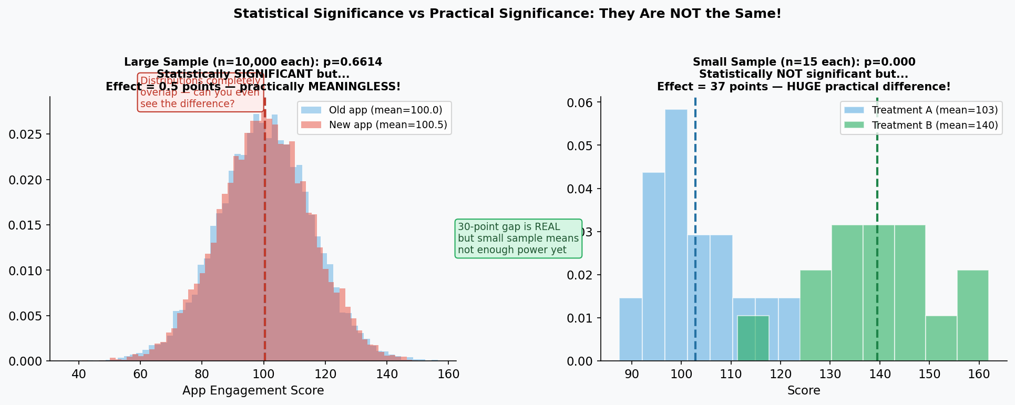

6.3 Type 1 and Type 2 Errors — The Two Ways to Be Wrong
When making a hypothesis test decision, you can make two kinds of mistakes:

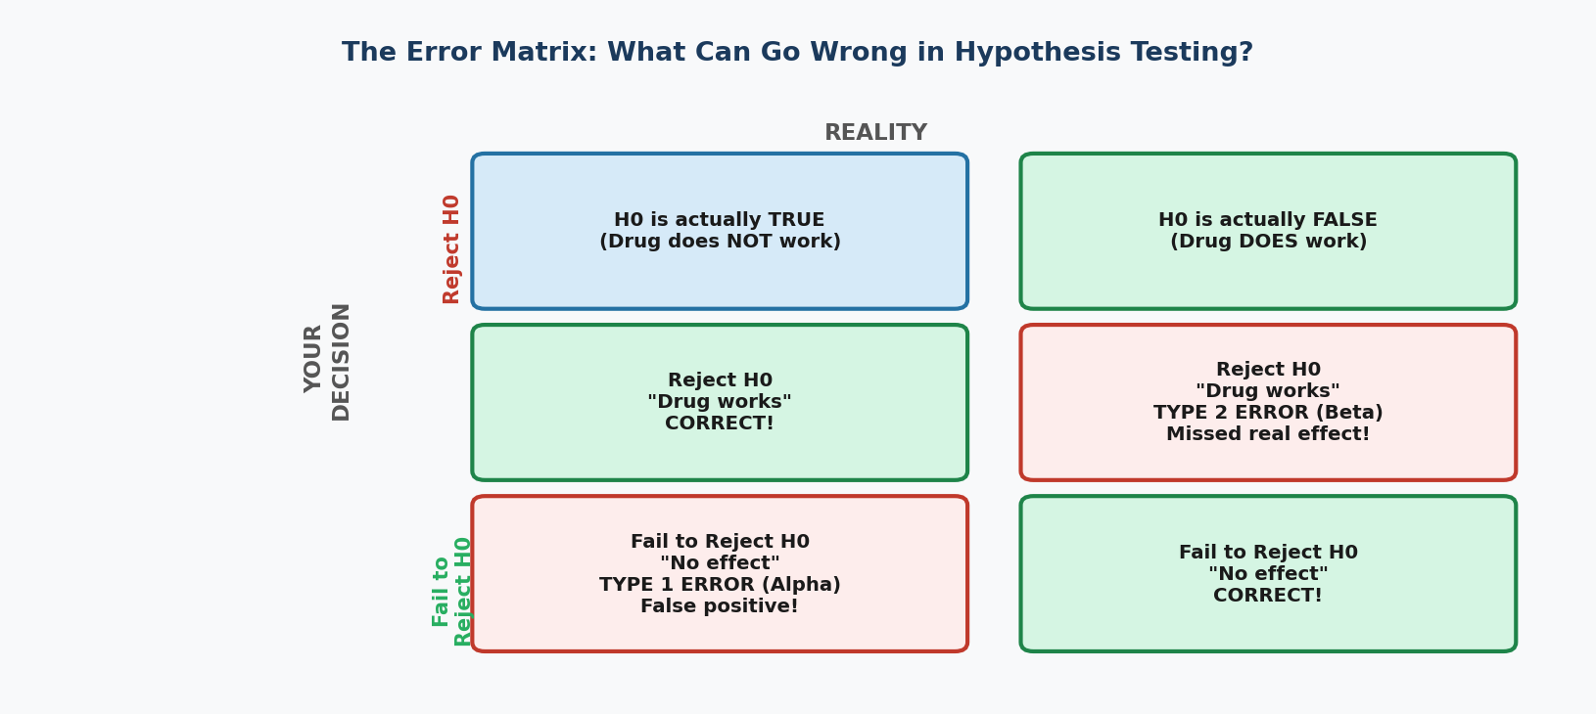

Type 1 Error (False Positive / Alpha Error)
Definition: Rejecting H0 when H0 is actually TRUE. You concluded something is happening when it is not.

Probability of Type 1 error = alpha (significance level). If alpha=0.05, you will make a Type 1 error 5% of the time when H0 is true.

Real example: A drug test says the drug works (reject H0: no effect), but in reality the drug does NOTHING. You approved a useless drug. The apparent success was just random luck in this trial.

Cost: Patients may take a useless or even harmful drug. Resources are wasted. Bad drugs may get approved.

Type 2 Error (False Negative / Beta Error)
Definition: Failing to reject H0 when H0 is actually FALSE. You missed a real effect.

Probability of Type 2 error = beta. Power = 1 - beta = probability of correctly detecting a real effect.

Real example: A drug test says the drug does NOT work (fail to reject H0: no effect), but in reality the drug DOES work. You rejected a beneficial drug. Your sample was too small to detect the effect.

Cost: Patients are denied an effective treatment. A promising drug is abandoned. Years of research are wasted.

 | [object Object] | [object Object]
Also called | False alarm / False positive | Missed detection / False negative
Symbol | Alpha | Beta
You decided | Drug works (reject H0) | Drug does not work (fail to reject H0)
Reality | Drug does NOT work | Drug DOES work
Controlled by | Choosing smaller alpha (e.g., 0.01 vs 0.05) | Larger sample size; Larger true effect size
Analogy | Convicting an innocent person | Acquitting a guilty person

6.4 The Trade-off: You Cannot Minimize Both Simultaneously
The Fundamental Trade-off:

If you lower alpha (e.g., from 0.05 to 0.01) to reduce Type 1 errors, you automatically INCREASE Type 2 errors (miss more real effects).
If you raise alpha to reduce Type 2 errors, you INCREASE Type 1 errors (more false positives).

The only way to reduce BOTH simultaneously: INCREASE SAMPLE SIZE. More data gives you more power to detect true effects while still controlling false positives.

6.5 Real-World Scenario — COVID-19 Test Accuracy
Real-World Scenario: Medical Diagnostic Testing
COVID-19 test characteristics: Sensitivity=95%, Specificity=99%
Sensitivity = probability of testing POSITIVE given you DO have COVID = 1 - Type 2 error rate = 95%
This means 5% of people WITH COVID test NEGATIVE (Type 2 error = false negative)
Specificity = probability of testing NEGATIVE given you do NOT have COVID = 1 - Type 1 error rate = 99%
This means 1% of people WITHOUT COVID test POSITIVE (Type 1 error = false positive)
During high prevalence: false positives are rare and manageable
During low prevalence: even a 1% false positive rate means MOST positives are actually false!
This is why the base rate (prevalence) matters enormously when interpreting test results.

Chapter 7: t-Tests — Standardized Test Statistics

7.1 What Is a t-Test?
A t-test is a hypothesis test that uses the t-distribution as its reference distribution. It determines whether means of groups are significantly different from each other or from a known value. The 't-statistic' standardizes the difference between means, telling you how many standard errors the difference is away from zero.

The t-statistic formula (one-sample):
t = (Sample Mean - Hypothesized Mean) / (Sample SD / sqrt(n))

In plain English: 'How many standard errors is our sample mean away from the value claimed in H0?' Large |t| = sample mean is far from H0 = evidence against H0.

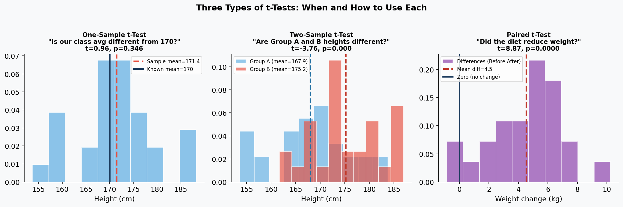

7.2 Three Types of t-Tests
Type 1: One-Sample t-Test
Purpose: Compare one group's mean to a KNOWN value (not another group).
Scenario | H0 | When to use
Is our factory's product 500g as claimed? | Mean weight = 500g | Testing against a specification or standard
Is average student IQ different from national average of 100? | Mean IQ = 100 | Comparing sample to published population value
Does the new machine fill exactly 350ml? | Mean fill = 350ml | Quality control vs target value

Type 2: Two-Sample (Independent) t-Test
Purpose: Compare means of TWO SEPARATE, unrelated groups.
Scenario | H0 | Key requirement
Does Treatment A produce better outcomes than Treatment B? | Mean(A) = Mean(B) | Subjects in Group A and B are DIFFERENT people
Are male and female salaries equal at this company? | Mean salary: Male = Female | The two groups must be independent
Does the new teaching method raise test scores vs old method? | Mean scores are equal | Different students in each teaching condition

Type 3: Paired t-Test
Purpose: Compare two measurements from the SAME subjects (before/after, or matched pairs).
Why paired is more powerful: It removes individual differences (Person A is naturally taller than Person B) by only looking at the CHANGE within each person. This reduces noise and increases sensitivity.

Examples:
- Blood pressure BEFORE and AFTER taking medication (same patients)
- Test score BEFORE and AFTER a training program (same students)
- Weight BEFORE and AFTER 6 months on a diet (same participants)
- Accuracy of two measurement devices on THE SAME samples

7.3 Real-World Scenario — Sleep Drug Trial
Real-World Scenario: Insomnia Drug Testing (Paired t-Test)
10 insomnia patients have their sleep duration measured:
Week 1: No medication. Average sleep = 5.2 hours (range: 4.0 to 6.5 hours)
Week 2: New sleep drug given. Average sleep = 7.1 hours (range: 6.2 to 8.1 hours)
Mean difference per patient = +1.9 hours, SD of differences = 0.8 hours
Paired t-statistic = 1.9 / (0.8/sqrt(10)) = 1.9 / 0.253 = 7.51
With df = 9, p-value = 0.00004
Conclusion: The drug significantly increases sleep duration by ~1.9 hours on average.
Why paired and not two-sample? Because some people naturally sleep more — pairing removes this background variation.

7.4 What is the 'Reference Distribution'?
The reference distribution is the probability distribution that the test statistic would follow IF H0 were true. For t-tests, this is the t-distribution. The p-value is the probability of getting a t-statistic as extreme as yours under this reference distribution.

Test | Reference Distribution | What it tells us
t-test (means) | t-distribution (with appropriate df) | How extreme is our mean difference under H0?
z-test (proportions) | Standard normal (z) | How extreme is our proportion difference?
ANOVA (multiple means) | F-distribution | How large is between-group vs within-group variance?
Chi-square test (categories) | Chi-square distribution | How different are observed vs expected counts?

7.5 Common Misconceptions About t-Tests

MISCONCEPTION / MYTH | REALITY / TRUTH
The two-sample t-test can only be used when both groups have the same size. | Completely false. The two-sample t-test works perfectly well with unequal group sizes (n1 ≠ n2). The formula simply uses the harmonic mean or pooled estimates. Most real studies have unequal groups — that is fine.

MISCONCEPTION / MYTH | REALITY / TRUTH
A significant t-test means the difference is large and important. | Not at all. With a sample of 10,000, even a trivial 0.1-point difference (completely meaningless in practice) can yield t = 5.0 and p < 0.001. Always report effect size (Cohen's d) alongside the t-test to convey practical importance.

Chapter 8: ANOVA — Analysis of Variance

8.1 What Is ANOVA and Why Do We Need It?
ANOVA (Analysis of Variance) compares three or more group means simultaneously. You might wonder: why not just run multiple t-tests? The answer is the multiple comparisons problem.

The Multiple Comparisons Problem:

If you have 4 groups (A, B, C, D) and run all possible t-tests: you get 6 comparisons.
With alpha=0.05, each test has a 5% chance of false positive. But across 6 tests, your overall false positive rate EXPLODES:
P(at least one false positive) = 1 - (0.95)^6 = 1 - 0.735 = 26.5% — Not 5%!

ANOVA solves this: It tests ALL groups at once with a single test, maintaining the overall alpha = 0.05.

8.2 The F-Statistic: The Heart of ANOVA
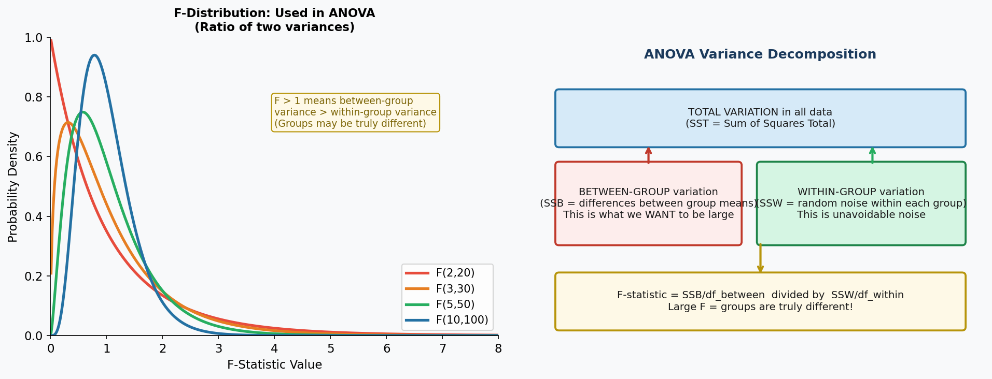

F = Between-Group Variance / Within-Group Variance

F = 1 → No evidence groups are different (between ≈ within variation)
F >> 1 → Strong evidence at least one group is different (much more variation between groups than within them)
F < 1 → Unusual (groups are MORE similar than random variation would expect)

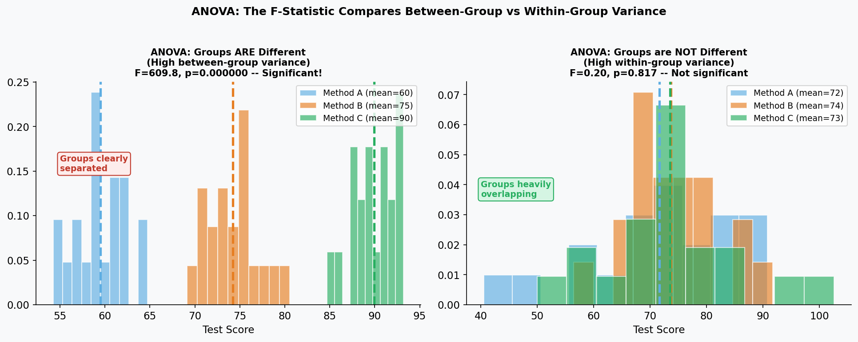

8.3 Real-World Scenario — Comparing Fertilizers
Real-World Scenario: Agricultural Yield Study
A farmer wants to find the best fertilizer for corn yield. Tests 4 types on separate plots (n=8 plots per type):
Fertilizer A: Mean yield = 45 bushels/acre, SD = 5
Fertilizer B: Mean yield = 52 bushels/acre, SD = 4
Fertilizer C: Mean yield = 48 bushels/acre, SD = 6
Fertilizer D: Mean yield = 61 bushels/acre, SD = 5
ANOVA result: F(3, 28) = 18.4, p < 0.0001 → Highly significant!
Conclusion: At least one fertilizer is different from the others.
BUT: ANOVA only tells you SOME difference exists — not WHICH ones. Need post-hoc tests.

8.4 Post-Hoc Tests: Pairwise Comparisons After ANOVA
When ANOVA is significant, you know at least one pair of groups differs — but not which ones. Post-hoc tests do all pairwise comparisons while controlling for multiple comparisons. The most common:

Post-Hoc Test | When to use it | What it controls
Tukey HSD | When groups have equal or similar sample sizes | Overall family-wise error rate — most commonly used
Bonferroni | When you have few planned comparisons | Divides alpha by number of comparisons — conservative
Scheffe | When doing complex comparisons, not just pairs | Most conservative — use when being very cautious
Games-Howell | When group variances are unequal | Does not assume equal variances (robust)

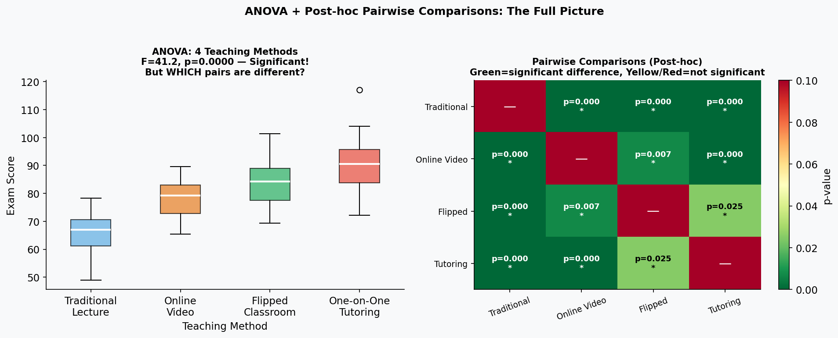

8.5 Real-World Scenario — Teaching Methods Study
Real-World Scenario: Education Research: Comparing 4 Teaching Methods
Researchers compare exam scores from 4 teaching methods (25 students each):
Method 1 (Traditional Lecture): Mean = 65, Method 2 (Online Video): Mean = 78
Method 3 (Flipped Classroom): Mean = 82, Method 4 (One-on-One Tutoring): Mean = 91
ANOVA: F(3, 96) = significant. At least one method differs.
Tukey HSD post-hoc results:
Traditional vs Tutoring: p < 0.001 (Tutoring clearly better)
Traditional vs Flipped: p = 0.003 (Flipped better)
Video vs Tutoring: p = 0.012 (Tutoring better)
Video vs Flipped: p = 0.71 (NOT significantly different from each other)
Conclusion: One-on-One tutoring is best, but Flipped and Video are statistically similar to each other.

8.6 Common ANOVA Misconceptions

MISCONCEPTION / MYTH | REALITY / TRUTH
ANOVA tests whether group means are different — so it only looks at means. | Despite the name 'Analysis of VARIANCE', ANOVA absolutely does test means. The 'variance' refers to the METHOD: it compares variability BETWEEN groups to variability WITHIN groups to determine if group means differ. The F-statistic is a variance ratio, not a means ratio.

MISCONCEPTION / MYTH | REALITY / TRUTH
If ANOVA is significant, all pairs of groups are different from each other. | ANOVA only tells you that at least ONE pair is different. It says nothing about which pairs. You need post-hoc tests to identify specific differences. In the teaching example, video and flipped classroom were NOT significantly different from each other despite ANOVA being significant.

Chapter 9: Chi-Square Test, Fisher's Exact Test & Detecting Fraud

9.1 What Is the Chi-Square Test?
The Chi-Square test is for categorical data — when your variables are groups, not numbers. You are comparing COUNTS in categories. It asks: 'Are the observed counts different from what we would expect if nothing interesting were happening?'

Chi-Square Goodness-of-Fit  Tests if a single categorical variable follows an expected distribution.  Examples:  - Does the die produce all 6 faces equally?  - Are birth rates equal across all 12 months?  - Do survey responses match the expected 40/40/20 split? | Chi-Square Test of Independence  Tests if TWO categorical variables are related to each other.  Examples:  - Is gender related to career choice?  - Is smoking status related to cancer diagnosis?  - Is geographic region related to political party preference?

9.2 The Chi-Square Statistic Formula
chi² = sum of [ (Observed - Expected)² / Expected ] for all cells

In plain English: For each category, calculate how far off your observed count is from what you expected, square it (to make it positive and penalize larger deviations more), divide by expected (to standardize), then add them all up. A LARGE chi² means BIG differences between observed and expected.

Degrees of freedom:
Goodness-of-fit: df = (number of categories) - 1
Test of Independence: df = (rows - 1) × (columns - 1)

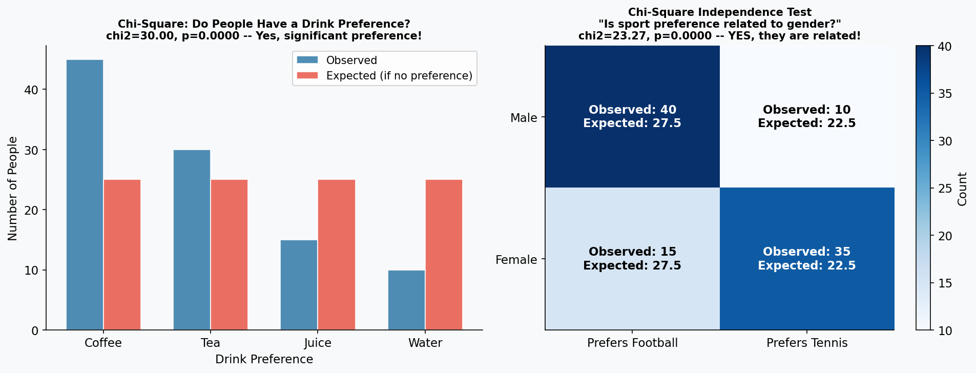

9.3 Real-World Scenario — Hospital Infection Rates
Real-World Scenario: Healthcare Quality Improvement
A hospital suspects infection rates differ across 3 wards. Over 6 months they record:
Ward A: 12 infections out of 200 patients (6%)
Ward B: 8 infections out of 200 patients (4%)
Ward C: 25 infections out of 200 patients (12.5%)
Overall infection rate = 45/600 = 7.5%, so expected infections per ward = 200 × 0.075 = 15
chi² = (12-15)²/15 + (8-15)²/15 + (25-15)²/15 = 0.6 + 3.27 + 6.67 = 10.54
df = 3-1 = 2, critical value at alpha=0.05 is 5.99
10.54 > 5.99 → Reject H0. Infection rates ARE significantly different across wards!
Ward C has a significantly higher infection rate — hospital investigates and finds inadequate hand-washing protocol.

9.4 Fisher's Exact Test — When Chi-Square Fails
The Chi-Square test has one major limitation: it becomes unreliable when expected cell counts are small (< 5). When this happens, use Fisher's Exact Test, which calculates the EXACT probability of your contingency table (and all more extreme tables) under H0.

When to use Fisher's Exact Test:
- Any cell in your 2×2 table has an expected count < 5
- Sample size is small (n < 20 total)
- Rare events — one category has very few occurrences

Example: Testing a rare side effect. 5 patients get Drug A (2 develop rash, 3 don't), 5 get Drug B (0 rash, 5 don't). Expected counts would be too small for chi-square — use Fisher's Exact Test.

9.5 Detecting Scientific Fraud with Statistics
One remarkable application of chi-square is detecting when scientists fabricate or manipulate data. Real data has natural randomness — perfectly clean data is actually SUSPICIOUS.

Method 1: Benford's Law
In naturally occurring datasets (population sizes, financial data, scientific measurements), the FIRST DIGIT of numbers follows a specific distribution: 1 appears 30% of the time, 2 appears 17.6%, 3 appears 12.5%, ..., 9 appears only 4.6%.
Fraudsters tend to distribute digits more 'randomly' or avoid leading 1s, making their data fail Benford's Law. A chi-square goodness-of-fit test against Benford's expected distribution can flag suspicious datasets.

Method 2: Too-Good Results (Last-Digit Tests)
Real-World Scenario: Detecting Research Fraud
A psychology researcher published 20 studies. A statistician notices the p-values cluster suspiciously close to 0.05 (just barely significant).
Under honest research, p-values below 0.05 should be roughly uniformly distributed from 0 to 0.05.
Using a chi-square test on the distribution of p-values, the statistician tests whether the distribution of reported p-values is too suspicious.
The test reveals p-values cluster at 0.04 to 0.049 far more than expected — suggesting selective reporting (only publishing studies that just barely succeed).
This is called 'p-hacking' or the 'file drawer problem' — statistically detectable patterns in published p-values.
Similar tests detected fraud in Diederik Stapel's psychology research (2011) and Jan Hendrik Schon's physics papers (2002).
Method: Test if distribution of published p-values is consistent with what honest research would produce using chi-square test.

Method 3: Variance Too Low (Fabricated Averages)
When researchers fabricate individual data points, they often use random number generators that produce LESS variance than real human data. For example, if measuring blood pressure readings, a fraudster might generate numbers that are too uniform.
Test: Use a chi-square test for variance — does the observed variance match what the population variance should be? If SD is suspiciously small, the data may be fabricated.

9.6 Assumptions and Limitations of Chi-Square Test
Assumption | Requirement | What to do if violated
Sample size | Each expected cell count ≥ 5 | Use Fisher's Exact Test for 2×2 tables, or combine categories
Independence | Observations are independent | Do not use if subjects appear in multiple cells
Random sampling | Data should be a random sample | Results cannot be generalized if sampling is biased
Categorical data only | Variables must be categories, not continuous numbers | For continuous data, use t-test or correlation instead

9.7 Common Misconceptions in Chi-Square Tests

MISCONCEPTION / MYTH | REALITY / TRUTH
A significant chi-square test tells you which cells drove the significance. | Chi-square gives you ONE overall test statistic for the entire table. It does not identify which specific cells are unusual. To find contributing cells, examine 'Pearson residuals' (standardized differences between observed and expected) — large residuals indicate problem cells.

MISCONCEPTION / MYTH | REALITY / TRUTH
Chi-square test can be used for any type of data. | Chi-square tests are ONLY for categorical (count) data. If you have continuous measurements (heights, weights, temperatures), use t-tests or ANOVA. Forcing continuous data into a chi-square test (by creating arbitrary categories) loses information and gives less powerful results.

Chapter 10: How Everything Connects — The Big Picture

10.1 Which Test Do I Use? The Decision Guide
Question | Data Type | Number of Groups | Test to Use | Distribution Used
Is my sample mean different from a known value? | Continuous (mean) | 1 group vs. fixed value | One-sample t-test | t-distribution
Are two group means different? | Continuous (mean) | 2 independent groups | Two-sample t-test | t-distribution
Did individuals change (before/after)? | Continuous (mean) | Same people measured twice | Paired t-test | t-distribution
Are 3+ group means different? | Continuous (mean) | 3 or more groups | ANOVA (F-test) | F-distribution
Which specific pairs differ (after ANOVA)? | Continuous (mean) | Multiple pairs | Post-hoc tests (Tukey, Bonferroni) | t-distribution
Are two categorical variables related? | Categorical (counts) | 2+ categories each | Chi-square independence test | Chi-square distribution
Does observed distribution match expected? | Categorical (counts) | 1 variable, multiple categories | Chi-square goodness-of-fit | Chi-square distribution
Are two proportions equal? | Binary (pass/fail) | 2 groups | z-test for proportions (or chi-square) | Normal / Chi-square
Small samples with categorical data? | Categorical counts | 2×2 table with small n | Fisher's Exact Test | Hypergeometric
How does one variable predict another? | Continuous | 2 continuous variables | Correlation / Regression | Normal / t-distribution

10.2 The Hierarchy of Evidence
From strongest to weakest causal evidence:

1. Double-blind Randomized Controlled Trial (RCT) → Gold standard. Random assignment + blinding = causal claims justified.
2. Single-blind RCT → Strong. Randomization preserved, but researcher bias possible.
3. Observational Study with Matching → Moderate. Attempts to control confounders by matching similar subjects.
4. Observational Study (Cohort/Case-Control) → Weaker. Cannot fully control for confounding variables.
5. Cross-Sectional Survey → Weakest for causation. Can only describe associations, not cause-and-effect.

Key rule: Only randomized experiments justify causal language ('causes', 'leads to', 'produces'). Observational studies can only show 'associated with' or 'correlated with'.

10.3 Common Mistakes That Apply to ALL Tests
Mistake | What it is | The consequence | How to avoid it
Data Dredging / p-hacking | Running many tests on the same data until something is significant | False positive rate skyrockets — most findings will be spurious | Pre-register hypotheses; use Bonferroni correction for multiple tests
HARKing | Hypothesizing After Results are Known — presenting post-hoc findings as if pre-planned | Inflates false positive rate; misleads readers | Register hypotheses BEFORE collecting data; clearly label exploratory analyses
Ignoring effect size | Reporting only p-values, not the size of the actual difference | Readers cannot judge practical importance | Always report Cohen's d, eta², or odds ratio alongside p-values
Cherry-picking | Reporting only the statistically significant results | Publication bias; misleading picture of evidence | Report all results including non-significant findings
Small sample overconfidence | Drawing strong conclusions from n=5 or n=10 | Results are unreliable and unlikely to replicate | Calculate required sample size BEFORE starting (power analysis)

Summary: The Statistical Thinking Mindset

Before choosing a test, ask yourself 5 questions:

- WHAT am I comparing? (a mean, a proportion, categories, variances?)
- HOW MANY groups? (1, 2, or 3+?)
- Are my observations INDEPENDENT or PAIRED/REPEATED?
- Is my data CONTINUOUS (numbers) or CATEGORICAL (groups)?
- How large is my sample? (small = need t-distribution; large categories = chi-square works well)

Then always remember the three-step interpretation:

- Statistical significance: Is the p-value below alpha? (Could this be chance?)
- Practical significance: Is the effect size large enough to matter in the real world?
- Confidence interval: What is the plausible RANGE of the true effect?

