P-Values
From Normal to Non-Normal Data
A Complete Beginner's Walkthrough

What's inside:
1. P-value visualised on the bell curve
2. One-tailed tests on normal data
3. Two-tailed tests on normal data
4. Non-normal data: transform OR use non-parametric tests
5. Two real data science use cases
Table of Contents

1. P-Value on the Normal Distribution (Quick Reset)
Before we get into one-tailed and two-tailed tests, let's anchor the basic picture.
The normal distribution is the bell-shaped curve. It tells you what values are common (near the middle) and what values are rare (in the tails). The p-value is just the area in the tail beyond your data point.
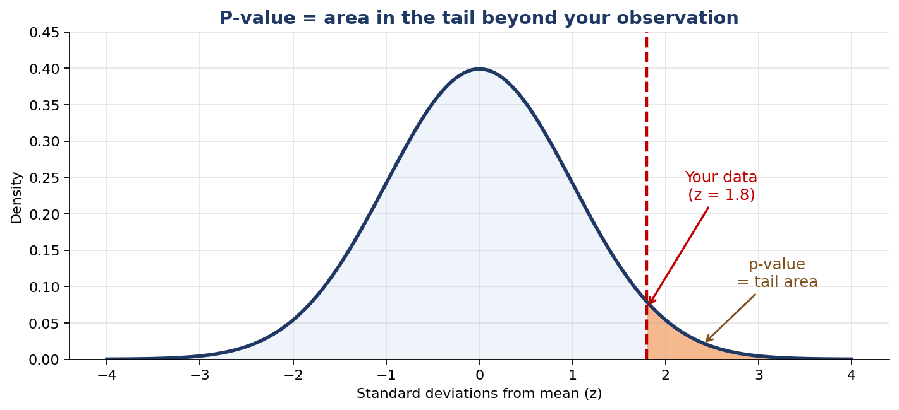
The p-value = the shaded tail area beyond your observation.
THE BRIDGE: Z-SCORES
To use the normal curve, we convert raw data into z-scores. A z-score says how many standard deviations your value is from the mean.
z = (your value − mean) / standard deviation
Once you have z, the p-value is the area in the tail beyond z. Bigger |z| → smaller p-value → more surprising data.

A Grounding Example
EXAMPLE 1 — Daily Steps
- Your fitness band says the average person walks 8,000 steps/day
- Standard deviation: 1,500 steps
- You walked 11,000 steps yesterday
How unusual is that?

z = (11,000 − 8,000) / 1,500 = 2.0
Tail area beyond z = 2.0 is about 0.023.
So if you were typical, you'd hit 11,000 steps only on about 2.3% of days. Yesterday was unusually active.

2. One-Tailed Test on the Normal Distribution
A one-tailed test is used when you only care about ONE direction of difference — "is the value too LOW?" or "is the value too HIGH?" — but not both.
Picture the bell curve. The p-value is the area in JUST ONE tail.
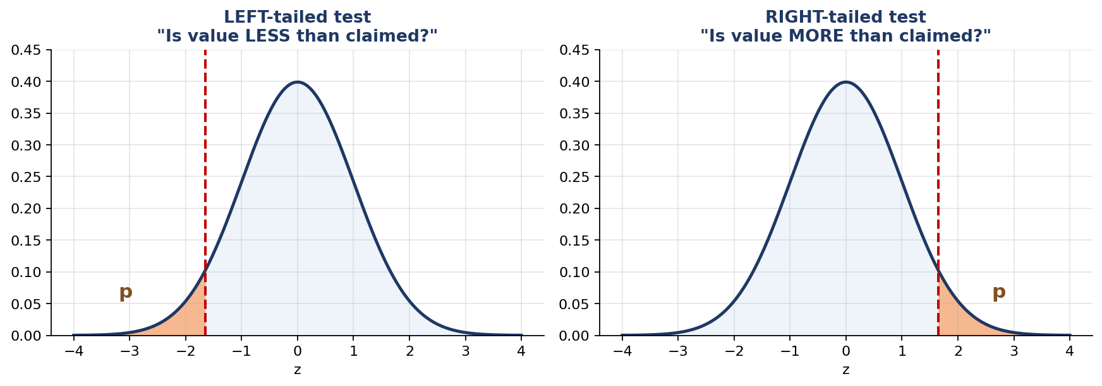
Left-tailed (suspect lower) vs Right-tailed (suspect higher).

When to Use a One-Tailed Test
You suspect… | Tail to use | Example phrasing
The value is LOWER than claimed | LEFT tail | "Are bottles UNDER-filled?"
The value is HIGHER than claimed | RIGHT tail | "Does this medicine RAISE blood pressure?"
You don't know which direction | Use two-tailed (see Section 3) | "Is the value DIFFERENT from claimed?"

Worked Example: Energy Drink Caffeine
EXAMPLE 2 — Is the Drink Under-Caffeinated?
A drink claims AT LEAST 80 mg of caffeine per can. You don't believe it — you suspect it's actually less.
- Claimed mean: μ₀ = 80 mg
- Known standard deviation: σ = 6 mg
- You test 25 cans. Sample mean = 77.5 mg

H₀ (null): true mean caffeine = 80 mg (company is honest)
H₁ (alternative): true mean < 80 mg (drink is under-caffeinated)
Because we only care about ONE direction (less than), this is a LEFT-tailed test.
Compute the standard error (spread of the sample mean):
SE = σ / √n = 6 / √25 = 1.2 mg
Compute z:
z = (77.5 − 80) / 1.2 = −2.083
Left-tail p-value (area below z = −2.083): about 0.019 (or 1.9%)
If the drink really had 80 mg on average, you'd see a sample this low only 1.9% of the time. That's strong evidence the drink is under-caffeinated.

Python Code
from scipy.stats import norm
import numpy as np

sample_mean = 77.5
claimed_mean = 80
sigma = 6
n = 25

se = sigma / np.sqrt(n)
z = (sample_mean - claimed_mean) / se

# LEFT-tailed: area to the left of z
p_value = norm.cdf(z)

print(f'z = {z:.3f}')
print(f'p = {p_value:.4f}')
print('Reject the claim' if p_value < 0.05 else 'Cannot reject the claim')

RIGHT-TAILED VERSION
If instead you suspected the drink was OVER-caffeinated (claim was "at most 80 mg"), you'd compute the same z and then use:
p_value = 1 - norm.cdf(z) # or norm.sf(z)
Right-tailed tests look at the right side of the curve instead of the left.

3. Two-Tailed Test on the Normal Distribution
Use a two-tailed test when you care about BOTH directions — whether the true value might be either higher OR lower than claimed.
The p-value is the sum of BOTH tail areas.
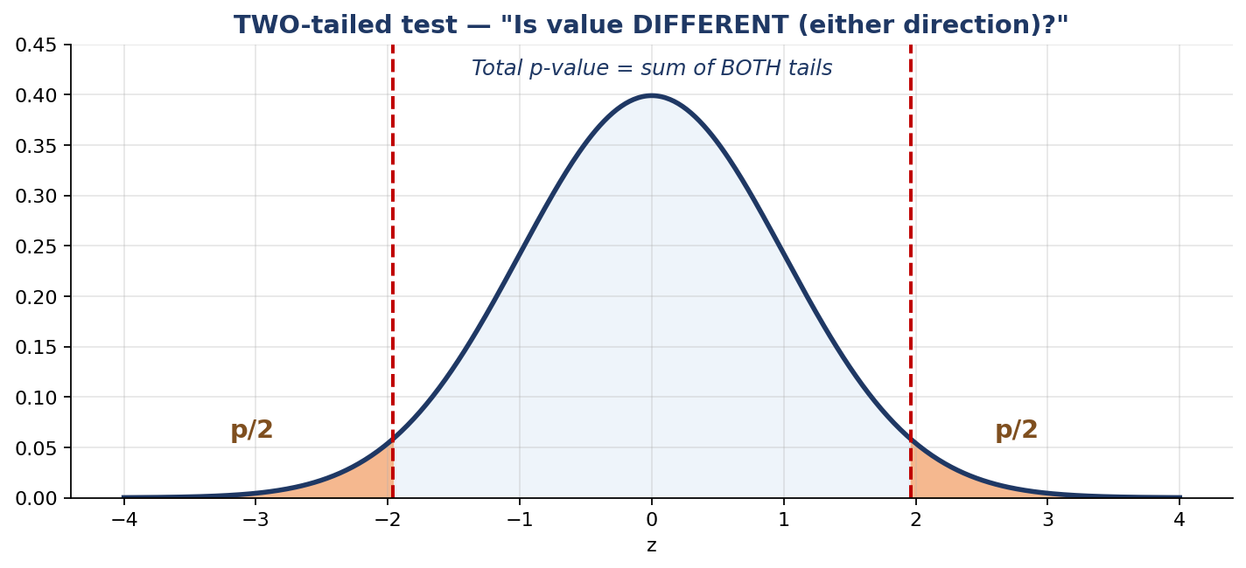
Two-tailed test: shade both tails, add them up.

When to Use a Two-Tailed Test
- You don't know whether the deviation will be positive or negative.
- You only want to know whether the value is DIFFERENT, not which direction.
- When in doubt — use two-tailed. It is the more cautious default.

Worked Example: Snack Packet Weight
EXAMPLE 3 — Are Snack Packets the Right Weight?
A factory claims its packets weigh EXACTLY 250 g on average. Quality control wants to know if the line is misadjusted in EITHER direction.
- Claimed mean: μ₀ = 250 g
- Standard deviation: σ = 5 g
- Sample of 40 packets, sample mean = 252.3 g

H₀: true mean weight = 250 g
H₁: true mean weight ≠ 250 g (either over OR under)
SE = 5 / √40 ≈ 0.791 g
z = (252.3 − 250) / 0.791 ≈ 2.91
Two-tailed p-value = 2 × (area beyond |z| = 2.91)
p ≈ 2 × 0.0018 = 0.0036
If the line were perfectly calibrated, you'd see a sample this far from 250 g (in either direction) only 0.36% of the time. The line is almost certainly miscalibrated.

Python Code
from scipy.stats import norm
import numpy as np

sample_mean = 252.3
claimed_mean = 250
sigma = 5
n = 40

se = sigma / np.sqrt(n)
z = (sample_mean - claimed_mean) / se

# TWO-tailed: double the one-sided tail area
p_value = 2 * norm.sf(abs(z))

print(f'z = {z:.3f}')
print(f'p = {p_value:.4f}')

THE RULE
Two-tailed p-value = 2 × (one-tailed p-value)
…as long as the distribution is symmetric (and the normal distribution is).

4. What If the Data Is NOT Normally Distributed?
Everything we've done so far assumed the bell curve. But real data often is NOT bell-shaped. Income, wait times, website session durations, social media engagement, salaries — these are often heavily skewed.
If you run a z-test or t-test on data that's very non-normal, the p-value can be misleading.
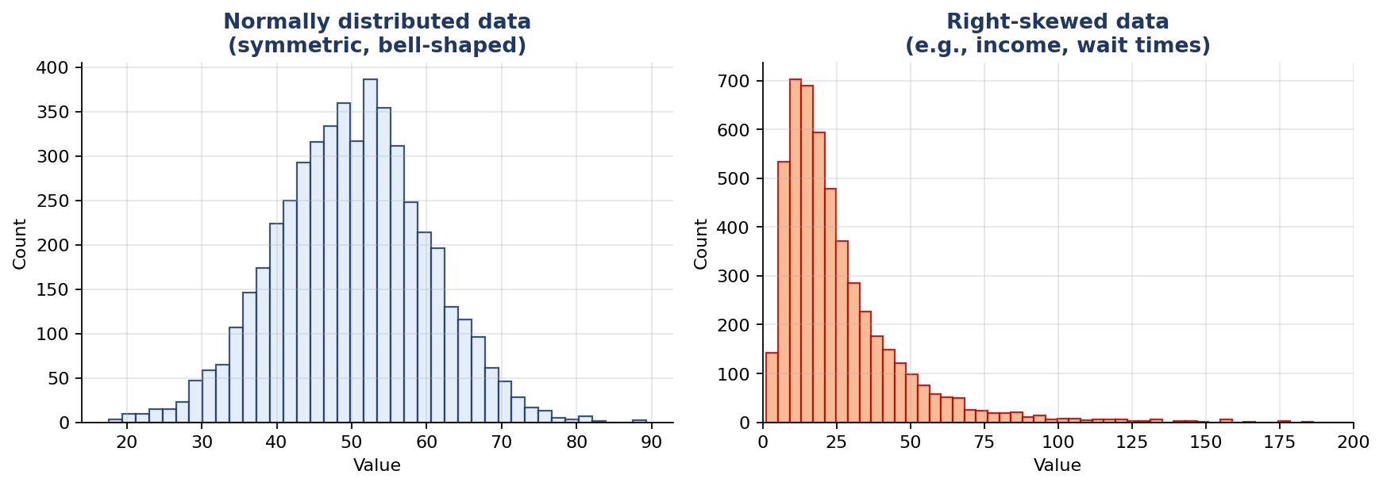
Left: normal. Right: right-skewed (long tail to the right) — very common in real-world data.

4.1 How to Check If Your Data Is Normal
Three quick checks:
- Plot a histogram. If it looks roughly bell-shaped and symmetric, you're probably fine. If it has a long tail on one side, it's skewed.
- Plot a Q-Q plot. If the points sit on the diagonal line, data is normal. If they curve away, it's not.
- Use Shapiro-Wilk (with caution). scipy.stats.shapiro returns a p-value for the test "is this data normal?" BUT — with samples bigger than ~5,000, this test rejects normality even when the data is normal enough. Trust the plots more than the test.
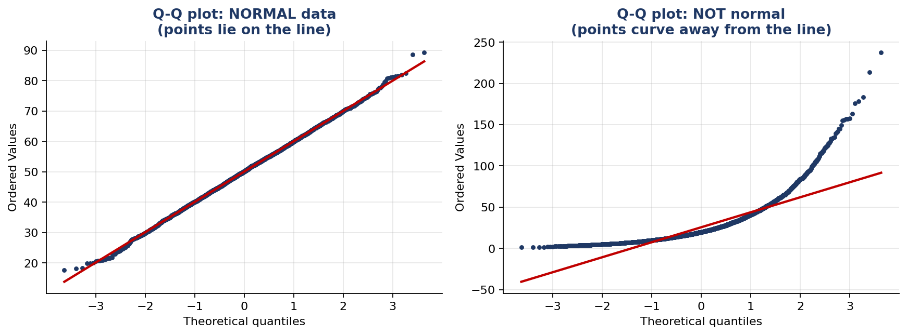
Q-Q plot comparison: normal data follows the line; non-normal data curves away.

4.2 Decision Flow
Once you know your data isn't normal, you have two main options:
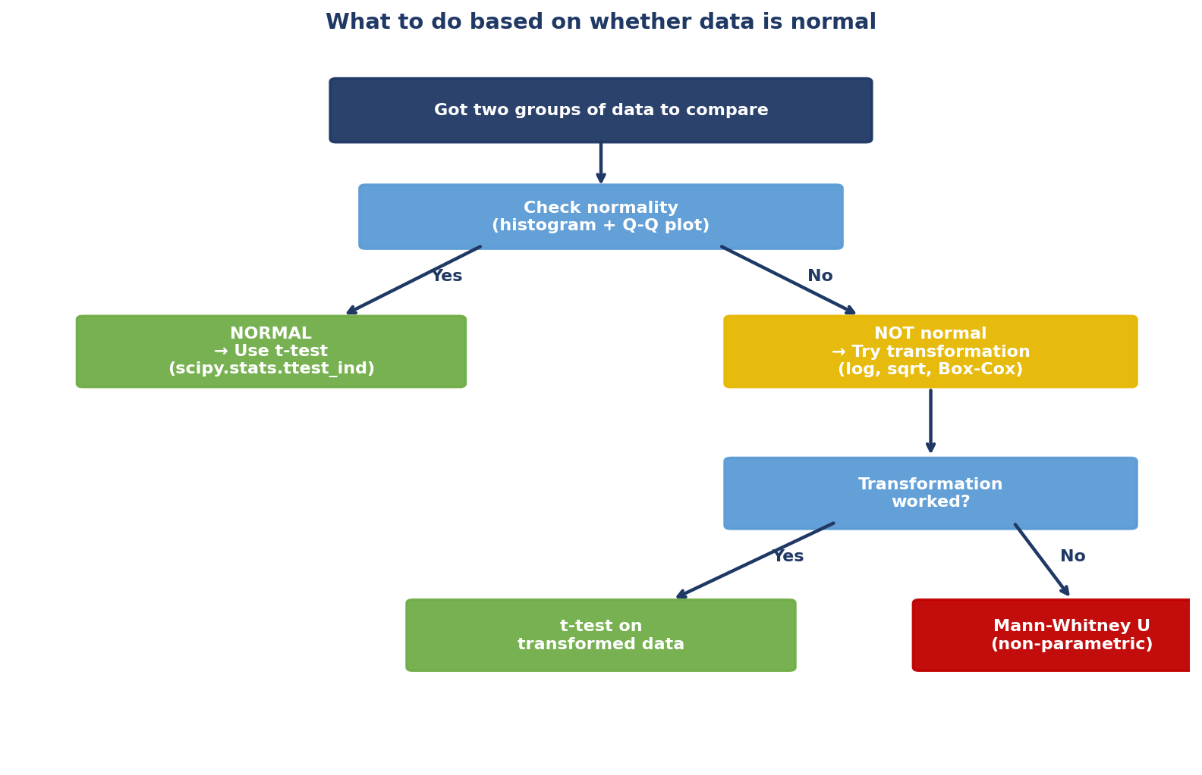
The two routes when your data isn't normal.

4.3 Path A — Try to Transform the Data to Normal
If your data is skewed, a mathematical transformation might pull it back into a bell shape. The most common transformations are:
Transformation | Use when… | Python
Log (np.log) | Data is right-skewed AND all positive (income, prices, durations) | np.log(x)
Square root | Mild right skew (e.g., counts: number of visits) | np.sqrt(x)
Box-Cox | Right-skewed, all positive — picks the best power automatically | scipy.stats.boxcox(x)
Yeo-Johnson | Like Box-Cox but works with negative or zero values | scipy.stats.yeojohnson(x)
Reciprocal (1/x) | Very heavy right skew, no zeros | 1 / x

Example: Customer Income
EXAMPLE 4 — Average Income Comparison
You want to compare average income between customers from two cities. Income data is right-skewed (most people earn modest amounts, a few earn a lot).
If you ran a t-test directly, the result would be unreliable. Solution: take the log of income first.

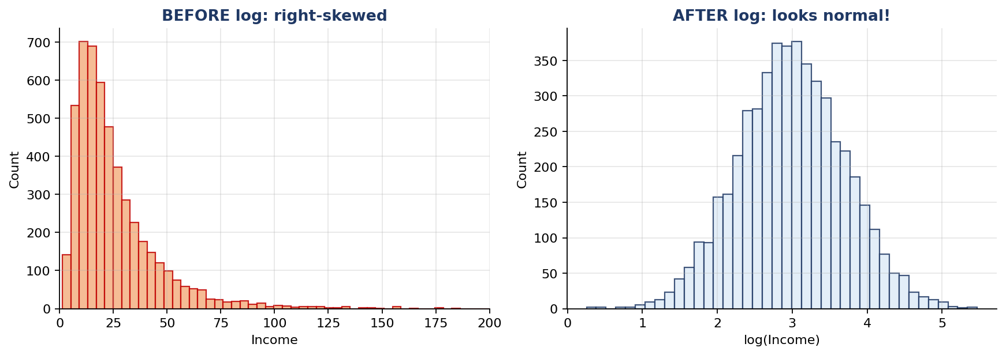
Before log: heavily skewed. After log: nicely bell-shaped — now safe to use a t-test.

Python Code — Transform Then Test
import numpy as np
from scipy.stats import ttest_ind, shapiro

city_A_income = np.array([25000, 32000, 28000, 45000, 80000, 22000, 60000])
city_B_income = np.array([30000, 42000, 38000, 55000, 95000, 28000, 70000])

# Step 1: Log-transform (income is right-skewed)
log_A = np.log(city_A_income)
log_B = np.log(city_B_income)

# Step 2: Confirm transformed data is roughly normal
print('Shapiro on log_A:', shapiro(log_A).pvalue)
print('Shapiro on log_B:', shapiro(log_B).pvalue)

# Step 3: Run a TWO-tailed t-test on the log-transformed data
stat, p_two = ttest_ind(log_A, log_B, equal_var=False)
print(f'two-tailed p = {p_two:.4f}')

# For a ONE-tailed test (e.g., is B's income higher?):
p_one = p_two / 2 if stat < 0 else 1 - p_two / 2
print(f'one-tailed p (B > A) = {p_one:.4f}')

IMPORTANT
When you transform the data, your conclusion is about the TRANSFORMED scale. For example, you're testing whether mean(log income) differs, which is equivalent to testing whether GEOMETRIC mean income differs (not arithmetic mean).
This is usually fine for comparison purposes. Just be aware when reporting numbers — back-transform with np.exp() if needed.

4.4 Path B — Can't Transform? Use Non-Parametric Tests
Sometimes transformation doesn't work — maybe the data is bimodal, or has crazy outliers, or contains zeros and negatives, or you tried Box-Cox and the result is still ugly.
In that case, switch to non-parametric tests. These tests don't assume any specific distribution. They work on the RANKS of the data rather than the raw values.
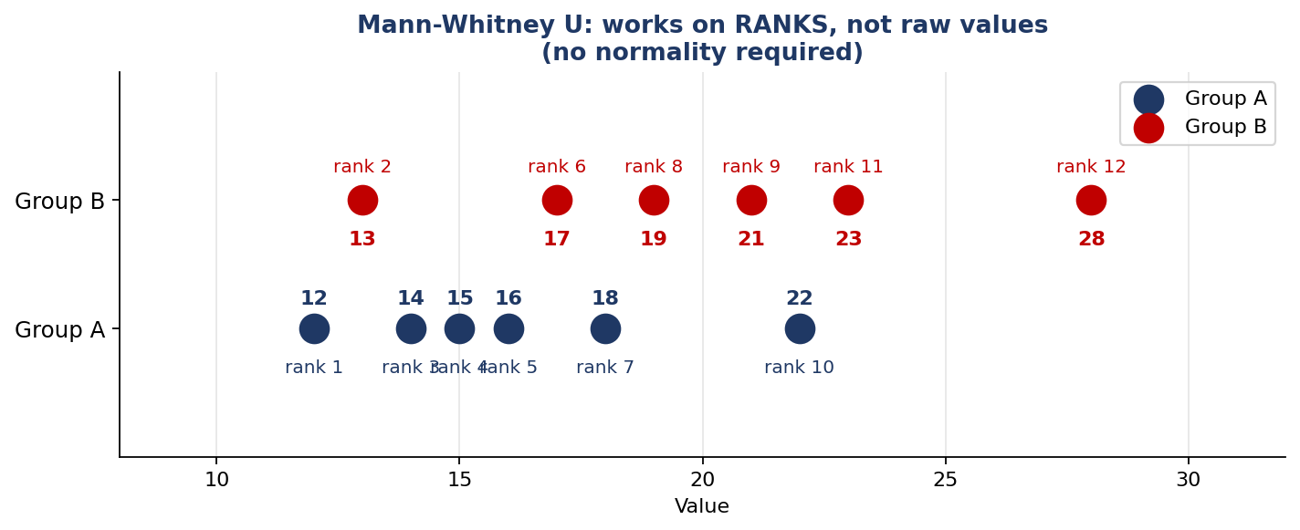
Mann-Whitney converts values to ranks and tests if one group ranks higher overall.

The Main Non-Parametric Tests
Situation | Normal-data test | Non-parametric replacement
Compare ONE sample to a claimed value | One-sample t-test | Wilcoxon signed-rank (one-sample)
Compare TWO independent groups | Two-sample t-test | Mann-Whitney U test
Compare paired/before-after data | Paired t-test | Wilcoxon signed-rank (paired)
Compare 3+ groups | ANOVA | Kruskal-Wallis H test

Worked Example — Customer Wait Times at Two Stores
EXAMPLE 5 — Wait Times (skewed data)
You time how long customers wait in line at two stores. Wait-time data is always right-skewed (most short, a few very long).
- Store A (12 customers): 2, 3, 4, 4, 5, 5, 6, 7, 8, 9, 12, 15 minutes
- Store B (12 customers): 3, 4, 5, 6, 7, 8, 9, 11, 13, 14, 18, 22 minutes
Is store B genuinely slower, or is it random variation?

Because the data is skewed, we use Mann-Whitney U instead of a t-test.
from scipy.stats import mannwhitneyu

store_A = [2, 3, 4, 4, 5, 5, 6, 7, 8, 9, 12, 15]
store_B = [3, 4, 5, 6, 7, 8, 9, 11, 13, 14, 18, 22]

# TWO-tailed: is wait time DIFFERENT?
stat, p_two = mannwhitneyu(store_A, store_B, alternative='two-sided')
print(f'two-tailed p = {p_two:.4f}')

# ONE-tailed: is store B SLOWER than store A?
stat, p_one = mannwhitneyu(store_A, store_B, alternative='less')
print(f'one-tailed p (A < B) = {p_one:.4f}')

ONE-TAILED VS TWO-TAILED IN scipy
Pass the alternative argument to control tail direction:
- alternative='two-sided' — two-tailed (default)
- alternative='less' — left-tailed (first group is smaller)
- alternative='greater' — right-tailed (first group is larger)
Same argument works for ttest_ind, mannwhitneyu, wilcoxon, and most scipy tests.

Paired Data Example — Before/After a Diet
EXAMPLE 6 — Did the Diet Reduce Weight?
Same 8 people, weighed before and after a 4-week diet (kg):
- Before: 78, 92, 65, 88, 102, 71, 95, 83
- After: 76, 89, 64, 87, 96, 71, 91, 80
Differences are small, may not be normally distributed. Use Wilcoxon signed-rank.

from scipy.stats import wilcoxon

before = [78, 92, 65, 88, 102, 71, 95, 83]
after = [76, 89, 64, 87, 96, 71, 91, 80]

# ONE-tailed: did weight DECREASE? (so before > after)
stat, p = wilcoxon(before, after, alternative='greater')
print(f'one-tailed p = {p:.4f}')

# TWO-tailed: did weight CHANGE in either direction?
stat, p = wilcoxon(before, after, alternative='two-sided')
print(f'two-tailed p = {p:.4f}')

WHY NON-PARAMETRIC TESTS ARE SAFE
Non-parametric tests don't assume any particular shape, so they work whether your data is normal, skewed, has outliers, or is bumpy.
The trade-off: when the data IS normal, they have slightly less statistical power than a t-test (need a bit more data to detect the same effect). But the safety is usually worth it.

5. Two Common Data Science Use Cases
Two ways p-values show up in everyday data science work, with full code you can copy-paste.

Use Case 1 — A/B Testing a Website Change
THE SETUP
Your team changed the checkout button from "Buy Now" to "Get Yours Today." You ran an A/B test for one week:
- Group A (old button): 5,000 visitors, 320 purchases
- Group B (new button): 5,000 visitors, 365 purchases
Conversion rates: A = 6.4%, B = 7.3%. Is B genuinely better?

Because we're comparing PROPORTIONS (purchased vs not), use a chi-square test. This doesn't require normal data — it works on counts.
from scipy.stats import chi2_contingency

# Rows = groups, columns = [bought, didn't buy]
table = [[320, 5000 - 320],
[365, 5000 - 365]]

chi2, p, dof, expected = chi2_contingency(table)
print(f'p-value = {p:.4f}')

if p < 0.05:
print('Statistically significant — new button is better.')
else:
print('Not significant — could be random variation.')

WHAT TO ALSO CHECK
Even if the p-value is significant, ask:
- How big is the lift? (0.9 percentage points here) Is that worth the cost of changing things?
- Did you run the test long enough to capture weekly patterns?
- Are there any segments where the new button does worse?

Use Case 2 — Is This Feature Useful for Prediction?
THE SETUP
You're building a model to predict whether a customer will churn. You have a column called "total_minutes_on_app_last_month." Is this feature actually related to churn, or just noise?
Plan: compare the distribution of app-time for churners vs non-churners. If they differ, the feature is useful.

Step 1: Check if app-time is normally distributed.
Step 2a: If yes → t-test.
Step 2b: If no → log-transform OR Mann-Whitney U.
import numpy as np
import pandas as pd
from scipy.stats import ttest_ind, mannwhitneyu, shapiro

df = pd.read_csv('customers.csv')
app_time_churned = df.loc[df.churned == 1, 'total_minutes']
app_time_retained = df.loc[df.churned == 0, 'total_minutes']

# Check normality (use a sample if dataset is huge)
p_norm_1 = shapiro(app_time_churned.sample(min(500, len(app_time_churned)))).pvalue
p_norm_2 = shapiro(app_time_retained.sample(min(500, len(app_time_retained)))).pvalue
is_normal = (p_norm_1 > 0.05) and (p_norm_2 > 0.05)

if is_normal:
stat, p = ttest_ind(app_time_churned, app_time_retained, equal_var=False)
test_used = 't-test'
else:
# App-time is usually right-skewed → use Mann-Whitney
stat, p = mannwhitneyu(app_time_churned, app_time_retained,
alternative='two-sided')
test_used = 'Mann-Whitney U'

print(f'Test used: {test_used}')
print(f'p-value = {p:.4f}')

if p < 0.05:
print('App-time differs between churners and non-churners — keep the feature.')
else:
print('No clear difference — this feature may not help the model.')

REMINDER FROM EARLIER
A high p-value doesn't mean the feature is useless for ALL models. A tree-based model might find non-linear patterns the test misses.
Use p-values as ONE signal among many — alongside correlation, mutual information, and model-based feature importance.

6. The Whole Decision in One Table
Bookmark this. It maps every situation to the right test.
Your situation | Test to use | scipy function | Tail control
Data is normal, one sample vs claim | One-sample t-test (or z-test) | ttest_1samp | alternative='less'/'greater'/'two-sided'
Data is normal, two groups | Two-sample t-test | ttest_ind | alternative='less'/'greater'/'two-sided'
Data is normal, paired | Paired t-test | ttest_rel | alternative='less'/'greater'/'two-sided'
Data is skewed but can be log-transformed | Transform, then t-test | ttest_ind (on log) | Same as above
Data is non-normal, one sample | Wilcoxon signed-rank | wilcoxon | alternative='less'/'greater'/'two-sided'
Data is non-normal, two groups | Mann-Whitney U | mannwhitneyu | alternative='less'/'greater'/'two-sided'
Data is non-normal, paired | Wilcoxon signed-rank (paired) | wilcoxon | alternative='less'/'greater'/'two-sided'
Comparing proportions (A/B test) | Chi-square test | chi2_contingency | (two-tailed only — use Fisher's exact for small data)
Three or more groups (normal) | ANOVA | f_oneway | (two-tailed by nature)
Three or more groups (non-normal) | Kruskal-Wallis | kruskal | (two-tailed by nature)

THE BIG PICTURE
1. P-value = how surprising your data is, IF the null hypothesis were true.
2. On a normal curve, p-value = area in the tail(s).
3. One-tailed = one direction only. Two-tailed = either direction.
4. If data isn't normal → transform it, OR use a non-parametric test (which works on ranks).
5. Same tail-direction logic applies to non-parametric tests via the alternative parameter.
6. Always pair the p-value with effect size and a visual sanity check.

