DSA FAANG Phase — Study Guide
52 Days of Pattern-Grinding & Mock Interviews

F1 — F10 • Companies' favorites • 10 Mock Interviews

What this phase is about: Stages 1–5 gave you the fundamentals. The FAANG phase is about SPEED, PATTERN RECOGNITION, and INTERVIEW EXECUTION. You won't learn new theory here — you'll repeat patterns until they become reflexes. This is the part most candidates skip and then fail at the whiteboard.

How this guide is structured
- 10 batches (F1–F10), each focused on one topic family.
- Daily schedule for each batch: which day does what (practice vs review vs mock).
- Each problem has: name, difficulty, approach, Python solution, complexity.
- Mocks are spread throughout — not just at the end.
- After each batch: a checkpoint to self-assess before moving on.

How long this phase takes
Two hours per weekday × 52 weekdays ≈ 10 calendar weeks. If you skip days, just resume — don't try to make up multiple days at once or you'll burn out. Slow and steady beats sprinting.

How to Use This Guide
The 52 days at a glance
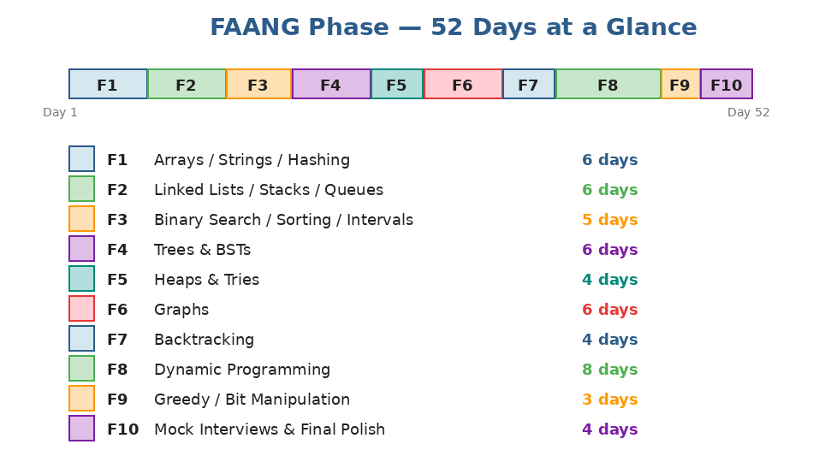
10 batches sized by importance. DP gets the most days (8) because it's the most-feared topic. Mocks alone get 4 days at the end, but mocks also pop up inside earlier batches.
Your 2-hour daily routine
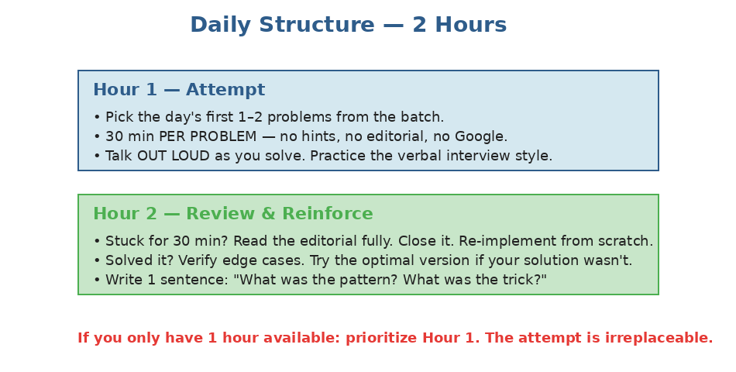
Two distinct hours. Don't blur them — the attempt is what builds skill, the review is what cements it.
The 8-step problem attack
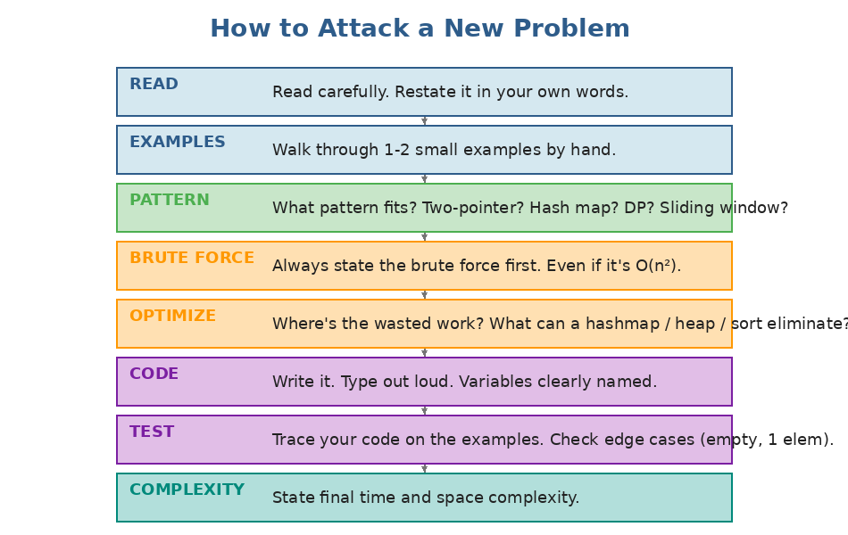
Don't skip steps 1–5. Most candidates jump straight to coding and fall apart. Verbalizing the brute force first is what FAANG interviewers want to hear.
Mock interview structure (45 minutes)
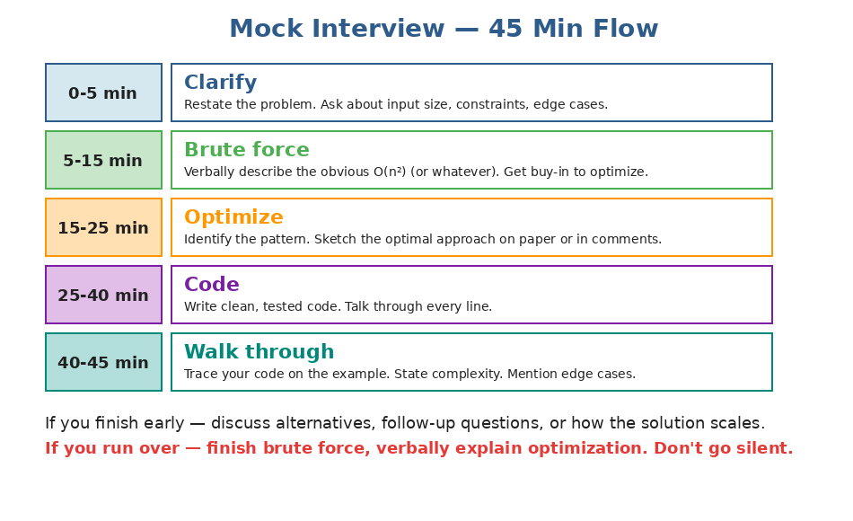
In a real interview, structure beats brilliance. Stick to the timing.
Pattern recognition cheat-sheet
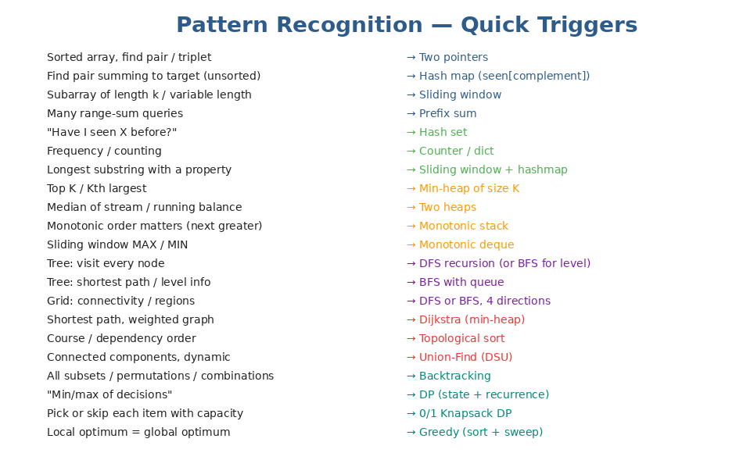
Print this and tape it next to your monitor. Within 30 seconds of reading a problem, you should have a pattern guess.
Weekly weakness drill
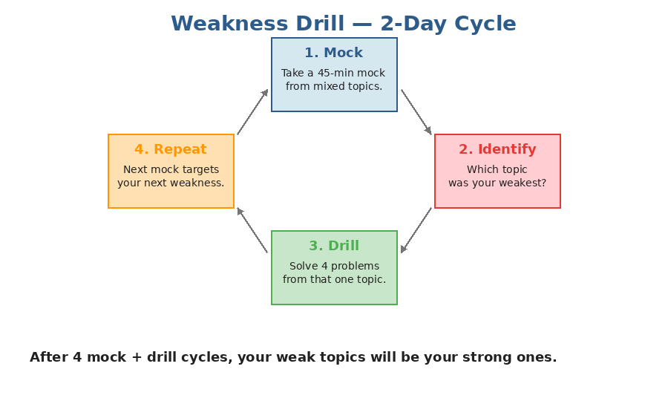
After every mock, identify the topic that hurt the most. That's your drill target for the next 2-day cycle.
Three rules to obey throughout
Rule 1 — The 25-minute timer: If you've been stuck for 25 minutes, STOP. Read the editorial fully. Close it. Re-implement from scratch. Beating your head against a problem for an hour teaches frustration, not patterns.

Rule 2 — Verbalize everything: Practice talking through your solution OUT LOUD as you write code. Real interviews are 50% communication. Silent solving builds a habit you'll have to unlearn.

Rule 3 — Always state complexity: After every problem, write a one-line comment with the time and space complexity. Treat it as part of the solution.

F1 — Arrays, Strings, Hashing (6 days)
FAANG-favorite topic. About 30% of interview problems use one of these patterns. Master them first.
Daily schedule
Day | Type | Content
Day 1 | Practice | Two Sum, Best Time to Buy/Sell Stock, Contains Duplicate, Valid Anagram
Day 2 | Practice | Group Anagrams, Top K Frequent Elements, Product of Array Except Self
Day 3 | Practice | Longest Substring Without Repeating Characters, Longest Repeating Character Replacement
Day 4 | Practice | Minimum Window Substring, Valid Sudoku, Encode/Decode Strings
Day 5 | Mock | 45-min mock: pick 1 random problem from F1, solve under timer
Day 6 | Review | Re-solve any 3 problems you struggled with. Update pattern notes.

Problems with solutions
Two Sum [Easy]
Approach: Walk the array; for each x, check if target - x is in seen. Otherwise record x → its index. One pass.
def two_sum(nums, target):
seen = {}
for i, x in enumerate(nums):
if target - x in seen:
return [seen[target - x], i]
seen[x] = i

Complexity: O(n) time, O(n) space.
Best Time to Buy and Sell Stock [Easy]
Approach: Track the minimum price seen so far. Profit at each day = price - min_so_far. Track the max profit.
def max_profit(prices):
min_price = float('inf')
best = 0
for p in prices:
min_price = min(min_price, p)
best = max(best, p - min_price)
return best

Complexity: O(n) time, O(1) space.
Contains Duplicate [Easy]
Approach: Compare len(nums) to len(set(nums)). Or walk with a set, return True on first repeat.
def contains_duplicate(nums):
return len(nums) != len(set(nums))

Complexity: O(n) time, O(n) space.
Valid Anagram [Easy]
Approach: Compare character frequencies. Counter from collections is the cleanest.
from collections import Counter
def is_anagram(s, t):
return Counter(s) == Counter(t)

Complexity: O(n) time, O(1) space (26 letters).
Group Anagrams [Medium]
Approach: Bucket strings by sorted tuple of characters. Sorted-letters key groups all anagrams together.
from collections import defaultdict
def group_anagrams(strs):
groups = defaultdict(list)
for s in strs:
key = tuple(sorted(s))
groups[key].append(s)
return list(groups.values())

Complexity: O(n × k log k) where k = max string length.
Top K Frequent Elements [Medium]
Approach: Count frequencies. Use a min-heap of size k by frequency, or bucket sort by frequency for O(n).
from collections import Counter
import heapq
def top_k_frequent(nums, k):
counts = Counter(nums)
return heapq.nlargest(k, counts.keys(), key=counts.get)

Complexity: O(n log k) time, O(n) space.
Product of Array Except Self [Medium]
Approach: Two passes. First pass: prefix products from left. Second pass: multiply each entry by suffix product from right (carry a single suffix variable).
def product_except_self(nums):
n = len(nums)
out = [1] * n
# prefix from left
p = 1
for i in range(n):
out[i] = p
p *= nums[i]
# suffix from right
s = 1
for i in range(n - 1, -1, -1):
out[i] *= s
s *= nums[i]
return out

Complexity: O(n) time, O(1) extra space (output array doesn't count).
Longest Substring Without Repeating Characters [Medium]
Approach: Sliding window. Right pointer expands; when a duplicate is seen, shrink from left until removed.
def length_of_longest_substring(s):
last = {}
left = 0
best = 0
for right, ch in enumerate(s):
if ch in last and last[ch] >= left:
left = last[ch] + 1
last[ch] = right
best = max(best, right - left + 1)
return best

Complexity: O(n) time, O(min(n, alphabet)) space.
Longest Repeating Character Replacement [Medium]
Approach: Sliding window. Track counts of letters. Window is valid if (window_size - max_count) ≤ k. Shrink from left when invalid.
from collections import Counter
def character_replacement(s, k):
counts = Counter()
left = 0
best = 0
max_count = 0
for right, ch in enumerate(s):
counts[ch] += 1
max_count = max(max_count, counts[ch])
if (right - left + 1) - max_count > k:
counts[s[left]] -= 1
left += 1
best = max(best, right - left + 1)
return best

Complexity: O(n) time.
Minimum Window Substring [Hard]
Approach: Sliding window with a need-counter. Expand right; when window covers all of t, shrink left while still covering. Track min window.
from collections import Counter
def min_window(s, t):
if not t or not s: return ""
need = Counter(t)
missing = len(t)
left = 0
best = (float('inf'), 0, 0)
for right, ch in enumerate(s):
if need[ch] > 0:
missing -= 1
need[ch] -= 1
while missing == 0:
if right - left + 1 < best[0]:
best = (right - left + 1, left, right)
need[s[left]] += 1
if need[s[left]] > 0:
missing += 1
left += 1
return "" if best[0] == float('inf') else s[best[1]:best[2]+1]

Complexity: O(|s| + |t|) time.
Valid Sudoku [Medium]
Approach: Track 9 row sets, 9 column sets, 9 box sets. For each filled cell, check if the digit is already in the corresponding sets; otherwise add it.
def is_valid_sudoku(board):
rows = [set() for _ in range(9)]
cols = [set() for _ in range(9)]
boxes = [set() for _ in range(9)]
for r in range(9):
for c in range(9):
v = board[r][c]
if v == '.': continue
b = (r // 3) * 3 + c // 3
if v in rows[r] or v in cols[c] or v in boxes[b]:
return False
rows[r].add(v); cols[c].add(v); boxes[b].add(v)
return True

Complexity: O(1) — board is fixed 9×9.
Encode and Decode Strings [Medium]
Approach: Length-prefix encoding: for each string, write its length, a delimiter (#), then the string. Decoder reads the length first, then exactly that many chars.
def encode(strs):
return ''.join(f"{len(s)}#{s}" for s in strs)

def decode(s):
result = []
i = 0
while i < len(s):
j = i
while s[j] != '#': j += 1
length = int(s[i:j])
result.append(s[j+1:j+1+length])
i = j + 1 + length
return result

Complexity: O(n) for both.
F1 Checkpoint: Before moving to F2, you should be able to solve Two Sum, Group Anagrams, Top K Frequent, and Longest Substring Without Repeating from a blank file in under 10 minutes each.

F2 — Linked Lists, Stacks, Queues (6 days)
Pointer manipulation + the monotonic stack pattern. Both show up constantly.
Daily schedule
Day | Type | Content
Day 1 | Practice | Reverse Linked List, Merge Two Sorted Lists, Linked List Cycle
Day 2 | Practice | Remove Nth Node From End, Reorder List, Copy List with Random Pointer
Day 3 | Practice | Valid Parentheses, Min Stack, Evaluate Reverse Polish Notation
Day 4 | Practice | Daily Temperatures, Largest Rectangle in Histogram, Sliding Window Maximum
Day 5 | Mock | 45-min mock from F1+F2 random problem
Day 6 | Review | Re-solve 2 hardest problems. Speed-pass: Reverse LL + Valid Parens in under 5 min.

Problems with solutions
Reverse Linked List [Easy]
Approach: Three-pointer technique. prev = None, curr = head. At each step: save next, flip curr, advance.
def reverse_list(head):
prev = None
curr = head
while curr:
nxt = curr.next
curr.next = prev
prev = curr
curr = nxt
return prev

Complexity: O(n) time, O(1) space.
Merge Two Sorted Lists [Easy]
Approach: Dummy node + tail pointer. Walk both lists, attach smaller node to tail. Append remainder at end.
def merge_two_lists(l1, l2):
dummy = ListNode()
tail = dummy
while l1 and l2:
if l1.val <= l2.val:
tail.next = l1; l1 = l1.next
else:
tail.next = l2; l2 = l2.next
tail = tail.next
tail.next = l1 or l2
return dummy.next

Complexity: O(n + m) time, O(1) space.
Linked List Cycle [Easy]
Approach: Floyd's tortoise & hare. Slow moves 1, fast moves 2. They meet inside the cycle, or fast hits None.
def has_cycle(head):
slow = fast = head
while fast and fast.next:
slow = slow.next
fast = fast.next.next
if slow == fast: return True
return False

Complexity: O(n) time, O(1) space.
Remove Nth Node From End of List [Medium]
Approach: Two pointers with a dummy node. Advance fast n steps, then move both until fast reaches the end. Slow now sits before the node to remove.
def remove_nth_from_end(head, n):
dummy = ListNode(0, head)
fast = slow = dummy
for _ in range(n):
fast = fast.next
while fast.next:
fast = fast.next
slow = slow.next
slow.next = slow.next.next
return dummy.next

Complexity: O(n) time, O(1) space.
Reorder List [Medium]
Approach: Three steps: (1) find the middle with slow/fast; (2) reverse the second half; (3) merge the two halves alternately.
def reorder_list(head):
if not head or not head.next: return
# 1. middle
slow = fast = head
while fast and fast.next:
slow = slow.next
fast = fast.next.next
# 2. reverse second half
prev, curr = None, slow.next
slow.next = None
while curr:
nxt = curr.next
curr.next = prev
prev = curr
curr = nxt
# 3. merge
first, second = head, prev
while second:
t1, t2 = first.next, second.next
first.next = second
second.next = t1
first, second = t1, t2

Complexity: O(n) time, O(1) space.
Copy List with Random Pointer [Medium]
Approach: Two-pass: first pass builds a hashmap from old node → new node (just values). Second pass wires up next and random by looking up via the map.
def copy_random_list(head):
if not head: return None
mapping = {}
curr = head
while curr:
mapping[curr] = Node(curr.val)
curr = curr.next
curr = head
while curr:
if curr.next: mapping[curr].next = mapping[curr.next]
if curr.random: mapping[curr].random = mapping[curr.random]
curr = curr.next
return mapping[head]

Complexity: O(n) time, O(n) space.
Valid Parentheses [Easy]
Approach: Stack of openers. On a closer, pop and check it matches. End must be empty stack.
def is_valid(s):
pairs = {')': '(', ']': '[', '}': '{'}
stack = []
for ch in s:
if ch in '([{':
stack.append(ch)
else:
if not stack or stack.pop() != pairs[ch]:
return False
return not stack

Complexity: O(n) time, O(n) space.
Min Stack [Medium]
Approach: Two stacks: regular + min-stack. On push, push min(new, current_min) onto min-stack. Pop both together.
class MinStack:
def __init__(self):
self.stack = []
self.mins = []
def push(self, val):
self.stack.append(val)
self.mins.append(val if not self.mins else min(val, self.mins[-1]))
def pop(self):
self.stack.pop(); self.mins.pop()
def top(self): return self.stack[-1]
def getMin(self): return self.mins[-1]

Complexity: O(1) per operation.
Evaluate Reverse Polish Notation [Medium]
Approach: Walk tokens. Numbers go on stack. Operators pop b then a, compute a OP b, push result.
def eval_rpn(tokens):
stack = []
for t in tokens:
if t in {'+', '-', '*', '/'}:
b, a = stack.pop(), stack.pop()
if t == '+': stack.append(a + b)
elif t == '-': stack.append(a - b)
elif t == '*': stack.append(a * b)
else: stack.append(int(a / b))
else:
stack.append(int(t))
return stack[0]

Complexity: O(n) time, O(n) space.
Daily Temperatures [Medium]
Approach: Monotonic decreasing stack of indices. When today's temp is warmer than the index on top, pop and record the gap.
def daily_temperatures(temps):
n = len(temps)
answer = [0] * n
stack = []
for i, t in enumerate(temps):
while stack and temps[stack[-1]] < t:
j = stack.pop()
answer[j] = i - j
stack.append(i)
return answer

Complexity: O(n) time, O(n) space.
Largest Rectangle in Histogram [Hard]
Approach: Monotonic increasing stack of indices. When a shorter bar appears, pop and compute area for the popped height. Width spans from after the new top to the current index. Append a 0 sentinel to drain.
def largest_rectangle(heights):
stack = []
heights = heights + [0]
best = 0
for i, h in enumerate(heights):
while stack and heights[stack[-1]] > h:
top = stack.pop()
width = i if not stack else i - stack[-1] - 1
best = max(best, heights[top] * width)
stack.append(i)
return best

Complexity: O(n) time, O(n) space.
Sliding Window Maximum [Hard]
Approach: Monotonic decreasing deque of indices. Pop smaller from back before pushing. Drop front when out of window. Front is the current window's max.
from collections import deque
def max_sliding_window(nums, k):
dq = deque()
result = []
for i, x in enumerate(nums):
while dq and nums[dq[-1]] < x:
dq.pop()
dq.append(i)
if dq[0] <= i - k:
dq.popleft()
if i >= k - 1:
result.append(nums[dq[0]])
return result

Complexity: O(n) time, O(k) space.
F2 Checkpoint: Reverse LL, Linked List Cycle, Valid Parens, Min Stack, and Daily Temperatures should all be on autopilot. If Sliding Window Max still feels hard, that's normal — re-solve it twice this week.

F3 — Binary Search, Sorting, Intervals (5 days)
Three patterns that look easy until they aren't. Binary search has many variants; intervals reward sort + sweep.
Daily schedule
Day | Type | Content
Day 1 | Practice | Binary Search, Search in Rotated Sorted Array, Find Minimum in Rotated Sorted Array
Day 2 | Practice | Search a 2D Matrix, Koko Eating Bananas, Find First and Last Position
Day 3 | Practice | Merge Intervals, Insert Interval, Non-overlapping Intervals
Day 4 | Practice | Meeting Rooms II, Sort Colors
Day 5 | Mock | 45-min mock + checkpoint review

Problems with solutions
Binary Search [Easy]
Approach: Standard inclusive [lo, hi] binary search. Pick the convention and stick with it.
def search(nums, target):
lo, hi = 0, len(nums) - 1
while lo <= hi:
mid = (lo + hi) // 2
if nums[mid] == target: return mid
elif nums[mid] < target: lo = mid + 1
else: hi = mid - 1
return -1

Complexity: O(log n) time.
Search in Rotated Sorted Array [Medium]
Approach: Binary search with a twist: at each mid, one side is sorted. Check whether target lies in the sorted side.
def search(nums, target):
lo, hi = 0, len(nums) - 1
while lo <= hi:
mid = (lo + hi) // 2
if nums[mid] == target: return mid
if nums[lo] <= nums[mid]:
if nums[lo] <= target < nums[mid]: hi = mid - 1
else: lo = mid + 1
else:
if nums[mid] < target <= nums[hi]: lo = mid + 1
else: hi = mid - 1
return -1

Complexity: O(log n) time.
Find Minimum in Rotated Sorted Array [Medium]
Approach: Binary search for the rotation point. Compare nums[mid] with nums[hi]: if mid > hi, min is to the right; else min could be mid.
def find_min(nums):
lo, hi = 0, len(nums) - 1
while lo < hi:
mid = (lo + hi) // 2
if nums[mid] > nums[hi]: lo = mid + 1
else: hi = mid
return nums[lo]

Complexity: O(log n) time.
Search a 2D Matrix [Medium]
Approach: Treat the matrix as a flattened sorted array of m*n elements. Binary search using row = idx // cols, col = idx % cols.
def search_matrix(matrix, target):
if not matrix: return False
m, n = len(matrix), len(matrix[0])
lo, hi = 0, m*n - 1
while lo <= hi:
mid = (lo + hi) // 2
v = matrix[mid // n][mid % n]
if v == target: return True
elif v < target: lo = mid + 1
else: hi = mid - 1
return False

Complexity: O(log(m*n)) time.
Koko Eating Bananas [Medium]
Approach: Binary search on the answer (eating speed k). Range: 1 to max(piles). For each k, total hours = sum(ceil(p/k)) — feasible if ≤ h.
import math
def min_eating_speed(piles, h):
def can_finish(k):
return sum(math.ceil(p / k) for p in piles) <= h
lo, hi = 1, max(piles)
while lo < hi:
mid = (lo + hi) // 2
if can_finish(mid): hi = mid
else: lo = mid + 1
return lo

Complexity: O(n log m) where m = max(piles).
Find First and Last Position of Element in Sorted Array [Medium]
Approach: Two binary searches: leftmost and rightmost. Or use Python's bisect_left and bisect_right.
from bisect import bisect_left, bisect_right
def search_range(nums, target):
left = bisect_left(nums, target)
right = bisect_right(nums, target) - 1
if left <= right and right < len(nums) and nums[left] == target:
return [left, right]
return [-1, -1]

Complexity: O(log n) time.
Merge Intervals [Medium]
Approach: Sort by start. Walk through; if current overlaps with last merged, extend end. Else start a new merged interval.
def merge(intervals):
intervals.sort(key=lambda x: x[0])
merged = []
for s, e in intervals:
if merged and s <= merged[-1][1]:
merged[-1][1] = max(merged[-1][1], e)
else:
merged.append([s, e])
return merged

Complexity: O(n log n) time.
Insert Interval [Medium]
Approach: Three phases on the already-sorted list: skip non-overlapping before, merge overlapping into the new interval, append rest.
def insert(intervals, new):
result = []
i, n = 0, len(intervals)
while i < n and intervals[i][1] < new[0]:
result.append(intervals[i]); i += 1
while i < n and intervals[i][0] <= new[1]:
new[0] = min(new[0], intervals[i][0])
new[1] = max(new[1], intervals[i][1])
i += 1
result.append(new)
while i < n:
result.append(intervals[i]); i += 1
return result

Complexity: O(n) time.
Non-overlapping Intervals [Medium]
Approach: Sort by END. Greedily keep each interval whose start ≥ previous kept end. Removed = total - kept.
def erase_overlap(intervals):
intervals.sort(key=lambda x: x[1])
kept, end = 0, float('-inf')
for s, e in intervals:
if s >= end:
kept += 1
end = e
return len(intervals) - kept

Complexity: O(n log n) time.
Meeting Rooms II [Medium]
Approach: Sort starts and ends separately. Merge-walk: each start needs a room, each end frees one. Track running count's max.
def min_meeting_rooms(intervals):
starts = sorted(i[0] for i in intervals)
ends = sorted(i[1] for i in intervals)
rooms = best = 0
s = e = 0
while s < len(starts):
if starts[s] < ends[e]:
rooms += 1
best = max(best, rooms)
s += 1
else:
rooms -= 1
e += 1
return best

Complexity: O(n log n) time.
Sort Colors [Medium]
Approach: Dutch National Flag. Three pointers: low (next 0 slot), mid (cursor), high (next 2 slot). One pass, O(1) space.
def sort_colors(nums):
low = mid = 0
high = len(nums) - 1
while mid <= high:
if nums[mid] == 0:
nums[low], nums[mid] = nums[mid], nums[low]
low += 1; mid += 1
elif nums[mid] == 1:
mid += 1
else:
nums[mid], nums[high] = nums[high], nums[mid]
high -= 1

Complexity: O(n) time, O(1) space.
F3 Checkpoint: Binary search variants are the topic where off-by-one bugs hide. After this batch, you should be able to write classic Binary Search, Search in Rotated, and Koko in under 5 min each.

F4 — Trees and BSTs (6 days)
Trees show up in 25%+ of FAANG interviews. The recursion templates here transfer to graphs and DP later.
Daily schedule
Day | Type | Content
Day 1 | Practice | Maximum Depth, Same Tree, Invert Binary Tree, Diameter of Binary Tree
Day 2 | Practice | Balanced Binary Tree, Subtree of Another Tree, Lowest Common Ancestor of BST
Day 3 | Practice | Binary Tree Level Order Traversal, Binary Tree Right Side View, Count Good Nodes
Day 4 | Practice | Validate BST, Kth Smallest in BST, Construct Tree from Preorder and Inorder
Day 5 | Practice | Binary Tree Maximum Path Sum, Serialize and Deserialize Binary Tree
Day 6 | Mock | 45-min mock + review

Problems with solutions
Maximum Depth of Binary Tree [Easy]
Approach: Classic recursion: depth(None) = 0; otherwise 1 + max(depth(left), depth(right)).
def max_depth(root):
if not root: return 0
return 1 + max(max_depth(root.left), max_depth(root.right))

Complexity: O(n) time, O(h) space.
Same Tree [Easy]
Approach: Recurse on both at once. Equal iff both None, or values match and both subtrees match.
def is_same_tree(p, q):
if not p and not q: return True
if not p or not q: return False
return p.val == q.val and is_same_tree(p.left, q.left) and is_same_tree(p.right, q.right)

Complexity: O(n) time.
Invert Binary Tree [Easy]
Approach: At each node swap left and right, recurse on both.
def invert_tree(root):
if not root: return None
root.left, root.right = invert_tree(root.right), invert_tree(root.left)
return root

Complexity: O(n) time, O(h) space.
Diameter of Binary Tree [Easy]
Approach: For each node, diameter through it = left_depth + right_depth. Track max in a closure while computing depths.
def diameter(root):
best = [0]
def depth(node):
if not node: return 0
L = depth(node.left)
R = depth(node.right)
best[0] = max(best[0], L + R)
return 1 + max(L, R)
depth(root)
return best[0]

Complexity: O(n) time.
Balanced Binary Tree [Easy]
Approach: Helper returns height, or -1 if unbalanced subtree found. Propagate -1 up.
def is_balanced(root):
def check(node):
if not node: return 0
L = check(node.left)
if L == -1: return -1
R = check(node.right)
if R == -1 or abs(L - R) > 1: return -1
return 1 + max(L, R)
return check(root) != -1

Complexity: O(n) time.
Subtree of Another Tree [Easy]
Approach: Walk root, at each node check is_same_tree(node, sub).
def is_subtree(root, sub):
if not root: return False
if is_same_tree(root, sub): return True
return is_subtree(root.left, sub) or is_subtree(root.right, sub)

Complexity: O(n × m) time.
Lowest Common Ancestor of a BST [Medium]
Approach: Use BST property. Walk down: if both p, q < root → left; both > → right; otherwise root is the split point.
def lowest_common_ancestor(root, p, q):
while root:
if p.val < root.val and q.val < root.val:
root = root.left
elif p.val > root.val and q.val > root.val:
root = root.right
else:
return root

Complexity: O(h) time.
Binary Tree Level Order Traversal [Medium]
Approach: BFS with a queue. Capture level_size at the start of each loop iteration.
from collections import deque
def level_order(root):
if not root: return []
result = []
q = deque([root])
while q:
size = len(q)
level = []
for _ in range(size):
node = q.popleft()
level.append(node.val)
if node.left: q.append(node.left)
if node.right: q.append(node.right)
result.append(level)
return result

Complexity: O(n) time, O(w) space.
Binary Tree Right Side View [Medium]
Approach: BFS by level, take the LAST node of each level.
from collections import deque
def right_side_view(root):
if not root: return []
result = []
q = deque([root])
while q:
size = len(q)
for i in range(size):
node = q.popleft()
if i == size - 1:
result.append(node.val)
if node.left: q.append(node.left)
if node.right: q.append(node.right)
return result

Complexity: O(n) time.
Count Good Nodes in Binary Tree [Medium]
Approach: DFS carrying max-so-far down the path. A node is 'good' if its value ≥ max-so-far.
def good_nodes(root):
def dfs(node, max_so_far):
if not node: return 0
good = 1 if node.val >= max_so_far else 0
new_max = max(max_so_far, node.val)
return good + dfs(node.left, new_max) + dfs(node.right, new_max)
return dfs(root, float('-inf'))

Complexity: O(n) time.
Validate Binary Search Tree [Medium]
Approach: Recurse with (low, high) bounds. At each node, val must lie strictly inside. Tightening on each side.
def is_valid_bst(root):
def helper(node, lo, hi):
if not node: return True
if not (lo < node.val < hi): return False
return helper(node.left, lo, node.val) and helper(node.right, node.val, hi)
return helper(root, float('-inf'), float('inf'))

Complexity: O(n) time.
Kth Smallest Element in a BST [Medium]
Approach: Iterative inorder with a stack. Each pop is the next smallest. Stop when k decrements to 0.
def kth_smallest(root, k):
stack = []
curr = root
while stack or curr:
while curr:
stack.append(curr)
curr = curr.left
curr = stack.pop()
k -= 1
if k == 0: return curr.val
curr = curr.right

Complexity: O(h + k) time.
Construct Binary Tree from Preorder and Inorder Traversal [Medium]
Approach: First preorder element is root. Find it in inorder; left of it = left subtree's inorder, right = right subtree's. Recurse. Use a hashmap of inorder positions for O(1) lookup.
def build_tree(preorder, inorder):
pos = {v: i for i, v in enumerate(inorder)}
pre_iter = iter(preorder)
def helper(lo, hi):
if lo > hi: return None
val = next(pre_iter)
root = TreeNode(val)
i = pos[val]
root.left = helper(lo, i - 1)
root.right = helper(i + 1, hi)
return root
return helper(0, len(inorder) - 1)

Complexity: O(n) time, O(n) space.
Binary Tree Maximum Path Sum [Hard]
Approach: Helper returns max gain from this node DOWN one branch. At each node, candidate path sum = node.val + max(0, left_gain) + max(0, right_gain). Update best.
def max_path_sum(root):
best = [float('-inf')]
def gain(node):
if not node: return 0
L = max(0, gain(node.left))
R = max(0, gain(node.right))
best[0] = max(best[0], node.val + L + R)
return node.val + max(L, R)
gain(root)
return best[0]

Complexity: O(n) time.
Serialize and Deserialize Binary Tree [Hard]
Approach: Preorder DFS with 'null' markers for missing children. Deserialize using an iterator over the tokens.
class Codec:
def serialize(self, root):
out = []
def dfs(node):
if not node: out.append('#'); return
out.append(str(node.val))
dfs(node.left); dfs(node.right)
dfs(root)
return ','.join(out)

def deserialize(self, data):
it = iter(data.split(','))
def build():
v = next(it)
if v == '#': return None
node = TreeNode(int(v))
node.left = build(); node.right = build()
return node
return build()

Complexity: O(n) time.
F4 Checkpoint: Tree traversal templates (DFS recursive + BFS with level_size) should be muscle memory now. Maximum Path Sum is the hardest — re-solve it twice if needed.

F5 — Heaps and Tries (4 days)
Heaps power top-K and stream-median problems. Tries power prefix queries. Both have crisp templates.
Daily schedule
Day | Type | Content
Day 1 | Practice | Kth Largest Element, K Closest Points to Origin, Last Stone Weight
Day 2 | Practice | Find Median from Data Stream, Task Scheduler
Day 3 | Practice | Implement Trie, Word Dictionary with wildcard, Word Search II
Day 4 | Mock | 45-min mock + review

Problems with solutions
Kth Largest Element in an Array [Medium]
Approach: Min-heap of size k. After all pushes/pops, the smallest in the heap IS the kth largest.
import heapq
def find_kth_largest(nums, k):
heap = []
for x in nums:
heapq.heappush(heap, x)
if len(heap) > k:
heapq.heappop(heap)
return heap[0]

Complexity: O(n log k) time.
K Closest Points to Origin [Medium]
Approach: Max-heap of size k by squared distance (negate for max-heap). Squared distance avoids sqrt.
import heapq
def k_closest(points, k):
heap = []
for x, y in points:
d = -(x*x + y*y)
heapq.heappush(heap, (d, x, y))
if len(heap) > k:
heapq.heappop(heap)
return [[x, y] for _, x, y in heap]

Complexity: O(n log k) time.
Last Stone Weight [Easy]
Approach: Max-heap (negate values). Pop two largest, smash, push the difference if non-zero.
import heapq
def last_stone_weight(stones):
heap = [-s for s in stones]
heapq.heapify(heap)
while len(heap) > 1:
a = -heapq.heappop(heap)
b = -heapq.heappop(heap)
if a != b:
heapq.heappush(heap, -(a - b))
return -heap[0] if heap else 0

Complexity: O(n log n) time.
Find Median from Data Stream [Hard]
Approach: Two heaps: max-heap (lo, negated) for smaller half, min-heap (hi) for larger. Keep |lo|=|hi| or |lo|=|hi|+1.
import heapq
class MedianFinder:
def __init__(self):
self.lo, self.hi = [], []
def addNum(self, num):
heapq.heappush(self.lo, -num)
heapq.heappush(self.hi, -heapq.heappop(self.lo))
if len(self.hi) > len(self.lo):
heapq.heappush(self.lo, -heapq.heappop(self.hi))
def findMedian(self):
if len(self.lo) > len(self.hi):
return -self.lo[0]
return (-self.lo[0] + self.hi[0]) / 2

Complexity: O(log n) per add, O(1) per median.
Task Scheduler [Medium]
Approach: Formula: with M = max frequency and c = number of tasks tied at M, answer = max(len(tasks), (M-1)*(n+1) + c).
from collections import Counter
def least_interval(tasks, n):
counts = Counter(tasks)
max_count = max(counts.values())
tied = sum(1 for v in counts.values() if v == max_count)
return max(len(tasks), (max_count - 1) * (n + 1) + tied)

Complexity: O(n) time.
Implement Trie (Prefix Tree) [Medium]
Approach: Nested dict per node, '#' marks end of word. Walk character by character.
class Trie:
def __init__(self):
self.root = {}
def insert(self, word):
node = self.root
for ch in word:
if ch not in node: node[ch] = {}
node = node[ch]
node['#'] = True
def search(self, word):
node = self._walk(word)
return node is not None and '#' in node
def startsWith(self, prefix):
return self._walk(prefix) is not None
def _walk(self, s):
node = self.root
for ch in s:
if ch not in node: return None
node = node[ch]
return node

Complexity: O(L) per operation where L = word length.
Design Add and Search Words Data Structure [Medium]
Approach: Trie with wildcard search. On '.', try ALL children recursively.
class WordDictionary:
def __init__(self):
self.root = {}
def addWord(self, word):
node = self.root
for ch in word:
if ch not in node: node[ch] = {}
node = node[ch]
node['#'] = True
def search(self, word):
def dfs(node, i):
if i == len(word): return '#' in node
ch = word[i]
if ch == '.':
for k, child in node.items():
if k != '#' and dfs(child, i + 1): return True
return False
if ch not in node: return False
return dfs(node[ch], i + 1)
return dfs(self.root, 0)

Complexity: Search worst-case O(26^L) with wildcards, otherwise O(L).
Word Search II [Hard]
Approach: Build trie of words. DFS from each cell, walk trie in parallel. Mark visited with '#', restore on backtrack.
def find_words(board, words):
trie = {}
for w in words:
node = trie
for ch in w:
if ch not in node: node[ch] = {}
node = node[ch]
node['$'] = w
rows, cols = len(board), len(board[0])
found = set()
def dfs(r, c, node):
ch = board[r][c]
if ch not in node: return
nxt = node[ch]
if '$' in nxt: found.add(nxt['$'])
board[r][c] = '#'
for dr, dc in [(-1,0),(1,0),(0,-1),(0,1)]:
nr, nc = r+dr, c+dc
if 0 <= nr < rows and 0 <= nc < cols and board[nr][nc] != '#':
dfs(nr, nc, nxt)
board[r][c] = ch
for r in range(rows):
for c in range(cols):
dfs(r, c, trie)
return list(found)

Complexity: O(rows × cols × 4^L) worst case.
F5 Checkpoint: Top K Frequent, K Closest Points, and the Trie class should be 5-minute writes. Median Finder is the trickiest — practice it twice.

F6 — Graphs (6 days)
Graphs and grid-as-graph. The biggest topic outside DP. Most companies will ask at least one graph problem.
Daily schedule
Day | Type | Content
Day 1 | Practice | Number of Islands, Max Area of Island, Clone Graph
Day 2 | Practice | Pacific Atlantic Water Flow, Surrounded Regions, Rotting Oranges
Day 3 | Practice | Course Schedule, Course Schedule II, Number of Connected Components
Day 4 | Practice | Graph Valid Tree, Redundant Connection, Word Ladder
Day 5 | Practice | Network Delay Time, Cheapest Flights with K Stops
Day 6 | Mock | 45-min mock from F4–F6, then review

Problems with solutions
Number of Islands [Medium]
Approach: DFS or BFS from each unvisited land cell. Count starts.
def num_islands(grid):
if not grid: return 0
rows, cols = len(grid), len(grid[0])
count = 0
def dfs(r, c):
if not (0 <= r < rows and 0 <= c < cols): return
if grid[r][c] != '1': return
grid[r][c] = '0'
for dr, dc in [(-1,0),(1,0),(0,-1),(0,1)]:
dfs(r+dr, c+dc)
for r in range(rows):
for c in range(cols):
if grid[r][c] == '1':
count += 1
dfs(r, c)
return count

Complexity: O(rows × cols) time.
Max Area of Island [Medium]
Approach: DFS that returns the size of the explored region; track max.
def max_area(grid):
rows, cols = len(grid), len(grid[0])
def dfs(r, c):
if not (0 <= r < rows and 0 <= c < cols) or grid[r][c] != 1: return 0
grid[r][c] = 0
return 1 + dfs(r+1,c) + dfs(r-1,c) + dfs(r,c+1) + dfs(r,c-1)
best = 0
for r in range(rows):
for c in range(cols):
if grid[r][c] == 1:
best = max(best, dfs(r, c))
return best

Complexity: O(rows × cols) time.
Clone Graph [Medium]
Approach: DFS with a hashmap from old-node to new-node. Recurse, attach cloned neighbors.
def clone_graph(node):
if not node: return None
cloned = {}
def dfs(n):
if n in cloned: return cloned[n]
copy = Node(n.val)
cloned[n] = copy
for nei in n.neighbors:
copy.neighbors.append(dfs(nei))
return copy
return dfs(node)

Complexity: O(V + E) time.
Pacific Atlantic Water Flow [Medium]
Approach: Reverse direction: start from each ocean's edge cells, walk to higher-or-equal cells. Intersection is the answer.
def pacific_atlantic(heights):
if not heights: return []
rows, cols = len(heights), len(heights[0])
pacific, atlantic = set(), set()
def dfs(r, c, visited):
visited.add((r, c))
for dr, dc in [(-1,0),(1,0),(0,-1),(0,1)]:
nr, nc = r+dr, c+dc
if (0 <= nr < rows and 0 <= nc < cols
and (nr, nc) not in visited
and heights[nr][nc] >= heights[r][c]):
dfs(nr, nc, visited)
for c in range(cols):
dfs(0, c, pacific); dfs(rows-1, c, atlantic)
for r in range(rows):
dfs(r, 0, pacific); dfs(r, cols-1, atlantic)
return [list(p) for p in pacific & atlantic]

Complexity: O(rows × cols) time.
Surrounded Regions [Medium]
Approach: Mark border-connected 'O's as safe (e.g. with '#'). Then flip remaining 'O' to 'X', restore '#' to 'O'.
def solve(board):
if not board: return
rows, cols = len(board), len(board[0])
def dfs(r, c):
if not (0 <= r < rows and 0 <= c < cols): return
if board[r][c] != 'O': return
board[r][c] = '#'
for dr, dc in [(-1,0),(1,0),(0,-1),(0,1)]:
dfs(r+dr, c+dc)
for r in range(rows):
dfs(r, 0); dfs(r, cols-1)
for c in range(cols):
dfs(0, c); dfs(rows-1, c)
for r in range(rows):
for c in range(cols):
board[r][c] = 'O' if board[r][c] == '#' else 'X'

Complexity: O(rows × cols) time.
Rotting Oranges [Medium]
Approach: Multi-source BFS. Start with all rotten oranges; layer counts equal minutes. Track fresh remaining; -1 if any left.
from collections import deque
def oranges_rotting(grid):
rows, cols = len(grid), len(grid[0])
q = deque()
fresh = 0
for r in range(rows):
for c in range(cols):
if grid[r][c] == 2: q.append((r, c, 0))
elif grid[r][c] == 1: fresh += 1
minutes = 0
while q:
r, c, t = q.popleft()
minutes = t
for dr, dc in [(-1,0),(1,0),(0,-1),(0,1)]:
nr, nc = r+dr, c+dc
if 0 <= nr < rows and 0 <= nc < cols and grid[nr][nc] == 1:
grid[nr][nc] = 2
fresh -= 1
q.append((nr, nc, t + 1))
return minutes if fresh == 0 else -1

Complexity: O(rows × cols) time.
Course Schedule [Medium]
Approach: Cycle detection in directed graph via Kahn's topo sort. Track in-degrees; if all nodes get processed, no cycle.
from collections import defaultdict, deque
def can_finish(num_courses, prerequisites):
graph = defaultdict(list)
in_deg = [0] * num_courses
for a, b in prerequisites:
graph[b].append(a); in_deg[a] += 1
q = deque(i for i in range(num_courses) if in_deg[i] == 0)
taken = 0
while q:
c = q.popleft(); taken += 1
for nxt in graph[c]:
in_deg[nxt] -= 1
if in_deg[nxt] == 0: q.append(nxt)
return taken == num_courses

Complexity: O(V + E) time.
Course Schedule II [Medium]
Approach: Same as above, but RETURN the order. Append to a list as you pop from the queue.
from collections import defaultdict, deque
def find_order(num_courses, prerequisites):
graph = defaultdict(list)
in_deg = [0] * num_courses
for a, b in prerequisites:
graph[b].append(a); in_deg[a] += 1
q = deque(i for i in range(num_courses) if in_deg[i] == 0)
order = []
while q:
c = q.popleft(); order.append(c)
for nxt in graph[c]:
in_deg[nxt] -= 1
if in_deg[nxt] == 0: q.append(nxt)
return order if len(order) == num_courses else []

Complexity: O(V + E) time.
Number of Connected Components in an Undirected Graph [Medium]
Approach: Union-Find. Each successful union decrements the component count.
def count_components(n, edges):
parent = list(range(n))
def find(x):
while parent[x] != x:
parent[x] = parent[parent[x]]
x = parent[x]
return x
count = n
for a, b in edges:
ra, rb = find(a), find(b)
if ra != rb:
parent[ra] = rb
count -= 1
return count

Complexity: O((V + E) α(V)) time.
Graph Valid Tree [Medium]
Approach: Tree iff exactly n-1 edges AND fully connected. Union-Find: any union that's already in the same set means cycle.
def valid_tree(n, edges):
if len(edges) != n - 1: return False
parent = list(range(n))
def find(x):
while parent[x] != x:
parent[x] = parent[parent[x]]; x = parent[x]
return x
for a, b in edges:
ra, rb = find(a), find(b)
if ra == rb: return False
parent[ra] = rb
return True

Complexity: O((V + E) α(V)) time.
Redundant Connection [Medium]
Approach: Process edges in order. The first edge whose endpoints are already in the same set is the redundant one.
def find_redundant(edges):
n = len(edges)
parent = list(range(n + 1))
def find(x):
while parent[x] != x:
parent[x] = parent[parent[x]]; x = parent[x]
return x
for a, b in edges:
ra, rb = find(a), find(b)
if ra == rb: return [a, b]
parent[ra] = rb

Complexity: O(E α(V)) time.
Word Ladder [Hard]
Approach: BFS on words. Use pattern buckets ('h*t' → ['hot', 'hat', ...]) to find neighbors fast.
from collections import defaultdict, deque
def ladder_length(begin, end, word_list):
if end not in word_list: return 0
word_set = set(word_list)
patterns = defaultdict(list)
for w in word_set:
for i in range(len(w)):
patterns[w[:i] + '*' + w[i+1:]].append(w)
q = deque([(begin, 1)])
visited = {begin}
while q:
word, length = q.popleft()
if word == end: return length
for i in range(len(word)):
pat = word[:i] + '*' + word[i+1:]
for nei in patterns[pat]:
if nei not in visited:
visited.add(nei)
q.append((nei, length + 1))
patterns[pat] = []
return 0

Complexity: O(N × L²) where L = word length.
Network Delay Time [Medium]
Approach: Dijkstra from k. Answer is max of finalized distances; -1 if any unreachable.
import heapq
from collections import defaultdict
def network_delay_time(times, n, k):
graph = defaultdict(list)
for u, v, w in times:
graph[u].append((v, w))
dist = {k: 0}
heap = [(0, k)]
while heap:
d, node = heapq.heappop(heap)
if d > dist.get(node, float('inf')): continue
for nei, w in graph[node]:
nd = d + w
if nd < dist.get(nei, float('inf')):
dist[nei] = nd
heapq.heappush(heap, (nd, nei))
if len(dist) < n: return -1
return max(dist.values())

Complexity: O((V + E) log V) time.
Cheapest Flights Within K Stops [Medium]
Approach: Modified Dijkstra: state = (cost, node, stops_used). Only push if stops_used ≤ k.
import heapq
from collections import defaultdict
def find_cheapest_price(n, flights, src, dst, k):
graph = defaultdict(list)
for u, v, w in flights:
graph[u].append((v, w))
heap = [(0, src, 0)]
best = {}
while heap:
cost, node, stops = heapq.heappop(heap)
if node == dst: return cost
if stops > k: continue
for nei, w in graph[node]:
new_cost = cost + w
if new_cost < best.get((nei, stops + 1), float('inf')):
best[(nei, stops + 1)] = new_cost
heapq.heappush(heap, (new_cost, nei, stops + 1))
return -1

Complexity: O((V × K) log(V × K)) worst case.
F6 Checkpoint: Number of Islands, Course Schedule, and Network Delay Time should all flow naturally. Word Ladder and Cheapest Flights are the toughest — re-solve them in your weakness drill.

F7 — Backtracking (4 days)
Choose / explore / un-choose. Once you internalize the template, you can solve any backtracking problem.
Daily schedule
Day | Type | Content
Day 1 | Practice | Subsets, Permutations, Combination Sum
Day 2 | Practice | Subsets II, Permutations II, Letter Combinations of Phone Number
Day 3 | Practice | Word Search, Generate Parentheses, Palindrome Partitioning
Day 4 | Mock | 45-min mock + review

Problems with solutions
Subsets [Medium]
Approach: At each index, choose include or skip. Append a copy of current at the leaf.
def subsets(nums):
result = []
current = []
def backtrack(i):
if i == len(nums):
result.append(current[:]); return
backtrack(i + 1)
current.append(nums[i])
backtrack(i + 1)
current.pop()
backtrack(0)
return result

Complexity: O(n × 2^n) time.
Permutations [Medium]
Approach: Track 'used' array. At each level, pick any unused element.
def permute(nums):
result = []
used = [False] * len(nums)
current = []
def backtrack():
if len(current) == len(nums):
result.append(current[:]); return
for i in range(len(nums)):
if used[i]: continue
used[i] = True
current.append(nums[i])
backtrack()
current.pop()
used[i] = False
backtrack()
return result

Complexity: O(n × n!) time.
Combination Sum [Medium]
Approach: At each index, either pick (stay at i for reuse) or skip to i+1. Stop when remaining ≤ 0.
def combination_sum(candidates, target):
result = []
current = []
def backtrack(i, remaining):
if remaining == 0:
result.append(current[:]); return
if i == len(candidates) or remaining < 0: return
current.append(candidates[i])
backtrack(i, remaining - candidates[i])
current.pop()
backtrack(i + 1, remaining)
backtrack(0, target)
return result

Complexity: O(2^target) worst case.
Subsets II (with duplicates) [Medium]
Approach: Sort first. Skip duplicates at the SAME level: if i > start and nums[i] == nums[i-1], skip.
def subsets_with_dup(nums):
nums.sort()
result = []
current = []
def backtrack(start):
result.append(current[:])
for i in range(start, len(nums)):
if i > start and nums[i] == nums[i-1]: continue
current.append(nums[i])
backtrack(i + 1)
current.pop()
backtrack(0)
return result

Complexity: O(n × 2^n) time.
Permutations II (with duplicates) [Medium]
Approach: Sort first. Skip if previous identical element wasn't used (avoids generating same permutation twice).
def permute_unique(nums):
nums.sort()
result = []
used = [False] * len(nums)
current = []
def backtrack():
if len(current) == len(nums):
result.append(current[:]); return
for i in range(len(nums)):
if used[i]: continue
if i > 0 and nums[i] == nums[i-1] and not used[i-1]: continue
used[i] = True; current.append(nums[i])
backtrack()
current.pop(); used[i] = False
backtrack()
return result

Complexity: O(n × n!) worst case.
Letter Combinations of a Phone Number [Medium]
Approach: Backtrack: for each digit's letters, recurse to the next digit.
def letter_combinations(digits):
if not digits: return []
mapping = {'2':'abc','3':'def','4':'ghi','5':'jkl',
'6':'mno','7':'pqrs','8':'tuv','9':'wxyz'}
result = []
current = []
def backtrack(i):
if i == len(digits):
result.append(''.join(current)); return
for ch in mapping[digits[i]]:
current.append(ch)
backtrack(i + 1)
current.pop()
backtrack(0)
return result

Complexity: O(4^n) time.
Word Search [Medium]
Approach: DFS from each cell. Mark visited with a sentinel '#', restore on backtrack.
def exist(board, word):
rows, cols = len(board), len(board[0])
def dfs(r, c, i):
if i == len(word): return True
if not (0 <= r < rows and 0 <= c < cols): return False
if board[r][c] != word[i]: return False
saved = board[r][c]; board[r][c] = '#'
found = (dfs(r+1, c, i+1) or dfs(r-1, c, i+1)
or dfs(r, c+1, i+1) or dfs(r, c-1, i+1))
board[r][c] = saved
return found
for r in range(rows):
for c in range(cols):
if dfs(r, c, 0): return True
return False

Complexity: O(rows × cols × 4^L) where L = word length.
Generate Parentheses [Medium]
Approach: Track open and close counts. Add '(' if open < n; add ')' if close < open.
def generate_parenthesis(n):
result = []
def backtrack(s, o, c):
if len(s) == 2 * n:
result.append(s); return
if o < n: backtrack(s + '(', o + 1, c)
if c < o: backtrack(s + ')', o, c + 1)
backtrack('', 0, 0)
return result

Complexity: Catalan number — O(4^n / sqrt(n)).
Palindrome Partitioning [Medium]
Approach: At each position, try every prefix; if it's a palindrome, recurse on the rest.
def partition(s):
result = []
current = []
def is_pal(t): return t == t[::-1]
def backtrack(start):
if start == len(s):
result.append(current[:]); return
for end in range(start + 1, len(s) + 1):
piece = s[start:end]
if is_pal(piece):
current.append(piece)
backtrack(end)
current.pop()
backtrack(0)
return result

Complexity: O(n × 2^n) worst case.
F7 Checkpoint: After F7, the choose/explore/un-choose template should be reflexive. Subsets, Permutations, and Combination Sum should each be sub-5-minute writes.

F8 — Dynamic Programming (8 days)
The biggest batch. DP is the topic that decides whether you pass interviews. Don't skip days.
Daily schedule
Day | Type | Content
Day 1 | Practice | Climbing Stairs, House Robber, House Robber II
Day 2 | Practice | Decode Ways, Word Break, Maximum Subarray (Kadane)
Day 3 | Practice | Longest Increasing Subsequence, Coin Change, Coin Change 2
Day 4 | Practice | Unique Paths, Min Path Sum, Maximal Square
Day 5 | Practice | Longest Common Subsequence, Edit Distance, Longest Palindromic Substring
Day 6 | Practice | Best Time to Buy/Sell Stock with Cooldown, Partition Equal Subset Sum, Target Sum
Day 7 | Mock | 45-min DP mock — pick a hard one
Day 8 | Drill | Re-solve all 'hard' DP problems from above. Slow is fine.

Problems with solutions
Climbing Stairs [Easy]
Approach: dp[i] = dp[i-1] + dp[i-2]. Optimize to two variables.
def climb_stairs(n):
if n <= 2: return n
a, b = 1, 2
for _ in range(3, n + 1):
a, b = b, a + b
return b

Complexity: O(n) time, O(1) space.
House Robber [Medium]
Approach: dp[i] = max(skip → dp[i-1], rob → dp[i-2] + nums[i]).
def rob(nums):
if not nums: return 0
if len(nums) == 1: return nums[0]
prev2, prev1 = nums[0], max(nums[0], nums[1])
for i in range(2, len(nums)):
prev2, prev1 = prev1, max(prev1, prev2 + nums[i])
return prev1

Complexity: O(n) time, O(1) space.
House Robber II (circular) [Medium]
Approach: Run House Robber on nums[:-1] and on nums[1:]. Take the max.
def rob(nums):
if len(nums) == 1: return nums[0]
def rob_linear(arr):
prev2 = prev1 = 0
for x in arr:
prev2, prev1 = prev1, max(prev1, prev2 + x)
return prev1
return max(rob_linear(nums[:-1]), rob_linear(nums[1:]))

Complexity: O(n) time, O(1) space.
Decode Ways [Medium]
Approach: dp[i] = dp[i-1] (if s[i-1] != '0') + dp[i-2] (if s[i-2:i] is a valid 10-26 code).
def num_decodings(s):
if not s or s[0] == '0': return 0
n = len(s)
dp = [0] * (n + 1)
dp[0] = dp[1] = 1
for i in range(2, n + 1):
if s[i-1] != '0':
dp[i] += dp[i-1]
two = int(s[i-2:i])
if 10 <= two <= 26:
dp[i] += dp[i-2]
return dp[n]

Complexity: O(n) time.
Word Break [Medium]
Approach: dp[i] = True iff there's some j < i where dp[j] AND s[j:i] is in the dictionary.
def word_break(s, word_dict):
word_set = set(word_dict)
n = len(s)
dp = [False] * (n + 1)
dp[0] = True
for i in range(1, n + 1):
for j in range(i):
if dp[j] and s[j:i] in word_set:
dp[i] = True
break
return dp[n]

Complexity: O(n²) average.
Maximum Subarray (Kadane) [Medium]
Approach: At each i, current = max(x, current + x). Track best.
def max_subarray(nums):
current = best = nums[0]
for x in nums[1:]:
current = max(x, current + x)
best = max(best, current)
return best

Complexity: O(n) time, O(1) space.
Longest Increasing Subsequence [Medium]
Approach: dp[i] = LIS ending at i. For each i, look at all j < i with nums[j] < nums[i].
def length_of_lis(nums):
if not nums: return 0
n = len(nums)
dp = [1] * n
for i in range(1, n):
for j in range(i):
if nums[j] < nums[i]:
dp[i] = max(dp[i], dp[j] + 1)
return max(dp)

Complexity: O(n²) time.
Coin Change [Medium]
Approach: dp[w] = min coins for amount w. dp[w] = min(dp[w-coin] + 1) over all coins ≤ w.
def coin_change(coins, amount):
dp = [float('inf')] * (amount + 1)
dp[0] = 0
for w in range(1, amount + 1):
for c in coins:
if w >= c:
dp[w] = min(dp[w], dp[w-c] + 1)
return dp[amount] if dp[amount] != float('inf') else -1

Complexity: O(amount × len(coins)) time.
Coin Change 2 [Medium]
Approach: Number of ways. Outer loop over coins (combinations, not permutations).
def change(amount, coins):
dp = [0] * (amount + 1)
dp[0] = 1
for c in coins:
for w in range(c, amount + 1):
dp[w] += dp[w - c]
return dp[amount]

Complexity: O(amount × len(coins)) time.
Unique Paths [Medium]
Approach: dp[i][j] = dp[i-1][j] + dp[i][j-1]. Top row & left col are all 1.
def unique_paths(m, n):
dp = [[1] * n for _ in range(m)]
for i in range(1, m):
for j in range(1, n):
dp[i][j] = dp[i-1][j] + dp[i][j-1]
return dp[m-1][n-1]

Complexity: O(m × n) time, O(m × n) space.
Minimum Path Sum [Medium]
Approach: dp[i][j] = grid[i][j] + min(dp[i-1][j], dp[i][j-1]). Modify in place.
def min_path_sum(grid):
m, n = len(grid), len(grid[0])
for i in range(m):
for j in range(n):
if i == 0 and j == 0: continue
up = grid[i-1][j] if i > 0 else float('inf')
left = grid[i][j-1] if j > 0 else float('inf')
grid[i][j] += min(up, left)
return grid[m-1][n-1]

Complexity: O(m × n) time.
Maximal Square [Medium]
Approach: dp[i][j] = side length of biggest square with bottom-right at (i,j) = 1 + min(top, left, top-left) if grid[i][j]='1'.
def maximal_square(matrix):
if not matrix: return 0
m, n = len(matrix), len(matrix[0])
dp = [[0]*n for _ in range(m)]
best = 0
for i in range(m):
for j in range(n):
if matrix[i][j] == '1':
if i == 0 or j == 0:
dp[i][j] = 1
else:
dp[i][j] = 1 + min(dp[i-1][j], dp[i][j-1], dp[i-1][j-1])
best = max(best, dp[i][j])
return best * best

Complexity: O(m × n) time.
Longest Common Subsequence [Medium]
Approach: Match-or-skip recurrence on prefixes.
def lcs(s1, s2):
m, n = len(s1), len(s2)
dp = [[0]*(n+1) for _ in range(m+1)]
for i in range(1, m+1):
for j in range(1, n+1):
if s1[i-1] == s2[j-1]:
dp[i][j] = dp[i-1][j-1] + 1
else:
dp[i][j] = max(dp[i-1][j], dp[i][j-1])
return dp[m][n]

Complexity: O(m × n) time.
Edit Distance [Hard]
Approach: Match → carry; mismatch → 1 + min(insert, delete, replace).
def min_distance(s1, s2):
m, n = len(s1), len(s2)
dp = [[0]*(n+1) for _ in range(m+1)]
for i in range(m+1): dp[i][0] = i
for j in range(n+1): dp[0][j] = j
for i in range(1, m+1):
for j in range(1, n+1):
if s1[i-1] == s2[j-1]:
dp[i][j] = dp[i-1][j-1]
else:
dp[i][j] = 1 + min(dp[i-1][j], dp[i][j-1], dp[i-1][j-1])
return dp[m][n]

Complexity: O(m × n) time.
Longest Palindromic Substring [Medium]
Approach: Expand-around-center. For each center, expand both odd and even cases. O(n²) but no DP table needed.
def longest_palindrome(s):
if not s: return ""
start = end = 0
def expand(l, r):
while l >= 0 and r < len(s) and s[l] == s[r]:
l -= 1; r += 1
return l + 1, r - 1
for i in range(len(s)):
l1, r1 = expand(i, i) # odd
l2, r2 = expand(i, i + 1) # even
if r1 - l1 > end - start: start, end = l1, r1
if r2 - l2 > end - start: start, end = l2, r2
return s[start:end+1]

Complexity: O(n²) time, O(1) space.
Best Time to Buy and Sell Stock with Cooldown [Medium]
Approach: Three states: cash, hold, cooldown. Daily transitions.
def max_profit(prices):
if not prices: return 0
cash, hold, cooldown = 0, -prices[0], 0
for p in prices[1:]:
cash, hold, cooldown = (
max(cash, cooldown),
max(hold, cash - p),
hold + p,
)
return max(cash, cooldown)

Complexity: O(n) time, O(1) space.
Partition Equal Subset Sum [Medium]
Approach: Subset-sum DP. Target = total/2 (must be even). Iterate dp backwards (0/1 knapsack).
def can_partition(nums):
total = sum(nums)
if total % 2: return False
target = total // 2
dp = [False] * (target + 1)
dp[0] = True
for x in nums:
for w in range(target, x - 1, -1):
dp[w] = dp[w] or dp[w - x]
return dp[target]

Complexity: O(n × target) time.
Target Sum [Medium]
Approach: P + N = total, P - N = target → P = (total + target) / 2. Count subsets summing to P.
def find_target_sum_ways(nums, target):
total = sum(nums)
if abs(target) > total or (total + target) % 2: return 0
p = (total + target) // 2
dp = [0] * (p + 1)
dp[0] = 1
for x in nums:
for w in range(p, x - 1, -1):
dp[w] += dp[w - x]
return dp[p]

Complexity: O(n × p) time.
F8 Checkpoint: Climbing Stairs, House Robber, Coin Change, Unique Paths, LCS — all in 10 minutes or less from memory. Edit Distance and Cooldown Stocks are the hardest. If they don't click yet, dedicate your weakness drill to them.

F9 — Greedy and Bit Manipulation (3 days)
Two short topics. Greedy patterns are quick to learn; bit problems are pure trick-recognition.
Daily schedule
Day | Type | Content
Day 1 | Practice | Jump Game, Jump Game II, Gas Station, Partition Labels
Day 2 | Practice | Single Number, Number of 1 Bits, Counting Bits, Reverse Bits, Missing Number, Sum of Two Integers
Day 3 | Mock | 45-min mock from F7–F9 + review

Problems with solutions
Jump Game [Medium]
Approach: Track farthest reachable. If at any i > farthest, return False.
def can_jump(nums):
farthest = 0
for i, x in enumerate(nums):
if i > farthest: return False
farthest = max(farthest, i + x)
return True

Complexity: O(n) time.
Jump Game II [Medium]
Approach: BFS-on-array: track current jump's end and the farthest reachable in this jump. Increment jumps when i hits end.
def jump(nums):
jumps = end = farthest = 0
for i in range(len(nums) - 1):
farthest = max(farthest, i + nums[i])
if i == end:
jumps += 1
end = farthest
return jumps

Complexity: O(n) time.
Gas Station [Medium]
Approach: If sum(gas) < sum(cost), impossible. Otherwise, greedy: when tank < 0, restart from i+1.
def can_complete_circuit(gas, cost):
if sum(gas) < sum(cost): return -1
start = tank = 0
for i in range(len(gas)):
tank += gas[i] - cost[i]
if tank < 0:
start = i + 1
tank = 0
return start

Complexity: O(n) time.
Partition Labels [Medium]
Approach: Record each letter's last index. Walk; extend current partition's end to max last-index seen. Close when i == end.
def partition_labels(s):
last = {ch: i for i, ch in enumerate(s)}
result = []
start = end = 0
for i, ch in enumerate(s):
end = max(end, last[ch])
if i == end:
result.append(end - start + 1)
start = i + 1
return result

Complexity: O(n) time.
Single Number [Easy]
Approach: XOR all values. Pairs cancel; the unique remains.
def single_number(nums):
result = 0
for x in nums:
result ^= x
return result

Complexity: O(n) time, O(1) space.
Number of 1 Bits [Easy]
Approach: n & (n-1) clears the lowest set bit. Count iterations until n is zero.
def hamming_weight(n):
count = 0
while n:
n &= (n - 1)
count += 1
return count

Complexity: O(set bits) time.
Counting Bits [Easy]
Approach: DP: dp[i] = dp[i >> 1] + (i & 1).
def count_bits(n):
dp = [0] * (n + 1)
for i in range(1, n + 1):
dp[i] = dp[i >> 1] + (i & 1)
return dp

Complexity: O(n) time.
Reverse Bits [Easy]
Approach: Build result bit by bit. Shift result left, OR in n's lowest bit, shift n right.
def reverse_bits(n):
result = 0
for _ in range(32):
result = (result << 1) | (n & 1)
n >>= 1
return result

Complexity: O(1) — fixed 32 iterations.
Missing Number [Easy]
Approach: Expected sum is n*(n+1)/2. Or: XOR all numbers and all indices [0..n].
def missing_number(nums):
n = len(nums)
return n * (n + 1) // 2 - sum(nums)

Complexity: O(n) time.
Sum of Two Integers (without + or -) [Medium]
Approach: Use bitwise: sum without carry = a XOR b; carry = (a AND b) << 1. Repeat until carry is 0. Mask to 32 bits in Python.
def get_sum(a, b):
mask = 0xFFFFFFFF
while b & mask:
carry = ((a & b) << 1) & mask
a = (a ^ b) & mask
b = carry
return a if a <= 0x7FFFFFFF else ~(a ^ mask)

Complexity: O(1) — fixed 32 iterations.
F9 Checkpoint: Greedy problems should feel like 'spot the pattern'. Bit problems are pure templates. If Sum of Two Integers still feels weird, that's normal — it's the trickiest one.

F10 — Final Mocks and Polish (4 days)
The last batch isn't about new problems — it's about EXECUTION. Four full-length mocks, then a final review day.
Daily schedule
Day | Type | Content
Day 1 | Mock | Mock #1: random Medium from F1–F3 (45 min, full talk-aloud)
Day 2 | Mock | Mock #2: random Medium from F4–F6 (45 min)
Day 3 | Mock | Mock #3: random Medium/Hard from F7–F9 (45 min)
Day 4 | Mock | Mock #4: pick your weakest topic, hardest problem (60 min, no time pressure)

How to do a mock by yourself
You don't need a partner to run a mock. Here's how:
- Pick a problem from a topic you HAVEN'T solved before. Use the Blind 75 list or NeetCode 150.
- Set a 45-minute timer.
- Read the problem ALOUD. Restate it in your own words.
- State the brute force out loud. Then optimize.
- Code in a plain text editor (no autocomplete). Talk through every line.
- After coding, walk a test case through your code while narrating.
- State final time and space complexity.
- Then — and only then — run your code against actual tests.
Self-grading rubric: After each mock, score yourself: Did I clarify before coding? (yes/no) Did I state brute force? Did I talk through my code? Did I get to a working solution? Did I state complexity? Did I catch edge cases? If you scored less than 5/6, that's the area to drill.

Final polish — what to review
- Re-read your pattern recognition cheatsheet (printed). Quiz yourself on triggers.
- Re-skim each batch's checkpoint. Any topic that didn't feel solid: do 2 problems from it.
- Review the Big-O table from Stage 1. You'll need to recite it in interviews.
- Review behavioral prep: tell-me-about-yourself, why-this-company, weaknesses, conflict, leadership.
- Confirm logistics: laptop charged, water, paper, environment quiet.
On interview day
Three small habits that boost performance:
- Sleep. Cramming the night before lowers performance more than missing one day of practice.
- Read the question twice. Slowly. The first miss is usually a misread requirement.
- Don't go silent. If you're stuck for 30 seconds, narrate what you're considering. Interviewers can help.
You're done.: If you've completed all 222 days of the original plan, you've earned this. Walk in confident — the prep is done, all that's left is to perform. Good luck.

Are You FAANG-Ready?
Before scheduling onsites, run through this self-test honestly:
Pattern recognition
- I can read a problem and within 30 seconds make a strong pattern guess.
- I can name 5 trigger phrases per pattern (Top K → min-heap, sorted array → two pointers, etc).
Speed
- Easy problems: under 10 minutes including testing.
- Medium problems: under 25 minutes for the canonical templates.
- Hard problems: I can at least articulate the approach in 10 minutes.
Communication
- I always state the brute force first.
- I narrate as I code, naming variables aloud.
- I walk through a test case at the end.
- I state final time and space complexity unprompted.
Coverage
- I'm comfortable with all 27 topics from Stages 1–5.
- I've completed at least 4 mock interviews.
- I have an 'in case of emergency' fallback for every topic family.

If you can check 80%+ of the boxes above, schedule the interviews. Don't wait for 100% — that's a moving target. If you're under 50%, do another full lap of weak batches before scheduling.

That's the whole plan.
From a blank-slate Python learner who could only spend 2 hours per day, you've now built a complete DSA toolkit across 222 days of structured study and 174 problems with full solutions. Most candidates don't make it this far. You did. Go interview.

